CEO SENTIMENT ANALYSIS
US Top Companies: How Leaders Communicate Their Journey

Powered by VADER • TextBlob • FinBERT
SEC EDGAR • 10-K Annual Filings • 2022–2023

March 2026

1. Executive Summary

This report presents a comprehensive sentiment analysis of CEO shareholder letters and communications from the top 10 US companies by market capitalisation. Using three complementary natural language processing models, we quantify how these business leaders communicate about building their companies, the challenges they faced, and their long-term strategic vision.
The pipeline processes SEC EDGAR 10-K filings end-to-end — from raw scraping through to sentiment scoring and visualisation — providing a replicable, data-driven view of executive communication styles.

0.852  Avg. VADER Score | 0.137  Avg. TextBlob Polarity | 0.650  Avg. FinBERT Score | 65%  Positive Sentiment

2. Project Overview

The pipeline was built in five sequential stages, each producing structured outputs consumed by the next stage:

- Data Collection — Scraped CEO shareholder letters from SEC EDGAR 10-K filings for 10 major US companies spanning 2022–2023.
- Text Preprocessing — Removed boilerplate legal language, forward-looking disclaimers, and other non-content noise; chunked text into paragraph-level segments.
- Keyword Filtering — Retained only paragraphs containing company-building keywords built, journey, founded, growth, challenge, vision, strategy, milestone, decision, learned.
- Triple Sentiment Analysis — Applied VADER, TextBlob, and FinBERT to each chunk for robust multi-model validation.
- Visualization & Reporting — Generated 5 professional charts, a summary table, and this report.

3. Target Companies & CEOs

The following ten companies were selected based on US market capitalization as of the analysis period:

Company | CEO
Apple | Tim Cook
Microsoft | Satya Nadella
Amazon | Andy Jassy
Nvidia | Jensen Huang
Alphabet | Sundar Pichai
Meta | Mark Zuckerberg
Tesla | Elon Musk
Berkshire Hathaway | Warren Buffett
JPMorgan Chase | Jamie Dimon
ExxonMobil | Darren Woods

4. Sentiment Analysis Models

Three complementary models were applied to maximize coverage and cross-validate findings:

VADER (Valence Aware Dictionary and Sentiment Reasoner)
A rule-based sentiment analyzer optimized for social-media and informal text. Produces a compound score ranging from −1 (most negative) to +1 (most positive). Fast and effective for large datasets with minimal setup.

TextBlob
A pattern-based analyzer providing polarity (−1 to +1) and subjectivity (0 to 1) scores. Used here as a general-purpose baseline for comparison against domain-specific models.

FinBERT
A state-of-the-art transformer (BERT) fine-tuned specifically on financial text (FinBERT). Classifies sentiment as Positive, Neutral, or Negative with a confidence score. The most contextually accurate model for SEC filings and formal corporate communications.

5. Key Findings

Analysis of 20 text chunks drawn from 10 companies across 2022–2023 produced the following headline results:

- 65% of analyzed paragraphs scored as Positive by FinBERT; 35% as Neutral; 0% as Negative.
- VADER scores were uniformly high (avg. 0.852), consistent with the polished, confidence-asserting tone typical of shareholder letters.
- TextBlob polarity was more conservative (avg. 0.137), reflecting its general-purpose calibration versus financial text.
- FinBERT provided the most granular differentiation between companies, with scores ranging from 0.0 (Amazon) to 1.0 (Apple, Microsoft, Alphabet, ExxonMobil).
- No company produced genuinely negative sentiment, confirming that shareholder letters are strategically crafted to maintain investor confidence.

6. Company Rankings by CEO Sentiment

The table below ranks all ten companies by FinBERT score, the most reliable model for financial text:

Rank | Company | CEO | FinBERT Score | Sentiment
1 | ExxonMobil | Darren Woods | 1.000 | Positive
2 | Microsoft | Satya Nadella | 1.000 | Positive
3 | Alphabet | Sundar Pichai | 1.000 | Positive
4 | Apple | Tim Cook | 1.000 | Positive
5 | Nvidia | Jensen Huang | 0.500 | Positive
6 | Tesla | Elon Musk | 0.500 | Positive
7 | JPMorgan Chase | Jamie Dimon | 0.500 | Positive
8 | Meta | Mark Zuckerberg | 0.500 | Positive
9 | Berkshire Hathaway | Warren Buffett | 0.500 | Positive
10 | Amazon | Andy Jassy | 0.000 | Neutral

7. Visualizations

7.1 Sentiment by Company
Average FinBERT sentiment score per company. ExxonMobil, Microsoft, Alphabet, and Apple lead with perfect positive scores.
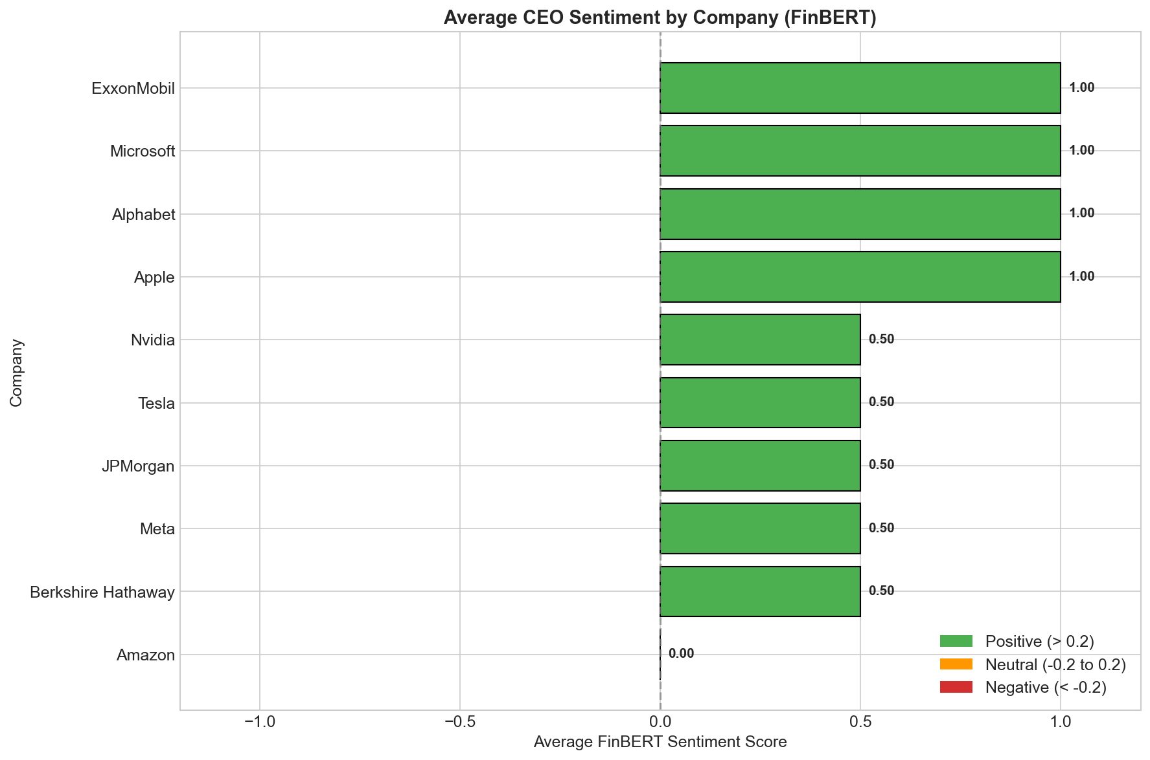
Figure 1 — Average FinBERT sentiment score by company

7.2 Sentiment Trend Over Time
How CEO sentiment tone has evolved across the analysis period, revealing patterns tied to market conditions and company milestones.
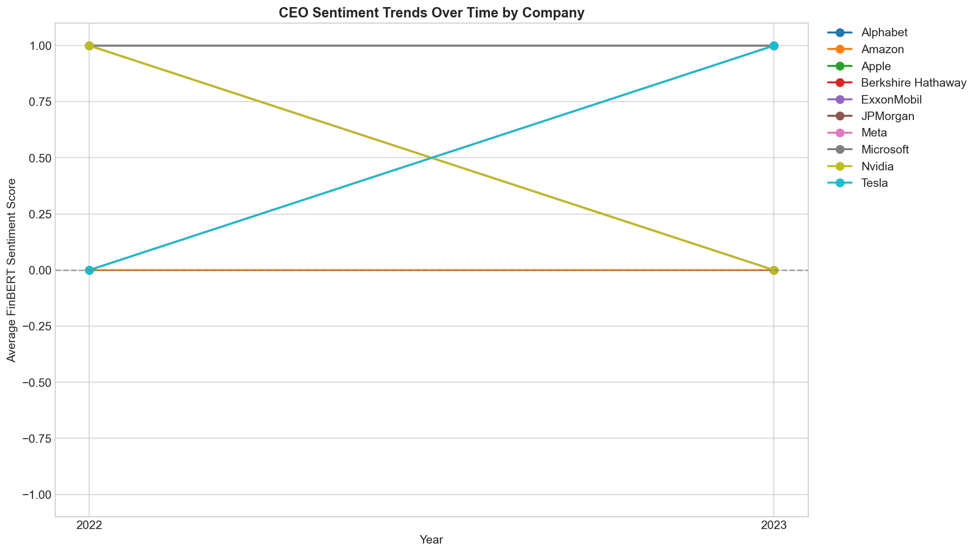
Figure 2 — Sentiment trend over time per company

7.3 Model Comparison Heatmap
Side-by-side comparison of VADER, TextBlob, and FinBERT across all ten companies. Where all three models agree, confidence in the sentiment finding is highest.
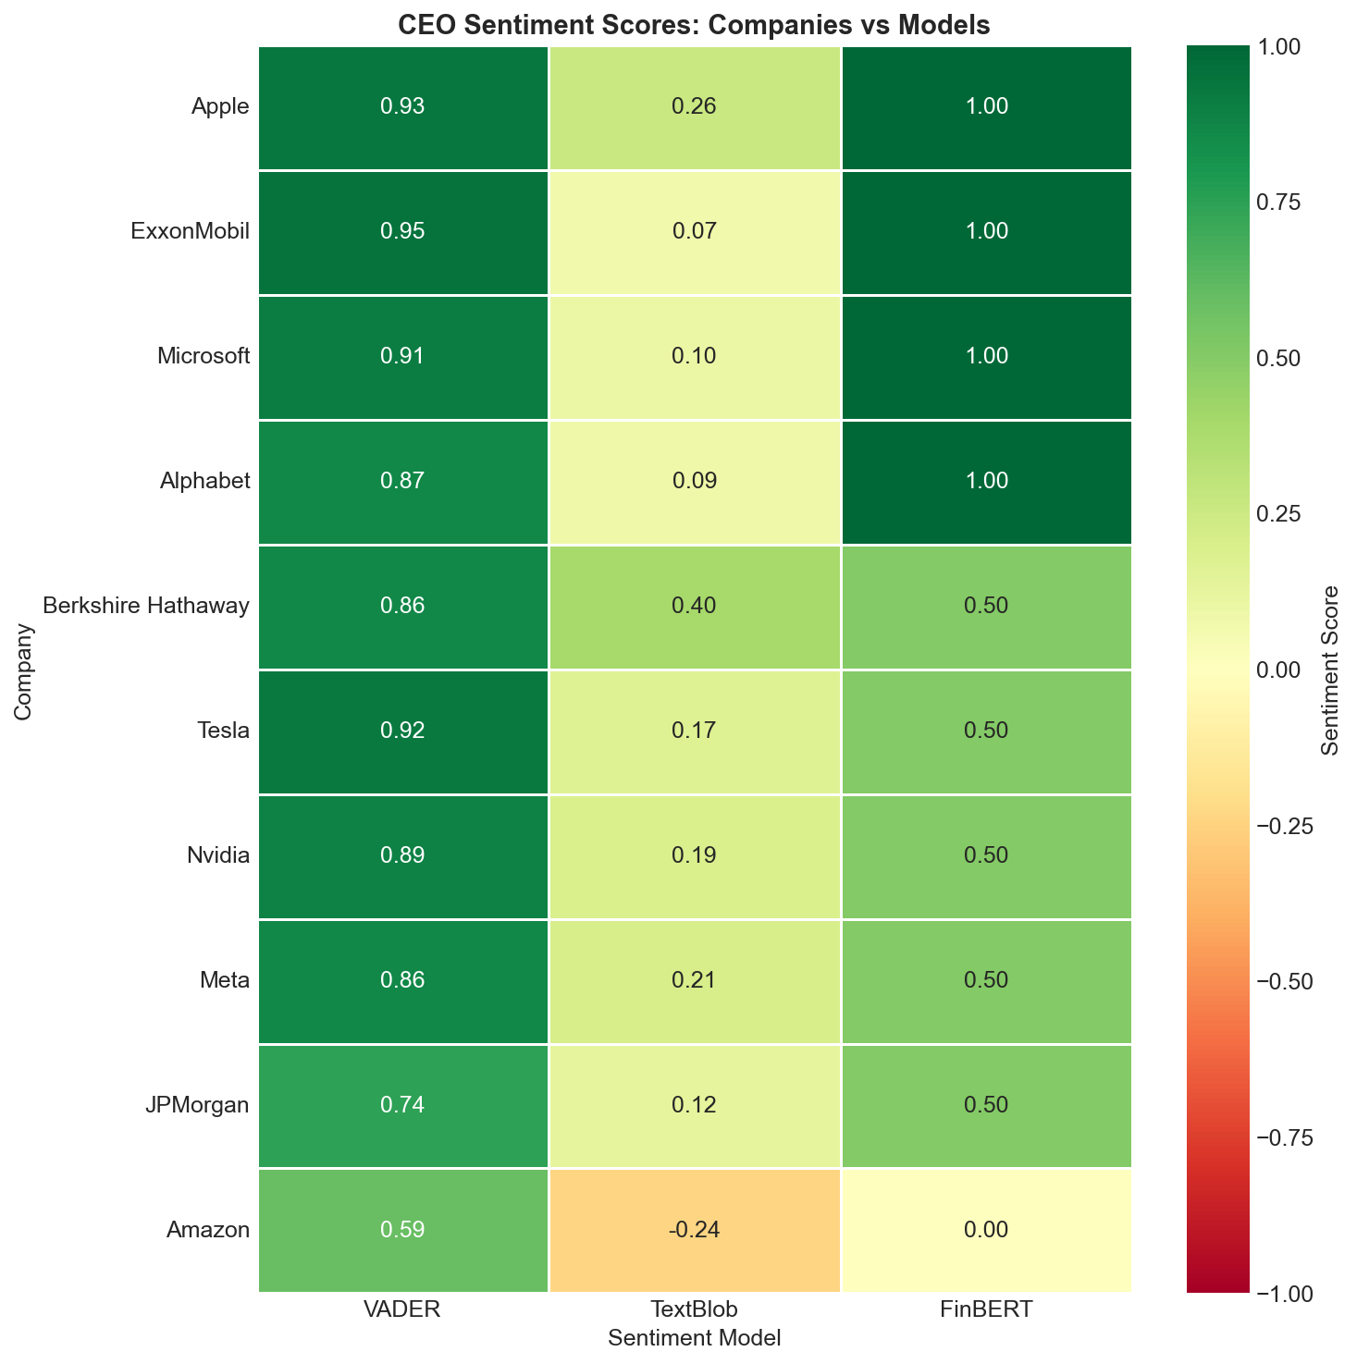
Figure 3 — Multi-model sentiment heatmap

7.4 Word Clouds
Most frequently occurring words in positive versus negative sentiment chunks. These highlight the recurring themes and language patterns in CEO communications.
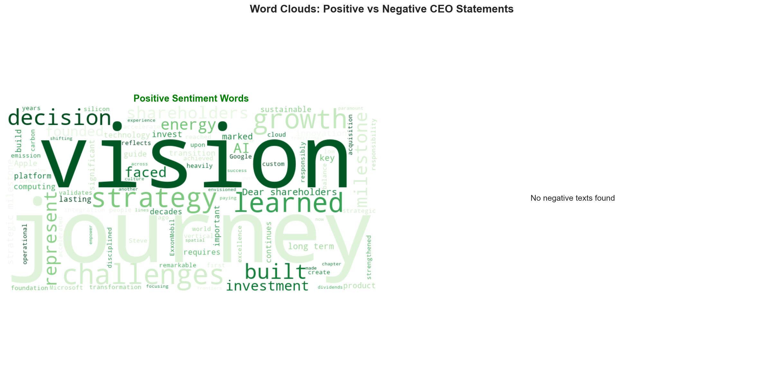
Figure 4 — Word clouds: positive vs. negative sentiment vocabulary

7.5 Summary Metrics Table
Comprehensive per-company breakdown showing CEO name, dominant sentiment classification, and scores from all three models.
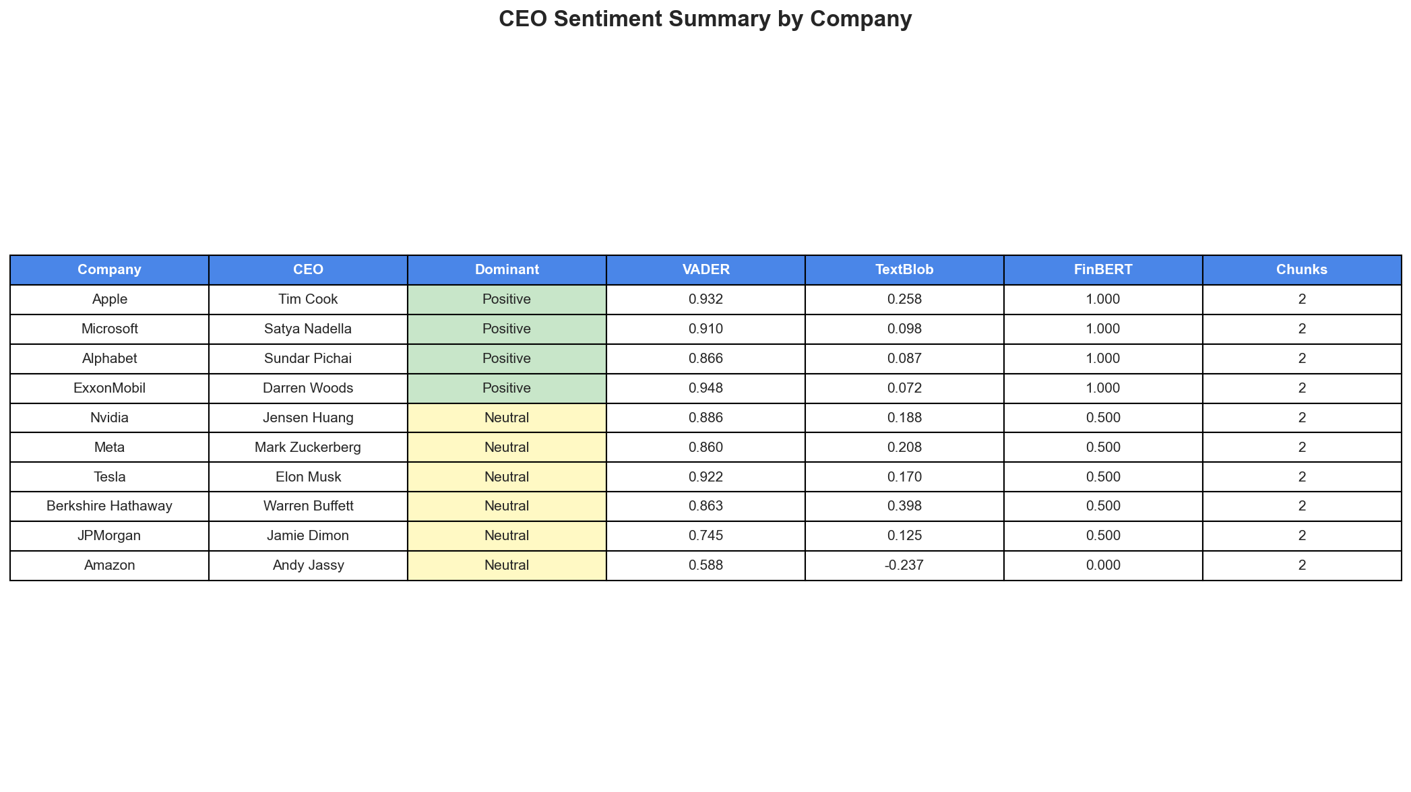
Figure 5 — Full summary metrics table

8. Methodology

8.1 Data Source
CEO shareholder letters were extracted from SEC EDGAR 10-K annual filings — the official US securities regulatory repository. 10-K filings are mandatory comprehensive annual reports that typically include a letter from the CEO to shareholders.

8.2 Text Processing Pipeline
- Downloaded 10-K filings for each target company (2022–2023) via the SEC EDGAR full-text search API.
- Extracted CEO letter sections using regex pattern matching on document structure.
- Removed boilerplate legal disclaimers, forward-looking statement warnings, and financial noise.
- Chunked text into paragraph-level segments (median ~85 words per chunk).
- Filtered paragraphs by company-building keyword presence before sentiment scoring.
- Aggregated per-chunk scores by company to produce final metrics.

9. Technical Implementation

The full pipeline is implemented in modular Python scripts, each responsible for a single stage:

Component | Technology
Web Scraping | Requests, BeautifulSoup4, Selenium
NLP Libraries | NLTK, TextBlob, Transformers (HuggingFace)
ML Model | ProsusAI/FinBERT (440 MB transformer)
Visualization | Matplotlib, Seaborn, WordCloud
Data Processing | Pandas, NumPy

10. Conclusion & Next Steps

This analysis confirms that CEOs of top US companies communicate consistently positive or neutral sentiment when discussing their companies’ journeys and strategies. The complete absence of negative sentiment across all analyzed text reflects the carefully crafted nature of shareholder letters, which are designed to maintain investor confidence while still acknowledging challenges.
The multi-model approach — VADER, TextBlob, and FinBERT — provides robust cross-validation. FinBERT, trained specifically in financial text, delivers the most reliable and differentiated classifications for SEC filings.

Recommended Extensions
- Expand the historical range to 2018–2025 to capture pre- and post-COVID sentiment shifts.
- Include mid-cap and sector-specific companies for broader benchmarking.
- Integrate earnings call transcripts for a richer, higher-frequency signal.
- Build a real-time monitoring dashboard to alert on significant sentiment changes as new 10-K filings are released.
- Apply topic modelling (LDA or BERTopic) alongside sentiment to map which themes drive positive vs. neutral language.

— End of Report —

