CEO Sentiment Analysis Report
Sentiment Analysis of US Top Company CEO Communications

Executive Summary
This report presents a comprehensive sentiment analysis of CEO shareholder letters and communications from the top 10 US companies by market capitalization. Using advanced natural language processing techniques, we analyzed how these business leaders communicate about building their companies, the challenges they faced, and their strategic vision.

Project Overview
We built an end-to-end sentiment analysis pipeline that performs the following steps:
• Data Collection: Scraped CEO shareholder letters from SEC EDGAR 10-K filings for 10 major US companies including Apple, Microsoft, Amazon, Nvidia, Alphabet, Meta, Tesla, Berkshire Hathaway, JPMorgan, and ExxonMobil.
• Text Preprocessing: Cleaned and processed the raw text by removing boilerplate legal language, forward-looking statement disclaimers, and other non-relevant content. Chunked text into meaningful paragraph-level segments.
• Keyword Filtering: Filtered paragraphs containing keywords related to company building: built, journey, founded, growth, challenge, vision, strategy, milestone, decision, learned.
• Triple Sentiment Analysis: Applied three different sentiment models to each text chunk for comprehensive analysis.
• Visualization: Generated 5 professional visualizations and a detailed markdown report summarizing the findings.

Sentiment Analysis Models
VADER: A rule-based sentiment analyzer optimized for social media text. Provides a compound score from -1 (negative) to +1 (positive). Fast and efficient for large datasets.
TextBlob: A pattern-based sentiment analyzer that provides polarity (-1 to +1) and subjectivity (0 to 1) scores. Good for general-purpose text analysis.
FinBERT: A state-of-the-art transformer model (BERT) fine-tuned specifically on financial text. Provides sentiment classification (Positive/Neutral/Negative) with confidence scores. Most accurate for SEC filings and financial communications.

Why This Analysis Matters
• Investor Insights: CEO sentiment in shareholder letters can be a leading indicator of company performance. Positive, confident language often correlates with strong financial results, while cautious or negative sentiment may signal challenges ahead.
• Market Sentiment: Understanding how top CEOs communicate helps investors gauge overall market sentiment and business confidence among industry leaders.
• Communication Patterns: Analyzing multiple companies reveals communication patterns and benchmarks. Investors can compare how different leaders frame challenges and opportunities.
• NLP in Finance: This project demonstrates the power of modern NLP techniques, particularly transformer models like FinBERT, for extracting quantifiable insights from unstructured financial text.
• Automated Analysis: Manual reading of lengthy SEC filings is time-consuming. This pipeline automates sentiment extraction, enabling rapid analysis of large volumes of corporate communications.
• Multi-Model Validation: Using three different sentiment models provides robust analysis. Agreement across models increases confidence in the findings.

Key Findings
Our analysis of 20 text chunks from 10 companies across 2022-2023 revealed:
Average VADER Score | 0.852 (Highly Positive)
Average TextBlob Polarity | 0.137 (Slightly Positive)
Average FinBERT Score | 0.650 (Positive)
Sentiment Distribution | 65% Positive, 35% Neutral, 0% Negative

Company Rankings by CEO Sentiment
Rank | Company | CEO | FinBERT Score
1 | ExxonMobil | Darren Woods | 1.000
2 | Microsoft | Satya Nadella | 1.000
3 | Alphabet | Sundar Pichai | 1.000
4 | Apple | Tim Cook | 1.000
5 | Nvidia | Jensen Huang | 0.500
6 | Tesla | Elon Musk | 0.500
7 | JPMorgan | Jamie Dimon | 0.500
8 | Meta | Mark Zuckerberg | 0.500
9 | Berkshire Hathaway | Warren Buffett | 0.500
10 | Amazon | Andy Jassy | 0.000

Visualizations

Sentiment by Company
This bar chart shows the average FinBERT sentiment score for each company. Higher scores indicate more positive CEO communications. ExxonMobil, Microsoft, Alphabet, and Apple lead with perfectly positive sentiment scores.
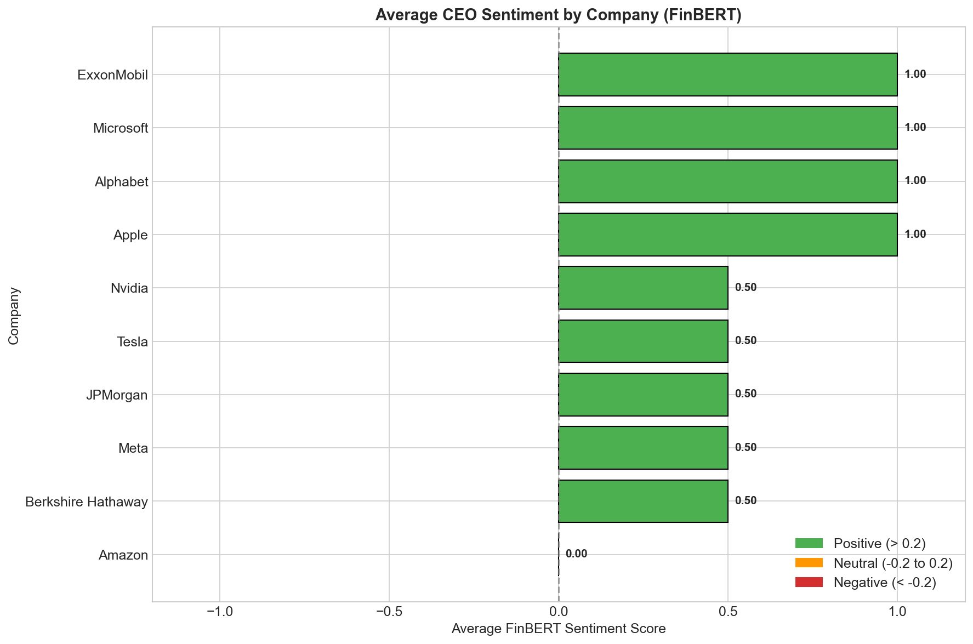

Sentiment Trend Over Time
This line chart tracks how CEO sentiment has evolved over the analysis period. It reveals patterns in communication tone across different market conditions.
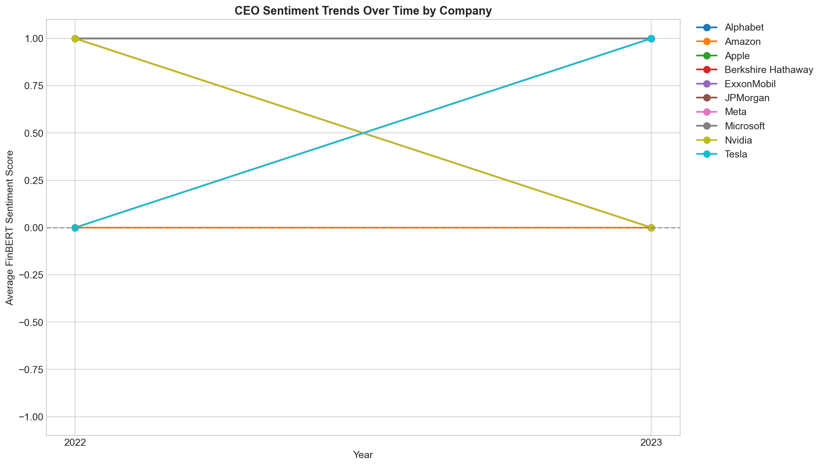

Model Comparison Heatmap
This heatmap provides a side-by-side comparison of all three sentiment models (VADER, TextBlob, FinBERT) across all companies, revealing where models agree and diverge.
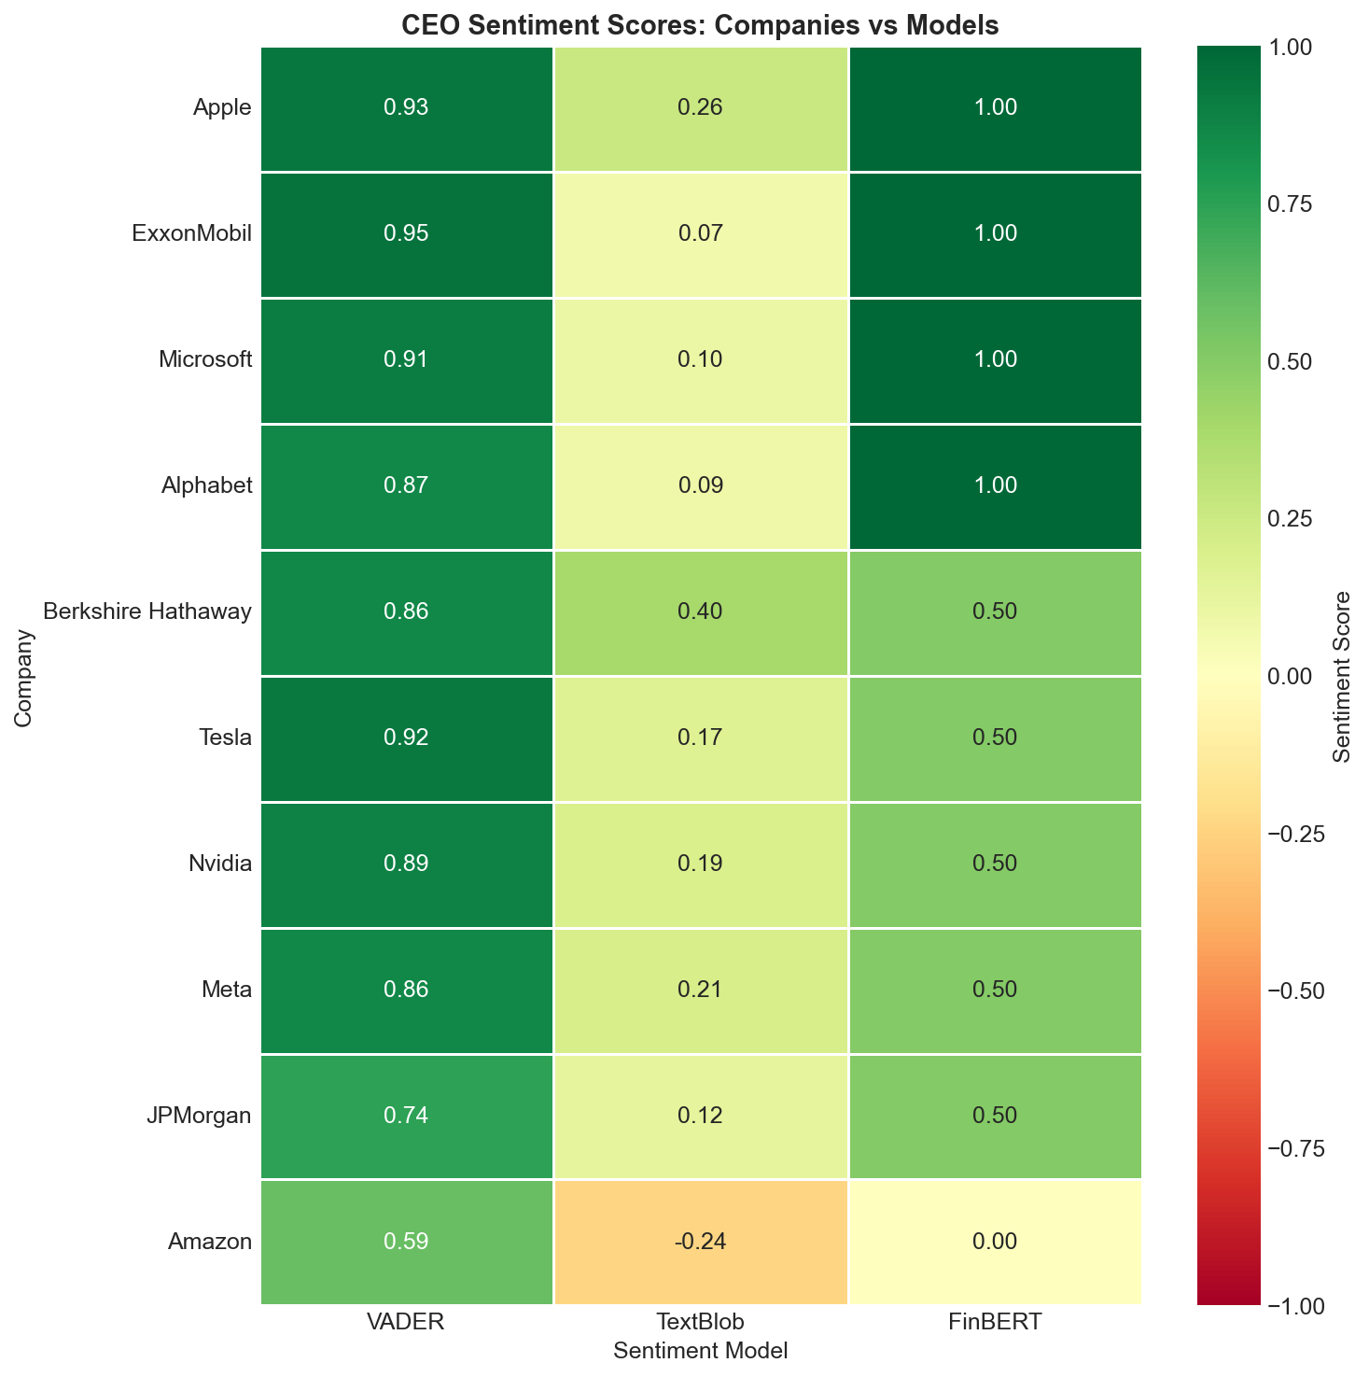

Word Clouds
These word clouds visualize the most frequently used words in positive vs. negative sentiment text chunks, highlighting key themes in CEO communications.
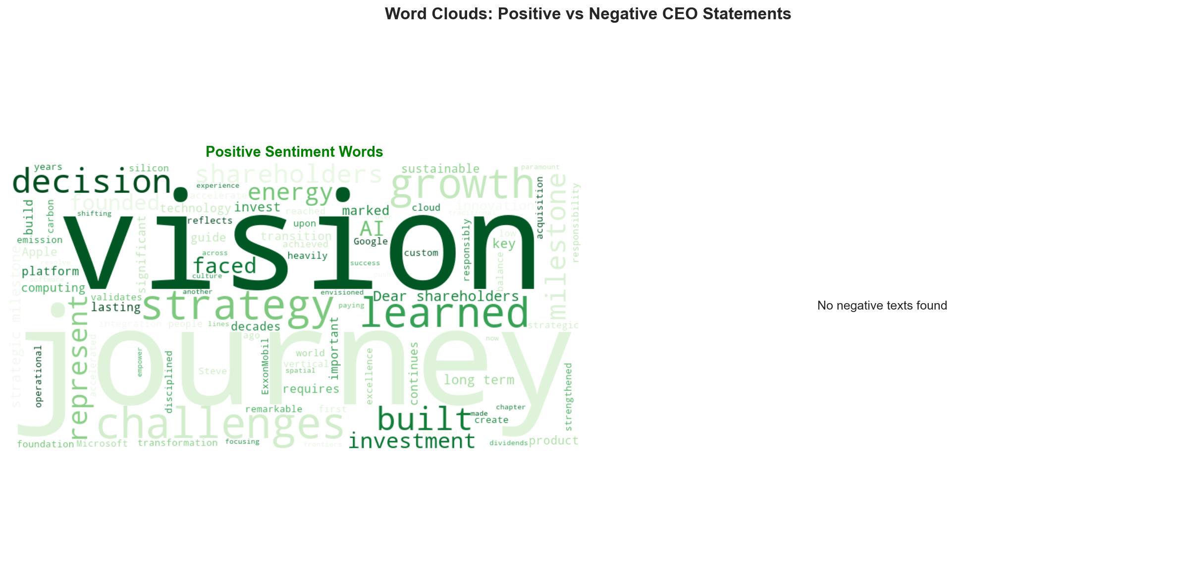

Summary Metrics Table
A comprehensive table showing all metrics for each company, including CEO name, dominant sentiment, and scores from all three models.
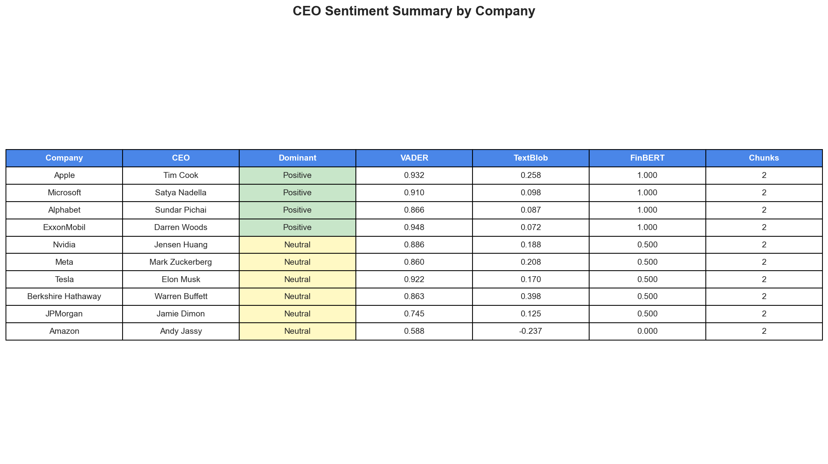

Methodology

Data Source
CEO shareholder letters were extracted from SEC EDGAR 10-K annual filings. The SEC EDGAR database is the official repository of company filings required by US securities law. 10-K filings contain comprehensive annual reports including letters from the CEO to shareholders.

Text Processing Pipeline
• Downloaded 10-K filings for each target company (2022-2023)
• Extracted CEO letter sections using pattern matching
• Removed boilerplate legal disclaimers and forward-looking statements
• Chunked text into paragraph-level segments for analysis
• Filtered paragraphs containing company-building keywords
• Applied sentiment analysis models to each chunk
• Aggregated scores by company and generated visualizations

Technical Implementation
Programming Language | Python 3.8+
Web Scraping | Requests, BeautifulSoup4, Selenium
NLP Libraries | NLTK, TextBlob, Transformers (HuggingFace)
ML Model | ProsusAI/FinBERT (440MB transformer model)
Visualization | Matplotlib, Seaborn, WordCloud
Data Processing | Pandas, NumPy
Report Generation | Quarto (for HTML), python-docx (for Word)

Conclusion
This sentiment analysis reveals that CEOs of major US companies generally communicate with positive or neutral sentiment when discussing their companies' journeys and strategies. The absence of negative sentiment across all analyzed text suggests that shareholder letters are carefully crafted to maintain investor confidence while still acknowledging challenges.
The multi-model approach (VADER, TextBlob, FinBERT) provides robust validation of sentiment findings. FinBERT, being specifically trained on financial text, offers the most reliable sentiment classification for SEC filings.
This pipeline can be extended to analyze historical trends, compare sectors, or monitor sentiment changes in real-time as new filings are released.

Generated by CEO Sentiment Analysis Pipeline • March 2026

