

DEPARTMENT: INFORMATION AND COMMUNICATION TECHNOLOGY OPTION INFORMATION TECHNOLOGY
PROGRAM: BACHELOR OF TECHNOLOGY IN INFORMATION TECHNOLOGY

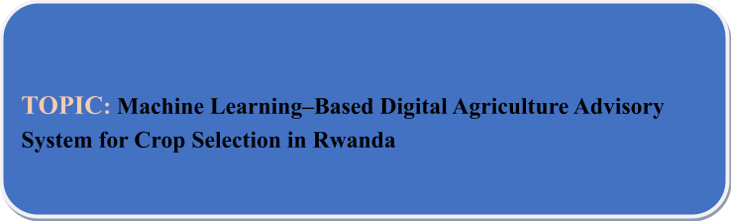

Prepared By: Registration Number:
Phionah MUTONI 25RP21050

Under the guidance of:
Mr. EMMANUEL KANYANDEKWE

Academic Year: Date of Submission:
2025/2026 ……… /…. /2026

DECLARATION
I here declare that this work titled “Machine Learning-Based Digital Agriculture Advisory System” presented for the award of Bachelor of Technology in Information Technology at Rwanda Polytechnic NGOMA College is entirely my own work and has never been presented or submitted at any university or higher learning institute, either in whole or in part. The case study for this project is the YOUR CASE STUDY.
Declared by: Phionah MUTONI

STUDENTS NAMES: SIGNATURE: DATE

Phionah MUTONI …........................... ……/…. /2026

DEDICATION
I dedicate this project to the incredible people who have supported me along the way. First, to God Almighty. Thank you for your kindness and for your faithfulness in fulfilling your promise. I wouldn’t have made it to this point without you. To my amazing parents, you have been my greatest supporters from the day I was born to this day. I’m thankful and proud to be your daughter. Thanks to my awesome supervisor, thank you for your guidance and patience; it truly helped make this project a success. Finally, to my great classmates and colleagues, thanks for being there for me, studying late nights together, and making this whole experience even better. We did it!

ACKNOWLEDGMENT
I would like to express my deepest gratitude to those who made this project possible. First and foremost, my heartfelt thanks go to God Almighty, whose kindness and unwavering faithfulness have been my guiding light. Without Your grace, I would not have reached this milestone. To my incredible parents, your boundless love and sacrifices have seen me through every challenge, and your dedication and willingness to let God work through you have profoundly shaped who I am today. I am immensely thankful and proud to be your son. My deepest appreciation also goes to my supervisor, Mr. Emmanuel KANYANDEKWE, for your invaluable guidance and patience, which were instrumental in making this project a success. Finally, I extend my thanks to my wonderful classmates and colleagues; your companionship during late-night study sessions made this experience both bearable and memorable. Thank you all for being part of this journey.

APPROVAL
This is to certify that the project titled “Machine Learning-Based Digital Agriculture Advisory System” completed by Phionah MUTONI has been reviewed and approved. It meets the requirements for the B-Tech IT degree at RP Ngoma College and demonstrates significant technical and practical value. The case study for this project is the YOUR CASE STUDY.

SUPERVISOR: HEAD OF DEPARTMENT:

Signature: …………………. Signature: ………………….

KANYANDEKWE Emmanuel YANKURIJE Madeleine

Date ...….../…/2026 Date …… /…/2026

ABSTRACT
Agriculture is one of the most important sectors in Rwanda’s economy and serves as the main source of employment and livelihood for the majority of the population, especially smallholder farmers who depend heavily on farming for food security and income generation. Despite its importance, the agricultural sector continues to experience several challenges, including poor crop selection practices, limited access to agricultural extension and advisory services, unpredictable climate conditions, low adoption of modern farming technologies, and inadequate access to reliable, data-driven agricultural information. These challenges often lead to low productivity, reduced farm yields, and increased risks of crop failure among farmers. In response to these issues, this project presents the design and development of a Machine Learning-Based Digital Agriculture Advisory System aimed at improving crop selection and supporting precision agriculture among smallholder farmers in Rwanda through intelligent and personalized recommendations. The system was developed as a web-based platform that applies machine learning algorithms to analyze agricultural and environmental factors such as soil nutrients and properties, rainfall patterns, temperature levels, humidity, altitude, and district location in order to recommend the most suitable crops for cultivation under specific conditions. The study adopted an applied research design and integrated agricultural data collected from multiple trusted sources, including the Rwanda Agriculture and Animal Resources Development Board (RAB), the National Institute of Statistics of Rwanda (NISR), Meteo Rwanda, and publicly available APIs such as SoilGrids and Open-Meteo, to ensure accurate and reliable recommendations. The developed platform enables users to input farm-related conditions and receive crop recommendations accompanied by confidence scores, allowing farmers to make informed farming decisions based on scientific analysis rather than traditional assumptions. In addition, the system contributes to reducing crop failure, improving productivity, promoting sustainable farming practices, and enhancing access to digital agricultural advisory services in rural communities.

Keywords: Machine Learning, Digital Agriculture, Crop Recommendation, Precision Agriculture, Rwanda, Smallholder Farmers, Advisory System.

Table of Contents
DECLARATION 2
DEDICATION 3
ACKNOWLEDGMENT 4
APPROVAL 5
LIST OF ACRONYMS AND ABBREVIATIONS 8
LIST OF FIGURES 9
CHAPTER ONE: GENERAL INTRODUCTION 10
1. Introduction 10
2. Problem Statement 10
3. Background 11
4. Objectives 12
4.1 Main Objective 12
4.2 Specific Objectives 12
5. Research Questions 12
6. Scope and Limitations 13
6.1 Scope 13
6.2 Limitations 13
7. Geographical Scope 13
8. Interest of the Project 13
8.1 Personal Interest 13
8.2 Common Interest 13
9. Organization of the Research Project 14
10. Project Timeline 14
CHAPTER TWO: LITERATURE REVIEW 15
2.1 Introduction 15
2.2 Theoretical Concept 15
2.3 Related Work 16
2.4 Proposed System 17
2.4.1 Requirements Analysis 17
2.4.1.1 Functional Requirements 17
2.4.1.2 Non-Functional Requirements 17
2.4.1.3 System Requirements 18
2.4.1.3.2 Software Requirements 18
2.4.2 Expected Outcome 18
CHAPTER THREE: RESEARCH METHODOLOGY AND DEVELOPMENT METHODOLOGY 19
3. Research Methodology 19
3.1 Research Design 19
3.2 Data Sources 19
3.2.1 Rwanda Agriculture and Animal Resources Development Board (RAB) 19
3.2.2 National Institute of Statistics of Rwanda (NISR) 19
3.2.3 Rwanda Meteorology Agency (Meteo Rwanda) 20
3.2.4 SoilGrids and Open-Meteo APIs 20
3.3 Data Pre-processing 20
3.4 Machine Learning Model Selection 20
3.5 System Development Methodology 21
3.5.1 Agile Methodology Diagram 21
3.5.2 Agile Sprint Descriptions 22
3.5.3 Conclusion 22
CHAPTER FOUR: SYSTEM ANALYSIS, DESIGN 23
4.1 Illustration of the Existing System 23
4.2 Description and Illustration of the New System 24
4.3 System Design of the New System 24
4.3.1 System Architecture Design 24
4.3.2 Data Flow Diagram (DFD) 25
4.3.3 Use Case Diagram 25
4.3.4 Flowchart Diagram 26
4.3.5 Entity Relationship Diagram (ERD) 27
4.4 Data Dictionary 27
4.5 System Implementation 30
CHAPTER FIVE: CONCLUSIONS AND RECOMMENDATIONS 33
5.1 Conclusion 33
5.2 Recommendations 33
REFERENCES 34

LIST OF ACRONYMS AND ABBREVIATIONS

ICT: Information and Communication Technology
AI: Artificial Intelligence
API: Application Programming Interface
ML: Machine Learning
NNK: K-Nearest Neighbour
SVM: Support Vector Machine
UI: User Interface
UML: Unified Modelling Language
ERD: Entity Relationship Diagram
FAO: Food and Agriculture Organization of the United Nations
MINAGRI: Ministry of Agriculture and Animal Resources
NISR: National Institute of Statistics of Rwanda
PSTA: Plan for Agriculture Transformation
RAB: Rwanda Agriculture and Animal Resources Development Board
RP: Rwanda Polytechnic

LIST OF TABLES
Table 1: Cooperative Table 29
Table 2: Farmers Table 30
Table 3: Recommendation Table 31
Table 4:Prediction Table 31

LIST OF FIGURES

Figure 1: Project Timeline Gantt Chart 15
Figure 2: Agile Development Methodology 22
Figure 3: Data Flow Diagram 26
Figure 4: Use case Diagram 26
Figure 5: Flowchart Diagram 27
Figure 6:Entity Relationship Diagram 28
Figure 7: Login Page 31
Figure 8: Admin Dashboard 32
Figure 9: Weather Forecast 32
Figure 10: Get Recommendation 33
Figure 11: Recommendation Page 33

CHAPTER ONE: GENERAL INTRODUCTION

Introduction
The Machine Learning-Based Digital Agriculture Advisory System for Crop Selection in Rwanda is a web-based system that uses Machine Learning techniques to help smallholder farmers in Rwanda choose the right crops to plant. The system uses data such as soil type, weather conditions, rainfall, altitude, and district location to generate crop recommendations. Machine Learning is used to analyze historical agricultural data and learn patterns between environmental conditions and crop performance. Based on this analysis, the system predicts the most suitable crops for a specific location.
Around 65-70% of people in Rwanda depend on agriculture for their livelihoods. However, farmers face many challenges such as poor soil conditions, climate change, and limited access to agricultural advice. Many farmers do not receive sufficient support from agricultural extension officers. This system helps to address this problem by providing data-driven crop recommendations using Machine Learning. The system recommends suitable crops such as maize, beans, cassava, rice, and Irish potatoes. It also provides basic planting guidance through a simple web interface that farmers can easily use.

Problem Statement
Many smallholder farmers in Rwanda, especially in rural areas, do not have access to proper agricultural guidance. Most farmers make farming decisions without accurate information. They plant crops that are not suitable for their soil or climate, and some farmers also use fertilizers incorrectly. This results in poor harvests and financial losses. Agricultural studies show that crop production in Rwanda is lower than expected, and one major reason is that agricultural extension officers are too few to reach all farmers [4].
Rwanda's agricultural sector faces several challenges, including limited agricultural extension services, soil degradation, climate change, lack of farming information, and incorrect crop selection. Farmers do not have access to a simple digital system that uses Machine Learning to analyze farming data and provide location-based crop recommendations. As a result, farmers experience low yields and food insecurity.

Background
In many developing countries, digital technology is considered an important tool for improving agriculture. International organizations such as the Food and Agriculture Organization (FAO) and the World Bank show that using data and Machine Learning in agriculture can help increase food production, improve farm efficiency, and reduce the impact of climate change [1], [2]. These technologies enable farmers to make better decisions based on real data instead of relying on experience or guesswork.
Machine Learning techniques are increasingly used in agriculture to analyze large volumes of data such as soil properties, rainfall, temperature, and historical crop yields. Studies show that Machine Learning models can accurately predict suitable crops, improve yield estimation, and support better farm planning [3]. Decision support systems that integrate Machine Learning help farmers select crops that match their local environmental conditions, which leads to higher productivity and reduced losses.
In Rwanda, the government has prioritized agricultural modernization through programs such as the Strategic Plan for Agriculture Transformation (SPAT). These initiatives have improved farmers' access to agricultural inputs, extension services, and markets [4]. Despite these efforts, many farmers still lack timely and personalized agricultural advice. Agricultural extension workers are responsible for supporting a large number of farmers, making it difficult to provide location-specific and data-driven guidance.
Most existing digital agriculture systems in Rwanda provide general farming information and are not designed to fully consider local farming conditions. Many systems do not apply Machine Learning to analyze variations in soil types, rainfall patterns, altitude, and agro-ecological zones across the country. Platforms such as the Rwanda Agricultural Board's e-extension services offer useful information but lack predictive capabilities. Other systems such as Esoko and Digital Green mainly focus on market information and do not use Machine Learning models to generate crop recommendations tailored to individual farm conditions [5]. Therefore, there is a strong need for a Machine Learning-based Digital Agriculture Advisory System that can provide location-specific crop recommendations tailored to Rwanda's agricultural environment.

Objectives

Main Objective
To develop a web-based Machine Learning-Based Digital Agriculture Advisory System that predicts suitable crops for smallholder farmers in Rwanda using historical and current agricultural data.

Specific Objectives
    - To collect and analyze historical agricultural data, including soil types, rainfall patterns, and crop performance in Rwanda.
    - To integrate current weather and environmental data into the system for timely advisory services.
    - To design and develop an online platform that provides location-based crop and fertilizer recommendations.
    - To implement a Machine Learning prediction engine that uses past and present data to support informed farming decisions.
    - To evaluate the effectiveness of the Machine Learning model in improving decision-making among smallholder farmers.

Research Questions
- How can Machine Learning be used to analyze soil, weather, and location data to recommend suitable crops in Rwanda?
- How effective is a Machine Learning-based system in improving crop selection decisions among smallholder farmers?
- How accurate are crop recommendations generated using historical and current agricultural data?
- What challenges affect the performance of a Machine Learning-based agriculture advisory system in Rwanda?

Scope and Limitations

Scope
The project focuses on developing a web-based platform accessible via desktop and mobile browsers. It covers five major crops: maize, beans, cassava, rice, and Irish potatoes. The system covers all 30 districts of Rwanda. It uses Machine Learning models trained on historical and current agricultural data to generate crop recommendations. Weather and soil data are obtained from publicly available sources. The system includes user authentication and recommendation history.

Limitations
The system relies on publicly available and simulated data due to limited real field trial data. Machine Learning model accuracy depends on the quality and completeness of the data. Internet connectivity is required to access the web system. The system provides advisory support only and does not guarantee farming outcomes or yields.

Geographical Scope
The project will be implemented in Rwanda, covering all 30 districts across the four provinces and the City of Kigali. Machine Learning models will be trained using data relevant to Rwandan agricultural conditions.

Interest of the Project

Personal Interest
This project allows the application of Information Technology and Machine Learning skills to solve real agricultural challenges. It provides practical experience in developing a data-driven web-based advisory system and supports career development in data science and agricultural informatics.

Common Interest
The project benefits farmers, agricultural extension officers, and policymakers. Farmers receive data-based crop recommendations, extension officers can reach more farmers efficiently, and the project supports Rwanda's goal of modernizing agriculture through digital technologies.

Organization of the Research Project
Chapter 1: General Introduction - This chapter contains the general introduction, background, problem statement, objectives, scope, and project timeline.
Chapter 2: Literature Review - This chapter discusses what other researchers have done and justifies the use of Machine Learning as the solution approach.
Chapter 3: Research Methodology and Development Methodology - This chapter presents the data collection approach, the research design, and the software development methodology used to build the system.
Chapter 4: System Analysis and Design - This chapter presents the system architecture, database design, and interface wireframes.
Chapter 5: Implementation - This chapter explains the implementation of the system based on the design.
Chapter 6: Conclusion and Recommendation - This chapter presents the main findings and recommendations for future work.

Project Timeline
The table below presents the planned schedule for project activities from February 2026 to June 2026, aligned with the final defense in June 2026.

Activity / Phase | February | March | April | May | June
Proposal & Planning
Data Collection & Analysis
System Design
ML Model Development
System Implementation
Testing & Validation
Report Writing & Documentation
Final Defense Preparation
Figure 1: Project Timeline Gantt Chart

CHAPTER TWO: LITERATURE REVIEW

Introduction
The literature review aims to provide a comprehensive understanding of the current state of Machine Learning applications in agriculture, crop recommendation systems, and digital advisory tools globally and specifically in Rwanda. By examining existing studies, reports, and related works, it provides a complete list of published and unpublished studies related to the subject. This chapter also justifies the choice of Machine Learning as the core technology for the proposed system.

Theoretical Concept
The Food and Agriculture Organization of the United Nations defines precision agriculture as the use of data and technology to optimize farming decisions at the field level, enabling farmers to apply the right inputs at the right place and at the right time [1]. Machine Learning is a subset of artificial intelligence that enables computer systems to learn from data and improve their predictions over time without being explicitly programmed. In agriculture, Machine Learning models are trained on datasets containing soil properties, climate variables, and historical crop yields to predict the most suitable crops for a given location [6].
Studies show that crop selection is one of the most critical decisions a farmer makes each season, and poor crop-soil-climate matching is a leading cause of low yields in sub-Saharan Africa [3]. Traditional advisory approaches rely on static recommendation tables prepared by agronomists, which cannot adapt to the variability of individual farm conditions. Machine Learning models such as Random Forest, Decision Tree, and Naive Bayes classifiers have demonstrated strong performance in crop recommendation tasks because they can capture non-linear relationships between multiple input variables and produce location-specific predictions [9].
In Rwanda, the Rwanda Agriculture and Animal Resources Development Board (RAB) and the Ministry of Agriculture and Animal Resources (MINAGRI) have identified inadequate access to personalized agricultural advisory services as a major constraint on smallholder productivity [4]. The Strategic Plan for Agriculture Transformation Phase IV (PSTA IV) specifically calls for the use of digital technologies to scale advisory services to all farmers across Rwanda's 30 districts [4]. These policy frameworks provide the national context within which this project is positioned.

Related Work
Sharma et al. [9] conducted a comprehensive review of Machine Learning applications in precision agriculture and found that classification algorithms, particularly Random Forest and Support Vector Machines, achieved accuracies above 90% in crop suitability prediction tasks using soil and climate data. Their work demonstrates that ensemble methods are well suited for handling the multivariate nature of agricultural datasets. However, their review was conducted across diverse global contexts and did not address the specific agro-ecological conditions of Rwanda, leaving a gap that this project addresses.
Kamilaris, Kartakoullis, and Prenafeta-Boldu [3] reviewed the application of big data analytics in agriculture and found that integrating multiple data sources, including soil sensors, satellite imagery, and meteorological stations, significantly improves prediction accuracy in crop planning systems. They highlighted that the lack of localized, high-quality datasets remains the primary barrier to deploying such systems in developing countries. This finding directly informs the data collection strategy of the proposed system, which draws on RAB soil surveys, NISR seasonal reports, and Meteo Rwanda climate records.
Liakos et al. [6] surveyed Machine Learning in agriculture across four domains: crop management, livestock management, water management, and soil management. Their survey confirmed that Decision Tree and Random Forest models are the most widely used for crop recommendation due to their interpretability and robustness to noisy data. They also noted that web-based deployment of such models is limited in sub-Saharan Africa, underscoring the practical contribution of the proposed system.
Tsan et al. [5] analyzed the digitalization of African agriculture and found that while numerous digital agriculture platforms exist across Africa, most provide static information and lack predictive The World Bank [2] emphasized that data-driven advisory systems can increase smallholder yields by 10 to 20 percent when recommendations are personalized to local conditions. The report highlighted that digital advisory systems are most effective when accessible through
capabilities based on Machine Learning. They noted that platforms such as Esoko and Digital Green focus primarily on market price information and do not generate personalized crop recommendations, confirming the need for a Machine Learning-driven system tailored to Rwandan farming conditions.
mobile and web interfaces, a consideration that directly shapes the interface design of the proposed system.

Proposed System
The proposed system is a web-based Machine Learning-Based Digital Agriculture Advisory System for Crop Selection in Rwanda. The system will collect soil, climate, and geographic data for a given district and apply trained Machine Learning models to recommend the most suitable crops for planting. The system aims to improve crop selection decisions among smallholder farmers by providing accessible, data-driven recommendations through a simple web interface.

Requirements Analysis

Functional Requirements
- The system shall collect and pre-process soil, climate, and geographic data for all 30 districts of Rwanda.
- The system shall apply a trained Machine Learning model to generate crop recommendations based on user-provided farm data.
- The system shall display recommended crops along with basic planting guidance for each recommendation.
- The system shall allow users to register, log in securely, and view their recommendation history.
- The system shall integrate real-time weather data through an external API to support timely advisory outputs.

Non-Functional Requirements
✔ The system shall be accessible via desktop and mobile web browsers without requiring software installation.
✔ The system shall return crop recommendations within an acceptable response time.
✔ The system shall be scalable to accommodate additional crops, districts, and data sources in future versions.
✔ The system shall maintain compatibility with existing agricultural data formats used by RAB and NISR.
✔ The system shall store user data securely with appropriate authentication and access controls.

System Requirements
        - Hardware Requirements
The hardware required for this project includes a computer with sufficient processing power to handle data analysis and Machine Learning model training. A stable internet connection with adequate bandwidth is required for accessing datasets, downloading software libraries, and deploying the web application.

Software Requirements
The operating system can be either Linux or Windows. The database system will be MySQL for storing and managing agricultural and user data. The web server will be Apache HTTP Server. The frontend will use HTML, CSS (Bootstrap), and JavaScript. The backend will be developed using Python with the Flask framework. Machine Learning tasks will use Python libraries including scikit-learn and XGBoost. Data analysis will be conducted using Jupyter Notebook, and data visualization will use Matplotlib, Seaborn, and Plotly. The development environment will use Visual Studio Code or PyCharm.

Expected Outcome
The expected outcome of the proposed system is a functional web-based platform that accurately recommends suitable crops to smallholder farmers in Rwanda based on their soil type, climate conditions, and district location. The system is expected to improve crop selection decisions, reduce crop failures, and contribute to increased agricultural productivity across Rwanda's farming communities.

CHAPTER THREE: RESEARCH METHODOLOGY AND DEVELOPMENT METHODOLOGY

Research Methodology
This chapter describes the approach used to design, develop, and validate the Machine Learning-Based Digital Agriculture Advisory System for Crop Selection in Rwanda. It covers the research design, the sources and types of data used, and the software development methodology applied to build the system.

Research Design
This project follows an applied research design, which focuses on using existing knowledge and technologies to solve a specific practical problem. The problem identified is the inability of smallholder farmers in Rwanda to access timely, location-specific crop selection advice. The solution is developed by collecting agricultural data, training Machine Learning models on that data, and deploying the models within a web-based advisory platform.
The research combines quantitative data analysis, where crop yield records, soil measurements, and climate figures are processed numerically, with a system development component, where the findings of the analysis are translated into a working software application. This combination ensures that the system is both scientifically grounded and practically useful.

Data Sources
The quality and relevance of the data used to train the Machine Learning models directly determines the accuracy of the crop recommendations the system produces. The following data sources were identified and used in this project.

Rwanda Agriculture and Animal Resources Development Board (RAB)
RAB maintains district-level records of crop performance, soil classification maps, and seasonal planting calendars for Rwanda. These records were used to compile the training dataset for the Machine Learning model, providing information on which crops have historically performed well under specific soil and climate conditions across Rwanda's agro-ecological zones [7].

National Institute of Statistics of Rwanda (NISR)
The NISR publishes seasonal agricultural survey reports that document crop yields by district, covering crops including maize, beans, cassava, Irish potato, rice, and sorghum. Data from these
surveys for the period 2018 to 2023 were used to build the historical performance component of the training dataset [8].

Rwanda Meteorology Agency (Meteo Rwanda)
Meteo Rwanda provides historical and seasonal climate data including rainfall totals, average temperatures, and humidity levels by district. This data was used to populate the climate input variables of the Machine Learning model, ensuring that recommendations reflect actual weather patterns in each district [10].

SoilGrids and Open-Meteo APIs
For districts where locally measured soil data was incomplete, the SoilGrids global soil information service was used to obtain predicted values for soil pH, nitrogen, phosphorus, and potassium content. The Open-Meteo API was used to retrieve current and forecast weather data to support real-time recommendation generation within the deployed web system.

Data Pre-processing
Raw agricultural data from the sources described above required cleaning and transformation before it could be used to train Machine Learning models. Missing values in soil nutrient fields were filled using district-level averages derived from the SoilGrids API. Categorical variables such as district name and soil type were encoded numerically using label encoding. Continuous variables including rainfall, temperature, and soil pH were normalized to a common scale to prevent any single variable from dominating the model's predictions. The final processed dataset contains records for Rwanda's 30 districts covering five crop types, with each record consisting of eight input features: soil pH, nitrogen content, phosphorus content, potassium content, average annual rainfall, average temperature, average humidity, and altitude [11].

Machine Learning Model Selection
Four supervised classification algorithms were selected for training and comparison based on their established performance in crop recommendation literature: Random Forest, Decision Tree, Naive Bayes, and K-Nearest Neighbor (KNN). Each algorithm was trained on 70% of the dataset and evaluated on the remaining 30% using accuracy, precision, recall, and F1-score as performance metrics [12]. The algorithm achieving the highest F1-score on the test set was selected for integration into the web advisory system. Random Forest was anticipated to perform
best given its robustness to overfitting and its ability to handle multiple correlated input features, which is a common characteristic of agricultural datasets [6].

System Development Methodology
The Agile methodology was selected as the software development framework for this project. Agile organizes development into short, iterative cycles called sprints, each producing a working and testable component of the system. This approach is well suited to a project where requirements may be refined as the Machine Learning models are evaluated and user feedback is gathered. It also supports the parallel development of the data pipeline, model training, and web interface components without one blocking the other.

Agile Methodology Diagram
The diagram below illustrates the six sprints of the Agile development cycle applied in this project, showing how each phase connects to the central iterative process.

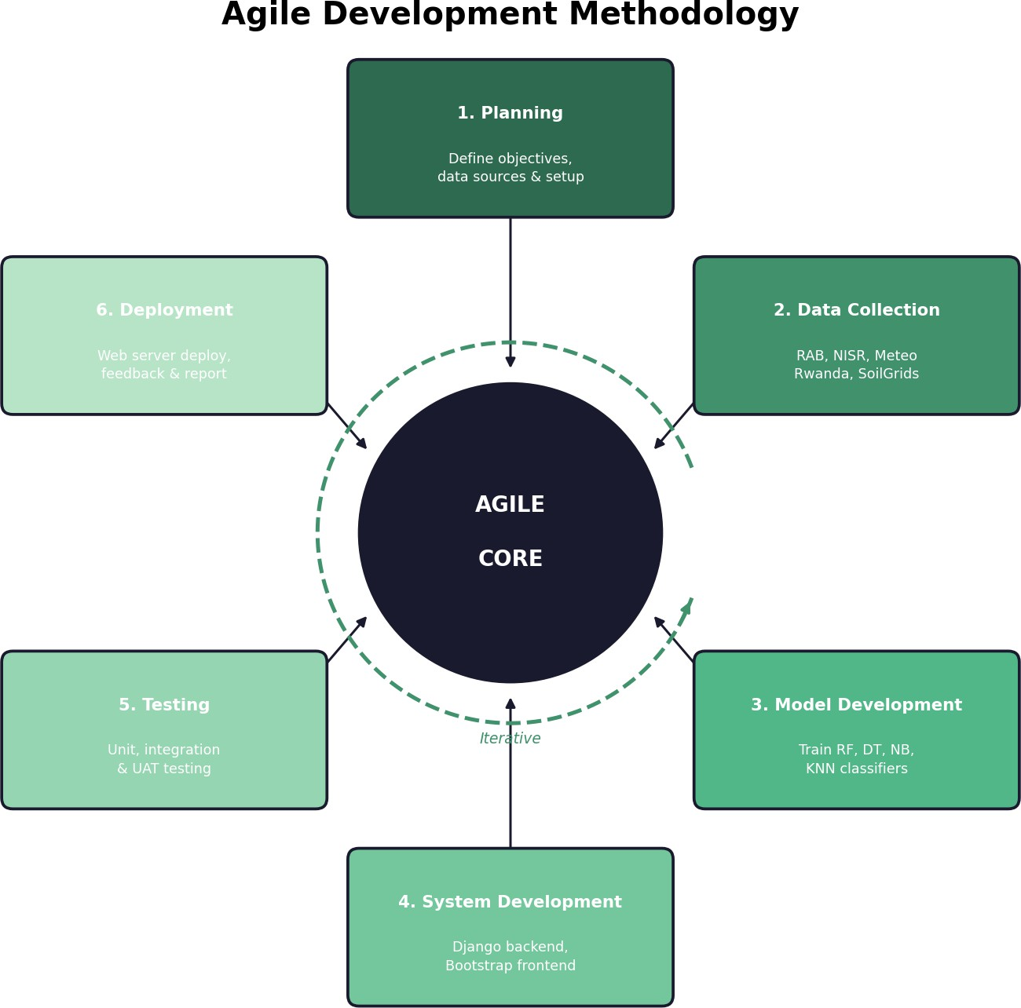

Figure 2: Agile Development Methodology

Agile Sprint Descriptions
Sprint 1 — Planning: All data source agreements were finalized, version control was configured using Git, the development environment was set up with Python, Flask, and MySQL, and the complete system requirements were documented.
Sprint 2 — Data Collection: Datasets were downloaded and merged from RAB, NISR, Meteo Rwanda, and the SoilGrids API. Data cleaning, encoding, and normalization were applied to produce a ready-to-train dataset.
Sprint 3 — Model Development: The four selected Machine Learning classifiers were trained and evaluated. The best-performing model was selected based on F1-score and saved as a serialized file for backend integration.
Sprint 4 — System Development: The Flask web application was built, the MySQL database schema was designed, the Bootstrap frontend interface was developed, and the trained model was connected to the crop recommendation endpoint.
Sprint 5 — Testing: Unit tests were performed on individual modules, integration tests covered the full request-response cycle, and user acceptance testing was conducted with a sample of farmers and extension officers.
Sprint 6 — Deployment and Review: The system was deployed to a web server, user feedback was collected, final issues were resolved, and the project report was completed.

Conclusion
The combination of applied research design, multi-source agricultural data collection, structured data pre-processing, comparative Machine Learning model evaluation, and Agile sprint-based development provides a rigorous and practical framework for building the proposed crop advisory system. This methodology ensures that the system is grounded in real Rwandan agricultural data, technically sound, and developed in a structured and testable manner.

CHAPTER FOUR: SYSTEM ANALYSIS, DESIGN AND IMPLEMENTATION
This chapter presents a detailed analysis, design, and implementation of the digitalAgri system — a Machine Learning-Based Digital Agriculture Advisory System for Crop Selection developed for agricultural famers in Rwanda. The chapter begins by examining the shortcomings of the existing manual advisory system, then introduces the proposed system with its design artefacts, and concludes with an overview of the implemented system through screenshots.
The design artefacts covered include the system architecture, data flow diagrams, use case diagrams, flowcharts, and an Entity Relationship Diagram (ERD). Together, these artefacts document how the system processes farm data, interacts with users, and delivers crop recommendations powered by a trained Random Forest machine learning model.

4.1 Illustration of the Existing System
Before the development of digitalAgri, agricultural cooperative agents in Rwanda mainly relied on manual and experience-based methods to advise farmers on crop selection. Agents typically visited farms, observed soil conditions visually, consulted printed agricultural materials, and used personal experience to recommend crops. In most cases, decisions were not supported by quantitative soil testing data or up-to-date weather information.
The advisory process had a limited scientific basis. Cooperative agents did not have simple access to soil nutrient analysis tools or climate-based recommendation systems, so many decisions depended largely on personal judgement and observation. The system also faced scalability challenges because a single agent could only support a limited number of farmers, and there was no centralised platform for managing or monitoring advisory activities across cooperatives.
Finally, cooperative administrators had limited visibility into the work being done in the field. Without a digital system to record activities, it was difficult to monitor agent performance, generate reports, or plan agricultural support services effectively. These challenges highlighted the need for a more standardised, data-driven, and accountable agricultural advisory system such as digitalAgri.

4.2 Description and Illustration of the New System
The digitalAgri system replaces the traditional manual advisory process with a web-based platform that uses a trained Machine Learning model to provide data-driven crop recommendations. The system was designed to improve the accuracy, consistency, and management of agricultural advisory services within cooperatives in Rwanda. It supports two main user roles: Cooperative Agents, who interact directly with farmers and collect farm information, and Administrators, who manage the platform and monitor cooperative activities.
Under the proposed system, a cooperative agent first registers their organisation on the platform. Once the registration is reviewed and approved by an administrator, the agent can log in and begin using the system. The agent is able to register farmers, record farm details, and collect important agricultural data such as soil nutrient values (nitrogen, phosphorus, potassium, and pH), weather information obtained from Meteo Rwanda, humidity, temperature, rainfall, and farm altitude. This information is submitted through a crop recommendation form within the platform.
After submission, the system automatically sends the collected data to a trained Random Forest Classifier model. The model analyses the farm conditions and instantly returns the top three most suitable crops together with confidence percentages.
In addition to crop recommendations, the system improves data management and accountability by storing all farmer records and recommendation history in a centralised database. This allows cooperative agents and administrators to review previous recommendations and monitor advisory activities over time.
Overall, the proposed system introduces a more standardised, scientific, and scalable approach to agricultural advisory services by combining machine learning, farm data collection, and centralised management within a single digital platform.

4.3 System Design of the New System
The following subsections present the formal design artefacts developed for the digitalAgri system. These diagrams provide a structured specification of the system's architecture, data flow, user interactions, process logic, and data storage.

4.3.1 System Architecture Design
This part includes different techniques and procedures that used in order to build the system circuit and carry out the experiment.

4.3.2 Data Flow Diagram (DFD)
A data-flow diagram is a way of representing a flow of data through a process or a system. The DFD also provides information about the outputs and inputs of each entity and the process itself.
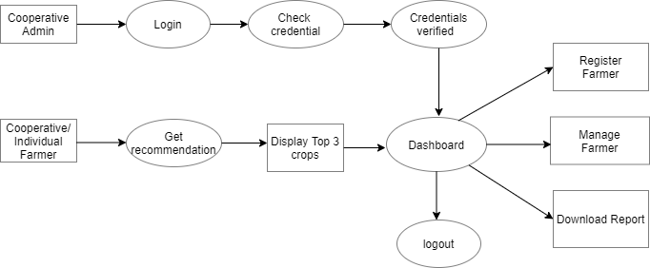
Figure 3: Data Flow Diagram

4.3.3 Use Case Diagram
A Use Case Diagram models the functional requirements of a system by showing the interactions between actors and the use cases the system provides.
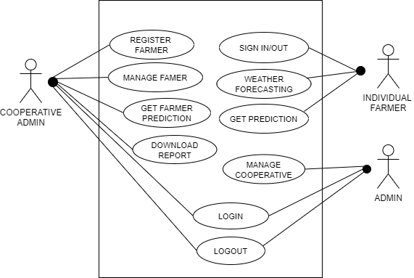
Figure 4: Use case Diagram

4.3.4 Flowchart Diagram
The flowcharts below describe the step-by-step logic of two key processes in the digitalAgri system: the cooperative registration and approval workflow, and the crop recommendation workflow from data entry to ML prediction output.
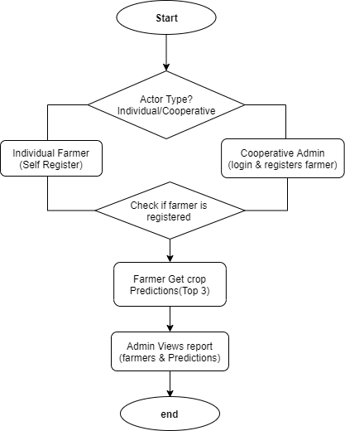

Figure 5: Flowchart Diagram

4.3.5 Entity Relationship Diagram (ERD)
An Entity Relationship Diagram (ERD) represents the logical structure of a database. It identifies the entities (tables), their attributes (fields), and the relationships between them.
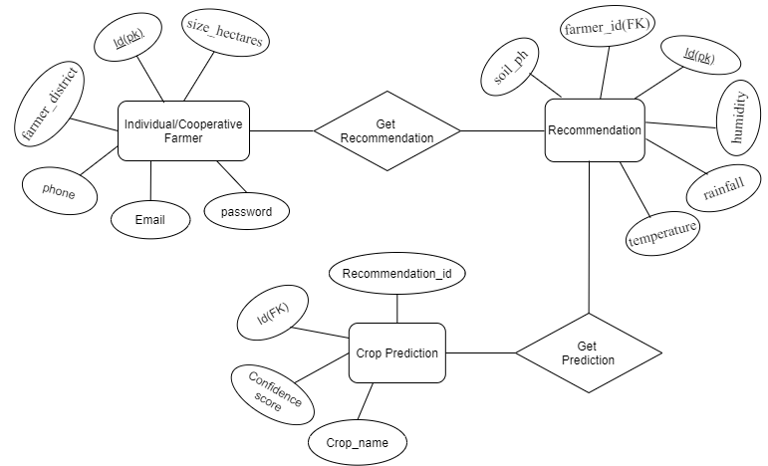
Figure 6:Entity Relationship Diagram

4.4 Data Dictionary
The data dictionary provides a detailed description of every table and field in the DigitalAgri database. It specifies the data type, constraints, and purpose of each field.
Table 4.2. Cooperative
Field Name | Data Type | Constraints | Description
id | INT | PK, Auto-increment, NOT NULL | Unique identifier for each cooperative
name | VARCHAR(150) | NOT NULL | Name of the cooperative organisation
email | VARCHAR(150) | UNIQUE, NOT NULL | Login email; must be unique across the system
password | VARCHAR(255) | NOT NULL | Bcrypt-hashed password
phone_number | VARCHAR(20) | NULLABLE | Contact phone number in Rwanda format
district | VARCHAR(100) | NOT NULL | Rwanda district where the cooperative is
Table 1: Cooperative Table

Table 4.3. Farmer
Field Name | Data Type | Constraints | Description
id | INT | PK, Auto-increment, NOT NULL | Unique identifier for each farmer
name | VARCHAR(100) | NOT NULL | Full name of the farmer
farmer_district | VARCHAR(100) | NOT NULL | District where the farmer resides (reference only)
phone_number | VARCHAR(20) | NULLABLE | Farmer's contact phone number
farm_size_hectares | DECIMAL(6,2) | NULLABLE | Size of the farm measured in hectares
gender | ENUM | NOT NULL | Farmer's gender: Male / Female / Other
created_at | TIMESTAMP | DEFAULT NOW() | Timestamp of farmer registration
Table 2: Farmers Table
Table 4.4. Recommendation
Field Name | Data Type | Constraints | Description
id | INT | PK, Auto-increment | Unique identifier for each recommendation record
farmer_id | INT | FK → Farmer.id | The farmer for whom the recommendation is made
soil_ph | DECIMAL(4,2) | NOT NULL | Soil pH value — ML input feature (range: 4.0–8.5)
potassium | DECIMAL(6,2) | NOT NULL | Potassium content in kg/ha — ML input feature
rainfall | DECIMAL(7,2) | NOT NULL | Annual rainfall in mm — sourced from Meteo Rwanda
temperature | DECIMAL(5,2) | NOT NULL | Average temperature in Celsius — from Meteo Rwanda
humidity | DECIMAL(5,2) | NOT NULL | Average humidity percentage — from Meteo Rwanda
altitude | DECIMAL(7,2) | NOT NULL | Altitude in metres above sea level — ML input feature
farm_district | VARCHAR(100) | NOT NULL | District where the farm land is located — ML input
farmer_district | VARCHAR(100) | NOT NULL | Auto-filled from farmer record; for reference only
season | ENUM | NOT NULL | Rwanda planting season: Season A / Season B / Season C
created_at | TIMESTAMP | DEFAULT NOW() | Timestamp of form submission
Table 3: Recommendation Table
Table 4.5. Prediction
Field Name | Data Type | Constraints | Description
id | INT | PK, Auto-increment, NOT NULL | Unique identifier for each prediction row
recommendation_id | INT | FK → Recommendation.id, NOT NULL | The recommendation that produced this prediction
crop_name | VARCHAR(100) | NOT NULL | Predicted crop name (e.g. Maize, Beans, Rice)
confidence_score | DECIMAL(5,2) | NOT NULL | Model confidence expressed as a percentage (0–100)
predicted_at | TIMESTAMP | DEFAULT NOW() | Timestamp of when the prediction was generated
Table 4:Prediction Table

4.5 System Implementation
This section presents the implemented digitalAgri system through screenshots of the key pages. The screenshots demonstrate the final user interface for both the cooperative agent and the administrator, showing how the designed system has been brought to life.
4.5.1 Login Page
After a Farmer or Cooperative Administrator registers, they are redirected to the login page, where they enter their credentials to access the system.



Figure 7: Login Page

4.5.2. Admin Dashboard page
This dashboard serves as the main interface of the system. Whether the user is a Cooperative Administrator or an Individual Farmer, they can manage activities and access system features from this dashboard.
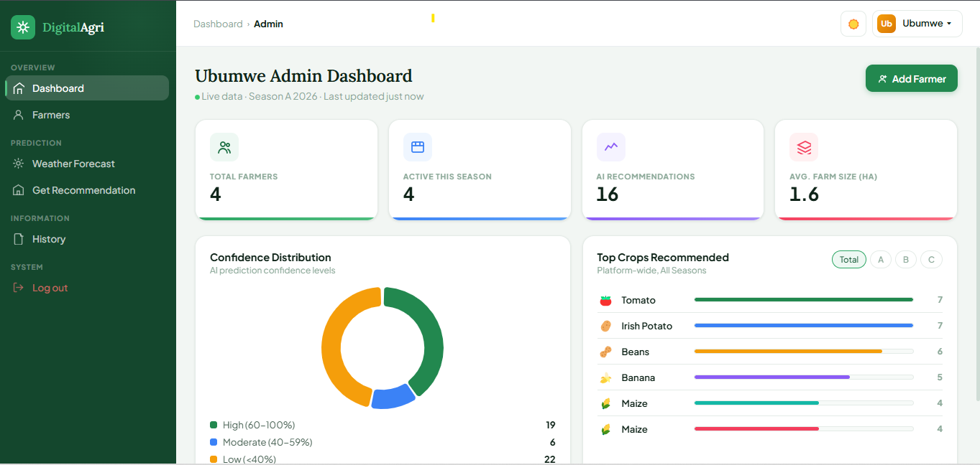
Figure 8: Admin Dashboard

4.5.3. Weather Forecast Page:
This page displays the weather forecast for each district, including temperature, humidity, and altitude. This information helps improve crop prediction accuracy.
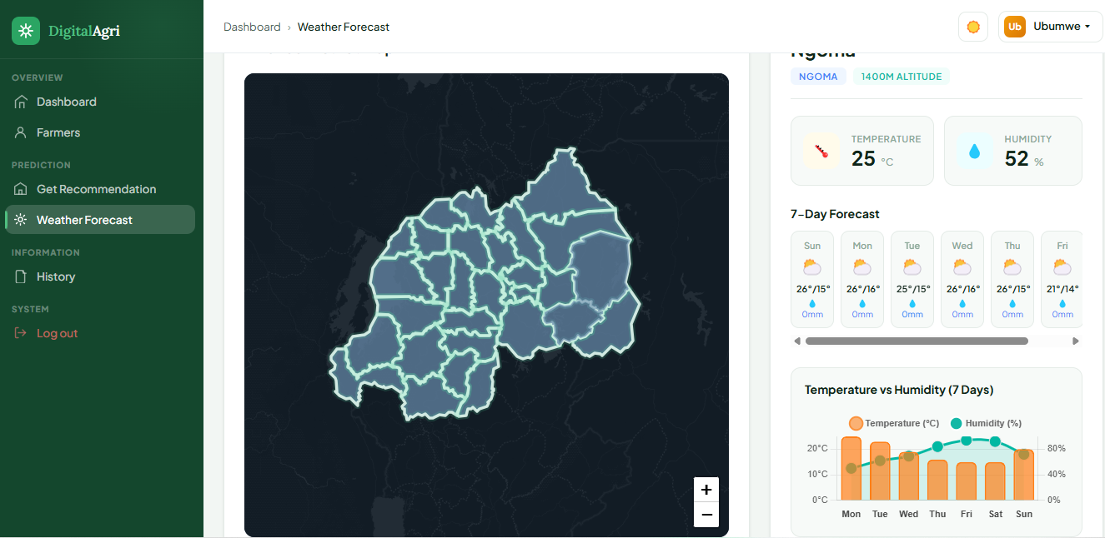
Figure 9: Weather Forecast

4.5.4. Get Recommendation Page
This page is where you predict the most suitable crop for a farmer based on weather conditions, farming season, and soil type.
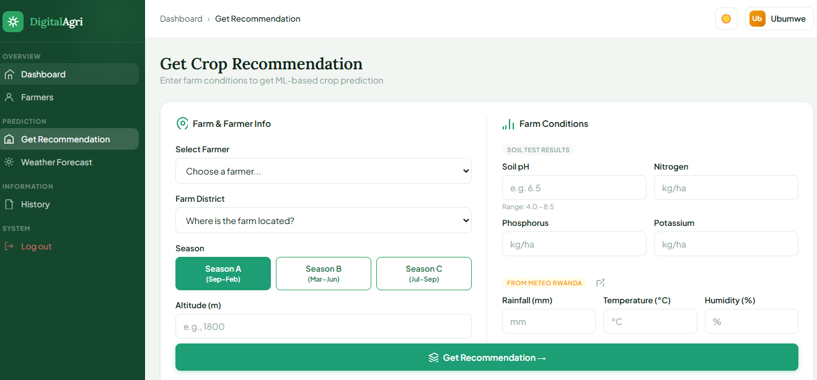
Figure 10: Get Recommendation

4.5.6. Prediction Results Page:
This page displays the top three recommended crops along with farming advice and recommendations for the farmer.
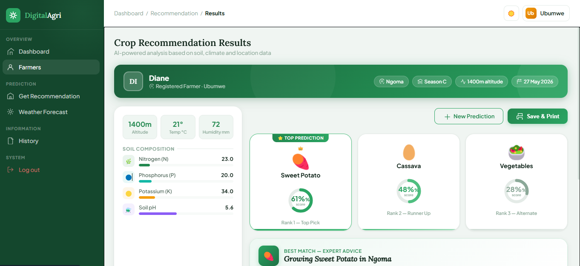
Figure 11: Recommendation Page

CHAPTER FIVE: CONCLUSIONS AND RECOMMENDATIONS

5.1 Conclusion
Agriculture is one of the most important sectors in Rwanda and supports the livelihoods of most of the population. However, many smallholder farmers still lack access to reliable, data-driven farming advice. The digitalAgri system was developed to help address this challenge by supporting cooperative agents with better crop recommendation tools.
The system was successfully designed and implemented as a web-based platform that uses a Random Forest Machine Learning model to recommend suitable crops based on eight farm-related factors. These include soil pH, nitrogen, phosphorus, potassium, rainfall, temperature, humidity, and altitude. The system provides the top three recommended crops together with confidence scores to help users understand the recommendations. The model was trained using 16,000 Rwanda-specific agricultural records and achieved about 86% accuracy during testing, showing that machine learning can be effectively applied in Rwanda’s agricultural sector when local data is used.
Overall, digitalAgri demonstrates that digital agriculture in Rwanda is both possible and achievable with the right combination of local data, simple technology, and practical implementation. agricultural cooperatives.

5.2 Recommendations
Based on the development, implementation, and evaluation of the digitalAgri system, several recommendations are proposed for future improvement and wider deployment. First, the system would benefit from integrating real soil testing data collected through field trials. The current machine learning model relies partly on simulated and API-sourced soil data due to the limited availability of field-measured records.
In addition, developing a dedicated mobile application would significantly extend the reach and usability of the platform, especially in rural areas with limited or unstable internet connectivity. Although the current system is accessible through mobile browsers, an offline-capable application that synchronises data once connectivity is restored would improve accessibility for cooperative agents working in remote locations.
Future versions of the system should also include a fertilizer recommendation module. Crop recommendation alone may not be sufficient to improve agricultural productivity. This would make digitalAgri a more comprehensive farming support tool.

REFERENCES
- Food and Agriculture Organization of the United Nations (FAO), Digital Technologies in Agriculture and Rural Areas: Briefing Paper, Rome, Italy, 2019. Available: https://www.fao.org/3/ca4887en/ca4887en.pdf
- World Bank, Harvesting Prosperity: Technology and Productivity Growth in Agriculture, Washington,
DC, USA, 2019. Available: https://openknowledge.worldbank.org/handle/10986/32350
- A. Kamilaris, A. Kartakoullis, and F. X. Prenafeta-Boldu, 'A review on the practice of big data analysis in agriculture,' Computers and Electronics in Agriculture, vol. 143, pp. 23-37, 2017.
Available: https://doi.org/10.1016/j.compag.2017.09.037
- Ministry of Agriculture and Animal Resources (MINAGRI), Strategic Plan for Agriculture Transformation - Phase IV (PSTA IV), Kigali, Rwanda, 2018. Available: https://www.minagri.gov.rw/fileadmin/user_upload/documents/Policies/PSTA_IV.pdf
- M. Tsan, S. Totapally, M. Hailu, and B. Addom, The Digitalization of African Agriculture Report 2018-2019, World Bank & CTA, 2019. Available: https://documents.worldbank.org/en/publication/documents-reports/documentdetail/52396155420 4834001
- K. G. Liakos, P. Busato, D. Moshou, S. Pearson, and D. Bochtis, 'Machine learning in agriculture: A review,' Sensors, vol. 18, no. 8, p. 2674, 2018. Available: https://doi.org/10.3390/s18082674
- Rwanda Agriculture and Animal Resources Development Board (RAB), Annual Report: Crop Production Statistics and Advisory Services, Kigali, Rwanda, 2023. Available: https://www.rab.gov.rw
- National Institute of Statistics of Rwanda (NISR), Seasonal Agricultural Survey Report 2022, Kigali,
Rwanda, 2022. Available: https://www.statistics.gov.rw
- A. Sharma, A. Jain, P. Gupta, and V. Chowdary, 'Machine learning applications for precision agriculture: A comprehensive review,' IEEE Access, vol. 9, pp. 4843-4873, 2021. Available: https://doi.org/10.1109/ACCESS.2020.3048415
- Rwanda Meteorology Agency (Meteo Rwanda), Climate Data and Seasonal Rainfall Forecasts for Rwanda, Kigali, Rwanda, 2023. Available: https://www.meteorwanda.gov.rw
- G. Shmueli, P. C. Bruce, I. Yahav, N. R. Patel, and K. C. Lichtendahl, Data Mining for Business Analytics, 3rd ed., Wiley, New Jersey, USA, 2018.
- T. M. Chukwudi, O. Eze, and K. Nwosu, 'Comparative analysis of machine learning classifiers for crop recommendation,' International Journal of Computer Applications, vol. 183, no. 12, pp. 1-7, 2021. Available: https://doi.org/10.5120/ijca2021921438

