|  |  |
| --- | --- |
|  | Printed Circuit Board Workbench for FreeCAD (PCB) |
| marmni ([marmni@onet.eu](mailto:marmni@onet.eu))  Copyright 2013-2021 |

|  |  |
| --- | --- |
|  | <https://github.com/marmni/FreeCAD-PCB> |
|  |  |
|  | <https://sourceforge.net/projects/eaglepcb2freecad/> |
|  |  |
|  | <https://www.freecadweb.org/> |

Spis treści

GENERAL INFORMATIONS 5

LICENCE 6

INTRODUCTION 7

Requirements 7

Supported softwares 8

INSTALLATION 9

Manual installation 9

Addon manager 11

CONFIGURATION 12

Setting PCB module as main workbench 13

CUSTOMIZING WORKBENCH 14

General 15

Export board 17

Colors 18

ACCESSING THE WORKBENCH 19

MENU BAR 20

TOOLBARS 21

PCB Settings toolbar 21

PCB View toolbar 22

Displaying toolbars 22

SPECIFICATION TREE 24

OBJECTS PROPERTIES 27

3D models 31

ASSIGN MODELS 33

Working with workbench 34

OpenING/ImportING board 35

CREATING BOARD FROM SCRATCH 36

CREATING GLUE PATHS 37

ADDING ANNOTATIONS 38

ADDING NEW MODELS 39

UPDATING models 40

CREATING CONSTRAINST AREAS 41

GENERATING BOUNDING BOX 42

CREATING SECTION CUTS 43

EXPORTING HOLE LOCATIONS 44

EXPORTING HOLE LOCATIONS REPORT 45

CREATING DRILLING MAP 46

BOM 47

CENTROID 48

EXPORTING BOARD 49

VIEW OPTIONS 50

Display modes 51

Grouping parts 52

LAYERS 53

Cut to board outline 54

HOLES SETTINGS 55

SIGNALS MARKING 56

EXPLODE 57

Bounding box 58

RENDERS 59

Kerkythea 60

POV-RAY 61

OTHER 62

GENERATE MODELS 63

SCRIPTS 64

Eagle 64

EXAMPLES 65

# GENERAL INFORMATIONS

## LICENCE

#****************************************************************************

#*

#* This program is free software; you can redistribute it and/or modify

#* it under the terms of the GNU Lesser General Public License (LGPL)

#* as published by the Free Software Foundation; either version 2 of

#* the License, or (at your option) any later version.

#* for detail see the LICENCE text file.

#*

#* This program is distributed in the hope that it will be useful,

#* but WITHOUT ANY WARRANTY; without even the implied warranty of

#* MERCHANTABILITY or FITNESS FOR A PARTICULAR PURPOSE. See the

#* GNU Library General Public License for more details.

#*

#* You should have received a copy of the GNU Library General Public

#* License along with this program; if not, write to the Free Software

#* Foundation, Inc., 59 Temple Place, Suite 330, Boston, MA 02111-1307

#* USA

#*

#****************************************************************************

## INTRODUCTION

Printed Circuit Board Workbench for FreeCAD. Workbench allows you to:

1. Importing boards created in various dedicated PCB softwares. Layers/colors are supported. Supported softwares:

* Eagle (*.brd),
* FreePCB (*.fpc),
* gEDA (*.pcb),
* KiCad (*.kicad_pcb),
* IDF v2/v3.

1. Creating and exporting boards to various formats. Supported formats:

* Eagle (*.brd),
* FreePCB (*.fpc),
* gEDA (*.pcb),
* KiCad (*.kicad_pcb),
* IDF v2/v3.

|  |  |  |  |
| --- | --- | --- | --- |
|  |  | Workbench supports 3D models saved in one of the following formats: STP/IGS |  |

### Requirements

FreeCAD-PCB require FreeCAD in version 0.18 (or newer) and Python **2.7** (or newer). Module was tested on Windows and GNU/Linux.

### Supported softwares

|  |  |  |  |  |  |  |  |  |  |  |  |  |
| --- | --- | --- | --- | --- | --- | --- | --- | --- | --- | --- | --- | --- |
| **Soft name** | **PCB** | | | | | | | | | | | |
|  | **Holes/Vias** | **Parts** | **Border** | **Measures** | **Soldermask** | **Keepout layers** | **Paths** | **Pads** | **Soldermask ARC** | **PCB round corners** | **Annotations** |
| Eagle | brd |  |  |  |  |  |  |  |  |  |  |  |
| gEDA | pcb |  |  |  |  |  |  |  |  |  |  |  |
| FreePCB | fpc |  |  |  |  |  |  |  |  |  |  |  |
| KiCad | kicad_pcb |  |  |  |  |  |  |  |  |  |  |  |
| FidoCadJ | fcd |  |  |  |  |  |  |  |  |  |  |  |
| Razen | rzp |  |  |  |  |  |  |  |  |  |  |  |
| IDF v2 | idf |  |  |  |  |  |  |  |  |  |  |  |
| IDF v3 | idf |  |  |  |  |  |  |  |  |  |  |  |
| IDF v4 |  |  |  |  |  |  |  |  |  |  |  |  |
| HyperLynx | HYP |  |  |  |  |  |  |  |  |  |  |  |

|  |  |
| --- | --- |
|  | Yes |
|  | No |
|  | Never |
|  | In progress |
|  | Future |

## INSTALLATION

There are two method to install workbench: manually and by FreeCAD-addons manager. Second solution is recommended.

### Manual installation

Unpack downloaded zip file from github/sourceforge and copy extracted folder to:

* **GNU/Linux**

On GNU/Linux distributions better do not keep PCB workbench folder under standard FreeCAD installation path (often under /sys path). This is connected with root permissions. Better idea is to keep it under /home directory.

Go to your user directory ‘/home/**userName**’ and display all hidden folders. Search for folder “.FreeCAD”. Under this directory you should find subfolder ‘Mod’

/home/**userName**/.FreeCAD/Mod

Replace **username** with our user name

Next change read/write permissions to 777 (also for subfolers).

chmod 777 -R PCB

* **Windows**

C:\Users\**userName**\AppData\Roaming\FreeCAD\Mod\PCB

Replace **username** with our user name.

It is recommended also to change read/write permission for all users. Click right button on PCB folder and select Properties ➝ Security ➝ Edit ➝ Users and mark all checkboxes under ’Allow’ option.

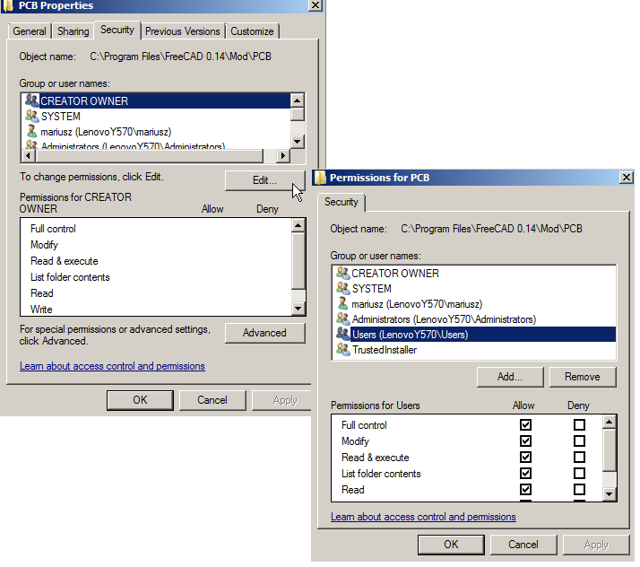

### Addon manager

FreeCAD-addons is a standard part of FreeCAD which allows you to automatically install new workbenches/macros for FreeCAD. You will find it in the main menu Tools -> Addon manager

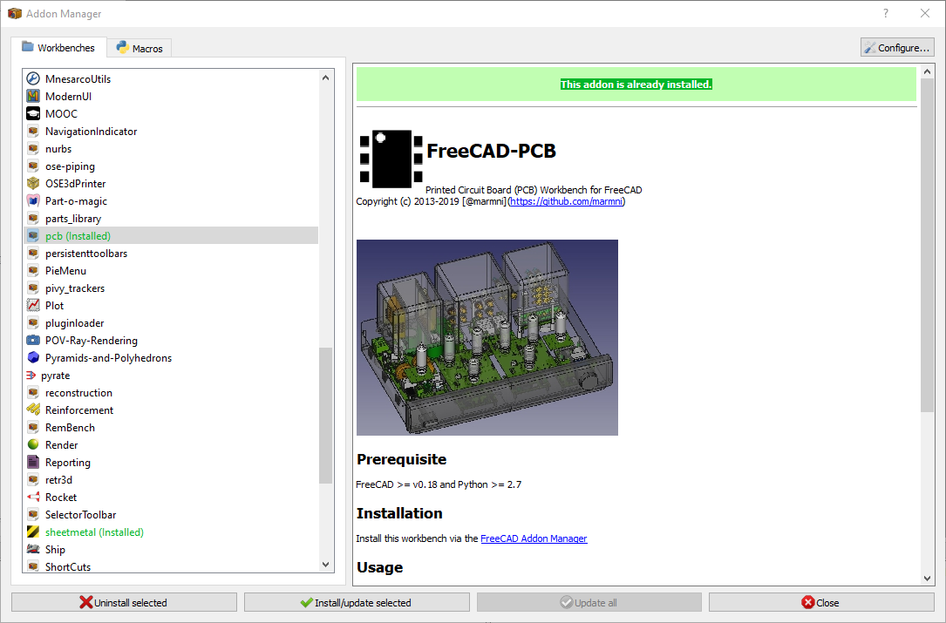

|  |  |  |  |
| --- | --- | --- | --- |
|  |  | It is recommended to use the add-ons manager instead of manual installation. The manager also allows you to update installed modules. |  |

## CONFIGURATION

Most of variables/parameters are stored in FreeCAD configure files. You can find a parameter editor in the main menu.

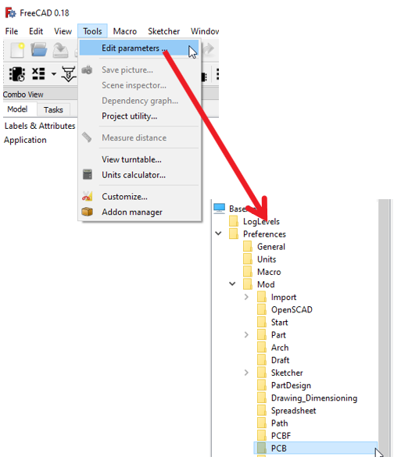

|  |  |  |  |
| --- | --- | --- | --- |
|  |  | **Do not change anything in file ‘PCBconf.py’!** |  |

### Setting PCB module as main workbench

There is a possibility to set PCB module as main workbench. To do this choose General tab (Edit -> Preferences). Under this tab you should find 'Start up' section, where you can set which workbench should be loaded after FreeCAD start.

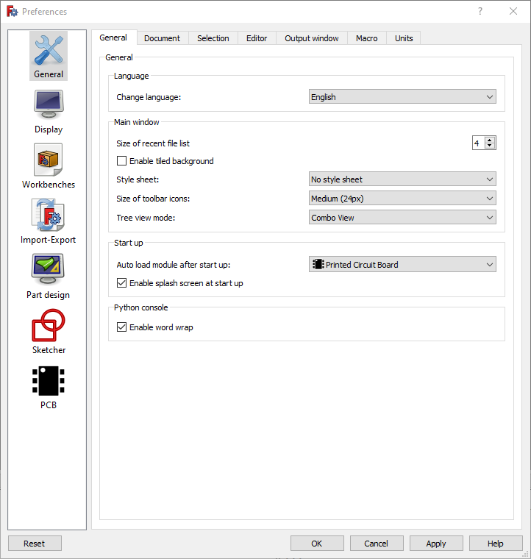

## **CUSTOMIZING WORKBENCH**

Workbench is fully configurable - you can set various variables which are directly connected with importing/exporting PCB boards. All setting are automatically stored in FreeCAD so you need to set them only once (of course you can change them also whenever you want).

In main menu choose Edit → Preferences - > PCB.

In the PCB section you can find all the configuration settings that are included in three tabs:

* General
* Export board
* Colors

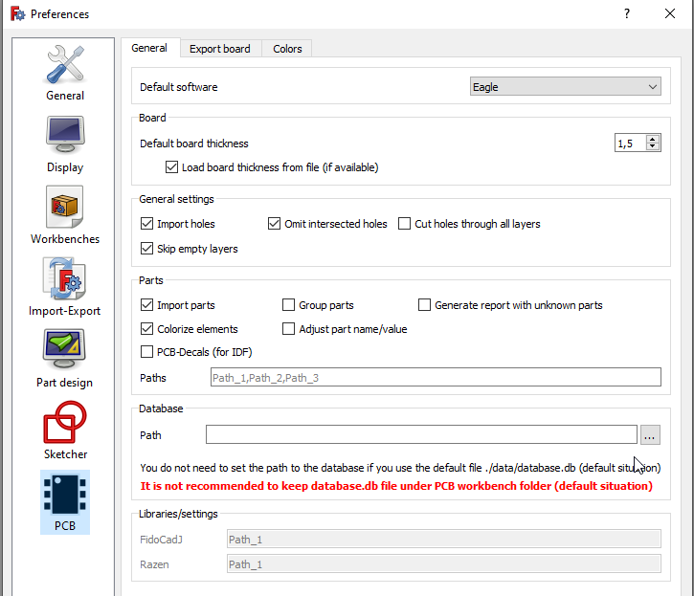

### General

In this tab all settings are arranged under six sections.

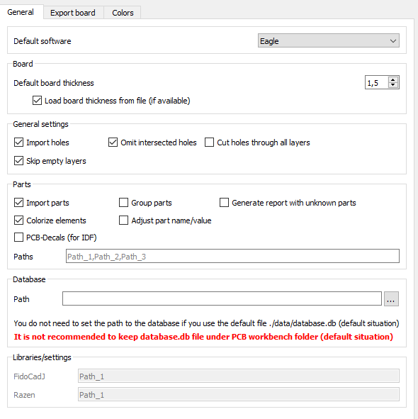

6 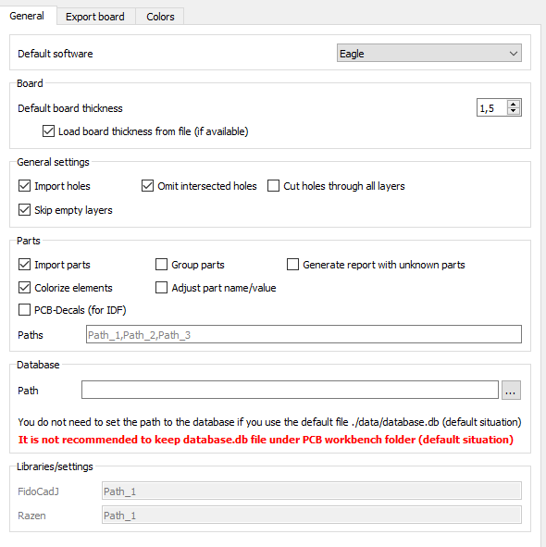

5 

2 

1 

3

4 

|  |  |
| --- | --- |
| 1 | Set default software which you are using. |
| 2 | Set default boart thickness (parameter can be changed even after importing the board) |
| 3 | **Import holes** – import holes from file (if checked)  **Omit intersected holes** - to avoid problems during loading PCB board this option should be always checked  **Cut holes through all layers** – it is possible to show/hide holes in layers (for example paths/pads, parameter can be changed even after importing the board)  **Skip empty layers** – this option decrease time necessary to generate 3D representation of the PCB board – empty layers will not be generated |
| 4 | **Import parts** – import or skip 3D models of the parts  **Group parts** – group imported 3D models in categories  **Generate report with unknown parts** – if 3D representation for imported package will not be recognize you can generate report (txt file) which will contain missing 3D models  **Colorize elements** – import colorized 3D models (if selected) or gray scale models (if option is not selected)  **Adjust part name/value** -  **PCB-Decals** – check this option if you will import IDF files  **Paths** – add here a path under which you are storing 3D models. Do not change anything (leave empty) if you are using standard localization (PCB/parts) . Separate different paths by comma |
| 5 | **Path** – path to database.db file (only one). Do not change anything (leave empty) if you are using standard localization (PCB/data/atabase.db)   |  |  |  |  | | --- | --- | --- | --- | |  |  | **It is not recommended to keep database.db file under PCB workbench folder (default situation)** |  | |
| 6 | Libraries – for future |

### Export board

In this section you can set the default layers that will be included when exporting the board to one of the supported formats.

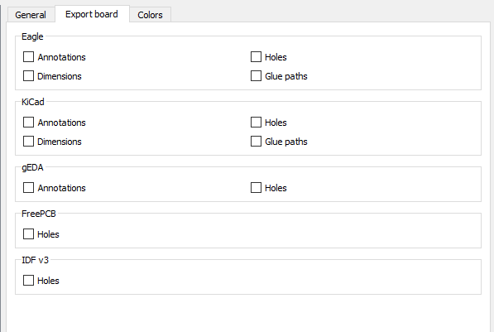

### Colors

Default colors for imported layer.

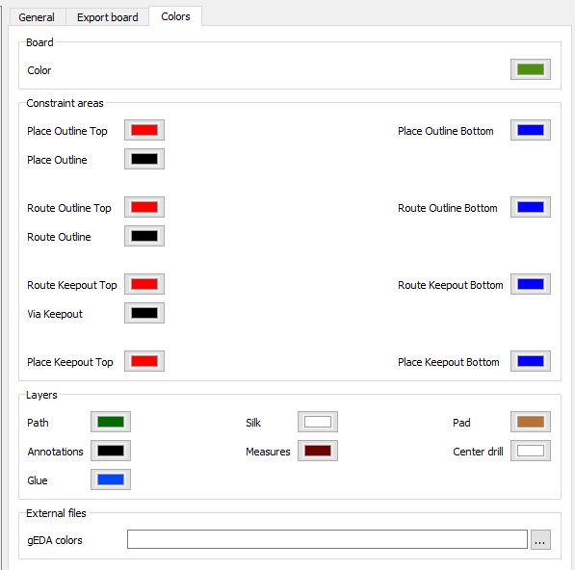

## ACCESSING THE WORKBENCH

There are two methods to access to the PCB workbench:

* In one of the available toolbars locate drop down list and choose ’Printed Circuit Board’.

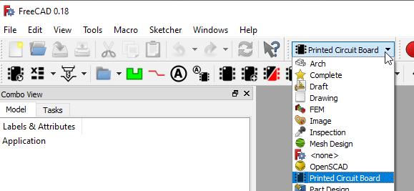

* From top menu bar choose View ➝ Workbench ➝ Printed Circuit Board.

## MENU BAR

There are no menu bars dedicated for PCB workbench.

## TOOLBARS

Two special toolbars are available:

* PCB View.
* PCB Settings.

This section describes the various icons available in mentioned toolbars.

### PCB Settings toolbar



|  |  |  |
| --- | --- | --- |
|  | **Option** | **Description** |
|  | Export PCB | Check Export board section |
|  | Export BOM | Check Export Bill Of Materials (BOM) section |
|  | Centroid | Check centroid section |
|  | Export hole locations | Check Export hole locations section |
|  | Export hole locations report | Check Export hole locations report section |
|  | Create drilling map | Check Create drilling map section |
|  | Create PCB | Check Create PCB section |
|  | Create glue path | Check Create glue path section |
|  | Add annotation | Check Add annotation section |
|  | Store Name/Value as parm |  |
|  | Assign models | Check Assign models section |
|  | Add model | Check Add model section |
|  | Update models | Check Update models section |
|  | Download models | Check Download models section |
|  | Generate models | Check generate models section |
|  | **Option** | **Description** |
|  | Explode | Check Explode section |
|  | Create constraint area | Check Create constraint area section |
|  | Bounding box | Check Bounding box section |
|  | Section cuts | Check Section cuts section |

### PCB View toolbar



|  |  |  |
| --- | --- | --- |
|  |  |  |
|  |  |  |
|  |  |  |
|  |  |  |
|  |  |  |

### Displaying toolbars

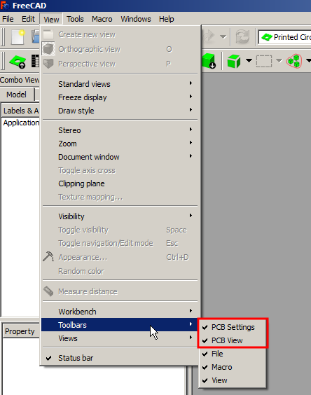When mentioned toolbars are not displaying automatically after choosing PCB workbench in the main window, you need to do it manually. From top menu bar choose View ➝ Toolbars and mark toolbars from Printed Circuit Board workbench.

## SPECIFICATION TREE

There are several types of objects directly related to the PCB workbench. You can see them in the "Combo View" and recognize them by the corresponding icons. For some of them specific context menu is available.

|  |  |  |
| --- | --- | --- |
|  | **Object** | **Context menu** |
|  | Explode objects | * Edit |
|  | 3D representation found in database | * Update model * Placement model |
|  | The 3D representation was not found in the database | * Assign model * Update model * Find model on-line |
|  | Board | --------------------------------- |
|  | Constraint area | --------------------------------- |
|  | Layer | --------------------------------- |
|  | Annotation/Object Name/Object Value | --------------------------------- |
|  | **Object** | **Context menu** |
|  | Glue path | --------------------------------- |

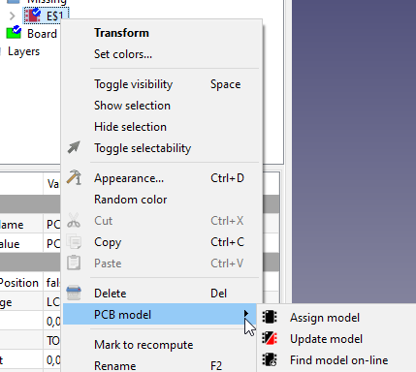

|  |  |  |  |
| --- | --- | --- | --- |
|  |  | **Context menu for specific objects is only available in the PCB environment.** |  |

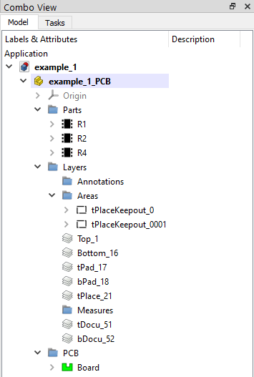

## OBJECTS PROPERTIES

Each object created in PCB workbench has unique parameters that can be set in the Property View (View or Data tab).

|  |  |  |
| --- | --- | --- |
|  | **Board** |  |
| **Group:** all objects which are directly connected with board  **Display Holes**: show/blank holes  **Holes**: reference to sketch that containing holes  **Border**: reference to sketch that containing board outline  **Thickness**: board thickness | |

|  |  |  |
| --- | --- | --- |
|  | **Glue path** |  |
| **Base**: reference to sketch that containing  glue path shape  **Flat**: if this parameter is set to True, object will ignore Width/Height parameters  **Height**: glue path height  **Width**: glue path width  **Length**: glue seam lenght (for specific W/H)  **Volume**: for specific W/H | |

|  |  |  |
| --- | --- | --- |
|  | **Part model founded in database** |  |
| **Part Name**: reference to part name object  **Part Value**: reference to part value  object  **Keep Position**: part will ignore changes in correction values if this value will be set to True  **Package**: 3D model name, parameter disabled for editing  **Rot**: rotation value around Z axis  **Side**: part position on board (top/bottom side)  **Socket:** socket height / model position in Z direction  **X**: model position in X direction  **Y**: model position in Y direction | |

|  |  |  |
| --- | --- | --- |
|  | **Constraint area** |  |
| **Height**: area height, parameter available only for some constraints areas type (on TOP/BOTTOM side)  **Base**: reference to sketch that containing area outline | |

|  |  |  |
| --- | --- | --- |
|  | **Part model not founded in database** |  |
| **Part Name**: reference to part name object  **Part Value**: reference to part value  object  **Keep Position**: part will ignore changes in  correction values if this value will be set to  True  **Package**: 3D model name, parameter  disabled for editing  **Rot**: rotation value around Z axis  **Side**: part position on board (top/bottom side)  **Socket:** socket height / model position in Z direction  **X**: model position in X direction  **Y**: model position in Y direction | |

|  |  |  |
| --- | --- | --- |
|  | **Explode objects** |  |
| **Active**: turn of/off explode effect  **Bottom Step Size**: distance between parts placed on bottom side of board  **Inverse**: switch exploded parts from top to bottom and conversely  **Top Step Size**: distance between parts placed on top side of board. | |

|  |  |  |
| --- | --- | --- |
|  | **Annotation/Object Name/Object Value** |  |
| **Font:** font name  **Font file**: it is possible to use own font  **Justification**: text position according to X, Y values  **Line distance:** distance between lines (in % according to fonf size)  **Size**: font size  **Spin**: if parameter set to True text will keep rotation, parameter works for angle value >= 90deg  **Text**: text displayed by annotation object  **Tracking**: distance between letters  **Rot**: rotation value around Z axis  **Side**: text position on board (top/bottom side)  **X**: text position in X direction  **Y**: text position in Y direction | |

|  |  |  |
| --- | --- | --- |
|  | **Layer** |  |
| **Cut**: show/blank holes  **Cut To Board**: cut shape to board outline | |

## 3D models

Workbench comes without 3D model so it is necessery to dowload them separatelly. You can bring up the ‘Download models’ window from the PCB Settings toolbar. Mentioned window contains links to sites when you can find free 3D models.

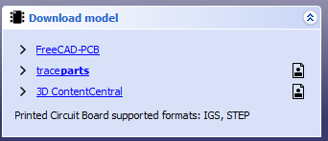



Registration is necessary to download models

There is also possibility to search for concrete model. To do this just right click on missing model in specification tree and choose PCB model → Find model on-line

|  |  |  |  |
| --- | --- | --- | --- |
|  |  | **Models from FreeCAD-PCB (github site) are directly connected with default database.db file.** |  |

|  |  |  |  |
| --- | --- | --- | --- |
|  |  | **To add/remove paths you need to open Preferences window. More info you can find in section** **Customizing workbench****.** |  |

|  |  |  |  |
| --- | --- | --- | --- |
|  |  | **Workbench supports 3D models saved in one of the following formats: STP/IGS** |  |

|  |  |  |  |
| --- | --- | --- | --- |
|  |  | **The default path is set to the “/Parts" folder which is located in the main PCB Workbench folder.** |  |

|  |  |  |  |
| --- | --- | --- | --- |
|  |  | **It is recommended to keep parts outside PCB folder - to avoid data lost during workbench update.** |  |

## ASSIGN MODELS

# Working with workbench

## OpenING/ImportING board

## CREATING BOARD FROM SCRATCH

## CREATING GLUE PATHS

## ADDING ANNOTATIONS

## ADDING NEW MODELS

## UPDATING models

## CREATING CONSTRAINST AREAS

## GENERATING BOUNDING BOX

## CREATING SECTION CUTS

## EXPORTING HOLE LOCATIONS

## EXPORTING HOLE LOCATIONS REPORT

## CREATING DRILLING MAP

## BOM

## CENTROID

## E**XPORTING BOARD**

# VIEW OPTIONS

## Display modes

## Grouping parts

## LAYERS

## Cut to board outline

## HOLES SETTINGS

## SIGNALS MARKING

## EXPLODE

## Bounding box

# RENDERS

## Kerkythea

## POV-RAY

# OTHER

## GENERATE MODELS

## SCRIPTS

There are available few scripts which are helping exporting the boards to FreeCAD.

### Eagle

Directly exporting boards from Eagle to FreeCAD [path: scripts/eagle]

scripts/eagle/ulp/freecad.ulp – copy file to $EAGLEDIR/ulp/

scripts/eagle/scr/freecad.scr – copy file to $EAGLEDIR/scr/

scripts/eagle/bin/freecad.png – copy file to $EAGLEDIR/bin/

In Eagle choose File → Execute Script → freecad.

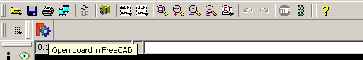

On Linux to set path to FreeCAD change value of var 'programPath_LIN' in file freecad.ulp.

On Windows to set path to FreeCAD change value of var 'programPath_WIN' in file freecad.ulp.

The script is useful for Eagle versions lower than 7.

## EXAMPLES

