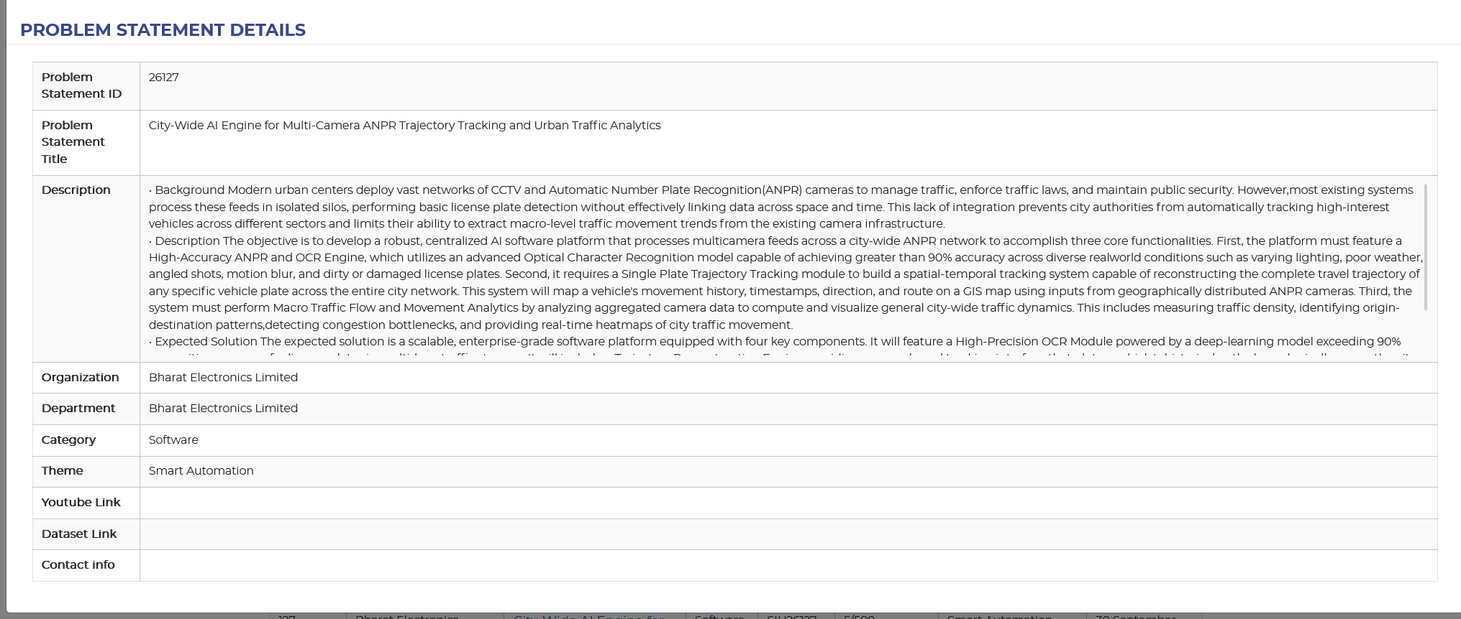
Description | • Background Modern urban centers deploy vast networks of CCTV and Automatic Number Plate Recognition(ANPR) cameras to manage traffic, enforce traffic laws, and maintain public security. However,most existing systems process these feeds in isolated silos, performing basic license plate detection without effectively linking data across space and time. This lack of integration prevents city authorities from automatically tracking high-interest vehicles across different sectors and limits their ability to extract macro-level traffic movement trends from the existing camera infrastructure.  • Description The objective is to develop a robust, centralized AI software platform that processes multicamera feeds across a city-wide ANPR network to accomplish three core functionalities. First, the platform must feature a High-Accuracy ANPR and OCR Engine, which utilizes an advanced Optical Character Recognition model capable of achieving greater than 90% accuracy across diverse realworld conditions such as varying lighting, poor weather, angled shots, motion blur, and dirty or damaged license plates. Second, it requires a Single Plate Trajectory Tracking module to build a spatial-temporal tracking system capable of reconstructing the complete travel trajectory of any specific vehicle plate across the entire city network. This system will map a vehicle's movement history, timestamps, direction, and route on a GIS map using inputs from geographically distributed ANPR cameras. Third, the system must perform Macro Traffic Flow and Movement Analytics by analyzing aggregated camera data to compute and visualize general city-wide traffic dynamics. This includes measuring traffic density, identifying origin-destination patterns,detecting congestion bottlenecks, and providing real-time heatmaps of city traffic movement.  • Expected Solution The expected solution is a scalable, enterprise-grade software platform equipped with four key components. It will feature a High-Precision OCR Module powered by a deep-learning model exceeding 90% recognition accuracy for license plates in multi-lane traffic streams. It will include a Trajectory Reconstruction Engine providing a query-based tracking interface that plots a vehicle's historical path chronologically across the city map with accurate timestamps and camera locations. Furthermore, it will integrate a City Traffic Analytics Dashboard to serve as a centralized, GIS-integrated web platform displaying heatmaps, average vehicle speeds, route densities, and traffic flow trends across all camera nodes. Finally, the platform will incorporate an Alert System capable of flagging blacklisted vehicles and suspicious route anomalies in real time.
Draft 1 ideas

SIH26127 – Expected Solutions and Additional Solutions
1. Expected Solutions
1.1 High-Accuracy ANPR and OCR
- Detect vehicles and number plates from camera feeds.
- Convert number plate images into readable text.
- Achieve more than 90% recognition accuracy.
- Work in conditions such as night, rain, blur, tilted plates, and damaged plates.
1.2 Cross-Camera Vehicle Tracking
- Identify the same vehicle across multiple cameras.
- Record plate number, camera location, direction, and timestamp.
- Reconstruct the vehicle's movement across the city.
- Display the journey on a GIS/map interface.
1.3 City-Wide Traffic Analytics
- Calculate traffic density and vehicle flow.
- Identify major routes and congestion areas.
- Analyze origin and destination patterns.
- Display traffic information using maps, heatmaps, and graphs.
1.4 Alert System
- Detect vehicles present in a watchlist/blacklist.
- Generate real-time alerts.
- Identify unusual or suspicious movement patterns.

2. Additional Solutions
2.1 Vehicle Behavior Profile
Create a historical profile for frequently observed vehicles to understand their regular movement patterns.
2.2 Vehicle Relationship Detection
Identify vehicles that repeatedly appear together at different cameras or locations for further human review.
2.3 Parking and Long-Stay Detection
Identify vehicles that remain in a particular area for an unusually long period, providing useful parking and stay information.
2.4 Journey Summary
Convert multiple camera detections into a simple summary of a vehicle's journey instead of displaying every individual detection.
2.5 Traffic Data Reliability Score
Show the reliability of traffic information in each area based on camera availability, image quality, OCR confidence, and missing data.
2.6 Camera Performance Monitoring
Monitor camera health, including online/offline status, last received frame, detection rate, and data-quality issues.
2.7 "What Changed Today?" Feature
Automatically highlight important changes in traffic, such as unusual increases, decreases, route changes, or camera failures.
2.8 Traffic Event Timeline
Create a timeline of major traffic events to show how a situation developed and eventually returned to normal.
2.9 What-If Traffic Simulation
Allow authorities to test hypothetical situations, such as the possible impact of closing a road or increasing traffic on a particular corridor.
2.10 Automatic Daily Report
Generate a daily summary containing major traffic changes, congestion areas, vehicle observations, alerts, and camera issues.
2.11 Dynamic Traffic Light Timings
Use real-time traffic information from cameras to adjust or recommend traffic signal timings according to traffic volume.
Example: If one direction has significantly more vehicles than another, the system can provide more green-light time to the heavier traffic direction.
This can help:
- Reduce waiting time
- Reduce queue lengths
- Improve traffic flow
- Adapt signals to real-time conditions

