**Assignment#1**

*Q#1*

First, I show you the ZIP File which I need to Crack by the tool John the Ripper

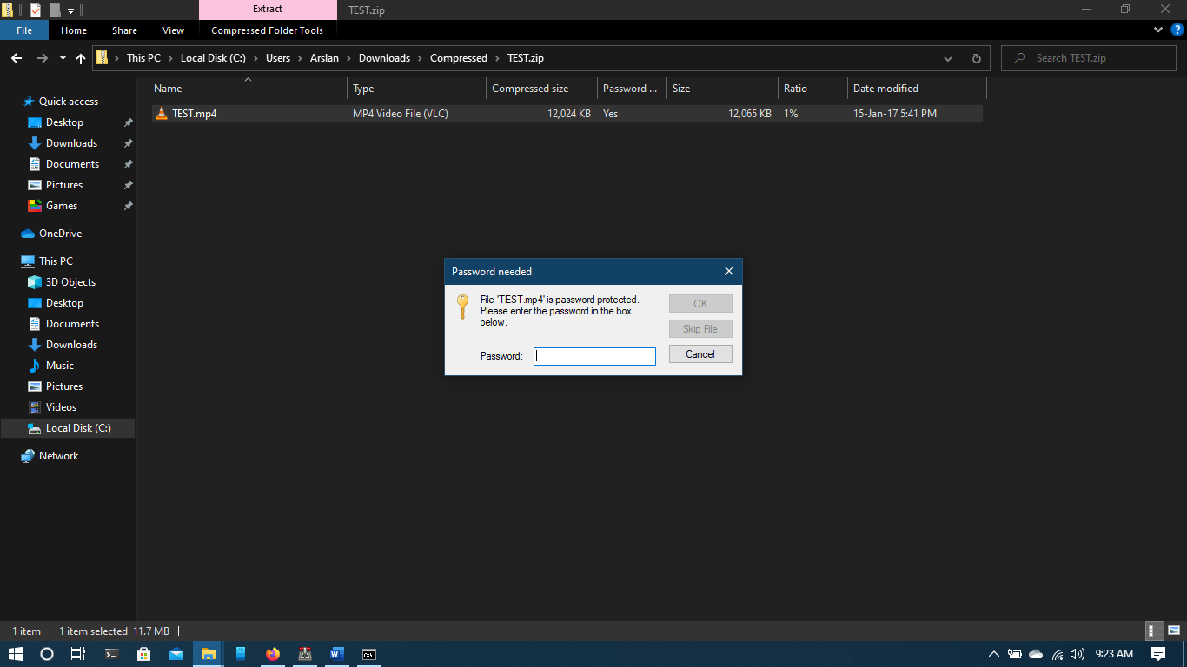

Now, As you See there is a Password Required to Open this TEST.mp4 which I crack by using John the Ripper in below Screenshot.

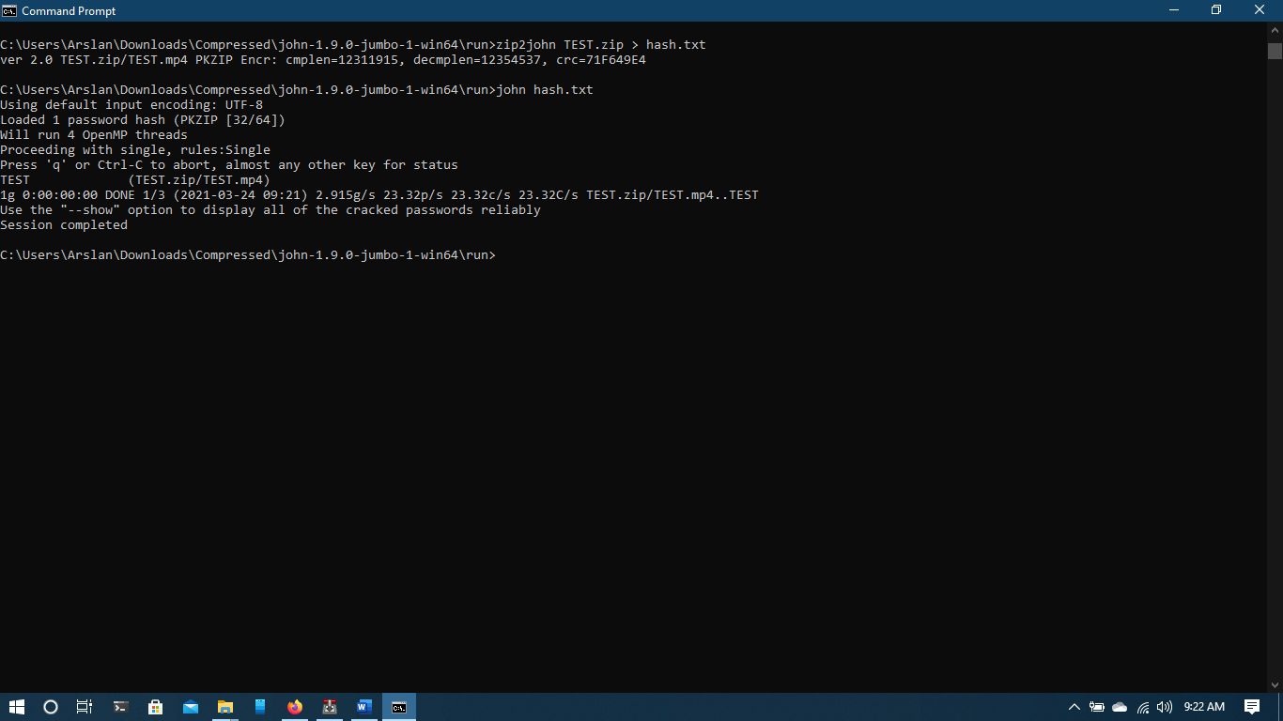

Q#2

Write a brief description the NSA programs exposed.

Ans:

What Ed Snowden exposed is not an information, he disclosed how we collected information. So, The question is why everyone call him a Whistle blower and here is the Reason he is the how know that the NSA has Collected the information of 600 million of American Telephone Records and he exposed them. He is the one who leaked the secret of the telephone and Surveillance of NSA.

(ii)

Specify the Attacks and programs shown.

Ans:

A Program named PRISM which is used for Monitoring the communication around the world. It might ba Stuxnet attack is type of attack which is used in World War they but a USB in a system and the hidden files do the rest.

(iii)

Discuss the Penetration technique and Attack Strategy used and its impact.

Ans:

The point is how the Edward Snowden breach the information. First, The trust established by cryptographic keys and digital certificates to breach the NSA. By using these Digital SSH Key and accessed from the Colleagues Account so they Can access the Information that they needed.

**Q # 03:**

Discuss the importance of Cyber Security and the impacts of Cyber warfare. Give example.

Ans:

Now a days Cyber Security is Raising at there best level. As everything is on cloud like Drop Box and OneDrive etc as well for these kind of Data we need some kind of protection that’s why Cyber Crimes are Increasing day by day due to there are very less Security Management in that area.

Cyber risk during the Modern world. There are hundred of Problems that we every day faces in which on of them is the Cyber attacks and there Penetration. So for that there a lot of Strategies that now a days a lot of Organization is using and Stop the Cyber Crimes you can say the Cyber Warfare is very great impact on the Cyber Security for avoiding the Attacks and also catching those Red hat Hacker for this Cyber Warfare is play there role in this Modern World of Era.