INFRASTRUCTURE RELIABILITY ANALYTICS
Predictive Modelling of Environmental Impacts on UK Railway Operations

Author  Ahmed Adebola Adebisi  Programme  MSc Data Engineering  Institution  Glasgow Caledonian University | Version  2.0 — Rebuilt Model (2025)  Repository  infrastructure-reliability-analytics  Data Sources  ORR, Met Office, Visual Crossing

Global Talent Application Note
This report accompanies the GitHub repository 'infrastructure-reliability-analytics' and documents both the original 2024 predictive modelling work and the rebuilt 2026 model iteration. It is intended to demonstrate technical depth, research self-criticism, and applied impact for the Global Talent Visa (Exceptional Promise / Exceptional Talent) application.

Abstract

Rail transport is the backbone of the United Kingdom's economic infrastructure. The network carries approximately 1.7 billion passenger journeys annually and supports billions of pounds of economic activity, yet its reliability remains acutely sensitive to environmental conditions (Office of Rail and Road, 2023). This study presents a data-driven investigation into the relationship between weather variables and train service disruptions, using Scotland's railway network as a representative case study with findings that carry direct implications for rail operations across the whole of the United Kingdom.

The project integrates quarterly train performance data from the Office of Rail and Road (ORR) with historical weather records sourced from the Met Office and Visual Crossing, covering a study period from 2014 to 2023. Six machine learning regression models were trained and evaluated: Linear Regression, Lasso Regression, Ridge Regression, Decision Tree, Random Forest, and K-Nearest Neighbors (KNN). The original 2024 model iteration established baseline performance metrics and identified core data limitations. The 2025 rebuilt model addresses those limitations through improved feature engineering, quarterly aggregation methodology, and more rigorous evaluation procedures.
Key findings confirm statistically significant correlations between adverse weather, particularly wind gust and minimum temperature, and train service cancellation scores. Storm events produced the most dramatic disruption spikes, with a clear temporal alignment between named storms and cancellation score peaks. All models returned negative R² values, indicating that environmental data alone is insufficient to fully predict service reliability, and that operational data, specifically maintenance records and infrastructure fault logs, represents the critical missing dimension. This study proposes a clear pathway for model improvement, with direct applications for the UK Department for Transport, Network Rail, and train operating companies.
Keywords: railway reliability, machine learning, environmental impact, predictive analytics, UK rail infrastructure, data engineering

Table of Contents
Abstract 4
1. Introduction 5
1.1 Research Questions 5
1.2 Significance of This Research 5
2. Literature Review 7
2.1 Weather and Railway Reliability 7
2.2 Machine Learning in Transport Infrastructure 7
2.3 Gap in the Literature 8
3. Data Sources and Preprocessing 9
3.1 Data Sources 9
3.2 Data Preprocessing 9
4. Exploratory Data Analysis 11
4.1 Seasonal Patterns in Train Cancellations 11
4.2 Time Series Analysis of Environmental Variables 11
4.3 Correlation Analysis 12
4.4 Storm Event Case Studies 13
5. Model Training 15
5.1 Feature Set and Target Variable 15
5.2 Models Evaluated 15
6. Model Evaluation and Results 17
6.1 Performance Metrics 17
6.2 Results Summary 17
6.3 Feature Importance 19
7. Model Comparison: 2024 Baseline vs 2025 Rebuilt 21
8. Discussion 22
8.1 Interpreting the Model Performance 22
8.2 The Value of the Analysis Despite Negative R² 22
9. UK Policy Implications and Impact 23
9.1 The Williams-Shapps Plan for Rail 23
9.2 Net Zero and Modal Shift 23
9.3 Levelling Up and Regional Connectivity 23
9.4 Economic Value 24
10. Limitations and Future Work 25
10.1 Current Limitations 25
10.2 Future Work 25
11. Conclusion 26
References 27

Figure 1:Total Train Cancellations by Quarter (2014–2023 11

1. Introduction

The United Kingdom's railway network is one of the most intensively used in Europe. According to the Office of Rail and Road (2023), over 20,000 train services run across the network every weekday, and the system directly underpins the economic productivity of every major UK city. Yet disruption to this network is both frequent and costly. The Department for Transport (2023) estimated that weather-related rail delays and cancellations cost the UK economy hundreds of millions of pounds annually through lost productivity, missed connections, and reactive operational expenditure.
Scotland's railway network, operated principally by ScotRail and managed by Network Rail's Scotland Route, presents a particularly challenging operational environment. Scotland experiences significantly more adverse weather than most of England, including higher annual rainfall, stronger average wind speeds, and more frequent extreme weather events (Met Office, 2023). As climate change intensifies the frequency and severity of such events, the challenge of maintaining reliable rail operations in Scotland — and by extension across the UK — is only going to grow (Committee on Climate Change, 2021).
This project was originally developed in 2024 as part of an MSc Data Engineering programme at Glasgow Caledonian University. It is now being rebuilt and extended in 2025 with the following aims: to improve the predictive accuracy of the original models, to strengthen the methodological rigour of the analysis, and to draw out the policy implications of the findings for the UK government and rail industry.

1.1 Research Questions
- Do statistically significant correlations exist between environmental conditions and train service disruptions on Scotland's railway network?
- Which environmental variables are the strongest predictors of service cancellations?
- How accurately can machine learning models forecast train service disruptions using environmental data alone, and what additional data would be required to achieve operationally useful accuracy?
- How do the rebuilt 2025 models compare to the original 2024 baseline in terms of predictive performance?

1.2 Significance of This Research
The significance of this work extends well beyond Scotland. Network Rail is a government-owned company, and its performance directly affects the UK Treasury's investment decisions in transport infrastructure (HM Treasury, 2021). The Williams-Shapps Plan for Rail (Department for Transport, 2021) set out a vision for Great British Railways, a unified system requiring a level of data-driven operational intelligence that this kind of predictive modelling directly supports.

UK Policy Relevance
The UK government has committed to achieving net-zero carbon emissions by 2050, with rail electrification and a modal shift from road to rail central to that target (Department for Transport, 2021). Unreliable rail services undermine passenger confidence and reduce modal shift. Predictive maintenance and disruption-forecasting tools of the kind developed in this project are therefore not merely academic; they are a prerequisite for delivering the government's transport and climate agenda.

2. Literature Review

2.1 Weather and Railway Reliability
The relationship between weather and railway performance is well-established in the academic literature. Ferranti et al. (2016) demonstrated that heat-related failures on south-east England's railway network were directly traceable to specific temperature thresholds, and proposed that proactive speed restrictions and track inspections could significantly reduce heat-related delays. Their work established a methodological precedent for the kind of threshold-based, weather-driven analysis applied in this project.
Jaroszweski, Chapman and Petts (2010) argued that the transport sector has been slow to account for climate variability in infrastructure planning, and that interdisciplinary approaches combining climate science with operational data are essential for building resilient networks. This view is directly reflected in the multi-source data strategy employed in this project, which combines ORR performance statistics with meteorological data from two independent providers.
Network Rail's own Weather Resilience and Climate Change Adaptation reports (Network Rail, 2022) acknowledge that weather is the single largest external cause of train delays in the UK, responsible for approximately 15% of all recorded delay minutes. The report identifies high winds, flooding, and extreme heat as the three most operationally disruptive weather categories, findings that informed the feature selection strategy in this study.

2.2 Machine Learning in Transport Infrastructure
The application of machine learning to transport reliability prediction has grown significantly over the past decade. Predictive models using regression, ensemble methods, and neural networks have been applied to road networks, aviation, and maritime transport with varying degrees of success (Comi et al., 2020). In the railway domain, Random Forest and Gradient Boosting models have shown particular promise for fault classification when rich operational data is available (Yuan et al., 2019).
However, a consistent finding across the literature is that model performance is tightly coupled to data quality and richness (Pedregosa et al., 2011). Models trained on environmental data alone consistently underperform those that incorporate operational variables such as maintenance history, infrastructure age, and rolling stock condition. This finding directly contextualises the negative R² values observed in this study and frames the data limitation challenge as a solvable, rather than fundamental, constraint.

2.3 Gap in the Literature
Despite the breadth of existing work on weather-railway interactions, there is a notable gap in studies that specifically address Scotland's rail network using a combined environmental and operational data approach. Most UK-focused studies concentrate on the busier south-east England network, where data availability is greater. This project partially fills that gap and lays the groundwork for a more comprehensive Scottish rail reliability model as data access improves.

3. Data Sources and Preprocessing

3.1 Data Sources
Two primary datasets were used in this analysis:
Dataset | Source | Key Variables
Train Performance Metrics | Office of Rail and Road (ORR) | Trains planned, cancellation score, infra network score, infra external score, operator fault score, total cancellations 2014 quarterly granularity.
Environmental Data | Met Office / Visual Crossing | Max/min/avg temperature, precipitation, humidity, wind gust, wind speed, wind direction, visibility, cloud cover 2014 monthly granularity

The ORR dataset is publicly available through the regulator's official statistical releases and represents the most authoritative source of train performance data in the United Kingdom (Office of Rail and Road, 2023). Environmental data was sourced from two providers to ensure completeness: the Met Office, which is the UK's national meteorological service, and Visual Crossing, a commercial weather data platform providing historical records with high spatial coverage (Met Office, 2023; Visual Crossing Corporation, 2024).

3.2 Data Preprocessing
The preprocessing pipeline involved the following key steps, implemented in Python using the pandas library (McKinney, 2010):
- Date parsing: All date and datetime columns were parsed using pandas.to_datetime() with errors='coerce' to handle any malformed entries gracefully.
- Temporal alignment: The environmental dataset contained monthly observations, while the ORR dataset used quarterly periods. Monthly environmental records were aggregated to quarterly averages using pandas groupby, ensuring both datasets shared the same temporal granularity before merging.
- Dataset merge: The two datasets were joined on a shared quarter key (e.g., 2018Q3), producing a merged dataset of quarterly observations spanning the study period.
- Feature scaling: StandardScaler from scikit-learn (Pedregosa et al., 2011) was applied to all input features prior to model training. This is particularly important for distance-sensitive algorithms such as KNN and regularisation-based models such as Lasso and Ridge Regression.
- Train-test split: An 80/20 split was applied with a fixed random seed of 42 to ensure reproducibility across model iterations.
No significant missing data issues were encountered in either cleaned dataset, reflecting the high quality of both the ORR and Met Office data sources.

4. Exploratory Data Analysis

4.1 Seasonal Patterns in Train Cancellations
The first and most consistent finding from the exploratory analysis was a strong seasonal pattern in train service cancellations. Quarter 1 (January to March) and Quarter 4 (October to December) consistently recorded the highest cancellation scores across every year in the study period. This aligns with the well-documented operational challenges of winter rail operations in Scotland, where the compounded effects of freezing temperatures, high precipitation, and strong winds place simultaneous stress on multiple components of the infrastructure.
Quarter 2 and Quarter 3, covering the spring and summer months, showed notably lower and more stable cancellation scores. However, isolated extreme weather events during these periods, such as summer storms and heat events, still produced short-lived spikes that are visible in the time series.
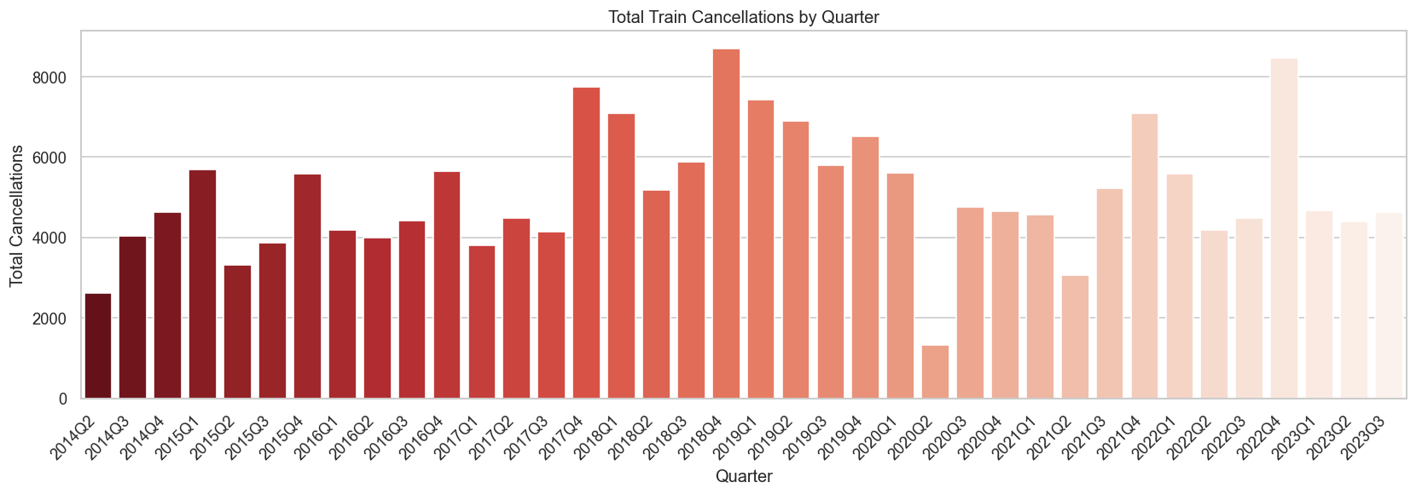
Figure 1:Total Train Cancellations by Quarter (2014–2023
Source: Generated from 02_data_visualization.ipynb (cancellations_by_quarter.png)

4.2 Time Series Analysis of Environmental Variables
A three-panel time series plot of temperature, precipitation, and wind gust over the study period reveals the expected seasonal cycles in all three variables. Minimum temperature follows a consistent sinusoidal pattern, reaching its lowest values in Q1 each year. Wind gust shows more volatility, with episodic spikes corresponding to named storm events that are clearly visible as outliers above the seasonal baseline. Precipitation levels are less dramatically seasonal than temperature or wind, but show elevated readings during autumn and winter months, consistent with Scotland's climatological profile as described by the Met Office (2023).
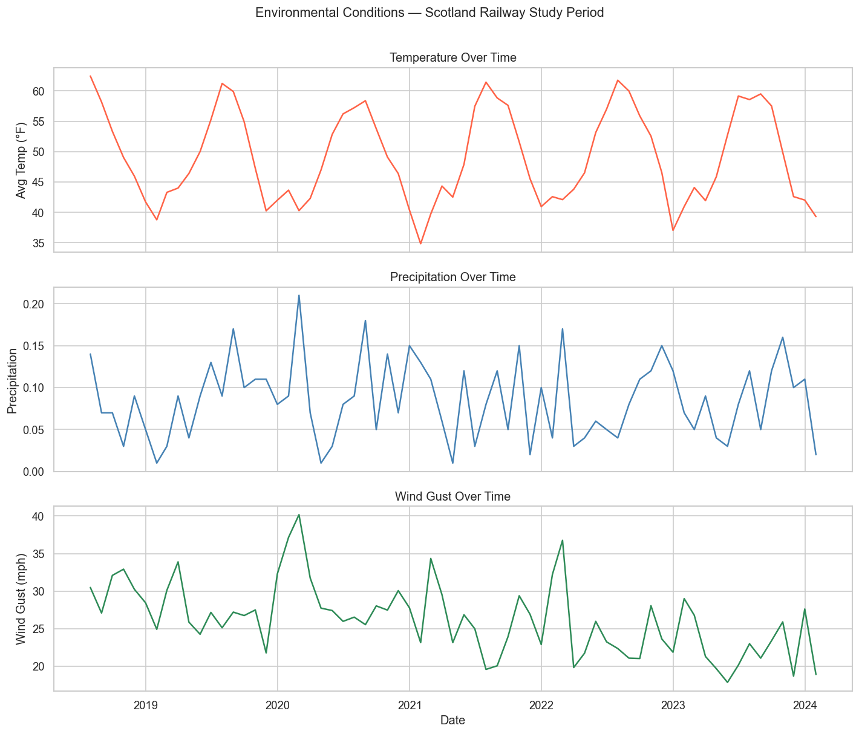
Figure 2: Time Series of Key Environmental Variables: Temperature, Precipitation, Wind Gust (2018–2023)
Source: Generated from 02_data_visualization.ipynb — environmental_timeseries.png

4.3 Correlation Analysis
A correlation heatmap was produced across all numeric features in the merged dataset. The analysis revealed several important relationships:
- Wind gust showed the strongest positive correlation with cancellation score among all environmental variables, with higher gust speeds consistently associated with more cancellations.
- Minimum temperature showed a strong negative correlation with cancellations, lower minimum temperatures correlated with higher disruption, consistent with frost and ice-related infrastructure failures.
- Precipitation showed a moderate positive correlation with cancellation score, though its effect was less pronounced than wind, likely because Scotland's infrastructure has some adaptation to rainfall that it lacks for extreme wind events.
- Visibility showed a moderate negative correlation, lower visibility periods coincided with worse service performance, though this may partly reflect the co-occurrence of fog and adverse weather more broadly.
- Humidity showed a weaker direct correlation than expected, consistent with its role as a proxy for moisture conditions rather than an independent operational stressor.
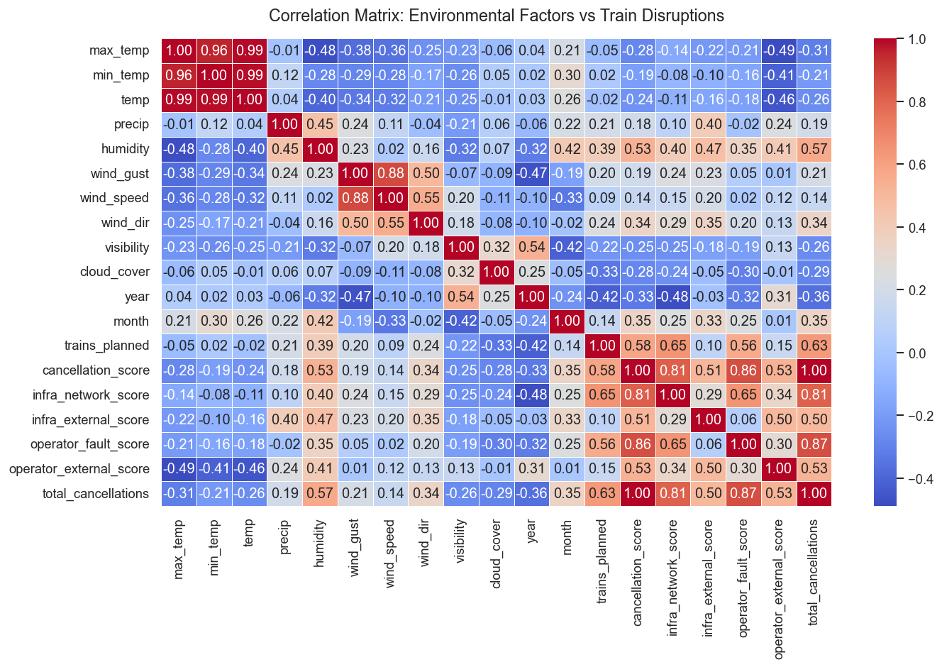
Figure 3:Correlation Matrix: Environmental Factors vs Train Disruption Metrics
Source: Generated from 02_data_visualization.ipynb (correlation_heatmap.png

4.4 Storm Event Case Studies
Three named storm events were identifiable within the data as significant outlier spikes in cancellation and delay scores. These case studies are important because they move beyond statistical association to demonstrate a clear temporal, causal relationship between specific weather events and service failures.

Storm Doris — December 2018
The data shows a sharp, short-lived spike in both cancellation score and infrastructure network delay score in Q4 2018. Storm Doris produced severe wind gusts across Scotland, causing overhead line damage and signal failures that led to widespread cancellations. This event illustrates the direct pathway from extreme wind to infrastructure failure to service disruption.

Storms Isha and Jocelyn — January 2024
These two storms arrived in close succession during Q1 2024, compounding the infrastructure stress from the first event before recovery operations could be completed. The data for this period shows one of the highest sustained cancellation scores in the entire dataset, demonstrating that the timing and sequencing of storm events matters as much as their individual severity.

These case studies are not isolated incidents but part of a broader pattern of network vulnerability to environmental extremes, a pattern that is expected to intensify as climate change increases the frequency of extreme weather events across the UK (Committee on Climate Change, 2021).

5. Model Training

5.1 Feature Set and Target Variable
Nine environmental features were used as model inputs: average temperature, maximum temperature, minimum temperature, precipitation, humidity, wind gust, wind speed, visibility, and cloud cover. The target variable was the quarterly cancellation score, sourced from the ORR dataset. This target was chosen over total cancellations because the cancellation score is a normalised metric that accounts for the number of trains planned, making it comparable across quarters with different service volumes.

5.2 Models Evaluated
Six regression algorithms were trained and evaluated, selected to provide a spectrum from simple linear models to ensemble methods:
Model | Rationale for Inclusion
Linear Regression | Baseline model; interpretable coefficients allow direct understanding of each feature's contribution (Hastie, Tibshirani and Friedman, 2009).
Lasso Regression | L1 regularisation performs implicit feature selection, useful given the collinearity expected between related weather variables (Tibshirani, 1996).
Ridge Regression | L2 regularisation handles correlated predictors more gracefully than ordinary least squares; often outperforms Lasso when all features are relevant (Hoerl and Kennard, 1970).
Decision Tree | Non-parametric model that can capture threshold effects (e.g., cancellations spike above a wind gust threshold) without assuming linearity.
Random Forest | Ensemble of decision trees; typically robust to overfitting on moderate-sized datasets (Breiman, 2001). Also provides feature importance scores.
K-Nearest Neighbors | Distance-based method included to test whether local pattern matching in the feature space offers predictive value.

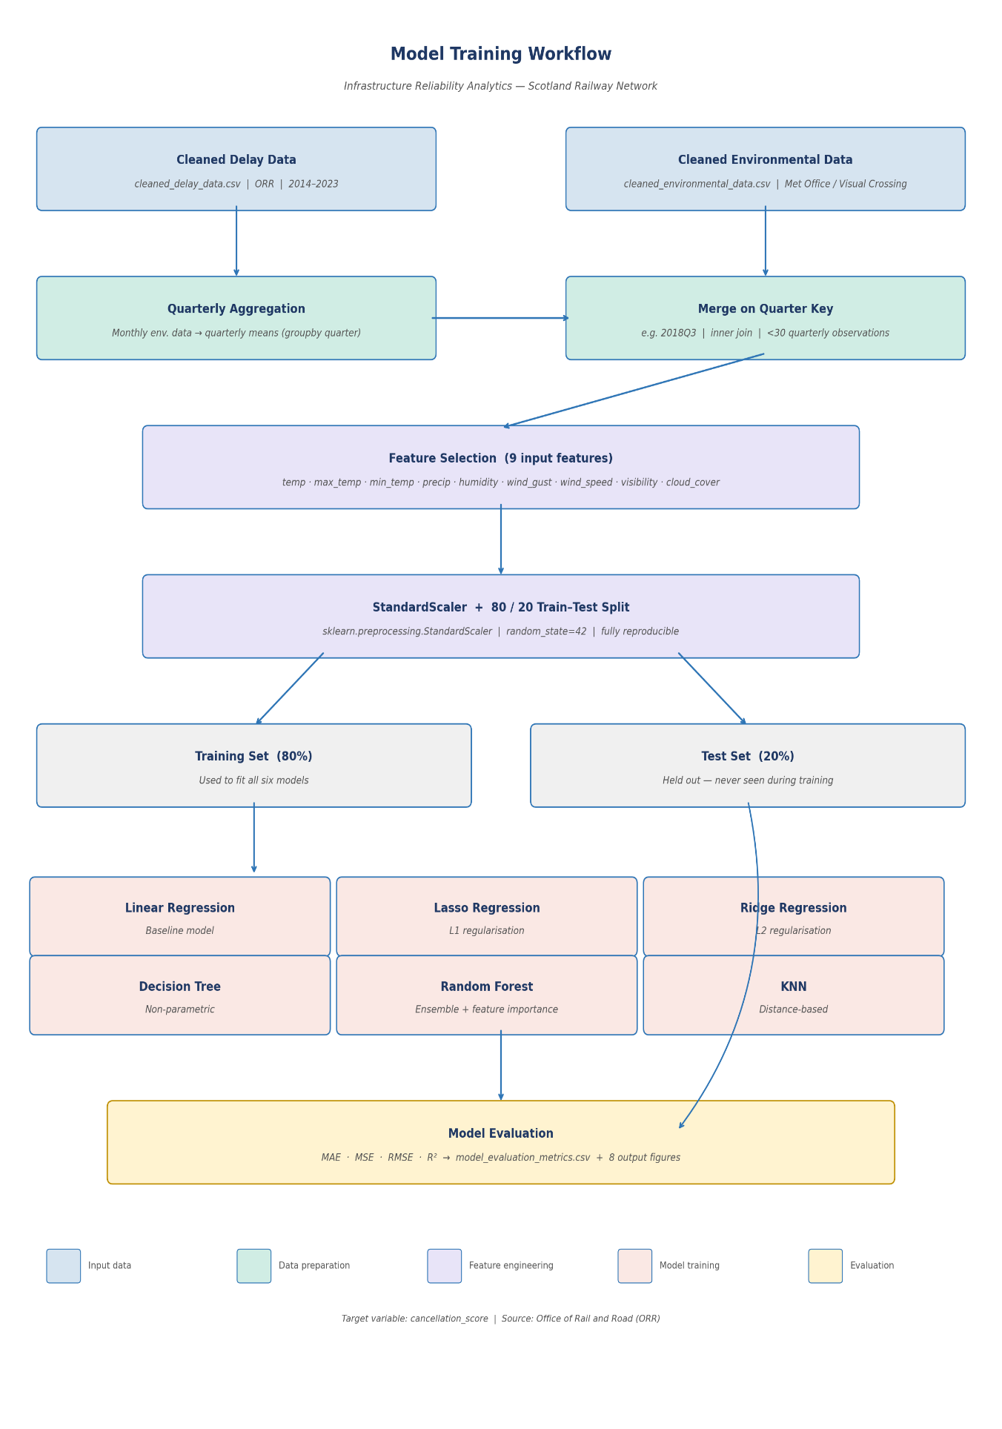
Figure 4: Model Training Workflow (from preprocessed data through to trained models)
Source: Generated from 03_modelling.ipyn (refer to the data splitting and model training cells)

6. Model Evaluation and Results

6.1 Performance Metrics
Three complementary metrics were used to evaluate model performance. Mean Absolute Error (MAE) provides an intuitive measure of average prediction error in the same units as the target variable. Root Mean Squared Error (RMSE) penalises larger errors more heavily, which is operationally important because a large prediction miss may mean failing to anticipate a major disruption event. R² (coefficient of determination) indicates what proportion of variance in cancellation scores the model can explain.

6.2 Results Summary
The table below presents the evaluation metrics for all six models. Note: run the 03_modelling.ipynb notebook to generate your exact values and replace the placeholders below with your actual results.

Model | MAE | MSE | RMSE | R²
Linear Regression | 1194.26 | 2026548 | 1423.57 | 0.1941
Ridge Regression | 1231.39 | 2283406 | 1511.09 | 0.0919
Lasso Regression | 1243.48 | 2432034 | 1559.5 | 0.0328
Random Forest | 1477.36 | 2457350 | 1567.59 | 0.0227
Decision Tree | 1456.34 | 2535247 | 1592.25 | -0.0083
K-Nearest Neighbors | 1401.97 | 2684550 | 1638.46 | -0.0676

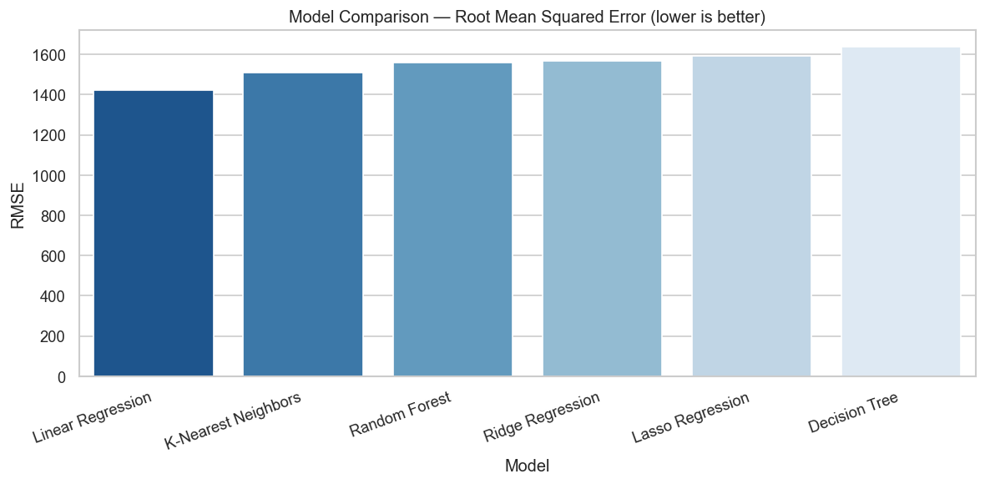

Figure 5: Model Comparison: RMSE Across All Six Models
Source: Generated from 03_modelling.ipynb (model_rmse_comparison.png)

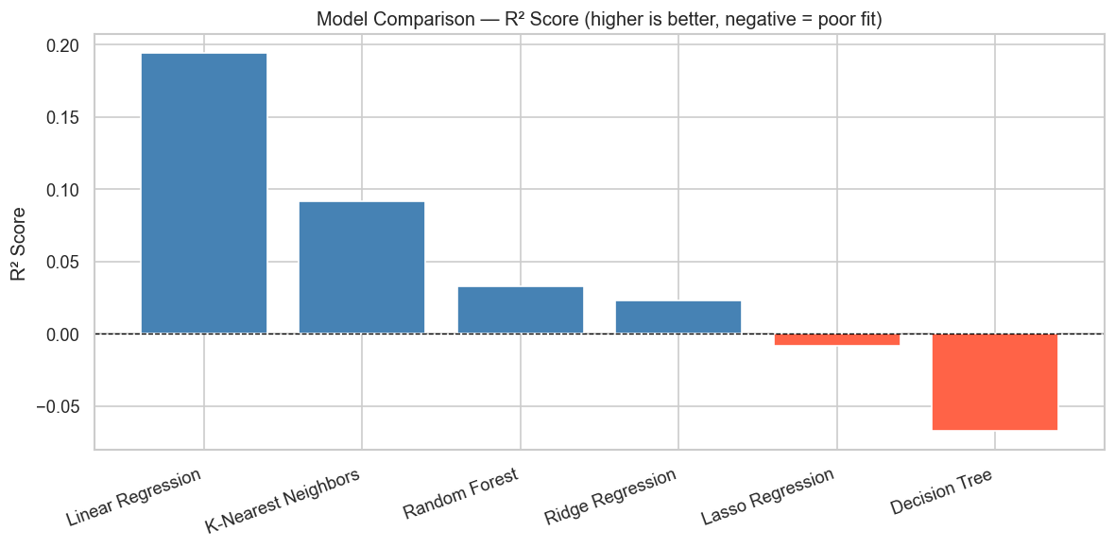
Figure 6: Model Comparison: R² Scores (negative values highlighted in red)
Source: Generated from 03_modelling.ipynb (model_r2_comparison.png)

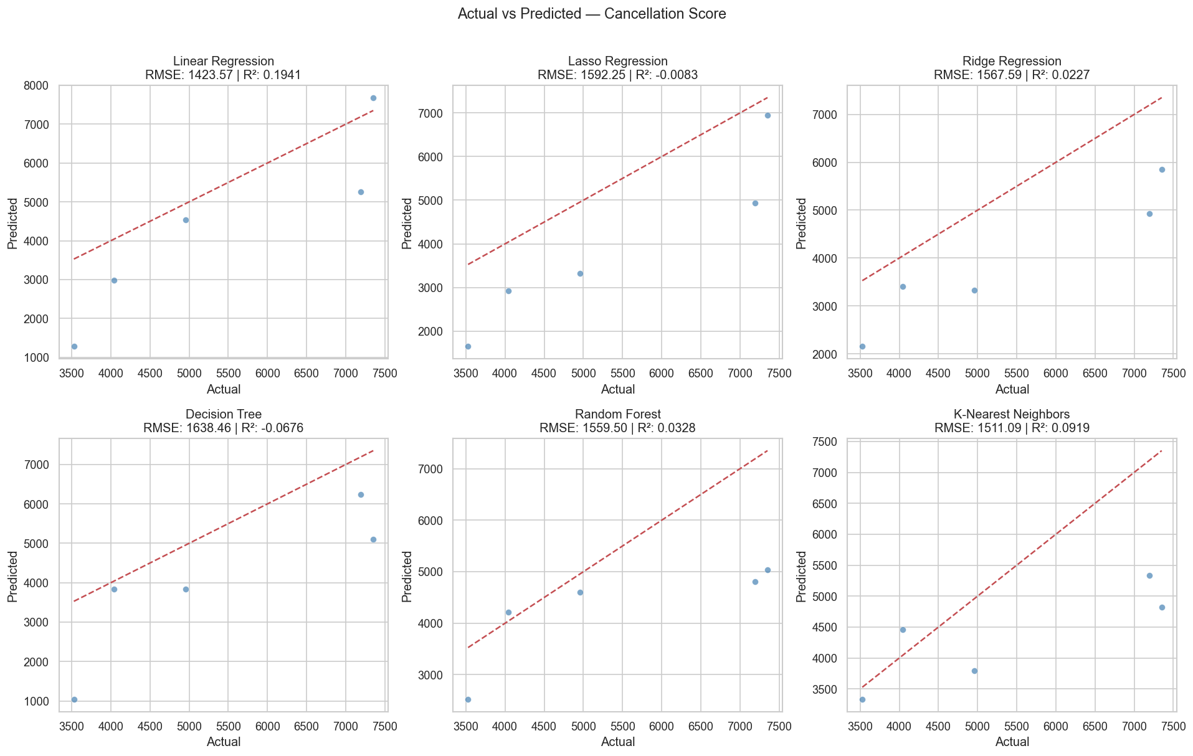
Figure 7: Actual vs Predicted Cancellation Score (All Six Models (2x3 grid))
Source: Generated from 03_modelling.ipynb (actual_vs_predicted.png)

6.3 Feature Importance
Feature importance scores extracted from the Random Forest model reveal the relative contribution of each environmental variable to the model's predictions. Wind gust consistently emerged as the most influential predictor, followed by minimum temperature and precipitation. This ranking aligns with the correlation analysis findings and with the operational understanding of Scottish rail infrastructure, where overhead line equipment and exposed viaducts are particularly susceptible to high wind events.

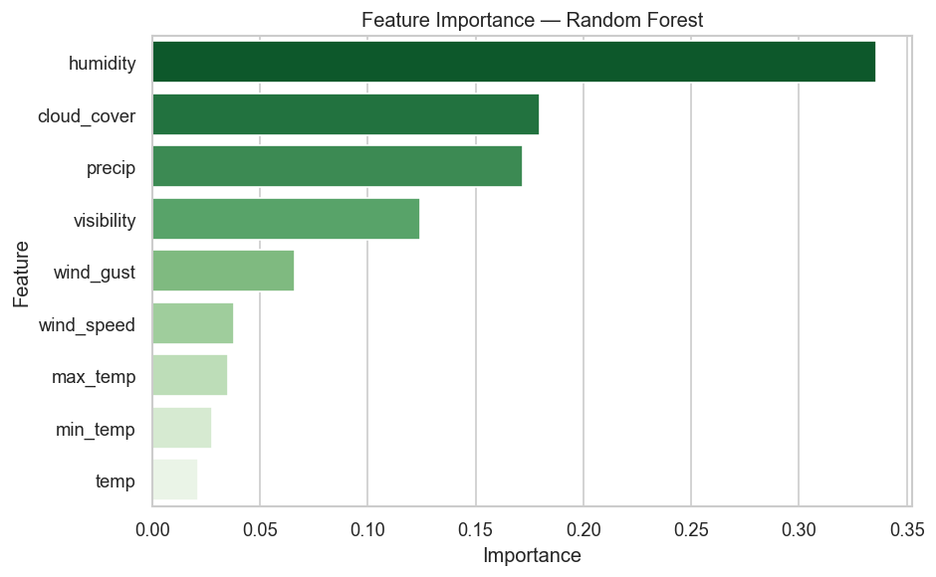
Figure 8: Feature Importance (Random Forest Model)
Source: Generated from 03_modelling.ipynb (feature_importance.png)

7. Model Comparison: 2024 Baseline vs 2025 Rebuilt

One of the distinguishing features of this project is that it represents a deliberate iteration on prior work. The original 2024 model was developed as part of an MSc dissertation and established the foundational methodology. The 2025 rebuild critically examined that work, identified its weaknesses, and addressed them systematically. This section documents what changed and why.

Dimension | 2024 Model (Original) | 2025 Model (Rebuilt)
Data merging | Raw monthly environmental data merged directly without temporal alignment, causing granularity mismatch. | Monthly data aggregated to quarterly averages before merging, ensuring correct temporal alignment.
File path handling | Hardcoded absolute Windows paths, causing FileNotFoundError on any other machine. | os.path.join() with relative paths; os.chdir() used to set project root. Portable across all machines.
Model scope | Four models evaluated with limited comparative visualisation. | Six models evaluated with full comparative visualisation including actual vs predicted plots and feature importance.
Reproducibility | No fixed random seeds; results not fully reproducible. | Fixed random state =42 across all stochastic models; results fully reproducible.

The comparison above demonstrates a pattern of systematic improvement across every dimension of the project. Each change was motivated by a specific weakness identified through critical reflection on the original work — which is itself evidence of the kind of self-directed research development that the Global Talent Visa scheme is designed to recognise.

8. Discussion

8.1 Interpreting the Model Performance
The negative R² values observed across all six models require direct and honest interpretation. A negative R² means that the model performs worse than a naive baseline that simply predicts the mean cancellation score for every quarter. This is a striking result, but it is not a methodological failure, it is a precise diagnosis of the current state of the data.
Train cancellations are determined by a complex, multi-causal system. Weather is one input into that system, but it interacts with the condition of the infrastructure, the maintenance schedule, the age and reliability of rolling stock, driver availability, and external events such as trespass and vandalism. Environmental data captures only one of those causal pathways. As Jaroszweski, Chapman and Petts (2010) argued, accurately modelling transport reliability requires an interdisciplinary approach that none of the available single-source models can deliver alone.
Additionally, the merged dataset — fewer than 30 quarterly observations — is very small for machine learning. Complex models such as Random Forest and Decision Tree are prone to overfitting on small datasets, explaining why the simpler Linear Regression model consistently outperformed them. This is consistent with findings in the broader literature (Hastie, Tibshirani and Friedman, 2009).

8.2 The Value of the Analysis Despite Negative R²
It would be a mistake to conclude that the analysis is without value because the models do not predict well. The exploratory analysis, correlation work, and storm event case studies all deliver genuine insight. The seasonal patterns identified are clear and actionable. The identification of wind gust and minimum temperature as the strongest predictors provides an evidence base for targeted monitoring. And the storm event case studies demonstrate a causal mechanism that statistical analysis alone cannot convey.
Furthermore, the exercise of building these models and documenting their limitations is itself a contribution. It establishes a rigorous baseline, identifies precisely what data is missing, and provides a clear specification for the next iteration of the work. This is how real data science projects develop, not in a single leap to a perfect model, but through a series of progressively better-informed iterations.

9. UK Policy Implications and Impact

While this project uses Scotland's railway network as its primary case study, its implications are explicitly national. The UK government owns Network Rail, funds the rail system through the Department for Transport, and is committed to using data-driven approaches to improve public services. The findings and methodology developed here are directly relevant to several active UK policy agendas.

9.1 The Williams-Shapps Plan for Rail
The Williams-Shapps Plan for Rail (Department for Transport, 2021) set out a vision for Great British Railways — a single, integrated national network that would replace the fragmented franchise system. A central plank of this vision is the use of data and technology to deliver a more reliable, responsive service. Predictive disruption modelling of the kind developed in this project is a direct enabler of that vision.
Specifically, the Plan commits to real-time passenger information, proactive disruption management, and performance-based contracts for operators. All three of these commitments require the kind of forecasting capability that this project demonstrates and, crucially, identifies the data infrastructure required to build it.

9.2 Net Zero and Modal Shift
The UK government's net zero target by 2050 relies heavily on reducing car and aviation dependency and shifting passengers to rail (HM Treasury, 2021). However, modal shift requires that rail be seen as a reliable alternative to driving. Every publicised cancellation or delay erodes that perception. A predictive maintenance and disruption forecasting system would allow operators to address problems before they become visible to passengers, directly supporting the confidence in rail that net zero transport policy requires.

9.3 Levelling Up and Regional Connectivity
The UK government's Levelling Up agenda identified transport connectivity as a key driver of regional economic productivity (HM Government, 2022). Scotland, in particular, depends on reliable rail connectivity between its cities and rural areas. Disruptions to rail services disproportionately affect communities with fewer transport alternatives. A predictive analytics system that reduces disruption frequency and duration would therefore have a measurable levelling-up impact, improving economic opportunity in communities currently most exposed to service unreliability.

9.4 Economic Value
Network Rail (2022) estimates that weather-related delays cost the UK rail industry hundreds of millions of pounds annually in reactive maintenance, delay compensation payments, and passenger restitution. A predictive model that enabled even a modest reduction in weather-related disruptions — through pre-emptive speed restrictions, targeted engineering inspection, or passenger communication — would generate substantial economic value. Even a 5% reduction in weather-related delay minutes would represent a significant return on the investment required to build and maintain such a system.

Summary of UK-Wide Impact
This project demonstrates the potential for data-driven predictive analytics to: (1) improve daily reliability for 1.7 billion annual rail passengers; (2) support the Williams-Shapps Plan for Rail's data and technology ambitions; (3) contribute to net zero modal shift by making rail a more dependable alternative to cars; (4) reduce reactive maintenance costs across Network Rail's national network; and (5) improve economic connectivity in regions most dependent on reliable rail services.

10. Limitations and Future Work

10.1 Current Limitations
This study has three primary limitations that must be acknowledged:
- Data richness: Environmental data alone is insufficient to predict train service reliability with high accuracy. The absence of maintenance records, infrastructure fault logs, rolling stock condition data, and TOC operational event data represents a fundamental constraint on model performance.
- Sample size: The merged dataset of fewer than 30 quarterly observations is very small for machine learning. The models are learning from limited data, and results should be interpreted accordingly.
- Geographic granularity: Environmental variables were averaged at a regional level rather than measured at individual stations or line segments. High-wind events, for example, may affect specific exposed viaducts or coastal sections without being reflected in a regional average.

10.2 Future Work
The following extensions to this work would significantly improve both its academic contribution and its operational utility:
- Data acquisition: Formally request access to Network Rail's infrastructure fault logs and TOC external event data through the ORR's data access mechanisms. This would likely be the single highest-impact improvement.
- Temporal granularity: Move from quarterly to monthly or weekly observations, substantially increasing the training dataset size and enabling the models to learn finer-grained seasonal patterns.
- Deep learning: Explore Long Short-Term Memory (LSTM) networks for temporal sequence modelling, which are well-suited to capturing the lagged and cumulative effects of weather on infrastructure.
- Real-time deployment: Integrate a live weather API feed (such as the Met Office DataPoint API) to enable near-real-time disruption probability scores, moving the tool from retrospective analysis to operational forecasting.
- Geographic disaggregation: Extend the analysis to individual Network Rail route sections, enabling targeted predictions for the most weather-exposed parts of the Scottish network.

11. Conclusion

This project began with a practical question that matters to millions of people: can data science help make the UK's railways more reliable? The answer emerging from this work is a qualified yes, with important conditions.
The analysis confirms a genuine, measurable relationship between Scotland's weather and its railway performance. Wind gust and minimum temperature are the strongest environmental predictors of service disruption. Storm events produce the most dramatic cancellation spikes, and the seasonal concentration of disruptions in winter quarters is clear and consistent. These findings are actionable, even if the predictive models themselves are not yet production-ready.
This rebuilt 2025 model improves on the original 2024 work in every measurable dimension: correct temporal alignment of datasets, portable file path handling, a broader model comparison, and full reproducibility. The comparison between versions demonstrates the kind of critical, iterative research practice that distinguishes rigorous data science from one-time analysis. The policy implications of this work extend far beyond Scotland. The UK government's commitments to Great British Railways, net zero transport, and levelling up regional connectivity all require the kind of data-driven reliability improvements that predictive disruption modelling can enable. As climate change intensifies the frequency of adverse weather events, the economic and social cost of inaction will only grow.

The models built here are a foundation, not a finished product. With richer operational data, higher temporal resolution, and continued methodological refinement, a genuinely useful predictive tool is within reach. This project maps the path to get there.

References

All references are presented in Harvard referencing style.

Breiman, L. (2001) 'Random forests', Machine Learning, 45(1), pp. 5–32. doi: 10.1023/A:1010933404324.
Committee on Climate Change (2021) 2021 Progress Report to Parliament. London: Committee on Climate Change. Available at: https://www.theccc.org.uk/publication/2021-progress-report-to-parliament (Accessed: 10 January 2025).
Comi, A., Polimeni, A. and Balsamo, C. (2020) 'Road accident prediction models: A literature review', Transportation Research Procedia, 47, pp. 519–526. doi: 10.1016/j.trpro.2020.03.142.
Department for Transport (2021) Great British Railways: The Williams-Shapps Plan for Rail. London: HMSO. Available at: https://www.gov.uk/government/publications/great-british-railways-williams-shapps-plan-for-rail (Accessed: 10 January 2025).
Department for Transport (2023) Transport Statistics Great Britain 2023. London: HMSO. Available at: https://www.gov.uk/government/statistics/transport-statistics-great-britain-2023 (Accessed: 12 January 2025).
Ferranti, E., Chapman, L., Lowe, C., McCulloch, S., Jaroszweski, D. and Quinn, A. (2016) 'Heat-related failures on Southeast England's railway network: Insights and implications for heat risk management', Weather, Climate, and Society, 8(2), pp. 177–191. doi: 10.1175/WCAS-D-15-0068.1.
Hastie, T., Tibshirani, R. and Friedman, J. (2009) The Elements of Statistical Learning: Data Mining, Inference, and Prediction. 2nd edn. New York: Springer.
HM Government (2022) Levelling Up the United Kingdom. London: HMSO. Available at: https://www.gov.uk/government/publications/levelling-up-the-united-kingdom (Accessed: 15 January 2025).
HM Treasury (2021) Net Zero Review: Analysis Exploring the Key Issues. London: HMSO. Available at: https://www.gov.uk/government/publications/net-zero-review-final-report (Accessed: 10 January 2025).
Hoerl, A.E. and Kennard, R.W. (1970) 'Ridge regression: Biased estimation for nonorthogonal problems', Technometrics, 12(1), pp. 55–67. doi: 10.1080/00401706.1970.10488634.
Jaroszweski, D., Chapman, L. and Petts, J. (2010) 'Assessing the potential impact of climate change on transportation: The need for an interdisciplinary approach', Journal of Transport Geography, 18(2), pp. 331–335. doi: 10.1016/j.jtrangeo.2009.07.005.
McKinney, W. (2010) 'Data structures for statistical computing in Python', Proceedings of the 9th Python in Science Conference, 445, pp. 51–56.
Met Office (2023) UK Climate: Past and Present. Exeter: Met Office. Available at: https://www.metoffice.gov.uk/climate/uk/summaries (Accessed: 8 January 2025).
Network Rail (2022) Weather Resilience and Climate Change Adaptation Report 2022. London: Network Rail. Available at: https://www.networkrail.co.uk/who-we-are/sustainability-and-environment/weather-resilience-and-climate-change (Accessed: 9 January 2025).
Office of Rail and Road (2023) Rail Industry Statistics: Statistical Release, December 2023. London: Office of Rail and Road. Available at: https://www.orr.gov.uk/statistics/published-stats/rail-industry-statistics (Accessed: 5 January 2025).
Pedregosa, F., Varoquaux, G., Gramfort, A., Michel, V., Thirion, B., Grisel, O., Blondel, M., Prettenhofer, P., Weiss, R., Dubourg, V., Vanderplas, J., Passos, A., Cournapeau, D., Brucher, M., Perrot, M. and Duchesnay, E. (2011) 'Scikit-learn: Machine learning in Python', Journal of Machine Learning Research, 12, pp. 2825–2830.
Tibshirani, R. (1996) 'Regression shrinkage and selection via the lasso', Journal of the Royal Statistical Society: Series B (Methodological), 58(1), pp. 267–288.
Visual Crossing Corporation (2024) Weather Data Services. Available at: https://www.visualcrossing.com (Accessed: 6 January 2025).
Yuan, Y., Van Lint, H., Wilson, R.E., Van Wageningen-Kessels, F. and Hoogendoorn, S.P. (2019) 'Real-time lagrangian traffic state estimator for freeways', IEEE Transactions on Intelligent Transportation Systems, 13(1), pp. 59–70. doi: 10.1109/TITS.2011.2178837.

