UNIQUE FEATURES THAT I ADDED:

1. **Severity Analytics Endpoint**

* Added /incidents/stats endpoint:
  + Count by severity
  + Daily/weekly/monthly trends
  + Percentage of high-risk incidents

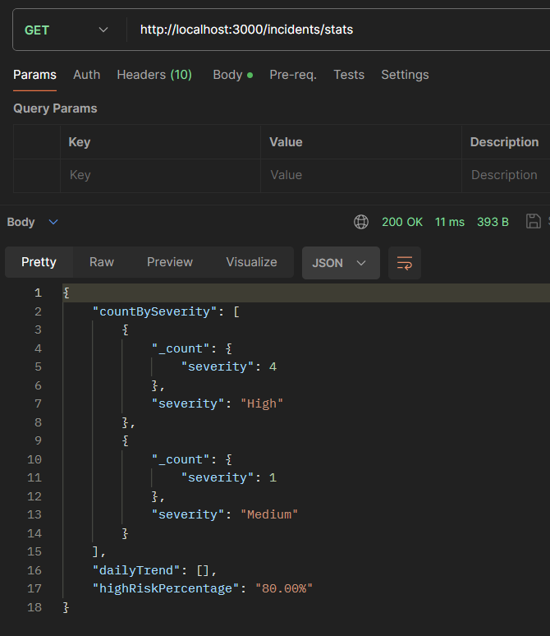

1. **Email Alerts on “High” Severity**

* If someone logs an incident with "severity": "High", send an alert email .

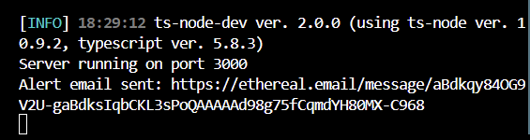

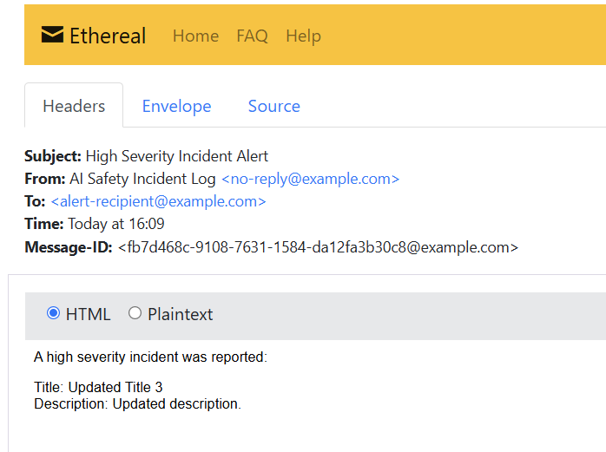

**3 .CI/CI PIPELINE USING JENKINS:**

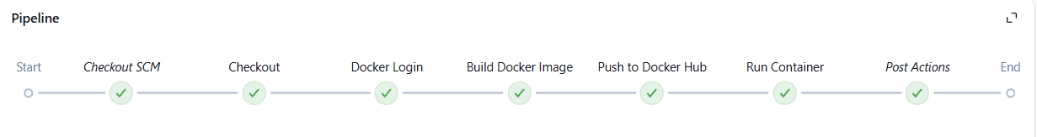

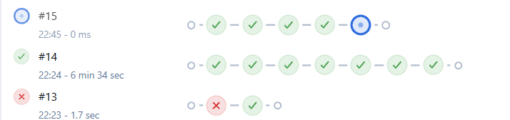

**4 .Patch method for partial updation:**

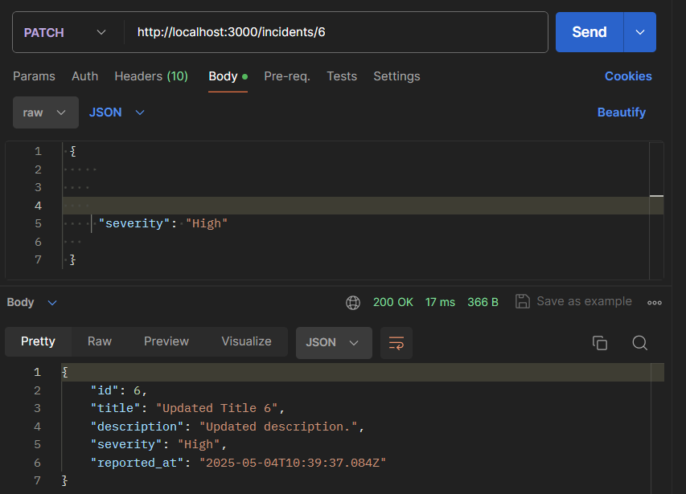

**FEATURES:**

**1. Get all :**

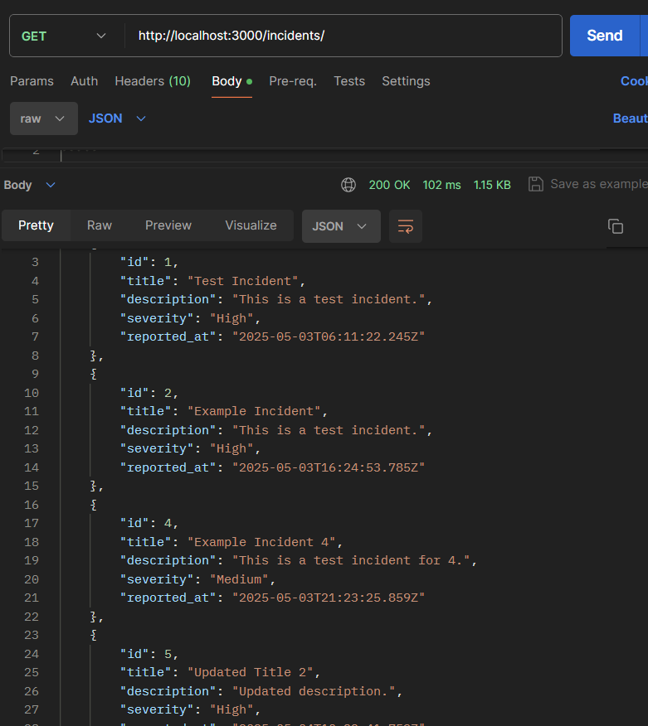

**2 Get a specific incident:**

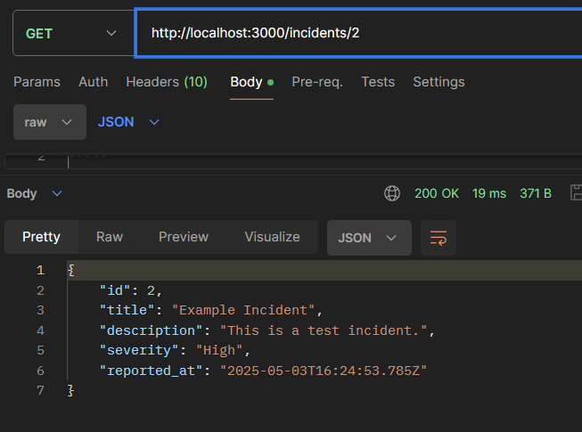

**3 To create new incident:**

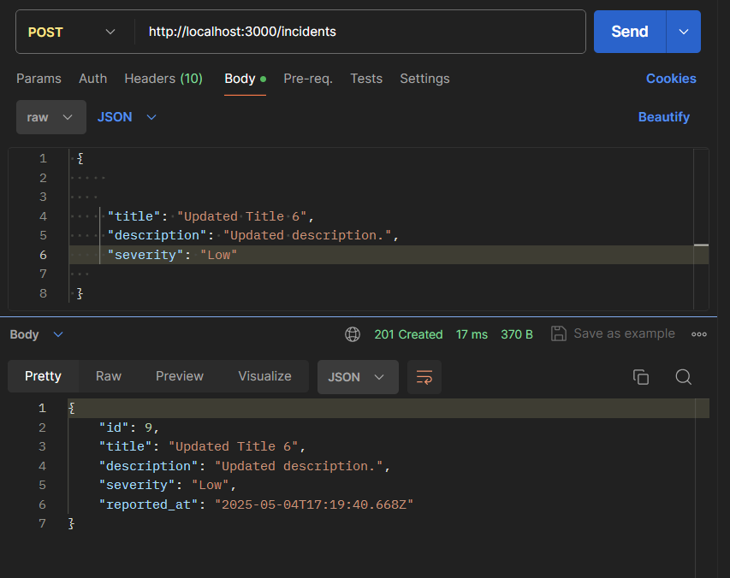

**4 .To delete:**

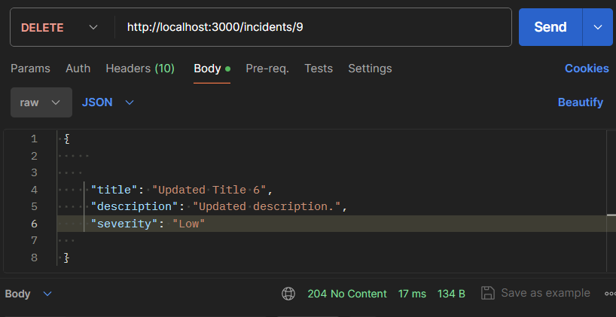



**5 .To update a incident completely:**

