诚实考试吾心不虚 ，公平竞争方显实力，
……………………………………………………………装 订 线…………………………………………………
考试失败尚有机会 ，考试舞弊前功尽弃。
上海财经大学《时间序列分析》课程考试卷
课程代码 课程序号
20 —20 学年第一学期
姓名 学号 班级
题号 | 一 | 二 | 三 | 四 | 五 | 六 | 总分
得分
得分
- Give a definition of second-order stationary. [10 marks]

- Re-write the 1st order autoregressive process:
得分
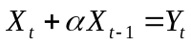
In term of 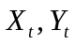 and the backwards operator B: 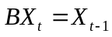. For what values of a is the the stationary? [15 marks]

- Re-write the 1st order moving average process:
得分
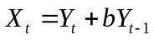
In term of and the backwards operator B: 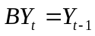. For what values of b is the the invertible? [15 marks]
- What are the roots λ1，λ2 of the characteristic equation for the AR(2) process:
得分
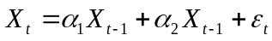
what condition must λ1，λ2 satisfy in order for the AR(2) process to be expressed as an infinite order MA process? [15 marks]
- Derive the Yule-Walker equations for the AR(3) process
得分

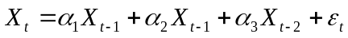
where 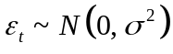.
(a) Express the Yule-Walker equation in the matrix form. [10 marks]
(b) Given sample value 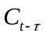 of the covariance function 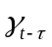 how would you estimate the parameters 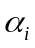of the AR(3) process. [10 marks]
(c) Write down the distribution of 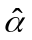that depends on a variance-covariance matrix that must provide. [10 marks]
- Given the observations 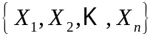generated by the process
得分
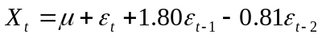
where  is a real constant and 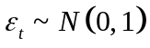. Find the exact distribution of the sample mean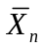. Evaluate 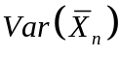 with n=10. Compare the 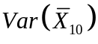 with the variance of the sample mean of a random sample of size 10 drawn from the distribution of 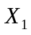.[15 marks]

