|  |  |  |
| --- | --- | --- |
| **Problem Chosen** Z | **2023 MCM/ICM Summary Sheet** | **Team Control Number** 2330619 |

Summary

The objective of this paper is to identify the key factors that impact a country's willingness to bid for hosting the Olympic Games and quantify their effects. Drawing from our analysis, we offer actionable recommendations to foster greater interest in bidding for the Olympics and ensure the successful hosting of the games.

Firstly, We **calculated the application information** of countries that have applied to host the Olympic Games and used the **average shift method** to obtain the bid willingness of each bidding country in different years.

Secondly, We collected two types of data to support our study. **The first part** is the data related to the host cities that have hosted the Summer Olympics Games or Winter Olympics Games. Five indicators were selected: Contribution to GDP and tourism, Venue abandonment rate, public satisfaction and impact, and ROI. Then we utilize the TOPSIS weighed by **entropy method** to score the previous Olympic Games. And **the second part** is comprehensive data on the **world's development** over the past seven decades, including changes in economic, social, and investment in education and culture and international influence. From these, we extracted the changes in the level of national development of the countries bidding to host the Olympic Games.

Thirdly, In order to better analyze the influence of factors such as **the level of development** of a country on its willingness to bid for the Olympics, we used **cluster analysis** to classify all bidding countries into four categories using ward distances. We selected a total of eight indicators to measure the willingness to bid degree, including GDP development, GDP per capita development, urbanization level, scientific and cultural development level, international status potential, people's happiness index, and government financial burden level.

Fourthly, We exert **factor analysis** to identify the most siginigicant factor influencing the willingness of each category of countries. We considered four public factors: empirical factors(**the effect of hosting the previous two Olympic Games**), economic factor, social development factor, cultural and educational factor, and one special factor: international political and cultural influence factor.

Fifthly, We performed validation and sensitivity analysis of the previously established model to calculate the willingness level based on the data of 2024 as well as 2026 Olympic Games bidders and other non-bidding countries. The calculation results are consistent with the actual situation. Then we took the data from previous years to conduct sensitivity analysis, and the analysis results verified the correctness of the model.

Finally, we synthesize each indicator and its importance and give suggestions on how to improve the motivation of countries to bid for the Olympic Games, based on the established model.

**Keywords**: Olympic Games TOPSIS Cluster Analysis Factor Analysis willingness

**Content**

1 Introduction 2

1.1 Problem Background 2

1.2 Our Work 2

2 Assumptions and Justifications 3

3 Model Preparation 4

3.1 Notations 4

3.2 The Data 5

3.2.1 Data Collection 5

3.2.2 Data Cleaning 5

4 MODEL I:Olympic Games Evaluation Model 6

4.1 Model Construction 7

4.2 Results 11

5 MODEL II: Willingness model 12

5.1 Statistics on the willingness of bidder countries 13

5.2 Clustering 14

5.3 Clustering results 15

5.4 Factor Analysis 17

5.5 Factor analysis results 19

6 Sensitivity analysis 19

6.1 Model Validation 19

6.2 Sensitivity analysis 19

7 Model Evaluation and Further Discussion 20

7.1 Strengths 20

7.2 Possible Improvements 20

8 Conclusion 20

Reference 21

Memo 1

# Introduction

## Problem Background

In the past, the competition for hosting the Olympic Games has been fiercely contested. However, due to various short-term and long-term negative impacts experienced by host cities/countries, the number of bids for hosting both the Summer and Winter Olympics is on a declining trend. Some scholars are exploring diverse strategies to address this issue, such as establishing permanent host cities for the Summer and Winter Olympics respectively, or segmenting the Olympics into four groups based on seasonality and holding them separately. These options and strategies aim to mitigate risks borne by bidding countries and cities while also attracting greater international participation in the Olympic Games.



Figure LOGO:five rings

To ensure the success of the Olympics and foster global connections through sports, ICMG suggests establishing measurement standards from various angles to evaluate the impacts of hosting the event, including land use, economic effects, human satisfaction, tourism, opportunities for future improvements, and the reputation of the host city/country. Participants are invited to make recommendations supporting ICMG's work, taking into account feasibility, implementation timelines, and the potential impact of their strategies on the set indicators[1]. Participants should also write a memorandum to the National Olympic Committee describing their proposed strategies and policy recommendations. These suggestions and policies will help ensure a successful Olympics while promoting global sports development and cultural exchange.

## Our Work

The assignment requires us to develop measurement standards to evaluate the impacts of hosting the Olympics from different angles while considering the proposal's feasibility, implementation timeline[2], and the potential impact of strategies on the set indicators. Our plan is as follows:

●Establishing an evaluation model for the effectiveness of hosting previous Olympic Games.

●Based on indicators data from previous bidding countries and the impact of the first two Olympic Games, establish a willingness evaluation model.

●Testing the accuracy and sensitivity of the evaluation model.

●Providing opinions and suggestions based on the aforementioned analysis.

# Assumptions and Justifications

To streamline our analysis, we will operate under the following basic assumptions, all of which are reasonable and valid.

**●Assumption1:**Assume that every bidding country for each Olympic event has a "strong willingness" to host.

**Justification:**As the Olympics is a globally renowned event, every host country must compete vigorously with others and invest considerable resources into the event. As such, we can assume that each bidding country has a strong desire to host the Olympics, having weighed the costs and benefits carefully before submitting their bid[3].

**●Assumption2:**Assume that the willingness strength of each bidding country for each Olympic event is influenced by the success level of the host countries from the previous two events.

**Justification:**Considering the massive investment of manpower and resources required to host the Olympics, it is crucial to carefully evaluate the effectiveness of past events before making any decisions about hosting future ones.

**●Assumption3:**Assuming that the Olympics are not significantly impacted by extreme and uncontrollable factors (such as war, pandemics), we consider that any changes in a host city’s evaluation indicators during an Olympic year are mainly due to the impact of hosting the event.

**Justification:**Due to the impact of uncontrollable factors such as war and pandemics, there have been some exceptional cases in Olympic history, such as the 1980 Moscow Olympics and the 2021 Tokyo Olympics. To keep our model more universally applicable, we will temporarily exclude these events from consideration. Furthermore, given the unprecedented scale and influence of the Olympics, as well as the high correlation between the event and our selected indicators, we will focus on major factors and attribute any changes in a host city's evaluation indicators during an Olympic year to the impact of hosting the event.

**●Assumption4:**To ensure the relevance and accuracy of our analysis, we will focus solely on data concerning the Olympic events that have taken place following World War II.

**Justification:**Given the significance of World War II in shaping global history, we acknowledge that it marks an important turning point in the evolution of the modern world.[4] Therefore, to ensure our conclusions reflect the present-day context, we will focus solely on data related to the Olympic events held since the end of WWII.

The willingness to bid for hosting the Olympic Games can be influenced by the past hosting effects. Therefore, we have collected data on all previous bidding cities and established an Olympic evaluation model to score each Olympics based on a set of evaluation criteria. The data from the two previous Olympic Games before the bidding will be used as part of the evaluation index, along with several other appropriate indicators. Due to the vast number of bidding countries, we first carried out clustering analysis and then used factor analysis to calculate the weight of each indicator, ultimately obtaining a complete model for evaluating the willingness to bid. This model reflects the factors that affect willingness and their corresponding weights. After conducting accuracy tests and sensitivity analysis on the model, we will provide relevant recommendations to the International Olympic Committee (IOC).

In summary, the entire modeling process is shown below:



Figure Schematic diagram of the modeling process

# Model Preparation

This section outlines the preliminary steps necessary for modeling, including a description of the mathematical symbols used throughout the article and details on how we collected and processed the relevant data.

## Notations

Table 1 displays the key symbols utilized throughout this article.

Table Notations

|  |  |
| --- | --- |
| Symbol | Description |
|  | Distance of the th evaluation object from the maximum value |
|  | Distance of the  th evaluation object from the minimum value |
|  | Information entropy |
|  | Information utility value |
|  | Degree of willingness of the sponsoring country |
|  | Is the j-th country involved in the bid for the i-th |
|  | Predicted values for period |
|  | Weights of observations in period |
|  | Number of weights |
|  | Distance between sample points |

## The Data

As there are significant differences between the Winter Olympics and Summer Olympics in multiple aspects, we will treat these two events separately. Given the sizable volume of data involved, as well as its complexity and diversity, we will utilize visualizations to display some of this data more intuitively[5].

### Data Collection

Our data collection efforts have yielded two distinct datasets, as illustrated in Table 2. The left column contains data related to each Olympic event's host city, while the right column provides information on each bidding country's characteristics.

Table Resources

|  |  |  |  |
| --- | --- | --- | --- |
| Data Name | Source | Data Name | Source |
| GDP 7 years before hosting the Olympics | https://www.imf.org/en/Home | Calendar year GDP of the host country | https://ourworldindata.org/ |
| Number of tourists 7 years before hosting the Olympic Games | https://ourworldindata.org/ | Per capita GDP of the host country in the calendar year | https://ourworldindata.org/ |
| Population satisfaction | https://zh.wikipedia.org/ | Government expenditures of the sponsoring country for the calendar year | https://ourworldindata.org/ |
| Number of venues built | https://zh.wikipedia.org/ | Population change in the host country over the years | https://ourworldindata.org/ |
| Amount of investment | https://olympics.com/en/ | Changes in investment in education over the years in the sponsoring countries | https://ourworldindata.org/ |
| Olympic revenue | https://olympics.com/en/ | Cultural influence ranking of the bidding countries | www.usnews.com |
| Number of abandoned venues | https://zh.wikipedia.org/ |  |  |

### Data Cleaning

Given the significant volume and variety of data collected, our work included the following steps:

●To ensure consistency and comparability between different types of data, we standardized their respective units of measurement. Specifically, we converted GDP, Olympic revenue, and investment figures to million US dollars, while tourist numbers were expressed in tens of thousands.

●For non-numeric data such as satisfaction levels, we utilized an expert system to convert these qualitative measures into quantitative data that could be analyzed alongside other numeric data points.

●To account for the potential impact of exchange rate fluctuations and inflation over the course of our extensive dataset, we have standardized all financial data relative to the purchasing power of the US dollar as of April 1, 2023, according to Eastern Standard Time.

●To ensure accurate calculations for GDP and tourist figures related to Olympic host cities, we obtained data from the six years preceding each Olympic event. Using an adaptive filtering method, we extrapolated the GDP and tourist numbers for the year of the Olympic event. We then computed the percentage difference between the actual and ideal values relative to the actual value, using this figure as a benchmark indicator for our analysis. The basic formula is as follows:



Please consult the Notations section of this article for a detailed explanation of the symbols utilized throughout.

●Given the significant amount of data involved for investment amounts and Olympic revenue, we have merged these two indicators and expressed them as an investment return rate.

●As part of our analysis, we have utilized the ratio of abandoned venues to the total number of constructed venues as a key evaluation indicator, known as the venue abandonment rate.

# MODEL I:Olympic Games Evaluation Model

Drawing on the processed data, we have identified five key evaluation indicators for constructing our model: Contribution to GDP and tourism, Venue abandonment rate, public satisfaction, and ROI[6]. We then employ a TOPSIS model that weighting by entropy method to calculate a score for each Olympic event, providing us with a measure of its overall effectiveness.

|  |  |  |  |  |  |
| --- | --- | --- | --- | --- | --- |
| **Time** | **GDP** | **Tour** | **Venue abandonment rate** | **Satisfaction&Impact** | **ROI** |
| 2016 | 0.0323 | -0.0008 | 0/33 | 8 | 0.6267 |
| 2012 | -0.0006 | 0.2412 | 0/34 | 8 | 0.8682 |
| 2008 | 0.0311 | 0.5260 | 1/37 | 10 | 0.7182 |
| 2004 | 0.0518 | 0.3269 | 2/34 | 8 | 0.7327 |
| 2000 | 0.0177 | 0.1815 | 2/40 | 8 | -0.2440 |
| 1996 | 0.0119 | 0.2787 | 0/26 | 8 | 0.2259 |
| 1992 | 0.0185 | 0.3123 | 2/29 | 5 | 0.8072 |
| 1988 | -0.0220 | 0.2059 | 1/31 | 6 | -0.0256 |
| 1984 | 0.0000 | 0.0967 | 1/28 | 8 | 0.9450 |
| 1976 | 0.0149 | 0.1358 | 2/27 | 8 | 0.9900 |
| 1972 | -0.0147 | 0.2649 | 2/31 | 4 | 0.9750 |
| 1968 | -0.0035 | 0.1724 | 1/18 | 6 | 0.9945 |
| 1964 | -0.0180 | 0.2759 | 2/19 | 8 | 0.9467 |
| 1960 | 0.0192 | 0.1979 | 2/17 | 8 | 0.9463 |
| 1956 | -0.0277 | 0.2500 | 2/16 | 7 | 0.9663 |
| 1952 | 0.0209 | 0.4148 | 1/21 | 9 | 0.9866 |

Table Indicators of previous Summer Olympics

|  |  |  |  |  |  |
| --- | --- | --- | --- | --- | --- |
| **Time** | **GDP** | **Tour** | **Venue abandonment rate** | **Satisfaction** | **ROI** |
| 2018 | 0.0494 | 0.1175 | 2/28 | 6 | -0.3926 |
| 2014 | 0.2088 | 0.1789 | 2/19 | 6 | -0.9147 |
| 2010 | -0.0003 | 0.0338 | 2/14 | 8 | -0.4365 |
| 2006 | -0.0015 | 0.0189 | 2/17 | 8 | -0.2650 |
| 2002 | -0.0087 | -0.0100 | 2/14 | 7 | 0.0455 |
| 1994 | 0.0036 | 0.4750 | 2/17 | 8 | -0.8592 |
| 1992 | 0.0000 | 0.2730 | 0/13 | 9 | -0.7950 |
| 1988 | -0.0033 | 0.3588 | 0/7 | 7 | -0.2400 |
| 1984 | 0.0025 | 0.1412 | 2/9 | 8 | 3.2300 |
| 1980 | -0.0201 | -0.0400 | 0/17 | 5 | -0.4727 |
| 1976 | -0.0033 | 0.1250 | 0/8 | 7 | 0.0250 |
| 1972 | 0.0201 | 0.0072 | 1/11 | 8 | -0.6367 |
| 1968 | 0.0830 | 0.0684 | 0/12 | 8 | -0.9540 |
| 1964 | 0.0345 | 0.1709 | 0/7 | 8 | -0.5720 |
| 1960 | 0.2301 | 0.1630 | 0/10 | 6 | -0.6000 |
| 1956 | 0.0255 | 0.2105 | 1/5 | 8 | -0.8167 |

Table Indicators of previous Winter Olympics

## Model construction

The TOPSIS method is a widely utilized approach to comprehensive evaluation that effectively leverages the information contained within raw data to capture the differences between different evaluation schemes. In order to minimize the impact of subjective biases, we have employed an entropy weighting technique to determine the relative weights of each indicator used in our analysis.



Figure Flowchart of Model 1

***STEP1*** To begin, we further processed the data collected for each indicator and computed the rank sum ratio (RSR) for each.



Here,  is the number of indicators， is the number of groups， is the rank of each indicator，and the RSR value is the average rank across all indicators. The higher the RSR value, the better.

***STEP2*** We standardize all indicators to be maximization type indicators (the higher, the better) through a normalization process[7]. The transformation function form is not unique. Assuming the original data sequence is ，the following method is used to transform each type of indicator into a maximization type indicator.



***STEP3*** To account for potential variations in scale or units across different indicators, we normalize the positive matrix to eliminate any influence stemming from these differences. Assuming that the positive matrix is denoted as ，the resulting standardized matrix  may be calculated as follows:



***STEP4*** Calculate the scores and normalize them. Assume that there are  objects to be evaluated,  evaluation indicators with sizes of  , and a standardized matrix .

Define Maximum Value:

Define Minimum Value:

Define the Distance between the -th Object and the Maximum Value:



Define the Distance between the  -th Object and the Minimum Value:



It is possible to calculate the non-normalized score of the  -th object:

Finally, we normalize the scores (normalizing the scores does not affect the ranking):

***STEP5*** The aforementioned process did not consider the relative importance of each indicator. To address this issue, we may introduce the entropy weighting method to determine the appropriate weights for each indicator. The entropy weighting method is an objective approach that assigns weights based on the principle that indicators with lower variability reflect less information and therefore correspond to lower weights (i.e., the data itself can inform us of the appropriate weighting). Specifically, the entropy weighting method assumes that events with a higher probability have lower information content, while events with a lower probability have higher information content. This relationship between information content and probability is depicted in the following graph:



Figure Entropy method information quantity as a function of probability

Consider an event denoted by  that occurs under specific conditions, with a corresponding probability of occurrence represented by . The entropy of this event may be defined as:



The essence of entropy is that it represents the expected value of information content. In the context of the entropy weighting method, higher entropy values indicate lower levels of information content, as they reflect a greater degree of uncertainty or variability in the data. This is because larger entropy values imply that the probability distribution of outcomes for a given indicator is more evenly spread out, indicating that the information provided by that indicator is less informative when compared to other indicators with lower entropy values. Therefore, in the entropy weighting method, we seek to assign smaller weights to indicators with higher entropy values, and larger weights to those with lower entropy values

***STEP6*** To calculate the weights using the entropy weighting method, we first check for the presence of negative values in the judgment matrix[8]. If any negative values are detected, we must re-standardize the matrix to the non-negative range to ensure that all elements are non-negative when computing probabilities in subsequent steps. This process can be achieved as follows:

Suppose there are  objects to be evaluated, each assessed using  evaluation indicators that have already been normalized. Further, let  denote the normalization matrix. Then, each element of the resulting standardized matrix denoted by  satisfies



If there are negative numbers in the matrix  , another normalization method should be used on:



Calculate the weight of the  -th sample under the  -th indicator, and treat it as the probability used in the calculation of relative entropy:For the non-negative standardized matrix obtained in the previous step, calculate the probability matrix , with each element denoted by calculated using the following formula:



Calculate the entropy of each indicator, and compute the information utility value. Normalize the resulting entropy weights to obtain the final weights for each indicator. For the  -th indicator, the formula for calculating its entropy is:



The information utility value represents the level of information content provided by each indicator relative to the other indicators. It is defined as 

Normalizing the information utility values yields the entropy weight for each indicator:



***STEP7*** The TOPSIS method outlined above does not account for differences in the importance of different indicators. However, when using the entropy weighting method to determine the weights of each indicator, we can simply recompute the matrices and for each evaluated object, incorporating the appropriate weights into the calculations. The other steps involved in the TOPSIS algorithm remain the same.



## Results

Suppose that we have combined the relative errors of GDP and return on investment into a single economic indicator, and combined the relative errors of people's satisfaction, venue abandonment rate, and tourist numbers into four distinct categories of indicators. We use these indicators to score each Olympic Games based on their performance across these dimensions. By following the steps outlined above, we can derive the weights of each indicator in the scoring process. These weights will allow us to more accurately assess the overall performance of each Olympic Games, and identify areas for improvement in future events.

Figure Evaluation metrics for Model 1

The results are shown in the following table:

Table Weighting of the impact of each indicator on the Olympic Games score

|  |  |  |  |  |
| --- | --- | --- | --- | --- |
| **Olympic** | **Economy** | **Tour** | **Satisfaction** | **Venue abandonment rate** |
| summer | 0.3021 | 0.2171 | 0.1962 | 0.2845 |
| winter | 0.2739 | 0.3855 | 0.1907 | 0.1499 |

Using the weights and indicators derived from the above analysis, we have computed the scores for each host country across all Olympic Games. These scores are presented in the following table:

Table Scores of previous Winter Olympics

|  |  |  |  |  |  |
| --- | --- | --- | --- | --- | --- |
| **Time** | **Host country** | **Score** | **Time** | **Host country** | **Score** |
| 1956 | Italy | 0.0616 | 1992 | France | 0.0839 |
| 1960 | America | 0.0600 | 1994 | Norway | 0.0926 |
| 1964 | Austria | 0.0667 | 1998 | Japan | 0.0507 |
| 1968 | France | 0.0585 | 2002 | America | 0.0362 |
| 1972 | Japan | 0.0480 | 2006 | Italy | 0.0501 |
| 1976 | Austria | 0.0534 | 2010 | Canadn | 0.0488 |
| 1980 | America | 0.0337 | 2014 | Russia | 0.0591 |
| 1984 | Yugoslavia | 0.0633 | 2018 | Korea | 0.053 |
| 1988 | Canadn | 0.0804 |  |  |  |

Table Scores of previous Summer Olympics

|  |  |  |  |  |  |
| --- | --- | --- | --- | --- | --- |
| **Time** | **Host country** | **Score** | **Time** | **Host country** | **Score** |
| 1952 | Finland | 0.0738 | 1988 | Korea | 0.0629 |
| 1956 | Australia | 0.0371 | 1992 | Spain | 0.0556 |
| 1960 | Italy | 0.0470 | 1996 | America | 0.0812 |
| 1964 | Japan | 0.0474 | 2000 | Australia | 0.0812 |
| 1968 | Mexico | 0.0377 | 2004 | Greece | 0.0839 |
| 1972 | Germany | 0.0447 | 2008 | China | 0.1006 |
| 1976 | Canada | 0.0538 | 2012 | England | 0.0711 |
| 1984 | America | 0.0556 | 2016 | Brazil | 0.0662 |

# MODEL II: Willingness model

To build a model for assessing a country's willingness to host the Olympic Games, we will consider several factors, including the scores obtained by previous hosts (as described in Section 4.2) and the current state of the country across various indicators. Specifically, we will focus on countries that have expressed a strong interest in hosting the Olympics in the past and use their commonalities across relevant indices to anchor our analysis.

By examining the features shared by these countries, we can create a set of criteria for determining which countries are most likely to be interested in hosting the Olympics. These criteria might include a high level of economic development, a strong infrastructure base, political stability, and a favorable public opinion towards hosting large-scale events. We will then use regression analysis to identify the relative importance of each criterion and construct a predictive model for assessing a country's willingness to host the Olympics at a given point in time.

Ultimately, this model can help stakeholders better understand the factors that drive a country's decision to host the Olympics and provide guidance for future event planning and management.

## Statistics on the willingness of the applicant countries

To better understand the factors that influence a country's willingness to host the Olympic Games, we will begin by examining the bidding history for each host country across all previous Olympic Games. For each country, we will record whether they applied to host the event or not, using "1" and "0" to denote bidding and non-bidding years, respectively (represented by " " symbol). Additionally, if a country consistently bids for multiple consecutive Olympic Games, its willingness to host the event is likely to be higher than other countries. To account for this, we will consider the bidding history from two consecutive Olympic Games as a reference point when evaluating a country's willingness to host the event for a given year. Thus, we can calculate a country's willingness to bid for the Olympics in a given year using the following equation:



The results are presented in the following graph:

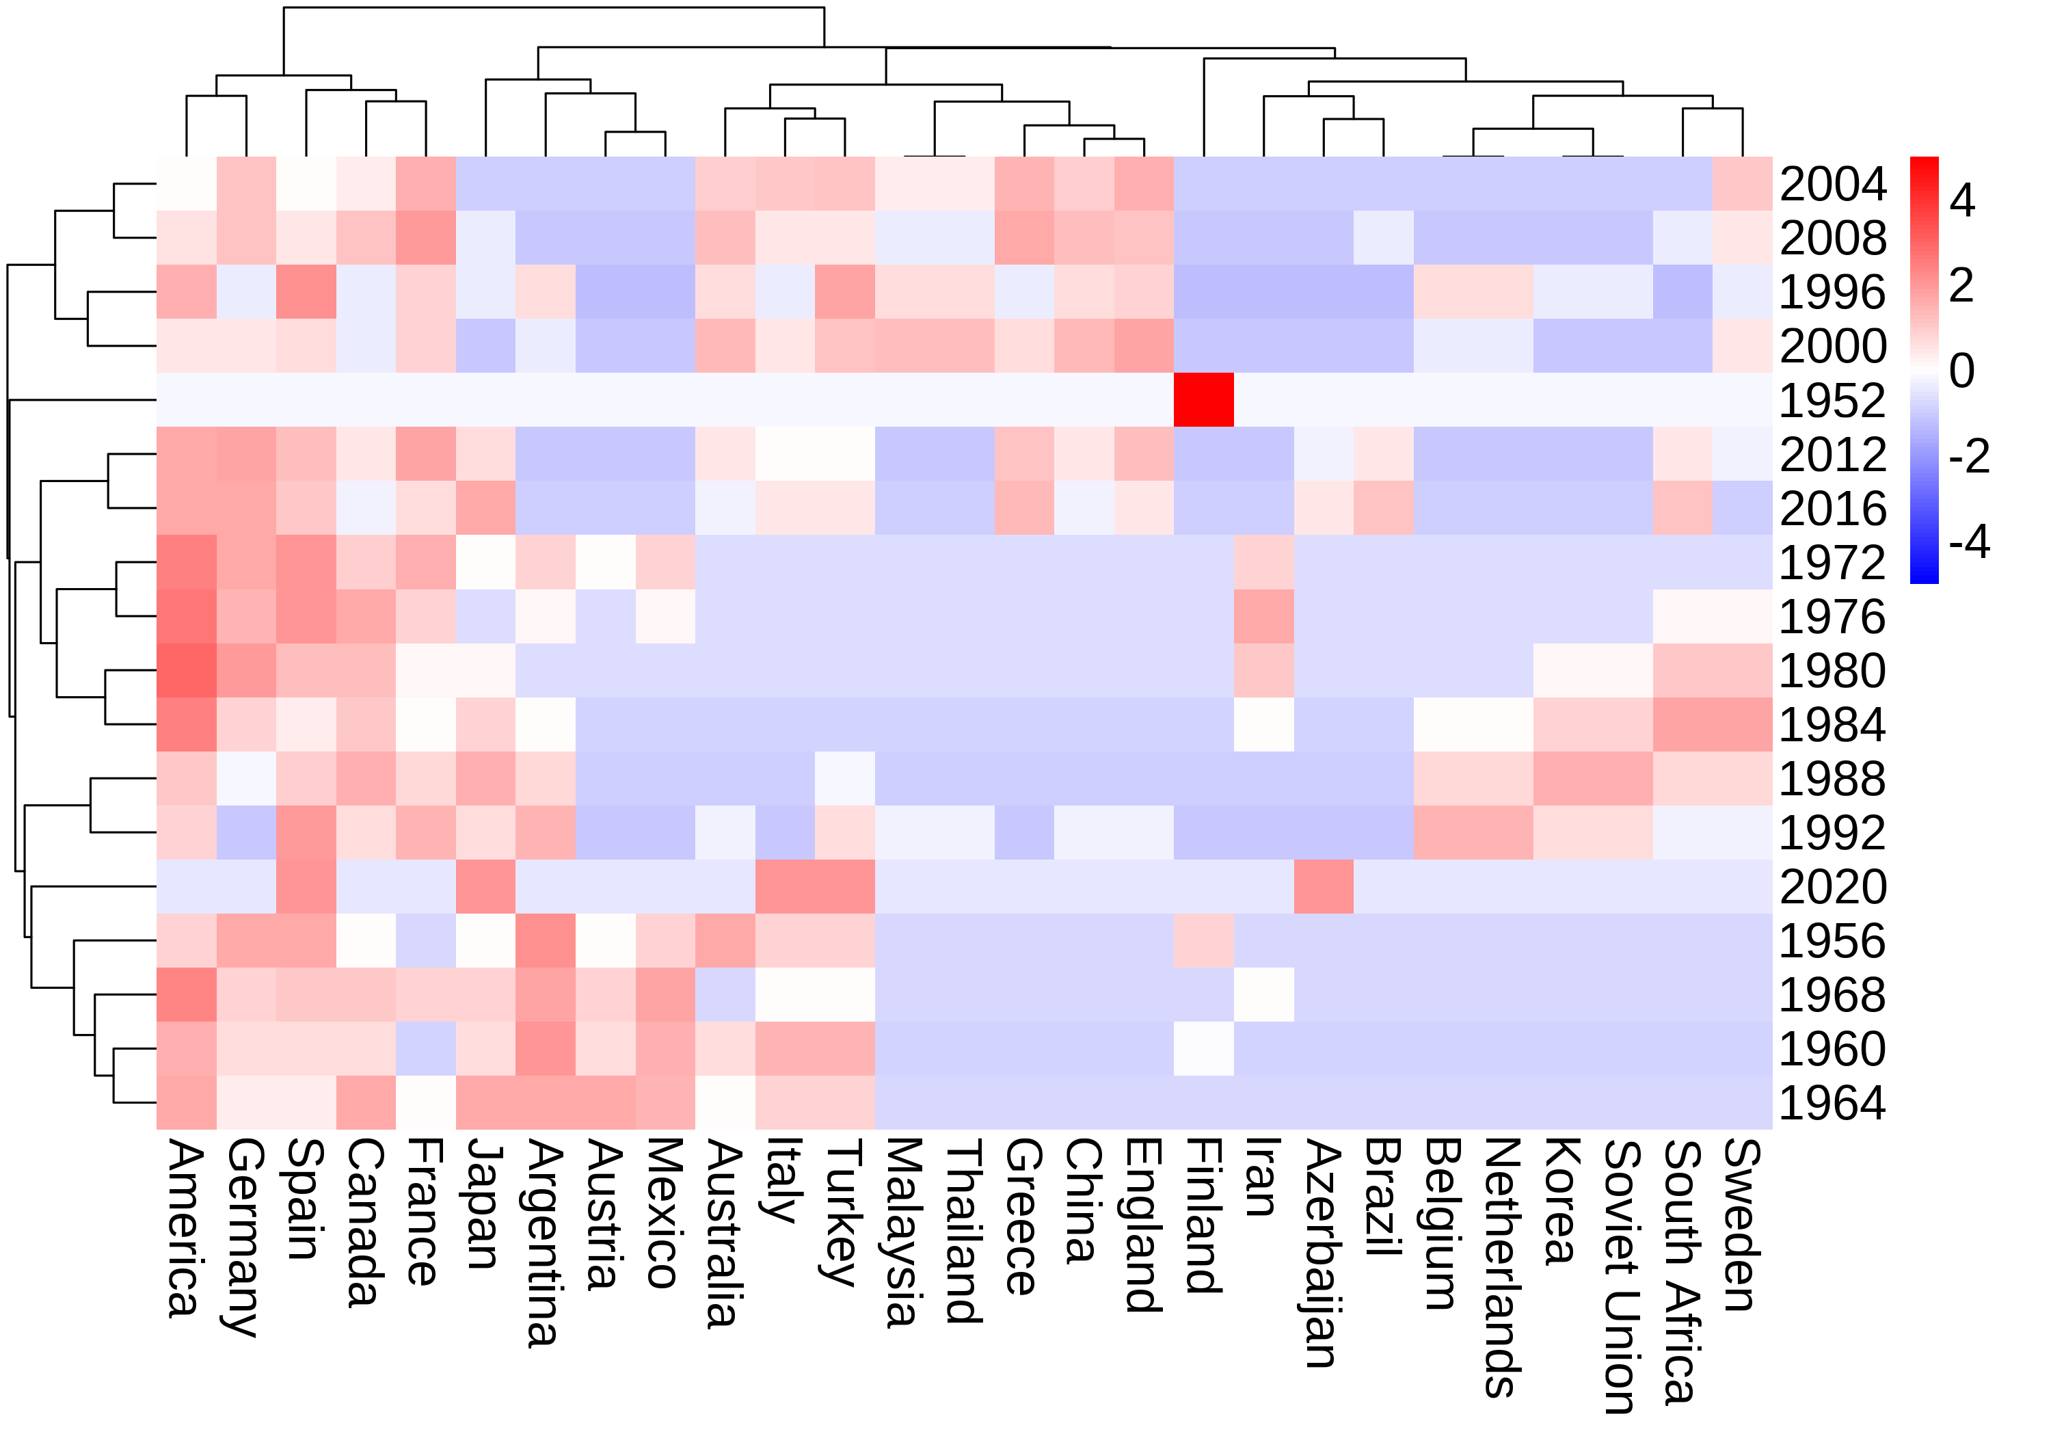

Figure Heat map of the willingness of countries bidding to host the Summer Olympics

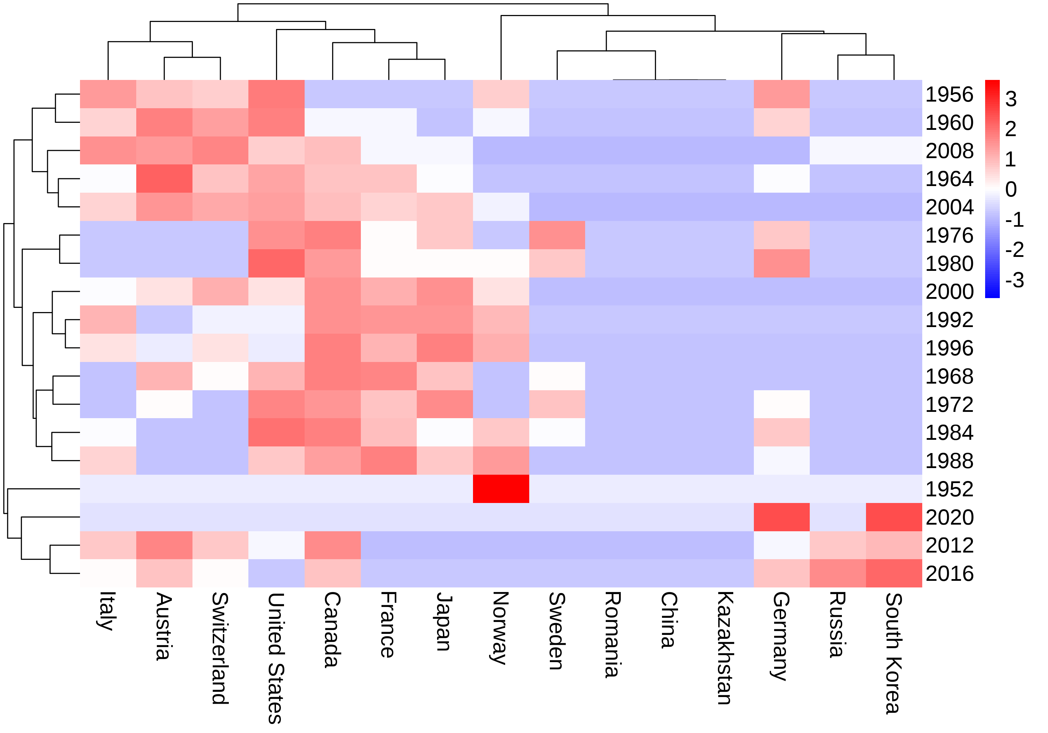

Figure Heat map of the willingness of countries bidding to host theWinter Olympics

To better understand the factors that influence a country's willingness to host the Olympic Games, we will group bidding countries into 4 categories. These categories will be determined based on each country's level of economic development, infrastructure capacity, political stability, and other relevant indicators.

We will then use clustering techniques to group countries with similar characteristics together within each category. For example, developed countries may be clustered based on their GDP per capita, infrastructure quality, and level of public support for hosting large-scale events. Developing countries may be grouped based on their population size, current levels of investment in infrastructure, and degree of political stability.

Finally, we will use factor analysis to determine the relative weight of each indicator in influencing a country's willingness to bid for the Olympics, taking into account potential interactions between different variables. This analysis will help us identify the key drivers of Olympic host country willingness, and provide insights into how different factors may evolve over time in shaping a country's decision to bid for the event.

## Clustering

Clustering analysis can be classified into two main categories: Q-type and R-type clustering, depending on the nature of the objects being grouped. Q-type clustering is used to group together samples that share common features or characteristics, and can provide a more nuanced and thorough understanding of the data than traditional qualitative classification methods.

Suppose each sample has  indicators, and the observed values are denoted by:



Each sample  can be seen as a point in an dimensional space. The distance between each sample can be used to measure their similarity or dissimilarity. The distances between samples must satisfy the following conditions:



When the distance does not satisfy the third condition in Equation (13), we use Euclidean distance instead:



## Clustering results

We have collected data on eight different indicators for all bidding countries over the past 70 years, including GDP per capita, national GDP, government expenditure, urbanization level, the proportion of exports in GDP, national happiness index, population size, and military spending as a percentage of GDP. Each year, we use clustering techniques to group all countries based on their performance across these indicators, taking into account the changing developmental status of different countries over time. Here are the clustering results for four different periods. To obtain the clustering results for a specific year, one simply needs to input the relevant indicator data for that year into the model.

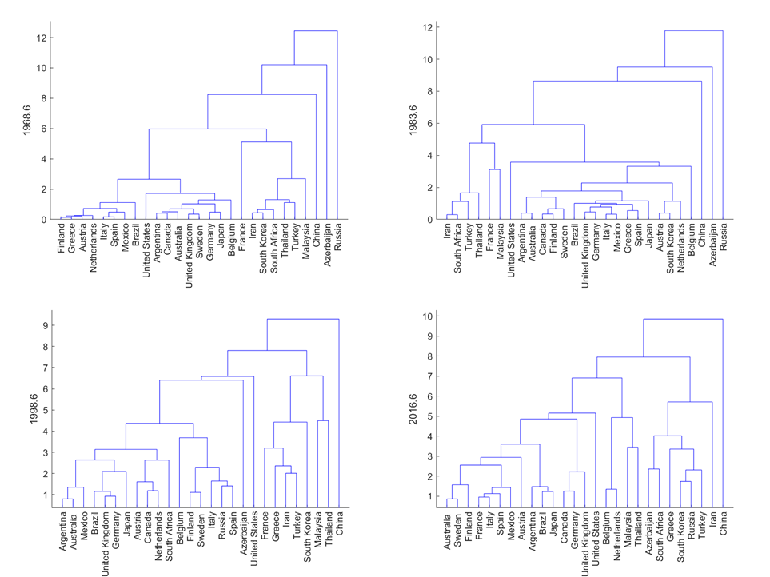

Figure Summer Olympic Games bid countries classification results dendgram

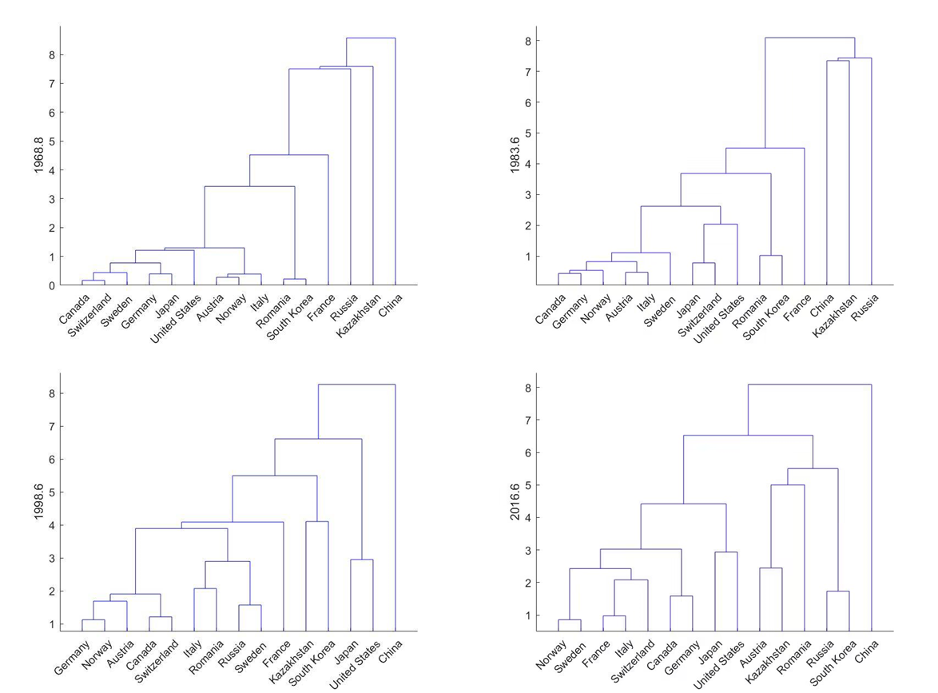

Figure Winter Olympic Games bid countries classification results dendgram

The heat map of willingness to bid over time for these four categories of countries is shown below:

***Clustering results for countries willing to bid for the Summer Olympics***

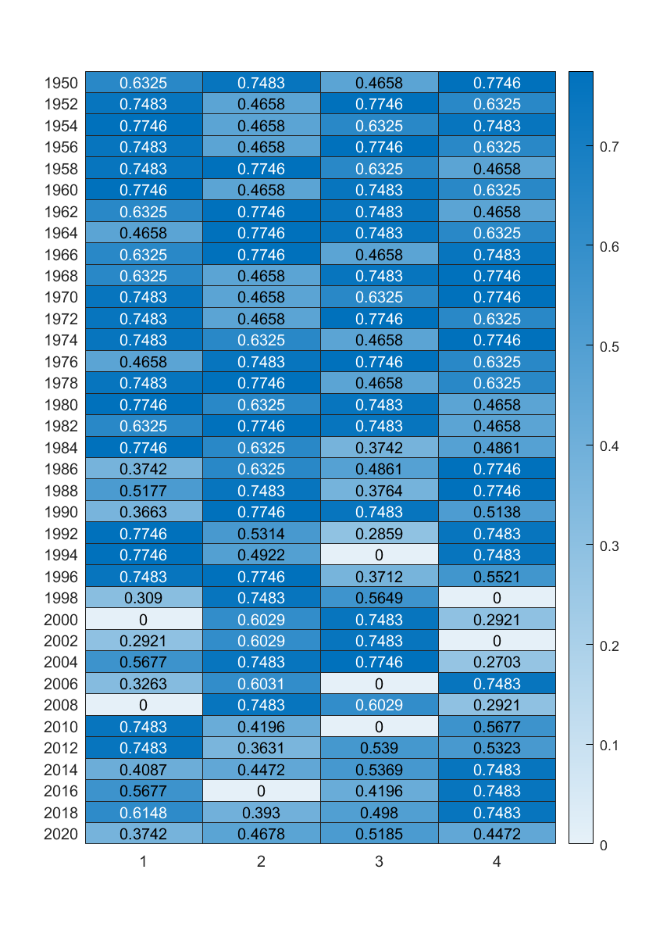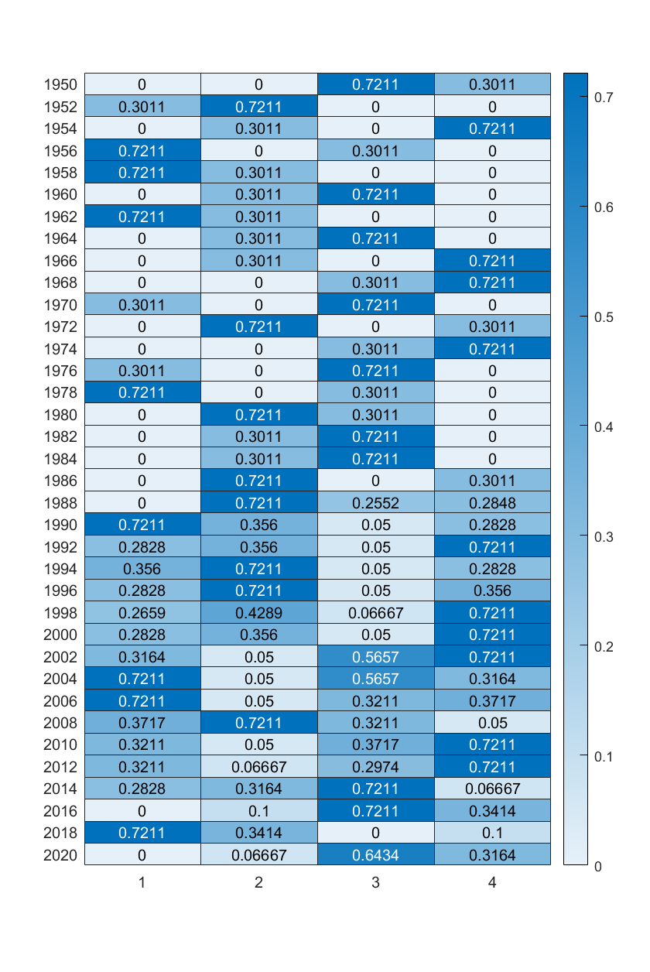

Summer Winter

## Factor Analysis

We have identified eight different indicators as key factors that impact a country's willingness to host the Olympic Games. These factors include GDP growth, per capita GDP growth, the perceived success of previous Olympic Games, urbanization level, scientific and cultural development, international status potential, national happiness index. To understand the relative importance of each of these factors on the final outcome, we will use factor analysis.

Factor analysis is a statistical technique used to study the underlying structure of a set of variables by extracting common factors from them. Common factors refer to the hidden factors that are intrinsic to different variables. The basic idea behind factor analysis is to group variables into different sets based on their inter-correlations, such that variables within each group have a high degree of correlation with each other, while variables in different groups are uncorrelated or have low correlation. Each group of variables represents a basic underlying structure, i.e., a common factor.



Figure Factor analysis flow chart

***STEP1*** The common factors in factor analysis are latent variables that cannot be directly observed but have an objective existence as shared underlying factors. Each variable can be expressed as a linear function of the common factors and an error term, i.e.,



In the above equation,  represents the common factors, and， represents the unique or specific factors of  . This model can be represented by matrices as:





Furthermore, the model has the following characteristics:

i:；

ii:，That is ,the common factors and unique or specific factors are uncorrelated with each other in factor analysis.

ii:，That is, each common factor is uncorrelated and has a variance of 1.

iv: The special factors are not correlated and the variances are not required to be equal.

The matrix in the model  is called the factor loading matrix and  is called the factor "loading" and is the loading of the -th variable on the - th factor. If the variable  is considered as a point in the  dimensional space, then  represents its projection on the coordinate axis.

***STEP2*** Solving for the factor loading matrix. We use the principal factor method to solve the factor loading matrix. The principal factor method is a modification of the principal component method, assuming that we first perform a normalized transformation of the variables. Then



Call  is the approximately correlated matrix, The elements on the diagonal are ,not ，and we assume that  is an estimate of  . Then we have:



***STEP3*** Rotation of the factor loading matrix. Let  be an  order orthogonal matrix such that ,then:



Since the factor loading matrix obtained in the previous subsection is not unique, in fact the new matrix obtained after the orthogonal transformation of the matrix can be regarded as the factor loading matrix.

When we obtain an estimate of the factor loading matrix, it is possible that multiple variables have large factor loadings on the same factor or that one variable has large loadings on multiple factors. This can make it difficult to interpret or name the factors. In this case, we may want to rotate the factor loading matrix to obtain a new, simplified matrix where the factor loadings are more distinct and easier to interpret.

***STEP4*** Calculating factor scores. After obtaining the factor loading matrix, sometimes we want to use the common factors for other studies, such as cluster analysis or regression analysis, when we want to estimate the common factors from the original variables, i.e., to obtain the factor scores.

For the model ，if the effect of the special factor is not considered, we can obtain，but the matrix is of order, and in the model we require ，usually the number of factors is much smaller than the number of variables, i.e.，so the loading matrix is not invertible and the estimation of  cannot be obtained directly, where we use the regression method for the estimation of the common factors.

## Results of Factor Analysis

For the convenience of presentation, we denote each of the eight indicators by the numbers 1-8 and derive their influence weights on willingness as shown in the following table:

表 7

|  |  |  |  |  |  |  |  |  |
| --- | --- | --- | --- | --- | --- | --- | --- | --- |
|  | 1 | 2 | 3 | 4 | 5 | 6 | 7 | 8 |
| Summer | 0.27 | 0.25 | 0.18 | 0.08 | 0.06 | 0.09 | 0.02 | 0.05 |
| Winter | 0.26 | 0.23 | 0.19 | 0.07 | 0.05 | 0.09 | 0.03 | 0.08 |

# Sensitivity analysis

## Model Validation

In order to verify the accuracy of the model, we selected the bidding countries for the 2024 Summer Olympics and the 2026 Winter Olympics and several randomly selected countries that did not bid to host the games, and assessed their willingness separately. The results show that the bidding countries for the 2024 Olympic Games: France and the United States have significantly higher willingness than several other countries. 2026 Winter Olympic Games presents the same results, which supports the validity of the model.

Figure Summer Olympics validation results Figure Winter Olympics validation results

## Sensitivity Analysis

We try to do sensitivity analysis with the example of Britain's bid to host the Summer Olympics in 1996, making eight indicators change by 10%, 20% and 50% respectively. The impact on the results corresponds to the weight of the indicator, i.e., the greater the weight the greater the impact on the results when the indicator is changed. The reasonableness of the model is proved.

Figure Sensitivity analysis results

# Model Evaluation and Further Discussion

Based on the various data collected, we developed a model of the success of holding the Olympic Games as well as a model of willingness. The models were analyzed for sensitivity and showed good performance

## Strengths

The selection of indicators used for model building is quite reasonable, taking into account multiple indicators from various perspectives that may affect the success and willingness of hosting the Olympics.

Sensitivity analysis was conducted on the model to verify its effectiveness under different circumstances.

The model was further validated for its validity by using data from countries bidding for the Olympics in the coming years.

## Possible Improvements

The number of indicators selected for the model construction is limited, and the impact of the Olympics as well as the perspectives considered by countries when evaluating whether to bid for the Olympics are complex and diverse. If more indicators are selected, the conclusions will be more comprehensive.

The data collected is limited, and if more data can be obtained, the accuracy of the results will be further improved.

# Conclusion

Based on the model developed earlier, the willingness to bid for the Olympics is influenced by a number of factors: GDP growth, per capita GDP growth, the perceived success of previous Olympic Games, urbanization level, scientific and cultural development, international status potential, national happiness index.

The influence weight of each indicator on the degree of willingness to bid is shown in section 5.5. It is easy to see that for both the Winter and Summer Olympics, the country's GDP has the greatest degree of influence on the degree of willingness to bid, and GDP per capita and the effect of the previous two Olympic Games are equally important. Therefore, it is possible to start from these perspectives.

i: Measures to help global economic recovery

ii: Improve livelihood protection and increase GDP per capita

iii: Improving the quality of each Olympic Games, creating a positive effect and attracting more countries to participate in hosting the Games

# Reference

1. D. E. KNUTH The TEXbook the American Mathematical Society and Addison-Wesley Publishing Company, 1984-1986.
2. Burgan B, Mules T 1992. Economic impact of sporting events. Annals of Tourism Research, 19 (4): 700–710. [Google Scholar]
3. Hall Jane [The Role of Chartered Physiotherapists in Olympic Sports](https://schlr.cnki.net/Detail/index/GARJ8099_1/SJESJ3F933CD7D619355634D66B5058AE7272)[J]  Physiotherapy, 1989, 75(12)
4. Relationship Between Total Rewards Perceptions and Work Engagement Among Chinese Kindergarten Teachers: Organizational Identification as a Mediator [J]. Ji Dongying;Cui Li. Frontiers in Psychology. 2021
5. Analysis of the Main Contradictions of Contemporary Sports Development and Its Solution Path[J]. Jie Yang. International Journal of Intelligent Information and Management Science. 2021(5)
6. Wei Min, Li Shuhao. Taking the Winter Olympics as an Opportunity to Assist the Transformation and Upgrade of the Tourism Industry in Beijing and Zhangjiakou: Action Path and Guarantee Mechanism [J]. Journal of Tourism, 2020,35 (04): 7-9. DOI: 10.19765/j.cnki.1002-5006.2020.04.004
7. Zhang Fuli Research on the Impact of the Winter Olympics on Zhangjiakou's Tourism Industry and Countermeasures [D]. Beijing Second Foreign Languages Institute, 2016
8. Wang Kefeng, Zhang Ce, Yang Jiankun. Study on the social benefit evaluation of hosting the Beijing Olympic Games [J]. Journal of Shenyang Institute of Physical Education, 2009,28(04):28-31

# Memo

**To**:IOC

**From**:Team#2330619

**Date**:2th April 2023

**Subject**: Suggestions on the hosting of the Olympic Games

Our team has conducted an in-depth analysis of various data from countries that have hosted previous Olympic Games and drawn a series of conclusions through various models. At the same time, we provide some targeted recommendations to promote the success of the Olympic Games and its implementation.

According to our findings, GDP and venue utilization are two types of indicators that have a relatively large impact on the hosting of the Olympic Games in the summer.In the Winter Olympics, economy and tourism are two categories of indicators that have a relatively large impact on the hosting of the Games.

Comprehensive above several major influencing factors, our team believes that in order to improve the enthusiasm of countries to declare the Olympic Games and promote the successful development and holding of the Olympic Games, the following aspects can be considered:

1. Provide better organization and guarantee: The organizers need to provide better and reliable guarantee in terms of venue construction, security, transportation, etc. to ensure that the Olympic Games can be held smoothly.

2. Reduce the economic burden: The organizers can reduce the economic burden of hosting the Olympics by simplifying the approval process, attracting more sponsors, and controlling the costs of preparing and holding the Olympics so that more countries can afford it.

3. Increase visibility: The organizers can increase the visibility and influence of the Olympic Games through publicity, promotion and marketing to attract more countries to participate in them.

4. Strengthen cooperation and communication: The organizers can strengthen cooperation and communication with governments, sports organizations and media to promote understanding and trust, and enhance friendship and cooperation among countries.

5. Promote sustainable development: The organizers should pay attention to environmental protection, social responsibility and sustainable economic development, encourage countries to share their experiences and practices, promote sustainable development, and increase the enthusiasm of countries to declare the Olympic Games.

Our team is confident in the above recommendations. First, all our data are based on previous Olympic Games, and all our analysis is targeted to solve the problem of declining enthusiasm to bid for the Olympic Games. Secondly, the model we built can fully explore the relationship and influence degree of each indicator with high accuracy. Finally, we have conducted model validation, which is very consistent with the reality and highly reliable.

We sincerely hope that our analysis results and suggestions can help you, and we thank you for your support and trust.