Aive Node Creatures
Single-Character 2D Rigging Prompts
70 source-specific prompts. Each prompt is intentionally short, literal, and image-generator-facing: one character, exact source style, exact scale, separated rigging pieces, no presentation filler.

Sheet 1 — 18281
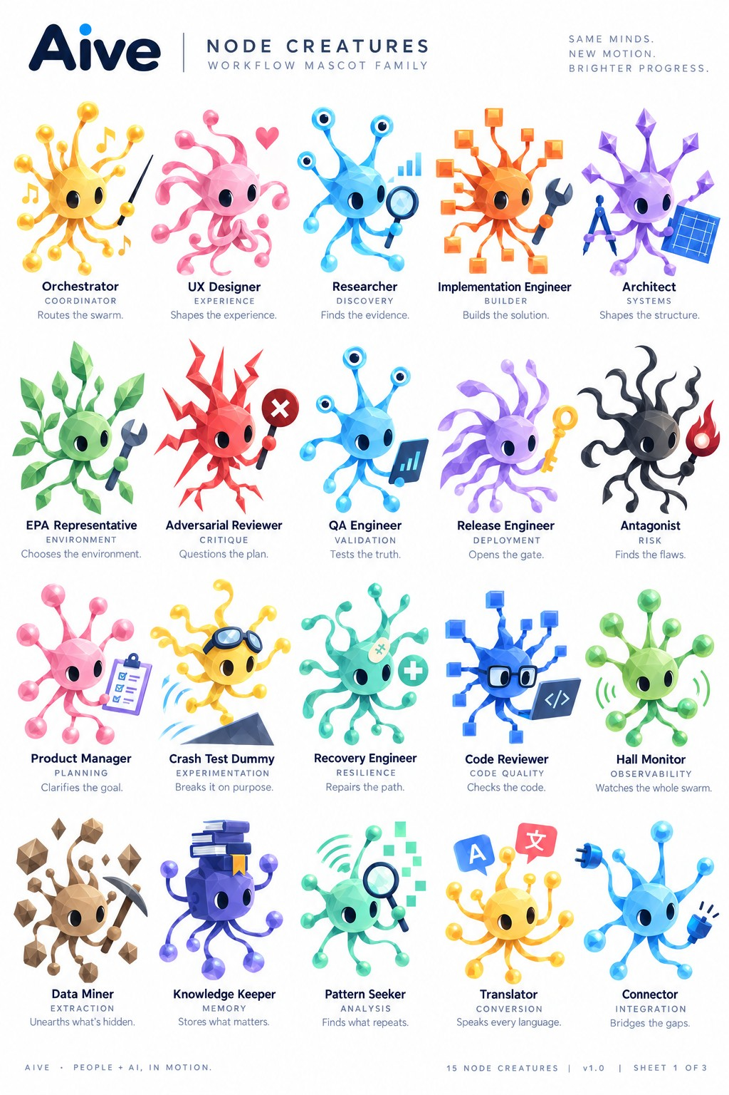
Reference sheet for the prompts below.

1. Orchestrator
Use ONLY the Orchestrator character in the attached reference. Create one transparent PNG sprite sheet containing only its actual 2D rigging pieces. Preserve the exact source-relative sizes, proportions, silhouettes, faceted/polygonal texture, colors, gradients, shading, highlights, translucency, and finish. Character-specific anatomy: yellow faceted spherical core; many long ball-ended tendrils; conductor baton; floating musical-note elements. Output the complete visible body/core at its real size; each actual eye white separately with NO pupil baked in; each pupil separately; upper and lower eyelids separately; every movable upper appendage as separate base, mid, and tip/terminal pieces; every lower gestation limb as separate base, mid, and bud-tip pieces; and each real prop/effect as its own asset. Do not invent alternate views, generic replacement anatomy, extra parts, labels, text, diagrams, or an assembled character. Do not enlarge small pieces or shrink the body for presentation. Keep unique body shapes unique. Use a transparent background with generous empty spacing so every part can be sliced by a rectangular bounding box without touching another asset.

2. UX Designer
Use ONLY the UX Designer character in the attached reference. Create one transparent PNG sprite sheet containing only its actual 2D rigging pieces. Preserve the exact source-relative sizes, proportions, silhouettes, faceted/polygonal texture, colors, gradients, shading, highlights, translucency, and finish. Character-specific anatomy: pink faceted rounded core; numerous soft curling ribbon-like tendrils; heart element. Output the complete visible body/core at its real size; each actual eye white separately with NO pupil baked in; each pupil separately; upper and lower eyelids separately; every movable upper appendage as separate base, mid, and tip/terminal pieces; every lower gestation limb as separate base, mid, and bud-tip pieces; and each real prop/effect as its own asset. Do not invent alternate views, generic replacement anatomy, extra parts, labels, text, diagrams, or an assembled character. Do not enlarge small pieces or shrink the body for presentation. Keep unique body shapes unique. Use a transparent background with generous empty spacing so every part can be sliced by a rectangular bounding box without touching another asset.

3. Researcher
Use ONLY the Researcher character in the attached reference. Create one transparent PNG sprite sheet containing only its actual 2D rigging pieces. Preserve the exact source-relative sizes, proportions, silhouettes, faceted/polygonal texture, colors, gradients, shading, highlights, translucency, and finish. Character-specific anatomy: cyan/blue faceted core; three eye-stalk terminals; additional curved limbs; magnifying glass; small bar-chart element. Output the complete visible body/core at its real size; each actual eye white separately with NO pupil baked in; each pupil separately; upper and lower eyelids separately; every movable upper appendage as separate base, mid, and tip/terminal pieces; every lower gestation limb as separate base, mid, and bud-tip pieces; and each real prop/effect as its own asset. Do not invent alternate views, generic replacement anatomy, extra parts, labels, text, diagrams, or an assembled character. Do not enlarge small pieces or shrink the body for presentation. Keep unique body shapes unique. Use a transparent background with generous empty spacing so every part can be sliced by a rectangular bounding box without touching another asset.

4. Implementation Engineer
Use ONLY the Implementation Engineer character in the attached reference. Create one transparent PNG sprite sheet containing only its actual 2D rigging pieces. Preserve the exact source-relative sizes, proportions, silhouettes, faceted/polygonal texture, colors, gradients, shading, highlights, translucency, and finish. Character-specific anatomy: orange faceted core; branching square/cube-ended appendages; dark wrench. Output the complete visible body/core at its real size; each actual eye white separately with NO pupil baked in; each pupil separately; upper and lower eyelids separately; every movable upper appendage as separate base, mid, and tip/terminal pieces; every lower gestation limb as separate base, mid, and bud-tip pieces; and each real prop/effect as its own asset. Do not invent alternate views, generic replacement anatomy, extra parts, labels, text, diagrams, or an assembled character. Do not enlarge small pieces or shrink the body for presentation. Keep unique body shapes unique. Use a transparent background with generous empty spacing so every part can be sliced by a rectangular bounding box without touching another asset.

5. Architect
Use ONLY the Architect character in the attached reference. Create one transparent PNG sprite sheet containing only its actual 2D rigging pieces. Preserve the exact source-relative sizes, proportions, silhouettes, faceted/polygonal texture, colors, gradients, shading, highlights, translucency, and finish. Character-specific anatomy: purple faceted core; pointed diamond/crystal-ended appendages; compass/divider tool; blue grid/blueprint. Output the complete visible body/core at its real size; each actual eye white separately with NO pupil baked in; each pupil separately; upper and lower eyelids separately; every movable upper appendage as separate base, mid, and tip/terminal pieces; every lower gestation limb as separate base, mid, and bud-tip pieces; and each real prop/effect as its own asset. Do not invent alternate views, generic replacement anatomy, extra parts, labels, text, diagrams, or an assembled character. Do not enlarge small pieces or shrink the body for presentation. Keep unique body shapes unique. Use a transparent background with generous empty spacing so every part can be sliced by a rectangular bounding box without touching another asset.

6. EPA Representative
Use ONLY the EPA Representative character in the attached reference. Create one transparent PNG sprite sheet containing only its actual 2D rigging pieces. Preserve the exact source-relative sizes, proportions, silhouettes, faceted/polygonal texture, colors, gradients, shading, highlights, translucency, and finish. Character-specific anatomy: green faceted core; plant-like limbs with leaf terminals and leaf clusters; dark wrench. Output the complete visible body/core at its real size; each actual eye white separately with NO pupil baked in; each pupil separately; upper and lower eyelids separately; every movable upper appendage as separate base, mid, and tip/terminal pieces; every lower gestation limb as separate base, mid, and bud-tip pieces; and each real prop/effect as its own asset. Do not invent alternate views, generic replacement anatomy, extra parts, labels, text, diagrams, or an assembled character. Do not enlarge small pieces or shrink the body for presentation. Keep unique body shapes unique. Use a transparent background with generous empty spacing so every part can be sliced by a rectangular bounding box without touching another asset.

7. Adversarial Reviewer
Use ONLY the Adversarial Reviewer character in the attached reference. Create one transparent PNG sprite sheet containing only its actual 2D rigging pieces. Preserve the exact source-relative sizes, proportions, silhouettes, faceted/polygonal texture, colors, gradients, shading, highlights, translucency, and finish. Character-specific anatomy: red sharply faceted spiked core; angular branching limbs; circular X-sign prop. Output the complete visible body/core at its real size; each actual eye white separately with NO pupil baked in; each pupil separately; upper and lower eyelids separately; every movable upper appendage as separate base, mid, and tip/terminal pieces; every lower gestation limb as separate base, mid, and bud-tip pieces; and each real prop/effect as its own asset. Do not invent alternate views, generic replacement anatomy, extra parts, labels, text, diagrams, or an assembled character. Do not enlarge small pieces or shrink the body for presentation. Keep unique body shapes unique. Use a transparent background with generous empty spacing so every part can be sliced by a rectangular bounding box without touching another asset.

8. QA Engineer
Use ONLY the QA Engineer character in the attached reference. Create one transparent PNG sprite sheet containing only its actual 2D rigging pieces. Preserve the exact source-relative sizes, proportions, silhouettes, faceted/polygonal texture, colors, gradients, shading, highlights, translucency, and finish. Character-specific anatomy: cyan/blue faceted core; multiple eye-stalks plus lower limbs; dark blue data/QA panel. Output the complete visible body/core at its real size; each actual eye white separately with NO pupil baked in; each pupil separately; upper and lower eyelids separately; every movable upper appendage as separate base, mid, and tip/terminal pieces; every lower gestation limb as separate base, mid, and bud-tip pieces; and each real prop/effect as its own asset. Do not invent alternate views, generic replacement anatomy, extra parts, labels, text, diagrams, or an assembled character. Do not enlarge small pieces or shrink the body for presentation. Keep unique body shapes unique. Use a transparent background with generous empty spacing so every part can be sliced by a rectangular bounding box without touching another asset.

9. Release Engineer
Use ONLY the Release Engineer character in the attached reference. Create one transparent PNG sprite sheet containing only its actual 2D rigging pieces. Preserve the exact source-relative sizes, proportions, silhouettes, faceted/polygonal texture, colors, gradients, shading, highlights, translucency, and finish. Character-specific anatomy: lavender faceted core; long flowing ribbon/tentacle appendages; gold key. Output the complete visible body/core at its real size; each actual eye white separately with NO pupil baked in; each pupil separately; upper and lower eyelids separately; every movable upper appendage as separate base, mid, and tip/terminal pieces; every lower gestation limb as separate base, mid, and bud-tip pieces; and each real prop/effect as its own asset. Do not invent alternate views, generic replacement anatomy, extra parts, labels, text, diagrams, or an assembled character. Do not enlarge small pieces or shrink the body for presentation. Keep unique body shapes unique. Use a transparent background with generous empty spacing so every part can be sliced by a rectangular bounding box without touching another asset.

10. Antagonist
Use ONLY the Antagonist character in the attached reference. Create one transparent PNG sprite sheet containing only its actual 2D rigging pieces. Preserve the exact source-relative sizes, proportions, silhouettes, faceted/polygonal texture, colors, gradients, shading, highlights, translucency, and finish. Character-specific anatomy: charcoal faceted core; many irregular black curling tendrils; red flame prop. Output the complete visible body/core at its real size; each actual eye white separately with NO pupil baked in; each pupil separately; upper and lower eyelids separately; every movable upper appendage as separate base, mid, and tip/terminal pieces; every lower gestation limb as separate base, mid, and bud-tip pieces; and each real prop/effect as its own asset. Do not invent alternate views, generic replacement anatomy, extra parts, labels, text, diagrams, or an assembled character. Do not enlarge small pieces or shrink the body for presentation. Keep unique body shapes unique. Use a transparent background with generous empty spacing so every part can be sliced by a rectangular bounding box without touching another asset.

11. Product Manager
Use ONLY the Product Manager character in the attached reference. Create one transparent PNG sprite sheet containing only its actual 2D rigging pieces. Preserve the exact source-relative sizes, proportions, silhouettes, faceted/polygonal texture, colors, gradients, shading, highlights, translucency, and finish. Character-specific anatomy: pink faceted spherical core; radial ball-ended tendrils; clipboard/checklist. Output the complete visible body/core at its real size; each actual eye white separately with NO pupil baked in; each pupil separately; upper and lower eyelids separately; every movable upper appendage as separate base, mid, and tip/terminal pieces; every lower gestation limb as separate base, mid, and bud-tip pieces; and each real prop/effect as its own asset. Do not invent alternate views, generic replacement anatomy, extra parts, labels, text, diagrams, or an assembled character. Do not enlarge small pieces or shrink the body for presentation. Keep unique body shapes unique. Use a transparent background with generous empty spacing so every part can be sliced by a rectangular bounding box without touching another asset.

12. Crash Test Dummy
Use ONLY the Crash Test Dummy character in the attached reference. Create one transparent PNG sprite sheet containing only its actual 2D rigging pieces. Preserve the exact source-relative sizes, proportions, silhouettes, faceted/polygonal texture, colors, gradients, shading, highlights, translucency, and finish. Character-specific anatomy: yellow faceted core; irregular curling tendrils; separate goggles; gray crash-ramp/wedge element. Output the complete visible body/core at its real size; each actual eye white separately with NO pupil baked in; each pupil separately; upper and lower eyelids separately; every movable upper appendage as separate base, mid, and tip/terminal pieces; every lower gestation limb as separate base, mid, and bud-tip pieces; and each real prop/effect as its own asset. Do not invent alternate views, generic replacement anatomy, extra parts, labels, text, diagrams, or an assembled character. Do not enlarge small pieces or shrink the body for presentation. Keep unique body shapes unique. Use a transparent background with generous empty spacing so every part can be sliced by a rectangular bounding box without touching another asset.

13. Recovery Engineer
Use ONLY the Recovery Engineer character in the attached reference. Create one transparent PNG sprite sheet containing only its actual 2D rigging pieces. Preserve the exact source-relative sizes, proportions, silhouettes, faceted/polygonal texture, colors, gradients, shading, highlights, translucency, and finish. Character-specific anatomy: teal faceted core; many irregular curling tendrils; small bandage detail; green medical-plus disc. Output the complete visible body/core at its real size; each actual eye white separately with NO pupil baked in; each pupil separately; upper and lower eyelids separately; every movable upper appendage as separate base, mid, and tip/terminal pieces; every lower gestation limb as separate base, mid, and bud-tip pieces; and each real prop/effect as its own asset. Do not invent alternate views, generic replacement anatomy, extra parts, labels, text, diagrams, or an assembled character. Do not enlarge small pieces or shrink the body for presentation. Keep unique body shapes unique. Use a transparent background with generous empty spacing so every part can be sliced by a rectangular bounding box without touching another asset.

14. Code Reviewer
Use ONLY the Code Reviewer character in the attached reference. Create one transparent PNG sprite sheet containing only its actual 2D rigging pieces. Preserve the exact source-relative sizes, proportions, silhouettes, faceted/polygonal texture, colors, gradients, shading, highlights, translucency, and finish. Character-specific anatomy: blue faceted core; branching square-ended appendages; separate black glasses; dark code panel. Output the complete visible body/core at its real size; each actual eye white separately with NO pupil baked in; each pupil separately; upper and lower eyelids separately; every movable upper appendage as separate base, mid, and tip/terminal pieces; every lower gestation limb as separate base, mid, and bud-tip pieces; and each real prop/effect as its own asset. Do not invent alternate views, generic replacement anatomy, extra parts, labels, text, diagrams, or an assembled character. Do not enlarge small pieces or shrink the body for presentation. Keep unique body shapes unique. Use a transparent background with generous empty spacing so every part can be sliced by a rectangular bounding box without touching another asset.

15. Hall Monitor
Use ONLY the Hall Monitor character in the attached reference. Create one transparent PNG sprite sheet containing only its actual 2D rigging pieces. Preserve the exact source-relative sizes, proportions, silhouettes, faceted/polygonal texture, colors, gradients, shading, highlights, translucency, and finish. Character-specific anatomy: green faceted core; radial ball-ended tendrils; green wireless/signal wave effects. Output the complete visible body/core at its real size; each actual eye white separately with NO pupil baked in; each pupil separately; upper and lower eyelids separately; every movable upper appendage as separate base, mid, and tip/terminal pieces; every lower gestation limb as separate base, mid, and bud-tip pieces; and each real prop/effect as its own asset. Do not invent alternate views, generic replacement anatomy, extra parts, labels, text, diagrams, or an assembled character. Do not enlarge small pieces or shrink the body for presentation. Keep unique body shapes unique. Use a transparent background with generous empty spacing so every part can be sliced by a rectangular bounding box without touching another asset.

16. Data Miner — Sheet 1 variant
Use ONLY the Data Miner — Sheet 1 variant character in the attached reference. Create one transparent PNG sprite sheet containing only its actual 2D rigging pieces. Preserve the exact source-relative sizes, proportions, silhouettes, faceted/polygonal texture, colors, gradients, shading, highlights, translucency, and finish. Character-specific anatomy: brown faceted spherical core; brown ball/cube-ended limbs; dark pickaxe; floating brown rock/crystal chunks. Output the complete visible body/core at its real size; each actual eye white separately with NO pupil baked in; each pupil separately; upper and lower eyelids separately; every movable upper appendage as separate base, mid, and tip/terminal pieces; every lower gestation limb as separate base, mid, and bud-tip pieces; and each real prop/effect as its own asset. Do not invent alternate views, generic replacement anatomy, extra parts, labels, text, diagrams, or an assembled character. Do not enlarge small pieces or shrink the body for presentation. Keep unique body shapes unique. Use a transparent background with generous empty spacing so every part can be sliced by a rectangular bounding box without touching another asset.

17. Knowledge Keeper — Sheet 1 variant
Use ONLY the Knowledge Keeper — Sheet 1 variant character in the attached reference. Create one transparent PNG sprite sheet containing only its actual 2D rigging pieces. Preserve the exact source-relative sizes, proportions, silhouettes, faceted/polygonal texture, colors, gradients, shading, highlights, translucency, and finish. Character-specific anatomy: deep purple faceted core; books stacked directly above/on the body; purple ball-ended limbs. Output the complete visible body/core at its real size; each actual eye white separately with NO pupil baked in; each pupil separately; upper and lower eyelids separately; every movable upper appendage as separate base, mid, and tip/terminal pieces; every lower gestation limb as separate base, mid, and bud-tip pieces; and each real prop/effect as its own asset. Do not invent alternate views, generic replacement anatomy, extra parts, labels, text, diagrams, or an assembled character. Do not enlarge small pieces or shrink the body for presentation. Keep unique body shapes unique. Use a transparent background with generous empty spacing so every part can be sliced by a rectangular bounding box without touching another asset.

18. Pattern Seeker — Sheet 1 variant
Use ONLY the Pattern Seeker — Sheet 1 variant character in the attached reference. Create one transparent PNG sprite sheet containing only its actual 2D rigging pieces. Preserve the exact source-relative sizes, proportions, silhouettes, faceted/polygonal texture, colors, gradients, shading, highlights, translucency, and finish. Character-specific anatomy: mint/teal faceted spherical core; ball-ended tendrils; magnifying glass; floating mint square/cube pattern elements. Output the complete visible body/core at its real size; each actual eye white separately with NO pupil baked in; each pupil separately; upper and lower eyelids separately; every movable upper appendage as separate base, mid, and tip/terminal pieces; every lower gestation limb as separate base, mid, and bud-tip pieces; and each real prop/effect as its own asset. Do not invent alternate views, generic replacement anatomy, extra parts, labels, text, diagrams, or an assembled character. Do not enlarge small pieces or shrink the body for presentation. Keep unique body shapes unique. Use a transparent background with generous empty spacing so every part can be sliced by a rectangular bounding box without touching another asset.

19. Translator — Sheet 1 variant
Use ONLY the Translator — Sheet 1 variant character in the attached reference. Create one transparent PNG sprite sheet containing only its actual 2D rigging pieces. Preserve the exact source-relative sizes, proportions, silhouettes, faceted/polygonal texture, colors, gradients, shading, highlights, translucency, and finish. Character-specific anatomy: yellow/orange faceted spherical core; ball-ended tendrils; blue A language panel and red character-language panel. Output the complete visible body/core at its real size; each actual eye white separately with NO pupil baked in; each pupil separately; upper and lower eyelids separately; every movable upper appendage as separate base, mid, and tip/terminal pieces; every lower gestation limb as separate base, mid, and bud-tip pieces; and each real prop/effect as its own asset. Do not invent alternate views, generic replacement anatomy, extra parts, labels, text, diagrams, or an assembled character. Do not enlarge small pieces or shrink the body for presentation. Keep unique body shapes unique. Use a transparent background with generous empty spacing so every part can be sliced by a rectangular bounding box without touching another asset.

20. Connector — Sheet 1 variant
Use ONLY the Connector — Sheet 1 variant character in the attached reference. Create one transparent PNG sprite sheet containing only its actual 2D rigging pieces. Preserve the exact source-relative sizes, proportions, silhouettes, faceted/polygonal texture, colors, gradients, shading, highlights, translucency, and finish. Character-specific anatomy: bright blue faceted spherical core; long blue ball-ended tendrils; blue electrical plug/connector terminal and cable. Output the complete visible body/core at its real size; each actual eye white separately with NO pupil baked in; each pupil separately; upper and lower eyelids separately; every movable upper appendage as separate base, mid, and tip/terminal pieces; every lower gestation limb as separate base, mid, and bud-tip pieces; and each real prop/effect as its own asset. Do not invent alternate views, generic replacement anatomy, extra parts, labels, text, diagrams, or an assembled character. Do not enlarge small pieces or shrink the body for presentation. Keep unique body shapes unique. Use a transparent background with generous empty spacing so every part can be sliced by a rectangular bounding box without touching another asset.

Sheet 2 — 18282
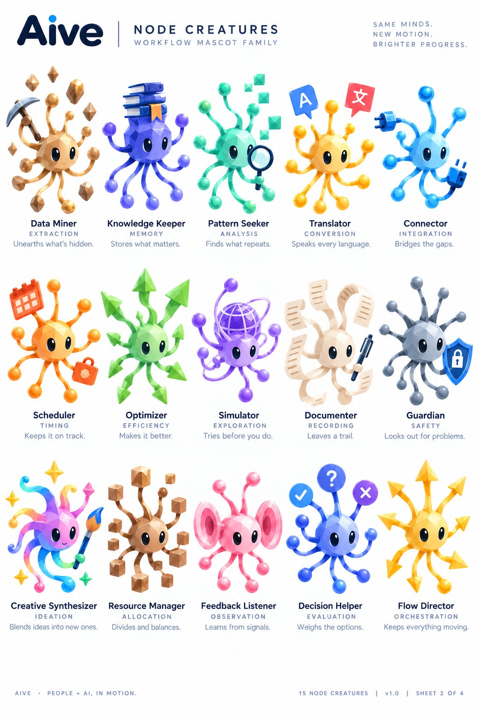
Reference sheet for the prompts below.

21. Data Miner — Sheet 2 variant
Use ONLY the Data Miner — Sheet 2 variant character in the attached reference. Create one transparent PNG sprite sheet containing only its actual 2D rigging pieces. Preserve the exact source-relative sizes, proportions, silhouettes, faceted/polygonal texture, colors, gradients, shading, highlights, translucency, and finish. Character-specific anatomy: tan/brown faceted spherical core; brown ball/cube-ended limbs; pickaxe; floating brown rock/crystal chunks. Output the complete visible body/core at its real size; each actual eye white separately with NO pupil baked in; each pupil separately; upper and lower eyelids separately; every movable upper appendage as separate base, mid, and tip/terminal pieces; every lower gestation limb as separate base, mid, and bud-tip pieces; and each real prop/effect as its own asset. Do not invent alternate views, generic replacement anatomy, extra parts, labels, text, diagrams, or an assembled character. Do not enlarge small pieces or shrink the body for presentation. Keep unique body shapes unique. Use a transparent background with generous empty spacing so every part can be sliced by a rectangular bounding box without touching another asset.

22. Knowledge Keeper — Sheet 2 variant
Use ONLY the Knowledge Keeper — Sheet 2 variant character in the attached reference. Create one transparent PNG sprite sheet containing only its actual 2D rigging pieces. Preserve the exact source-relative sizes, proportions, silhouettes, faceted/polygonal texture, colors, gradients, shading, highlights, translucency, and finish. Character-specific anatomy: indigo/purple faceted core; stack of blue/purple books mounted above body; purple ball-ended tendrils. Output the complete visible body/core at its real size; each actual eye white separately with NO pupil baked in; each pupil separately; upper and lower eyelids separately; every movable upper appendage as separate base, mid, and tip/terminal pieces; every lower gestation limb as separate base, mid, and bud-tip pieces; and each real prop/effect as its own asset. Do not invent alternate views, generic replacement anatomy, extra parts, labels, text, diagrams, or an assembled character. Do not enlarge small pieces or shrink the body for presentation. Keep unique body shapes unique. Use a transparent background with generous empty spacing so every part can be sliced by a rectangular bounding box without touching another asset.

23. Pattern Seeker — Sheet 2 variant
Use ONLY the Pattern Seeker — Sheet 2 variant character in the attached reference. Create one transparent PNG sprite sheet containing only its actual 2D rigging pieces. Preserve the exact source-relative sizes, proportions, silhouettes, faceted/polygonal texture, colors, gradients, shading, highlights, translucency, and finish. Character-specific anatomy: mint/green faceted spherical core; ball-ended tendrils; magnifying glass; floating teal cubes. Output the complete visible body/core at its real size; each actual eye white separately with NO pupil baked in; each pupil separately; upper and lower eyelids separately; every movable upper appendage as separate base, mid, and tip/terminal pieces; every lower gestation limb as separate base, mid, and bud-tip pieces; and each real prop/effect as its own asset. Do not invent alternate views, generic replacement anatomy, extra parts, labels, text, diagrams, or an assembled character. Do not enlarge small pieces or shrink the body for presentation. Keep unique body shapes unique. Use a transparent background with generous empty spacing so every part can be sliced by a rectangular bounding box without touching another asset.

24. Translator — Sheet 2 variant
Use ONLY the Translator — Sheet 2 variant character in the attached reference. Create one transparent PNG sprite sheet containing only its actual 2D rigging pieces. Preserve the exact source-relative sizes, proportions, silhouettes, faceted/polygonal texture, colors, gradients, shading, highlights, translucency, and finish. Character-specific anatomy: gold/yellow faceted spherical core; ball-ended tendrils; separate blue A panel and red language-character panel. Output the complete visible body/core at its real size; each actual eye white separately with NO pupil baked in; each pupil separately; upper and lower eyelids separately; every movable upper appendage as separate base, mid, and tip/terminal pieces; every lower gestation limb as separate base, mid, and bud-tip pieces; and each real prop/effect as its own asset. Do not invent alternate views, generic replacement anatomy, extra parts, labels, text, diagrams, or an assembled character. Do not enlarge small pieces or shrink the body for presentation. Keep unique body shapes unique. Use a transparent background with generous empty spacing so every part can be sliced by a rectangular bounding box without touching another asset.

25. Connector — Sheet 2 variant
Use ONLY the Connector — Sheet 2 variant character in the attached reference. Create one transparent PNG sprite sheet containing only its actual 2D rigging pieces. Preserve the exact source-relative sizes, proportions, silhouettes, faceted/polygonal texture, colors, gradients, shading, highlights, translucency, and finish. Character-specific anatomy: light-blue faceted spherical core; several blue tendrils; plug and socket/connector elements. Output the complete visible body/core at its real size; each actual eye white separately with NO pupil baked in; each pupil separately; upper and lower eyelids separately; every movable upper appendage as separate base, mid, and tip/terminal pieces; every lower gestation limb as separate base, mid, and bud-tip pieces; and each real prop/effect as its own asset. Do not invent alternate views, generic replacement anatomy, extra parts, labels, text, diagrams, or an assembled character. Do not enlarge small pieces or shrink the body for presentation. Keep unique body shapes unique. Use a transparent background with generous empty spacing so every part can be sliced by a rectangular bounding box without touching another asset.

26. Scheduler — Sheet 2 variant
Use ONLY the Scheduler — Sheet 2 variant character in the attached reference. Create one transparent PNG sprite sheet containing only its actual 2D rigging pieces. Preserve the exact source-relative sizes, proportions, silhouettes, faceted/polygonal texture, colors, gradients, shading, highlights, translucency, and finish. Character-specific anatomy: orange/yellow faceted spherical core; ball-ended tendrils; orange calendar prop; orange lock/bag-like secondary prop. Output the complete visible body/core at its real size; each actual eye white separately with NO pupil baked in; each pupil separately; upper and lower eyelids separately; every movable upper appendage as separate base, mid, and tip/terminal pieces; every lower gestation limb as separate base, mid, and bud-tip pieces; and each real prop/effect as its own asset. Do not invent alternate views, generic replacement anatomy, extra parts, labels, text, diagrams, or an assembled character. Do not enlarge small pieces or shrink the body for presentation. Keep unique body shapes unique. Use a transparent background with generous empty spacing so every part can be sliced by a rectangular bounding box without touching another asset.

27. Optimizer — Sheet 2 variant
Use ONLY the Optimizer — Sheet 2 variant character in the attached reference. Create one transparent PNG sprite sheet containing only its actual 2D rigging pieces. Preserve the exact source-relative sizes, proportions, silhouettes, faceted/polygonal texture, colors, gradients, shading, highlights, translucency, and finish. Character-specific anatomy: green faceted spherical core; multiple leaf/arrow-like pointed terminals on appendages. Output the complete visible body/core at its real size; each actual eye white separately with NO pupil baked in; each pupil separately; upper and lower eyelids separately; every movable upper appendage as separate base, mid, and tip/terminal pieces; every lower gestation limb as separate base, mid, and bud-tip pieces; and each real prop/effect as its own asset. Do not invent alternate views, generic replacement anatomy, extra parts, labels, text, diagrams, or an assembled character. Do not enlarge small pieces or shrink the body for presentation. Keep unique body shapes unique. Use a transparent background with generous empty spacing so every part can be sliced by a rectangular bounding box without touching another asset.

28. Simulator
Use ONLY the Simulator character in the attached reference. Create one transparent PNG sprite sheet containing only its actual 2D rigging pieces. Preserve the exact source-relative sizes, proportions, silhouettes, faceted/polygonal texture, colors, gradients, shading, highlights, translucency, and finish. Character-specific anatomy: purple faceted spherical core; several ball-ended tendrils; orbital wireframe/globe cage around and above body. Output the complete visible body/core at its real size; each actual eye white separately with NO pupil baked in; each pupil separately; upper and lower eyelids separately; every movable upper appendage as separate base, mid, and tip/terminal pieces; every lower gestation limb as separate base, mid, and bud-tip pieces; and each real prop/effect as its own asset. Do not invent alternate views, generic replacement anatomy, extra parts, labels, text, diagrams, or an assembled character. Do not enlarge small pieces or shrink the body for presentation. Keep unique body shapes unique. Use a transparent background with generous empty spacing so every part can be sliced by a rectangular bounding box without touching another asset.

29. Documenter
Use ONLY the Documenter character in the attached reference. Create one transparent PNG sprite sheet containing only its actual 2D rigging pieces. Preserve the exact source-relative sizes, proportions, silhouettes, faceted/polygonal texture, colors, gradients, shading, highlights, translucency, and finish. Character-specific anatomy: cream faceted spherical core; curled paper/page appendages surrounding body; dark pen. Output the complete visible body/core at its real size; each actual eye white separately with NO pupil baked in; each pupil separately; upper and lower eyelids separately; every movable upper appendage as separate base, mid, and tip/terminal pieces; every lower gestation limb as separate base, mid, and bud-tip pieces; and each real prop/effect as its own asset. Do not invent alternate views, generic replacement anatomy, extra parts, labels, text, diagrams, or an assembled character. Do not enlarge small pieces or shrink the body for presentation. Keep unique body shapes unique. Use a transparent background with generous empty spacing so every part can be sliced by a rectangular bounding box without touching another asset.

30. Guardian
Use ONLY the Guardian character in the attached reference. Create one transparent PNG sprite sheet containing only its actual 2D rigging pieces. Preserve the exact source-relative sizes, proportions, silhouettes, faceted/polygonal texture, colors, gradients, shading, highlights, translucency, and finish. Character-specific anatomy: gray faceted spherical core; radial gray ball-ended tendrils; blue shield with lock. Output the complete visible body/core at its real size; each actual eye white separately with NO pupil baked in; each pupil separately; upper and lower eyelids separately; every movable upper appendage as separate base, mid, and tip/terminal pieces; every lower gestation limb as separate base, mid, and bud-tip pieces; and each real prop/effect as its own asset. Do not invent alternate views, generic replacement anatomy, extra parts, labels, text, diagrams, or an assembled character. Do not enlarge small pieces or shrink the body for presentation. Keep unique body shapes unique. Use a transparent background with generous empty spacing so every part can be sliced by a rectangular bounding box without touching another asset.

31. Creative Synthesizer
Use ONLY the Creative Synthesizer character in the attached reference. Create one transparent PNG sprite sheet containing only its actual 2D rigging pieces. Preserve the exact source-relative sizes, proportions, silhouettes, faceted/polygonal texture, colors, gradients, shading, highlights, translucency, and finish. Character-specific anatomy: pink faceted core with multicolor rainbow curling tendrils; paintbrush; small sparkle/star elements. Output the complete visible body/core at its real size; each actual eye white separately with NO pupil baked in; each pupil separately; upper and lower eyelids separately; every movable upper appendage as separate base, mid, and tip/terminal pieces; every lower gestation limb as separate base, mid, and bud-tip pieces; and each real prop/effect as its own asset. Do not invent alternate views, generic replacement anatomy, extra parts, labels, text, diagrams, or an assembled character. Do not enlarge small pieces or shrink the body for presentation. Keep unique body shapes unique. Use a transparent background with generous empty spacing so every part can be sliced by a rectangular bounding box without touching another asset.

32. Resource Manager — Sheet 2 variant
Use ONLY the Resource Manager — Sheet 2 variant character in the attached reference. Create one transparent PNG sprite sheet containing only its actual 2D rigging pieces. Preserve the exact source-relative sizes, proportions, silhouettes, faceted/polygonal texture, colors, gradients, shading, highlights, translucency, and finish. Character-specific anatomy: brown faceted spherical core; branching appendages ending in brown cubes; additional floating brown cubes. Output the complete visible body/core at its real size; each actual eye white separately with NO pupil baked in; each pupil separately; upper and lower eyelids separately; every movable upper appendage as separate base, mid, and tip/terminal pieces; every lower gestation limb as separate base, mid, and bud-tip pieces; and each real prop/effect as its own asset. Do not invent alternate views, generic replacement anatomy, extra parts, labels, text, diagrams, or an assembled character. Do not enlarge small pieces or shrink the body for presentation. Keep unique body shapes unique. Use a transparent background with generous empty spacing so every part can be sliced by a rectangular bounding box without touching another asset.

33. Feedback Listener
Use ONLY the Feedback Listener character in the attached reference. Create one transparent PNG sprite sheet containing only its actual 2D rigging pieces. Preserve the exact source-relative sizes, proportions, silhouettes, faceted/polygonal texture, colors, gradients, shading, highlights, translucency, and finish. Character-specific anatomy: pink faceted spherical core; two large concentric ear/disc structures at left and right; small pink ball-ended limbs. Output the complete visible body/core at its real size; each actual eye white separately with NO pupil baked in; each pupil separately; upper and lower eyelids separately; every movable upper appendage as separate base, mid, and tip/terminal pieces; every lower gestation limb as separate base, mid, and bud-tip pieces; and each real prop/effect as its own asset. Do not invent alternate views, generic replacement anatomy, extra parts, labels, text, diagrams, or an assembled character. Do not enlarge small pieces or shrink the body for presentation. Keep unique body shapes unique. Use a transparent background with generous empty spacing so every part can be sliced by a rectangular bounding box without touching another asset.

34. Decision Helper
Use ONLY the Decision Helper character in the attached reference. Create one transparent PNG sprite sheet containing only its actual 2D rigging pieces. Preserve the exact source-relative sizes, proportions, silhouettes, faceted/polygonal texture, colors, gradients, shading, highlights, translucency, and finish. Character-specific anatomy: blue faceted spherical core; radial tendrils; top terminal discs showing checkmark, question mark, and X. Output the complete visible body/core at its real size; each actual eye white separately with NO pupil baked in; each pupil separately; upper and lower eyelids separately; every movable upper appendage as separate base, mid, and tip/terminal pieces; every lower gestation limb as separate base, mid, and bud-tip pieces; and each real prop/effect as its own asset. Do not invent alternate views, generic replacement anatomy, extra parts, labels, text, diagrams, or an assembled character. Do not enlarge small pieces or shrink the body for presentation. Keep unique body shapes unique. Use a transparent background with generous empty spacing so every part can be sliced by a rectangular bounding box without touching another asset.

35. Flow Director
Use ONLY the Flow Director character in the attached reference. Create one transparent PNG sprite sheet containing only its actual 2D rigging pieces. Preserve the exact source-relative sizes, proportions, silhouettes, faceted/polygonal texture, colors, gradients, shading, highlights, translucency, and finish. Character-specific anatomy: yellow faceted spherical core; numerous appendages ending in large faceted arrowheads. Output the complete visible body/core at its real size; each actual eye white separately with NO pupil baked in; each pupil separately; upper and lower eyelids separately; every movable upper appendage as separate base, mid, and tip/terminal pieces; every lower gestation limb as separate base, mid, and bud-tip pieces; and each real prop/effect as its own asset. Do not invent alternate views, generic replacement anatomy, extra parts, labels, text, diagrams, or an assembled character. Do not enlarge small pieces or shrink the body for presentation. Keep unique body shapes unique. Use a transparent background with generous empty spacing so every part can be sliced by a rectangular bounding box without touching another asset.

Sheet 3 — 18284
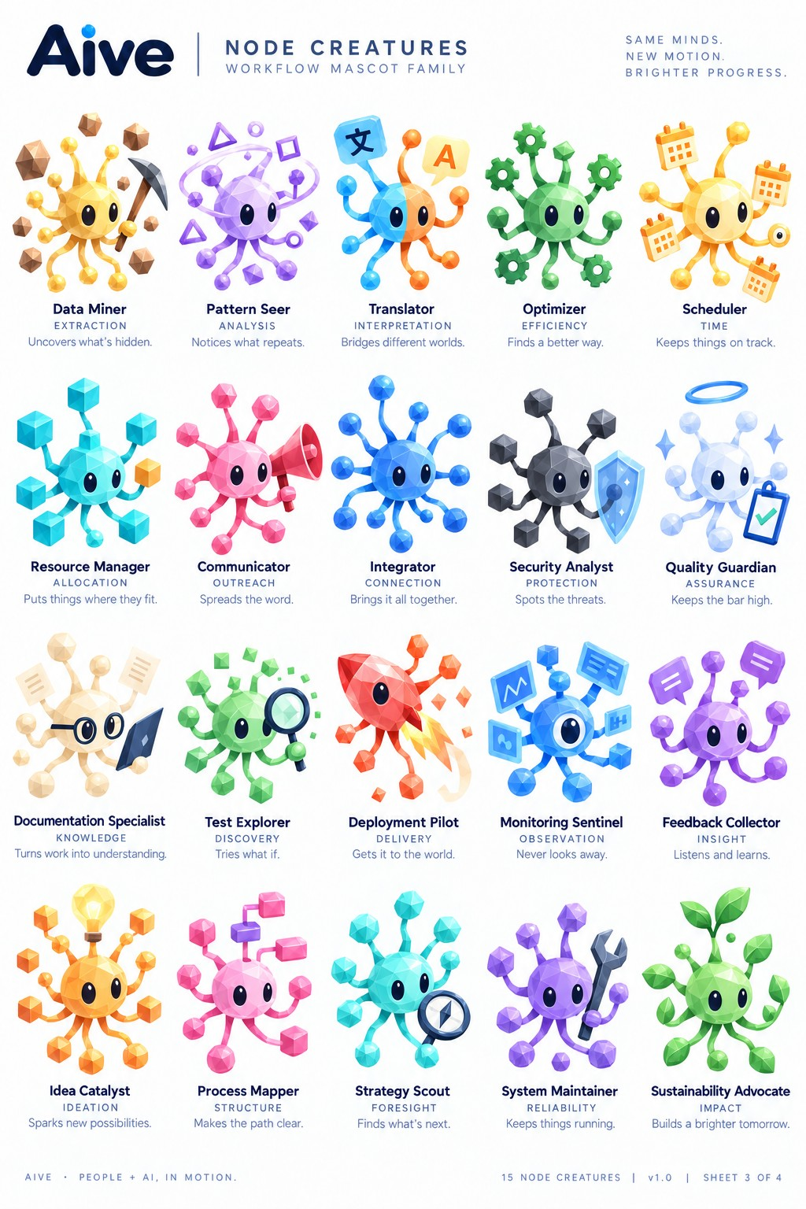
Reference sheet for the prompts below.

36. Data Miner — Sheet 3 variant
Use ONLY the Data Miner — Sheet 3 variant character in the attached reference. Create one transparent PNG sprite sheet containing only its actual 2D rigging pieces. Preserve the exact source-relative sizes, proportions, silhouettes, faceted/polygonal texture, colors, gradients, shading, highlights, translucency, and finish. Character-specific anatomy: yellow faceted spherical core; yellow ball-ended tendrils; dark pickaxe; floating brown rock/crystal chunks. Output the complete visible body/core at its real size; each actual eye white separately with NO pupil baked in; each pupil separately; upper and lower eyelids separately; every movable upper appendage as separate base, mid, and tip/terminal pieces; every lower gestation limb as separate base, mid, and bud-tip pieces; and each real prop/effect as its own asset. Do not invent alternate views, generic replacement anatomy, extra parts, labels, text, diagrams, or an assembled character. Do not enlarge small pieces or shrink the body for presentation. Keep unique body shapes unique. Use a transparent background with generous empty spacing so every part can be sliced by a rectangular bounding box without touching another asset.

37. Pattern Seer
Use ONLY the Pattern Seer character in the attached reference. Create one transparent PNG sprite sheet containing only its actual 2D rigging pieces. Preserve the exact source-relative sizes, proportions, silhouettes, faceted/polygonal texture, colors, gradients, shading, highlights, translucency, and finish. Character-specific anatomy: lavender faceted spherical core; looping orbital tendrils and floating purple triangle, circle, square, and diamond forms. Output the complete visible body/core at its real size; each actual eye white separately with NO pupil baked in; each pupil separately; upper and lower eyelids separately; every movable upper appendage as separate base, mid, and tip/terminal pieces; every lower gestation limb as separate base, mid, and bud-tip pieces; and each real prop/effect as its own asset. Do not invent alternate views, generic replacement anatomy, extra parts, labels, text, diagrams, or an assembled character. Do not enlarge small pieces or shrink the body for presentation. Keep unique body shapes unique. Use a transparent background with generous empty spacing so every part can be sliced by a rectangular bounding box without touching another asset.

38. Translator — Sheet 3 variant
Use ONLY the Translator — Sheet 3 variant character in the attached reference. Create one transparent PNG sprite sheet containing only its actual 2D rigging pieces. Preserve the exact source-relative sizes, proportions, silhouettes, faceted/polygonal texture, colors, gradients, shading, highlights, translucency, and finish. Character-specific anatomy: split cyan-blue/orange faceted spherical core; matching blue and orange tendrils; blue character panel and yellow A panel. Output the complete visible body/core at its real size; each actual eye white separately with NO pupil baked in; each pupil separately; upper and lower eyelids separately; every movable upper appendage as separate base, mid, and tip/terminal pieces; every lower gestation limb as separate base, mid, and bud-tip pieces; and each real prop/effect as its own asset. Do not invent alternate views, generic replacement anatomy, extra parts, labels, text, diagrams, or an assembled character. Do not enlarge small pieces or shrink the body for presentation. Keep unique body shapes unique. Use a transparent background with generous empty spacing so every part can be sliced by a rectangular bounding box without touching another asset.

39. Optimizer — Sheet 3 variant
Use ONLY the Optimizer — Sheet 3 variant character in the attached reference. Create one transparent PNG sprite sheet containing only its actual 2D rigging pieces. Preserve the exact source-relative sizes, proportions, silhouettes, faceted/polygonal texture, colors, gradients, shading, highlights, translucency, and finish. Character-specific anatomy: green faceted spherical core; green tendrils terminating in gear shapes plus one faceted leaf/diamond terminal. Output the complete visible body/core at its real size; each actual eye white separately with NO pupil baked in; each pupil separately; upper and lower eyelids separately; every movable upper appendage as separate base, mid, and tip/terminal pieces; every lower gestation limb as separate base, mid, and bud-tip pieces; and each real prop/effect as its own asset. Do not invent alternate views, generic replacement anatomy, extra parts, labels, text, diagrams, or an assembled character. Do not enlarge small pieces or shrink the body for presentation. Keep unique body shapes unique. Use a transparent background with generous empty spacing so every part can be sliced by a rectangular bounding box without touching another asset.

40. Scheduler — Sheet 3 variant
Use ONLY the Scheduler — Sheet 3 variant character in the attached reference. Create one transparent PNG sprite sheet containing only its actual 2D rigging pieces. Preserve the exact source-relative sizes, proportions, silhouettes, faceted/polygonal texture, colors, gradients, shading, highlights, translucency, and finish. Character-specific anatomy: pale yellow faceted spherical core; several calendar-bearing tendrils; small circular clock/indicator. Output the complete visible body/core at its real size; each actual eye white separately with NO pupil baked in; each pupil separately; upper and lower eyelids separately; every movable upper appendage as separate base, mid, and tip/terminal pieces; every lower gestation limb as separate base, mid, and bud-tip pieces; and each real prop/effect as its own asset. Do not invent alternate views, generic replacement anatomy, extra parts, labels, text, diagrams, or an assembled character. Do not enlarge small pieces or shrink the body for presentation. Keep unique body shapes unique. Use a transparent background with generous empty spacing so every part can be sliced by a rectangular bounding box without touching another asset.

41. Resource Manager — Sheet 3 variant
Use ONLY the Resource Manager — Sheet 3 variant character in the attached reference. Create one transparent PNG sprite sheet containing only its actual 2D rigging pieces. Preserve the exact source-relative sizes, proportions, silhouettes, faceted/polygonal texture, colors, gradients, shading, highlights, translucency, and finish. Character-specific anatomy: cyan faceted spherical core; appendages ending in cyan cubes plus one yellow cube. Output the complete visible body/core at its real size; each actual eye white separately with NO pupil baked in; each pupil separately; upper and lower eyelids separately; every movable upper appendage as separate base, mid, and tip/terminal pieces; every lower gestation limb as separate base, mid, and bud-tip pieces; and each real prop/effect as its own asset. Do not invent alternate views, generic replacement anatomy, extra parts, labels, text, diagrams, or an assembled character. Do not enlarge small pieces or shrink the body for presentation. Keep unique body shapes unique. Use a transparent background with generous empty spacing so every part can be sliced by a rectangular bounding box without touching another asset.

42. Communicator
Use ONLY the Communicator character in the attached reference. Create one transparent PNG sprite sheet containing only its actual 2D rigging pieces. Preserve the exact source-relative sizes, proportions, silhouettes, faceted/polygonal texture, colors, gradients, shading, highlights, translucency, and finish. Character-specific anatomy: pink faceted spherical core; pink ball-ended tendrils; large red/pink megaphone. Output the complete visible body/core at its real size; each actual eye white separately with NO pupil baked in; each pupil separately; upper and lower eyelids separately; every movable upper appendage as separate base, mid, and tip/terminal pieces; every lower gestation limb as separate base, mid, and bud-tip pieces; and each real prop/effect as its own asset. Do not invent alternate views, generic replacement anatomy, extra parts, labels, text, diagrams, or an assembled character. Do not enlarge small pieces or shrink the body for presentation. Keep unique body shapes unique. Use a transparent background with generous empty spacing so every part can be sliced by a rectangular bounding box without touching another asset.

43. Integrator
Use ONLY the Integrator character in the attached reference. Create one transparent PNG sprite sheet containing only its actual 2D rigging pieces. Preserve the exact source-relative sizes, proportions, silhouettes, faceted/polygonal texture, colors, gradients, shading, highlights, translucency, and finish. Character-specific anatomy: saturated blue faceted spherical core; many radial blue ball-ended tendrils. Output the complete visible body/core at its real size; each actual eye white separately with NO pupil baked in; each pupil separately; upper and lower eyelids separately; every movable upper appendage as separate base, mid, and tip/terminal pieces; every lower gestation limb as separate base, mid, and bud-tip pieces; and each real prop/effect as its own asset. Do not invent alternate views, generic replacement anatomy, extra parts, labels, text, diagrams, or an assembled character. Do not enlarge small pieces or shrink the body for presentation. Keep unique body shapes unique. Use a transparent background with generous empty spacing so every part can be sliced by a rectangular bounding box without touching another asset.

44. Security Analyst
Use ONLY the Security Analyst character in the attached reference. Create one transparent PNG sprite sheet containing only its actual 2D rigging pieces. Preserve the exact source-relative sizes, proportions, silhouettes, faceted/polygonal texture, colors, gradients, shading, highlights, translucency, and finish. Character-specific anatomy: charcoal faceted spherical core; multiple dark cube-ended appendages; blue shield. Output the complete visible body/core at its real size; each actual eye white separately with NO pupil baked in; each pupil separately; upper and lower eyelids separately; every movable upper appendage as separate base, mid, and tip/terminal pieces; every lower gestation limb as separate base, mid, and bud-tip pieces; and each real prop/effect as its own asset. Do not invent alternate views, generic replacement anatomy, extra parts, labels, text, diagrams, or an assembled character. Do not enlarge small pieces or shrink the body for presentation. Keep unique body shapes unique. Use a transparent background with generous empty spacing so every part can be sliced by a rectangular bounding box without touching another asset.

45. Quality Guardian
Use ONLY the Quality Guardian character in the attached reference. Create one transparent PNG sprite sheet containing only its actual 2D rigging pieces. Preserve the exact source-relative sizes, proportions, silhouettes, faceted/polygonal texture, colors, gradients, shading, highlights, translucency, and finish. Character-specific anatomy: very pale translucent blue/white faceted spherical core; pale tendrils; blue halo; clipboard with green check; small sparkle effects. Output the complete visible body/core at its real size; each actual eye white separately with NO pupil baked in; each pupil separately; upper and lower eyelids separately; every movable upper appendage as separate base, mid, and tip/terminal pieces; every lower gestation limb as separate base, mid, and bud-tip pieces; and each real prop/effect as its own asset. Do not invent alternate views, generic replacement anatomy, extra parts, labels, text, diagrams, or an assembled character. Do not enlarge small pieces or shrink the body for presentation. Keep unique body shapes unique. Use a transparent background with generous empty spacing so every part can be sliced by a rectangular bounding box without touching another asset.

46. Documentation Specialist
Use ONLY the Documentation Specialist character in the attached reference. Create one transparent PNG sprite sheet containing only its actual 2D rigging pieces. Preserve the exact source-relative sizes, proportions, silhouettes, faceted/polygonal texture, colors, gradients, shading, highlights, translucency, and finish. Character-specific anatomy: cream faceted spherical core; separate dark round glasses; page/document props; dark tablet/book panel. Output the complete visible body/core at its real size; each actual eye white separately with NO pupil baked in; each pupil separately; upper and lower eyelids separately; every movable upper appendage as separate base, mid, and tip/terminal pieces; every lower gestation limb as separate base, mid, and bud-tip pieces; and each real prop/effect as its own asset. Do not invent alternate views, generic replacement anatomy, extra parts, labels, text, diagrams, or an assembled character. Do not enlarge small pieces or shrink the body for presentation. Keep unique body shapes unique. Use a transparent background with generous empty spacing so every part can be sliced by a rectangular bounding box without touching another asset.

47. Test Explorer
Use ONLY the Test Explorer character in the attached reference. Create one transparent PNG sprite sheet containing only its actual 2D rigging pieces. Preserve the exact source-relative sizes, proportions, silhouettes, faceted/polygonal texture, colors, gradients, shading, highlights, translucency, and finish. Character-specific anatomy: green faceted spherical core; mixed green faceted cube/diamond terminals; magnifying glass; floating geometric fragments. Output the complete visible body/core at its real size; each actual eye white separately with NO pupil baked in; each pupil separately; upper and lower eyelids separately; every movable upper appendage as separate base, mid, and tip/terminal pieces; every lower gestation limb as separate base, mid, and bud-tip pieces; and each real prop/effect as its own asset. Do not invent alternate views, generic replacement anatomy, extra parts, labels, text, diagrams, or an assembled character. Do not enlarge small pieces or shrink the body for presentation. Keep unique body shapes unique. Use a transparent background with generous empty spacing so every part can be sliced by a rectangular bounding box without touching another asset.

48. Deployment Pilot
Use ONLY the Deployment Pilot character in the attached reference. Create one transparent PNG sprite sheet containing only its actual 2D rigging pieces. Preserve the exact source-relative sizes, proportions, silhouettes, faceted/polygonal texture, colors, gradients, shading, highlights, translucency, and finish. Character-specific anatomy: red/orange faceted rocket-like asymmetric body; small appendages with polygon terminals; layered yellow/orange flame exhaust; floating red/orange diamond fragments. Output the complete visible body/core at its real size; each actual eye white separately with NO pupil baked in; each pupil separately; upper and lower eyelids separately; every movable upper appendage as separate base, mid, and tip/terminal pieces; every lower gestation limb as separate base, mid, and bud-tip pieces; and each real prop/effect as its own asset. Do not invent alternate views, generic replacement anatomy, extra parts, labels, text, diagrams, or an assembled character. Do not enlarge small pieces or shrink the body for presentation. Keep unique body shapes unique. Use a transparent background with generous empty spacing so every part can be sliced by a rectangular bounding box without touching another asset.

49. Monitoring Sentinel
Use ONLY the Monitoring Sentinel character in the attached reference. Create one transparent PNG sprite sheet containing only its actual 2D rigging pieces. Preserve the exact source-relative sizes, proportions, silhouettes, faceted/polygonal texture, colors, gradients, shading, highlights, translucency, and finish. Character-specific anatomy: blue faceted cyclopean core dominated by one large central eye/lens; short appendages ending in blue monitoring/chart panels and blue blocks. Output the complete visible body/core at its real size; each actual eye white separately with NO pupil baked in; each pupil separately; upper and lower eyelids separately; every movable upper appendage as separate base, mid, and tip/terminal pieces; every lower gestation limb as separate base, mid, and bud-tip pieces; and each real prop/effect as its own asset. Do not invent alternate views, generic replacement anatomy, extra parts, labels, text, diagrams, or an assembled character. Do not enlarge small pieces or shrink the body for presentation. Keep unique body shapes unique. Use a transparent background with generous empty spacing so every part can be sliced by a rectangular bounding box without touching another asset.

50. Feedback Collector
Use ONLY the Feedback Collector character in the attached reference. Create one transparent PNG sprite sheet containing only its actual 2D rigging pieces. Preserve the exact source-relative sizes, proportions, silhouettes, faceted/polygonal texture, colors, gradients, shading, highlights, translucency, and finish. Character-specific anatomy: purple faceted spherical core; purple tendrils; speech/message panels as terminals/props. Output the complete visible body/core at its real size; each actual eye white separately with NO pupil baked in; each pupil separately; upper and lower eyelids separately; every movable upper appendage as separate base, mid, and tip/terminal pieces; every lower gestation limb as separate base, mid, and bud-tip pieces; and each real prop/effect as its own asset. Do not invent alternate views, generic replacement anatomy, extra parts, labels, text, diagrams, or an assembled character. Do not enlarge small pieces or shrink the body for presentation. Keep unique body shapes unique. Use a transparent background with generous empty spacing so every part can be sliced by a rectangular bounding box without touching another asset.

51. Idea Catalyst
Use ONLY the Idea Catalyst character in the attached reference. Create one transparent PNG sprite sheet containing only its actual 2D rigging pieces. Preserve the exact source-relative sizes, proportions, silhouettes, faceted/polygonal texture, colors, gradients, shading, highlights, translucency, and finish. Character-specific anatomy: orange/yellow faceted spherical core; cube-ended appendages; glowing yellow lightbulb mounted above body. Output the complete visible body/core at its real size; each actual eye white separately with NO pupil baked in; each pupil separately; upper and lower eyelids separately; every movable upper appendage as separate base, mid, and tip/terminal pieces; every lower gestation limb as separate base, mid, and bud-tip pieces; and each real prop/effect as its own asset. Do not invent alternate views, generic replacement anatomy, extra parts, labels, text, diagrams, or an assembled character. Do not enlarge small pieces or shrink the body for presentation. Keep unique body shapes unique. Use a transparent background with generous empty spacing so every part can be sliced by a rectangular bounding box without touching another asset.

52. Process Mapper
Use ONLY the Process Mapper character in the attached reference. Create one transparent PNG sprite sheet containing only its actual 2D rigging pieces. Preserve the exact source-relative sizes, proportions, silhouettes, faceted/polygonal texture, colors, gradients, shading, highlights, translucency, and finish. Character-specific anatomy: pink faceted spherical core; branching appendages ending in pink square/cube nodes with one purple connector block. Output the complete visible body/core at its real size; each actual eye white separately with NO pupil baked in; each pupil separately; upper and lower eyelids separately; every movable upper appendage as separate base, mid, and tip/terminal pieces; every lower gestation limb as separate base, mid, and bud-tip pieces; and each real prop/effect as its own asset. Do not invent alternate views, generic replacement anatomy, extra parts, labels, text, diagrams, or an assembled character. Do not enlarge small pieces or shrink the body for presentation. Keep unique body shapes unique. Use a transparent background with generous empty spacing so every part can be sliced by a rectangular bounding box without touching another asset.

53. Strategy Scout
Use ONLY the Strategy Scout character in the attached reference. Create one transparent PNG sprite sheet containing only its actual 2D rigging pieces. Preserve the exact source-relative sizes, proportions, silhouettes, faceted/polygonal texture, colors, gradients, shading, highlights, translucency, and finish. Character-specific anatomy: cyan faceted spherical core; faceted cyan terminals; circular compass prop. Output the complete visible body/core at its real size; each actual eye white separately with NO pupil baked in; each pupil separately; upper and lower eyelids separately; every movable upper appendage as separate base, mid, and tip/terminal pieces; every lower gestation limb as separate base, mid, and bud-tip pieces; and each real prop/effect as its own asset. Do not invent alternate views, generic replacement anatomy, extra parts, labels, text, diagrams, or an assembled character. Do not enlarge small pieces or shrink the body for presentation. Keep unique body shapes unique. Use a transparent background with generous empty spacing so every part can be sliced by a rectangular bounding box without touching another asset.

54. System Maintainer
Use ONLY the System Maintainer character in the attached reference. Create one transparent PNG sprite sheet containing only its actual 2D rigging pieces. Preserve the exact source-relative sizes, proportions, silhouettes, faceted/polygonal texture, colors, gradients, shading, highlights, translucency, and finish. Character-specific anatomy: purple faceted spherical core; faceted gem-like terminals; dark wrench. Output the complete visible body/core at its real size; each actual eye white separately with NO pupil baked in; each pupil separately; upper and lower eyelids separately; every movable upper appendage as separate base, mid, and tip/terminal pieces; every lower gestation limb as separate base, mid, and bud-tip pieces; and each real prop/effect as its own asset. Do not invent alternate views, generic replacement anatomy, extra parts, labels, text, diagrams, or an assembled character. Do not enlarge small pieces or shrink the body for presentation. Keep unique body shapes unique. Use a transparent background with generous empty spacing so every part can be sliced by a rectangular bounding box without touching another asset.

55. Sustainability Advocate
Use ONLY the Sustainability Advocate character in the attached reference. Create one transparent PNG sprite sheet containing only its actual 2D rigging pieces. Preserve the exact source-relative sizes, proportions, silhouettes, faceted/polygonal texture, colors, gradients, shading, highlights, translucency, and finish. Character-specific anatomy: green faceted spherical core; leaf-tipped/leaf-cluster appendages; large paired leaves above body. Output the complete visible body/core at its real size; each actual eye white separately with NO pupil baked in; each pupil separately; upper and lower eyelids separately; every movable upper appendage as separate base, mid, and tip/terminal pieces; every lower gestation limb as separate base, mid, and bud-tip pieces; and each real prop/effect as its own asset. Do not invent alternate views, generic replacement anatomy, extra parts, labels, text, diagrams, or an assembled character. Do not enlarge small pieces or shrink the body for presentation. Keep unique body shapes unique. Use a transparent background with generous empty spacing so every part can be sliced by a rectangular bounding box without touching another asset.

Sheet 4 — 18283
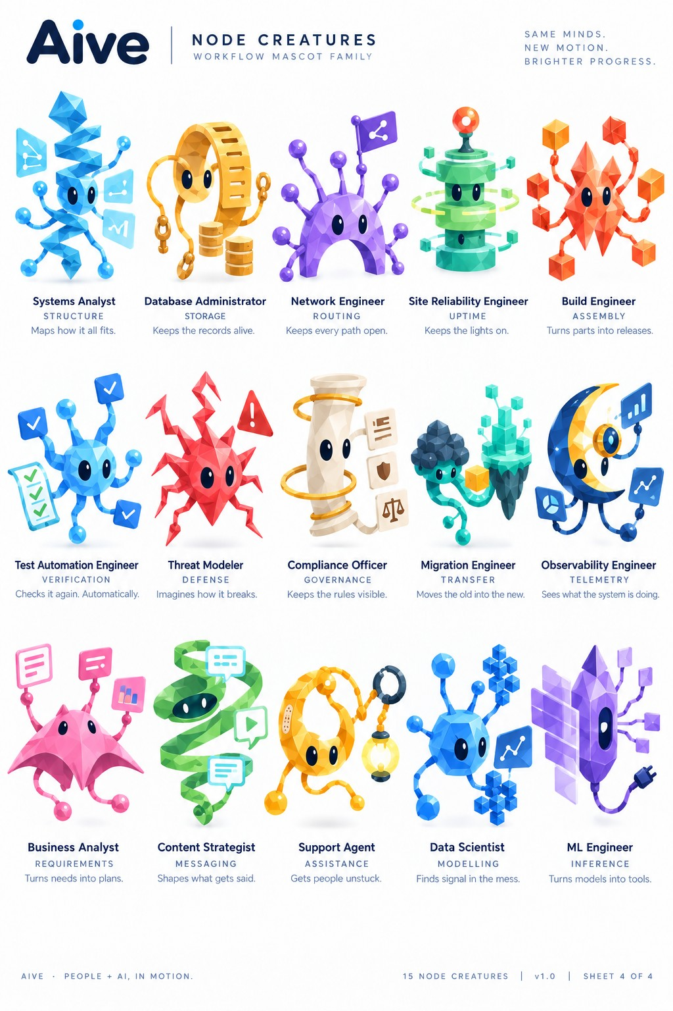
Reference sheet for the prompts below.

56. Systems Analyst
Use ONLY the Systems Analyst character in the attached reference. Create one transparent PNG sprite sheet containing only its actual 2D rigging pieces. Preserve the exact source-relative sizes, proportions, silhouettes, faceted/polygonal texture, colors, gradients, shading, highlights, translucency, and finish. Character-specific anatomy: unique blue stacked zig-zag/crystalline central body, not a sphere; blue ball-ended tendrils; three translucent blue schematic/network panels. Output the complete visible body/core at its real size; each actual eye white separately with NO pupil baked in; each pupil separately; upper and lower eyelids separately; every movable upper appendage as separate base, mid, and tip/terminal pieces; every lower gestation limb as separate base, mid, and bud-tip pieces; and each real prop/effect as its own asset. Do not invent alternate views, generic replacement anatomy, extra parts, labels, text, diagrams, or an assembled character. Do not enlarge small pieces or shrink the body for presentation. Keep unique body shapes unique. Use a transparent background with generous empty spacing so every part can be sliced by a rectangular bounding box without touching another asset.

57. Database Administrator
Use ONLY the Database Administrator character in the attached reference. Create one transparent PNG sprite sheet containing only its actual 2D rigging pieces. Preserve the exact source-relative sizes, proportions, silhouettes, faceted/polygonal texture, colors, gradients, shading, highlights, translucency, and finish. Character-specific anatomy: unique gold hollow ring/arched body, not a sphere; looped chain appendages; separate stacked gold database cylinders. Output the complete visible body/core at its real size; each actual eye white separately with NO pupil baked in; each pupil separately; upper and lower eyelids separately; every movable upper appendage as separate base, mid, and tip/terminal pieces; every lower gestation limb as separate base, mid, and bud-tip pieces; and each real prop/effect as its own asset. Do not invent alternate views, generic replacement anatomy, extra parts, labels, text, diagrams, or an assembled character. Do not enlarge small pieces or shrink the body for presentation. Keep unique body shapes unique. Use a transparent background with generous empty spacing so every part can be sliced by a rectangular bounding box without touching another asset.

58. Network Engineer
Use ONLY the Network Engineer character in the attached reference. Create one transparent PNG sprite sheet containing only its actual 2D rigging pieces. Preserve the exact source-relative sizes, proportions, silhouettes, faceted/polygonal texture, colors, gradients, shading, highlights, translucency, and finish. Character-specific anatomy: purple arched/dome body with open lower arch; multiple purple ball-tipped routing stalks; purple routing/network flag. Output the complete visible body/core at its real size; each actual eye white separately with NO pupil baked in; each pupil separately; upper and lower eyelids separately; every movable upper appendage as separate base, mid, and tip/terminal pieces; every lower gestation limb as separate base, mid, and bud-tip pieces; and each real prop/effect as its own asset. Do not invent alternate views, generic replacement anatomy, extra parts, labels, text, diagrams, or an assembled character. Do not enlarge small pieces or shrink the body for presentation. Keep unique body shapes unique. Use a transparent background with generous empty spacing so every part can be sliced by a rectangular bounding box without touching another asset.

59. Site Reliability Engineer
Use ONLY the Site Reliability Engineer character in the attached reference. Create one transparent PNG sprite sheet containing only its actual 2D rigging pieces. Preserve the exact source-relative sizes, proportions, silhouettes, faceted/polygonal texture, colors, gradients, shading, highlights, translucency, and finish. Character-specific anatomy: stacked green cylindrical machine-like body; multiple green rings/orbits; top red/orange beacon; small cube-ended side appendages. Output the complete visible body/core at its real size; each actual eye white separately with NO pupil baked in; each pupil separately; upper and lower eyelids separately; every movable upper appendage as separate base, mid, and tip/terminal pieces; every lower gestation limb as separate base, mid, and bud-tip pieces; and each real prop/effect as its own asset. Do not invent alternate views, generic replacement anatomy, extra parts, labels, text, diagrams, or an assembled character. Do not enlarge small pieces or shrink the body for presentation. Keep unique body shapes unique. Use a transparent background with generous empty spacing so every part can be sliced by a rectangular bounding box without touching another asset.

60. Build Engineer
Use ONLY the Build Engineer character in the attached reference. Create one transparent PNG sprite sheet containing only its actual 2D rigging pieces. Preserve the exact source-relative sizes, proportions, silhouettes, faceted/polygonal texture, colors, gradients, shading, highlights, translucency, and finish. Character-specific anatomy: red/orange crystalline diamond/star-shaped body; angular thin limbs ending in orange/red cubes. Output the complete visible body/core at its real size; each actual eye white separately with NO pupil baked in; each pupil separately; upper and lower eyelids separately; every movable upper appendage as separate base, mid, and tip/terminal pieces; every lower gestation limb as separate base, mid, and bud-tip pieces; and each real prop/effect as its own asset. Do not invent alternate views, generic replacement anatomy, extra parts, labels, text, diagrams, or an assembled character. Do not enlarge small pieces or shrink the body for presentation. Keep unique body shapes unique. Use a transparent background with generous empty spacing so every part can be sliced by a rectangular bounding box without touching another asset.

61. Test Automation Engineer
Use ONLY the Test Automation Engineer character in the attached reference. Create one transparent PNG sprite sheet containing only its actual 2D rigging pieces. Preserve the exact source-relative sizes, proportions, silhouettes, faceted/polygonal texture, colors, gradients, shading, highlights, translucency, and finish. Character-specific anatomy: blue faceted spherical/oval core; several blue tendrils; multiple blue checkmark panels; green checklist panel. Output the complete visible body/core at its real size; each actual eye white separately with NO pupil baked in; each pupil separately; upper and lower eyelids separately; every movable upper appendage as separate base, mid, and tip/terminal pieces; every lower gestation limb as separate base, mid, and bud-tip pieces; and each real prop/effect as its own asset. Do not invent alternate views, generic replacement anatomy, extra parts, labels, text, diagrams, or an assembled character. Do not enlarge small pieces or shrink the body for presentation. Keep unique body shapes unique. Use a transparent background with generous empty spacing so every part can be sliced by a rectangular bounding box without touching another asset.

62. Threat Modeler
Use ONLY the Threat Modeler character in the attached reference. Create one transparent PNG sprite sheet containing only its actual 2D rigging pieces. Preserve the exact source-relative sizes, proportions, silhouettes, faceted/polygonal texture, colors, gradients, shading, highlights, translucency, and finish. Character-specific anatomy: red sharply faceted spiky body; jagged angular limbs; separate red warning triangle. Output the complete visible body/core at its real size; each actual eye white separately with NO pupil baked in; each pupil separately; upper and lower eyelids separately; every movable upper appendage as separate base, mid, and tip/terminal pieces; every lower gestation limb as separate base, mid, and bud-tip pieces; and each real prop/effect as its own asset. Do not invent alternate views, generic replacement anatomy, extra parts, labels, text, diagrams, or an assembled character. Do not enlarge small pieces or shrink the body for presentation. Keep unique body shapes unique. Use a transparent background with generous empty spacing so every part can be sliced by a rectangular bounding box without touching another asset.

63. Compliance Officer
Use ONLY the Compliance Officer character in the attached reference. Create one transparent PNG sprite sheet containing only its actual 2D rigging pieces. Preserve the exact source-relative sizes, proportions, silhouettes, faceted/polygonal texture, colors, gradients, shading, highlights, translucency, and finish. Character-specific anatomy: cream scroll/column body, not a sphere; separate gold rings encircling column; cream legal/rule panels. Output the complete visible body/core at its real size; each actual eye white separately with NO pupil baked in; each pupil separately; upper and lower eyelids separately; every movable upper appendage as separate base, mid, and tip/terminal pieces; every lower gestation limb as separate base, mid, and bud-tip pieces; and each real prop/effect as its own asset. Do not invent alternate views, generic replacement anatomy, extra parts, labels, text, diagrams, or an assembled character. Do not enlarge small pieces or shrink the body for presentation. Keep unique body shapes unique. Use a transparent background with generous empty spacing so every part can be sliced by a rectangular bounding box without touching another asset.

64. Migration Engineer
Use ONLY the Migration Engineer character in the attached reference. Create one transparent PNG sprite sheet containing only its actual 2D rigging pieces. Preserve the exact source-relative sizes, proportions, silhouettes, faceted/polygonal texture, colors, gradients, shading, highlights, translucency, and finish. Character-specific anatomy: two floating rocky/island masses: dark upper cluster and teal lower crystalline island; teal curling limbs; yellow cube. Output the complete visible body/core at its real size; each actual eye white separately with NO pupil baked in; each pupil separately; upper and lower eyelids separately; every movable upper appendage as separate base, mid, and tip/terminal pieces; every lower gestation limb as separate base, mid, and bud-tip pieces; and each real prop/effect as its own asset. Do not invent alternate views, generic replacement anatomy, extra parts, labels, text, diagrams, or an assembled character. Do not enlarge small pieces or shrink the body for presentation. Keep unique body shapes unique. Use a transparent background with generous empty spacing so every part can be sliced by a rectangular bounding box without touching another asset.

65. Observability Engineer
Use ONLY the Observability Engineer character in the attached reference. Create one transparent PNG sprite sheet containing only its actual 2D rigging pieces. Preserve the exact source-relative sizes, proportions, silhouettes, faceted/polygonal texture, colors, gradients, shading, highlights, translucency, and finish. Character-specific anatomy: large blue-and-gold crescent-moon body, not a sphere; central circular lens/eye assembly; curved blue limbs; telemetry/chart panels. Output the complete visible body/core at its real size; each actual eye white separately with NO pupil baked in; each pupil separately; upper and lower eyelids separately; every movable upper appendage as separate base, mid, and tip/terminal pieces; every lower gestation limb as separate base, mid, and bud-tip pieces; and each real prop/effect as its own asset. Do not invent alternate views, generic replacement anatomy, extra parts, labels, text, diagrams, or an assembled character. Do not enlarge small pieces or shrink the body for presentation. Keep unique body shapes unique. Use a transparent background with generous empty spacing so every part can be sliced by a rectangular bounding box without touching another asset.

66. Business Analyst
Use ONLY the Business Analyst character in the attached reference. Create one transparent PNG sprite sheet containing only its actual 2D rigging pieces. Preserve the exact source-relative sizes, proportions, silhouettes, faceted/polygonal texture, colors, gradients, shading, highlights, translucency, and finish. Character-specific anatomy: pink manta/winged faceted body, not a sphere; two top message panels; small lower pink ball-ended limbs; small chart panel. Output the complete visible body/core at its real size; each actual eye white separately with NO pupil baked in; each pupil separately; upper and lower eyelids separately; every movable upper appendage as separate base, mid, and tip/terminal pieces; every lower gestation limb as separate base, mid, and bud-tip pieces; and each real prop/effect as its own asset. Do not invent alternate views, generic replacement anatomy, extra parts, labels, text, diagrams, or an assembled character. Do not enlarge small pieces or shrink the body for presentation. Keep unique body shapes unique. Use a transparent background with generous empty spacing so every part can be sliced by a rectangular bounding box without touching another asset.

67. Content Strategist
Use ONLY the Content Strategist character in the attached reference. Create one transparent PNG sprite sheet containing only its actual 2D rigging pieces. Preserve the exact source-relative sizes, proportions, silhouettes, faceted/polygonal texture, colors, gradients, shading, highlights, translucency, and finish. Character-specific anatomy: green spiral/ribbon body, not a sphere; dark inner face area; multiple cyan/green message/play panels attached around spiral. Output the complete visible body/core at its real size; each actual eye white separately with NO pupil baked in; each pupil separately; upper and lower eyelids separately; every movable upper appendage as separate base, mid, and tip/terminal pieces; every lower gestation limb as separate base, mid, and bud-tip pieces; and each real prop/effect as its own asset. Do not invent alternate views, generic replacement anatomy, extra parts, labels, text, diagrams, or an assembled character. Do not enlarge small pieces or shrink the body for presentation. Keep unique body shapes unique. Use a transparent background with generous empty spacing so every part can be sliced by a rectangular bounding box without touching another asset.

68. Support Agent
Use ONLY the Support Agent character in the attached reference. Create one transparent PNG sprite sheet containing only its actual 2D rigging pieces. Preserve the exact source-relative sizes, proportions, silhouettes, faceted/polygonal texture, colors, gradients, shading, highlights, translucency, and finish. Character-specific anatomy: orange looped/ring-like body, not a sphere; orange curling limbs; separate magnifying glass and hanging glowing lamp. Output the complete visible body/core at its real size; each actual eye white separately with NO pupil baked in; each pupil separately; upper and lower eyelids separately; every movable upper appendage as separate base, mid, and tip/terminal pieces; every lower gestation limb as separate base, mid, and bud-tip pieces; and each real prop/effect as its own asset. Do not invent alternate views, generic replacement anatomy, extra parts, labels, text, diagrams, or an assembled character. Do not enlarge small pieces or shrink the body for presentation. Keep unique body shapes unique. Use a transparent background with generous empty spacing so every part can be sliced by a rectangular bounding box without touching another asset.

69. Data Scientist
Use ONLY the Data Scientist character in the attached reference. Create one transparent PNG sprite sheet containing only its actual 2D rigging pieces. Preserve the exact source-relative sizes, proportions, silhouettes, faceted/polygonal texture, colors, gradients, shading, highlights, translucency, and finish. Character-specific anatomy: blue faceted spherical core; blue ball-ended stalks; distinct blue cube-cluster structures; blue chart/network panel. Output the complete visible body/core at its real size; each actual eye white separately with NO pupil baked in; each pupil separately; upper and lower eyelids separately; every movable upper appendage as separate base, mid, and tip/terminal pieces; every lower gestation limb as separate base, mid, and bud-tip pieces; and each real prop/effect as its own asset. Do not invent alternate views, generic replacement anatomy, extra parts, labels, text, diagrams, or an assembled character. Do not enlarge small pieces or shrink the body for presentation. Keep unique body shapes unique. Use a transparent background with generous empty spacing so every part can be sliced by a rectangular bounding box without touching another asset.

70. ML Engineer
Use ONLY the ML Engineer character in the attached reference. Create one transparent PNG sprite sheet containing only its actual 2D rigging pieces. Preserve the exact source-relative sizes, proportions, silhouettes, faceted/polygonal texture, colors, gradients, shading, highlights, translucency, and finish. Character-specific anatomy: tall purple crystalline slab/diamond body, not a sphere; translucent lavender side panels; small square-ended tendrils; black/blue plug and cable. Output the complete visible body/core at its real size; each actual eye white separately with NO pupil baked in; each pupil separately; upper and lower eyelids separately; every movable upper appendage as separate base, mid, and tip/terminal pieces; every lower gestation limb as separate base, mid, and bud-tip pieces; and each real prop/effect as its own asset. Do not invent alternate views, generic replacement anatomy, extra parts, labels, text, diagrams, or an assembled character. Do not enlarge small pieces or shrink the body for presentation. Keep unique body shapes unique. Use a transparent background with generous empty spacing so every part can be sliced by a rectangular bounding box without touching another asset.

