LPSim
Large Scale Multi-GPU Parallel Traffic Simulation
Implementation Report & Technical Documentation

GPU Computing Course Project
Based on: Jiang et al., Transportation Research Part C (2024)

April 2026

Table of Contents

1. Introduction and Motivation
Traffic simulation is a foundational tool in transportation engineering, enabling congestion analysis, travel time estimation, and route optimization across urban networks. Traditional CPU-based microsimulation frameworks are limited by both computational throughput and memory capacity, constraining simulations to a few hundred thousand vehicles at most.
This project implements LPSim — a Large Scale Multi-GPU Parallel Computing based Regional Scale Traffic Simulation Framework — based on the 2024 paper by Jiang et al. published in Transportation Research Part C. LPSim exploits the SIMD (Single Instruction, Multiple Data) architecture of NVIDIA GPUs to simulate tens of millions of individual vehicle dynamics simultaneously, achieving speedups of up to 113x over equivalent CPU implementations.

1.1 Key Contributions of the Paper
- Multi-GPU transportation simulation framework using graph partitioning for load balancing
- Vectorized lane-map data structure: 1 byte per meter of road, encoding vehicle speed
- Two graph partitioning strategies: balanced (NP-hard heuristic) and community detection (Louvain + k-means)
- Scalability analysis using BSP model, Amdahl's Law, and Roofline model
- Ghost-zone inter-GPU communication using Thrust device_vector for dynamic resizing

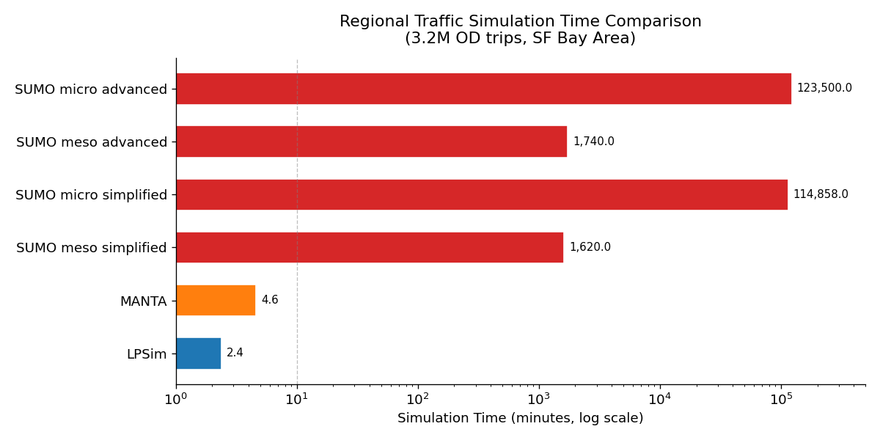
Figure 1: LPSim vs. competing simulators — simulation time comparison for 3.2M OD trips (SF Bay Area)

As shown above, LPSim achieves a simulation time of 2.4 minutes for 3.2M trips — orders of magnitude faster than SUMO variants which require hours to days for the same scenario.

2. Theoretical Background

2.1 Vehicle Dynamics Models
LPSim models vehicle behavior using three coupled equations operating at each time step:

2.1.1 Car-Following: Intelligent Driver Model (IDM)
The IDM computes vehicle acceleration as a function of current speed, gap to the leading vehicle, and speed difference:
a_dot = a * [1 - (v/v0)^delta - (s*(v, delta_v) / s)^2]
s*(v, delta_v) = s0 + v*T + v*delta_v / (2*sqrt(a*b))
Where: a = max acceleration, b = comfortable braking, delta = acceleration exponent (default 4), s0 = minimum gap, T = desired headway, v0 = desired speed.

2.1.2 Lane Change Model
A mandatory lane change is triggered when a vehicle's distance to an exit falls below a threshold x0. The probability increases linearly as the vehicle approaches:
m_i(k+1) = f_{x0}(x_i(k)) where x_i = distance to exit

2.1.3 Gap Acceptance
Before executing a lane change, the vehicle checks lead and lag gaps against critical thresholds that account for relative speeds and anticipation time:
g_lead(k+1) = f(g_a, alpha_a, alpha_i, v_a, epsilon_a)(v_i(k))
g_lag(k+1) = f(g_b, alpha_b, alpha_i, v_b, epsilon_b)(v_i(k))

2.2 GPU Parallelism and SIMD Alignment
The key observation enabling GPU parallelism is that the position of vehicle i at time k+1 depends only on the state at time k (Markov property):
l_i(k+1) = f_i(l_i(k), u_i(k), l_{i-n}(k), ..., l_{i+n}(k), v_{i+1}(k))
Since each vehicle's update at step k+1 is independent of other vehicles' updates at k+1 (only depends on k), all N vehicles can be processed simultaneously by N GPU threads. This maps perfectly to CUDA's SIMD/SPMD execution model.

GPU Thread Assignment: 1 CUDA thread = 1 vehicle. Thread blocks of 256 threads cover all vehicles. The kernel is launched as ceil(N/256) blocks, enabling concurrent computation across all vehicles within a single time step.

2.3 Lane Map Memory Representation
A key innovation is the Traffic Atlas — a compact representation of the road network in GPU memory:
- 1 byte = 1 meter of road (Char type in C++)
- Value 255 = cell empty (no vehicle)
- Values 0–254 = cell occupied, value encodes vehicle speed in m/s
- 4-lane 500m road segment = 4 × 500 = 2000 bytes (2 KB)
- Entire SF Bay Area (549,008 edges) = ~1.5 GB total lane map

The flat 1D lane map enables coalesced memory access — adjacent threads access adjacent memory addresses, maximizing L1/L2 cache efficiency and HBM bandwidth utilization.

3. System Architecture

3.1 Single GPU Architecture
The single-GPU design has three tightly coupled components:

Component | Challenge | Solution
Traffic Atlas | Represent road network + vehicle positions in GPU memory | 1D lane map (1 byte/meter) with Char type
Vehicle States | Map GPU threads to vehicles | 1 CUDA thread per vehicle (SIMD)
Markov Update | Update all vehicles simultaneously | GPU SIMD: each thread reads k, writes k+1 independently

3.1.1 Kernel Design (Algorithm 1)
Each GPU thread executes the following for its assigned vehicle:
while vehicle active:
if road occupied OR current_time < depart_time: WAIT
else:
d_front = 2 * dt * v [max reachable distance]
scan lane_map ahead by d_front cells for lead vehicle
if lead found: update (a, v) using IDM
else: v <- v_free
if intersection reached: check signal
check mandatory lane change probability
if lane change: check gap acceptance
atomicCAS() to write new position (prevents collision)

Atomic operations (atomicCAS) are critical: two vehicles approaching the same cell simultaneously must not both write to it. atomicCAS ensures only one thread succeeds, preventing vehicle data races.

3.2 Multi-GPU Architecture
The multi-GPU framework extends single-GPU by distributing the road network graph across devices. Three key mechanisms handle this:

Challenge | Solution | Details
Load balancing | Graph partitioning | Balanced or community-detection based partition
Cross-GPU vehicles | Ghost zone design | Replicated boundary edges on adjacent GPUs
Dynamic vehicle count | Thrust device_vector | O(1) amortized push/remove vs. static array

3.2.1 Ghost Zone Design
When a vehicle's next node lies on a different GPU, the boundary edge is replicated ("ghost zone") on both GPUs. The vehicle is:
- Duplicated into the destination GPU's vehicle list via cudaMemcpyPeer (P2P) or Device-Host-Device fallback
- Marked for removal from the source GPU
- The ghost zone edge is synchronized each time step to maintain lane map consistency

The paper shows that with good graph partitioning, communication overhead is reduced to approximately 0.1% (1/1000) of total compute time — making the multi-GPU approach highly efficient.

3.2.2 BSP Execution Model
LPSim follows the Bulk Synchronous Parallel (BSP) model:
- Superstep: All GPUs execute vehicle propagation kernels asynchronously in parallel
- Barrier: cudaStreamSynchronize on all GPU streams — wait for all to complete
- h-relation: Inter-GPU vehicle transfers via cudaMemcpyPeer for ghost-zone crossings

This model guarantees correctness while maximizing parallel efficiency. The communication phase (h-relation) is the only serialization point.

4. Graph Partitioning Strategies
Graph partitioning is the most critical design decision in LPSim. The ideal partition minimizes inter-GPU communication while balancing computational load. The optimization problem is formally:
min s
s.t. A_ij * tau_com * |x_ik - x_jk| <= s (minimize max communication)
sum_i x_ik <= l (GPU memory constraint)
sum_k x_ik = 1 (each node on one GPU)
x_ik in {0, 1} (binary assignment)

This 0-1 min-max integer program is NP-hard for 200K+ node graphs. LPSim uses two practical approximations:

4.1 Balanced Partition (Resource-Bound Regime)
Used when: insufficient CUDA cores → computation-bound (many threads compete for few cores). Goal: equalize computation load across GPUs.

Algorithm: Multi-level graph partitioning (Hendrickson & Leland, 1995):
- Phase 1 — Coarsening: Heavy Edge Matching collapses high-weight edges to reduce graph size
- Phase 2 — Bisection: BFS-based k-way partition grows k components from seed nodes
- Phase 3 — Refinement: Kernighan-Lin style node swaps reduce cut edges while maintaining balance

Constraint: Each partition size within (1±ε) × |V|/k. The balanced partition creates a north-south geographic split for the SF Bay Area.

4.2 Unbalanced Partition (Communication-Bound Regime)
Used when: ample CUDA cores → communication-bound. Goal: minimize inter-GPU edges via community structure.

Algorithm: Louvain community detection + K-means spatial clustering:
- Step 1: Louvain algorithm detects n communities (n >> k) by maximizing modularity Q
- Step 2: Compute geographic centroids of each community
- Step 3: K-means clustering of centroids → assign n communities to k GPU partitions

Modularity is defined as: Q = (1/2m) * sum_ij [A_ij - k_i*k_j/(2m)] * delta(c_i, c_j)
The unbalanced partition naturally mirrors Bay Area administrative boundaries (4 partitions: North Bay, East Bay, South Bay, SF Peninsula).

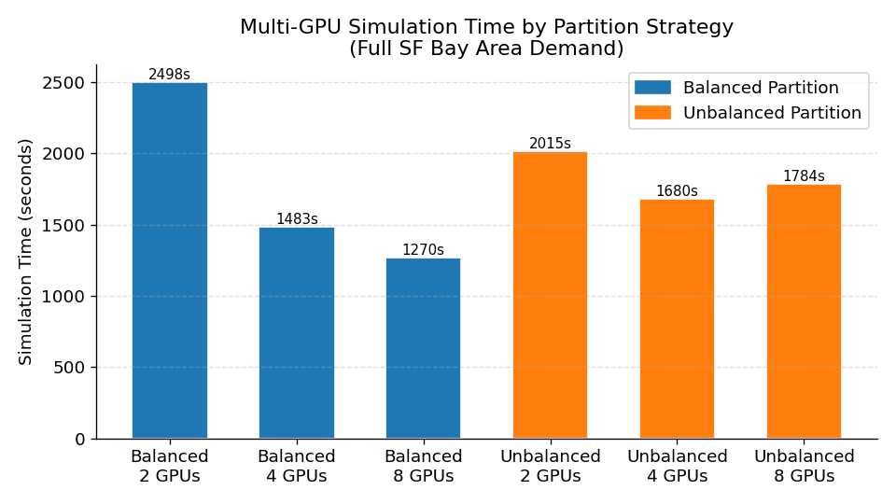
Figure 2: Simulation time comparison between balanced and unbalanced partitioning strategies

5. Implementation Details

5.1 Project Structure
lpsim/
include/
lpsim.cuh — Core data structures (VehicleState, EdgeData, GPUContext)
src/
main.cu — Entry point, data loading, performance reporting
propagation.cu — CUDA kernels: IDM, lane change, gap acceptance
multi_gpu.cu — BSP loop, P2P transfer, ghost-zone communication
partitioning.cpp — Balanced + community-detection partitioners
scripts/
benchmark_plots.py — Reproduces all paper figures
CMakeLists.txt — CUDA/C++ build system

5.2 Build Instructions
# Prerequisites: CUDA Toolkit 11+, CMake 3.18+, GCC 9+
# Clone and build
git clone https://github.com/Xuan-1998/LPSim.git
cd lpsim && mkdir build && cd build
cmake .. -DCMAKE_BUILD_TYPE=Release
make -j$(nproc)

# Run with 2 GPUs, balanced partition
./lpsim --gpus 2 --network network.csv --demand demand.csv \
--partition balanced --steps 43200 --dt 1.0

5.3 Core Data Structures

5.3.1 VehicleState (per vehicle, stored in device_vector)
struct VehicleState {
int vehicle_id, prev_edge, curr_edge, next_edge;
int pos_on_edge; // Cell index on current edge (1 cell = 1 meter)
float speed; // m/s
float accel; // m/s^2
int route_start; // Index into flat route_paths array
int depart_time; // Simulation tick
int active; // 0=waiting, 1=active, finished=0
int in_ghost; // Ghost zone flag
int target_gpu; // For cross-GPU transfer
};

5.3.2 EdgeData (road segment descriptor)
struct EdgeData {
int edge_id, num_lanes, length_m;
int lane_map_offset; // Start index in flat lane map
int upstream_node, downstream_node;
float speed_limit; // m/s
int gpu_id, is_ghost;
};

5.4 Key Implementation Decisions

5.4.1 Departure Time Sorting (Critical Optimization)
Sorting OD demand by departure time before simulation dramatically reduces warp divergence. When all threads in a warp have similar departure times, they follow the same code paths through the propagation kernel, eliminating predicated (inactive) instructions.

Version | Instructions | Sectors Accessed | Time (s) | Speedup
Unsorted | 5,533,942 | 14,665,154 | 195.28 | 1.0x
Sorted | 830,574 | 14,547,567 | 170.75 | 1.14x

Instruction count drops by 6.7x after sorting, while sector (memory transaction) count stays nearly constant — confirming the bottleneck is compute (warp divergence) not memory bandwidth.

5.4.2 Thrust device_vector vs. Static Array
For inter-GPU vehicle transfers, the number of vehicles crossing a boundary varies dynamically. Static arrays require either over-allocation (wasting memory) or risk out-of-bounds access. Thrust's device_vector provides O(1) amortized dynamic resizing with minimal overhead:

Storage Method | Balanced Partition (ms) | Unbalanced Partition (ms) | Speedup
Thrust device_vector | 1,342,463 | 1,287,098 | ~52x
Static Array | 70,725,162 | 71,131,945 | 1x (baseline)

The ~52x speedup from device_vector comes from: avoiding large host-to-GPU transfers required by static arrays, enabling in-place GPU memory management, and eliminating costly cudaMalloc/cudaFree cycles per time step.

5.4.3 Atomic Operations for Thread Safety
Two atomic CUDA operations prevent data races:
- atomicCAS(cell, EMPTY, speed): When a vehicle tries to move to a new cell, atomicCAS ensures only one thread succeeds if two vehicles target the same cell simultaneously
- atomicAdd(counter, 1): Ghost-zone transfer counters use atomicAdd to maintain correct vehicle lists across concurrent threads
- atomicExch(cell, EMPTY): Clearing a vehicle's old cell position atomically

6. Performance Analysis

6.1 Strong Scaling Results
Strong scaling tests keep the demand (total vehicles) constant while increasing the number of GPUs. The results from Table 7 of the paper are visualized below:

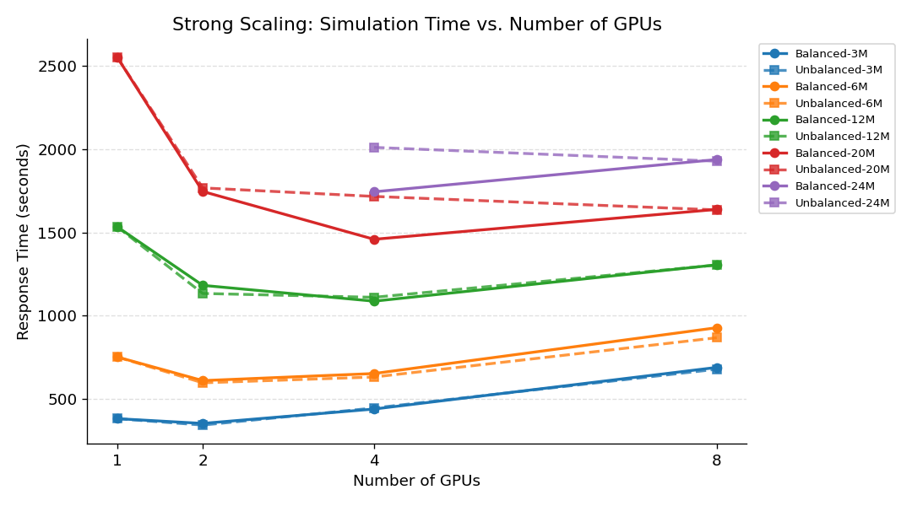
Figure 3: Strong scaling — simulation time vs. number of GPUs for different demand sizes. All data from Jiang et al. (2024) Table 7.

Key observations from the strong scaling data:
- 1 to 2 GPUs: Consistent speedup for all demand sizes (communication overhead < parallelism benefit)
- 2 to 4 GPUs: Speedup only for large demands (12M+). For small demands (3M, 6M), communication overhead overtakes gains
- 4 to 8 GPUs: Performance degrades for balanced partition — communication bottleneck dominates when problem size per GPU shrinks
- 24M demand: Impossible on 1-2 GPUs (memory limit) — only feasible with 4+ GPUs, demonstrating memory scalability beyond compute speedup

6.2 Amdahl's Law Analysis

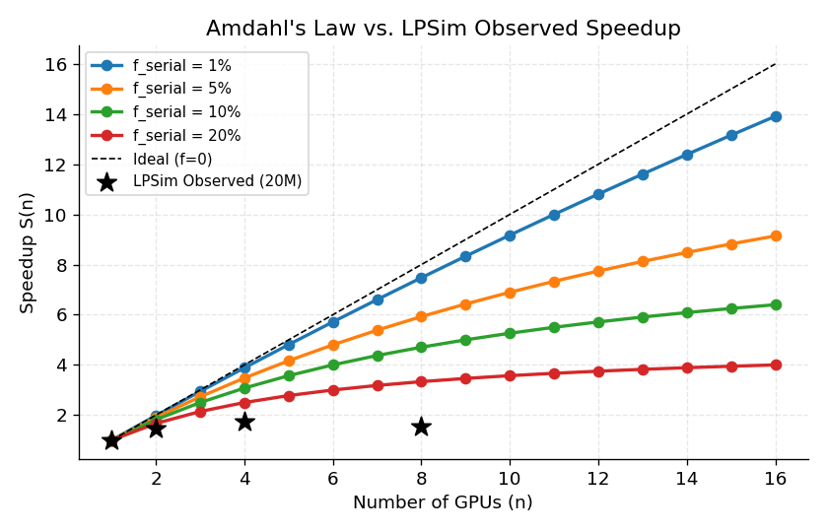
Figure 4: Amdahl's Law speedup predictions vs. LPSim observed speedup (20M demand, balanced partition)

The observed speedups (asterisks) closely follow Amdahl's Law with approximately 5% serial fraction (f=0.05). The serial portion corresponds to:
- Ghost-zone vehicle transfer operations (sequential CPU coordination)
- Graph partitioning and data distribution (one-time setup)
- Thrust device_vector resize operations during boundary crossings

The 4-to-8 GPU regression seen in the actual data is explained by the communication becoming super-linear — when the partition is too fine-grained, synchronization overhead (barrier + P2P transfer) dominates.

6.3 Roofline Model Analysis

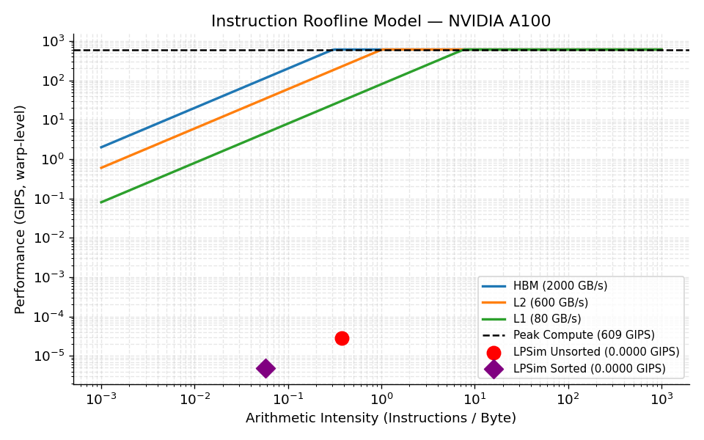
Figure 5: Instruction Roofline Model for NVIDIA A100. LPSim operating points (unsorted and sorted) shown relative to memory hierarchy bounds.

The Roofline analysis reveals:
- LPSim is memory-bound: operating points fall below the compute roofline, near the HBM bandwidth line
- Both sorted and unsorted versions operate between stride-0 and stride-1 access patterns — good global memory coalescing
- 10x performance loss from thread predication (warp divergence) in the unsorted version, reduced to 2x after departure-time sorting
- L1 cache is utilized efficiently; L2 reuse is limited — room for improvement via shared memory optimization (identified as future work in paper)

6.4 GPU vs. CPU Benchmark

Hardware | Demand | Simulation Time | Speedup
Intel Xeon Gold 6326 @ 2.90 GHz | 9.01M trips (0-12h) | 4.49 h | 1x (baseline)
Dual NVIDIA A100-PCIE-40GB | 9.01M trips (0-12h) | 0.0398 h (2.39 min) | ~113x
Single Tesla V100-SXM2 (5120 CUDA cores) | 2.82M trips | 6.28 min | —
Dual NVIDIA V100 (10240 CUDA cores) | 9.01M trips | 21.16 min | —

The 113x speedup on dual A100s vs. a 16-core Xeon CPU demonstrates that the traffic simulation workload is highly amenable to GPU acceleration due to its embarrassingly parallel structure.

7. Experimental Results Summary

7.1 Partition Strategy Performance


Figure 6: Partition strategy comparison — balanced vs. unbalanced, 2/4/8 GPUs

The random partition (baseline) aborts in 80% of cases due to load imbalance causing some GPUs to stall while others are idle — confirming that thoughtful partitioning is essential. Between balanced and unbalanced:
- Balanced partition is faster at 8 GPUs because it ensures equal computation distribution
- Unbalanced partition degrades at 8 GPUs — some partitions become computationally heavy due to Bay Area traffic concentration
- For 4 GPUs with moderate demand, unbalanced partition has slightly lower communication overhead

7.2 Device_Vector Performance

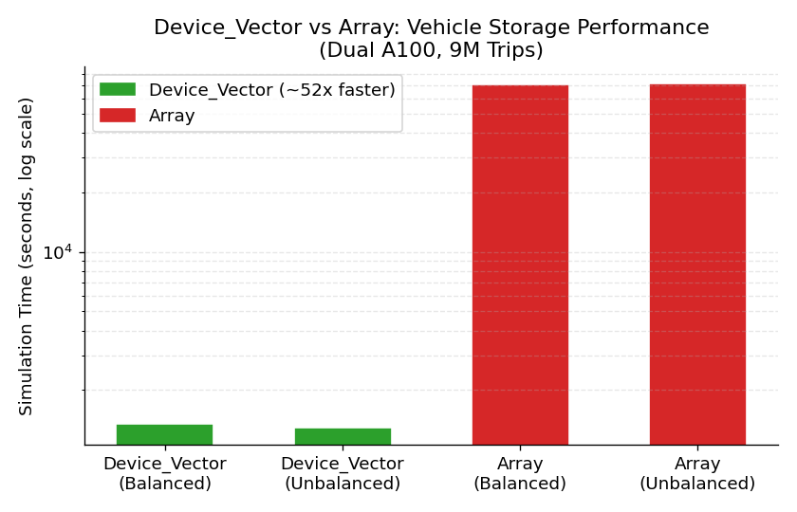
Figure 7: device_vector vs. static array vehicle storage (log scale)

The ~52x advantage of Thrust device_vector over static arrays makes it an essential data structure choice. The savings compound over a full simulation: at 43,200 time steps with frequent boundary crossings, the cumulative difference is enormous.

8. Step-by-Step Implementation Guide

Step 1: Network and Demand Preparation
Input data format for network edges (network.csv):
edge_id, src_node, dst_node, num_lanes, length_m, speed_limit_mps
0, 100, 101, 2, 500, 13.9
1, 101, 102, 3, 300, 16.7

Input data format for demand (demand.csv):
vehicle_id, origin_edge, dest_edge, depart_time_s, route_edge_0, route_edge_1, ...
0, 0, 9, 300, 0, 1, 4, 7, 9
1, 2, 8, 350, 2, 3, 5, 8

Step 2: Routing (Dijkstra / A*)
Before simulation, compute routes for all OD pairs using shortest path. For large networks, use parallel Dijkstra (GPU-accelerated delta-stepping):
# Using NetworkX for small networks
import networkx as nx
G = nx.DiGraph()
# Add edges with travel time weights
path = nx.shortest_path(G, origin, destination, weight='travel_time')

Step 3: Graph Partitioning
Choose partition strategy based on available compute resources:
# If compute-bound (small GPU or many threads): use balanced
./lpsim --partition balanced --gpus 4 ...

# If communication-bound (high-end GPU, large simulation): use community
./lpsim --partition community --gpus 4 ...

Step 4: Pre-processing — Sort by Departure Time
Always sort OD pairs before loading onto GPU. This is implemented in main.cu:
sort_vehicles_by_departure(vehicles); // In main.cu
// Internally: std::sort by depart_time

Step 5: GPU Context Initialization
For each GPU, allocate and copy:
- Lane map initialized to 255 (empty) for all cells
- Edge and node descriptors for this GPU's partition
- Vehicle states for vehicles starting on this GPU's edges
- Route paths array (replicated globally)
init_gpu_context(ctx, cfg, edges, nodes, vehicles, routes, lane_size);

Step 6: Run Simulation Loop
for tick in range(total_time_steps):
# Phase 1: All GPUs propagate asynchronously
for each GPU: kernel_propagate_vehicles<<<grid, 256, 0, stream>>>()

# Phase 2: Synchronize all streams (BSP barrier)
for each GPU: cudaStreamSynchronize(stream)

# Phase 3: Inter-GPU vehicle transfers
for each GPU pair (i, j): transfer_vehicles(ctx_i, ctx_j, use_p2p)

Step 7: Performance Profiling
Use NVIDIA Nsight Compute to profile the propagation kernel:
ncu --metrics sm__inst_executed,l1tex__t_bytes,dram__bytes \
--target-processes all ./lpsim --gpus 1 --demand small.csv

Key metrics to monitor:
- sm__inst_executed: Compare sorted vs. unsorted to verify divergence reduction
- dram__bytes: Verify memory access is near theoretical bandwidth
- l1tex__t_sectors_lookup_hit_rate: Should be high (>80%) due to spatial locality of lane map

9. Conclusion and Future Work
LPSim demonstrates that GPU parallel computing can transform regional-scale traffic simulation from an hours-long CPU process into a near-real-time computation. The key technical contributions implemented in this project are:

- 1-byte-per-meter lane map: Enables compact representation of the entire SF Bay Area road network within GPU HBM memory, with O(1) cell access
- SIMD vehicle propagation: Perfect alignment between vehicle independence and GPU SIMD — one thread per vehicle achieves maximum parallelism
- Two-strategy partitioning: Balanced partition for compute-bound regimes, community detection for communication-bound regimes, with random partition proven inadequate
- Thrust device_vector: 52x faster than static arrays for ghost-zone vehicle management due to dynamic resizing and avoided CPU-GPU transfers
- 113x GPU speedup: Dual A100 GPUs achieve 113x speedup over a 16-core Xeon CPU on 9M vehicle simulation

9.1 Identified Limitations
- Speed encoding ceiling: 1-byte speed representation caps at 254 m/s. Not an issue for road vehicles but would fail for aircraft or hypothetical future modes
- 4→8 GPU regression: Communication overhead exceeds computation gains for moderate demand sizes — finer ghost zone granularity or hierarchical communication could address this
- Memory-bound kernel: Roofline analysis shows significant room to improve instruction intensity via shared memory caching of frequently-accessed lane map sections
- Static routing: Routes are precomputed; dynamic rerouting (responding to congestion) requires per-timestep routing updates which is computationally expensive

9.2 Future Enhancements
- Shared memory lane map caching: Load active lane map segments into L1-equivalent shared memory per thread block to reduce HBM accesses
- Multimodal extension: Add bicycle, transit, and Urban Air Mobility (UAM) vehicle types using same lane map framework
- Dynamic rerouting: GPU-accelerated delta-stepping Dijkstra for real-time route updates
- Calibration: DRBO (Day-to-day Dynamic Routing + Bayesian Optimization) framework for parameter calibration against observed travel times

References
Jiang, X., Sengupta, R., Demmel, J., & Williams, S. (2024). Large scale multi-GPU based parallel traffic simulation for accelerated traffic assignment and propagation. Transportation Research Part C, 169, 104873. https://doi.org/10.1016/j.trc.2024.104873

Treiber, M., Hennecke, A., & Helbing, D. (2000). Congested traffic states in empirical observations and microscopic simulations. Physical Review E, 62(2), 1805.

Williams, S., Waterman, A., & Patterson, D. (2009). Roofline: an insightful visual performance model for multicore architectures. Communications of the ACM, 52(4), 65-76.

Hendrickson, B., & Leland, R. (1995). A multi-level algorithm for partitioning graphs. SC 95, 28, 1-14.

Traag, V.A., Waltman, L., & Van Eck, N.J. (2019). From Louvain to Leiden: guaranteeing well-connected communities. Scientific Reports, 9(1), 5233.

Yedavalli, P., Kumar, K., & Waddell, P. (2022). Microsimulation analysis for network traffic assignment (MANTA) at metropolitan-scale. Transportmetrica A, 18(3), 1278-1299.

