Dev diary.
13/03 Setup in Claude

Fix current codebase, first attempt:
Fix levelSystem.ts: guard calculateLevel against 0 XP and fix transport type matching
- Rewrite app/trip/[id].tsx to show real trip data from tripStorage
- Fix user.tsx: use tripStorage service, remove duplicated code, fix navigation route
- Fix QuickAddTripModal: show past dates, remove dead DateTimePicker
- Fix FinancialOverview: use klimaTicketCost prop, fix broken info text, fix Cost label

Overall Impression
The foundation is solid — it's a React Native (Expo) app with a clear purpose: track public transport trips to see if your annual KlimaTicket Ö subscription "pays off" vs. paying per ride. The UI has some nice touches (gradient cards, circular progress, XP leveling). But there are several meaningful bugs and inconsistencies that need attention.

What Works Well
- Core concept is well-scoped — tracking trips, showing break-even progress, financial overview. That's the right focus.
- Local persistence via AsyncStorage is implemented correctly, including proper Date serialization.
- tripStorage.ts service is a clean extraction of storage logic with loadTrips, saveTrips, getTripById.
- UI components look polished — UserLevelCard and FinancialOverview both use gradient styling nicely.
- react-hook-form is a good choice for the login form with proper validation.

Bugs & Issues

1. Trip detail screen is completely wrong
app/trip/[id].tsx shows hardcoded vacation data (Paris, Tokyo, Bali) with no connection to the actual trips stored in AsyncStorage. Tapping any trip card leads to "Trip not found" because the IDs don't match.
Additionally, the navigation call in user.tsx:215 is:
router.push(`/(tabs)/trip/${tripId}` as any);
But the file lives at app/trip/[id].tsx — the route should be /trip/${tripId}.

2. user.tsx duplicates code from the service layer
user.tsx has its own loadTrips, saveTrips, initialTrips, and a local Trip interface — all of which were already extracted into app/services/tripStorage.ts and app/types/trip.ts. The service file exists but isn't used by the main screen.

3. Date picker shows only future dates
In QuickAddTripModal.tsx:73-76, the custom picker generates dates for the next 7 days. Since you're logging trips you already took, it should show past dates. There's also dead inline <DateTimePicker> still rendered at line 182 alongside the custom modal — double date picker logic.

4. XP transport type multipliers never fire
In levelSystem.ts:30-44, the switch checks for 'bike', 'public transport', 'walk', 'car' — but the app only uses 'Bus', 'Train', 'Tram', 'Subway'. Every single trip falls through to default and gets no bonus.

5. calculateLevel(0) crashes
levelSystem.ts:7:
return Math.floor(Math.log(totalXP / 100) / Math.log(1.5)) + 1;
When totalXP is 0, this evaluates to Math.floor(-Infinity) + 1 = -Infinity. A new user with no XP will get an invalid level. Needs a guard for totalXP < 100.

6. klimaTicketCost prop is dead code
user.tsx:303 passes klimaTicketCost={1090} to FinancialOverview, but inside FinancialOverview.tsx:16 the price is hardcoded as const KLIMATICKET_PRICE = 1297.80 and the prop is never used. Also, €1,090 vs €1,297.80 — inconsistent values across the app.

7. Broken info text
FinancialOverview.tsx:132:
"Based on trips in the last {totalDistance} km"
This doesn't make sense semantically — distance isn't a timeframe.

8. No authentication guard
After login, the user is redirected to the trips screen, but there's nothing preventing direct navigation to /(tabs)/user without logging in. With Supabase already in the dependencies, this seems intended to have real auth eventually.

9. "Cost" field is confusing
The add-trip form asks for "Cost (€)" — but with a KlimaTicket, the user pays €0 per trip. The value entered is really the equivalent ticket price (what you would have paid without the pass). This should be clearer in the label or even auto-filled based on transport type and distance.

Structural Notes
- Mixed styling — index.tsx / LoginForm.tsx use NativeWind (className), while user.tsx uses StyleSheet. Pick one.
- Supabase is installed but unused — supabase-types.ts is generated and there's a Supabase project ID in package.json, so a backend was planned but auth is still dummy with DUMMY_USERS.
- new-trip.tsx exists but doesn't seem reachable from the current navigation — there's also NewTripForm.tsx and QuickAddTripModal.tsx, suggesting some confusion about which flow to use.

Priority Fixes
Priority | Issue
High | Fix trip detail screen to show real trip data
High | Fix navigation route (/(tabs)/trip/ → /trip/)
High | Use tripStorage.ts in user.tsx, remove duplicated code
High | Fix date picker to show past dates
Medium | Fix XP transport type matching
Medium | Guard calculateLevel against 0/low XP
Medium | Reconcile klimaTicketCost prop vs hardcoded constant
Low | Clarify "Cost" field label in add-trip form
Low | Fix broken info text in FinancialOverview

EXPO:
Problem 1:
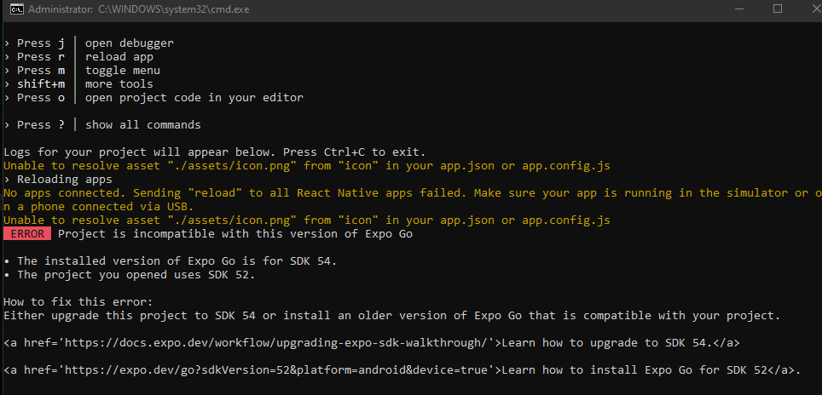
Easy fix?
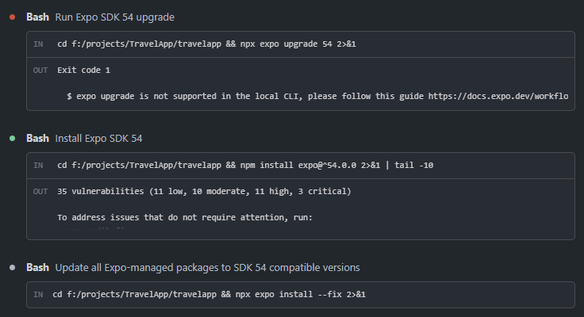
Color
as in Klimaticket color pallete.

bl
84c5dd
0b6c8a
00334f

gr
418880
3fb28f
9dcda2

r
e63c35
eb6c4c
e95b20

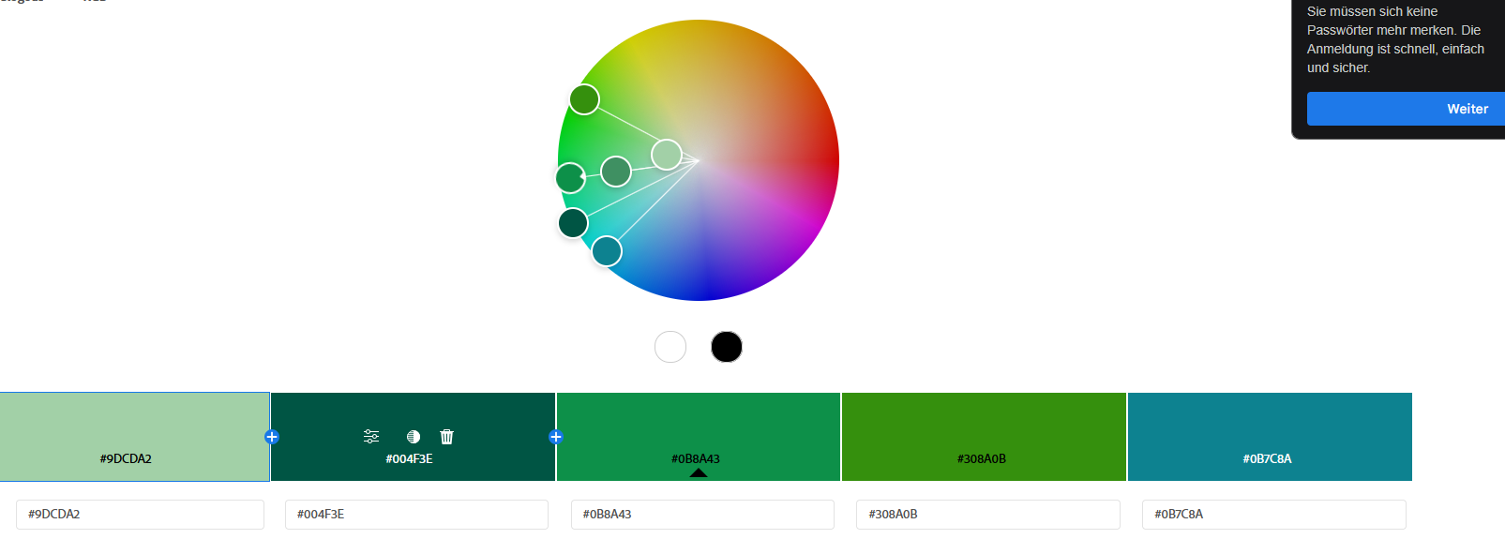
NAME

CarbonCrush

Alright, lets brainstorm a name for this baby. The app is basically a gamified public transport usage tracker. You start by adding your "climate friendly" ticket of choice, in Testing it will be Either a Klimaticket Ö (for all of Austria) or a Klimaticket K (Kaernten).
The aim is to reduce our dependence on individual (car) traffic and to make using public transport feel like a challenge/task/game. Reward players/users for achieving what benefits them and society - an increased usage of public transportation.
a core feature is the financial aspect of chasing your invested money, the gamification aims to assist, but ultimately its a challenge for the user to see if they use their subscription enough.

