Get Data Harga

Methot : Get

Url : http://localhost/segar/c_android/get_barang_in_pasar

Example :

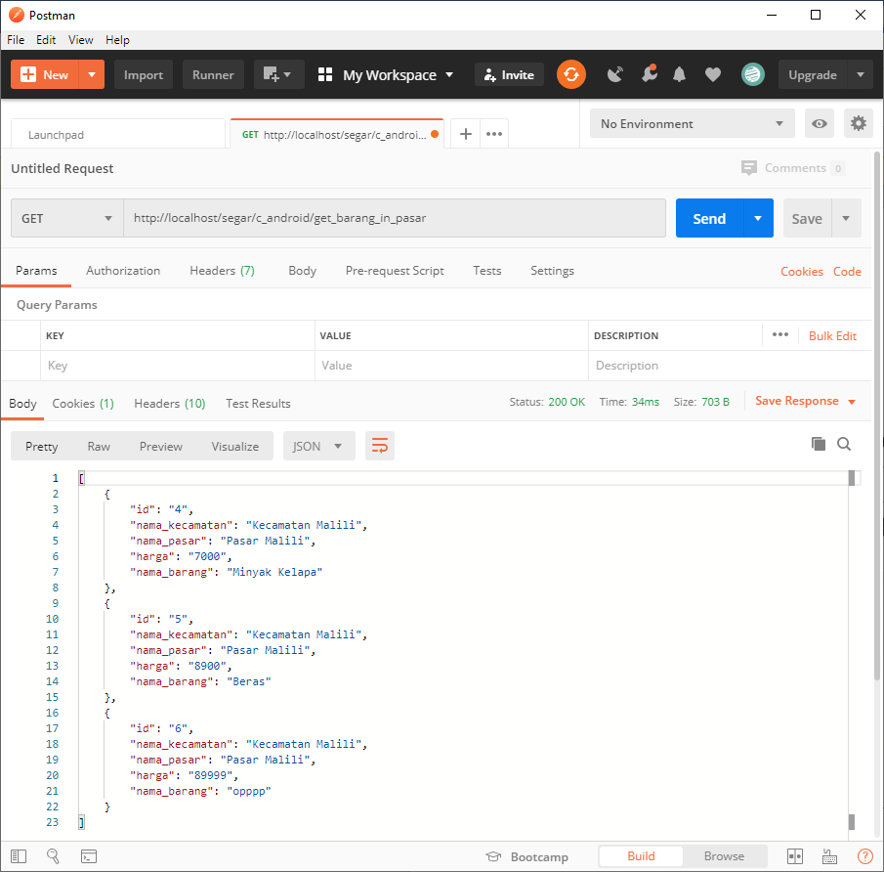

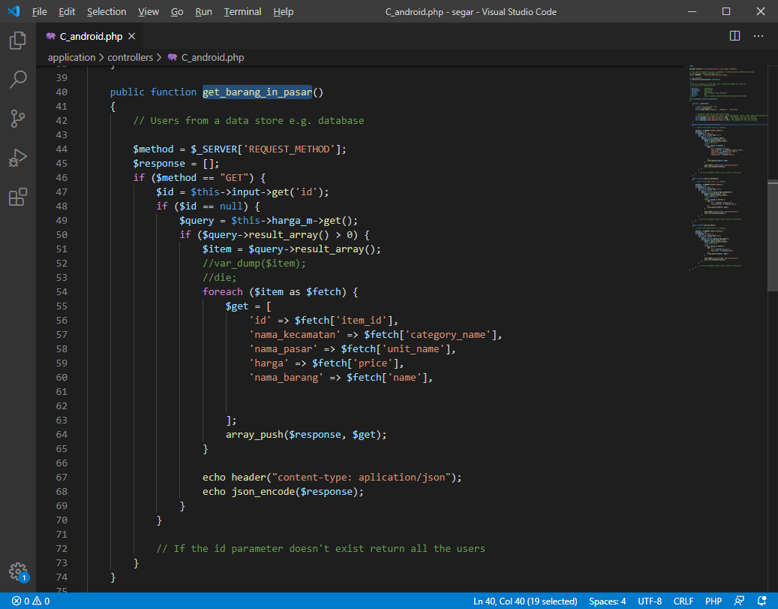

Respon : Ok

Get Data Kecamatan

Methot : Get

Url : <http://localhost/segar/c_android/get_all_kecamatan>

Example :

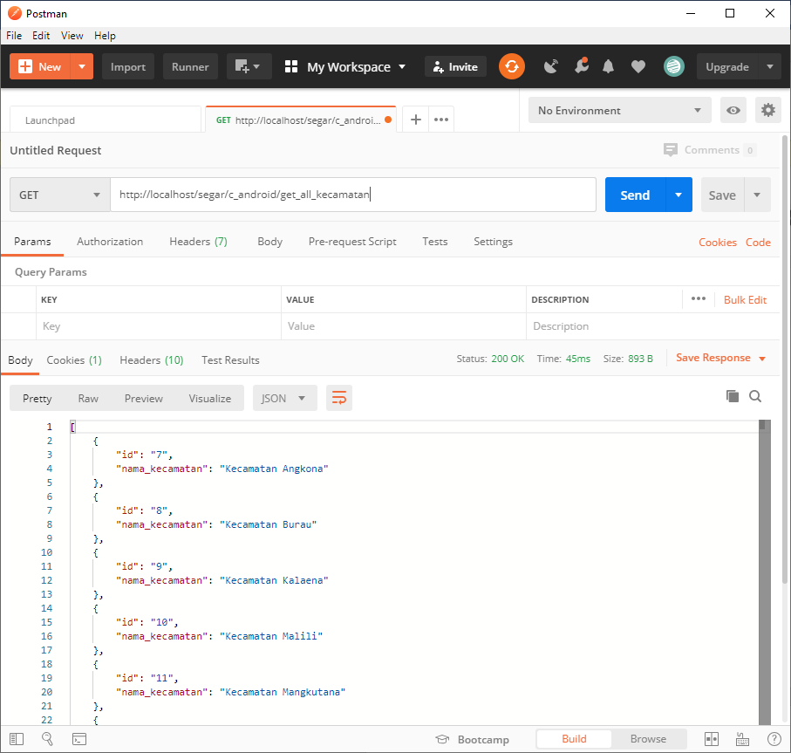

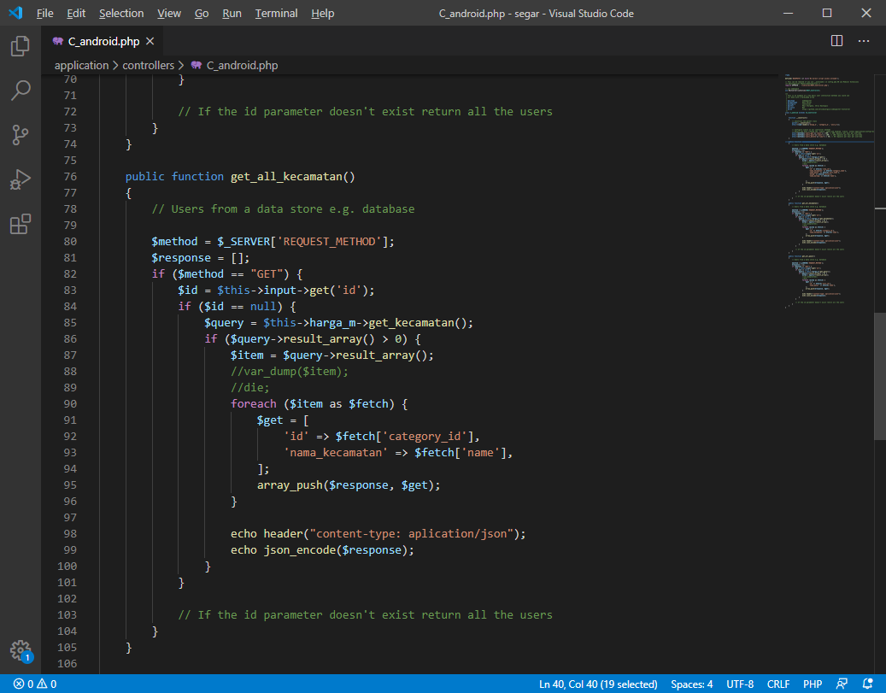

Respon : Ok

Get Data Pasar

Methot : Get

Url : <http://localhost/segar/c_android/get_all_kecamatan>

Example :

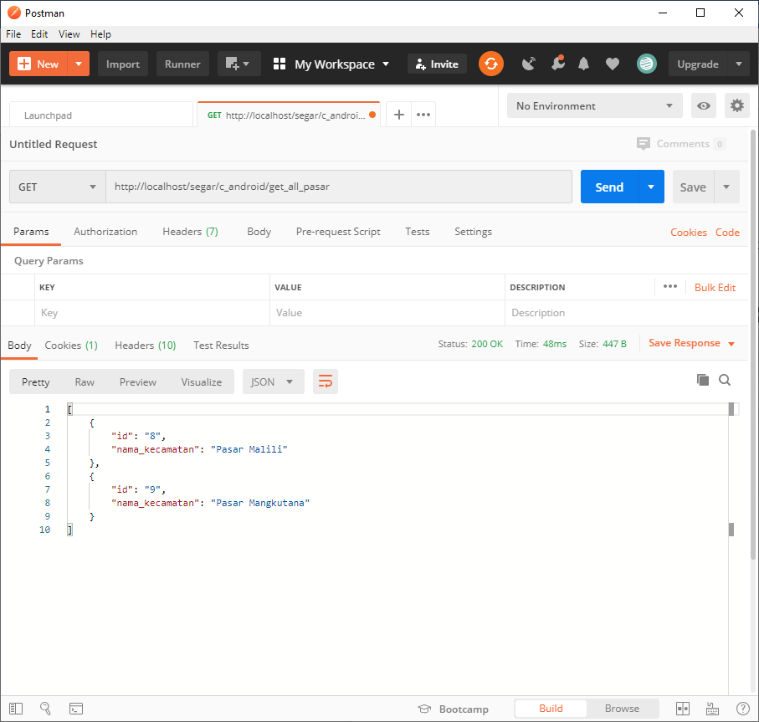

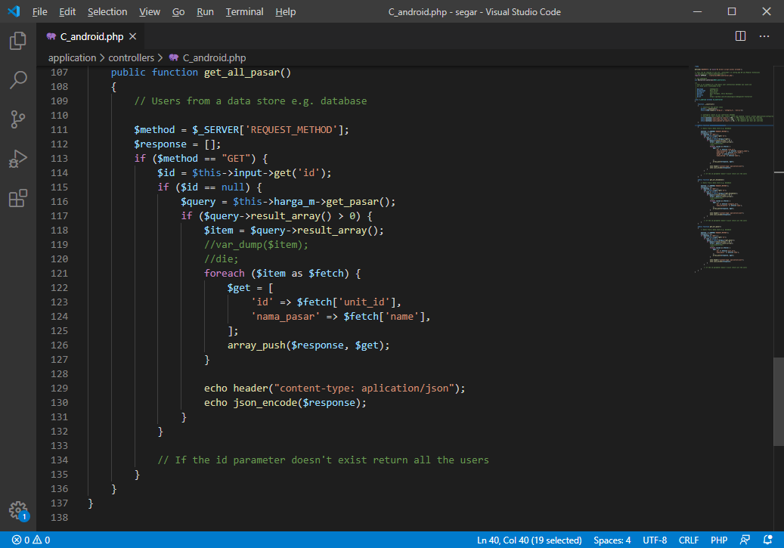

Respon : OK