
Institute Of Technology
A PROJECT REPORT ON
AUTO-DETECTING DIGITAL IC TESTER
USING STM32F446RE

Under the guidance of
Proff. Vijay Savani

Submitted by -
Herin Rashmikant Mandora - 25BEC512
B.TECH - E.C.E.

Department of Electronics and Communication Engineering
Nirma University
Academic Year 2026–27

CERTIFICATE

This is to certify that the project report entitled “Auto-Detecting Digital IC Tester Using STM32F446RE” has been carried out by the student under the guidance of the faculty member in partial fulfilment of the requirements for the award of the degree of Bachelor of Technology in Electronics and Communication Engineering.

This report describes the design, hardware interfacing, firmware and testing of the digital IC tester built using the STM32F446RE.
Date: 29/09/2026
Place: Ahmedabad
Proff. Vijay Savani
Project Guide

DECLARATION
I hereby declare that the project work entitled “Auto-Detecting Digital IC Tester Using STM32F446RE” was carried out by me as part of the Bachelor of Technology programme in Electronics and Communication Engineering.
This report describes the hardware and firmware that were implemented for the project.
Date: 29/09/2026
Place: Ahmedabad
Herin Mandora
25BEC512

ABSTRACT
This project is a digital IC tester built around the STM32F446RE microcontroller. The main aim is to test selected 74HC-series logic ICs without having to wire the gates manually on a breadboard each time. A 14-pin ZIF socket provides a reusable interface for the device under test, while the STM32 dynamically configures GPIO pins as logic inputs or outputs according to the gate being evaluated.
The supported IC families are 74HC00 NAND, 74HC02 NOR, 74HC04 NOT, 74HC08 AND, 74HC32 OR and 74HC86 XOR. The tester applies the required input combinations, reads the outputs and compares them with the expected truth-table values to identify the device and indicate a failure when the behaviour does not match. The firmware combines register-level C for clock, GPIO, I²C and board peripherals with an assembly-language testing engine for the IC test routines.
A 0.96-inch SSD1306 I²C OLED provides the user interface, while UP, DOWN and OK buttons control the menu. PASS and FAIL LEDs and a buzzer provide additional indication. The final implementation uses PA0–PA11 for the ZIF signal interface, PB8/PB9 for I²C1, and PC0–PC5 for controls and indicators.
This report covers the connections, firmware structure, testing method and limitations. The source files are provided with the project folder.

TABLE OF CONTENTS
Section | Title
1 | Introduction
2 | Technical Background
3 | System Requirements and Specifications
4 | System Architecture
5 | Hardware Design and Final Connections
6 | Firmware and Code Structure
7 | IC Testing Methodology
8 | Truth Tables and Verification
9 | OLED User Interface
10 | Testing and Results
11 | Limitations and Discussion
12 | Conclusion and Future Scope
Appendix A | Final Pin Mapping
Appendix B | Gate-to-Pin Mapping
Appendix C | Code, Outputs & Github

1. INTRODUCTION

1.1 Problem Statement
Testing digital logic ICs in a conventional laboratory setup generally requires a breadboard, switches or signal sources, LEDs or a logic probe, jumper wires and repeated manual wiring. This is useful for learning individual gates, but inconvenient when multiple ICs must be checked repeatedly.

1.2 Project Objectives
- Design a reusable tester around the STM32F446RE Nucleo board.
- Provide a 14-pin ZIF interface for common 74HC-series logic ICs.
- Automatically apply truth-table combinations and observe outputs.
- Identify supported IC behaviour and provide PASS/FAIL feedback.
- Provide an OLED menu with push-button navigation.
- Use register-level C for peripheral support while retaining the working assembly test engine.
- Keep individual IC routines modular.

1.3 Scope
The implemented scope is limited to six supported 74HC families and the final 14-pin ZIF arrangement. The tester performs functional digital checking; it is not a semiconductor characterization instrument and does not measure propagation delay, leakage current, noise margin or analog thresholds.

2. TECHNICAL BACKGROUND

2.1 CMOS Logic and 74HC Devices
The 74HC family consists of CMOS logic devices. In this project the DUT is powered from the Nucleo board's 3.3 V rail so that the MCU and supported logic devices share the same nominal logic-voltage domain.

2.2 Truth-Table Testing
A combinational gate can be verified by applying all possible input combinations and comparing the observed output with its truth table. Two-input gates require 00, 01, 10 and 11; an inverter requires 0 and 1.
IC | Function | Signature
74HC00 | NAND | 1110
74HC02 | NOR | 1000
74HC04 | NOT | 10
74HC08 | AND | 0001
74HC32 | OR | 0111
74HC86 | XOR | 0110

2.3 Dynamic GPIO Direction
Because ZIF pins are shared between stimulus and measurement, firmware changes their direction during testing. Gate input pins become outputs to drive 0/1 into the DUT; the gate output becomes an input for sampling.

2.4 Floating Output Protection
A weak internal pull-down on the Y/output pin prevents a disconnected or floating output from picking up capacitive coupling from adjacent driven pins. The test engine also uses repeated sampling with a settling interval so unstable observations do not become valid results.

3. SYSTEM REQUIREMENTS AND SPECIFICATIONS

3.1 Functional Requirements
Requirement | Implementation
DUT interface | 14-pin ZIF socket
Supported devices | 74HC00, 02, 04, 08, 32, 86
Controller | STM32F446RE Nucleo-64
Display | 0.96-inch 128×64 SSD1306 OLED
User input | UP, DOWN, OK
Result indication | PASS LED, FAIL LED, buzzer
Communication | I²C1 on PB8/PB9
Firmware | Register-level C + Assembly

3.2 Electrical Requirements
- DUT supply: 3.3 V from Nucleo.
- ZIF pin 7 → GND; ZIF pin 14 → 3.3 V.
- 1 kΩ series resistors on MCU-to-ZIF signal lines.
- 100 nF decoupling across DUT supply pins.
- GPIO output states controlled before sampling.

3.3 Design Constraints
The hardware intentionally uses STM32 GPIOs directly rather than external logic drivers. This reduces component count but makes safe GPIO direction changes and correct sequencing essential.

4. SYSTEM ARCHITECTURE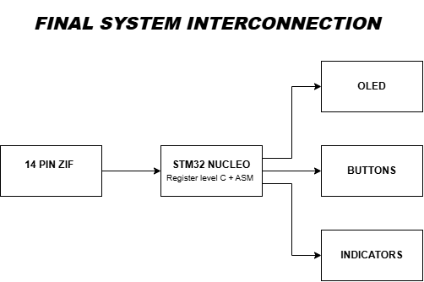

Figure 1. Final system interconnection used by the prototype.

4.1 Functional Flow
Power ON
⬇️
Clock / SysTick / GPIO / I²C initialization
⬇️
OLED initialization and main menu
⬇️
AUTO DETECT
⬇️
Sequential IC test routines
⬇️
Truth-table observations + candidate score
⬇️
PASS / UNKNOWN / EMPTY
⬇️
OLED + LED + buzzer indication
⬇️
Return to menu

4.2 Separation of Responsibilities
- Register-level C: clock, delays, GPIO, buttons, indicators and I²C/OLED support.
- Assembly: menu/test engine and per-family gate testing routines.
- Hardware: ZIF socket, DUT supply, resistor isolation and user interface.

5. HARDWARE DESIGN AND FINAL CONNECTIONS

5.1 Final ZIF-to-STM32 Connections
ZIF | STM32 / Supply | Role
1 | PA0 | Gate signal
2 | PA1 | Gate signal
3 | PA2 | Gate signal
4 | PA3 | Gate signal
5 | PA4 | Gate signal
6 | PA5 | Gate signal
7 | GND | DUT ground
8 | PA6 | Gate signal
9 | PA7 | Gate signal
10 | PA8 | Gate signal
11 | PA9 | Gate signal
12 | PA10 | Gate signal
13 | PA11 | Gate signal
14 | 3.3 V | DUT supply

5.2 User Interface
STM32 | Connected device | Configuration
PC0 | UP | Input, pull-up, active-low
PC1 | DOWN | Input, pull-up, active-low
PC2 | OK | Input, pull-up, active-low
PC3 | PASS LED | Push-pull output
PC4 | FAIL LED | Push-pull output
PC5 | Buzzer | Push-pull output
PB8 | OLED SCL | I²C1
PB9 | OLED SDA | I²C1

5.3 Physical Nucleo Notes
The final wiring retained the original working PA0–PA11 mapping used by the assembly tester. In the physical Nucleo wiring, PA2 corresponds to CN10 pin 35 and PA5 corresponds to CN10 pin 11; these are ZIF pin 3 and ZIF pin 6.

5.4 Protection
Each MCU-to-ZIF signal uses a 1 kΩ series resistor. This provides isolation and limits current during transitions or accidental direction conflicts. The DUT is powered directly from the board supply, not from a GPIO.

6. FIRMWARE AND CODE STRUCTURE

6.1 Final Project Structure
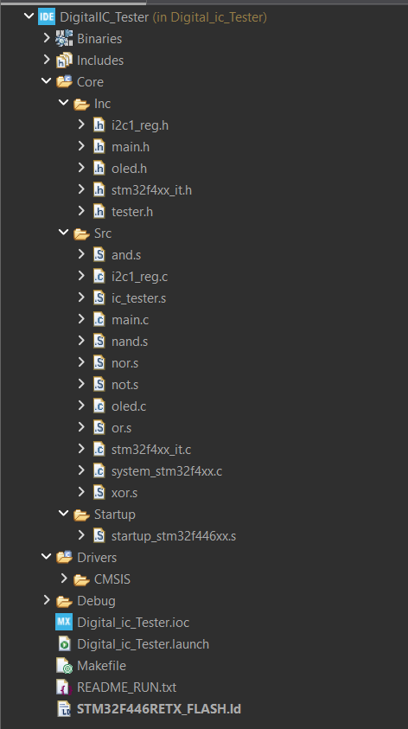

6.2 C + Assembly Design
The firmware uses both C and Assembly. Register-level C is used for the peripherals and board-level functions, while the working Assembly tester handles the main IC testing sequence.

6.3 Module Responsibilities
Module | Responsibility
main.c | Startup and application entry
i2c1_reg.c | Register-level I²C1 transactions
oled.c | SSD1306 display functions
ic_tester.s | Main tester/menu and orchestration
nand.s / nor.s / not.s | 74HC00 / 02 / 04 tests
and.s / or.s / xor.s | 74HC08 / 32 / 86 tests
startup...s | MCU startup/vector table
CMSIS | Device/register definitions

6.4 Maintainability
The display layer does not contain IC-testing decisions, the I²C layer only handles bus transactions, and the assembly gate files contain truth-table testing. This separation makes debugging easier and allows the peripheral implementation to change without rewriting gate logic.

7. IC TESTING METHODOLOGY

7.1 Test Sequence
For each supported IC family, the tester configures the GPIOs according to that device's internal gate arrangement. For a two-input gate, A and B are driven through 00, 01, 10 and 11 while Y is sampled. The resulting observations are accumulated into the detection result.

7.2 Gate-by-Gate Verification
Gate | Stimulus | Example expected output for NAND
G1 | 00, 01, 10, 11 | 1, 1, 1, 0
G2 | 00, 01, 10, 11 | 1, 1, 1, 0
G3 | 00, 01, 10, 11 | 1, 1, 1, 0
G4 | 00, 01, 10, 11 | 1, 1, 1, 0
AND, OR and XOR use the same four input combinations with their respective truth-table outputs. NOR uses its device-specific package mapping. The 74HC04 is tested as six independent inverters.

7.3 Auto Detection
The implemented firmware evaluates the supported routines sequentially and tracks observed test performance. Candidate selection follows the implemented score/threshold mechanism and reports UNKNOWN/FAIL when the acceptance condition is not satisfied. The detection method described here is the one implemented in the firmware.

8. TRUTH TABLES AND VERIFICATION

8.1 Two-Input Gates
A | B | NAND | NOR | AND | OR | XOR
0 | 0 | 1 | 1 | 0 | 0 | 0
0 | 1 | 1 | 0 | 0 | 1 | 1
1 | 0 | 1 | 0 | 0 | 1 | 1
1 | 1 | 0 | 0 | 1 | 1 | 0

8.2 Inverter
A | NOT A
0 | 1
1 | 0

8.3 Package Signatures
Device | Signature
74HC00 | 1110
74HC02 | 1000
74HC04 | 10
74HC08 | 0001
74HC32 | 0111
74HC86 | 0110

8.4 Fault Detection
Incorrect outputs on one or more gates reduce the candidate's test performance and can cause the final result to be UNKNOWN/FAIL. The diagnostic resolution depends on which gates fail and the accumulated result.

9. OLED USER INTERFACE

9.1 Main Menu
MENU

> AUTO DETECT
SUPPORTED ICs
ABOUT
AUTO DETECT is the primary testing operation. SUPPORTED ICs provides a reference list and ABOUT displays controller/project information.

9.2 Detection Screens
TESTING...

74HC08
PASS

or

UNKNOWN IC
FAIL

or

NO IC
EMPTY

9.3 Buttons
Button | Pin | Action
UP | PC0 | Move selection upward
DOWN | PC1 | Move selection downward
OK | PC2 | Select / confirm / return

9.4 Indicators
The OLED provides the detailed result while the PASS LED, FAIL LED and buzzer provide immediate physical feedback.

9.5 OLED Bus
The SSD1306 display is connected to I²C1: PB8 is SCL and PB9 is SDA. The display layer sends initialization, text and refresh operations through the register-level I²C driver.

10. TESTING AND RESULTS

10.1 Functional Test Plan
Test case | Expected behaviour | Observation
Power-on | Menu appears | As Expected
OLED | Text visible | As Expected
Buttons | Navigation works | As Expected
74HC00 | NAND accepted | As Expected
74HC02 | NOR accepted | As Expected
74HC04 | NOT accepted | As Expected
74HC08 | AND accepted | As Expected
74HC32 | OR accepted | As Expected
74HC86 | XOR accepted | As Expected
Empty socket | NO IC / EMPTY | As Expected

10.2 Reporting Discipline
The test cases below describe the expected behaviour of the prototype. Actual observations can be recorded during the demonstration.

10.3 Demonstration Sequence
- Power the Nucleo through USB.
- Insert a supported IC in the correct orientation.
- Select AUTO DETECT.
- Observe TESTING... and the result.
- Repeat for the supported devices.
- Remove the IC and verify the empty-socket message.
- Optionally test an incorrect or faulty device.

11. LIMITATIONS AND DISCUSSION

11.1 Functional, Not Parametric
The tester checks digital functionality. It does not characterize propagation delay, VIH/VIL margins, output drive, leakage, power consumption or temperature dependence.

11.2 Behavioural Identification Limit
Identification is based on observed logic behaviour. A damaged or incorrectly labelled device that behaves exactly like another supported family across all applied tests cannot be distinguished by a black-box functional tester.

11.3 Supported Device Set
Only six 74HC families are implemented. Adding more devices requires new package mappings, gate routines and truth-table definitions.

11.4 Electrical Safety
Correct insertion orientation and a stable 3.3 V supply are required. The ZIF interface is not intended for arbitrary ICs with unknown pinouts or supply requirements. Series resistors reduce fault current but do not make arbitrary devices safe.

11.5 Engineering Lessons
- Keeping the known-working assembly test logic unchanged reduced the risk of reintroducing gate-level faults.
- Replacing HAL dependencies with small register-level C modules made the final firmware self-contained.
- A single source of truth for pin mapping is essential; one wrong GPIO assignment can look like an algorithm failure.
- Floating output pins can produce false detections, so pull-down and repeated sampling are important.

12. CONCLUSION AND FUTURE SCOPE

12.1 Conclusion
The completed prototype shows how the STM32F446RE can be used to build a compact tester for digital logic ICs. The final prototype combines a 14-pin ZIF interface, register-level GPIO and I²C control, an SSD1306 OLED, push buttons and visual/audible result indicators.
One of the main parts of the project is the dynamic GPIO configuration used to drive the IC inputs and read its outputs. The assembly test engine performs gate-level verification while the C layer provides board and peripheral infrastructure. Retaining the original PA0–PA11 mapping preserved the working core test behaviour during the HAL-to-register-level transition.

12.2 Future Scope
- Add more 74HC/74LS/CMOS families.
- Store test history or statistics.
- Add UART/USB diagnostic logs.
- Add per-gate fault reporting.
- Add an exact-signature classifier if the firmware is later revised to use one.
- Add voltage/current monitoring.
- Design a custom PCB around the ZIF socket and protection.
- Add socket/insertion detection.

12.3 Final Takeaway
The project is divided into separate hardware, peripheral, display and testing modules, so individual parts can be improved later without changing the complete system.

APPENDIX A — FINAL PIN MAPPING

A.1 Complete Table
Subsystem | Pin | Final connection
ZIF | 1 | PA0
ZIF | 2 | PA1
ZIF | 3 | PA2
ZIF | 4 | PA3
ZIF | 5 | PA4
ZIF | 6 | PA5
ZIF | 7 | GND
ZIF | 8 | PA6
ZIF | 9 | PA7
ZIF | 10 | PA8
ZIF | 11 | PA9
ZIF | 12 | PA10
ZIF | 13 | PA11
ZIF | 14 | 3.3 V
Button | UP | PC0
Button | DOWN | PC1
Button | OK | PC2
Indicator | PASS LED | PC3
Indicator | FAIL LED | PC4
Indicator | Buzzer | PC5
OLED | SCL | PB8 / I²C1 SCL
OLED | SDA | PB9 / I²C1 SDA

A.2 Practical Checklist
- ZIF 7 ➡️ GND.
- ZIF 14 ➡️ 3.3 V.
- Do not use GPIO for ZIF supply pins.
- Use 1 kΩ series resistors on PA0–PA11 signal paths.
- Use active-low buttons with internal pull-ups.
- Verify IC orientation before AUTO DETECT.

APPENDIX B — GATE MAP

B.1 Gate Mapping
Family | Gate 1 | Gate 2 | Gate 3 | Gate 4
74HC00/08/32/86 | Z1,Z2➡️Z3 | Z4,Z5➡️Z6 | Z9,Z10➡️Z8 | Z12,Z13➡️Z11
74HC02 | Z2,Z3➡️Z1 | Z5,Z6➡️Z4 | Z8,Z9➡️Z10 | Z11,Z12➡️Z13

APPENDIX C — CODE & OUTPUTS & GitHub

C.1 Firmware and Source Code
The project firmware is developed for the STM32F446RE Nucleo board. The final firmware uses register-level C along with ARM Cortex-M4 Assembly for the IC testing functions. The OLED is controlled through I²C and the digital IC pins are controlled directly through GPIO registers.

C.1.1 Project Source Structure
File / Folder | Purpose
Core/Inc/main.h | Main project definitions and declarations.
Core/Inc/tester.h | Interface for the IC tester and Tester_Run().
Core/Inc/oled.h | OLED display function declarations.
Core/Inc/i2c1_reg.h | Register-level I²C declarations.
Core/Inc/stm32f4xx_it.h | Interrupt handler declarations.
Core/Src/main.c | Main program, clock setup, SysTick, GPIO/I²C initialization and main loop.
Core/Src/i2c1_reg.c | Register-level I²C1 implementation for the SSD1306 OLED.
Core/Src/oled.c | SSD1306 OLED display driver and display functions.
Core/Src/ic_tester.s | Main ARM Assembly tester logic, GPIO access, candidate testing and auto-detection.
Core/Src/nand.s | NAND gate testing routine.
Core/Src/nor.s | NOR gate testing routine.
Core/Src/not.s | NOT gate testing routine.
Core/Src/and.s | AND gate testing routine.
Core/Src/or.s | OR gate testing routine.
Core/Src/xor.s | XOR gate testing routine.
Core/Src/stm32f4xx_it.c | Interrupt/SysTick support and project delay compatibility function.
Core/Src/system_stm32f4xx.c | STM32 system support code.
Core/Startup/startup_stm32f446xx.s | STM32 startup code and interrupt vector table.
Drivers/CMSIS/ | CMSIS device/core support used by the STM32 project.

C.1.2 Main Firmware Flow
- STM32 starts from the startup code and enters main().
- System clock is configured using the internal HSI and PLL.
- GPIO pins, buttons and the I²C OLED interface are initialized.
- The OLED shows the main menu.
- When AUTO DETECT is selected, the tester places the ZIF pins in a safe state before testing.
- Each supported IC candidate is tested gate-by-gate using the required input combinations.
- The output pin is sampled with a weak pull-down and read twice after settling. An unstable reading causes that test to fail.
- The measured results are compared with the expected logic behaviour of the candidate IC.
- The candidate with a strict majority of matching tests is accepted. If no candidate reaches the required majority, the result is shown as UNKNOWN IC / FAIL.
- The result is shown on the OLED and the PASS/FAIL indicator and buzzer are controlled accordingly.

C.1.3 Supported ICs
IC | Logic Function | Testing
74HC00 | NAND | 4 gates × 4 input combinations
74HC02 | NOR | 4 gates × 4 input combinations
74HC04 | NOT | 6 gates × 2 input combinations
74HC08 | AND | 4 gates × 4 input combinations
74HC32 | OR | 4 gates × 4 input combinations
74HC86 | XOR | 4 gates × 4 input combinations

C.2 Project Outputs
This section is reserved for the actual screenshots and photographs obtained during the final demonstration. Replace the placeholders below with the corresponding images from the working hardware and STM32CubeIDE.

C.2.1 Output 1 – Successful Build
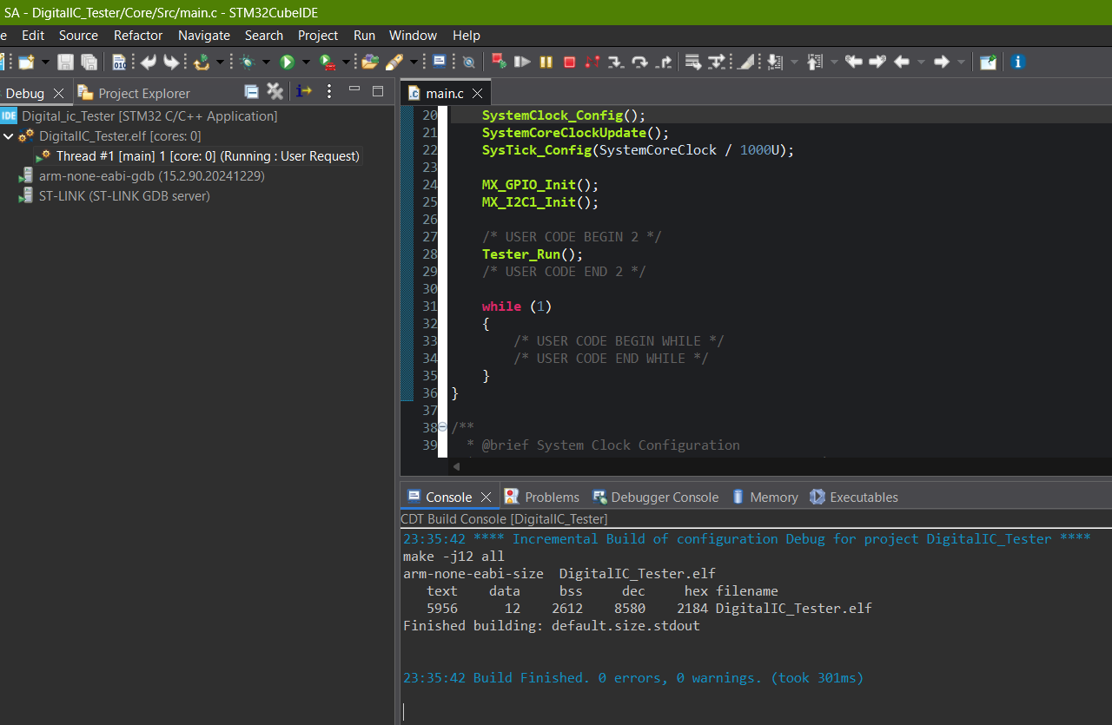

C.2.2 Output 2 – Main Menu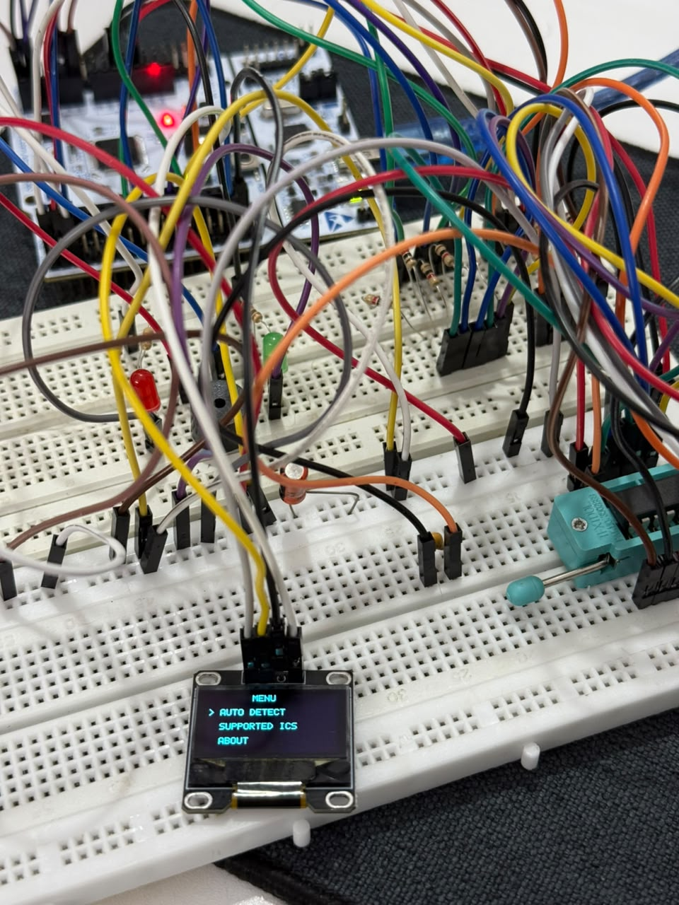

C.2.3 Output 3 – Testing Screen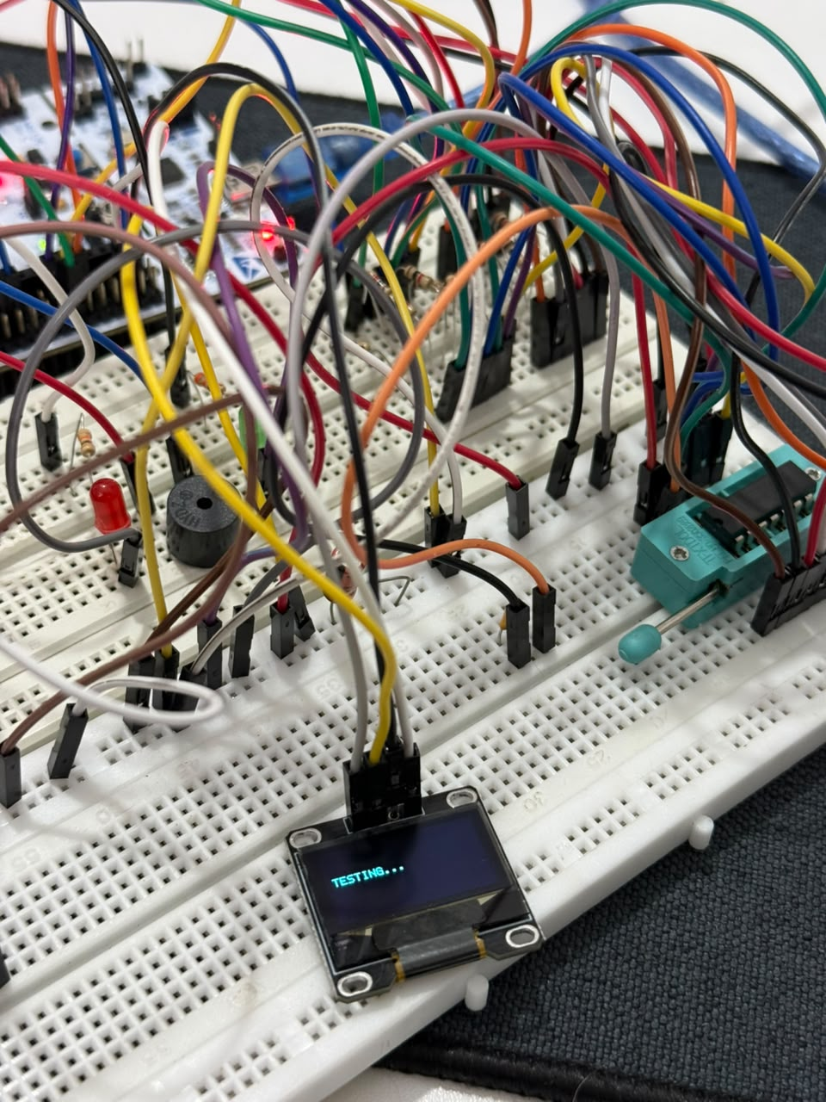

[

C.2.6 Output 4 – 74HC04 PASS
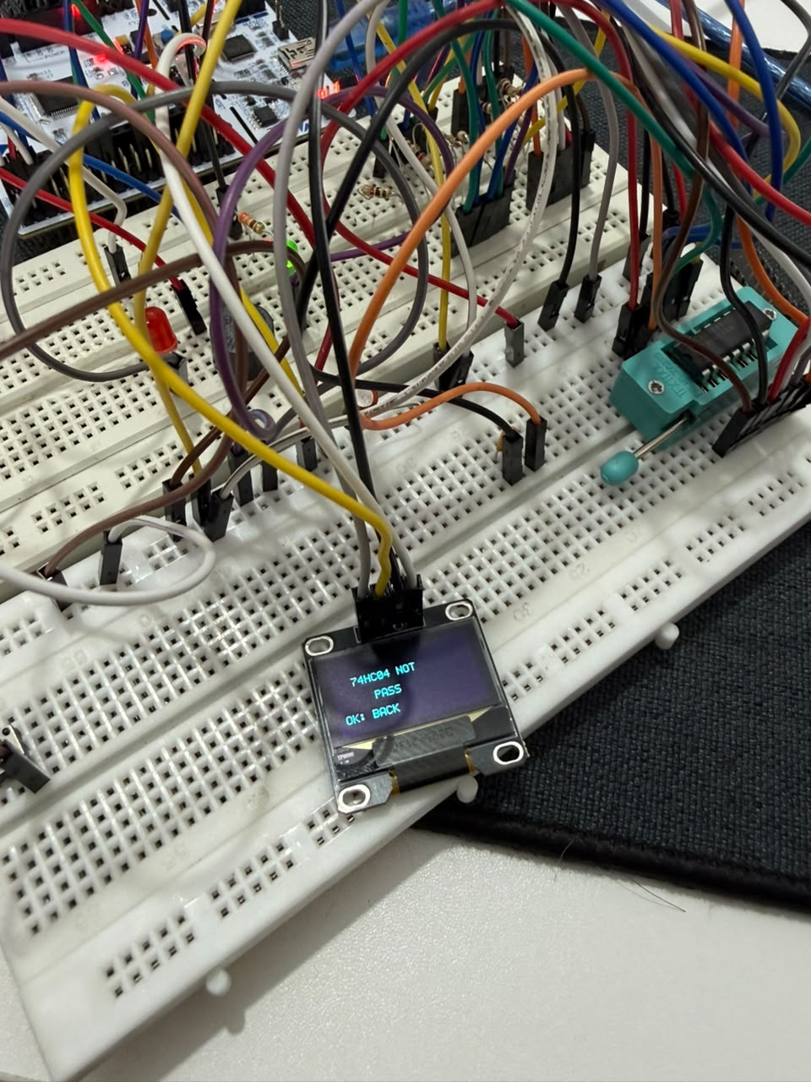

C.2.7 Output 5 – 74HC08 PASS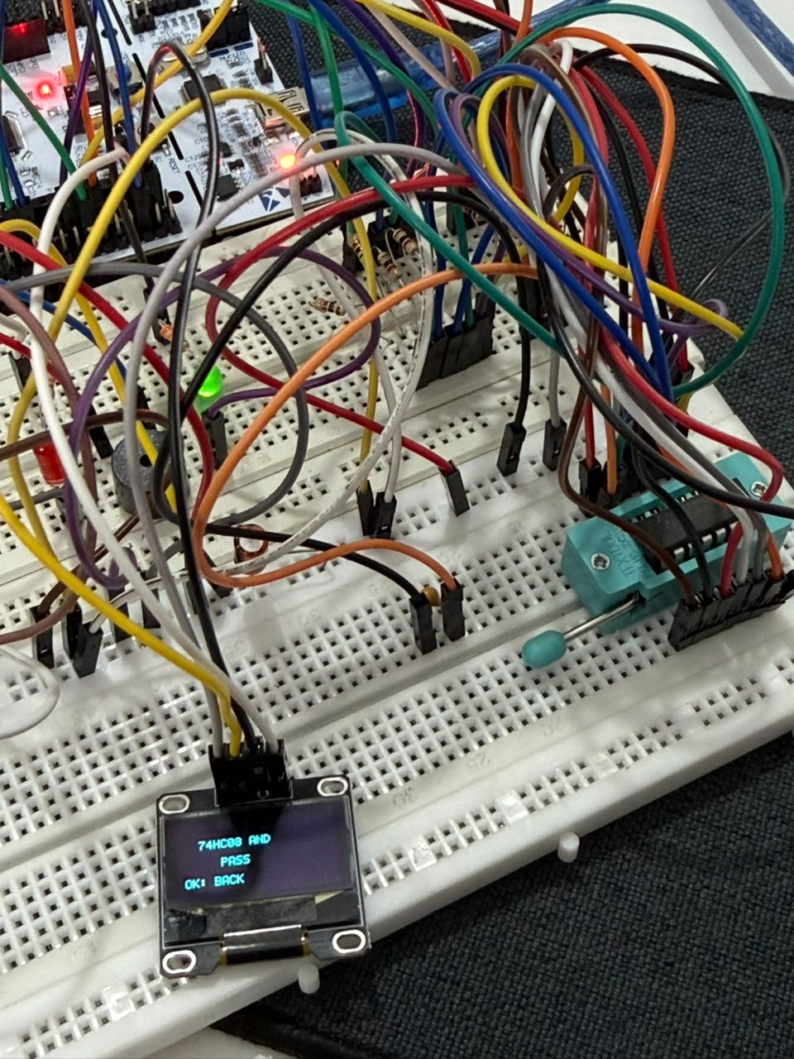

C.2.8 Output 6 – 74HC32 PASS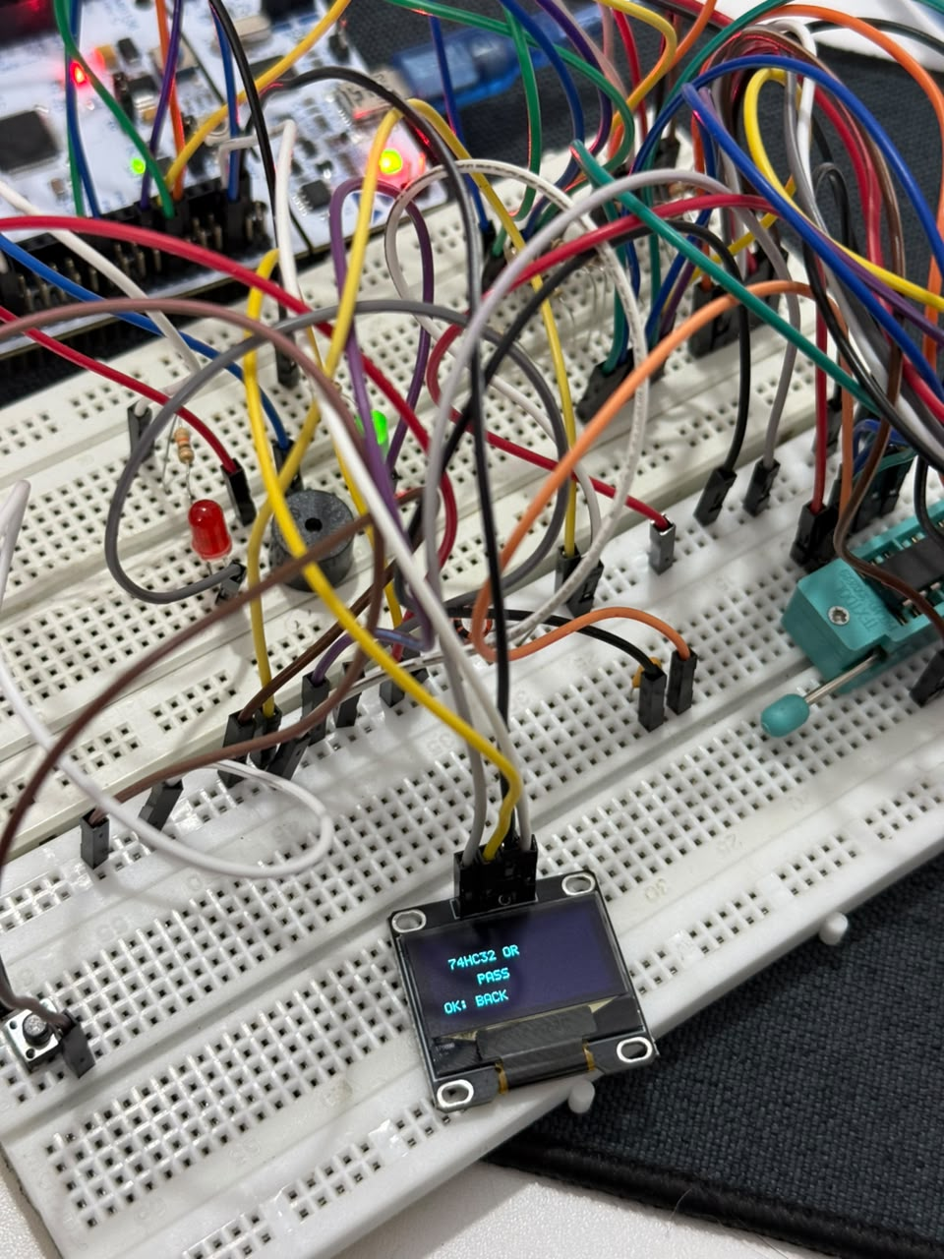

C.2.10 Output 7 – Empty Socket / Unknown IC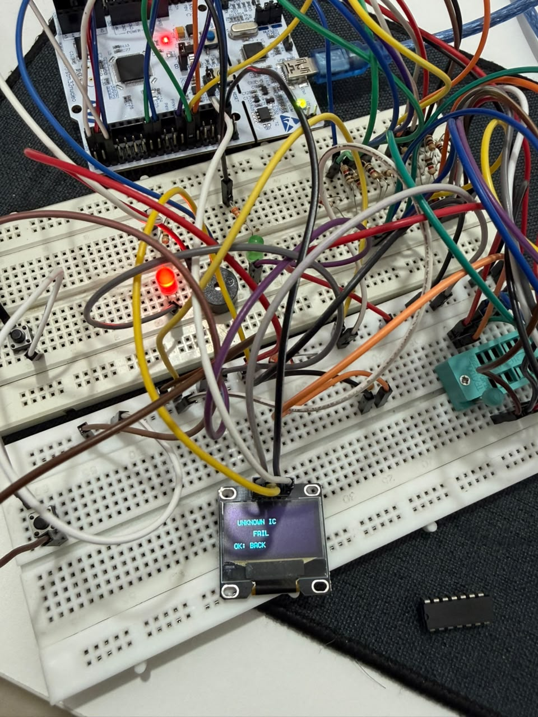

C.2.11 Output 8 – Complete Hardware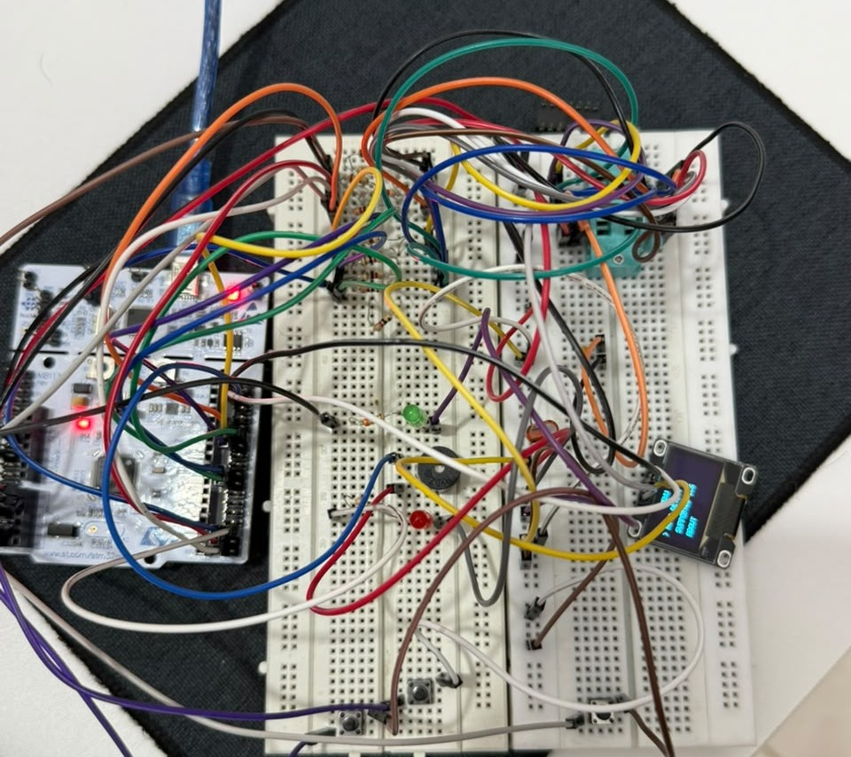

C.3.1 GitHub Repository :
Link : https://github.com/HerinMandora/Digital-ic-tester

C.3.1 Project Working video :
Link : https://github.com/HerinMandora/Digital-ic-tester/blob/main/Digital_IC_Tester.mp4

REFERENCES
- STMicroelectronics, STM32F446RE reference and programming documentation.
- STMicroelectronics, STM32 Nucleo-F446RE board documentation.
- 74HC-series logic IC datasheets for functional truth tables and pin assignments.
- SSD1306 controller documentation for I²C display operation.
- Submitted project source files and firmware archive used as the implementation basis.

