RELIABLE APPLIED MACHINE LEARNING
UNDER TEMPORAL AND GEOGRAPHIC DISTRIBUTION SHIFT
Two Case Studies in Forecasting and Semantic Segmentation
Herislei Pimentel
Independent Researcher | Electrical Engineer | Brazil
ORCID: 0009-0001-0692-4015
Technical Report HCP-TR-2026-01 | Version 1.0 | September 2026
Status and scope
Independent technical report synthesizing two applied machine-learning studies completed in September 2026. The report is intended for public research dissemination and has not undergone peer review. The emphasis is on leakage-aware evaluation, reproducibility, failure analysis, and transparent limitations.
Abstract
Reliable applied machine learning requires more than strong average predictive metrics: evaluation must respect the way a model will encounter future or geographically unseen data. This technical report presents two case studies built around that principle. The first examines Capital Bikeshare demand forecasting using 17,379 hourly observations from 2011-2012. A conservative walk-forward protocol prevents evaluation labels from leaking into later model fits. The best weather-enhanced Histogram Gradient Boosting model achieved MAE 36.59, RMSE 61.88, and RMSLE 0.461, reducing MAE by approximately 52.6% relative to a historical baseline. The second case study evaluates building-footprint segmentation under geographic shift. Austin, Chicago, and Kitsap were used for training, Tyrol-W for validation, and Vienna remained untouched until final testing. A U-Net with an ImageNet-pretrained ResNet-34 encoder achieved mean IoU 0.588, Dice 0.716, Precision 0.635, Recall 0.886, and Boundary F1 0.297 on Vienna. The combined evidence shows that strict temporal and spatial separation, interpretable diagnostics, and explicit failure analysis are central to credible assessment of applied machine-learning systems.
Keywords: reliable machine learning; distribution shift; time-series forecasting; semantic segmentation; data leakage; generalization; failure analysis
1. Introduction
Applied machine-learning performance can be overstated when training and evaluation data are not separated in a way that reflects deployment. Temporal leakage can occur when future information enters model fitting, directly or indirectly. Geographic leakage can occur when spatially adjacent or otherwise similar samples are divided across train and test sets. Both mechanisms can make evaluation easier than the real problem.
The two studies reported here use different tasks and data modalities, but they share a common experimental principle: model selection must occur without access to the final evaluation distribution. The first study evaluates forecasting under strict temporal ordering. The second evaluates semantic segmentation under an unseen-city test. In both cases, the analysis emphasizes assumptions, diagnostics, and failure modes rather than treating a single accuracy number as sufficient evidence of reliability.
2. Case Study I - Leakage-Aware Urban Mobility Forecasting
2.1 Data and leakage controls
The Capital Bikeshare analysis uses the UCI hourly Bike Sharing dataset with 17,379 observations from 1 January 2011 through 31 December 2012. The normalized weather variables were converted to the units specified in the original assessment. No missing values were present. Because casual users plus registered users exactly equal total count, the component user-count variables were reserved for descriptive analysis and excluded from predictive models.
For each month, days 21 through month-end form the evaluation window. Training uses only observations from days 1-20 that occur before that window. Labels from evaluation windows are not recycled into later fits. This walk-forward protocol is intentionally conservative and is designed to prevent temporal leakage.
2.2 Statistical diagnostics and modeling
Temperature and apparent temperature were highly correlated (r = 0.988), so temperature was retained and apparent temperature was excluded from the inferential model. A Poisson generalized linear model produced Pearson dispersion of 14.37; the analysis therefore used a Negative Binomial GLM with robust standard errors. Hour and month were modeled categorically, and an hour-by-working-day interaction allowed commuting behavior to vary by time of day. These regression results are interpreted as associations rather than causal effects.
Term | IRR | 95% CI low | 95% CI high
Temperature (+5 C) | 1.184 | 1.174 | 1.195
Humidity (+10 units) | 0.983 | 0.978 | 0.987
Wind (+10 units) | 0.958 | 0.951 | 0.965
Weather category 2 | 0.940 | 0.926 | 0.953
Weather category 3 | 0.602 | 0.583 | 0.622
Weather category 4 | 0.578 | 0.471 | 0.710
Year 2012 | 1.605 | 1.587 | 1.624

2.3 Forecasting results
Model | MAE | RMSE | RMSLE | Evaluation n
HGB-weather | 36.592 | 61.882 | 0.461 | 5,919
RF-weather-log | 39.140 | 65.496 | 0.465 | 5,919
HGB-calendar | 47.529 | 82.660 | 0.543 | 5,919
Historical baseline | 77.269 | 115.381 | 0.627 | 5,919

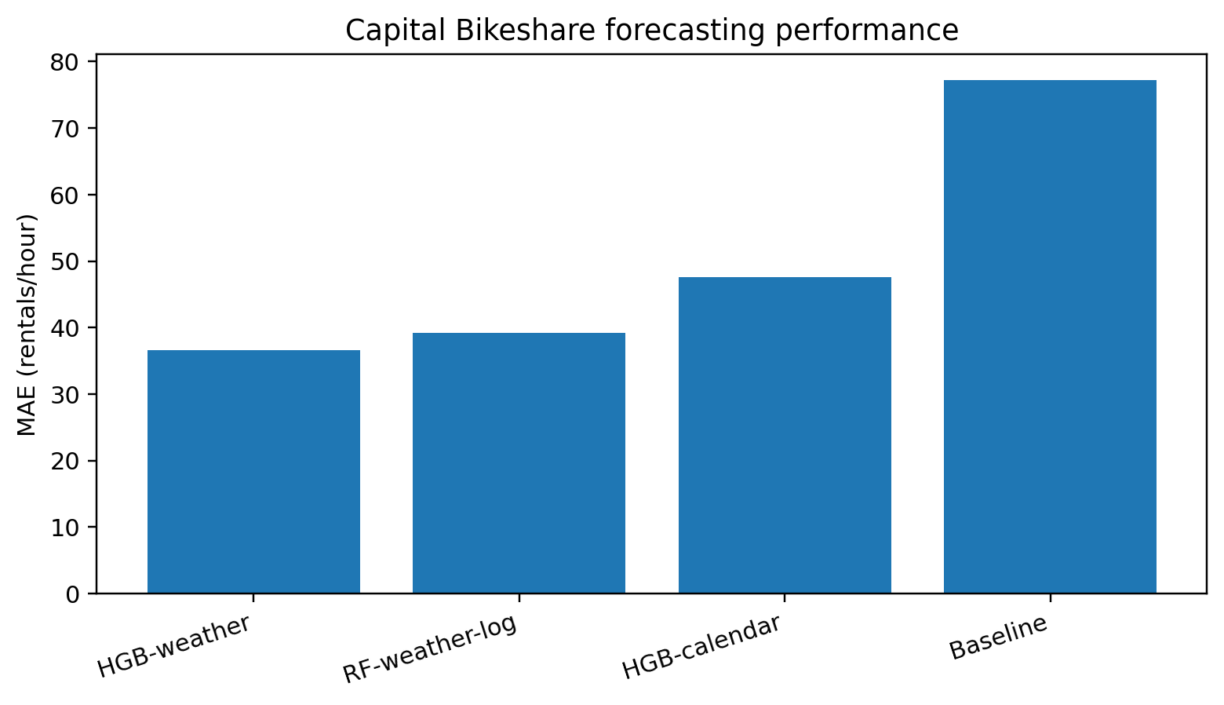
Figure 1. Mean absolute error under the walk-forward evaluation protocol.
The HGB-weather model produced the lowest errors, with MAE 36.592 compared with 77.269 for the historical baseline. This corresponds to an approximate 52.6% reduction in MAE. The weather-enhanced results assume that weather covariates are available ex ante from a forecast service; the calendar-only model provides a reference for performance without that assumption.
3. Case Study II - Building-Footprint Segmentation Under Geographic Shift
3.1 Spatial partitioning and model
The labeled Inria cities were partitioned before patch creation. Austin, Chicago, and Kitsap were used for training; Tyrol-W was used for validation; and Vienna was reserved exclusively for final testing. Each 5000 x 5000 tile contributed a deterministic 4 x 4 grid of non-overlapping 512 x 512 patches. This design blocks geographic leakage by construction because spatially adjacent crops cannot be assigned to different splits.
Split | Cities | Tiles | Patches
Training | Austin, Chicago, Kitsap | 108 | 1,728
Validation | Tyrol-W | 36 | 576
Final test | Vienna | 36 | 576

The segmentation model was a U-Net with an ImageNet-pretrained ResNet-34 encoder. The estimated foreground imbalance produced a positive-class weight of 5.96. The objective combined 0.45 weighted binary cross-entropy, 0.45 soft Dice loss, and 0.10 boundary loss. AdamW with learning rate 3e-4 and early stopping on validation IoU were used.
3.2 Test performance on unseen Vienna
Metric | Mean | Standard deviation
IoU | 0.5876 | 0.1955
Dice | 0.7156 | 0.2045
Precision | 0.6345 | 0.1979
Recall | 0.8859 | 0.1588
Boundary F1 | 0.2967 | 0.1889

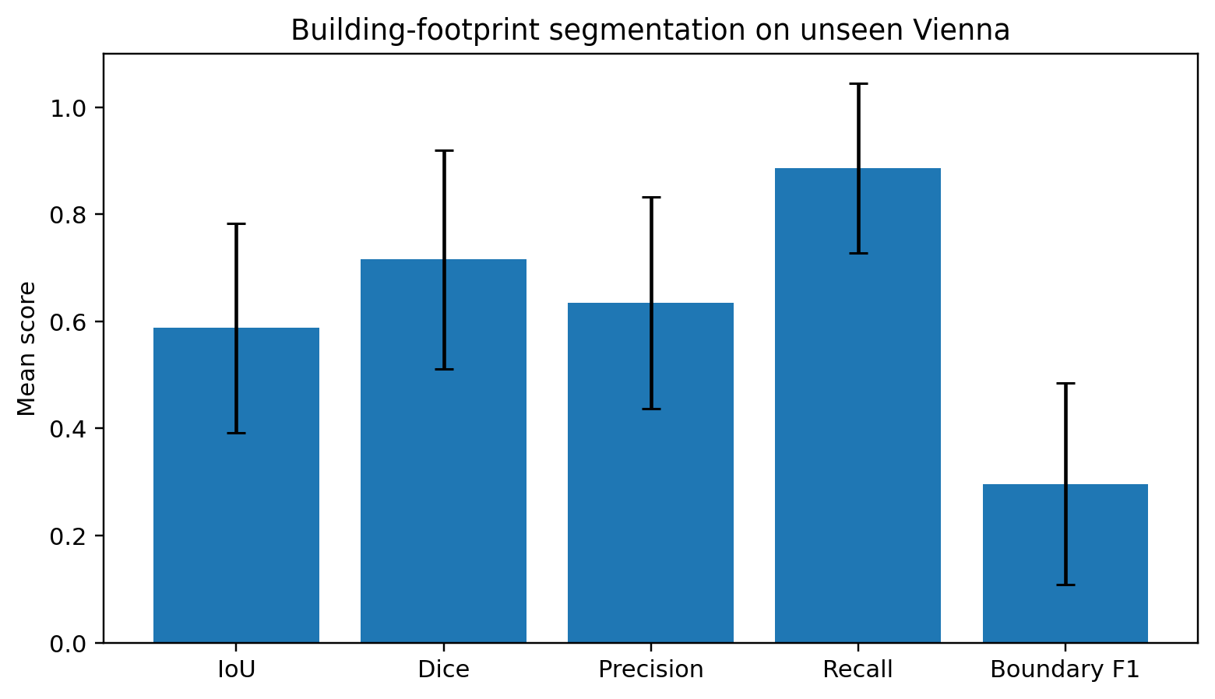
Figure 2. Mean segmentation metrics on the unseen Vienna test city; error bars show the reported standard deviation.
3.3 Failure analysis
The high Recall indicates that most building pixels were recovered, while the lower Precision indicates relevant false-positive over-segmentation. The substantially lower Boundary F1 identifies edge localization as a major weakness. The qualitative assessment retained low-performing examples rather than removing them as outliers. Observed errors included false positives on visually roof-like surfaces, missed small structures, and imperfect footprint boundaries.
The interpretation is intentionally limited: one held-out city supports a credible test of geographic transfer, but it does not establish universal robustness across unseen cities or operational environments.
4. Cross-Case Lessons for Reliable Applied ML
• Evaluation design is part of the model claim. Walk-forward testing and city-held-out testing answer harder, more deployment-relevant questions than random splits.
• Leakage prevention matters as much as model complexity. A sophisticated model evaluated with optimistic data separation can give less credible evidence than a simpler model under a strict protocol.
• Average metrics are not sufficient. Regression diagnostics, baseline comparisons, class-specific metrics, boundary quality, and qualitative error analysis reveal different failure modes.
• Assumptions should be explicit. The bikeshare weather-enhanced models assume ex-ante weather covariates; the segmentation study tests one unseen city rather than universal geographic robustness.
• Reliability-oriented machine learning should include mechanisms to recognize when a prediction is no longer trustworthy enough to use without review or fallback.
5. Research Extension: Failure-Aware Railway Perception
A natural extension is to transfer the distribution-shift framework to railway vision. A proposed exploratory design uses railway scenes with controlled visual degradation such as blur, low light, fog, noise, motion blur, and JPEG compression. The intended pipeline is: clean scene -> controlled shift -> perception -> reliability signals -> accept, warn, or fallback decision.
The central hypothesis is that a useful reliability signal should indicate degradation before the recall of safety-critical classes becomes unacceptable. Candidate research directions include confidence calibration, entropy-based diagnostics, out-of-distribution awareness, stronger boundary modeling, and fallback rules under operational constraints. No experimental results for this railway extension are claimed in this report.
6. Limitations and Reproducibility
• The bikeshare study covers only 2011-2012 and uses observed dataset weather as a proxy for ex-ante weather forecasts; deployed forecasting should ingest actual forecast values and monitor forecast error.
• The segmentation study uses one held-out test city. Broader claims require rotating held-out cities, larger training budgets, and repeated experiments.
• The segmentation probability threshold was not treated as evidence of calibrated uncertainty; future work should calibrate confidence using validation data only.
• The original technical assessment states that the data transformations, statistical models, walk-forward evaluation, spatial splitting, training, metrics, and figures were generated from an accompanying notebook. That notebook is not distributed in this public release.
7. Conclusion
The two case studies demonstrate a common principle: credible applied machine learning depends on how the experiment is separated, validated, and interpreted, not only on the choice of model. The forecasting study shows material error reduction under a strict temporal protocol. The segmentation study shows meaningful transfer to an unseen city while exposing substantial false-positive and boundary-localization weaknesses. Together, the results motivate a research direction centered on reliable, failure-aware, and uncertainty-conscious machine learning for engineering systems.
References
• Fanaee-T, H.; Gama, J. Bike Sharing Dataset. UCI Machine Learning Repository.
• Maggiori, E.; Tarabalka, Y.; Charpiat, G.; Alliez, P. (2017). Can semantic labeling methods generalize to any city? The Inria Aerial Image Labeling Benchmark. IGARSS.
• Ronneberger, O.; Fischer, P.; Brox, T. (2015). U-Net: Convolutional Networks for Biomedical Image Segmentation. MICCAI.
Suggested Citation
Pimentel, H. (2026). Reliable Applied Machine Learning under Temporal and Geographic Distribution Shift: Two Case Studies in Forecasting and Semantic Segmentation. Independent Technical Report HCP-TR-2026-01, Version 1.0.

