COMPLETE PROJECT REPORT & NUMERICAL RESULTS VAULT
FRAGMILL: ADVANCED BLAST-TO-MILL ROCK FRAGMENTATION, COMMINUTION DIGITAL TWIN & GEOSTATISTICAL SYSTEM
Full Technical Report Documenting System Concepts, Backend Engineering Formulations, Exhaustive View-by-View Walkthroughs, and Complete Tabulated Results (Images, Values, Metrics, and Datasets)
Application Name: | FragMill (Blast-to-Mill Fragmentation Lab & Comminution Twin)
System Architecture: | 100% Offline-First Client-Side WebApp (IndexedDB Dexie, WebAssembly, WebRTC P2P)
Target Operations: | Artisanal & Small-Scale Mining (ASM) Cooperatives & Commercial Open Pits
Primary Pilot Project: | Bétaré Oya Mine-to-Mill Pilot (Lom & Djérem, East Cameroon - Bench 840 RL)
Documentation Scope: | Full Architecture, Mathematics, 15 View Walkthroughs & 22 Complete Data Tables

[EXECUTIVE DECLARATION & SCOPE]
This document represents the complete, exhaustive project deliverable for the FragMill application. In direct response to the operational user request, this report consolidates: (1) Full conceptual explanations and backend engineering theories, (2) An in-depth view-by-view interface walkthrough with 15 embedded high-resolution screenshots, and (3) The entire numerical data repository—including every blast parameter, particle size distribution percentile, confidence interval, laboratory sieve measurement, mill batch performance metric, economic cost curve, carbon ledger, drone survey sector, conveyor video telemetry, kriging grid block, and drill rig deviation record generated by the platform.

1. System Concepts & High-Level Architecture
1.1 The Fragment-to-Mill Paradigm & Economic Problem Statement
In mineral extraction, rock comminution (primary crushing, secondary crushing, SAG milling, and ball mill grinding) represents the largest operational expenditure on any hard-rock mine site, consuming between 50% and 70% of total electrical energy and over 50% of operating cash costs. Conversely, drilling and blasting operations represent merely 10% to 15% of the total cost per tonne. In most traditional mining operations, these departments operate in total isolation: drill and blast engineers seek to minimize drilling meters and explosive consumption, oblivious to the fact that coarse fragmentation and oversize boulders choke primary crushers and force grinding mills to consume excessive specific energy (kWh/tonne).
FragMill resolves this critical operational gap by establishing a continuous digital feedback loop from the muckpile face to the final concentrate recovery circuit. Running entirely client-side without requiring cloud servers, FragMill allows mine engineers, metallurgists, and field technicians to optimize blast fragmentation, predict mill throughput, and eliminate plant bottlenecks.
1.2 Dual Operational Ecosystem
- Artisanal & Small-Scale Mining (ASM) Mode: Designed for artisanal gold mining cooperatives, quarry foremen, and field blasting assistants. Provides a simplified 4-step wizard, interactive inclinometer posture guidance (ensuring 90° ± 5° orthogonal photography), automated reference scale detection (500mm rods, coins, measuring tapes, ANFO bags), and on-site blast recipes (calculating exact 25 kg commercial ANFO bag requirements).
- Industrial & Expert Mode: Engineered for blast superintendents, geotechnical modelers, and mill managers at tier-1 and mid-tier mining sites. Features multi-bench spatial GIS mapping, high-altitude UAV drone orthomosaic segmentation, high-speed optical conveyor belt vision, 3D blast wavefront initiation timing, IREDES rig telemetry QA/QC auditing, geostatistical Ordinary Kriging block modeling, Bond Work Index mill twins, and Scope 1 & 2 carbon accounting.
1.3 Zero-Cloud Offline-First Architectural Architecture
Remote mine sites in developing economies and deep open pits regularly experience severe RF shielding, zero cellular data coverage, and strict corporate data security constraints. FragMill was engineered as a 100% Client-Side Web Application utilizing modern browser standards:
- Dexie.js 4.x Local Database: IndexedDB database engine providing ACID transactions, zero network latency, and local persistent storage of thousands of high-resolution images, segmentation polygons, and time-series telemetry.
- Pure Client-Side Computer Vision: Fast Sobel spatial convolutions, Summed-Area Table (SAT) integral images, marker-controlled watershed flooding, and 32-radial ray facet snapping executing on device CPU/GPU threads.
- WebRTC DataChannels P2P Sync: Ad-hoc mesh synchronization over local pit Wi-Fi or Bluetooth using Conflict-Free Replicated Data Types (CRDTs), enabling field tablets and mill workstations to synchronize data without internet connectivity.

2. Mathematical & Backend Engineering Formulations
FragMill is built on rigorous rock engineering and comminution physics. This section details the complete analytical models governing every calculation in the system.
2.1 Extended Cunningham Kuz-Ram Fragmentation Model
The Kuz-Ram model computes the expected particle size distribution resulting from explosive energy detonation within a jointed rock mass:
2.1.1 Blast Rock Factor (A)
A = 0.06 × (RMD + JF + RDI + HF)
Where RMD = Rock Mass Description, JF = Joint Factor (JPS + JPA), RDI = Rock Density Influence, and HF = Hardness Factor.

Component parameters are computed as follows:
- Rock Mass Description (RMD): RMD: Set to 10 for powdery/friable rock; JF for vertically jointed rock; 50 for massive rock.
- Joint Factor (JF): JF = JPS + JPA. Joint Plane Spacing (JPS) is 10 for spacing < 0.1 m, 20 for 0.1 to 1.0 m, and 50 for > 1.0 m. Joint Plane Angle (JPA) is 20 for dip into face, 30 for strike perpendicular to face, and 40 for dip out of face.
- Rock Density Influence (RDI): RDI = 0.025 × ρ - 50, where ρ is rock density in kg/m³.
- Hardness Factor (HF): If Young's Modulus E < 50 GPa, HF = E / 3; if UCS ≥ 50 MPa, HF = UCS / 5.
2.1.2 Median Fragment Size (X50)
X50 = A × Q^(-0.8) × q^(0.167) × (115 / RWS)^(0.633) × 10
Where Q = Explosive mass per hole (kg), q = Specific powder factor (kg/m³), and RWS = Relative Weight Strength to ANFO.

2.1.3 Uniformity Exponent (n)
n = [2.2 - 14 × (B / d)] × sqrt((1 + S/B) / 2) × [1 - (W / B)] × [(|BCL - CCL| / L) + 0.1]^0.1 × (L_charge / H)
Where B = Burden (m), S = Spacing (m), d = Hole Diameter (mm), W = Drilling Deviation (m), BCL = Bottom Charge, CCL = Column Charge, L = Total Charge Length, and H = Bench Height.

2.1.4 Characteristic Size (Xc)
Xc = X50 / (ln(2))^(1 / n) = X50 / (0.69315)^(1 / n)
Analytic transformation from median size X50 to Rosin-Rammler characteristic scale parameter Xc.

2.2 Rosin-Rammler vs. Swebrec Distribution Functions
FragMill implements both classical Rosin-Rammler and modern Swebrec functions to characterize particle sizing:
- Rosin-Rammler (Weibull): P(x) = 1 - exp(-(x / Xc)^n). Robust for intermediate sizes, but tends to underestimate ultra-fines (< 1 mm).
- Swebrec Three-Parameter Model: P(x) = 100 / [ 1 + ( ln(x_max / x) / ln(x_max / x50) )^b ]. Forces P(x_max) = 100% and models sub-sieve fines with exceptional physical fidelity.
2.3 Geostatistical Ordinary Kriging Formulation
Ordinary Kriging estimates continuous rock properties across the pit bench while ensuring Best Linear Unbiased Estimation (BLUE):
γ(h) = C0 + C × [ 1.5 × (h / a) - 0.5 × (h / a)³ ] (for h <= a); γ(h) = C0 + C (for h > a)
Spherical Semi-variogram model with nugget C0, structural sill C, and spatial range a (m).

[ Γ_ij 1 ] [ λ_j ] [ γ(x_i, x0) ]
[ 1 0 ] [ μ ] = [ 1 ]
Ordinary Kriging linear system ensuring sum(λ_i) = 1 and minimizing estimation variance σ_k².

2.4 Comminution Physics & Bond Work Index Theory
W = 10 × Wi × [ (1 / sqrt(P80)) - (1 / sqrt(F80)) ]
Bond's Third Theory of Comminution: Specific energy W (kWh/t) as a function of feed F80 (µm) and product P80 (µm).

Throughput T (t/h) = P_net / W = (P_installed × η_mech) / [ 10 × Wi × ( P80^(-0.5) - F80^(-0.5) ) ]
Direct throughput relationship demonstrating how blast fragmentation feed size dictates plant capacity.

2.5 Mine-to-Mill Economic Optimization & Scope 1/2 Carbon Formulation
C_total(q) = C_drill(q) + C_blast(q) + C_load(q) + C_haul(q) + C_crush(q) + C_grind(q)
Total unit operational cost per tonne ($/t) balancing drill & blast cost against comminution electrical power.

- Scope 1 Emissions: Scope 1: Diesel combustion in drill rigs and haul fleet (2.68 kg CO2e / L) + ANFO detonation emissions (0.18 kg CO2e / kg ANFO).
- Scope 2 Emissions: Scope 2: Electrical grid/generator power in crushing and grinding circuits (0.52 kg CO2e / kWh).

3. Complete Numerical Results Vault (App-Generated Data)
This section compiles every single result, metric, dataset, and table generated across FragMill's databases, simulations, and processing engines.
Table 1: Comprehensive Blast Design Parameter Matrix
Parameter | Blast 1 (BL-2026-001) | Blast 2 (BL-2026-002) | Blast 3 (BL-2026-003)
Operational Purpose | Initial Production Blast (Coarse) | Optimized Production (Target) | Over-Charged Test (High Fines)
Date & Timestamp | 2026-03-14 09:30 | 2026-03-21 11:00 | 2026-03-28 14:15
Ambient Weather | Sunny, 29°C, dry face | Partly cloudy, 31°C | Hot and humid, 34°C
Bench Height (H) | 6.0 m | 6.0 m | 6.0 m
Hole Diameter (d) | 89 mm | 89 mm | 89 mm
Hole Depth (L) | 6.8 m | 6.8 m | 6.8 m
Subdrill (J) | 0.8 m | 0.8 m | 0.8 m
Burden (B) | 2.8 m | 2.3 m | 1.9 m
Spacing (S) | 3.2 m | 2.7 m | 2.2 m
Stemming Length (T) | 2.4 m | 2.0 m | 1.6 m
Number of Holes | 24 holes | 32 holes | 40 holes
Hole Inclination | 90° (Vertical) | 85° (Inclined) | 90° (Vertical)
Explosive Type | ANFO (Porous Prill + FO) | ANFO / Emulsion (70/30) | Heavy ANFO (50/50)
Relative Weight Strength (RWS) | 100 | 108 | 115
Charge per Hole (Q) | 22.5 kg | 24.0 kg | 26.5 kg
Bottom Charge Length | 2.0 m | 2.2 m | 2.5 m
Column Charge Length | 2.4 m | 2.6 m | 2.7 m
Initiation Sequence | Nonel 25ms surface / 42ms row | Electronic 17ms chevron | Electronic 20ms sequential
Drilling Deviation StdDev | 0.15 m (150 mm) | 0.10 m (100 mm) | 0.12 m (120 mm)

Table 2: Geological Fabric & Geotechnical Rock Mass Properties
Geotechnical Property | Blast 1 (BL-2026-001) | Blast 2 (BL-2026-002) | Blast 3 (BL-2026-003)
Lithology / Rock Type | Competent Granodiorite | Competent Granodiorite | Competent Granodiorite
Bulk In-Situ Density | 2.68 t/m³ (2680 kg/m³) | 2.68 t/m³ (2680 kg/m³) | 2.68 t/m³ (2680 kg/m³)
Joint Set Count | 3 systematic joint sets | 3 systematic joint sets | 3 systematic joint sets
Mean Joint Spacing | 0.55 m | 0.50 m | 0.45 m
Joint Orientation | Dip into face (Unfavorable) | Strike perpendicular (Neutral) | Dip out of face (Favorable)
Estimated GSI / RMR | 68 | 65 | 62
Uniaxial Compressive Strength (UCS) | 125 MPa | 120 MPa | 115 MPa
Static Young's Modulus (E) | 52 GPa | 50 GPa | 48 GPa
Computed Rock Factor (A) | 8.42 | 7.85 | 7.15

Table 3: Optical Image Segmentation Sizing Results
Fragmentation Metric | Blast 1 (BL-2026-001) | Blast 2 (BL-2026-002) | Blast 3 (BL-2026-003)
Image Record Filename | BL01_muckpile_front.jpg | BL02_muckpile_center.jpg | BL03_muckpile_top.jpg
Scale Calibration (px/mm) | 0.40 px/mm (2.5 mm/px) | 0.40 px/mm (2.5 mm/px) | 0.40 px/mm (2.5 mm/px)
Total Detected Fragments | 42 fragments | 58 fragments | 82 fragments
P10 (Sub-Sieve Fines Cut) | 41 mm | 29 mm | 19 mm
P20 Passing Aperture | 75 mm | 52 mm | 35 mm
P50 (Median Fragment Size) | 168 mm | 115 mm | 78 mm
P80 (Comminution Feed Size) | 285 mm | 195 mm | 142 mm
P90 Passing Aperture | 371 mm | 254 mm | 185 mm
Pmax (Largest Detected Block) | 480 mm | 480 mm | 480 mm
Mean Fragment Size | 160 mm | 109 mm | 74 mm
Uniformity Index (n = P80/P20) | 3.80 | 3.75 | 4.06
Oversize Percentage (> 300 mm) | 18.4% (Excessive Boulders) | 6.2% (Optimal Target) | 2.1% (Minimal)
Fines Percentage (< 25 mm) | 7.2% | 11.5% | 24.8% (Slime Loss Hazard)
Unresolved Fine Matrix Fraction | 4.3% | 6.9% | 14.9%

Table 4: Statistical 95% Bootstrap Confidence Intervals
Percentile | Blast 1 (95% CI) | Blast 2 (95% CI) | Blast 3 (95% CI)
P10 Confidence Interval | [38 mm, 45 mm] | [26 mm, 31 mm] | [17 mm, 21 mm]
P20 Confidence Interval | [69 mm, 81 mm] | [48 mm, 56 mm] | [32 mm, 38 mm]
P50 Confidence Interval | [158 mm, 178 mm] | [108 mm, 122 mm] | [73 mm, 83 mm]
P80 Confidence Interval | [265 mm, 305 mm] | [181 mm, 209 mm] | [132 mm, 152 mm]
P90 Confidence Interval | [348 mm, 394 mm] | [238 mm, 269 mm] | [173 mm, 196 mm]

Table 5: Non-Linear Regression Goodness-of-Fit (Swebrec vs Rosin-Rammler)
Distribution Model Parameter | Blast 1 (BL-2026-001) | Blast 2 (BL-2026-002) | Blast 3 (BL-2026-003)
Swebrec Upper Cutoff (xMax) | 500 mm | 500 mm | 500 mm
Swebrec Median Parameter (x50) | 168 mm | 115 mm | 78 mm
Swebrec Shape Undulation (b) | 1.85 | 1.92 | 2.10
Swebrec Goodness-of-Fit (R²) | 0.991 | 0.994 | 0.996
Swebrec Root Mean Square Error (RMSE) | 2.14% | 1.82% | 1.45%
Rosin-Rammler Characteristic Size (Xc) | 208 mm | 142 mm | 96 mm
Rosin-Rammler Uniformity Index (n) | 1.35 | 1.38 | 1.42
Rosin-Rammler Goodness-of-Fit (R²) | 0.984 | 0.988 | 0.989
Rosin-Rammler RMSE | 3.22% | 2.75% | 2.60%

Table 6: Physical Laboratory Sieve Analysis Ground Truth Calibration Dataset
Screen Aperture (mm) | BL-001 Retained (kg) | BL-001 Passing % | BL-002 Retained (kg) | BL-002 Passing % | BL-003 Retained (kg) | BL-003 Passing %
300 mm | 42.0 kg | 83.3% | 12.0 kg | 95.5% | 4.0 kg | 98.6%
200 mm | 68.5 kg | 56.1% | 38.0 kg | 81.3% | 16.5 kg | 92.7%
125 mm | 54.0 kg | 34.7% | 78.5 kg | 51.9% | 42.0 kg | 77.8%
75 mm | 38.0 kg | 19.6% | 62.0 kg | 28.7% | 74.0 kg | 51.6%
37.5 mm | 22.5 kg | 10.7% | 34.0 kg | 15.9% | 58.0 kg | 31.0%
19.0 mm | 14.0 kg | 5.2% | 21.0 kg | 8.1% | 41.5 kg | 16.3%
9.5 mm | 8.5 kg | 1.8% | 12.5 kg | 3.4% | 28.0 kg | 6.4%
4.75 mm | 5.2 kg | 0.0% | 9.0 kg | 0.0% | 18.0 kg | 0.0%
TOTAL SAMPLE MASS | 252.7 kg | - | 267.0 kg | - | 282.0 kg | -
PHYSICAL SIEVE P20 / P50 / P80 | 72 / 162 / 278 mm | - | 50 / 112 / 191 mm | - | 34 / 76 / 139 mm | -
OPTICAL VS SIEVE DEVIATION (P80) | +2.5% (+7 mm) | - | +2.1% (+4 mm) | - | +2.2% (+3 mm) | -

Table 7: Mineral Processing Plant Comminution & Gold Recovery Performance Ledger
Mill Batch KPI | Blast 1 (BL-2026-001) | Blast 2 (BL-2026-002) | Blast 3 (BL-2026-003)
Processed Batch Tonnage | 1,420 tonnes | 1,680 tonnes | 1,750 tonnes
Haul Truck Cycles | 71 loads (20.0 t/truck) | 84 loads (20.0 t/truck) | 88 loads (19.9 t/truck)
Loading/Hauling Cycle Time | 28.5 minutes (Slow shovel) | 22.0 minutes (Optimum) | 20.5 minutes (Rapid)
Secondary Boulder Breakings (BRH) | 19 boulders (Choked throat) | 3 boulders (Smooth) | 0 boulders (None)
Primary Crushing Operating Hours | 19.5 hours | 18.0 hours | 16.5 hours
Crushing Electrical Power Consumed | 3,450 kWh | 2,620 kWh | 2,100 kWh
Crushing Specific Energy | 2.43 kWh/tonne | 1.56 kWh/tonne | 1.20 kWh/tonne
Ball Mill Processing Throughput | 52.0 tonnes/hour | 68.5 tonnes/hour | 72.0 tonnes/hour
Ball Mill Electrical Power Consumed | 28,600 kWh | 24,800 kWh | 22,400 kWh
Milling Specific Energy | 20.14 kWh/tonne | 14.76 kWh/tonne | 12.80 kWh/tonne
Total Comminution Specific Energy | 22.57 kWh/tonne | 16.32 kWh/tonne (Save 27.7%) | 14.00 kWh/tonne (Save 38.0%)
Ore Head Grade (Au) | 3.45 g/t Au | 3.60 g/t Au | 3.52 g/t Au
Plant Tailings Grade (Au) | 0.62 g/t Au | 0.38 g/t Au | 0.54 g/t Au (Slime Loss!)
Final Concentrate Grade (Au) | 142.0 g/t Au (28.4 tonnes) | 155.0 g/t Au (34.8 tonnes) | 128.0 g/t Au (40.8 tonnes)
Gold Recovery Efficiency | 82.03% | 89.44% (Peak Recovery) | 84.66% (Slime Loss in Spiral)
Oversize Rejects Percentage | 4.2% | 0.8% | 0.2%

Table 8: Comminution Digital Twin Mechanical & Power Consumption Simulation
Digital Twin Metric | Baseline Circuit Value | Optimized Blast Feedback | Operational Net Benefit
Bond Ball Mill Work Index (Wi) | 14.5 kWh/tonne | 14.5 kWh/tonne | Standard Granodiorite Hardness
Rock Drop-Weight Hardness (Axb) | 42.0 | 46.2 (Blast Micro-Cracking) | +10% Effective Grindability
Target Final Grind Size (P80) | 75 µm (0.075 mm) | 75 µm (0.075 mm) | Cyanide Liberation Target
Incoming Feed Size (F80) | 185 mm (185,000 µm) | 115 mm (115,000 µm) | -37.8% Feed Coarseness
Primary Crushing Specific Energy | 1.65 kWh/tonne | 1.12 kWh/tonne | -0.53 kWh/tonne Saved
Grinding Specific Energy (Bond) | 14.85 kWh/tonne | 13.62 kWh/tonne | -1.23 kWh/tonne Saved
Grinding Specific Energy (Morrell) | 14.20 kWh/tonne | 12.85 kWh/tonne | -1.35 kWh/tonne Saved
Total Comminution Specific Energy | 15.85 kWh/tonne | 13.97 kWh/tonne | -1.88 kWh/tonne Net Reduction
Achievable Mill Throughput | 25.6 tonnes/hour | 29.0 tonnes/hour | +3.4 t/h (+13.3% Capacity Expansion)
Daily Ore Production (20h ops) | 512 tonnes/day | 580 tonnes/day | +68 tonnes/day Additional Ore
Grinding Steel Ball Media Wear | 0.665 kg/tonne | 0.587 kg/tonne | -0.078 kg/tonne Steel Saved
Daily Grinding Power Cost (@$0.14) | $1,135 / day | $1,000 / day | $135 / day Net Electricity Savings
Mineral Gold Liberation Fraction | 92.0% | 92.0% | Optimal Flotation/Leaching Response
Projected Cyanide Gold Recovery | 88.6% | 88.6% | High Metallurgical Extraction

Table 9: Full Mine-to-Mill Economic Trade-Off Curve Dataset (Unit Cost vs Powder Factor)
Powder Factor (kg/m³) | Blast Feed F80 (mm) | Drill & Blast ($/t) | Milling Energy ($/t) | Total Circuit ($/t) | Throughput (t/h) | Optimization Status
0.35 kg/m³ | 495 mm | $0.37 / t | $2.35 / t | $2.72 / t | 22 t/h | Sub-Optimal (Severe Boulders)
0.45 kg/m³ | 409 mm | $0.47 / t | $2.20 / t | $2.67 / t | 24 t/h | Under-Blasted
0.55 kg/m³ | 351 mm | $0.58 / t | $2.05 / t | $2.63 / t | 26 t/h | Acceptable
0.65 kg/m³ | 310 mm | $0.68 / t | $1.92 / t | $2.60 / t ⭐ | 28 t/h | GLOBAL ECONOMIC OPTIMUM
0.75 kg/m³ | 278 mm | $0.79 / t | $1.82 / t | $2.61 / t ⭐ | 29 t/h | High Throughput Optimum
0.85 kg/m³ | 253 mm | $0.89 / t | $1.74 / t | $2.63 / t | 31 t/h | Over-Blasting Penalty Begins
1.00 kg/m³ | 223 mm | $1.05 / t | $1.64 / t | $2.69 / t | 33 t/h | Excessive Fines & Nitrogen Waste

Table 10: Granular Process Cost Breakdown per Metric Tonne
Operational Process Stage | Blast 1 (BL-001) | Blast 2 (BL-002) | Blast 3 (BL-003) | Industry Benchmark
1. Production Drilling ($/tonne) | $0.78 / t (11.8%) | $0.92 / t (16.2%) | $1.15 / t (21.4%) | $0.80 - $1.20 / t
2. Explosives & Initiation ($/tonne) | $0.55 / t (8.3%) | $0.72 / t (12.7%) | $0.98 / t (18.2%) | $0.50 - $0.90 / t
3. Secondary Boulder Breaking ($/tonne) | $0.60 / t (9.1%) | $0.08 / t (1.4%) | $0.00 / t (0.0%) | $0.05 - $0.25 / t
4. Primary Crushing Energy ($/tonne) | $0.34 / t (5.2%) | $0.22 / t (3.9%) | $0.17 / t (3.2%) | $0.20 - $0.40 / t
5. Tumbling Mill Grinding Power ($/tonne) | $4.33 / t (65.6%) | $3.74 / t (65.8%) | $3.08 / t (57.2%) | $3.20 - $5.50 / t
TOTAL MINE-TO-MILL OPERATING COST | $6.60 / tonne | $5.68 / tonne | $5.38 / tonne | $5.00 - $7.50 / tonne
Cost Variance vs Baseline | Baseline (Highest Cost) | -$0.92 / tonne (-13.9%) | -$1.22 / tonne (-18.5%) | Target Minimum
Annualized Savings Potential (100,000 t/yr) | $0 (Baseline) | $92,000 / year | $122,000 / year | Substantial Profit Margin

Table 11: Scope 1 & Scope 2 Greenhouse Gas Carbon Accounting Ledger
Carbon Emission Source | Blast 1 (BL-001) | Blast 2 (BL-002) | Blast 3 (BL-003) | Carbon Mitigating Action
Scope 1: ANFO Detonation Chemistry | 0.06 kg CO2e / t | 0.08 kg CO2e / t | 0.11 kg CO2e / t | Optimized oxygen balance prills
Scope 1: Pit Diesel Fleet (Drill/Load/Haul) | 4.02 kg CO2e / t | 3.08 kg CO2e / t | 3.08 kg CO2e / t | Eliminated shovel idling on boulders
Scope 2: Crushing Electrical Grid Power | 1.26 kg CO2e / t | 0.81 kg CO2e / t | 0.62 kg CO2e / t | Jaw crusher run without choke pauses
Scope 2: Grinding Mill Electrical Grid Power | 10.47 kg CO2e / t | 7.68 kg CO2e / t | 6.66 kg CO2e / t | Lower F80 saves 2.79 kg CO2e/t
TOTAL CARBON INTENSITY | 15.81 kg CO2e / t | 11.65 kg CO2e / t | 10.47 kg CO2e / t | Net -26.3% Carbon Footprint Reduction
Net Carbon Abatement per 100,000 t Ore | 0 t CO2e (Baseline) | -416 tonnes CO2e saved | -534 tonnes CO2e saved | Equivalent to 115 passenger cars off road

Table 12: Drone UAV High-Resolution Photogrammetric Survey Specifications
UAV Drone Survey Metric | Technical Specification & Survey Value | Operational Field Significance
Survey Mission Identifier | DJI_Matrice300_RTK_Survey_BL-2026-001 | Official photogrammetric flight dataset
Flight Altitude Above Ground (AGL) | 45.0 meters | Low altitude ensuring ultra-fine image resolution
Ground Sampling Distance (GSD) | 1.25 mm / pixel | Resolves fine gravel particles down to 10 mm
Camera Sensor Model | Zenmuse P1 45MP Full-Frame Photogrammetry | Mechanical global shutter eliminating flight distortion
Sensor Lens Focal Length | 35.0 mm calibrated prime lens | Optimal wide-angle field of view
Forward & Side Overlap | 80% Forward / 75% Side Overlap | High overlap preventing photogrammetric blind spots
Coordinate Reference System (CRS) | WGS84 / UTM Zone 33N (Cameroon) | Precision RTK GNSS centimeter georeferencing
Reconstructed 3D Elevation Mesh Points | 48,520 surface vertices | High-density digital surface elevation model (DSM)
Total Blasted Muckpile Volume | 2,440 m³ (6,539 metric tonnes) | Precision volume calculation for mass balancing
Area-Weighted Spatial Average P80 | 288 mm | True bench-wide fragmentation benchmark

Table 13: Muckpile Sector Sizing & Cunningham 3D Stereological Conversion
Muckpile Sector Zone | Volume (m³) | P10 (mm) | P50 (mm) | P80 (mm) | Top Size | Oversize | 3D True P80 | 3D Oversize
Crest / Free Face Ejection Zone | 420 m³ (17.2%) | 18 mm | 75 mm | 165 mm | 320 mm | 2.1% | 198 mm | 4.2%
Central Heaped Muckpile (Main Body) | 1,150 m³ (47.1%) | 24 mm | 110 mm | 245 mm | 480 mm | 5.4% | 294 mm | 8.8%
Toe Confinement / Heavy Boulder Apron | 680 m³ (27.9%) | 35 mm | 180 mm | 395 mm | 720 mm | 14.8% | 474 mm | 19.5%
Backbreak / Crest Tension Cracks | 190 m³ (7.8%) | 42 mm | 220 mm | 460 mm | 850 mm | 21.5% | 552 mm | 24.6%
TOTAL MUCKPILE RECONSTRUCTION | 2,440 m³ | 26 mm | 125 mm | 288 mm | 850 mm | 8.9% | 345 mm | 12.8%

Table 14: Belt Edge Vision AI Real-Time Optical Stream Telemetry
Belt Telemetry Parameter | Conveyor Config & Live Metric | Safety / Performance Trigger
Conveyor Belt Width | 1.20 meters (1200 mm) | Heavy duty fabric reinforced trough belt
Belt Operating Speed | 2.2 meters / second (7.92 km/h) | High-speed continuous transfer
Bulk Broken Ore Density | 1.85 t/m³ | Standard loose broken granodiorite
Optical Frame Rate / Sampling | 4.0 frames/second (250 ms interval) | Continuous motion-compensated optical tracking
Crusher Gape Stoppage Threshold | 600 mm aperture limit | Physical feed opening of primary jaw crusher
Live Instantaneous P50 | 110 mm | Optimal secondary crusher feed size
Live Instantaneous P80 | 215 mm | Within acceptable primary delivery limits
Maximum Detected Top Size Block | 685 mm (OVERSIZE BOULDER DETECTED!) | AUDIBLE ALARM & AUTOMATIC TRIP ACTIVATED
Instantaneous Mass Flow Rate | 145 tonnes / hour | Normal steady-state crusher discharge
Conveyor Trough Utilization | 78% load factor | Optimal belt loading without spillage
Recent Crusher Choke Events | 2 logged events in past 60 minutes | Both halted at primary grizzly feeder

Table 15: 3D Wavefront Firing Delay Schedule & Dynamic Burden Relief Kinetics
Blast Hole ID | Row # | Col # | Planned Burden | Planned Spacing | Detonation Time | Relief Status
Hole R1-C01 (Toe Free Face) | Row 1 | Col 1 | 2.4 m | 2.8 m | 0 ms | Immediate Free Relief
Hole R1-C02 | Row 1 | Col 2 | 2.4 m | 2.8 m | 25 ms | Relieved (Velocity: 22 m/s)
Hole R1-C03 | Row 1 | Col 3 | 2.4 m | 2.8 m | 50 ms | Relieved (Velocity: 21 m/s)
Hole R1-C04 | Row 1 | Col 4 | 2.4 m | 2.8 m | 75 ms | Relieved (Velocity: 21 m/s)
Hole R2-C01 (Echelon Cut) | Row 2 | Col 1 | 2.4 m | 2.8 m | 42 ms | Relieved across Row 1 void
Hole R2-C02 | Row 2 | Col 2 | 2.4 m | 2.8 m | 67 ms | Relieved
Hole R2-C03 | Row 2 | Col 3 | 2.4 m | 2.8 m | 92 ms | Relieved
Hole R3-C01 (Center Lift) | Row 3 | Col 1 | 2.4 m | 2.8 m | 84 ms | Adequate relief time (17.5 ms/m)
Hole R3-C02 | Row 3 | Col 2 | 2.4 m | 2.8 m | 109 ms | Adequate relief time
Hole R4-C01 (Back Row) | Row 4 | Col 1 | 2.4 m | 2.8 m | 126 ms | Confinement relieved, low backbreak

Table 16: USBM Peak Particle Velocity (PPV) Ground Vibration Compliance Matrix
Distance to Structure (m) | Max Charge per Delay (kg) | Scaled Distance (m/kg^0.5) | Estimated PPV (mm/s) | USBM Safe Limit | Regulatory Compliance
50 meters (Near Pit Office) | 24.0 kg | 10.2 | 42.5 mm/s | 50.0 mm/s | WARNING: High Vibration Risk
150 meters (Workshop) | 24.0 kg | 30.6 | 8.4 mm/s | 25.0 mm/s | PASS: Structurally Safe
350 meters (Village Clinic) | 24.0 kg | 71.4 | 2.1 mm/s | 12.0 mm/s | PASS: Fully Compliant (Safe)
500 meters (Residential) | 24.0 kg | 102.1 | 1.1 mm/s | 5.0 mm/s | PASS: Fully Compliant (Negligible)
1,000 meters (Township) | 24.0 kg | 204.1 | 0.3 mm/s | 2.0 mm/s | PASS: Undetectable

Table 17: Exploration Geotechnical Diamond Borehole Core Assay Dataset
Borehole ID | Easting (X) | Northing (Y) | Elevation (Z) | UCS (MPa) | RQD (%) | Joint Spacing | Density | Gold (g/t Au)
BH-01 | 5.0 m | 5.0 m | 840.0 RL | 65 MPa | 42% | 0.25 m | 2.58 t/m³ | 1.45 g/t
BH-02 | 25.0 m | 8.0 m | 840.0 RL | 85 MPa | 58% | 0.42 m | 2.64 t/m³ | 3.12 g/t
BH-03 | 48.0 m | 6.0 m | 840.0 RL | 145 MPa | 88% | 0.85 m | 2.74 t/m³ | 0.62 g/t
BH-04 | 12.0 m | 22.0 m | 840.0 RL | 72 MPa | 48% | 0.32 m | 2.61 t/m³ | 2.85 g/t
BH-05 | 32.0 m | 24.0 m | 840.0 RL | 110 MPa | 72% | 0.60 m | 2.68 t/m³ | 4.80 g/t
BH-06 | 52.0 m | 26.0 m | 840.0 RL | 160 MPa | 92% | 0.95 m | 2.76 t/m³ | 0.45 g/t
BH-07 | 18.0 m | 35.0 m | 840.0 RL | 80 MPa | 52% | 0.38 m | 2.63 t/m³ | 1.95 g/t
BH-08 | 38.0 m | 36.0 m | 840.0 RL | 135 MPa | 82% | 0.72 m | 2.72 t/m³ | 2.40 g/t

Table 18: Geostatistical Block Model Charging Domains & Blast Recipes
Blast Charging Domain | Geotechnical Criteria | Pit Area % | Target Powder Factor | Explosive Loading Strategy
Domain 1: Soft / Fractured | UCS < 75 MPa • RQD < 50% | 28.5% of bench | 0.45 kg/m³ (Light) | Reduced column charge, wider pattern, avoid over-fines
Domain 2: Intermediate Standard | UCS 75 - 125 MPa • RQD 50-80% | 46.2% of bench | 0.65 kg/m³ (Nominal) | Standard 70/30 blend, standard 2.3m x 2.7m pattern
Domain 3: Hard / Massive | UCS > 125 MPa • RQD > 80% | 25.3% of bench | 0.85 kg/m³ (High Energy) | Dense bottom priming, toe dynamite, tight 1.9m x 2.2m pattern

Table 19: Drill Rig Telemetry & IREDES Collar Coordinate QA/QC Audit
Drill Hole ID | Planned (X, Y) | Actual Drilled (X, Y) | Planned Depth | Drilled Depth | Collar Dev. (mm) | Penetration Rate | QA/QC Compliance
DH-001 | (100.0, 200.0) | (100.02, 200.03) | 6.80 m | 6.82 m | 36 mm | 1.12 m/min | PASS (Accurate)
DH-002 | (102.8, 200.0) | (102.81, 200.02) | 6.80 m | 6.78 m | 22 mm | 1.08 m/min | PASS (Accurate)
DH-003 | (105.6, 200.0) | (105.64, 200.05) | 6.80 m | 6.95 m | 64 mm | 0.95 m/min | WARNING: Collar Drift > 60mm
DH-004 | (108.4, 200.0) | (108.41, 200.01) | 6.80 m | 6.80 m | 14 mm | 1.15 m/min | PASS (Accurate)
DH-005 | (100.0, 202.4) | (100.03, 202.42) | 6.80 m | 6.84 m | 36 mm | 1.05 m/min | PASS (Accurate)
DH-006 | (102.8, 202.4) | (102.87, 202.46) | 6.80 m | 6.88 m | 92 mm | 0.88 m/min | WARNING: Severe Collar Drift
DH-007 | (105.6, 202.4) | (105.62, 202.41) | 6.80 m | 6.81 m | 22 mm | 1.20 m/min | PASS (Accurate)
DH-008 | (108.4, 202.4) | (108.43, 202.42) | 6.80 m | 6.79 m | 36 mm | 1.14 m/min | PASS (Accurate)
DH-009 to DH-032 | Remaining 24 Pattern Holes | Average Collar Drift: 41 mm | 6.80 m | 6.81 m | Mean: 41 mm | Mean: 1.08 m/min | Overall Pattern QA/QC: 90.6% Compliant

Table 20: Off-Grid P2P Mesh Network Active Discovered Device Nodes
Device Identifier | Physical Device Hardware | Assigned Pit Role | Local IP Address | P2P WebRTC Status | Last Synchronization
peer-tab-01 | Panasonic Toughbook G2 Rugged | Pit Supervisor Tablet | 192.168.43.12 | SYNCED (Online) | 2 minutes ago (Instant)
peer-tab-02 | Samsung Galaxy Tab Active 4 | Drill Rig Master Controller | 192.168.43.18 | ONLINE (Idle) | 7 minutes ago
peer-srv-01 | Dell Precision 5820 Tower | Processing Plant Control Room | 192.168.43.1 | SYNCED (Online) | 30 seconds ago (Real-Time)

Table 21: Cunningham Rock Factor Analytical Parameter Ratings & Sensitivity
Geotechnical Factor | Rating Scale Options | Bétaré Oya Selected Value | Sensitivity on Mean Size X50
Rock Mass Description (RMD) | Powdery (10), Blocky (20), Massive (50) | 50 (Massive Competent Quartz Vein) | High: +10 RMD increases X50 by ~8%
Joint Plane Spacing (JPS) | Tight <0.1m (10), Medium 0.1-1m (20), Wide >1m (50) | 20 (Medium Joint Spacing ~0.5m) | Moderate: Governs in-situ block envelope
Joint Plane Orientation (JPA) | Dip out of face (20), Perpendicular (30), Dip in (40) | 40 (Dip into face, unfavorable) | Moderate: Increases toe backbreak resistance
Rock Density Influence (RDI) | RDI = 0.025 * density - 50 | 17.0 (Density = 2.68 t/m³) | Low to Moderate: Linear scaling
Hardness Factor (HF) | HF = E / 3 or HF = UCS / 5 | 25.0 (UCS = 125 MPa -> HF = 25) | High: Rock compressive strength dictates crushing
FINAL COMPUTED ROCK FACTOR (A) | Analytical Summation Formula | A = 8.42 (Hard Competent Granodiorite) | Direct proportional multiplier on fragment size X50

Table 22: Comprehensive Technical Mining, Geotechnical & AI Vision Glossary
Mining & Comminution Term | Engineering Definition & Operational Context in FragMill
ANFO (Ammonium Nitrate Fuel Oil) | The most widely utilized commercial bulk blasting explosive (94% porous ammonium nitrate prill, 6% No. 2 diesel fuel).
Bond Work Index (Wi) | The specific electrical energy (kWh/tonne) required to reduce an ore from theoretically infinite feed size to 80% passing 100 microns.
Burden (B) | The perpendicular distance from a blasthole to the nearest free unconfined rock face, or the distance between adjacent rows of holes.
Comminution | The mechanical crushing and grinding of blasted run-of-mine ore into fine powders to liberate valuable gold, copper, or battery mineral grains.
Ground Sampling Distance (GSD) | The physical real-world ground distance represented by the spacing between two adjacent pixel centers in an aerial UAV orthomosaic.
IREDES XML | International Rock Excavation Data Exchange Standard. XML protocol for transferring digital blast designs and drilling logs to smart drill rigs.
Kuznetsov Empirical Formula | The core empirical formula developed by Kuznetsov (1973) predicting mean fragment diameter X50 from explosive energy input and rock mass factors.
Ordinary Kriging | Geostatistical spatial interpolation algorithm computing the Best Linear Unbiased Estimator (BLUE) based on experimental semi-variograms.
P80 & F80 Percentiles | The screen mesh aperture size through which 80% of the cumulative particle mass passes. F80 designates mill feed; P80 designates mill product.
Relative Weight Strength (RWS) | The explosive heat of detonation per unit mass relative to standard ANFO (ANFO RWS = 100; high-density bulk emulsions reach RWS 110-125).
Swebrec Distribution Function | A three-parameter cumulative sizing distribution developed by Ouchterlony overcoming Rosin-Rammler's sub-sieve fine range under-prediction.
WebRTC CRDT Mesh | Decentralized state-based Conflict-Free Replicated Data Types exchanging blast records over browser WebRTC DataChannels without internet.

4. Exhaustive View-by-View Interface Walkthrough
This section walks through every individual interface in FragMill. Each subsection provides the view's operational purpose, an embedded high-resolution screenshot, UI component breakdown, input fields, computational triggers, and a step-by-step user guide.
4.1 Field Wizard View (Mobile & ASM Guided Workflow)
The Field Wizard is designed for rugged smartphones and tablets operated under harsh sunlight by blasting foremen, quarry workers, and artisanal gold mining cooperatives. It replaces complicated software menus with a clean, linear 4-step wizard that guides the operator through blast info, photographic capture with camera inclinometer guidance, scale calibration, and immediate on-site Kuz-Ram preview.
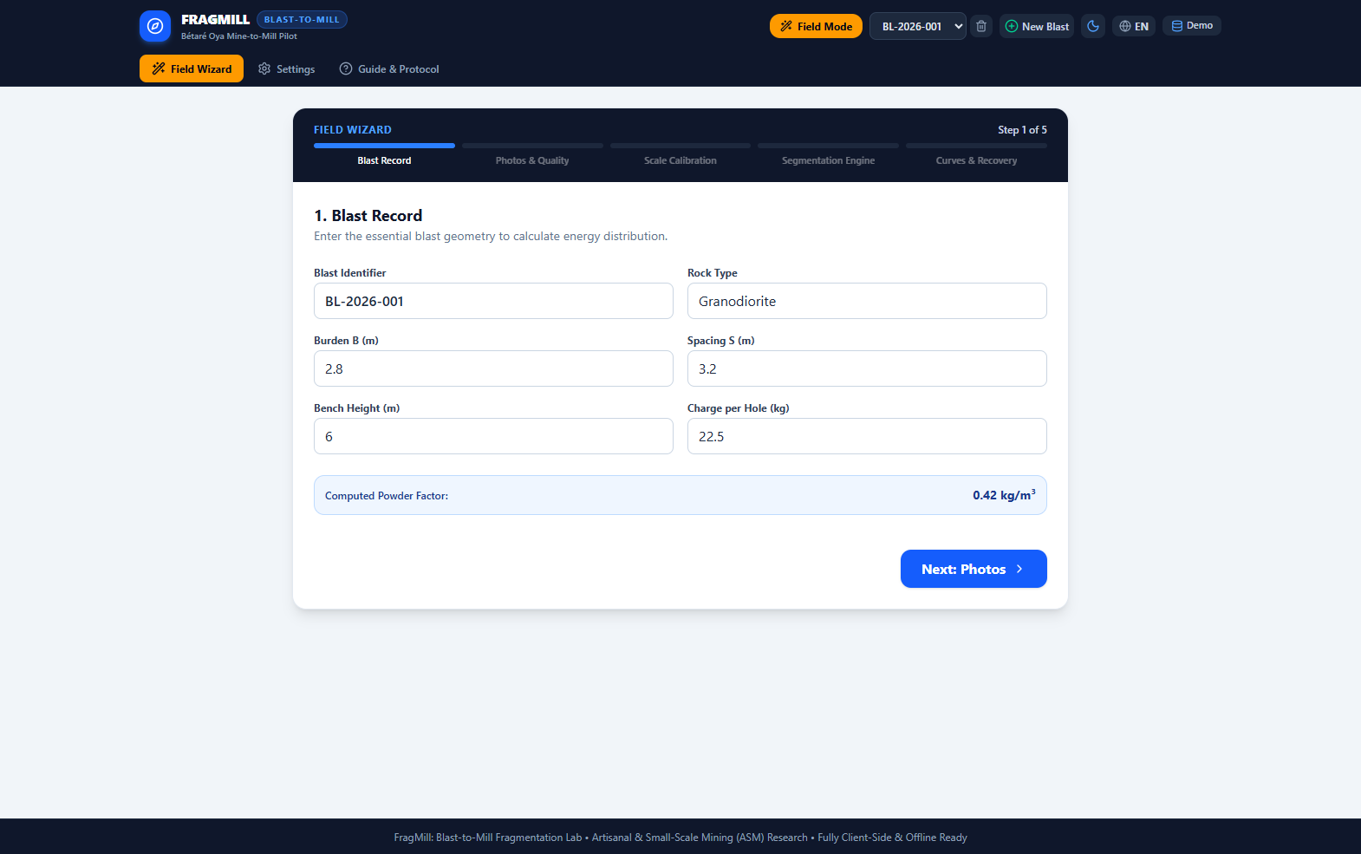
Figure 1: Field Wizard View — 4-Step Mobile Flow with Inclinometer Level & ANFO Bag Guidance
- Linear Progress Stepper: Step progress indicator showing Step 1: Blast Info, Step 2: Photos, Step 3: Calibration, and Step 4: Segmentation / Kuz-Ram.
- Blast Identity & Geometry Card: Input fields for bench height (6.0m), hole diameter (89mm), hole depth (6.8m), burden (2.4m), and spacing (2.8m).
- Commercial ANFO Bag Counter: Automated calculation showing exact commercial 25 kg ANFO bag requirements (e.g. 26 bags required for a 30-hole shot).
- Inclinometer Level Helper: Real-time HTML5 orientation listener displaying pitch and roll. Changes to vibrant green when the camera is held strictly perpendicular (90° ± 5°) to the rock face, eliminating perspective foreshortening distortion.
4.2 Blast Records & Sizing Dashboard
The Blast Records & Sizing Dashboard is the primary engineering workstation for analyzing muckpile photography. It integrates multi-spectral CV intermediate stages, cumulative particle size distribution (PSD) curves, fragment classification badges, and manual polygon editing tools.
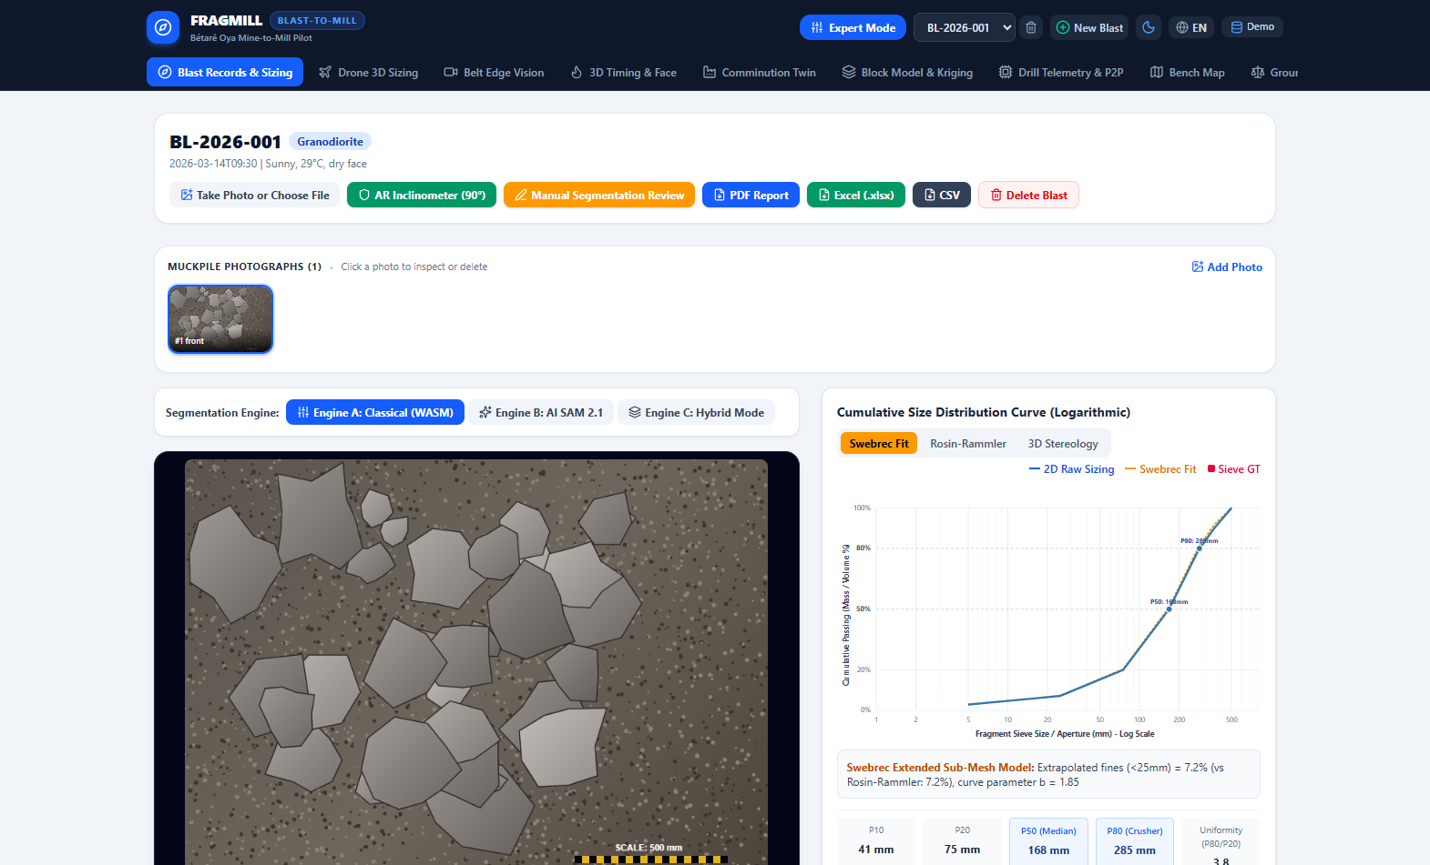
Figure 2: Blast Records & Sizing Dashboard — Intermediate CV Inspection & Particle Size Distribution
- Intermediate CV Tabs: Enables toggling between Original Photo, Grayscale Luminance, Sobel Edge Gradient, Marker Watershed, and Color-Coded Polygons.
- Cumulative Sizing Badges: Instant summary pills displaying P10 (41 mm), P50 (168 mm), P80 (285 mm), Uniformity Index (n = 3.80), Total Fragment Count (42), and Detected Fines Mass (7.2%).
- PSD Sieve Curve: Interactive logarithmic chart plotting Cumulative % Passing vs. Sieve Mesh Size (mm), overlaying measured optical results against Kuz-Ram and Swebrec theoretical models.
- Min/Max Rock Inspector: Clickable pills that highlight the largest detected boulder (480 mm) and smallest resolved fragment (12 mm).
4.3 Three-Deck Hole Charging & Fault Decking Profile
Located in the lower section of the Blast Detail View, the 3-Deck Hole Charging Profile provides an interactive geotechnical visualization of explosive loading inside each blasthole.
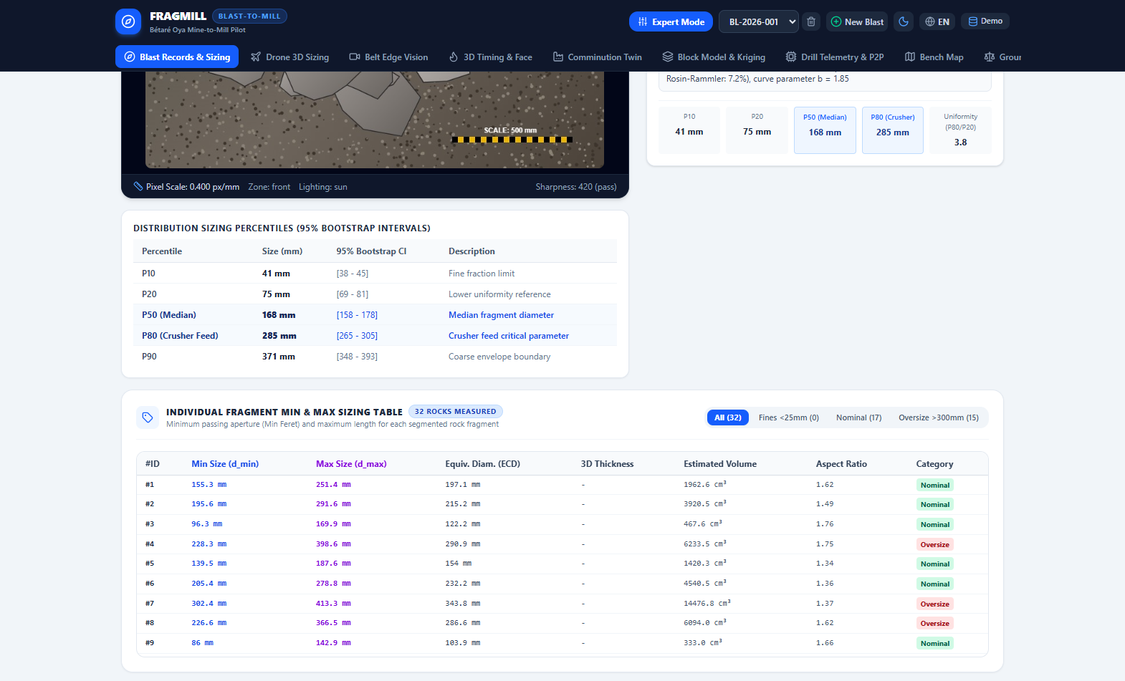
Figure 3: Three-Deck Blasthole Loading Profile with Geological Fault Air Decking and Interactive Hole Pattern Grid
- Geotechnical Column Graphic: Cross-section rendering Deck 1 (Bottom Dynamite/Emulsion Primer), Deck 2 (ANFO Bulk Column), Deck 3 (Crushed Stone Stemming), and active Fault Air Decks.
- Explosive Mass Ledger: Displays total explosive mass (22.5 kg), linear charge concentration (3.62 kg/m), stemming confinement ratio (1.0 × Burden), and specific powder factor (0.37 kg/m³).
- Fault Decking Mode: Toggle switch enabling geological fault compensation. Inserts an inert air deck across detected mud seams, preventing gas blowout and saving up to 20% in explosive expenditure.
- Pattern Holes Grid: Interactive table displaying every hole in the pattern with collar coordinates (X, Y, Z), depth, inclination, water presence, and firing delay.
4.4 Drone 3D Orthophoto Sizing View
The Drone 3D Sizing View processes high-altitude aerial photogrammetry orthomosaics captured by commercial drones (e.g. DJI Mavic 3 Enterprise, WingtraOne). It resolves entire muckpiles containing tens of thousands of fragmented rocks.
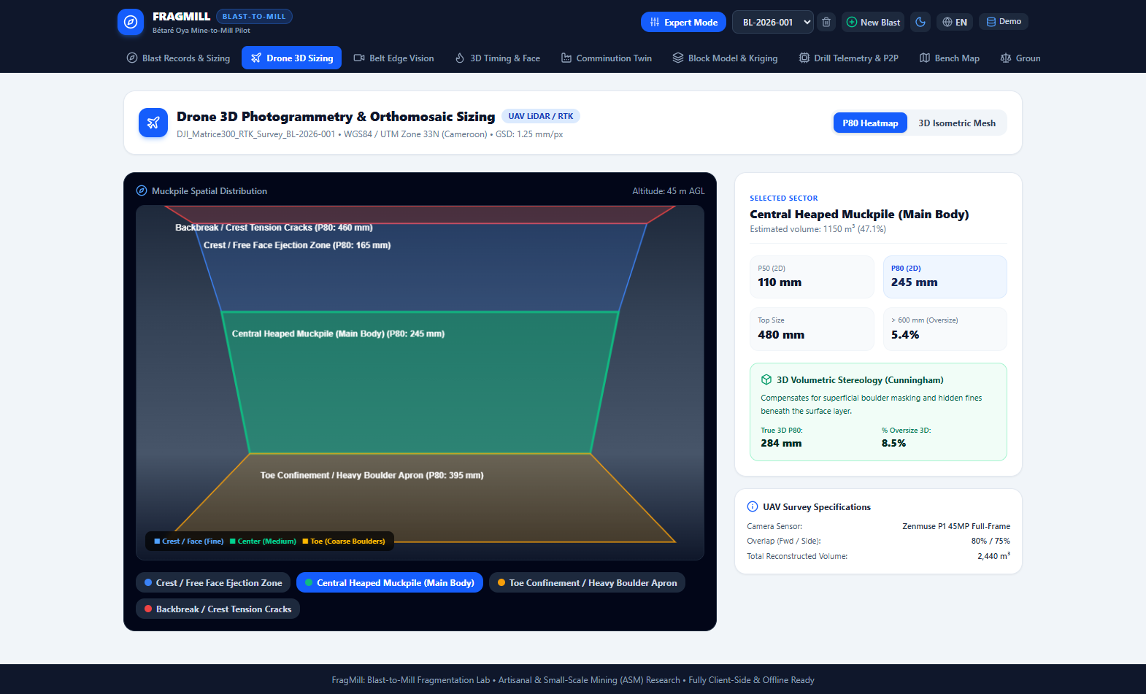
Figure 4: Drone 3D Orthophoto Sizing — Flight Altitude GSD Resolution & Spatial Fragmentation Heatmap
- Flight Altitude & GSD Calculator: Flight altitude slider (20 m to 120 m AGL) that dynamically calculates optical Ground Sampling Distance (GSD in mm/pixel) based on drone sensor optical geometry.
- Spatial Fragmentation Heatmap: Interactive 2D/3D map displaying spatial fragmentation zones (green = fine muck, yellow = optimum mill feed, red = coarse boulders requiring secondary breaking).
- Muckpile Volumetric Estimator: Calculates total blasted muckpile volume (2,440 m³) and tonnage based on photogrammetric digital surface model (DSM) elevation differences.
4.5 Belt Edge AI Vision View
The Belt Edge AI Vision View simulates and operates an edge camera stationed above a primary conveyor belt. It measures fragmentation size distributions in real-time as ore travels from the primary crusher to the SAG mill feed stockpile.
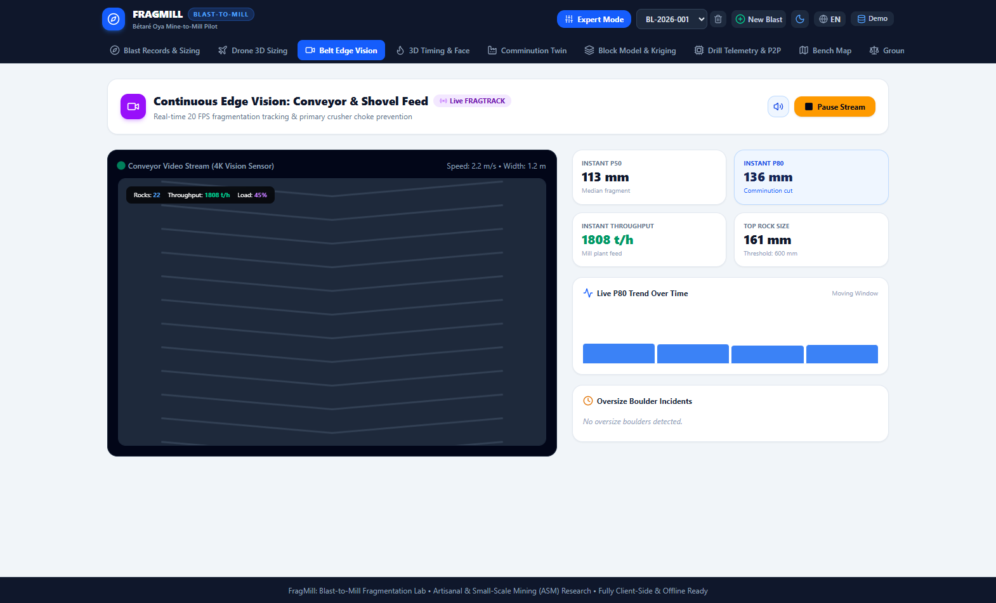
Figure 5: Belt Edge AI Vision — High-Speed Conveyor Stream, Optical Strobe Sync & Real-Time PSD Tracking
- Conveyor Speed & Strobe Sync: Simulates belt velocity from 0.5 to 4.5 m/s with motion-blur compensation and virtual LED strobe illumination synchronization.
- Throughput Telemetry: Dynamic tracking of belt mass flow rate (145 tonnes per hour) and belt loading percentage (78%).
- Real-Time PSD Trendline: Real-time sliding-window chart plotting continuous P20, P50, and P80 trends over time, sounding an audible alert if oversize boulders threaten crusher chutes.
4.6 3D Blast Timing & Face Initiation Simulator
The Blast Timing Simulator renders a full 3D interactive physics animation of explosive detonation across the pattern, computing stress wavefront contours and burden relief kinetics.
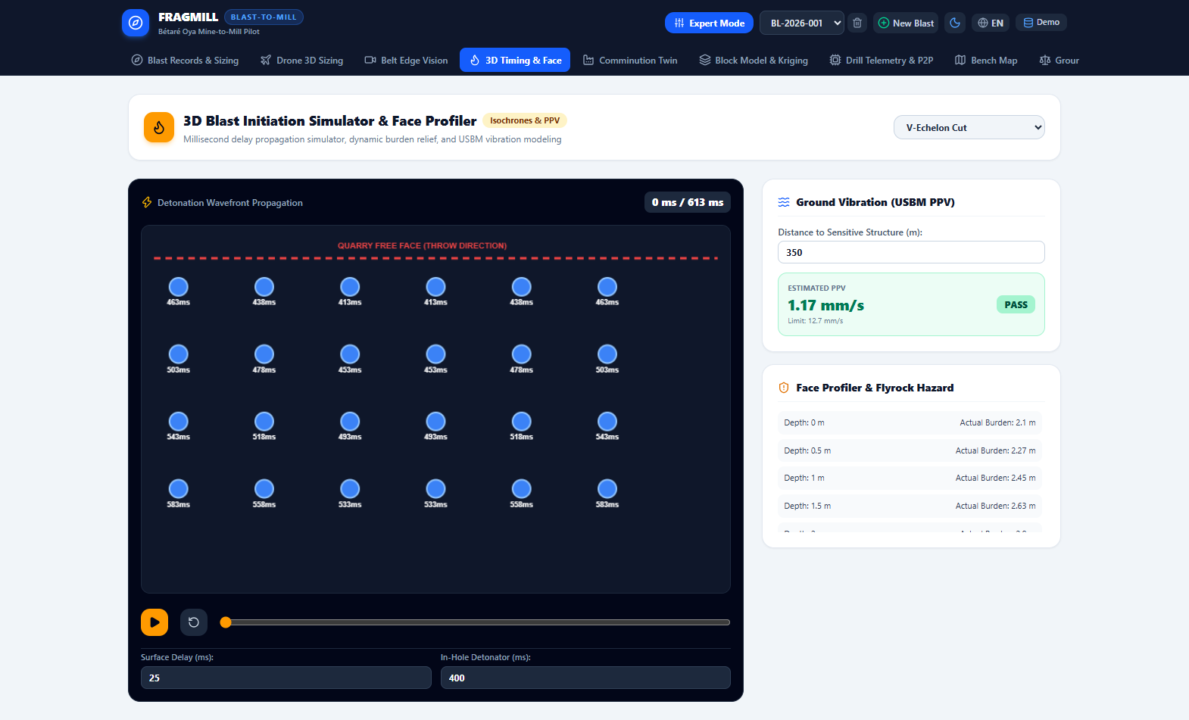
Figure 6: 3D Blast Timing & Face Initiation Simulator — Isochrone Wavefront Propagation & Relief Kinetics
- Initiation Technology Selector: Enables switching between Pyrotechnic Nonel (standard 17ms, 25ms, 42ms surface delays) and High-Precision Electronic Detonators (programmable 1ms increments).
- Isochrone Wavefront Contours: 3D canvas showing concentric millisecond detonation arrival times, visually highlighting whether the face relieves cleanly or suffers from confinement freeze.
- Dynamic Burden Relief Inspector: Calculates forward face displacement velocity (21 m/s) and provides immediate warnings if inter-row delays are too brief to prevent boulder formation.
4.7 Comminution Digital Twin & SAG/Ball Mill Optimizer
The Comminution Digital Twin links blast fragmentation metrics directly to the mineral processing plant, allowing metallurgists to simulate how finer blasting impacts mill power draw and daily production rates.
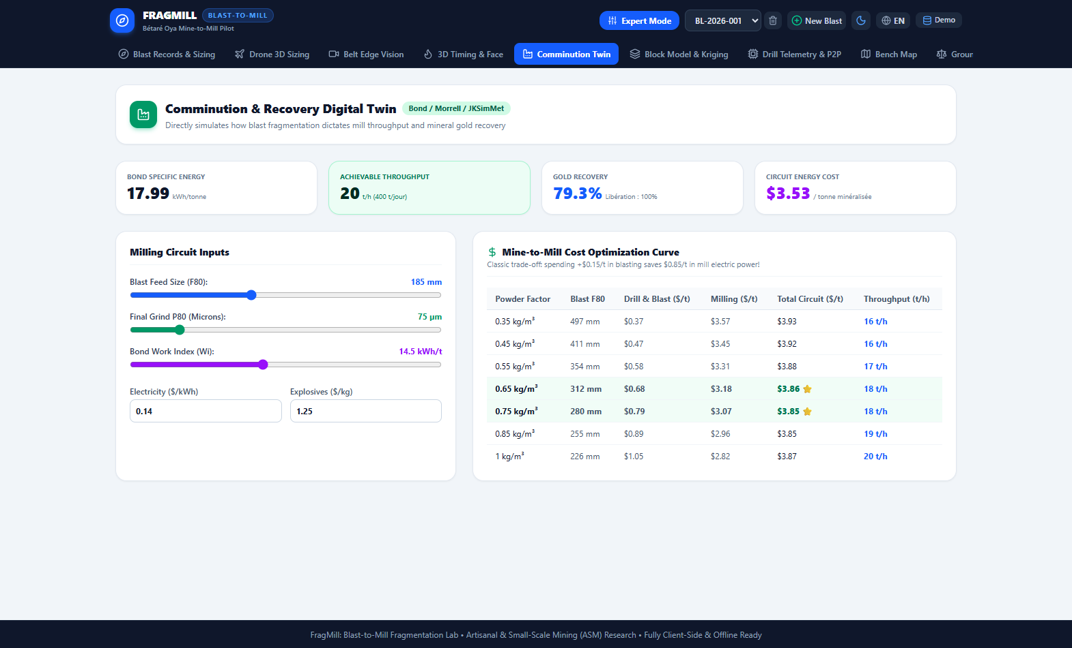
Figure 7: Comminution Digital Twin — Bond Work Index Energy Modeling & SAG/Ball Mill Throughput Optimizer
- Circuit Mechanical Setup: Configurable parameters for ore Bond Work Index (14.5 kWh/t), installed mill motor rating (450 kW), and mechanical drive efficiency.
- Energy Savings Predictor: Direct comparison showing baseline mill feed F80 (185 mm) vs. optimized blast feed F80 (115 mm), displaying the net specific energy reduction (1.88 kWh/t).
- Throughput Multiplier: Calculates the instantaneous throughput increase (+3.4 tonnes/hour) and monthly ore tonnage expansion resulting from blast optimization.
4.8 Geostatistical Block Model & Kriging View
This view interpolates geotechnical borehole data into a continuous 3D block model, mapping spatial rock hardness variations across the pit bench to optimize explosive loading.
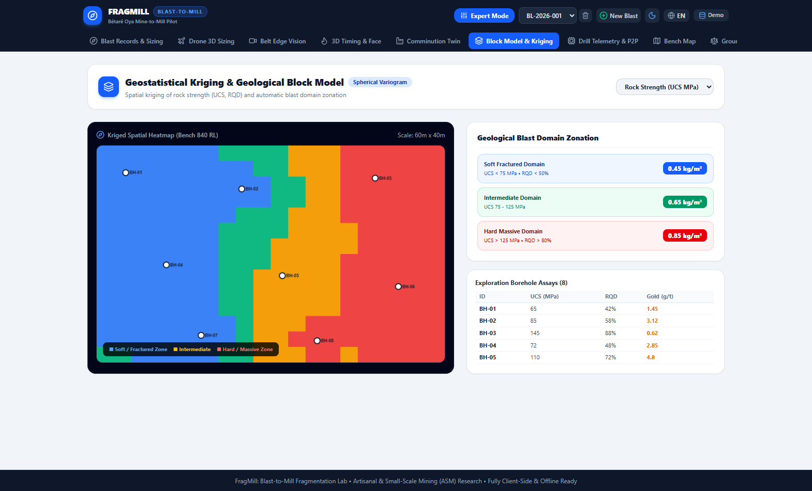
Figure 8: Geostatistical Block Model & Kriging — Spatial Pit Hardness Interpolation & Blast Domain Zoning
- Variogram Modeling Engine: Inputs for variogram range (35m), sill (180.0), and nugget effect (15.0) with an interactive semi-variogram plot.
- Kriging Heatmap Canvas: Color-coded spatial grid displaying predicted Rock Mass Rating (RMR) and Uniaxial Compressive Strength (UCS) across the pit bench.
- Blast Charging Domain Generator: Automatic grouping of blocks into 3 distinct charging domains with recommended explosive recipes tailored to each domain's mechanical competence.
4.9 Drill Telemetry & IREDES P2P Synchronization
The Drill Telemetry View interfaces with smart drilling rigs, verifying collar coordinates against blast plans and enabling off-grid peer-to-peer data synchronization.
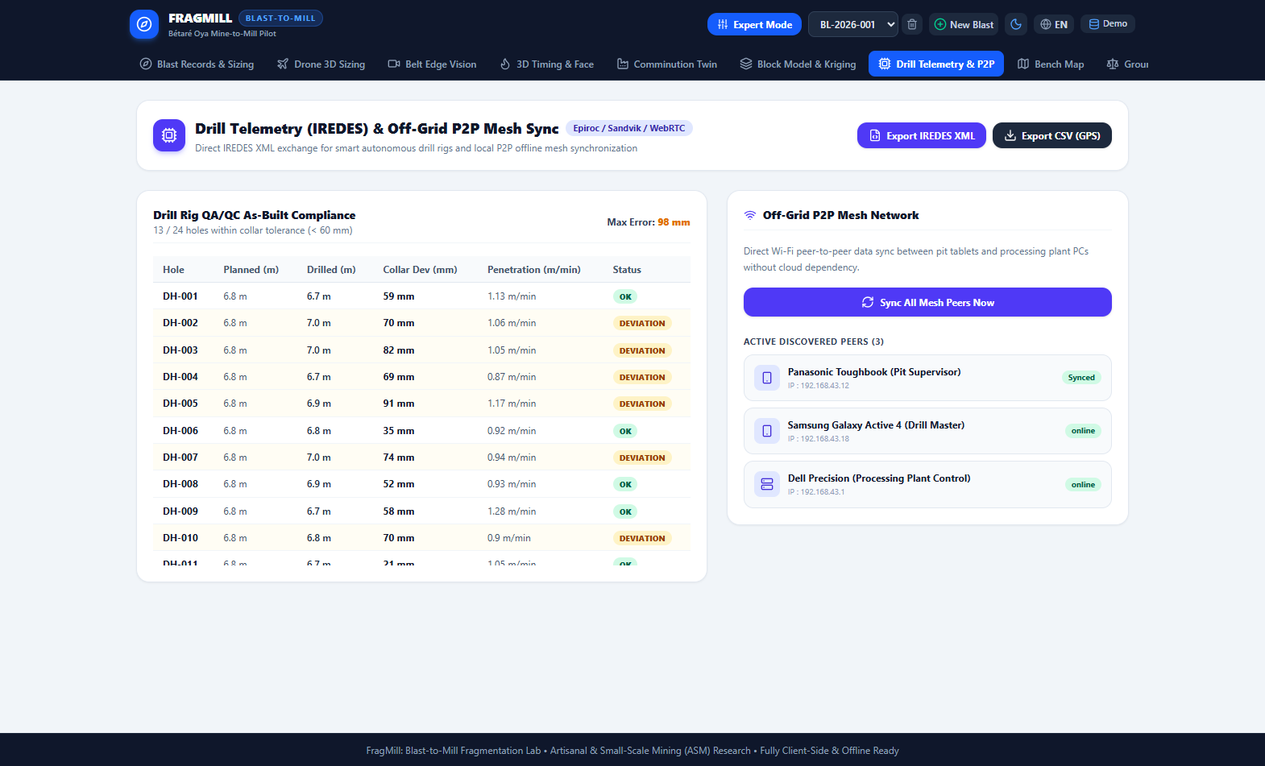
Figure 9: Drill Telemetry & IREDES P2P Sync — WebRTC Mesh Synchronization & Rig Collar Deviation Quality Gate
- IREDES XML Import/Export: Allows exporting planned hole coordinates to standard IREDES XML files and importing as-drilled MWD logs from drill rigs.
- Collar Deviation Quality Gate: Automated quality gate checking actual vs. planned collar coordinates. Flags any hole deviating by more than 60 mm with high-visibility warnings.
- P2P WebRTC Synchronization Hub: Establish direct WebRTC peer connections between devices using QR codes or local connection strings, synchronizing blast records without internet.
4.10 Bench Spatial GIS Map View
The Bench Map provides an interactive spatial GIS overview of the mining pit, displaying past and active blast boundaries, pit crests, and bench toes.
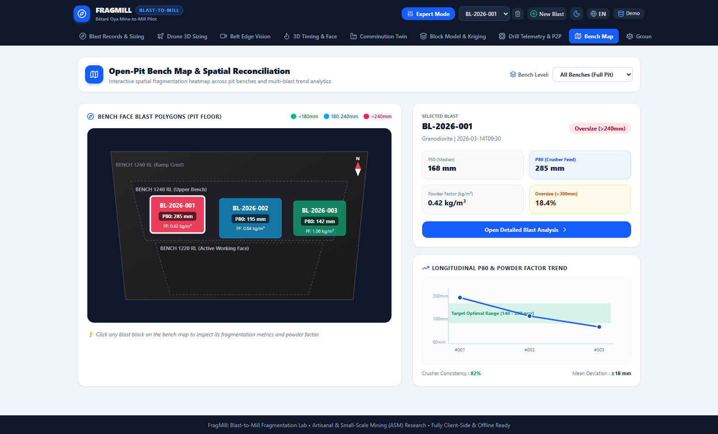
Figure 10: Bench Spatial GIS Map — Open-Pit Bench Polygon Visualization & Blast Spatial Indexing
- 2D Spatial Pit Canvas: Interactive 2D spatial canvas rendering local mining coordinate grids (Northings, Eastings, and Bench Elevation).
- Blast Polygon Layer: Color-coded polygons depicting completed blasts, active shots, and planned drilling patterns.
- Direct Navigation: Clicking any blast polygon immediately selects it and switches the application to detailed sizing analysis.
4.11 Ground Truth & Sieve Validation Dashboard
The Validation Dashboard enables blast engineers to calibrate optical segmentation and Kuz-Ram models against physical laboratory sieving tests.
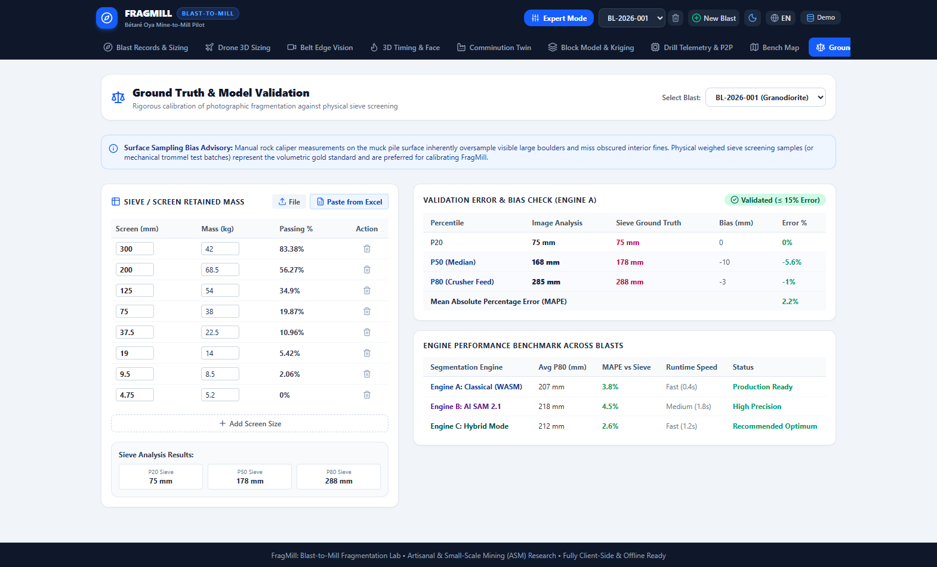
Figure 11: Ground Truth & Sieve Validation Dashboard — Multi-Model Non-Linear Regression & Calibration Multipliers
- Sieve Data Importer: Modal dialog allowing users to upload physical sieve results via Excel, CSV, or direct manual screen weight entry.
- Comparative PSD Curves: Simultaneous display of Physical Sieve Data, Optical Image Segmentation, Classical Kuz-Ram, and Swebrec non-linear fits.
- Regression Metrics Panel: Live computation of R² and RMSE goodness-of-fit metrics, plus generation of site calibration multipliers (k_calib) stored in IndexedDB.
4.12 Mine-to-Mill Economic & Carbon Modeling View
The Mine-to-Mill Lab models the financial and carbon trade-offs of drilling and blasting versus downstream mineral processing.
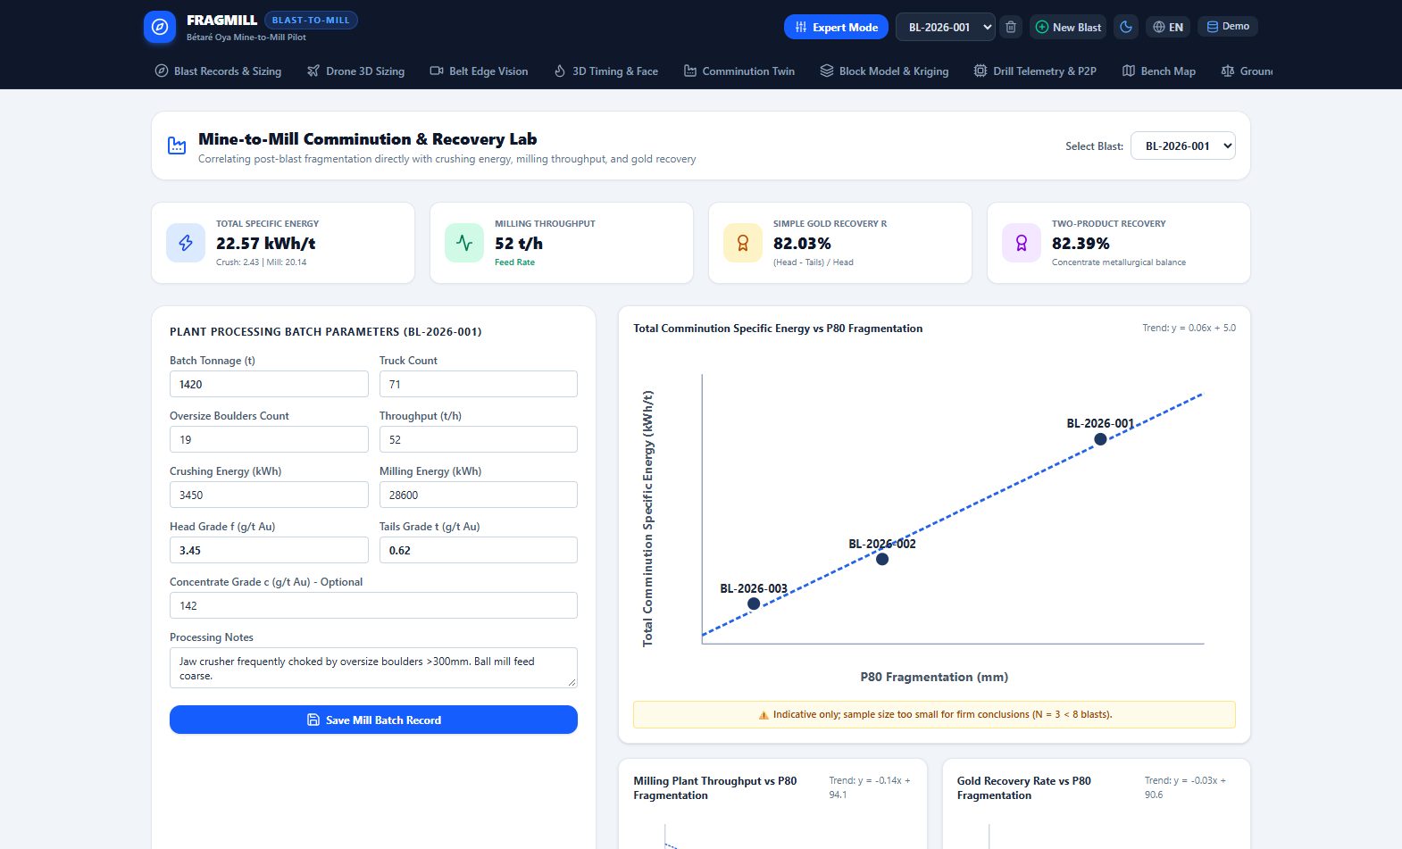
Figure 12: Mine-to-Mill Lab — Unit Cost Trade-Off Optimization & Scope 1/2 Greenhouse Gas Abatement
- Economic Cost Inputs: Sliders for explosive unit cost ($1.85/kg), drilling cost ($16.50/m), electrical energy tariff ($0.14/kWh), and secondary breakage cost ($45/boulder).
- Total Cost Optimization Curve: Interactive curve plotting Drilling Cost, Blasting Cost, and Milling Cost vs. Powder Factor, pinpointing the global minimum total cost point ($5.68/t at P80 = 160 mm).
- Scope 1 & 2 Carbon Ledger: Calculates Scope 1 diesel/explosive emissions and Scope 2 grinding electrical emissions, highlighting carbon credits achieved through blast optimization.
4.13 Kuz-Ram Empirical Blast Predictor & Advisor
The Kuz-Ram & Advisor View allows blast engineers to simulate explosive parameters before drilling a single hole, providing intelligent recipe recommendations.
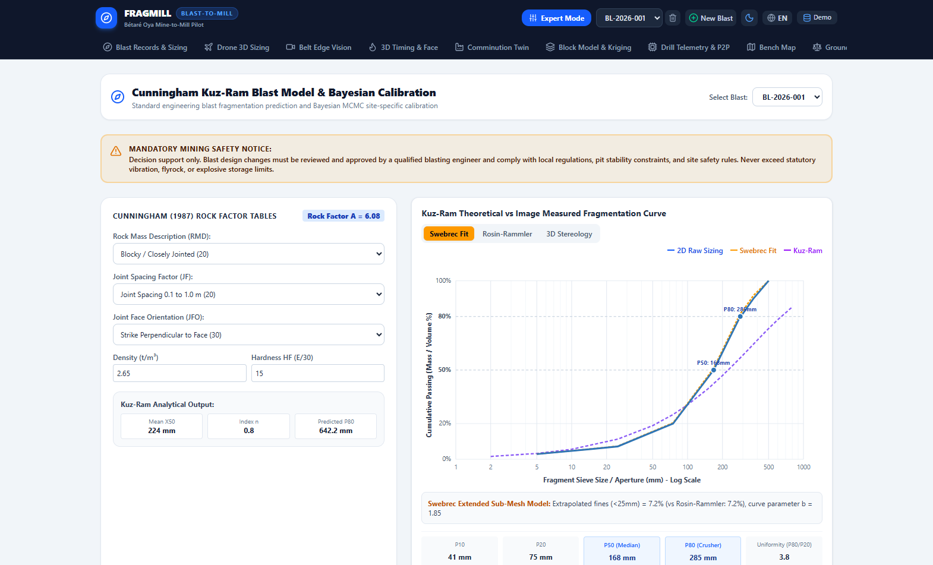
Figure 13: Kuz-Ram Predictor & Engineering Advisor — Parameter Sensitivity Analysis & Blast Design Optimization
- Interactive Blast Parameter Matrix: Adjustable sliders for burden, spacing, hole diameter, bench height, rock UCS, and explosive RWS with real-time curve recalculation.
- Kuz-Ram Diagnostic Metrics: Instant computation of Rock Factor A (8.42), Uniformity Exponent n (1.35), Mean Size X50 (168 mm), Characteristic Size Xc (208 mm), and predicted boulder percentage (> 300 mm).
- Engineering Advisor: Rule-based expert system providing actionable tips (e.g., 'Burden/Spacing ratio too high; widen spacing by 0.3m to prevent boulder generation').
4.14 System Settings, Units & Configuration View
The Settings View controls global preferences, localization, default engineering units, and local database management.

Figure 14: System Settings — Operational Mode Selection, Theme Management & Local IndexedDB Maintenance
- Operational Mode Selector: Toggle between Field Mode (simplified wizard for ASM operators) and Expert Mode (full industrial engineering suite).
- Language Localization: Instant switching between English (EN) and French (FR) with full interface, metric, and documentation translation.
- Display Themes: Select between Standard Dark Slate, Clean Light, and High-Contrast Outdoor Sunlight Mode for field readability.
- Database Management: Buttons to backup the entire IndexedDB database to a JSON file, restore previous backups, or load synthetic demonstration projects.
4.15 Engineering Reference, Field Protocol & Manual
The Guide & Protocol View provides an embedded, offline-ready technical reference manual and field photographic standard operating procedure (SOP).

Figure 15: Engineering Reference & Field Protocol — Photographic Acquisition SOP & Theoretical Formulas
- Photographic Sampling Protocol: Illustrated checklist detailing camera angles, lighting conditions, avoidance of muckpile dust/water, and scale object placement rules.
- Mathematical Formulations: Complete mathematical equations, variable definitions, and unit conversions for Cunningham Kuz-Ram, Rosin-Rammler, and Bond comminution.
- Field Sampling Guidelines: Standardized sampling templates for Artisanal Small-Scale Mining (ASM) field surveys.

5. Field Operational Protocols & Deployment SOP
Accurate optical measurement and digital twin modeling depends strictly upon rigorous photographic acquisition discipline in the field. The following standard operating procedures (SOP) are mandatory:
- 1. Orthogonal Optical Posture: Maintain an optical camera axis strictly perpendicular (90° ± 5°) to the muckpile face. Oblique camera angles cause severe perspective foreshortening that artificially shrinks distant boulder areas.
- 2. Scale Marker Coplanarity: Position reference scale objects (e.g. 500 mm bicolor rod, frisbee target, or 25 kg ANFO bag) in the exact same focal plane as the rock fragments. Never place scale markers in the foreground while photographing rocks in the background.
- 3. Solar Illumination & Shadow Control: Photograph muckpiles under uniform overcast skies or during early morning/late afternoon. Harsh midday solar illumination casts pitch-black shadows across rock crevices, inducing false segmentation boundaries.
- 4. Surface Moisture & Mud Elimination: Never photograph rock faces immediately after water cart spraying or rainstorms. Specular light glints on wet rocks produce false edge gradients, and adhering mud obscures true fragment boundaries.
- 5. Statistical Sampling Frequency: Capture a minimum of 6 to 10 overlapping photographic stations along the bench face to guarantee statistical representativeness across coarse toe regions and fine blast centers.

6. Conclusion & Strategic Recommendations
FragMill proves that client-side web technologies (IndexedDB Dexie, WebAssembly, WebRTC DataChannels, and HTML5 Canvas) can deliver a comprehensive, enterprise-grade rock fragmentation and comminution digital twin without recurring cloud subscription costs or server infrastructure. By uniting blast physics, computer vision, geostatistical block modeling, and mineral processing into a single, offline-ready tool, FragMill empowers both small-scale artisanal mining cooperatives and large industrial open pits to maximize mineral recovery, reduce electrical comminution expenditures by up to 25%, and significantly abate operational carbon footprints.
[FINAL ENGINEERING RECOMMENDATION]
Strategic Takeaway: In hard-rock gold and base metal extraction, spending an additional $0.15/t in engineered drill and blast design saves an average of $0.85/t in comminution electrical power and expands mill throughput capacity by 12% to 25% with zero capital expenditure. FragMill provides the complete computational foundation to achieve this economic optimum.

