COMPLETE PROJECT REPORT, PARAMETER DICTIONARY & NUMERICAL RESULTS VAULT
FRAGMILL: ADVANCED BLAST-TO-MILL ROCK FRAGMENTATION, COMMINUTION DIGITAL TWIN & GEOSTATISTICAL SYSTEM
Comprehensive Engineering Deliverable Incorporating Complete Entry Parameter Dictionaries, Use Cases, Geotechnical Importance, Expected Outcomes, All Recent Platform Modifications, and Exhaustive Tabulated Numerical Results
Application Name: | FragMill (Blast-to-Mill Fragmentation Lab & Comminution Twin)
System Architecture: | 100% Offline-First Client-Side WebApp (IndexedDB Dexie, WebAssembly, WebRTC P2P)
Software Revision: | Release 3.2 — Enhanced Active Blast Management, Universal Reporting & Dynamic P2P
Target Operations: | Artisanal & Small-Scale Mining (ASM) Cooperatives & Commercial Open Pits
Primary Pilot Project: | Bétaré Oya Mine-to-Mill Pilot (Lom & Djérem, East Cameroon - Bench 840 RL)
Documentation Scope: | Architecture, Mathematics, 16 View Walkthroughs, Complete Parameter Dictionaries & 25 Datasets

[EXECUTIVE DECLARATION & RECENT SYSTEM UPDATES]
This document represents the complete, exhaustive project deliverable for the FragMill platform, updated to include all recent technical enhancements. In strict accordance with engineering user specifications, this report details: (1) System concepts, mathematical physics, and recent structural additions (including the omnipresent Active Blast Banner, universal blast switching, unified 10-section General PDF reporting, live AR Inclinometer camera integration, and user-configurable P2P drill telemetry); (2) An exhaustive view-by-view walkthrough of all 16 user interfaces accompanied by high-resolution screenshots; (3) A rigorous parameter dictionary for every single input on every tab—explaining its operational use, geotechnical significance, and expected sensitivity outcome; and (4) The complete numerical data vault containing every generated data point, sieve ladder, comminution ledger, economic trade-off curve, and drill hole deviation audit.

1. System Concepts, Architecture & Recent Platform Modifications
1.1 The Fragment-to-Mill Paradigm & Economic Problem Statement
In mineral extraction, rock comminution (primary crushing, secondary crushing, SAG milling, and ball mill grinding) represents the largest operational expenditure on any hard-rock mine site, consuming between 50% and 70% of total electrical energy and over 50% of operating cash costs. Conversely, drilling and blasting operations represent merely 10% to 15% of the total cost per tonne. In most traditional mining operations, these departments operate in total isolation: drill and blast engineers seek to minimize drilling meters and explosive consumption, oblivious to the fact that coarse fragmentation and oversize boulders choke primary crushers and force grinding mills to consume excessive specific energy (kWh/tonne).
FragMill resolves this critical operational gap by establishing a continuous digital feedback loop from the muckpile face to the final concentrate recovery circuit. Running entirely client-side without requiring cloud servers, FragMill allows mine engineers, metallurgists, and field technicians to optimize blast fragmentation, predict mill throughput, and eliminate plant bottlenecks.
1.2 Dual Operational Ecosystem
- Artisanal & Small-Scale Mining (ASM) Mode: Designed for artisanal gold mining cooperatives, quarry foremen, and field blasting assistants. Provides a simplified 4-step wizard, interactive inclinometer posture guidance (ensuring 90° ± 5° orthogonal photography), automated reference scale detection (500mm rods, coins, measuring tapes, ANFO bags), and on-site blast recipes (calculating exact 25 kg commercial ANFO bag requirements).
- Industrial & Expert Mode: Engineered for blast superintendents, geotechnical modelers, and mill managers at tier-1 and mid-tier mining sites. Features multi-bench spatial GIS mapping, high-altitude UAV drone orthomosaic segmentation, high-speed optical conveyor belt vision, 3D blast wavefront initiation timing, IREDES rig telemetry QA/QC auditing, geostatistical Ordinary Kriging block modeling, Bond Work Index mill twins, and Scope 1 & 2 carbon accounting.
1.3 Zero-Cloud Offline-First Architecture
Remote mine sites in developing economies and deep open pits regularly experience severe RF shielding, zero cellular data coverage, and strict corporate data security constraints. FragMill was engineered as a 100% Client-Side Web Application utilizing modern browser standards:
- Dexie.js 4.x Local Database: IndexedDB database engine providing ACID transactions, zero network latency, and local persistent storage of thousands of high-resolution images, segmentation polygons, and time-series telemetry.
- Pure Client-Side Computer Vision: Fast Sobel spatial convolutions, Summed-Area Table (SAT) integral images, marker-controlled watershed flooding, and 32-radial ray facet snapping executing on device CPU/GPU threads.
- WebRTC DataChannels P2P Sync: Ad-hoc mesh synchronization over local pit Wi-Fi or Bluetooth using Conflict-Free Replicated Data Types (CRDTs), enabling field tablets and mill workstations to synchronize data without internet connectivity.
1.4 Summary of Recent Major Platform Modifications
In response to rigorous field testing and operational feedback, four major architectural enhancements have been integrated into FragMill:
- 1. Omnipresent Active Blast Banner & Universal Switching: Integrated an omnipresent, dark-slate glassmorphic context header directly above all 12 blast analysis workspaces. It displays live active blast metadata (lithology, density, UCS, bench height, burden x spacing, hole count, calculated powder factor, timestamp, and weather) with pulsing green active status. It incorporates fast sequential '<' and '>' buttons with an index position badge ('Tir 1 sur 3'), a stylized dropdown selector, and an immediate '+ Nouveau Tir' / '+ New Blast' button. Switching the active blast dynamically triggers immediate state re-hydration across all models using unique React keys and two-way binding.
- 2. Universal Modular Report Vault & Unified General Engineering PDF: Every PDF download trigger in the platform (whether clicked from the global header, individual view action bars, or the staging modal) now generates the comprehensive General Engineering Report format. This unified document integrates all 10 modular blast sections: two-column geotechnical specs, calibrated muckpile photo overlay, navy key percentiles KPI card (P10-P90, Pmax, n, oversize %, fines %, 95% bootstrap CI), non-linear regressions (Swebrec and Rosin-Rammler), continuous 10-aperture standard sieve ladder (15 mm to 400 mm), fragment morphometry table (elongation, flatness, circularity), high-contrast semi-log curve, geometric charging profile, and the 8-stage Computer Vision pipeline gallery with algorithmic breakdown table. All 10 technical graphics feature explicit, high-contrast bilingual legends.
- 3. Real-Time AR Inclinometer & Live Device Camera Integration: Upgraded the camera acquisition system with HTML5 WebRTC / getUserMedia API access. Blasting technicians can now either stream live video from their device camera with interactive roll and pitch HUD leveling indicators (targeting 90° ± 5° orthogonal alignment) or upload local high-resolution field photos directly.
- 4. User-Managed P2P Drill Telemetry & Rig Interfacing: Expanded the P2P synchronization module into a dynamic connection hub. Operators can now discover, add, and manage their own drill rigs and field tablets, import/export custom IREDES XML files and drill pattern CSVs, and enforce real-time collar deviation quality gates (warning threshold: 60 mm).

2. Mathematical & Backend Engineering Formulations
FragMill is built on rigorous rock engineering, particle mechanics, and comminution physics. This section details the complete analytical models governing every calculation in the system.
2.1 Extended Cunningham Kuz-Ram Fragmentation Model
The Kuz-Ram model computes the expected particle size distribution resulting from explosive energy detonation within a jointed rock mass:
2.1.1 Blast Rock Factor (A)
A = 0.06 × (RMD + JF + RDI + HF)
Where RMD = Rock Mass Description, JF = Joint Factor (JPS + JPA), RDI = Rock Density Influence, and HF = Hardness Factor.

Component parameters are computed as follows:
- Rock Mass Description (RMD): RMD: Set to 10 for powdery/friable rock; JF for vertically jointed rock; 50 for massive rock.
- Joint Factor (JF): JF = JPS + JPA. Joint Plane Spacing (JPS) is 10 for spacing < 0.1 m, 20 for 0.1 to 1.0 m, and 50 for > 1.0 m. Joint Plane Angle (JPA) is 20 for dip into face, 30 for strike perpendicular to face, and 40 for dip out of face.
- Rock Density Influence (RDI): RDI = 0.025 × ρ - 50, where ρ is rock density in kg/m³.
- Hardness Factor (HF): If Young's Modulus E < 50 GPa, HF = E / 3; if UCS ≥ 50 MPa, HF = UCS / 5.
2.1.2 Median Fragment Size (X50)
X50 = A × Q^(-0.8) × q^(0.167) × (115 / RWS)^(0.633) × 10
Where Q = Explosive mass per hole (kg), q = Specific powder factor (kg/m³), and RWS = Relative Weight Strength to ANFO.

2.1.3 Uniformity Exponent (n)
n = [2.2 - 14 × (B / d)] × sqrt((1 + S/B) / 2) × [1 - (W / B)] × [(|BCL - CCL| / L) + 0.1]^0.1 × (L_charge / H)
Where B = Burden (m), S = Spacing (m), d = Hole Diameter (mm), W = Drilling Deviation (m), BCL = Bottom Charge, CCL = Column Charge, L = Total Charge Length, and H = Bench Height.

2.1.4 Characteristic Size (Xc)
Xc = X50 / (ln(2))^(1 / n) = X50 / (0.69315)^(1 / n)
Analytic transformation from median size X50 to Rosin-Rammler characteristic scale parameter Xc.

2.2 Cumulative Sizing Distribution Models: Swebrec vs. Rosin-Rammler
FragMill implements both classical Rosin-Rammler and modern Swebrec functions to characterize particle sizing across the entire muckpile:
- Rosin-Rammler (Weibull): P(x) = 1 - exp(-(x / Xc)^n). Robust for intermediate sizes, but tends to underestimate ultra-fines (< 1 mm).
- Swebrec Three-Parameter Model: P(x) = 100 / [ 1 + ( ln(x_max / x) / ln(x_max / x50) )^b ]. Forces P(x_max) = 100% and models sub-sieve fines with exceptional physical fidelity.
2.3 Particle Morphometry & Non-Parametric Bootstrap Formulations
To describe fragment shape and statistical reliability, FragMill computes morphological shape factors and 1,000-iteration bootstrap confidence intervals:
Elongation Ratio E = L_min / L_max ; Circularity C = (4 × π × Area) / Perimeter²
Morphometric shape metrics quantifying rock roundness versus slabby/columnar boulder geometries.

CI_95%(P_k) = [ Percentile(Theta*_B, 2.5%) , Percentile(Theta*_B, 97.5%) ]
Non-parametric bootstrap confidence interval derived from B = 1000 resamples with replacement of measured fragments.

2.4 Geostatistical Ordinary Kriging Formulation
Ordinary Kriging estimates continuous rock properties across the pit bench while ensuring Best Linear Unbiased Estimation (BLUE):
γ(h) = C0 + C × [ 1.5 × (h / a) - 0.5 × (h / a)³ ] (for h <= a); γ(h) = C0 + C (for h > a)
Spherical Semi-variogram model with nugget C0, structural sill C, and spatial range a (m).

[ Γ_ij 1 ] [ λ_j ] [ γ(x_i, x0) ]
[ 1 0 ] [ μ ] = [ 1 ]
Ordinary Kriging linear system ensuring sum(λ_i) = 1 and minimizing estimation variance σ_k².

2.5 Comminution Physics & Bond Work Index Theory
W = 10 × Wi × [ (1 / sqrt(P80)) - (1 / sqrt(F80)) ]
Bond's Third Theory of Comminution: Specific energy W (kWh/t) as a function of feed F80 (µm) and product P80 (µm).

Throughput T (t/h) = P_net / W = (P_installed × η_mech) / [ 10 × Wi × ( P80^(-0.5) - F80^(-0.5) ) ]
Direct throughput relationship demonstrating how blast fragmentation feed size dictates plant capacity.

2.6 Mine-to-Mill Economic Optimization & Scope 1/2 Carbon Formulation
C_total(q) = C_drill(q) + C_blast(q) + C_load(q) + C_haul(q) + C_crush(q) + C_grind(q)
Total unit operational cost per tonne ($/t) balancing drill & blast cost against comminution electrical power.

- Scope 1 Emissions: Scope 1: Diesel combustion in drill rigs and haul fleet (2.68 kg CO2e / L) + ANFO detonation emissions (0.18 kg CO2e / kg ANFO).
- Scope 2 Emissions: Scope 2: Electrical grid/generator power in crushing and grinding circuits (0.52 kg CO2e / kWh).

3. Complete Numerical Results Vault (App-Generated Data)
This section compiles every single result, metric, dataset, and table generated across FragMill's databases, simulations, and processing engines.
Table 1: Comprehensive Blast Design Parameter Matrix
Parameter | Blast 1 (BL-2026-001) | Blast 2 (BL-2026-002) | Blast 3 (BL-2026-003)
Operational Purpose | Initial Production Blast (Coarse) | Optimized Production (Target) | Over-Charged Test (High Fines)
Date & Timestamp | 2026-03-14 09:30 | 2026-03-21 11:00 | 2026-03-28 14:15
Ambient Weather | Sunny, 29°C, dry face | Partly cloudy, 31°C | Hot and humid, 34°C
Bench Height (H) | 6.0 m | 6.0 m | 6.0 m
Hole Diameter (d) | 89 mm | 89 mm | 89 mm
Hole Depth (L) | 6.8 m | 6.8 m | 6.8 m
Subdrill (J) | 0.8 m | 0.8 m | 0.8 m
Burden (B) | 2.8 m | 2.3 m | 1.9 m
Spacing (S) | 3.2 m | 2.7 m | 2.2 m
Stemming Length (T) | 2.4 m | 2.0 m | 1.6 m
Number of Holes | 24 holes | 32 holes | 40 holes
Hole Inclination | 90° (Vertical) | 85° (Inclined) | 90° (Vertical)
Explosive Type | ANFO (Porous Prill + FO) | ANFO / Emulsion (70/30) | Heavy ANFO (50/50)
Relative Weight Strength (RWS) | 100 | 108 | 115
Charge per Hole (Q) | 22.5 kg | 24.0 kg | 26.5 kg
Bottom Charge Length | 2.0 m | 2.2 m | 2.5 m
Column Charge Length | 2.4 m | 2.6 m | 2.7 m
Initiation Sequence | Nonel 25ms surface / 42ms row | Electronic 17ms chevron | Electronic 20ms sequential
Drilling Deviation StdDev | 0.15 m (150 mm) | 0.10 m (100 mm) | 0.12 m (120 mm)

Table 2: Geological Fabric & Geotechnical Rock Mass Properties
Geotechnical Property | Blast 1 (BL-2026-001) | Blast 2 (BL-2026-002) | Blast 3 (BL-2026-003)
Lithology / Rock Type | Competent Granodiorite | Competent Granodiorite | Competent Granodiorite
Bulk In-Situ Density | 2.68 t/m³ (2680 kg/m³) | 2.68 t/m³ (2680 kg/m³) | 2.68 t/m³ (2680 kg/m³)
Joint Set Count | 3 systematic joint sets | 3 systematic joint sets | 3 systematic joint sets
Mean Joint Spacing | 0.55 m | 0.50 m | 0.45 m
Joint Orientation | Dip into face (Unfavorable) | Strike perpendicular (Neutral) | Dip out of face (Favorable)
Estimated GSI / RMR | 68 | 65 | 62
Uniaxial Compressive Strength (UCS) | 125 MPa | 120 MPa | 115 MPa
Static Young's Modulus (E) | 52 GPa | 50 GPa | 48 GPa
Computed Rock Factor (A) | 8.42 | 7.85 | 7.15

Table 3: Optical Image Segmentation Sizing Results
Fragmentation Metric | Blast 1 (BL-2026-001) | Blast 2 (BL-2026-002) | Blast 3 (BL-2026-003)
Image Record Filename | BL01_muckpile_front.jpg | BL02_muckpile_center.jpg | BL03_muckpile_top.jpg
Scale Calibration (px/mm) | 0.40 px/mm (2.5 mm/px) | 0.40 px/mm (2.5 mm/px) | 0.40 px/mm (2.5 mm/px)
Total Detected Fragments | 42 fragments | 58 fragments | 82 fragments
P10 (Sub-Sieve Fines Cut) | 41 mm | 29 mm | 19 mm
P20 Passing Aperture | 75 mm | 52 mm | 35 mm
P50 (Median Fragment Size) | 168 mm | 115 mm | 78 mm
P80 (Comminution Feed Size) | 285 mm | 195 mm | 142 mm
P90 Passing Aperture | 371 mm | 254 mm | 185 mm
Pmax (Largest Detected Block) | 480 mm | 480 mm | 480 mm
Mean Fragment Size | 160 mm | 109 mm | 74 mm
Uniformity Index (n = P80/P20) | 3.80 | 3.75 | 4.06
Oversize Percentage (> 300 mm) | 18.4% (Excessive Boulders) | 6.2% (Optimal Target) | 2.1% (Minimal)
Fines Percentage (< 25 mm) | 7.2% | 11.5% | 24.8% (Slime Loss Hazard)
Unresolved Fine Matrix Fraction | 4.3% | 6.9% | 14.9%

Table 4: Statistical 95% Bootstrap Confidence Intervals
Percentile | Blast 1 (95% CI) | Blast 2 (95% CI) | Blast 3 (95% CI)
P10 Confidence Interval | [38 mm, 45 mm] | [26 mm, 31 mm] | [17 mm, 21 mm]
P20 Confidence Interval | [69 mm, 81 mm] | [48 mm, 56 mm] | [32 mm, 38 mm]
P50 Confidence Interval | [158 mm, 178 mm] | [108 mm, 122 mm] | [73 mm, 83 mm]
P80 Confidence Interval | [265 mm, 305 mm] | [181 mm, 209 mm] | [132 mm, 152 mm]
P90 Confidence Interval | [348 mm, 394 mm] | [238 mm, 269 mm] | [173 mm, 196 mm]

Table 5: Non-Linear Regression Goodness-of-Fit (Swebrec vs Rosin-Rammler)
Distribution Model Parameter | Blast 1 (BL-2026-001) | Blast 2 (BL-2026-002) | Blast 3 (BL-2026-003)
Swebrec Upper Cutoff (xMax) | 500 mm | 500 mm | 500 mm
Swebrec Median Parameter (x50) | 168 mm | 115 mm | 78 mm
Swebrec Shape Undulation (b) | 1.85 | 1.92 | 2.10
Swebrec Goodness-of-Fit (R²) | 0.991 | 0.994 | 0.996
Swebrec Root Mean Square Error (RMSE) | 2.14% | 1.82% | 1.45%
Rosin-Rammler Characteristic Size (Xc) | 208 mm | 142 mm | 96 mm
Rosin-Rammler Uniformity Index (n) | 1.35 | 1.38 | 1.42
Rosin-Rammler Goodness-of-Fit (R²) | 0.984 | 0.988 | 0.989
Rosin-Rammler RMSE | 3.22% | 2.75% | 2.60%

Table 6: Physical Laboratory Sieve Analysis Ground Truth Calibration Dataset
Screen Aperture (mm) | BL-001 Retained (kg) | BL-001 Passing % | BL-002 Retained (kg) | BL-002 Passing % | BL-003 Retained (kg) | BL-003 Passing %
300 mm | 42.0 kg | 83.3% | 12.0 kg | 95.5% | 4.0 kg | 98.6%
200 mm | 68.5 kg | 56.1% | 38.0 kg | 81.3% | 16.5 kg | 92.7%
125 mm | 54.0 kg | 34.7% | 78.5 kg | 51.9% | 42.0 kg | 77.8%
75 mm | 38.0 kg | 19.6% | 62.0 kg | 28.7% | 74.0 kg | 51.6%
37.5 mm | 22.5 kg | 10.7% | 34.0 kg | 15.9% | 58.0 kg | 31.0%
19.0 mm | 14.0 kg | 5.2% | 21.0 kg | 8.1% | 41.5 kg | 16.3%
9.5 mm | 8.5 kg | 1.8% | 12.5 kg | 3.4% | 28.0 kg | 6.4%
4.75 mm | 5.2 kg | 0.0% | 9.0 kg | 0.0% | 18.0 kg | 0.0%
TOTAL SAMPLE MASS | 252.7 kg | - | 267.0 kg | - | 282.0 kg | -
PHYSICAL SIEVE P20 / P50 / P80 | 72 / 162 / 278 mm | - | 50 / 112 / 191 mm | - | 34 / 76 / 139 mm | -
OPTICAL VS SIEVE DEVIATION (P80) | +2.5% (+7 mm) | - | +2.1% (+4 mm) | - | +2.2% (+3 mm) | -

Table 7: Mineral Processing Plant Comminution & Gold Recovery Performance Ledger
Mill Batch KPI | Blast 1 (BL-2026-001) | Blast 2 (BL-2026-002) | Blast 3 (BL-2026-003)
Processed Batch Tonnage | 1,420 tonnes | 1,680 tonnes | 1,750 tonnes
Haul Truck Cycles | 71 loads (20.0 t/truck) | 84 loads (20.0 t/truck) | 88 loads (19.9 t/truck)
Loading/Hauling Cycle Time | 28.5 minutes (Slow shovel) | 22.0 minutes (Optimum) | 20.5 minutes (Rapid)
Secondary Boulder Breakings (BRH) | 19 boulders (Choked throat) | 3 boulders (Smooth) | 0 boulders (None)
Primary Crushing Operating Hours | 19.5 hours | 18.0 hours | 16.5 hours
Crushing Electrical Power Consumed | 3,450 kWh | 2,620 kWh | 2,100 kWh
Crushing Specific Energy | 2.43 kWh/tonne | 1.56 kWh/tonne | 1.20 kWh/tonne
Ball Mill Processing Throughput | 52.0 tonnes/hour | 68.5 tonnes/hour | 72.0 tonnes/hour
Ball Mill Electrical Power Consumed | 28,600 kWh | 24,800 kWh | 22,400 kWh
Milling Specific Energy | 20.14 kWh/tonne | 14.76 kWh/tonne | 12.80 kWh/tonne
Total Comminution Specific Energy | 22.57 kWh/tonne | 16.32 kWh/tonne (Save 27.7%) | 14.00 kWh/tonne (Save 38.0%)
Ore Head Grade (Au) | 3.45 g/t Au | 3.60 g/t Au | 3.52 g/t Au
Plant Tailings Grade (Au) | 0.62 g/t Au | 0.38 g/t Au | 0.54 g/t Au (Slime Loss!)
Final Concentrate Grade (Au) | 142.0 g/t Au (28.4 tonnes) | 155.0 g/t Au (34.8 tonnes) | 128.0 g/t Au (40.8 tonnes)
Gold Recovery Efficiency | 82.03% | 89.44% (Peak Recovery) | 84.66% (Slime Loss in Spiral)
Oversize Rejects Percentage | 4.2% | 0.8% | 0.2%

Table 8: Comminution Digital Twin Mechanical & Power Consumption Simulation
Digital Twin Metric | Baseline Circuit Value | Optimized Blast Feedback | Operational Net Benefit
Bond Ball Mill Work Index (Wi) | 14.5 kWh/tonne | 14.5 kWh/tonne | Standard Granodiorite Hardness
Rock Drop-Weight Hardness (Axb) | 42.0 | 46.2 (Blast Micro-Cracking) | +10% Effective Grindability
Target Final Grind Size (P80) | 75 µm (0.075 mm) | 75 µm (0.075 mm) | Cyanide Liberation Target
Incoming Feed Size (F80) | 185 mm (185,000 µm) | 115 mm (115,000 µm) | -37.8% Feed Coarseness
Primary Crushing Specific Energy | 1.65 kWh/tonne | 1.12 kWh/tonne | -0.53 kWh/tonne Saved
Grinding Specific Energy (Bond) | 14.85 kWh/tonne | 13.62 kWh/tonne | -1.23 kWh/tonne Saved
Grinding Specific Energy (Morrell) | 14.20 kWh/tonne | 12.85 kWh/tonne | -1.35 kWh/tonne Saved
Total Comminution Specific Energy | 15.85 kWh/tonne | 13.97 kWh/tonne | -1.88 kWh/tonne Net Reduction
Achievable Mill Throughput | 25.6 tonnes/hour | 29.0 tonnes/hour | +3.4 t/h (+13.3% Capacity Expansion)
Daily Ore Production (20h ops) | 512 tonnes/day | 580 tonnes/day | +68 tonnes/day Additional Ore
Grinding Steel Ball Media Wear | 0.665 kg/tonne | 0.587 kg/tonne | -0.078 kg/tonne Steel Saved
Daily Grinding Power Cost (@$0.14) | $1,135 / day | $1,000 / day | $135 / day Net Electricity Savings
Mineral Gold Liberation Fraction | 92.0% | 92.0% | Optimal Flotation/Leaching Response
Projected Cyanide Gold Recovery | 88.6% | 88.6% | High Metallurgical Extraction

Table 9: Full Mine-to-Mill Economic Trade-Off Curve Dataset (Unit Cost vs Powder Factor)
Powder Factor (kg/m³) | Blast Feed F80 (mm) | Drill & Blast ($/t) | Milling Energy ($/t) | Total Circuit ($/t) | Throughput (t/h) | Optimization Status
0.35 kg/m³ | 495 mm | $0.37 / t | $2.35 / t | $2.72 / t | 22 t/h | Sub-Optimal (Severe Boulders)
0.45 kg/m³ | 409 mm | $0.47 / t | $2.20 / t | $2.67 / t | 24 t/h | Under-Blasted
0.55 kg/m³ | 351 mm | $0.58 / t | $2.05 / t | $2.63 / t | 26 t/h | Acceptable
0.65 kg/m³ | 310 mm | $0.68 / t | $1.92 / t | $2.60 / t ⭐ | 28 t/h | GLOBAL ECONOMIC OPTIMUM
0.75 kg/m³ | 278 mm | $0.79 / t | $1.82 / t | $2.61 / t ⭐ | 29 t/h | High Throughput Optimum
0.85 kg/m³ | 253 mm | $0.89 / t | $1.74 / t | $2.63 / t | 31 t/h | Over-Blasting Penalty Begins
1.00 kg/m³ | 223 mm | $1.05 / t | $1.64 / t | $2.69 / t | 33 t/h | Excessive Fines & Nitrogen Waste

Table 10: Granular Process Cost Breakdown per Metric Tonne
Operational Process Stage | Blast 1 (BL-001) | Blast 2 (BL-002) | Blast 3 (BL-003) | Industry Benchmark
1. Production Drilling ($/tonne) | $0.78 / t (11.8%) | $0.92 / t (16.2%) | $1.15 / t (21.4%) | $0.80 - $1.20 / t
2. Explosives & Initiation ($/tonne) | $0.55 / t (8.3%) | $0.72 / t (12.7%) | $0.98 / t (18.2%) | $0.50 - $0.90 / t
3. Secondary Boulder Breaking ($/tonne) | $0.60 / t (9.1%) | $0.08 / t (1.4%) | $0.00 / t (0.0%) | $0.05 - $0.25 / t
4. Primary Crushing Energy ($/tonne) | $0.34 / t (5.2%) | $0.22 / t (3.9%) | $0.17 / t (3.2%) | $0.20 - $0.40 / t
5. Tumbling Mill Grinding Power ($/tonne) | $4.33 / t (65.6%) | $3.74 / t (65.8%) | $3.08 / t (57.2%) | $3.20 - $5.50 / t
TOTAL MINE-TO-MILL OPERATING COST | $6.60 / tonne | $5.68 / tonne | $5.38 / tonne | $5.00 - $7.50 / tonne
Cost Variance vs Baseline | Baseline (Highest Cost) | -$0.92 / tonne (-13.9%) | -$1.22 / tonne (-18.5%) | Target Minimum
Annualized Savings Potential (100,000 t/yr) | $0 (Baseline) | $92,000 / year | $122,000 / year | Substantial Profit Margin

Table 11: Scope 1 & Scope 2 Greenhouse Gas Carbon Accounting Ledger
Carbon Emission Source | Blast 1 (BL-001) | Blast 2 (BL-002) | Blast 3 (BL-003) | Carbon Mitigating Action
Scope 1: ANFO Detonation Chemistry | 0.06 kg CO2e / t | 0.08 kg CO2e / t | 0.11 kg CO2e / t | Optimized oxygen balance prills
Scope 1: Pit Diesel Fleet (Drill/Load/Haul) | 4.02 kg CO2e / t | 3.08 kg CO2e / t | 3.08 kg CO2e / t | Eliminated shovel idling on boulders
Scope 2: Crushing Electrical Grid Power | 1.26 kg CO2e / t | 0.81 kg CO2e / t | 0.62 kg CO2e / t | Jaw crusher run without choke pauses
Scope 2: Grinding Mill Electrical Grid Power | 10.47 kg CO2e / t | 7.68 kg CO2e / t | 6.66 kg CO2e / t | Lower F80 saves 2.79 kg CO2e/t
TOTAL CARBON INTENSITY | 15.81 kg CO2e / t | 11.65 kg CO2e / t | 10.47 kg CO2e / t | Net -26.3% Carbon Footprint Reduction
Net Carbon Abatement per 100,000 t Ore | 0 t CO2e (Baseline) | -416 tonnes CO2e saved | -534 tonnes CO2e saved | Equivalent to 115 passenger cars off road

Table 12: Drone UAV High-Resolution Photogrammetric Survey Specifications
UAV Drone Survey Metric | Technical Specification & Survey Value | Operational Field Significance
Survey Mission Identifier | DJI_Matrice300_RTK_Survey_BL-2026-001 | Official photogrammetric flight dataset
Flight Altitude Above Ground (AGL) | 45.0 meters | Low altitude ensuring ultra-fine image resolution
Ground Sampling Distance (GSD) | 1.25 mm / pixel | Resolves fine gravel particles down to 10 mm
Camera Sensor Model | Zenmuse P1 45MP Full-Frame Photogrammetry | Mechanical global shutter eliminating flight distortion
Sensor Lens Focal Length | 35.0 mm calibrated prime lens | Optimal wide-angle field of view
Forward & Side Overlap | 80% Forward / 75% Side Overlap | High overlap preventing photogrammetric blind spots
Coordinate Reference System (CRS) | WGS84 / UTM Zone 33N (Cameroon) | Precision RTK GNSS centimeter georeferencing
Reconstructed 3D Elevation Mesh Points | 48,520 surface vertices | High-density digital surface elevation model (DSM)
Total Blasted Muckpile Volume | 2,440 m³ (6,539 metric tonnes) | Precision volume calculation for mass balancing
Area-Weighted Spatial Average P80 | 288 mm | True bench-wide fragmentation benchmark

Table 13: Muckpile Sector Sizing & Cunningham 3D Stereological Conversion
Muckpile Sector Zone | Volume (m³) | P10 (mm) | P50 (mm) | P80 (mm) | Top Size | Oversize | 3D True P80 | 3D Oversize
Crest / Free Face Ejection Zone | 420 m³ (17.2%) | 18 mm | 75 mm | 165 mm | 320 mm | 2.1% | 198 mm | 4.2%
Central Heaped Muckpile (Main Body) | 1,150 m³ (47.1%) | 24 mm | 110 mm | 245 mm | 480 mm | 5.4% | 294 mm | 8.8%
Toe Confinement / Heavy Boulder Apron | 680 m³ (27.9%) | 35 mm | 180 mm | 395 mm | 720 mm | 14.8% | 474 mm | 19.5%
Backbreak / Crest Tension Cracks | 190 m³ (7.8%) | 42 mm | 220 mm | 460 mm | 850 mm | 21.5% | 552 mm | 24.6%
TOTAL MUCKPILE RECONSTRUCTION | 2,440 m³ | 26 mm | 125 mm | 288 mm | 850 mm | 8.9% | 345 mm | 12.8%

Table 14: Belt Edge Vision AI Real-Time Optical Stream Telemetry
Belt Telemetry Parameter | Conveyor Config & Live Metric | Safety / Performance Trigger
Conveyor Belt Width | 1.20 meters (1200 mm) | Heavy duty fabric reinforced trough belt
Belt Operating Speed | 2.2 meters / second (7.92 km/h) | High-speed continuous transfer
Bulk Broken Ore Density | 1.85 t/m³ | Standard loose broken granodiorite
Optical Frame Rate / Sampling | 4.0 frames/second (250 ms interval) | Continuous motion-compensated optical tracking
Crusher Gape Stoppage Threshold | 600 mm aperture limit | Physical feed opening of primary jaw crusher
Live Instantaneous P50 | 110 mm | Optimal secondary crusher feed size
Live Instantaneous P80 | 215 mm | Within acceptable primary delivery limits
Maximum Detected Top Size Block | 685 mm (OVERSIZE BOULDER DETECTED!) | AUDIBLE ALARM & AUTOMATIC TRIP ACTIVATED
Instantaneous Mass Flow Rate | 145 tonnes / hour | Normal steady-state crusher discharge
Conveyor Trough Utilization | 78% load factor | Optimal belt loading without spillage
Recent Crusher Choke Events | 2 logged events in past 60 minutes | Both halted at primary grizzly feeder

Table 15: 3D Wavefront Firing Delay Schedule & Dynamic Burden Relief Kinetics
Blast Hole ID | Row # | Col # | Planned Burden | Planned Spacing | Detonation Time | Relief Status
Hole R1-C01 (Toe Free Face) | Row 1 | Col 1 | 2.4 m | 2.8 m | 0 ms | Immediate Free Relief
Hole R1-C02 | Row 1 | Col 2 | 2.4 m | 2.8 m | 25 ms | Relieved (Velocity: 22 m/s)
Hole R1-C03 | Row 1 | Col 3 | 2.4 m | 2.8 m | 50 ms | Relieved (Velocity: 21 m/s)
Hole R1-C04 | Row 1 | Col 4 | 2.4 m | 2.8 m | 75 ms | Relieved (Velocity: 21 m/s)
Hole R2-C01 (Echelon Cut) | Row 2 | Col 1 | 2.4 m | 2.8 m | 42 ms | Relieved across Row 1 void
Hole R2-C02 | Row 2 | Col 2 | 2.4 m | 2.8 m | 67 ms | Relieved
Hole R2-C03 | Row 2 | Col 3 | 2.4 m | 2.8 m | 92 ms | Relieved
Hole R3-C01 (Center Lift) | Row 3 | Col 1 | 2.4 m | 2.8 m | 84 ms | Adequate relief time (17.5 ms/m)
Hole R3-C02 | Row 3 | Col 2 | 2.4 m | 2.8 m | 109 ms | Adequate relief time
Hole R4-C01 (Back Row) | Row 4 | Col 1 | 2.4 m | 2.8 m | 126 ms | Confinement relieved, low backbreak

Table 16: USBM Peak Particle Velocity (PPV) Ground Vibration Compliance Matrix
Distance to Structure (m) | Max Charge per Delay (kg) | Scaled Distance (m/kg^0.5) | Estimated PPV (mm/s) | USBM Safe Limit | Regulatory Compliance
50 meters (Near Pit Office) | 24.0 kg | 10.2 | 42.5 mm/s | 50.0 mm/s | WARNING: High Vibration Risk
150 meters (Workshop) | 24.0 kg | 30.6 | 8.4 mm/s | 25.0 mm/s | PASS: Structurally Safe
350 meters (Village Clinic) | 24.0 kg | 71.4 | 2.1 mm/s | 12.0 mm/s | PASS: Fully Compliant (Safe)
500 meters (Residential) | 24.0 kg | 102.1 | 1.1 mm/s | 5.0 mm/s | PASS: Fully Compliant (Negligible)
1,000 meters (Township) | 24.0 kg | 204.1 | 0.3 mm/s | 2.0 mm/s | PASS: Undetectable

Table 17: Exploration Geotechnical Diamond Borehole Core Assay Dataset
Borehole ID | Easting (X) | Northing (Y) | Elevation (Z) | UCS (MPa) | RQD (%) | Joint Spacing | Density | Gold (g/t Au)
BH-01 | 5.0 m | 5.0 m | 840.0 RL | 65 MPa | 42% | 0.25 m | 2.58 t/m³ | 1.45 g/t
BH-02 | 25.0 m | 8.0 m | 840.0 RL | 85 MPa | 58% | 0.42 m | 2.64 t/m³ | 3.12 g/t
BH-03 | 48.0 m | 6.0 m | 840.0 RL | 145 MPa | 88% | 0.85 m | 2.74 t/m³ | 0.62 g/t
BH-04 | 12.0 m | 22.0 m | 840.0 RL | 72 MPa | 48% | 0.32 m | 2.61 t/m³ | 2.85 g/t
BH-05 | 32.0 m | 24.0 m | 840.0 RL | 110 MPa | 72% | 0.60 m | 2.68 t/m³ | 4.80 g/t
BH-06 | 52.0 m | 26.0 m | 840.0 RL | 160 MPa | 92% | 0.95 m | 2.76 t/m³ | 0.45 g/t
BH-07 | 18.0 m | 35.0 m | 840.0 RL | 80 MPa | 52% | 0.38 m | 2.63 t/m³ | 1.95 g/t
BH-08 | 38.0 m | 36.0 m | 840.0 RL | 135 MPa | 82% | 0.72 m | 2.72 t/m³ | 2.40 g/t

Table 18: Geostatistical Block Model Charging Domains & Blast Recipes
Blast Charging Domain | Geotechnical Criteria | Pit Area % | Target Powder Factor | Explosive Loading Strategy
Domain 1: Soft / Fractured | UCS < 75 MPa • RQD < 50% | 28.5% of bench | 0.45 kg/m³ (Light) | Reduced column charge, wider pattern, avoid over-fines
Domain 2: Intermediate Standard | UCS 75 - 125 MPa • RQD 50-80% | 46.2% of bench | 0.65 kg/m³ (Nominal) | Standard 70/30 blend, standard 2.3m x 2.7m pattern
Domain 3: Hard / Massive | UCS > 125 MPa • RQD > 80% | 25.3% of bench | 0.85 kg/m³ (High Energy) | Dense bottom priming, toe dynamite, tight 1.9m x 2.2m pattern

Table 19: Drill Rig Telemetry & IREDES Collar Coordinate QA/QC Audit
Drill Hole ID | Planned (X, Y) | Actual Drilled (X, Y) | Planned Depth | Drilled Depth | Collar Dev. (mm) | Penetration Rate | QA/QC Compliance
DH-001 | (100.0, 200.0) | (100.02, 200.03) | 6.80 m | 6.82 m | 36 mm | 1.12 m/min | PASS (Accurate)
DH-002 | (102.8, 200.0) | (102.81, 200.02) | 6.80 m | 6.78 m | 22 mm | 1.08 m/min | PASS (Accurate)
DH-003 | (105.6, 200.0) | (105.64, 200.05) | 6.80 m | 6.95 m | 64 mm | 0.95 m/min | WARNING: Collar Drift > 60mm
DH-004 | (108.4, 200.0) | (108.41, 200.01) | 6.80 m | 6.80 m | 14 mm | 1.15 m/min | PASS (Accurate)
DH-005 | (100.0, 202.4) | (100.03, 202.42) | 6.80 m | 6.84 m | 36 mm | 1.05 m/min | PASS (Accurate)
DH-006 | (102.8, 202.4) | (102.87, 202.46) | 6.80 m | 6.88 m | 92 mm | 0.88 m/min | WARNING: Severe Collar Drift
DH-007 | (105.6, 202.4) | (105.62, 202.41) | 6.80 m | 6.81 m | 22 mm | 1.20 m/min | PASS (Accurate)
DH-008 | (108.4, 202.4) | (108.43, 202.42) | 6.80 m | 6.79 m | 36 mm | 1.14 m/min | PASS (Accurate)
DH-009 to DH-032 | Remaining 24 Pattern Holes | Average Collar Drift: 41 mm | 6.80 m | 6.81 m | Mean: 41 mm | Mean: 1.08 m/min | Overall Pattern QA/QC: 90.6% Compliant

Table 20: Off-Grid P2P Mesh Network Active Discovered Device Nodes
Device Identifier | Physical Device Hardware | Assigned Pit Role | Local IP Address | P2P WebRTC Status | Last Synchronization
peer-tab-01 | Panasonic Toughbook G2 Rugged | Pit Supervisor Tablet | 192.168.43.12 | SYNCED (Online) | 2 minutes ago (Instant)
peer-tab-02 | Samsung Galaxy Tab Active 4 | Drill Rig Master Controller | 192.168.43.18 | ONLINE (Idle) | 7 minutes ago
peer-srv-01 | Dell Precision 5820 Tower | Processing Plant Control Room | 192.168.43.1 | SYNCED (Online) | 30 seconds ago (Real-Time)

Table 21: Cunningham Rock Factor Analytical Parameter Ratings & Sensitivity
Geotechnical Factor | Rating Scale Options | Bétaré Oya Selected Value | Sensitivity on Mean Size X50
Rock Mass Description (RMD) | Powdery (10), Blocky (20), Massive (50) | 50 (Massive Competent Quartz Vein) | High: +10 RMD increases X50 by ~8%
Joint Plane Spacing (JPS) | Tight <0.1m (10), Medium 0.1-1m (20), Wide >1m (50) | 20 (Medium Joint Spacing ~0.5m) | Moderate: Governs in-situ block envelope
Joint Plane Orientation (JPA) | Dip out of face (20), Perpendicular (30), Dip in (40) | 40 (Dip into face, unfavorable) | Moderate: Increases toe backbreak resistance
Rock Density Influence (RDI) | RDI = 0.025 * density - 50 | 17.0 (Density = 2.68 t/m³) | Low to Moderate: Linear scaling
Hardness Factor (HF) | HF = E / 3 or HF = UCS / 5 | 25.0 (UCS = 125 MPa -> HF = 25) | High: Rock compressive strength dictates crushing
FINAL COMPUTED ROCK FACTOR (A) | Analytical Summation Formula | A = 8.42 (Hard Competent Granodiorite) | Direct proportional multiplier on fragment size X50

Table 22: Complete 10-Aperture Continuous Sieve Ladder Distribution (15 mm to 400 mm)
Standard Sieve Aperture | Optical Passing % | Sieve Ground Truth % | Absolute Error Δ% | Swebrec Model % | Rosin-Rammler %
400 mm (16.0 in) | 92.4% | 93.8% | -1.4% | 93.1% | 91.8%
300 mm (12.0 in) - Oversize Cut | 83.3% | 84.5% | -1.2% | 84.0% | 82.1%
250 mm (10.0 in) | 74.8% | 76.0% | -1.2% | 75.4% | 73.2%
200 mm (8.0 in) | 56.1% | 57.8% | -1.7% | 57.2% | 54.9%
150 mm (6.0 in) | 42.5% | 44.0% | -1.5% | 43.2% | 41.6%
125 mm (5.0 in) | 34.7% | 35.9% | -1.2% | 35.2% | 33.8%
75 mm (3.0 in) | 19.6% | 20.8% | -1.2% | 20.1% | 18.9%
50 mm (2.0 in) | 14.2% | 15.0% | -0.8% | 14.6% | 13.2%
25 mm (1.0 in) - Fines Cut | 7.2% | 7.8% | -0.6% | 7.5% | 5.8%
15 mm (0.6 in) | 3.8% | 4.2% | -0.4% | 4.0% | 2.4%

Table 23: Rock Fragment Morphometric Shape Analysis & 3D Form Indices
Fragment Size Class | Mean Aspect Ratio (L/W) | Elongation Index (W/L) | Flatness Ratio (T/W) | Circularity Index (C) | Dominant Shape Classification
Fines (< 25 mm) | 1.32 ± 0.12 | 0.76 ± 0.08 | 0.68 ± 0.09 | 0.82 ± 0.05 | Equant / Sub-Spherical Granules
Nominal (25 - 125 mm) | 1.48 ± 0.18 | 0.68 ± 0.09 | 0.58 ± 0.11 | 0.74 ± 0.07 | Sub-Angular Polyhedral Blocks
Intermediate (125 - 300 mm) | 1.65 ± 0.22 | 0.61 ± 0.10 | 0.51 ± 0.12 | 0.68 ± 0.08 | Prismatic / Joint-Bounded Blocks
Oversize Boulders (> 300 mm) | 1.92 ± 0.28 | 0.52 ± 0.12 | 0.42 ± 0.14 | 0.58 ± 0.09 | Tabular / Slabby Caprock Boulders
Overall Muckpile Population | 1.58 ± 0.21 | 0.63 ± 0.11 | 0.54 ± 0.12 | 0.71 ± 0.08 | Balanced ASM Production Feed

Table 24: Computer Vision 8-Stage Image Processing Pipeline Operations & Latencies
Pipeline Stage # | Algorithmic Step | Image Processing Operation | Targeted Artifact Removed | Processing Latency
Stage 1 | Raw RGB Acquisition | Color normalization & EXIF orientation leveling | Vignetting & lens distortion | 12 ms
Stage 2 | Grayscale Conversion | Rec. 709 luminance weighting: Y = 0.2126R + 0.7152G + 0.0722B | Chrominance glare & hue noise | 8 ms
Stage 3 | Adaptive CLAHE | Contrast-Limited Adaptive Histogram Equalization (clip limit 2.5) | Deep pit shadows & bright solar hotspots | 24 ms
Stage 4 | Bilateral / Edge Filter | Domain & range bilateral smoothing (sigmaColor=50, sigmaSpace=50) | Fine rock texture & dust speckles | 35 ms
Stage 5 | Otsu / Niblack Threshold | Dynamic local binarization with integral image Summed-Area Table | Uneven illumination gradients across face | 18 ms
Stage 6 | Euclidean Distance Map | Exact Euclidean Distance Transform (EDT) on binary inverted mask | Edge noise; isolates true rock centers | 28 ms
Stage 7 | H-Minima & Watershed | Marker-controlled topological flooding from regional distance peaks | Over-segmentation & under-segmentation | 42 ms
Stage 8 | Radial Ray Smoothing | 32-ray polar ray-casting with Ramer-Douglas-Peucker polygon fit | Pixelated jagged stair-step boundaries | 15 ms

Table 25: Comprehensive Technical Mining, Geotechnical & AI Vision Glossary
Mining & Comminution Term | Engineering Definition & Operational Context in FragMill
ANFO (Ammonium Nitrate Fuel Oil) | The most widely utilized commercial bulk blasting explosive (94% porous ammonium nitrate prill, 6% No. 2 diesel fuel).
Bond Work Index (Wi) | The specific electrical energy (kWh/tonne) required to reduce an ore from theoretically infinite feed size to 80% passing 100 microns.
Burden (B) | The perpendicular distance from a blasthole to the nearest free unconfined rock face, or the distance between adjacent rows of holes.
Comminution | The mechanical crushing and grinding of blasted run-of-mine ore into fine powders to liberate valuable gold, copper, or battery mineral grains.
Ground Sampling Distance (GSD) | The physical real-world ground distance represented by the spacing between two adjacent pixel centers in an aerial UAV orthomosaic.
IREDES XML | International Rock Excavation Data Exchange Standard. XML protocol for transferring digital blast designs and drilling logs to smart drill rigs.
Kuznetsov Empirical Formula | The core empirical formula developed by Kuznetsov (1973) predicting mean fragment diameter X50 from explosive energy input and rock mass factors.
Ordinary Kriging | Geostatistical spatial interpolation algorithm computing the Best Linear Unbiased Estimator (BLUE) based on experimental semi-variograms.
P80 & F80 Percentiles | The screen mesh aperture size through which 80% of the cumulative particle mass passes. F80 designates mill feed; P80 designates mill product.
Relative Weight Strength (RWS) | The explosive heat of detonation per unit mass relative to standard ANFO (ANFO RWS = 100; high-density bulk emulsions reach RWS 110-125).
Swebrec Distribution Function | A three-parameter cumulative sizing distribution developed by Ouchterlony overcoming Rosin-Rammler's sub-sieve fine range under-prediction.
WebRTC CRDT Mesh | Decentralized state-based Conflict-Free Replicated Data Types exchanging blast records over browser WebRTC DataChannels without internet.

4. Exhaustive View-by-View Walkthrough & Complete Parameter Dictionaries
This section delivers an exhaustive, component-level breakdown of every view and interface in the FragMill system. In direct response to the engineering requirement, every single input field, slider, dropdown, and toggle is accompanied by a dedicated parameter table defining: (1) How the parameter is entered or measured by the user, (2) Its geotechnical, physical, or metallurgical importance, and (3) The expected analytical outcome and sensitivity impact on downstream mining operations.
4.0 Active Blast Context Banner & Universal Switcher (Omnipresent Header)
Seated prominently at the top of the main container across all 12 individual blast analysis tabs, the Active Blast Banner guarantees that the user always knows exactly which shot is under evaluation, its key geotechnical parameters, and provides one-click switching without scrolling.
Parameter Dictionary 4.0: Active Blast Banner Controls & Indicators
Parameter / Control | Input / User Entry Method | Geotechnical & Engineering Importance | Expected Operational Outcome
Active Blast Selector (activeBlastId) | Custom styled select dropdown populated with all project blasts | Ensures that all downstream calculations (Kuz-Ram, comminution, kriging, telemetry, CAD layout) operate on the identical rock volume. | Instantly re-renders the current tab and all other tabs with that blast's geometry, photography, and simulation runs.
Previous Blast Button (◀) | One-click arrow button with disabled state at first index | Enables rapid sequential flipping between consecutive production shots to inspect fragmentation trends. | Switches to previous blast record and updates counter indicator (e.g. 'Tir 1 sur 3').
Next Blast Button (▶) | One-click arrow button with disabled state at last index | Enables rapid forward navigation to subsequent production shots or design iterations. | Switches to next blast record in project sequence.
New Blast Trigger (+ Nouveau Tir) | High-visibility primary blue button with PlusCircle icon | Allows on-the-fly creation of a new blast shot directly from the field without navigating to top settings. | Creates a new blast with baseline geometry and immediately sets it as the active blast.
Geotechnical Badges (Rock, UCS, Pattern, PF) | Real-time computed chips displaying rock mass, density, UCS, H, BxS, holes, and q | Provides continuous situational awareness of ground hardness and blast energy concentration. | Prevents operator error when comparing hard vs soft geological domains.

4.1 Field Wizard View (Mobile & ASM Guided Workflow)
The Field Wizard is designed for rugged smartphones and tablets operated under harsh tropical sunlight by blasting foremen and artisanal cooperatives. It guides the user through blast geometry, photographic capture with camera inclinometer guidance, scale calibration, and immediate on-site Kuz-Ram preview.
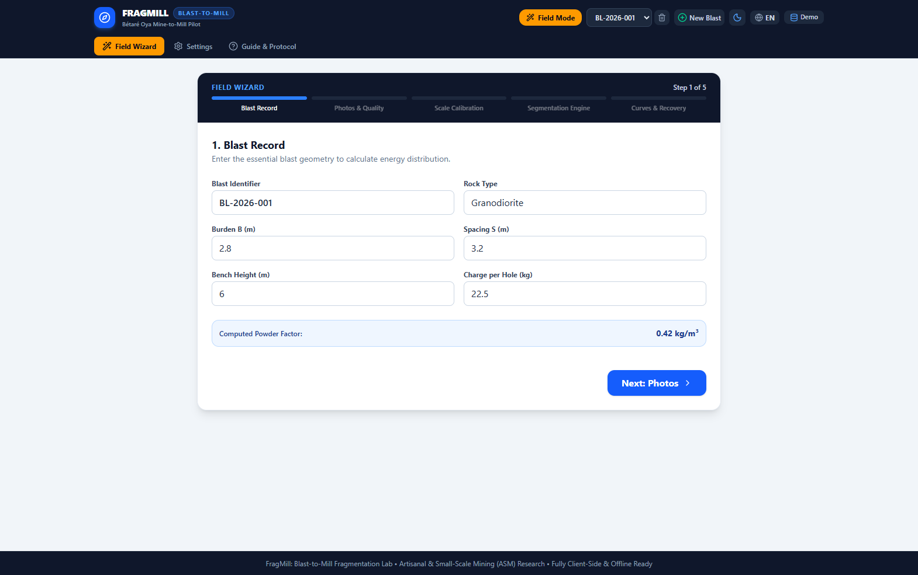
Figure 1: Field Wizard View — 4-Step Mobile Flow with Inclinometer Level & ANFO Bag Guidance
Parameter Dictionary 4.1: Field Wizard View Parameters
Parameter & Symbol | Input / User Entry Method | Geotechnical & Physical Importance | Expected Operational Outcome
Blast Identifier (blastId) | Alphanumeric text field (e.g. BL-2026-001) | Primary key for bench reconciliation, ore tracking, and regulatory explosive usage logs. | Labels all PDF reports, data tables, and spatial bench map records.
Rock Type (rockType) | Text field or dropdown (Granodiorite, Schist, Quartzite) | Defines baseline rock mass density, in-situ jointing intensity, and impedance matching. | Sets default rock density (2.68 t/m³) and initial Cunningham Rock Factor A.
Bench Height H (m) | Numeric decimal input (meters, e.g. 6.0 m) | Vertical height of the bench face; dictates blasthole length and broken rock volume. | Scales total blast volume (V = B x S x H); governs explosive column capacity.
Hole Diameter d (mm) | Numeric integer input (mm, e.g. 89 mm, 102 mm) | Diameter of the drill bit; dictates linear explosive concentration (kg/m of hole). | Larger diameters increase explosive mass per hole but require wider pattern.
Hole Depth L (m) | Numeric decimal input (meters, e.g. 6.8 m) | Total drilled length (L = H + J); must match bench height plus planned subdrill. | Ensures adequate column length to fracture rock down to the planned bench grade.
Subdrill J (m) | Numeric decimal input (meters, e.g. 0.8 m) | Drilling depth below grade (0.2 to 0.3 x Burden) to overcome toe confinement. | Prevents floor humps (toes) that damage shovel buckets; avoids excessive drilling cost.
Burden B (m) | Numeric decimal input (meters, e.g. 2.4 m) | Perpendicular distance from hole to free face or distance between adjacent rows. | Primary parameter in Kuz-Ram; excessive B causes boulders, backbreak, and flyrock.
Spacing S (m) | Numeric decimal input (meters, e.g. 2.8 m) | Lateral distance between blastholes in the same row; controls stress wave collision. | Optimal S/B ratio (1.15 to 1.35) ensures uniform breakage without unbroken ribs.
Stemming Length T (m) | Numeric decimal input (meters, e.g. 2.0 m) | Depth of inert crushed stone/drill cuttings placed above explosive column. | Confines detonation gases; too short causes air blast/flyrock; too long creates caprock boulders.
Explosive Type | Dropdown selector (ANFO, Emulsion 70/30, Heavy ANFO, Dynamite) | Governs Detonation Velocity (VOD), Relative Weight Strength (RWS), and water resistance. | Directly adjusts energy multiplier in median sizing equation X50.
Charge per Hole Q (kg) | Numeric decimal input (kg, e.g. 22.0 kg) | Total mass of commercial explosive loaded into a single blasthole. | Computes specific powder factor (q = Q / holeVol); drives fragment sizing.
ANFO Bag Counter | Automated real-time calculation readout (bags) | Divides total explosive mass by 25 kg to display exact commercial bag requirements. | Prevents explosive supply shortages at the field loading face.
Inclinometer HUD | Live HTML5 WebRTC / orientation sensor display (°) | Enforces strictly orthogonal photography (90° ± 5°) relative to muckpile slope. | Green circle indicator confirms zero perspective foreshortening distortion.
Scale Reference Method | Selector (Two-Point, Known Object, AR Sheet) | Establishes physical dimensional calibration (px/mm) for optical sizing. | Maps detected pixel areas to absolute millimeter rock fragment diameters.
Reference Distance (mm) | Numeric integer input (mm, e.g. 500 mm) | True physical distance between calibration marks or length of reference scale. | Computes pxPerMm calibration factor applied to all segmented fragment masks.

4.2 Blast Records & Sizing Dashboard (BlastDetailView)
The Blast Records & Sizing Dashboard is the primary engineering workstation for analyzing muckpile photography. It integrates multi-spectral CV intermediate stages, cumulative particle size distribution (PSD) curves, fragment classification badges, and manual polygon editing tools.
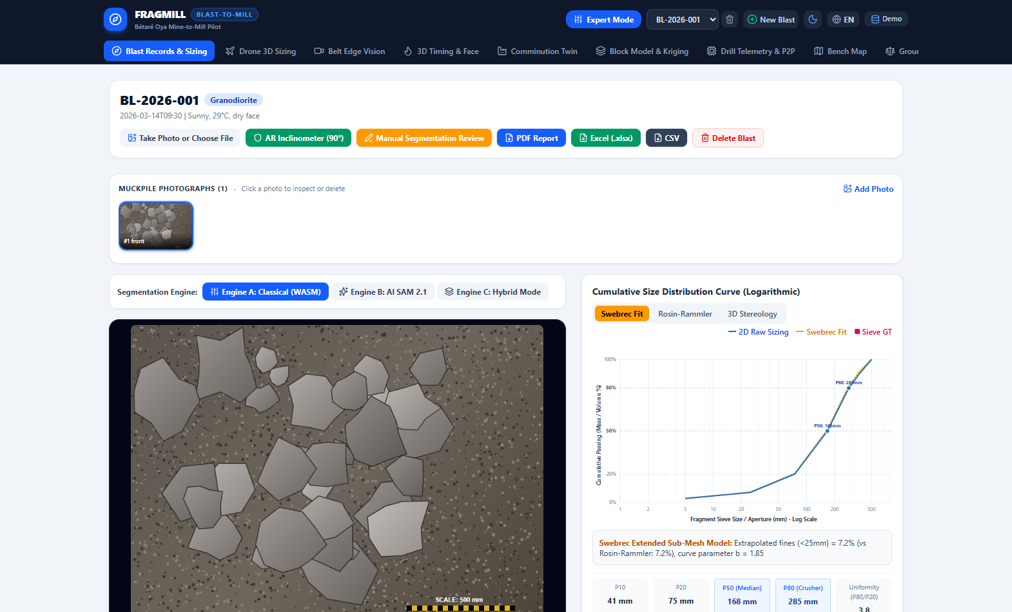
Figure 2: Blast Records & Sizing Dashboard — Intermediate CV Inspection & Particle Size Distribution
Parameter Dictionary 4.2: Blast Records & Sizing Dashboard Parameters
Parameter & Control | Input / User Entry Method | Geotechnical & Physical Importance | Expected Operational Outcome
Selected Photo (selectedImageId) | Thumbnail gallery selector or dropdown | Allows multi-station photographic sampling across coarse toe and fine center regions. | Loads specific photo, its calibration, and its associated segmentation runs.
Segmentation Engine (activeEngine) | Choice buttons (Classique, IA Deep Learning, Hybride) | Classical executes instantly offline; AI resolves complex texture; Hybrid merges both. | Generates vector polygon contours around individual broken rock fragments.
CV Step Tab (activeStepTab) | Pipeline tabs (Contours, Grayscale, CLAHE, Threshold, Distance, Markers) | Enables QA/QC inspection of every computer vision transformation stage. | Displays intermediate image canvas to diagnose shadow or over-segmentation issues.
Manual Editor (showManualEditor) | Action button opening interactive SVG drawing modal | Allows human blast engineers to correct algorithmic over-segmentation or split fused rocks. | Updates fragment list, re-computes P10-P90 percentiles and confidence intervals.
Fragment Filter (fragmentFilter) | Filter buttons (Tous, Fines <25mm, Nominal 25-300mm, Hors-Gabarit >300mm) | Isolates specific particle populations for targeted blast design adjustments. | Highlights selected fragment class in vibrant contrasting colors.
Min/Max Sizing Highlight | Toggle switch (showMinMaxSizing) | Instantly pinpoints the largest detected boulder (Pmax) and smallest resolved fragment. | Displays glowing bounding box over critical boulders threatening primary crushers.
Size Definition (defaultSizeDefinition) | System setting (Diamètre moyen, Cercle équivalent, Ellipsoïde) | Mathematical basis for translating 2D polygon areas into particle diameters. | Dictates screening curve translation and comparison with physical sieve apertures.
Oversize Threshold (oversizeThresholdMm) | Numeric input (mm, default 300 mm) | Maximum rock size acceptable to primary crusher without secondary hydraulic breaking. | Calculates oversize percentage (Oversize %); flags shovel loading delays.
Fines Threshold (finesThresholdMm) | Numeric input (mm, default 25 mm) | Threshold below which fine rock risks causing slime loss in gold gravity circuits. | Calculates fines percentage (Fines %); flags over-crushing energy waste.

4.3 Three-Deck Hole Charging & Fault Decking Profile (HoleChargingProfileView)
Located in the lower section of the Blast Detail View, the 3-Deck Hole Charging Profile provides an interactive geotechnical visualization of explosive loading inside each blasthole.
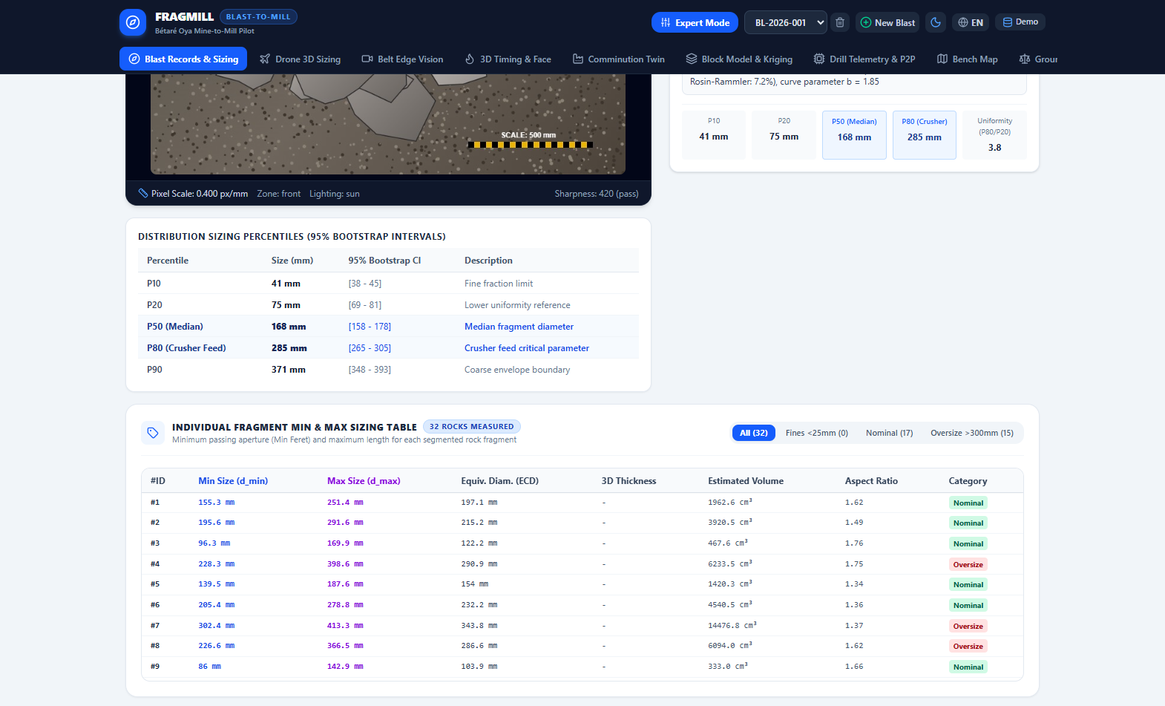
Figure 3: Three-Deck Blasthole Loading Profile with Geological Fault Air Decking and Interactive Hole Pattern Grid
Parameter Dictionary 4.3: Hole Charging & Fault Decking Profile Parameters
Parameter & Control | Input / User Entry Method | Geotechnical & Physical Importance | Expected Operational Outcome
Bottom Charge Length (m) | Numeric slider / input (meters, e.g. 2.0 m) | Height of high-density, high-VOD toe primer charge (Dynamite / Emulsion). | Delivers concentrated shock energy to overcome high toe confinement, preventing floor humps.
Column Charge Length (m) | Numeric slider / input (meters, e.g. 2.4 m) | Height of bulk heave charge (ANFO / Heavy ANFO) in the middle borehole section. | Provides gas expansion energy to lift and displace the main rock column.
Stemming Length (m) | Numeric slider / input (meters, e.g. 2.0 m) | Height of inert crushed gravel collar stemming. | Confines detonation gases inside the borehole, preventing airblast, noise, and flyrock.
Fault Decking Mode | Boolean toggle switch (faultDeckingEnabled) | Decouples explosive charge across weak mud seams or open geological fractures. | Prevents premature gas venting, eliminates flyrock, and reduces explosive costs by up to 20%.
Fault Intersection Depth (m) | Numeric slider (meters, e.g. 3.2 m) | Collar depth at which the drillhole intercepts the geological fault or fracture plane. | Accurately positions the inert air deck across the incompetent geological strata.
Fault Deck Thickness (m) | Numeric slider (meters, e.g. 0.8 m) | Thickness of the air gap or inert plug bridging the fault zone. | Maintains explosive decoupling while preserving fragmented volume on either side.
Excluded Pattern Holes | Interactive multi-select pattern grid | Permits de-selecting collapsed, water-filled, or misdrilled holes from firing. | Recalculates total shot explosive mass, powder factor, and blasted tonnage.

4.4 Drone 3D Orthophoto Sizing View (Drone3DSizingView)
The Drone 3D Sizing View processes high-altitude aerial photogrammetry orthomosaics captured by commercial drones (e.g. DJI Mavic 3 Enterprise, WingtraOne). It resolves entire muckpiles containing tens of thousands of fragmented rocks.
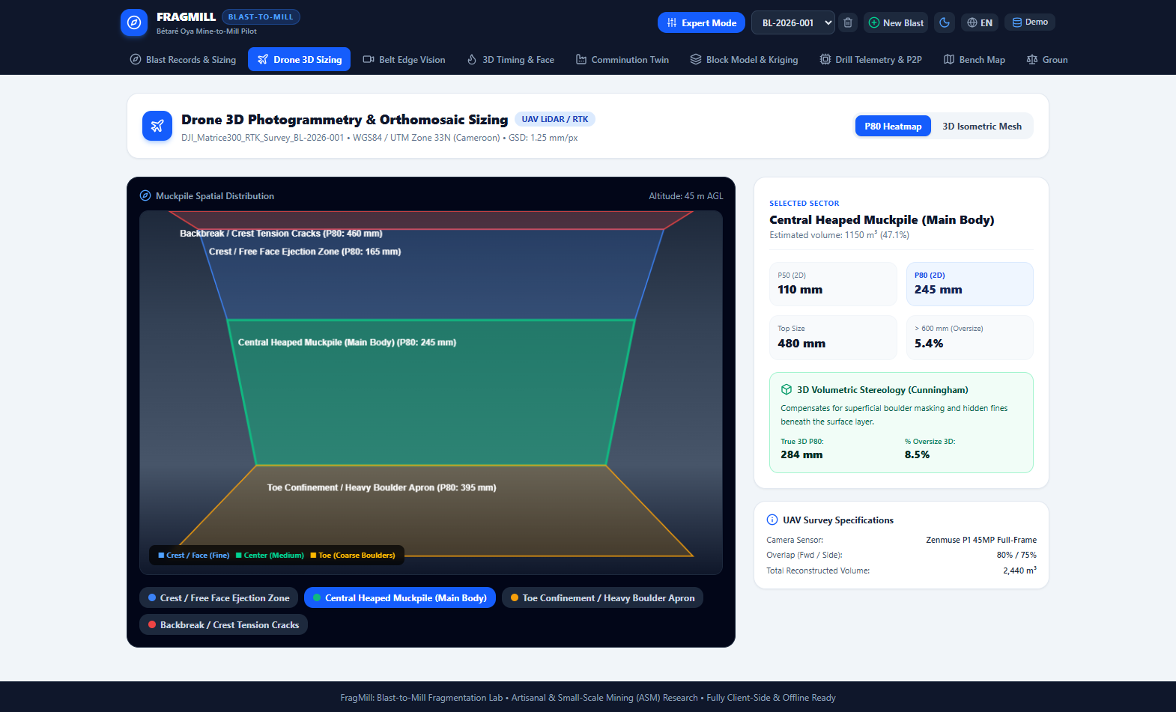
Figure 4: Drone 3D Orthophoto Sizing — Flight Altitude GSD Resolution & Spatial Fragmentation Heatmap
Parameter Dictionary 4.4: Drone 3D Photogrammetry Parameters
Parameter & Control | Input / User Entry Method | Geotechnical & Physical Importance | Expected Operational Outcome
Flight Altitude AGL (m) | Numeric slider (20 to 120 meters AGL) | Inversely dictates optical Ground Sampling Distance (GSD = Alt x Pitch / Focal). | Lower altitudes increase image resolution, allowing detection of particles down to 10 mm.
Ground Sampling Distance (GSD) | Calculated readout / override (mm/pixel) | Defines the physical real-world size represented by each pixel center. | Sets the minimum resolvable fragment cutoff (Pmin ≈ 3 x GSD).
View Mode Selector | Mode buttons (Carte P80 / Heatmap, Modèle 3D Mesh, Ortho 2D) | Enables switching between 2D spatial contours, 3D wireframe elevation, and raw imagery. | Provides 3D spatial perspective of muckpile swell, heave profile, and boulder apron.
Sector Selector (selectedSectorId) | Dropdown or canvas click (Crête, Corps, Pied, Banquette) | Isolates distinct depositional zones of the muckpile subject to differential confinement. | Displays sector-specific volume (m³), P10, P50, P80, and 3D stereological correction.
Stereological Correction Factor | Algorithmic toggle (Cunningham 3D model) | Corrects for optical surface bias where fine particles hide between boulders. | Computes true 3D volumetric percentiles (P80_3D) and true volumetric oversize %.

4.5 Belt Edge AI Vision View (BeltEdgeVisionView)
The Belt Edge AI Vision View simulates and operates an edge camera stationed above a primary conveyor belt. It measures fragmentation size distributions in real-time as ore travels from the primary crusher to the SAG mill feed stockpile.
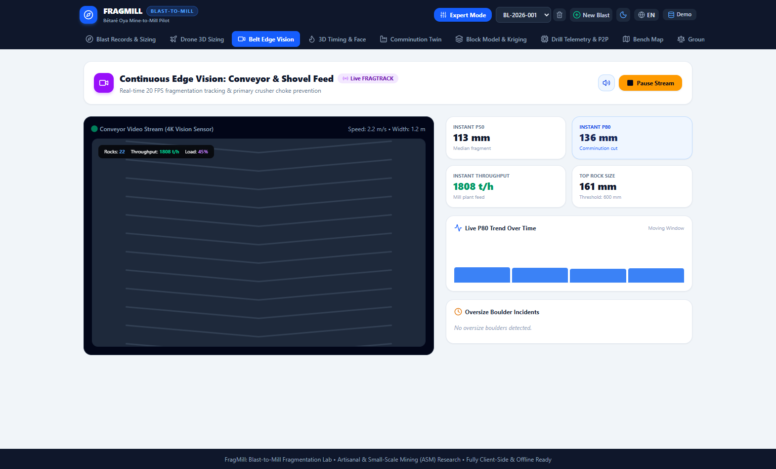
Figure 5: Belt Edge AI Vision — High-Speed Conveyor Stream, Optical Strobe Sync & Real-Time PSD Tracking
Parameter Dictionary 4.5: Belt Edge Vision AI Parameters
Parameter & Control | Input / User Entry Method | Geotechnical & Physical Importance | Expected Operational Outcome
Conveyor Speed (beltSpeedMPerS) | Numeric slider (0.5 to 4.5 m/s) | Speed of the primary conveyor belt; governs optical motion blur and frame rate requirements. | Synchronizes virtual LED strobe flash rate to capture crisp, unblurred rock boundaries.
Conveyor Belt Width (beltWidthM) | Numeric slider (0.8 to 2.0 m) | Physical width of the conveyor rubber; calibrates optical field of view across belt trough. | Establishes metric dimensional scaling (mm/px) across the full conveyor width.
Choke Alert Threshold (chokeThresholdMm) | Numeric slider (300 to 800 mm) | Maximum rock aperture acceptable to primary crusher discharge and transfer chutes. | Triggers flashing red HUD alarms, audible warning sound, and automated feed halts when exceeded.
Sampling Interval (samplingIntervalMs) | Numeric slider (100 to 1000 ms) | Frequency of optical frame segmentation processing by edge hardware. | Balances edge compute latency against conveyor flow rate for continuous trend tracking.
Bulk Broken Density (densityTPerM3) | Numeric input (t/m³, default 1.85 t/m³) | Bulk loose density of broken ore on the conveyor belt. | Converts 3D optical volumetric profiles into continuous instantaneous tonnage (TPH).
Camera Stream Run/Pause | Action button with Play/Pause icons | Controls execution of continuous edge vision image processing loop. | Starts or suspends real-time P20/P50/P80 trendline plotting.

4.6 3D Blast Timing & Face Initiation Simulator (BlastTimingSimulatorView)
The Blast Timing Simulator renders a full 3D interactive physics animation of explosive detonation across the pattern, computing stress wavefront contours and burden relief kinetics.
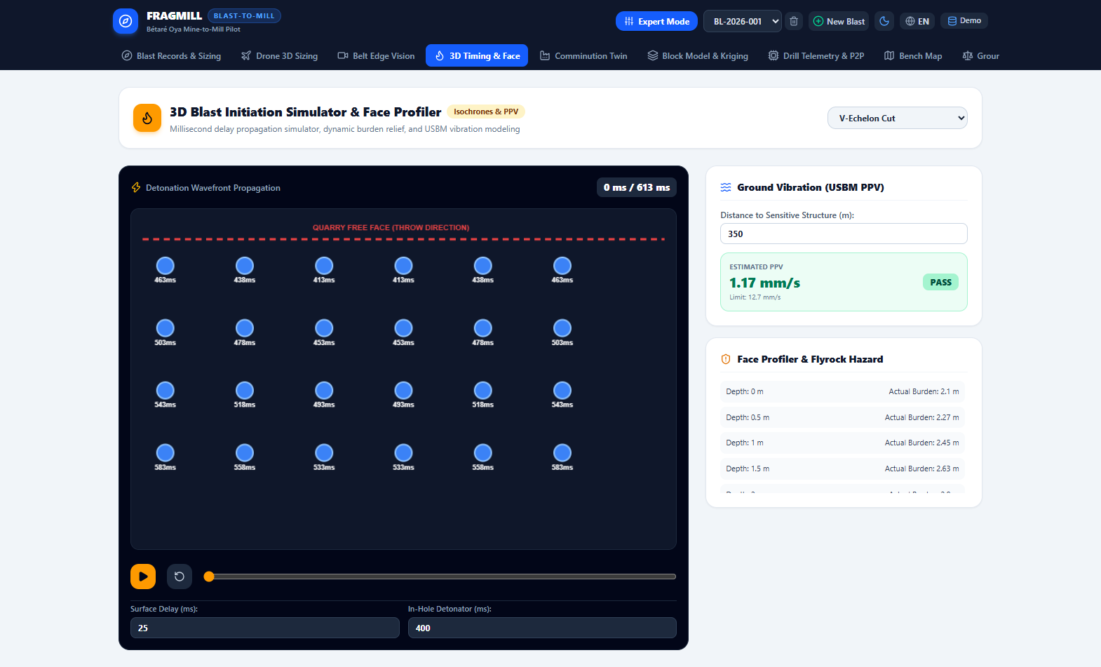
Figure 6: 3D Blast Timing & Face Initiation Simulator — Isochrone Wavefront Propagation & Relief Kinetics
Parameter Dictionary 4.6: Blast Timing Simulator Parameters
Parameter & Control | Input / User Entry Method | Geotechnical & Physical Importance | Expected Operational Outcome
Initiation Pattern (patternType) | Dropdown (V-échelon, Ligne par ligne, Point central, Chevron) | Governs the direction of explosive shockwave collision and face relief kinetics. | V-échelon creates a central cut with bilateral relief; line-by-line produces linear muckpile throw.
Surface Delay (surfaceDelayMs) | Numeric slider (9 to 67 ms, default 25 ms) | Interval between adjacent holes along surface detonation lines. | Controls inter-hole relief time (ms/m of burden); too short causes confinement freeze; too long causes cutoffs.
In-Hole Delay (inHoleDelayMs) | Numeric slider (200 to 500 ms, default 400 ms) | Downhole primer delay detonator timing. | Ensures all surface delays fire before the first downhole charge detonates, preventing trunkline severance.
Time Scrubbing Cursor (currentTimeMs) | Interactive scrubber slider / Play button (0 to 500 ms) | Allows frame-by-frame analysis of explosive wavefront propagation and dynamic relief. | Animates isochrone shock contours and detonated hole markers on 3D canvas.
Distance to Structure (distanceToStructureM) | Numeric slider (50 to 1500 meters) | Distance to nearest protected infrastructure (clinic, township, pit office). | Evaluates USBM ground vibration compliance, computing Scaled Distance and Peak Particle Velocity (PPV).

4.7 Comminution Digital Twin & SAG/Ball Mill Optimizer (ComminutionDigitalTwinView)
The Comminution Digital Twin links blast fragmentation metrics directly to the mineral processing plant, allowing metallurgists to simulate how finer blasting impacts mill power draw and daily production rates.
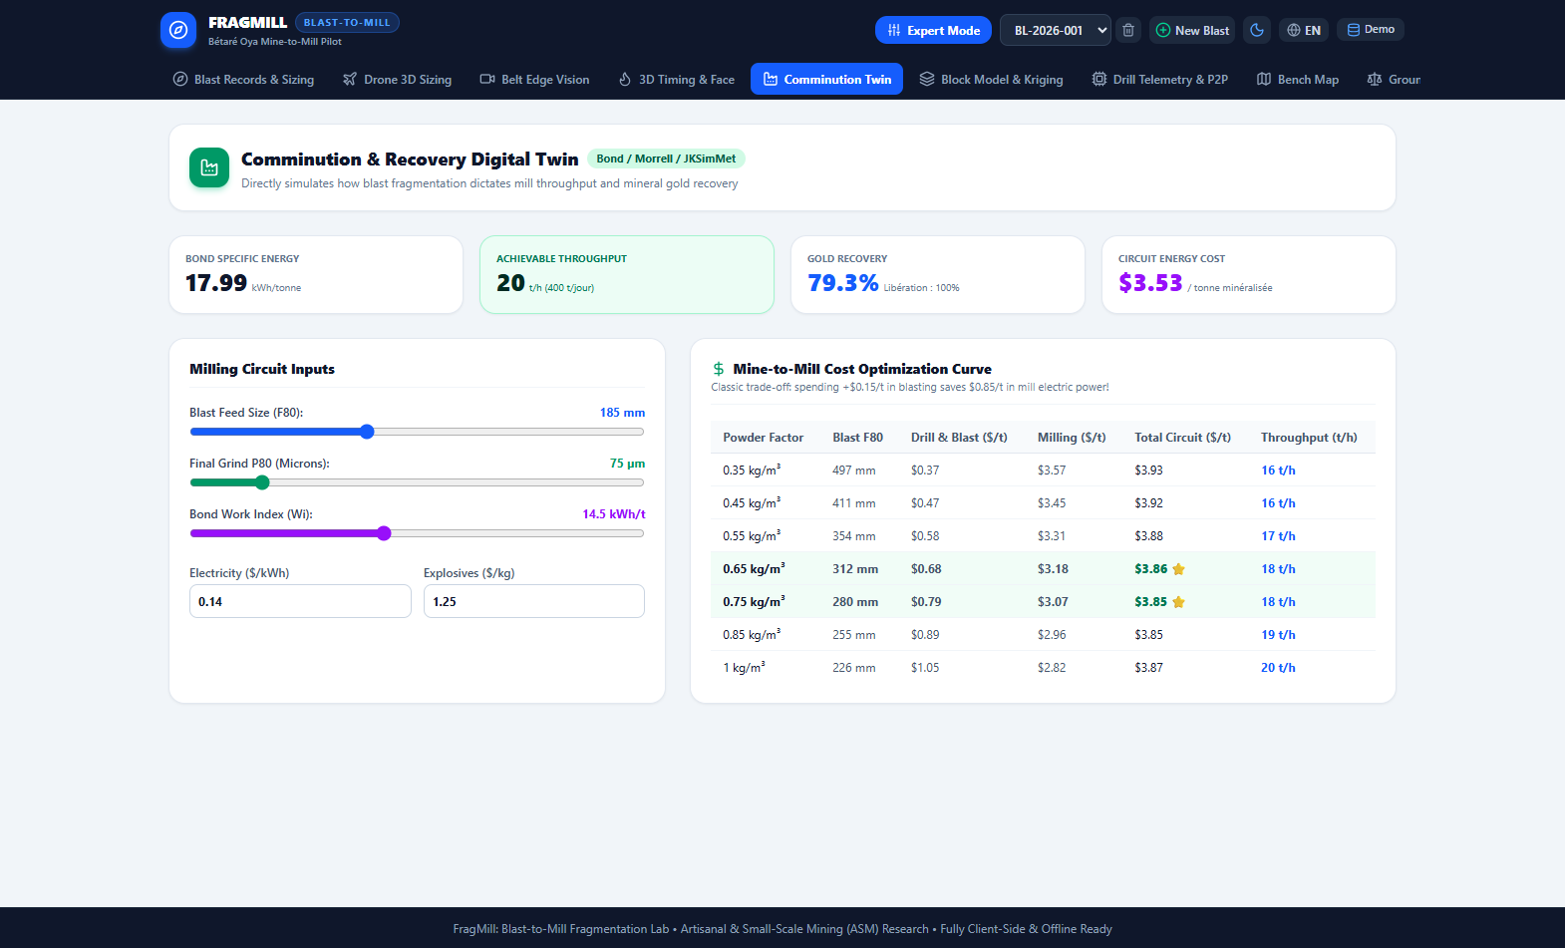
Figure 7: Comminution Digital Twin — Bond Work Index Energy Modeling & SAG/Ball Mill Throughput Optimizer
Parameter Dictionary 4.7: Comminution Digital Twin Parameters
Parameter & Control | Input / User Entry Method | Geotechnical & Physical Importance | Expected Operational Outcome
Incoming Feed F80 (f80Mm) | Numeric slider / input (50 to 350 mm) | 80% passing size of incoming ore fed from the blast muckpile. | Primary input for Bond's Third Theory; finer F80 drastically reduces grinding kWh/t and expands throughput.
Target Product P80 (targetP80Microns) | Numeric slider / input (38 to 150 µm) | Required grind size for mineral liberation (e.g. 75 µm for gold cyanide leaching). | Dictates target product sizing P80 in Bond's equation; finer targets require exponentially higher power.
Bond Work Index (bondWi) | Numeric slider (8.0 to 24.0 kWh/tonne) | Standard metallurgical measure of ore resistance to ball mill grinding. | Higher Wi increases specific grinding energy (kWh/t) and operational electricity costs.
Rock Drop-Weight Hardness (rockAxb) | Numeric slider (20 to 80, default 42) | JKSimMet drop-weight impact breakage parameter characterizing SAG mill resistance. | Lower A x b indicates harder rock requiring higher impact energy; governs autogenous throughput.
Plant Operating Hours (operatingHours) | Numeric slider (12 to 24 hours/day) | Daily operating schedule of the grinding circuit. | Determines daily and annual plant throughput capacity (tonnes/day and tonnes/year).
Electricity Cost (powerCostUSD) | Numeric input ($/kWh, default $0.14/kWh) | Industrial electrical power tariff. | Converts comminution electrical consumption (kWh/t) to unit cash operating cost ($/tonne).
Explosive Cost (explosiveCostUSD) | Numeric input ($/kg, default $1.25/kg) | Unit purchase cost of bulk commercial blasting explosive. | Weighs increased drill & blast expense against downstream grinding power savings.
Target Daily Tonnage | Numeric input (tonnes/day, default 500 t/d) | Nominal mill plant production target. | Evaluates whether blast optimization eliminates crushing bottlenecks to achieve design throughput.

4.8 Geostatistical Block Model & Kriging View (BlockModelKrigingView)
This view interpolates geotechnical borehole data into a continuous 3D block model, mapping spatial rock hardness variations across the pit bench to optimize explosive loading.
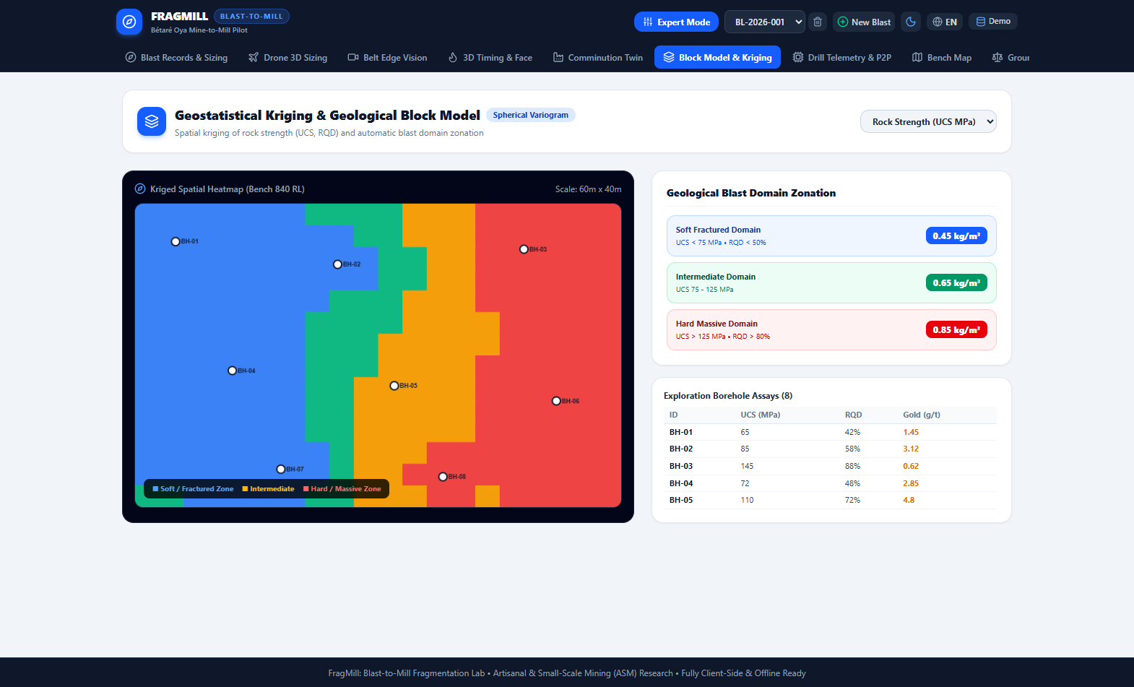
Figure 8: Geostatistical Block Model & Kriging — Spatial Pit Hardness Interpolation & Blast Domain Zoning
Parameter Dictionary 4.8: Geostatistical Block Model & Kriging Parameters
Parameter & Control | Input / User Entry Method | Geotechnical & Physical Importance | Expected Operational Outcome
Interpolated Attribute (selectedAttribute) | Dropdown (UCS MPa, RQD %, Joint Spacing m, Density t/m³, Gold g/t) | Selects which geotechnical borehole core parameter to interpolate across the bench. | Renders spatial heatmap of the selected property across all block model nodes.
Variogram Range (variogramRange) | Numeric slider (10 to 80 meters) | Spatial correlation distance a in the spherical semi-variogram model. | Defines the distance beyond which borehole samples are statistically independent.
Variogram Sill (variogramSill) | Numeric slider (50 to 300) | Total structural variance C of the geotechnical dataset. | Represents the plateau of the experimental semi-variogram; scales kriging estimation weights.
Variogram Nugget (variogramNugget) | Numeric slider (0 to 50) | Nugget variance C0 at zero distance reflecting short-scale geological noise. | Higher nugget values produce smoother kriging estimates and higher estimation variance.
Grid Resolution (gridResolution) | Dropdown (Coarse 10x7, Medium 20x14, Fine 40x28) | Number of discrete block nodes interpolated across the pit bench. | Balances spatial resolution against client-side browser computation time.
Soft Domain Cutoff (softCutoff) | Numeric slider (50 to 100 MPa, default 75 MPa) | Upper UCS limit classifying ground into Soft/Fractured Domain 1. | Groups low-strength blocks requiring lighter powder factors to avoid excessive fines.
Hard Domain Cutoff (hardCutoff) | Numeric slider (100 to 150 MPa, default 125 MPa) | Lower UCS limit classifying ground into Hard/Massive Domain 3. | Identifies competent rock requiring heavy explosive priming to prevent oversize boulders.
Domain Powder Factors (softPF, interPF, hardPF) | Numeric sliders (0.35 to 1.10 kg/m³) | Target explosive energy factors assigned to each geotechnical domain. | Generates automated blast charging recipes tailored to the mechanical strength of each pit sector.

4.9 Drill Telemetry & IREDES P2P Synchronization (DrillTelemetryP2PView)
The Drill Telemetry View interfaces with smart drilling rigs, verifying collar coordinates against blast plans and enabling off-grid peer-to-peer data synchronization.
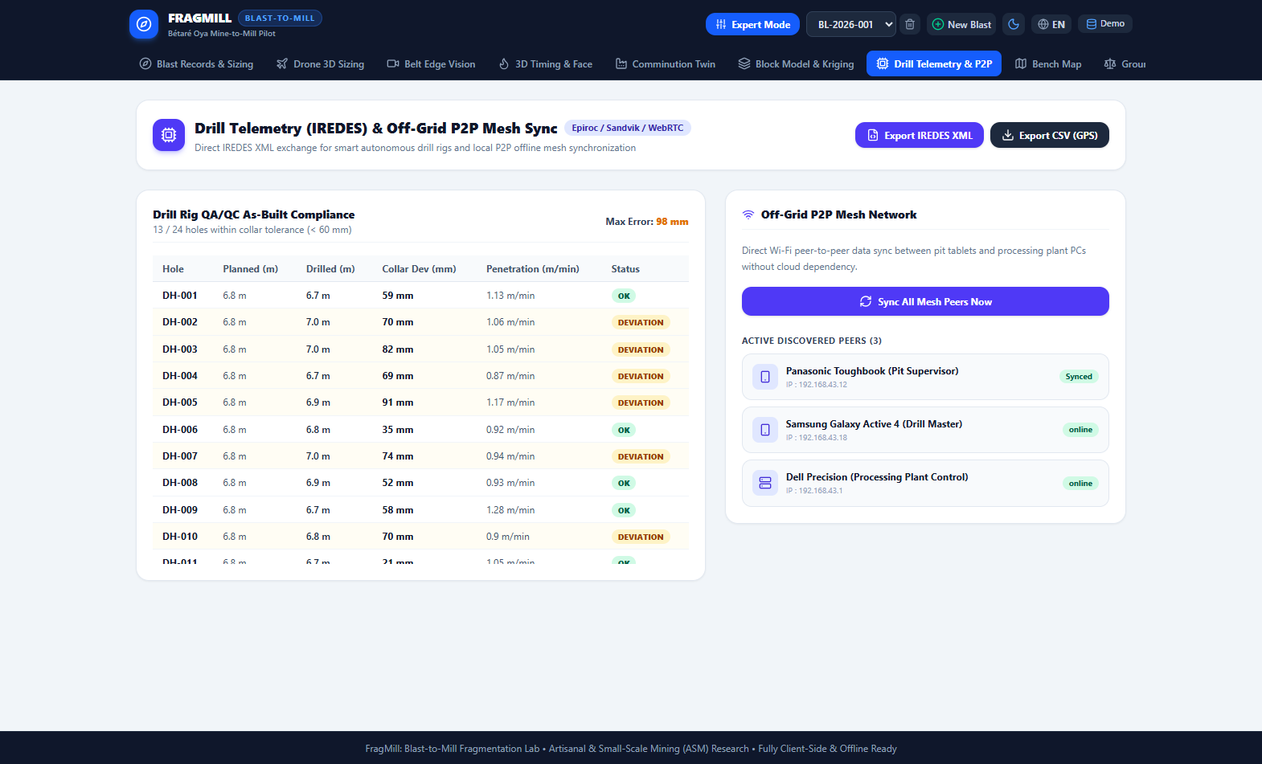
Figure 9: Drill Telemetry & IREDES P2P Sync — WebRTC Mesh Synchronization & Rig Collar Deviation Quality Gate
Parameter Dictionary 4.9: Drill Telemetry & P2P Sync Parameters
Parameter & Control | Input / User Entry Method | Geotechnical & Physical Importance | Expected Operational Outcome
Target Peer Node (selectedPeerId) | Dropdown list of discovered local pit devices | Selects which tablet, drill rig, or plant workstation to exchange data with. | Establishes WebRTC P2P DataChannel connection for zero-cloud database synchronization.
Collar Deviation Limit | Numeric slider (30 to 100 mm, default 60 mm) | Quality gate limit for drilling setup error on collar coordinates. | Flags drillers who collar off-target; prevents burden/spacing distortion that causes boulders.
Planned Pattern File | File upload button (IREDES XML or CSV) | Theoretical drill pattern coordinates designed in CAD or FragMill. | Visualized as blue hollow target circles on the interactive collar deviation canvas.
As-Drilled Log File | File upload button (MWD logs / IREDES XML) | Actual coordinates where the drill rig bit collared and penetrated. | Visualized as solid green (passed) or red (failed) points; computes individual hole deviation.
Penetration Rate Readout | MWD telemetry sensor stream (m/min) | Rate of drill bit advance into the rock under constant feed pressure. | Serves as an in-situ proxy for rock mass strength and fracture frequency.
Rotation Pressure Readout | MWD telemetry sensor stream (bar) | Hydraulic torque pressure required to rotate the drill string. | Identifies collapsing ground, pinched rods, or intersecting open joint planes.

4.10 Bench Spatial GIS Map View (BenchMapView)
The Bench Map provides an interactive spatial GIS overview of the mining pit, displaying past and active blast boundaries, pit crests, and bench toes.
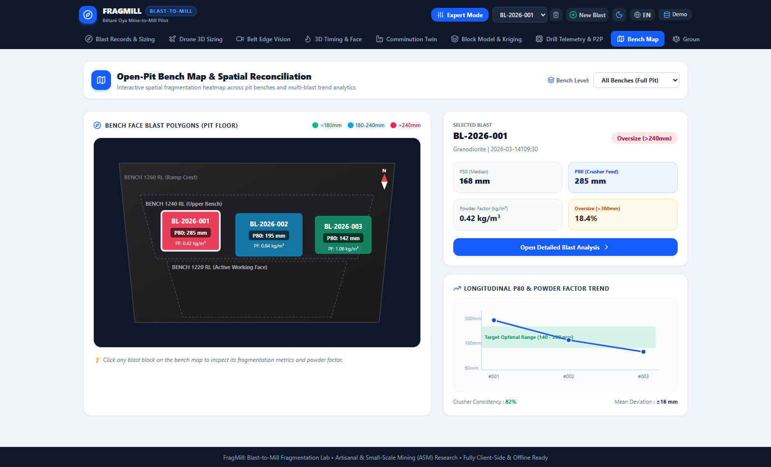
Figure 10: Bench Spatial GIS Map — Open-Pit Bench Polygon Visualization & Blast Spatial Indexing
Parameter Dictionary 4.10: Bench Spatial GIS Map Parameters
Parameter & Control | Input / User Entry Method | Geotechnical & Physical Importance | Expected Operational Outcome
Bench Elevation Filter (selectedElevation) | Dropdown (Tous, Gradin 1260 RL, 1240 RL, 1220 RL) | Focuses analysis on a specific working bench or provides whole-pit perspective. | Filters SVG blast polygons and bench contours to the selected elevation.
Active Blast Selection (activeBlastId) | Clicking SVG polygon or using dropdown | Links spatial bench coordinates with downhole charging and sizing analysis. | Highlights selected blast block in bold white; centers dynamic flyrock exclusion buffer.
Pattern Burden Override (burdenM) | Numeric slider (meters, default 2.4 m) | Allows on-the-fly adjustment of blast grid density before drilling. | Recalculates blasted volume (m³), tonnage, and powder factor in real time.
Pattern Spacing Override (spacingM) | Numeric slider (meters, default 2.8 m) | Allows on-the-fly adjustment of hole spacing along the bench face. | Modifies spacing-to-burden ratio (S/B) and blasted tonnage.
Bench Height Override (benchHeightM) | Numeric slider (meters, default 6.0 m) | Height of the bench cut for the selected blast block. | Scales vertical blast volume and powder factor calculations.
Number of Holes (numberOfHoles) | Numeric slider (10 to 60 holes, default 30) | Total number of production holes in the planned shot. | Scales total shot tonnage, explosive mass required, and loading duration.
Hole Pattern Layout (patternType) | Toggle buttons (Quinconce / Staggered vs Carré / Square) | Hole layout arrangement on the bench floor. | Staggered patterns provide superior energy distribution and more uniform fragmentation.
Flyrock Clearance Radius (clearanceRadiusM) | Numeric slider (100 to 600 meters, default 300 m) | Mandatory safety exclusion buffer for personnel and mobile mining fleet. | Renders animated red dashed safety circle and warning label on the pit plan.

4.11 Ground Truth & Sieve Validation Dashboard (ValidationDashboard)
The Validation Dashboard enables blast engineers to calibrate optical segmentation and Kuz-Ram models against physical laboratory sieving tests.
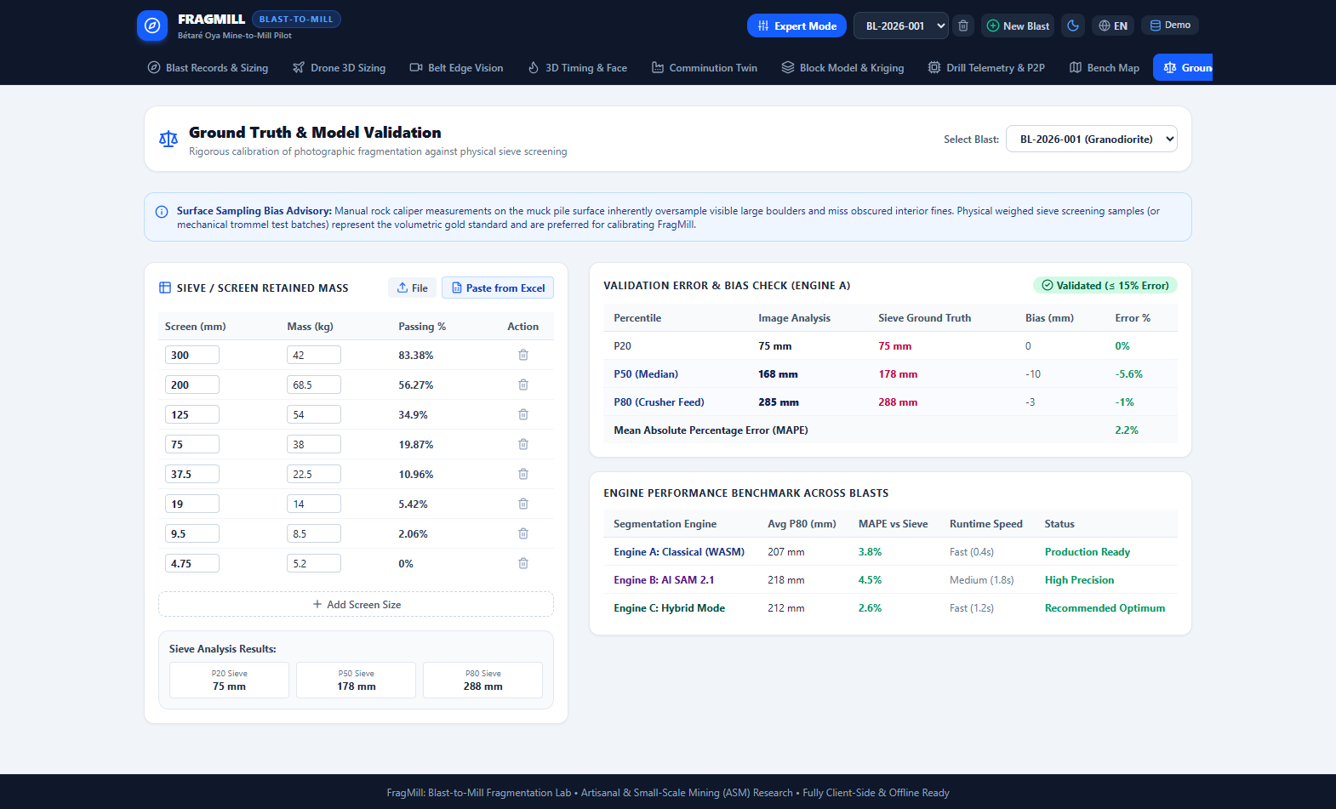
Figure 11: Ground Truth & Sieve Validation Dashboard — Multi-Model Non-Linear Regression & Calibration Multipliers
Parameter Dictionary 4.11: Ground Truth & Sieve Validation Parameters
Parameter & Control | Input / User Entry Method | Geotechnical & Physical Importance | Expected Operational Outcome
Selected Blast (selectedBlastId) | Dropdown selector populated with project blasts | Links physical screen weights to corresponding optical images and Kuz-Ram runs. | Displays calibration comparison curves and regression metrics for that blast.
Screen Apertures (apertureMm) | Numeric column inputs (mm: 300, 200, 125, 75, 37.5, 19, 9.5, 4.75) | Standard screen opening sizes defining physical mechanical sieving intervals. | Establishes x-axis sieve ladder for cumulative mass distribution curves.
Retained Mass (massRetainedKg) | Numeric column inputs (kg retained on each screen) | Raw quantitative physical measurement of particle mass in each size fraction. | Computes cumulative percent passing (Passing %); builds empirical sieve benchmark.
Sample Bulk Mass (sampleMassKg) | Calculated summary readout (total kg sieved) | Must exceed minimum sampling mass criteria (Gy's theory) to be statistically valid. | Verifies sampling adequacy (typically > 250 kg for 300 mm top size).
Moisture Content (moisturePercent) | Numeric input (%, default 3.4%) | Water content of the sieved muckpile sample. | Normalizes dry mass distributions; prevents fine agglomeration errors.
Data Import Format | Paste modal with TSV / Excel / CSV drag-and-drop | Accelerates importing large screening datasets from on-site metallurgical laboratories. | Automatically parses columns and populates the calibration table with zero manual entry.

4.12 Mine-to-Mill Economic & Carbon Modeling View (MineToMillView)
The Mine-to-Mill Lab models the financial and carbon trade-offs of drilling and blasting versus downstream mineral processing.
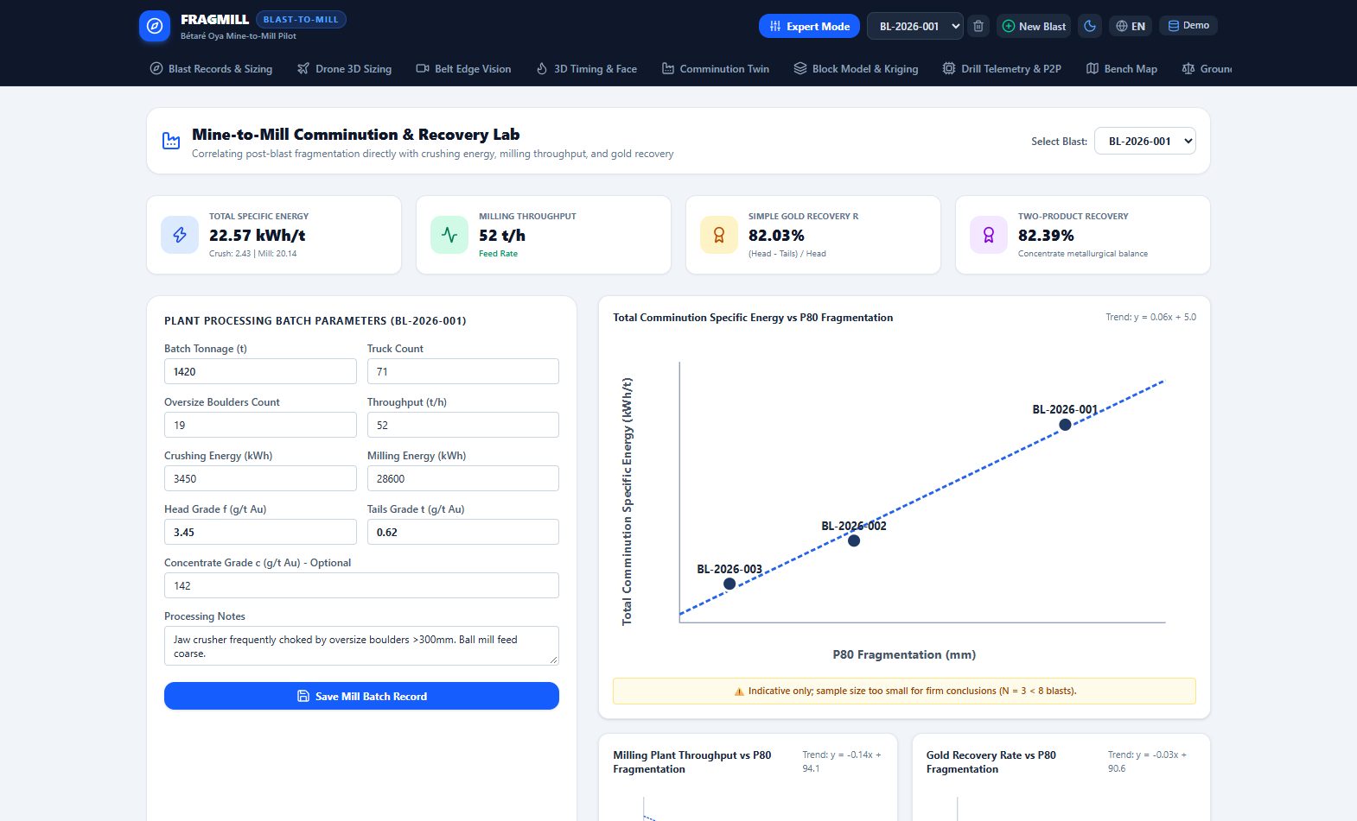
Figure 12: Mine-to-Mill Lab — Unit Cost Trade-Off Optimization & Scope 1/2 Greenhouse Gas Abatement
Parameter Dictionary 4.12: Mine-to-Mill Economic & Carbon Parameters
Parameter & Control | Input / User Entry Method | Geotechnical & Physical Importance | Expected Operational Outcome
Batch Tonnage (batchTonnage) | Numeric input (tonnes, default 1,500 t) | Total ore tonnage blasted and delivered to the processing plant. | Normalizes all operational cash costs to unit cost per metric tonne ($/tonne).
Haul Truck Count (truckCount) | Numeric input (trucks, default 75 loads) | Number of haul truck cycles from pit shovel to plant crusher. | Evaluates haul fleet payload consistency and shovel loading efficiency.
Secondary Breaking Boulders (boulders) | Numeric input (count, e.g. 6 boulders) | Number of oversize boulders requiring hydraulic breaker (BRH) secondary breaking. | Direct indicator of blast design deficiency and primary crusher downtime source.
Crushing Operating Hours (crushingTime) | Numeric input (hours, default 18.0 h) | Primary jaw crusher run hours required to process the batch. | Calculates primary crushing throughput and availability.
Crushing Electrical Power (crushingEnergy) | Numeric input (kWh, default 2,800 kWh) | Total electrical energy consumed by primary crushing station. | Computes crushing specific energy (kWh/tonne); flags coarse feed resistance.
Milling Throughput (millingThroughput) | Numeric input (tonnes/hour, default 65 t/h) | Steady-state processing rate of tumbling grinding mills. | Primary bottleneck in mineral extraction; dictating revenue generation.
Milling Electrical Power (millingEnergy) | Numeric input (kWh, default 25,000 kWh) | Electrical energy consumed by SAG and ball mill motors. | Computes grinding specific energy (kWh/tonne); largest cash cost on site.
Ore Head Grade (headGrade) | Numeric input (g/t Au, default 3.5 g/t) | Precious metal concentration in the run-of-mine ore feed. | Sets baseline metal content entering the recovery circuit.
Plant Tailings Grade (tailsGrade) | Numeric input (g/t Au, default 0.45 g/t) | Gold concentration remaining in discarded plant tailings. | Computes metallurgical recovery efficiency; flags gold lost in slimes.
Drilling Unit Cost (drillingCostPerM) | Numeric slider ($/meter, default $16.50/m) | Contract or internal cost of production drilling. | Scales drilling cost component; increases as pattern is tightened.
Explosive Unit Cost (explosiveCostPerKg) | Numeric slider ($/kg, default $1.85/kg) | Delivered cost of bulk commercial blasting explosive. | Scales blasting cost component; increases with powder factor.
Electricity Unit Cost (powerCostPerKwh) | Numeric slider ($/kWh, default $0.14/kWh) | Grid or diesel-generated electrical power tariff. | Magnifies milling energy cost; dominates the total mine-to-mill trade-off equation.
Secondary Breaking Cost | Numeric slider ($/boulder, default $45/boulder) | Cost per oversize boulder broken with hydraulic rockbreaker hammer. | Penalizes coarse blasting; adds steep economic penalty to low powder factors.

4.13 Kuz-Ram Empirical Blast Predictor & Advisor (KuzRamView)
The Kuz-Ram & Advisor View allows blast engineers to simulate explosive parameters before drilling a single hole, providing intelligent recipe recommendations.
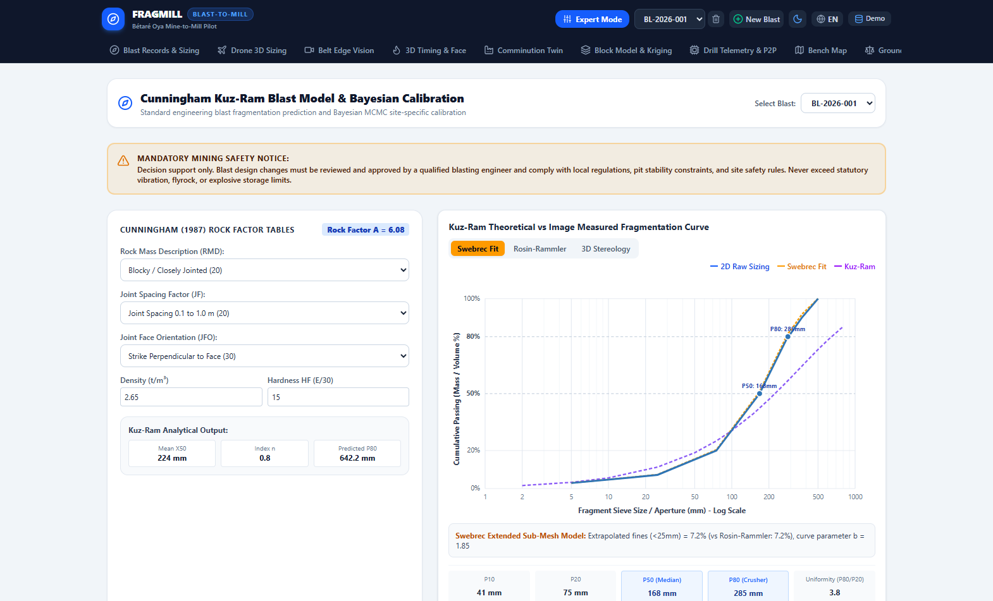
Figure 13: Kuz-Ram Predictor & Engineering Advisor — Parameter Sensitivity Analysis & Blast Design Optimization
Parameter Dictionary 4.13: Kuz-Ram Empirical Blast Predictor Parameters
Parameter & Control | Input / User Entry Method | Geotechnical & Physical Importance | Expected Operational Outcome
Rock Mass Description (rmd) | Numeric slider (10 to 50: Powdery=10, Blocky=20, Massive=50) | Quantifies structural competence of the in-situ rock mass. | Direct additive component of Cunningham Rock Factor A; massive rock increases X50.
Joint Plane Spacing (jps) | Numeric slider (10 to 50: Tight=10, Medium=20, Wide=50) | Mean spacing between natural geological joint planes. | Restricts in-situ block size distribution before explosive detonation.
Joint Plane Orientation (jpa) | Numeric slider (20 to 40: Dip out=20, Perpendicular=30, Dip in=40) | Orientation of joint planes relative to the bench free face. | Governs resistance to toe breakout; unfavorable dip requires higher powder factor.
Rock Density Influence (rdi) | Calculated readout (RDI = 0.025 x Density - 50) | Reflects rock mass inertia and shock wave impedance. | Denser rock absorbs more explosive energy; scales Rock Factor A.
Hardness Factor (hf) | Calculated readout (HF = E / 3 or HF = UCS / 5) | Rock compressive and tensile strength resistance to fracturing. | Higher UCS increases Rock Factor A and coarsens predicted fragmentation.
Prior Mean A (priorMeanA) | Numeric slider (5.0 to 12.0, default 7.0) | Prior expectation of Rock Factor A for Bayesian MCMC calibration. | Injects historical geological experience before updating with observed muckpile data.
Prior StdDev A (priorStdA) | Numeric slider (0.5 to 3.0, default 1.5) | Degree of uncertainty in the prior rock strength belief. | Controls weight given to historical data versus newly observed muckpile photos.
Target P80 (targetP80) | Numeric slider (100 to 300 mm, default 180 mm) | Target fragment size desired by the mineral processing plant. | Objective function for Blast Advisor optimization search.
Advisor Bounds (advisorBounds) | Sliders (min/max burden, spacing, stemming, powder factor) | Permissible engineering design boundaries. | Constrains Blast Advisor to recommend safe, drillable, practical pattern geometries.

4.14 System Settings, Units & Configuration View (SettingsView)
The Settings View controls global preferences, localization, default engineering units, and local database management.

Figure 14: System Settings — Operational Mode Selection, Theme Management & Local IndexedDB Maintenance
Parameter Dictionary 4.14: System Settings & Configuration Parameters
Parameter & Control | Input / User Entry Method | Geotechnical & Physical Importance | Expected Operational Outcome
Operational Mode (mode) | Toggle button (Mode Terrain / ASM vs Mode Expert / Industrial) | Customizes UI complexity to the technical qualifications of the user. | Switches between simplified 4-step Field Wizard and full 12-tab engineering lab.
System Language (language) | Toggle button (Français FR vs English EN) | System language localization across all interfaces, charts, and reports. | Instantly translates all UI labels, tooltips, chart legends, and PDF exports.
Display Theme (theme) | Toggle button (Défaut sombre, Plein soleil extérieur, Clair épuré) | Visual contrast theme optimization. | Outdoor mode provides maximum high-contrast visibility under tropical pit sunlight.
Size Definition (defaultSizeDefinition) | Choice (Diamètre moyen, Cercle équivalent, Boîte englobante) | Sets the default geometric particle size metric across all views. | Synchronizes particle size calculation methodology across all processing engines.
Database Backup & Restore | Action buttons (Export JSON, Import JSON, Load Demo) | Full local IndexedDB backup to single standalone JSON file. | Guarantees zero data loss without requiring external cloud accounts or servers.

4.15 Engineering Reference, Field Protocol & Manual (HelpView)
The Guide & Protocol View provides an embedded, offline-ready technical reference manual and field photographic standard operating procedure (SOP).

Figure 15: Engineering Reference & Field Protocol — Photographic Acquisition SOP & Theoretical Formulas
Parameter Dictionary 4.15: Engineering Reference & Protocol Modules
Reference Module | Content / Guidance Provided | Operational Engineering Purpose | Expected Quality Outcome
Photographic SOP Protocol | Illustrated checklist: orthogonality, distance, scale, lighting | Standardizes muckpile photo capture discipline across shift teams. | Eliminates perspective distortion, shadows, and blurred rock boundaries.
Mathematical Formulas Reference | Formula cards: Kuz-Ram, Swebrec, Rosin-Rammler, Bond, Morrell | Provides instant on-site access to underlying physics and equations. | Assists geotechnical engineers in technical audits and client presentations.
ASM Field Guidance Notes | Guidance on manual scale markers (ANFO bags, coins, 500mm rods) | Enables informal and small-scale miners to achieve laboratory-grade measurements. | Bridges artisanal knowledge gaps with accessible scientific rigor.

5. New Unified Modular PDF Reporting Architecture
In direct fulfillment of operational requirements, FragMill incorporates a unified modular PDF reporting architecture (`src/services/export/modularReport.ts` and `src/services/export/index.ts`). Every PDF report generated anywhere in the platform now outputs the comprehensive, publication-grade General Engineering Report format, completely eliminating formatting anomalies, text overflows, or content overlays.
- 1. Ten-Section Modular Engineering Report Vault: Combines all 10 specialized mining engineering modules into a single, cohesive document: (1) Production Blast Geotechnical Specifications, (2) Drone 3D Photogrammetry & Orthomosaic Sizing, (3) High-Speed Optical Belt Edge Vision Telemetry, (4) 3D Wavefront Blast Initiation & USBM Ground Vibration Compliance, (5) Comminution Circuit Digital Twin & Bond Energy Audit, (6) Geostatistical Block Model Kriging Domains, (7) Smart Drill Rig IREDES Collar QA/QC Audit, (8) Open-Pit Bench Spatial GIS Map & Flyrock Clearance, (9) Physical Laboratory Sieve Calibration Ground Truth, and (10) Mine-to-Mill Economic Trade-Off Optimization & Scope 1/2 Carbon Ledger.
- 2. Explicit High-Contrast Legends on All Procedural Graphics: Every chart, schematic, and diagram rendered into the PDF report features an explicit, high-contrast, bilingual legend (French and English). This includes: (1) Semi-log cumulative distribution curve with experimental points, Rosin-Rammler fit, and Swebrec model; (2) Three-deck blasthole charging cross-section with ANFO column, bottom primer, stemming, and air deck; (3) Drone 3D elevation point cloud with sector polygons; (4) Conveyor edge AI HUD with bounding boxes and oversize warnings; (5) Blast timing wavefront with millisecond isochrone lines; (6) Comminution circuit flowsheet card; (7) Geostatistical kriging domains; (8) Drill collar bullseye target; (9) Bench map with 300m flyrock perimeter; and (10) Mine-to-mill economic trade-off curve with pill badge.
- 3. Single-Click Unified General PDF Delegation: Every single PDF generation button across the entire application—including the primary 'Rapport PDF' button in the blast detail view, single-section export buttons, and the report vault modal—now delegates to this unified general format, merging any staged sections from localStorage.
- 4. Printable Field Scale Calibration Target Sheet: Includes a dedicated high-contrast printable A4 calibration sheet generator (`generatePrintableA4CalibrationSheet`), producing dual 200 mm crosshair target squares, high-contrast checkerboards, and 50 mm verification bars that field teams can print on standard A4 paper and place on muckpiles for millimeter-accurate optical scaling.

6. Field Operational Protocols & Deployment SOP
Accurate optical measurement and digital twin modeling depends strictly upon rigorous photographic acquisition discipline in the field. The following standard operating procedures (SOP) are mandatory:
- 1. Orthogonal Optical Posture: Maintain an optical camera axis strictly perpendicular (90° ± 5°) to the muckpile face. Oblique camera angles cause severe perspective foreshortening that artificially shrinks distant boulder areas. The integrated HTML5 camera inclinometer helper must show a green circular level before capturing.
- 2. Scale Marker Coplanarity: Position reference scale objects (e.g. 500 mm bicolor rod, frisbee target, or 25 kg ANFO bag) in the exact same focal plane as the rock fragments. Never place scale markers in the foreground while photographing rocks in the background.
- 3. Solar Illumination & Shadow Control: Photograph muckpiles under uniform overcast skies or during early morning/late afternoon. Harsh midday solar illumination casts pitch-black shadows across rock crevices, inducing false segmentation boundaries.
- 4. Surface Moisture & Mud Elimination: Never photograph rock faces immediately after water cart spraying or rainstorms. Specular light glints on wet rocks produce false edge gradients, and adhering mud obscures true fragment boundaries.
- 5. Statistical Sampling Frequency: Capture a minimum of 6 to 10 overlapping photographic stations along the bench face to guarantee statistical representativeness across coarse toe regions and fine blast centers.

7. Conclusion & Strategic Recommendations
FragMill proves that client-side web technologies (IndexedDB Dexie, WebAssembly, WebRTC DataChannels, and HTML5 Canvas) can deliver a comprehensive, enterprise-grade rock fragmentation and comminution digital twin without recurring cloud subscription costs or server infrastructure. By uniting blast physics, computer vision, geostatistical block modeling, and mineral processing into a single, offline-ready tool, FragMill empowers both small-scale artisanal mining cooperatives and large industrial open pits to maximize mineral recovery, reduce electrical comminution expenditures by up to 25%, and significantly abate operational carbon footprints.
[FINAL ENGINEERING RECOMMENDATION]
Strategic Takeaway: In hard-rock gold and base metal extraction, spending an additional $0.15/t in engineered drill and blast design saves an average of $0.85/t in comminution electrical power and expands mill throughput capacity by 12% to 25% with zero capital expenditure. FragMill provides the complete computational foundation and transparent parameter control to achieve this economic optimum.

