# 111021

# Lab Assignment

## Intermediate SQL

## Question 1

select max(enrollment), min(enrollment)

from (select sec_id, semester, year, count(distinct id) as enrollment

from takes

group by sec_id, semester, year) as alias1;

## 

## Question 2

SELECT T.sec_id, T.semester, T.year, T.enrollment FROM (select sec_id, semester, year, count(distinct id)from takes group by sec_id, semester, year) AS T JOIN

(select T.sec_id, T.semester, T.year, T.enrollment from T, (select max(enrollment) as ma, min(enrollment) from T) as tmp

where T.enrollment = tmp.ma;

## 

## Question 3

delete from course where course_id = 'CS-001';

delete from section where sec_id = '1' and semester = 'Fall' and year = '2010';

insert into course(course_id) values ('CS-001');

insert into section(course_id, sec_id, semester, year) values ('CS-001','1','Fall','2010');

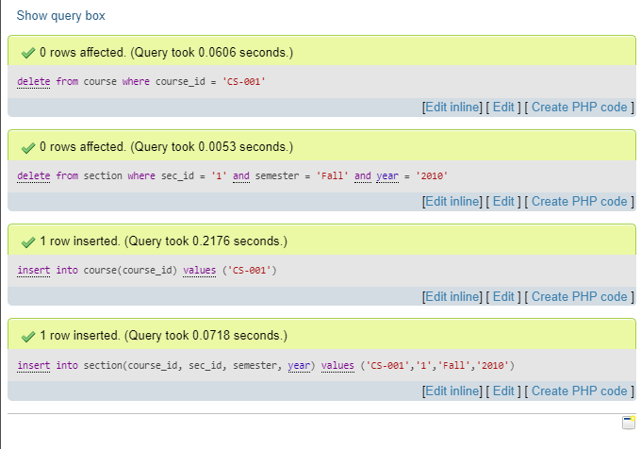

(a)

select distinct sec_id, semester, year, (

select count(distinct id) from takes

where (

takes.sec_id, takes.semester, takes.year

) = (

section.sec_id, section.semester, section.year))

as cnt from section;

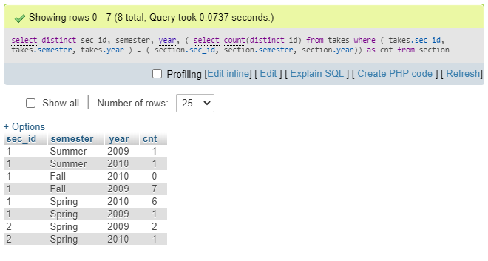

(b)

select distinct sec_id, semester, year, ifnull(cnt,0)

from section left outer join (

select sec_id, semester, year, count(distinct id) as cnt

from takes group by sec_id, semester, year) as T

using (sec_id, semester, year);

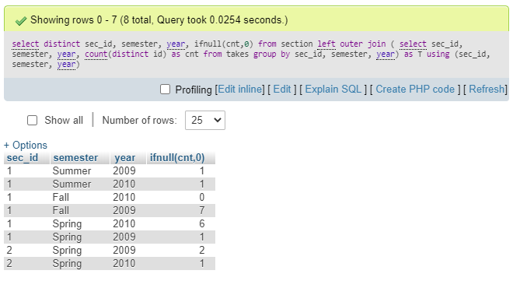

## Question 4

select course_id, title

from section natural join course

where course_id like 'CS-1%';

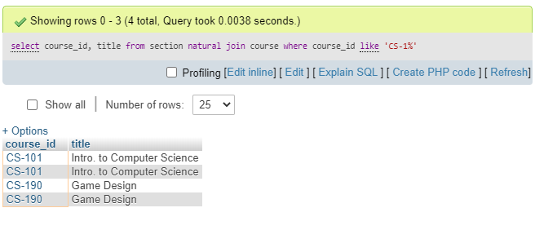

## Question 5

(a)

select distinct ID, name from (

select * from teaches natural join instructor)

as T where not exists (

select cs_course.course_id from (

select course_id from course

where course_id like 'CS-1%')

as cs_course where cs_course.course_id not in (

select course_id from (

select * from teaches natural join instructor)

as S where S.name = T.name));

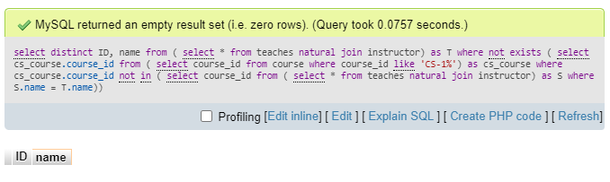

(b)

select S(course_id) as (

select distinct course_id

from teaches natural join instructor

where course_id like 'CS-1%') JOIN

(select distinct ID, name from (

select * from teaches natural join instructor) as T

where ((select count(course_id) from S)=(

select count(distinct course_id)

from teaches natural join instructor

where name = T.name and course_id like 'CS-1%'

)));

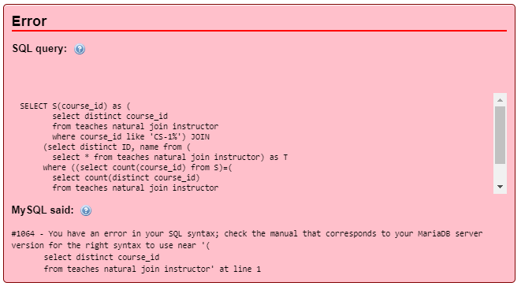

## Question 6

insert into student

select ID, name, dept_name, '0'

from instructor;

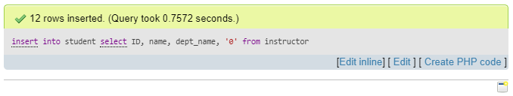

## Question 7

delete from student

where (ID, name, dept_name) in (

select ID, name, dept_name

from instructor);

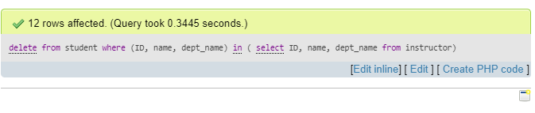

## Question 8

update student as S set tot_cred = (

select sum(credits)

from takes natural join course

where S.ID = takes.ID and takes.grade is not null);

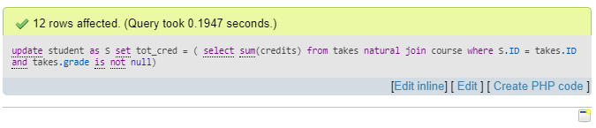

## Question 9

update instructor as I set salary = 10000 * (

select count(distinct sec_id, semester, year)

from teaches as T where I.ID = T.ID);

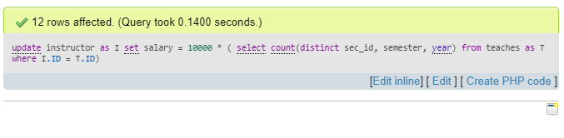

## Advanced SQL Queries

## Question 1

## Question 2

## Question 3

## Question 4

## Question 5

## Question 6

## Question 7

## Question 8

## Question 9

## Question 10