Minmis – Recording of Production Delays.

Maintenance: The dropdown selections have been pre-set and is maintained by the Maintenance Planner. All items are kept ALWAYS. If a change occurs and the item is not active, Un-tick the Active Indicator. Click the ArrowStar at the bottom on the page to add a new item and then link the Component and Discipline. All Components are linked to each equipment Item and all Failures are linked to each Equipment.

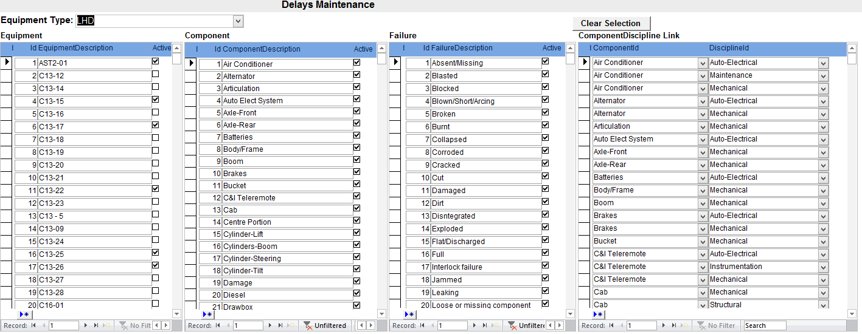

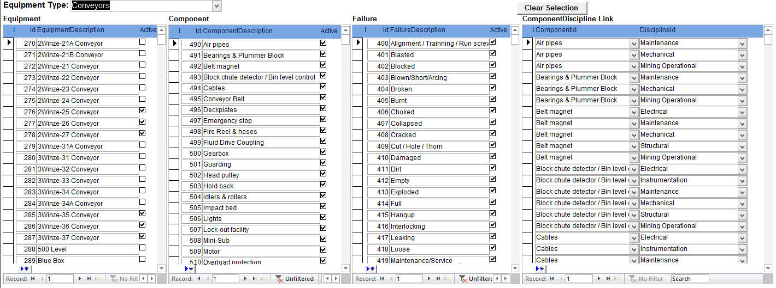

Actual Delays: are recorded by Control Room Operators.

Selections on page is based on data indicated as Active in the Maintenance pages. One selection will activate the next selection and at the end you will record the Start/End Time. Additional free text is available for comments. If an incorrect item was selected, click the GarbageBox on the top right of the item and it will clear or use Clear Selection button to re-do.

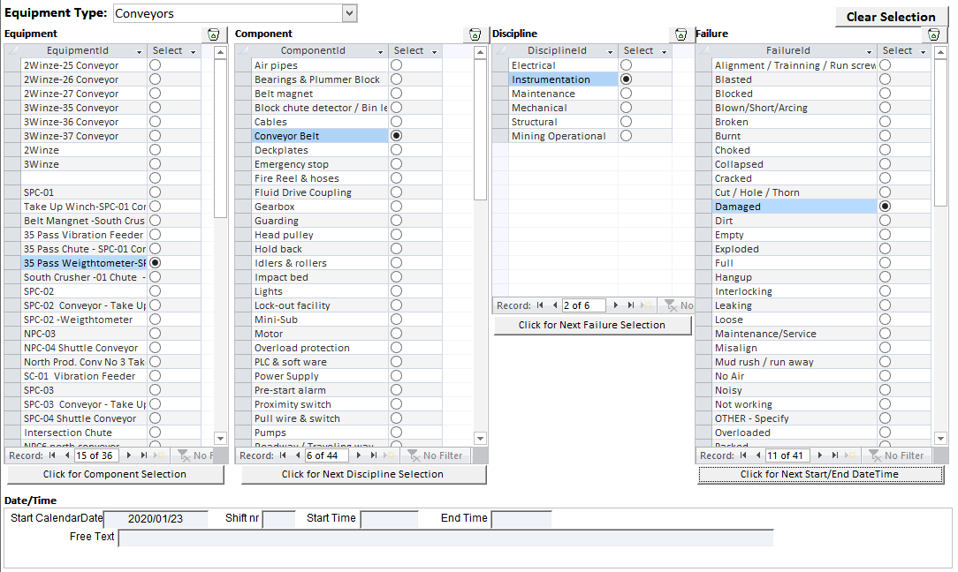

Complete Outstanding items without ENDTIME: This page will display all previously recorded selection – based on original recording. Note where EndTime is incomplete, you can update it here and it will calculate the Hours based on start and end time

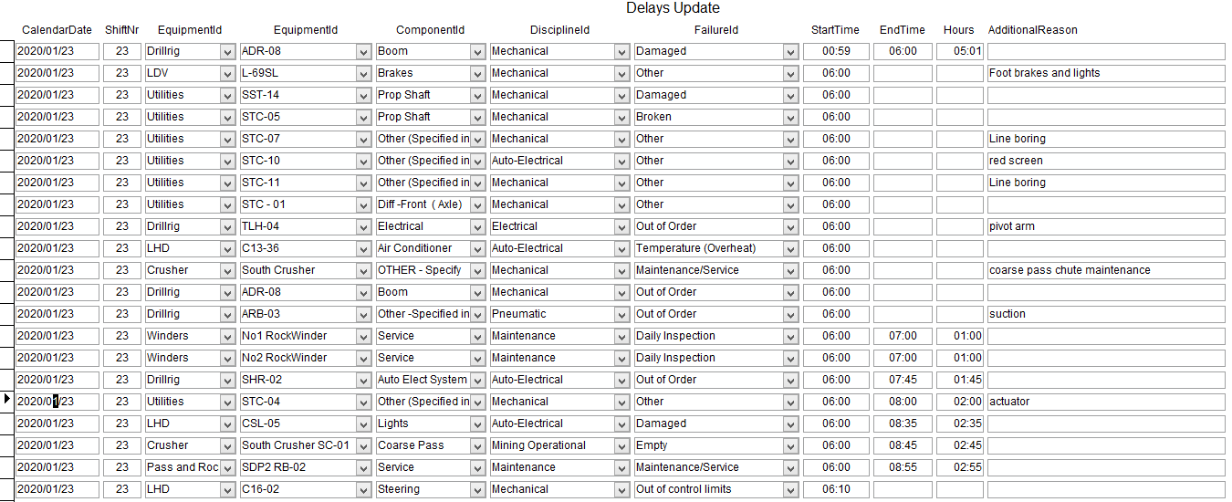

Reports: A ShiftReport is available on-screen based on the Calendardate you are placing the cursor in.

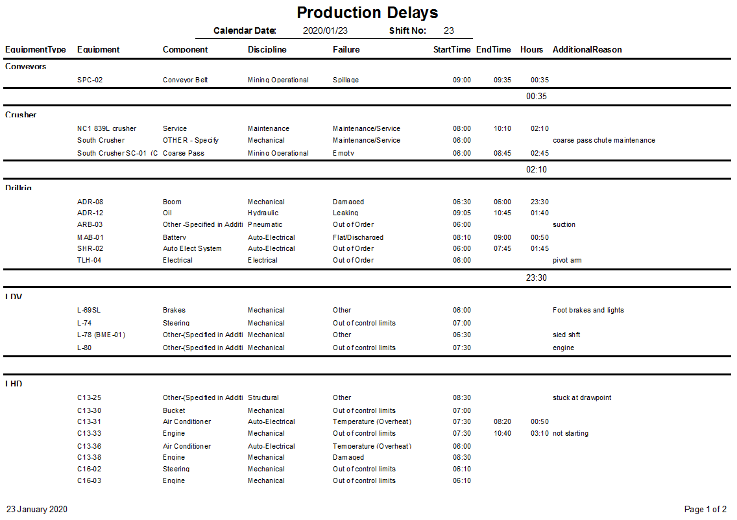

Additional reports will be available on request only.