Suncoast Technical College
Quiz your Friends

submitted to: Mr. Horneberger
submitted by: Thomas Herman
Introduction

Final Client Specifications
- Online multiplayer
- Player scoring
- Chat
- Public rooms
Original Client Specifications
- Online multiplayer
- Player accounts
- Player statistics
Quiz your Friends is an online multiplayer quiz game. Your friends and you will be able to ask custom questions, come up with wacky answers, and compete for first place!
An average game of Quiz your Friends is simple, and above all, fun. You can start playing the moment you enter the website (provided other players are online). You will be prompted to choose a display name, but for the indesicive, you can just allow the server to generate a unique random name for you! After choosing your display name you will be brought to the main menu. This is the menu you will be seeing for the entirety of the quiz. The content changes dynamically, so no need for refreshing or waiting for page loads!
From the main menu you will have the option of creating or joining a quiz. There is also a public lobby browser. Just click on any public lobby, that hasn't reached the maximum player count, to join. From here your screen will change to the ready up menu. Here you will wait for all players in the lobby to ready up. Meanwhile, feel free to chat with other players in the lobby using the message list.
Once all players have set their state to ready, the quiz will start! Well sort of. You will be taken to a new menu where each player will compose a custom question, one correct answer, and three wrong answers. After all players have submitted their answers, the actual quiz shall begin! Players will be awarded fifty points for each correct answer they get. Players real-time scores can be tracked via the player list, which shows all the players taking the quiz.
When every answer has been answered by all players, the quiz will end and declare the results. Players will have the option to play again, which will return them to the ready up menu. At any point when taking the quiz, players may leave, create a new quiz, or join another quiz. Players can only be in one quiz at a time, so upon creation or joining of another quiz, the user will be forced to leave their current quiz.
Algorithms

Inputs
- Name
- Lobby to join or create
- Players custom questions and answers
- Players answer

Outputs
- Public quizzes
- Lobby information
- Players in lobby
- Players in lobby state (ready, Score)
- Messages from players in lobby
- Players in lobbys' questions (including their own)
- Quiz results

Constants
- Max players
- Length of field entries
- Points awarded for correct answer

Formulas
- score = correct ? Score + 50 : score;
- quiz.isPrivate == false ? PublicQuizzes.add(quiz) : null
- message = message > 140 ? message.Substring(0, 140) : message

Psuedo-code
Client Side Code
- getName(userName)
- joinQuiz(quizName)
- readyUp()
- submitQuestion(question, answers)
- until (all questions answered)
submitAnswer(answer)
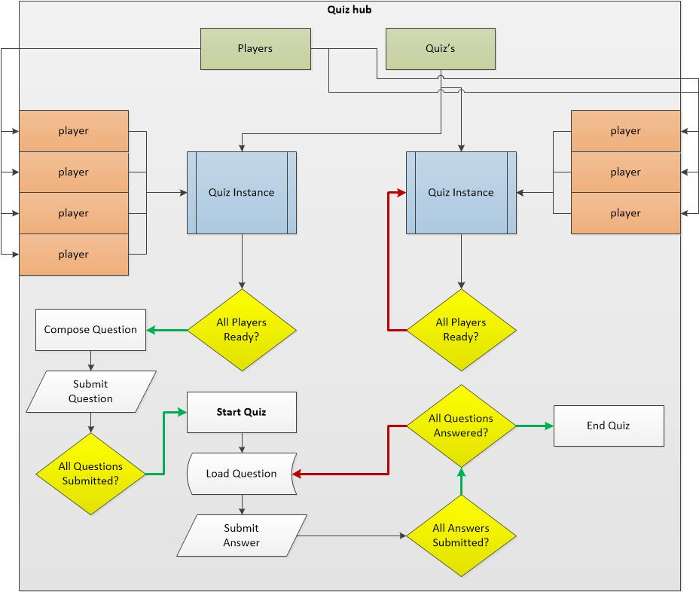
Illustration 1: Quiz logic
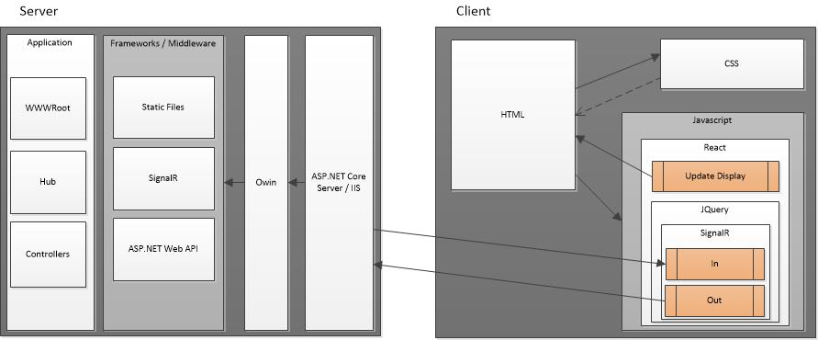
Illustration 2: Data flow
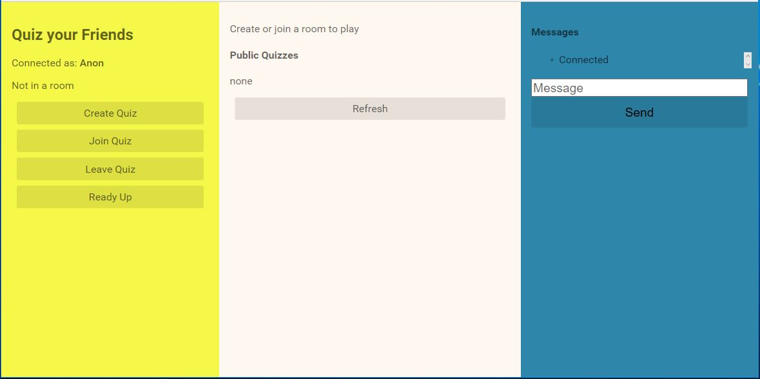
Quiz 1: Start menu
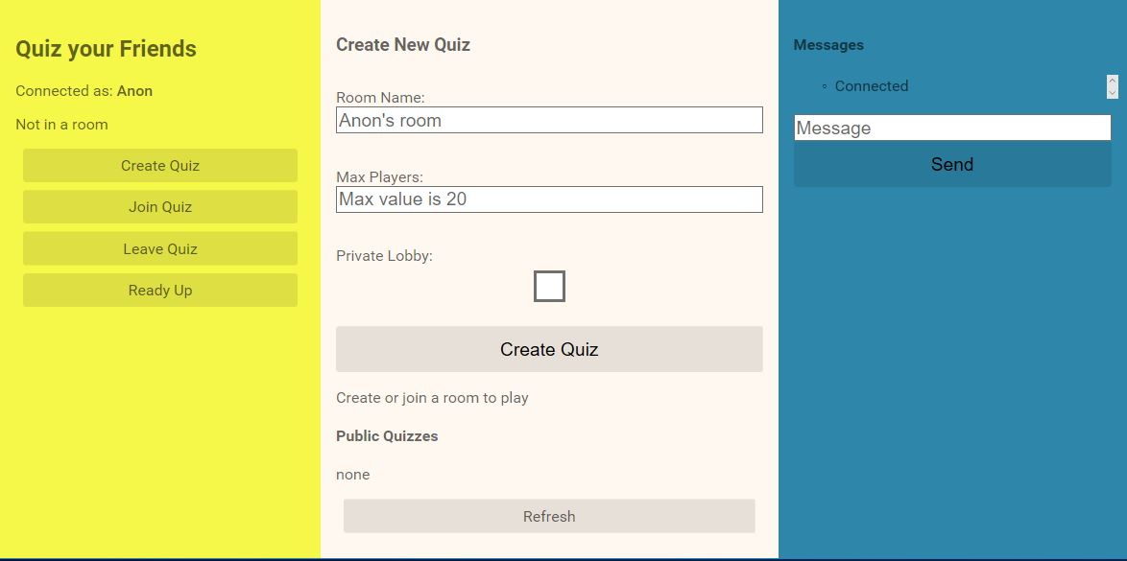
Quiz 2: Create quiz
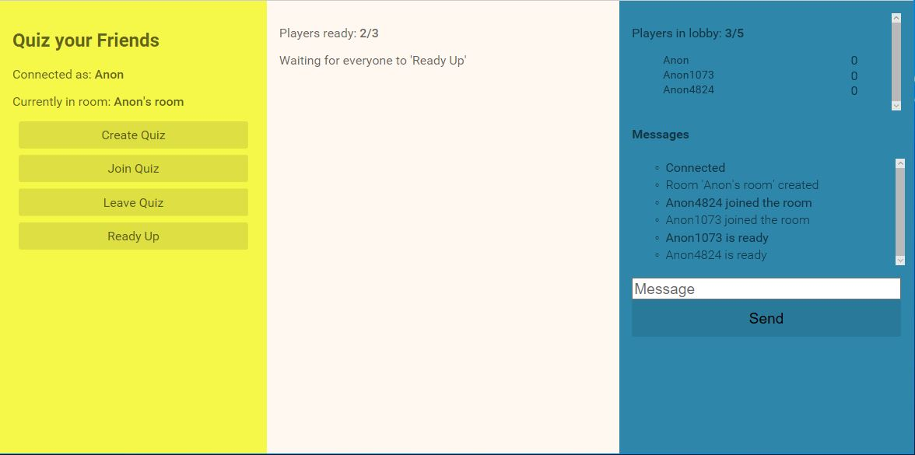
Quiz 3: Ready menu
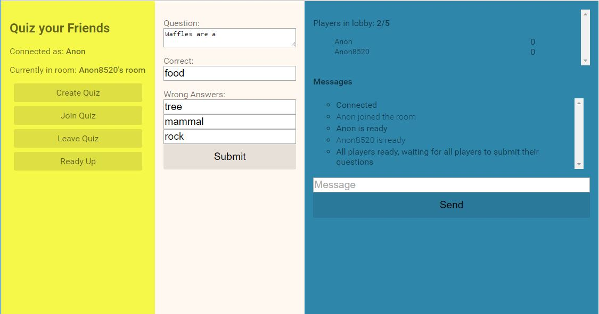
Quiz 4: Compose question
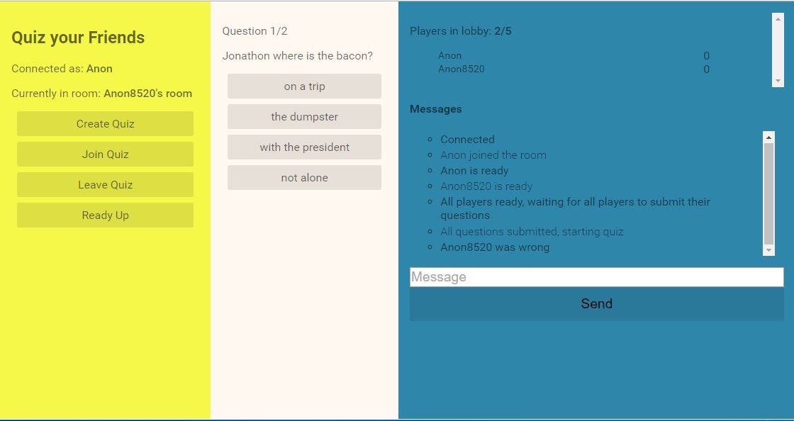
Quiz 5: Answer question
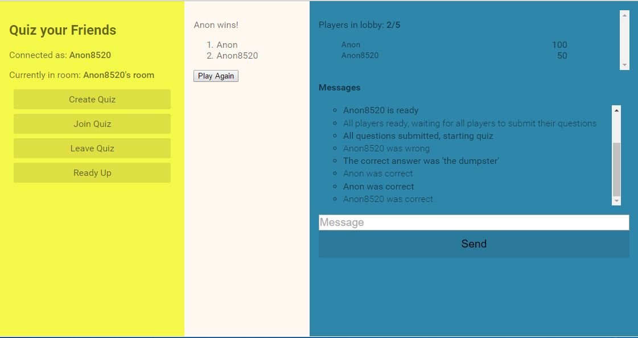
Quiz 6: Quiz end
Sample code
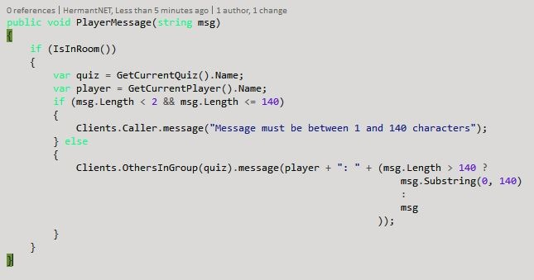
Code 1: Message handling for chat

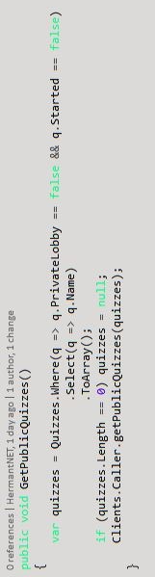
Code 2: Get an array of the public quizzes and send them to the client
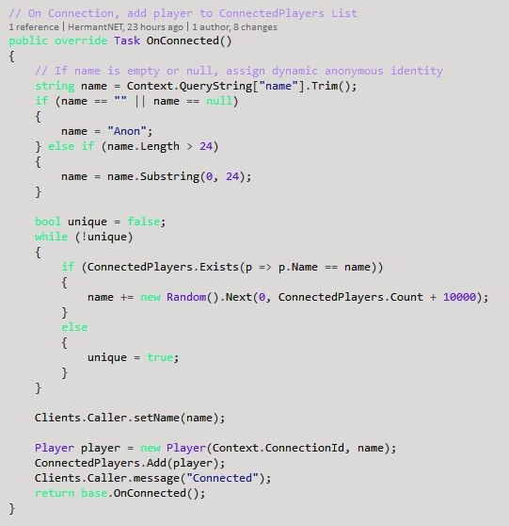
Code 3: When a player connects, get their name or assign them one if not unique.
Conclusion & Future Enhancements

After carefully considering the scope of the Quiz your Friends project, it became clear that the implementation of user accounts was unnecessary, and perhaps, destructive. Players want a simple, low -barrier-to-entry online experience. Having players make an account for the sole purpose of remembering their names and lifetime score was not reason enough to implement something as resource intensive as a database. Thus, the plan for user accounts and statistics was scrapped in favour of a low-barrier-to-entry naming schema.
The newer model works well and aligns with the project goals perfectly. Taking a quiz is simple, methodical, and above all fun. The introduction of private and public quizzes caters to the majority of the target demographic, social and casual gamers. The chat functionality further improves the social draw of the game.
There are many future enhancements I would like to implement for Quiz your Friends. Apart from visual queues and improved UX (user experience), I would like to implement a myriad of new game modes. Players would be able to vote on which game mode they wish to play, and if the vote comes to a tie then determine the winner randomly. One of the aforementioned game modes that I would like to implement is a time based mode. The difficulty with timers though, is that you must implement a timer on both the server and client side. Of course, you could have a timer solely on the server that sends an update call to the client every tick, but this is a waste of bandwidth.
Another feature I would love to implement is lobby leader. The lobby leader would have control of the room, dictating whether the room is public or private, setting a room password, kicking players, and force starting the quiz. If the product gains traction, I would eventually like to implement user accounts and a friends list, as well as room templates where players would be able to invite all players designated in the template to a room in a single click.
Originally, I had hoped to develop Quiz your Friends using test driven development principles. I did set up unit testing for C# and dabbled in the front-end JavaScript testing framework Jasmine, but I underestimated the learning curve of these programs. I was hoping it was going to be a quick four to five hours, and under normal circumstances, that would be all that is needed. But my application was using Websockets. This required me to set up a server within the unit testing project and complete an ample number of tasks to get the testing to work. Had I known these frameworks before starting the Quiz your friends project, I would have gone through with it. But the time sink was too great, and because I had no idea how long it would take to complete Quiz your Friends, the idea was scrapped.
References

React documentation: https://facebook.github.io/react/docs/getting-started.html
SignalR documentation: https://github.com/SignalR/SignalR/wiki
ASP.NET Core documentation: https://docs.asp.net/
ASP.NET Core & SignalR ref: http://www.codeproject.com/Articles/1115941/ASP-NET-Core- Building-a-Real-Time-Online-Poll-Syst
Color pallete creation: https://coolors.co/
Webpack: https://www.npmjs.com/package/webpack
Webpack sass-loader: https://www.npmjs.com/package/sass-loader
SASS css preprocessor: http://sass-lang.com/guide
OWIN: https://docs.asp.net/en/latest/fundamentals/owin.html

Credits

Project Leader  Thomas E Herman Jr  Suncoast Technical College  4748 Beneva Road  Sarasota, FL 34233  hermant.edu@gmail.com  941-321-3860 | Technical Advisor  Mr. Horneberger  Suncoast Technical College  4748 Beneva Road  Sarasota, FL 34233

