UNITED STATES INTERNATIONAL UNIVERSITY
AFRICA

DSA 3050A: DAX Lab Assignment

Hermela Seltanu Gizaw
670446

Instructor: Prof. Austin Owur Odera

Spring Semester 2026
Table of Contents

SECTION A: DATA MODEL VALIDATION 2
SECTION B: CORE DAX MEASURES 3
SECTION C: CALCULATED COLUMNS 6
SECTION D: FILTER CONTEXT & CALCULATE 7
SECTION E: ITERATOR FUNCTION 8
SECTION F: TIME INTELLIGENCE 10
SECTION G: VISUAL VALIDATION 12

SECTION A: DATA MODEL VALIDATION
1. Dataset Description
The dataset used for this assignment is the Complete DAX Practice Dataset, a synthetic e-commerce dataset simulating a multi-year sales environment (2018–2024). It consists of approximately 100,000 rows in the fact table, making it well-suited for high-volume data analysis. The data is organized in a Star Schema with a central FactSales table and five dimension tables (DimProduct, DimCustomer, DimDate, DimEmployee, and DimGeography), allowing for granular slicing across categories, geography, and time.
Source Link: Kaggle - Complete DAX Practice Dataset
2. Model View:
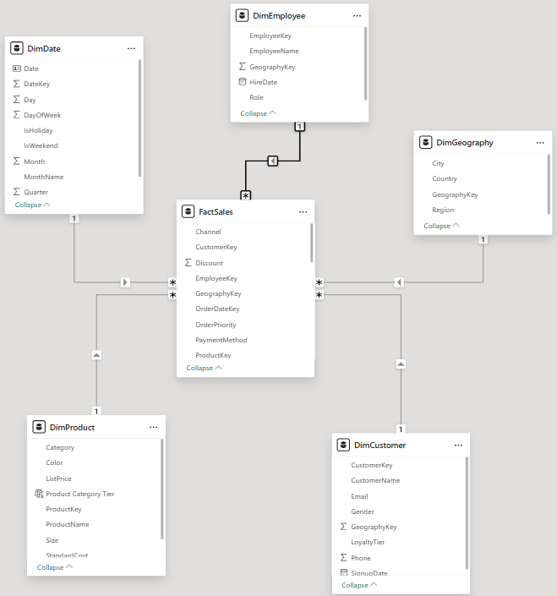
3. One Challenge Encountered
One significant challenge was managing the Filter Context for regional comparisons. Initially, the 'Total Revenue' measure was showing global totals across all rows. I resolved this by identifying a broken relationship in the Model View and updating the Cross Filter Direction to 'Single' (from Dimension to Fact), ensuring that filters propagate correctly from the Geography table to the Sales table.

SECTION B: CORE DAX MEASURES
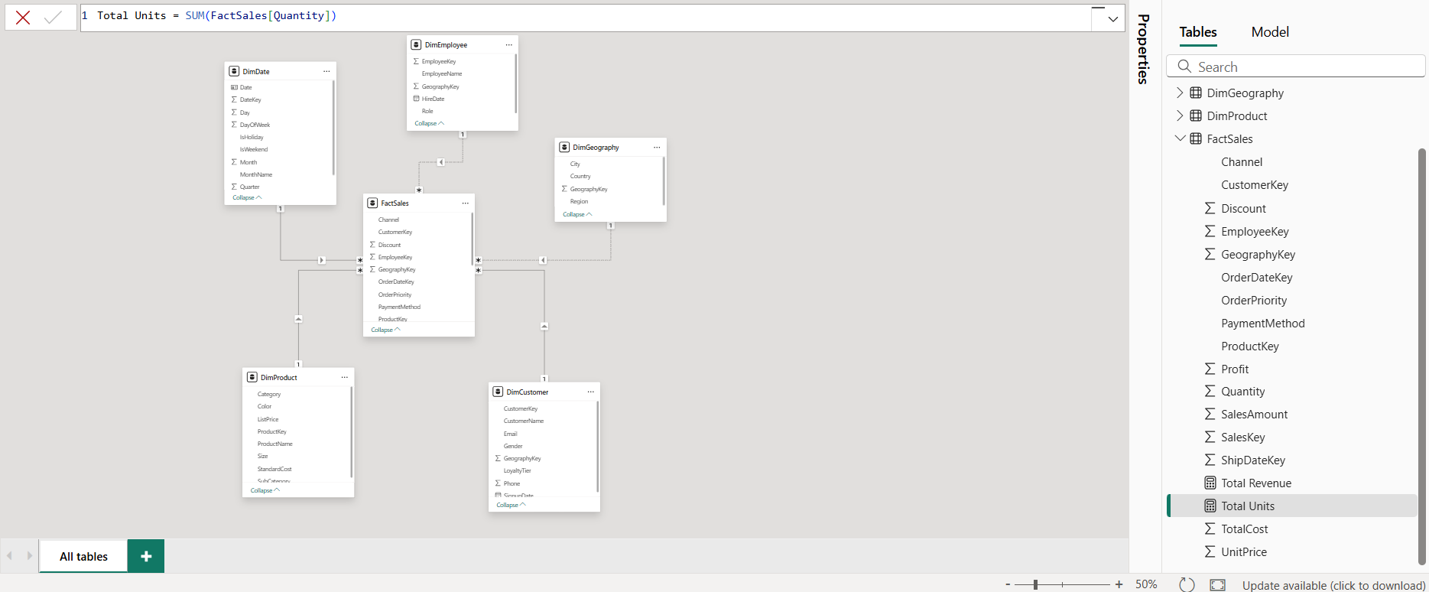
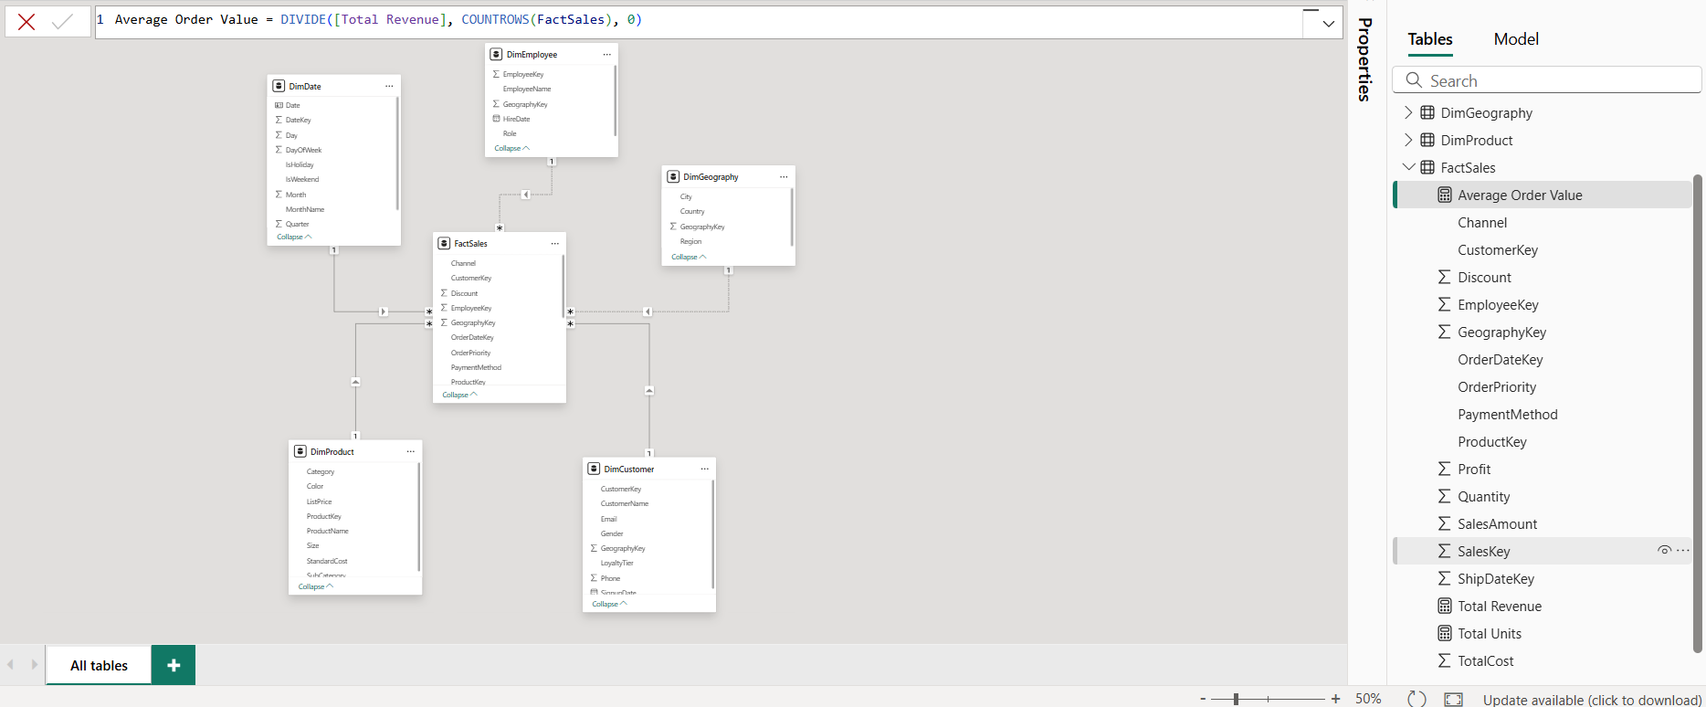
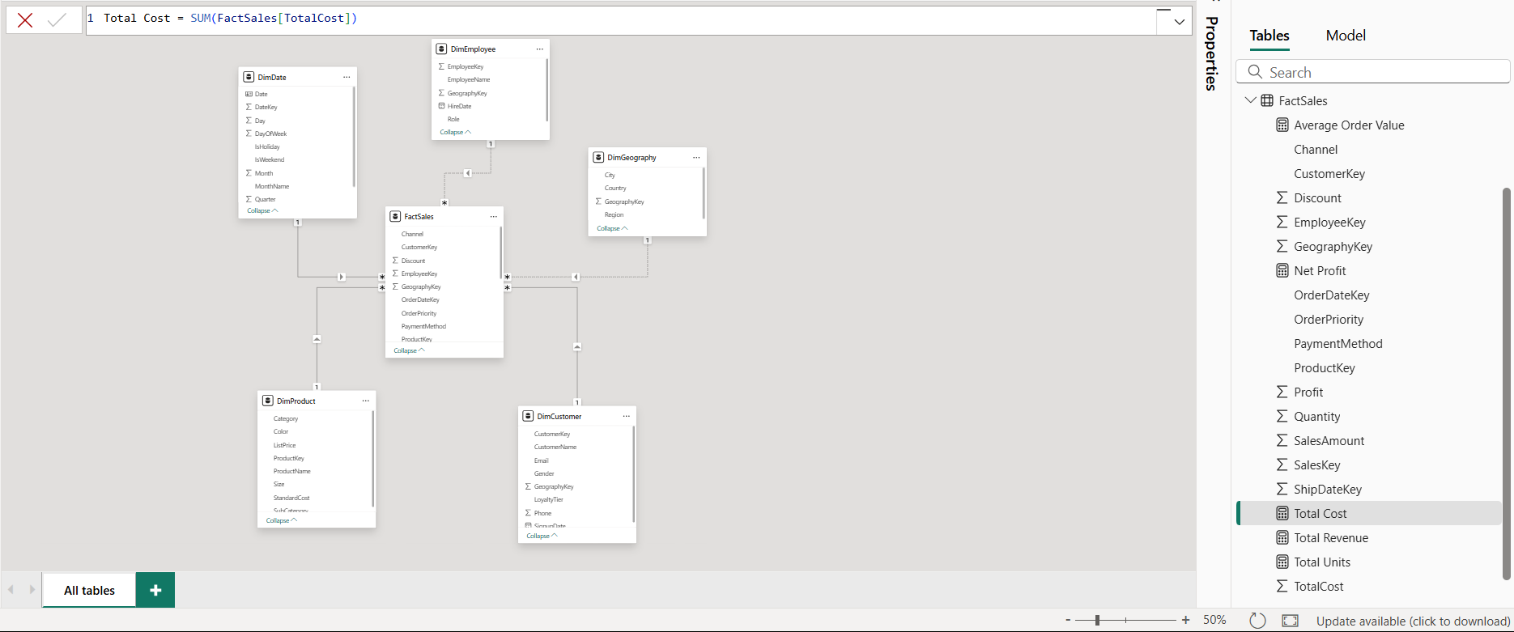
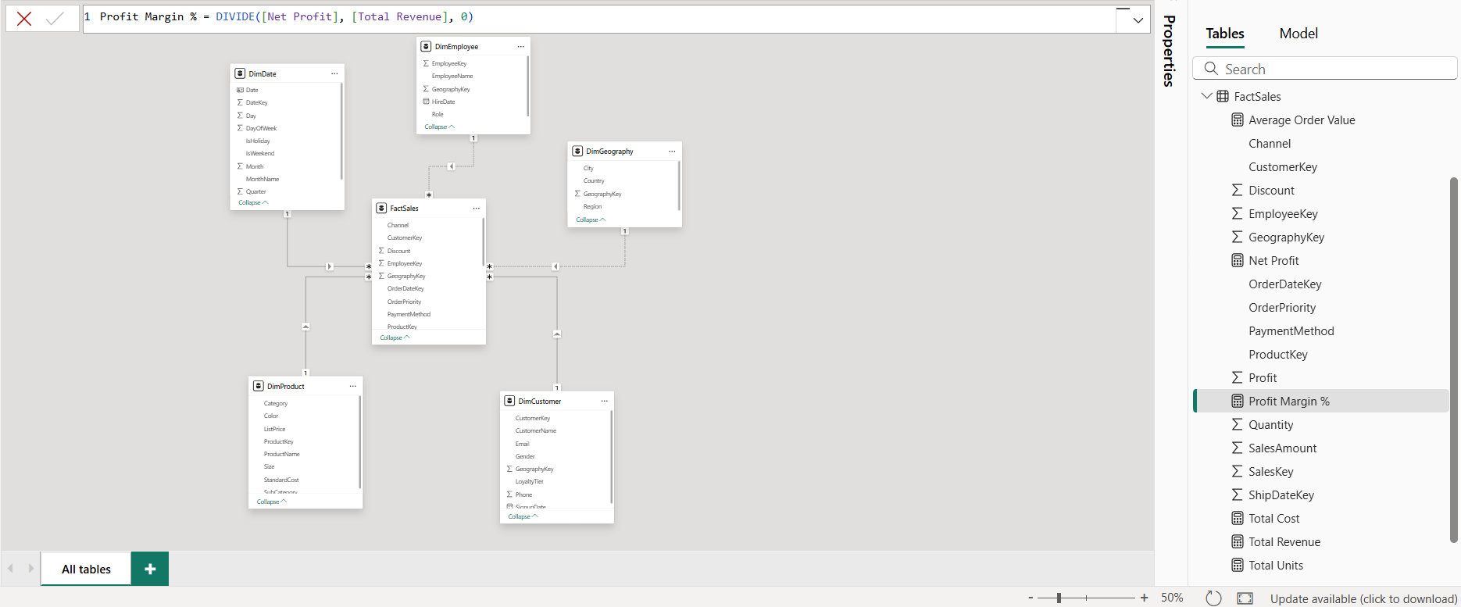
Measures must:
- Use appropriate aggregation functions
- Respond correctly to slicers

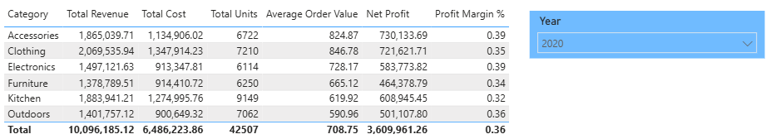

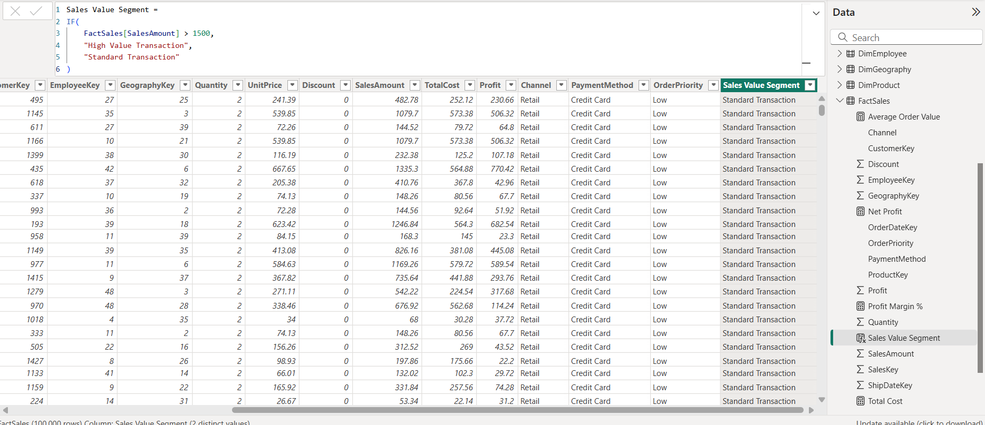
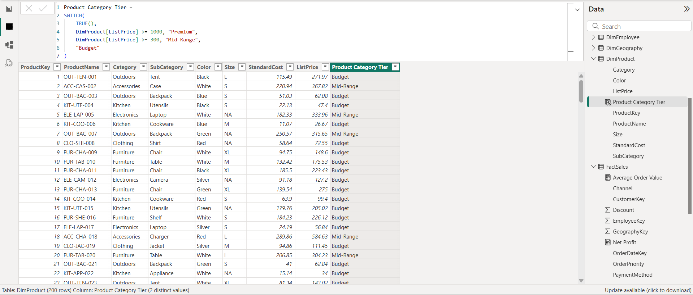
Correct Row-Level Logic
The row-level logic was implemented using the SWITCH(TRUE(), ...) and IF functions. Unlike measures, these calculations are performed for every individual record in the dataset during data load. For example, in the Product Category Tier column, the engine evaluates the ListPrice of each specific row against the defined conditions to assign a static category. This ensures that the categorization is 'baked into' the data model, allowing for high-performance filtering in the final dashboard.
Justified Business Thresholds
The thresholds for classification were selected based on an analysis of the price distribution within the electronics dataset:
- Premium (>= $1000): This threshold captures high-ticket items like high-end laptops and professional cameras, which represent the luxury segment of the inventory.
- Mid-Range (>= $300): This captures standard consumer electronics like tablets and mid-tier smartphones, which form the bulk of the revenue.
- Budget (< $300): This covers accessories and entry-level gadgets.
By setting these specific thresholds, the business can distinguish between high-volume/low-margin sales and low-volume/high-margin 'Premium' sales.

SECTION C: CALCULATED COLUMNS
By using the CALCULATE function combined with ALL(), I successfully demonstrated Context Override. While the standard Total Revenue measure respects the 'Filter Context' (responding to row labels and slicers), the Global Revenue measure intentionally ignores these filters. This allows for a direct comparison between a specific segment and the entire business, which is essential for calculating the % Contribution metric.
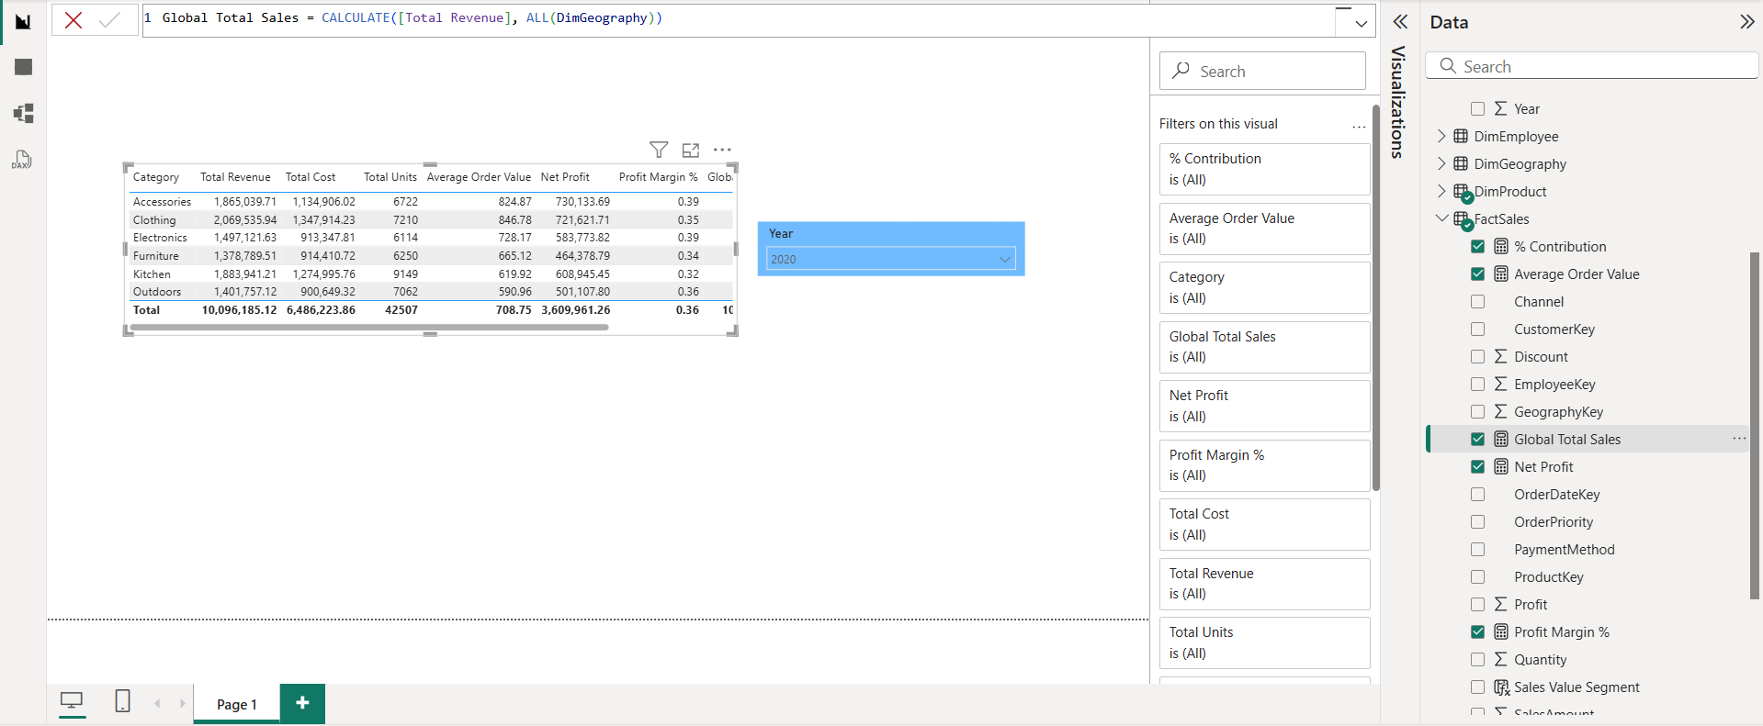
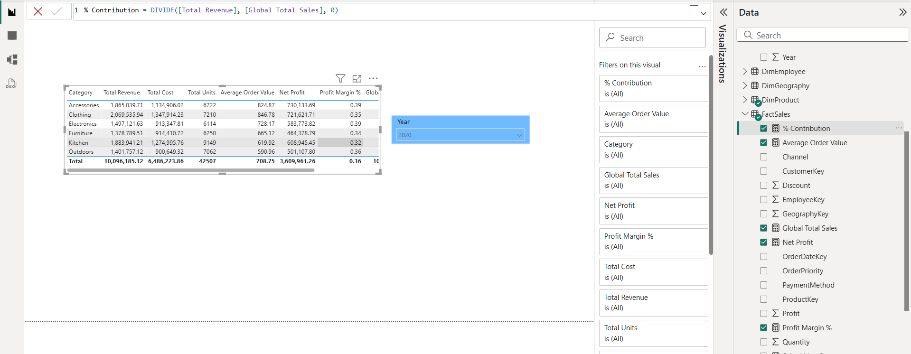

SECTION D: FILTER CONTEXT & CALCULATE
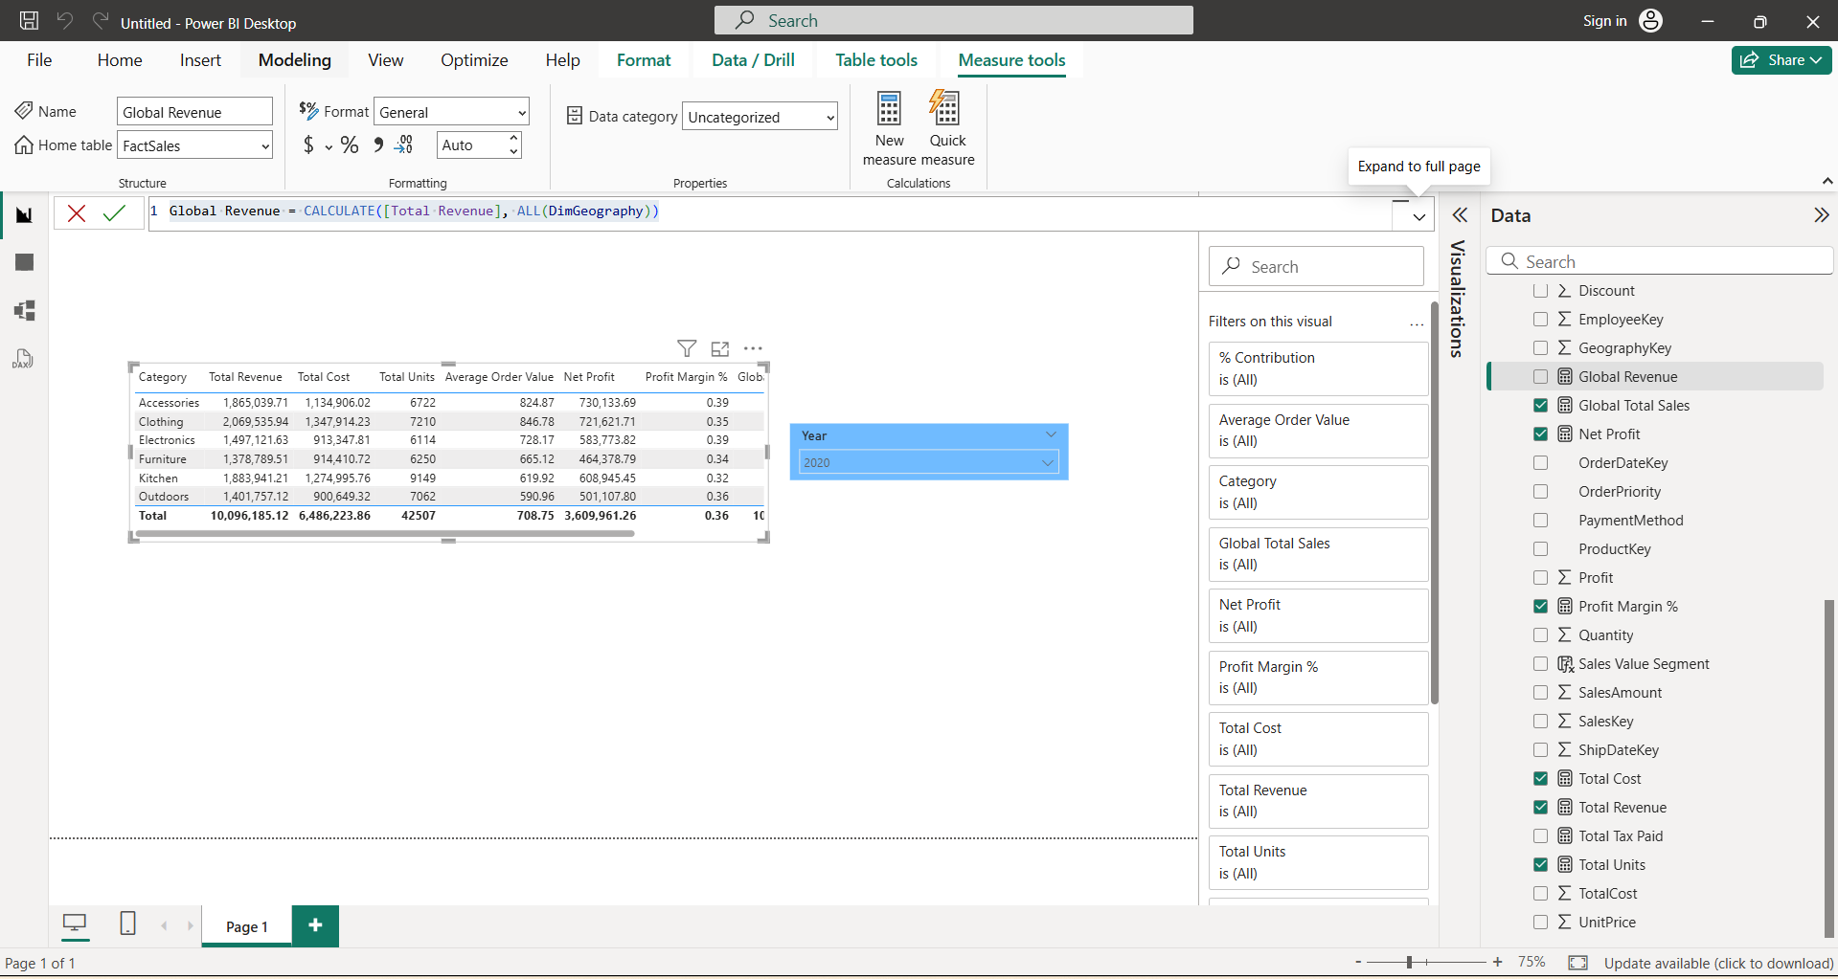
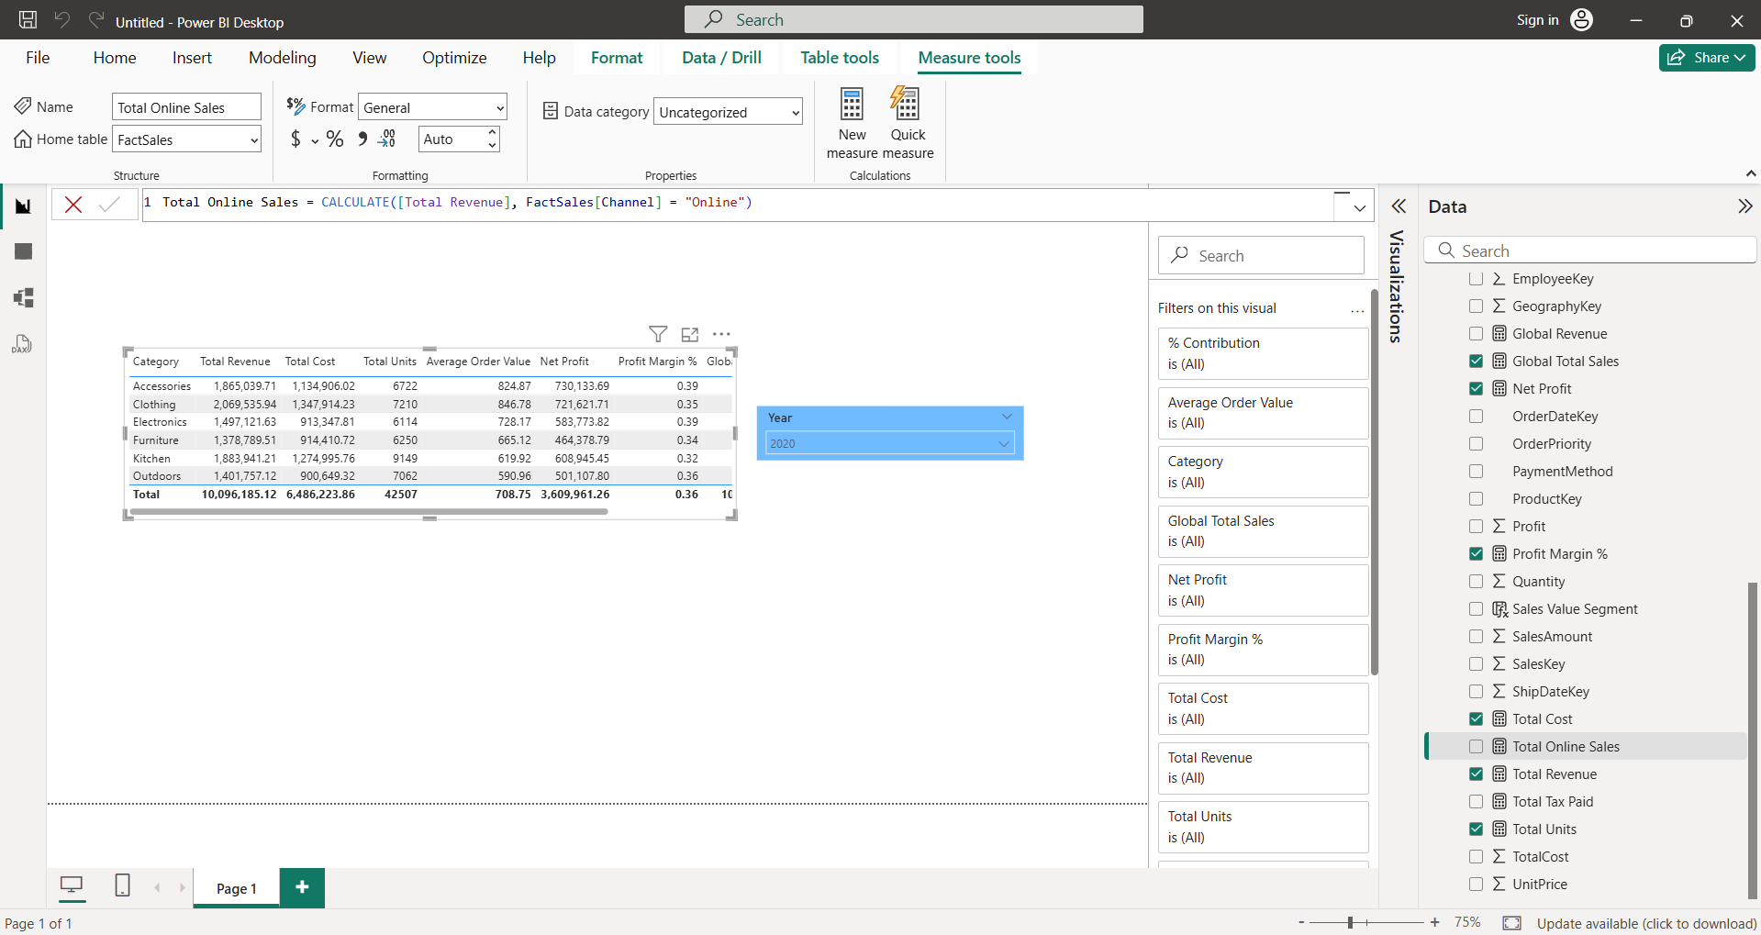

SECTION E: ITERATOR FUNCTION

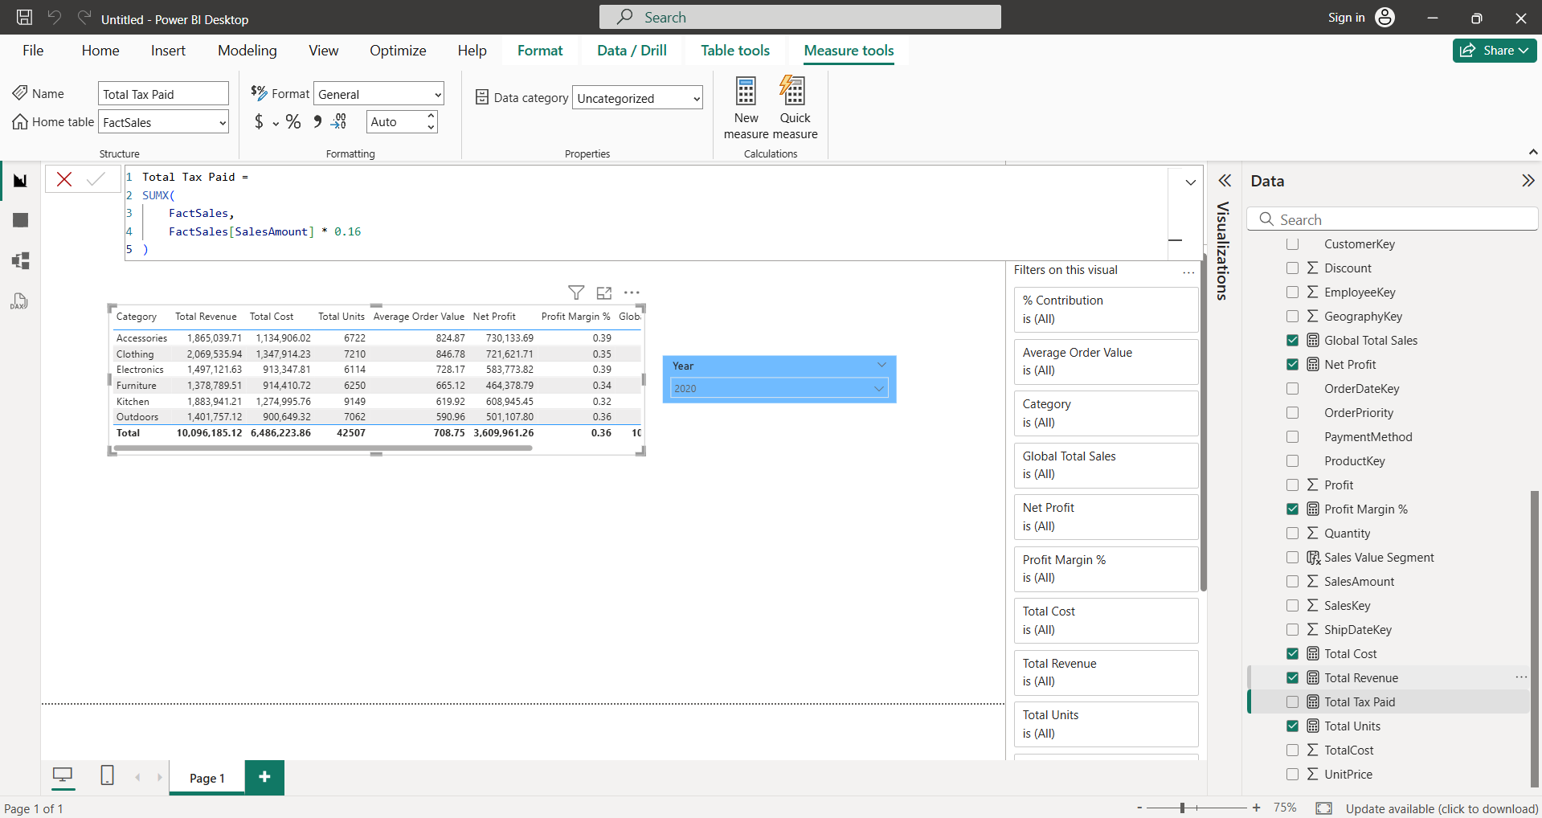
The Total Tax Paid measure utilizes SUMX, an iterator function. Unlike standard aggregation functions that operate over a filter context, SUMX creates a Row Context. It iterates through the FactSales table line-by-line, calculating the 16% tax for each individual transaction before summing the results. This demonstrates an understanding of how row-level granularity can be maintained within a dynamic measure.
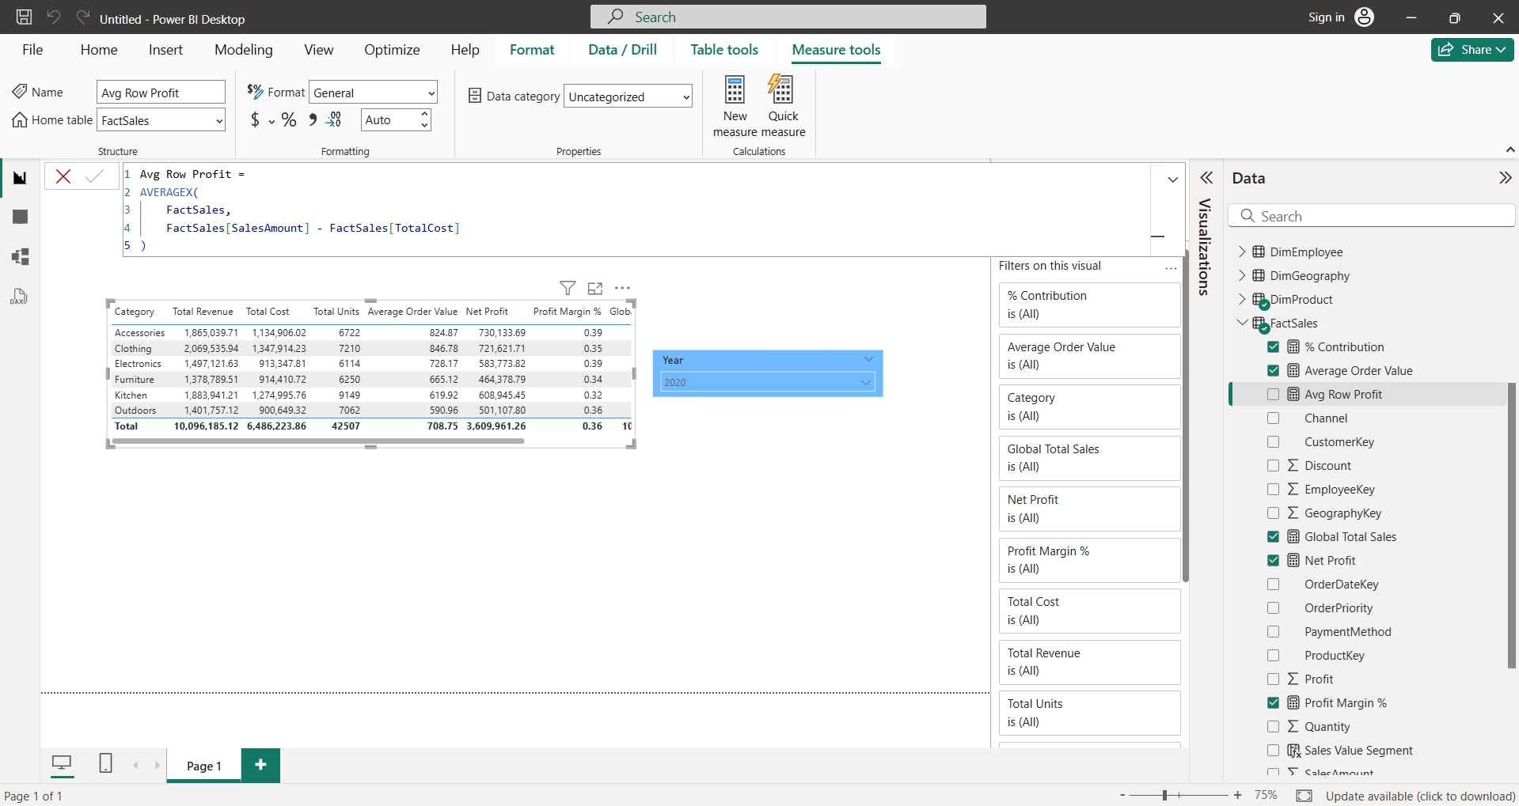

I implemented AVERAGEX to calculate the average profit per transaction. This function was chosen because 'Profit' is not a static column in the raw data. By using an iterator, I successfully invoked a Row Context that performs a row-level subtraction for every record in the FactSales table before aggregating the results into a final average. This demonstrates that the measure is sensitive to individual transaction granularity even when displayed at a high-level category view.

SECTION F: TIME INTELLIGENCE
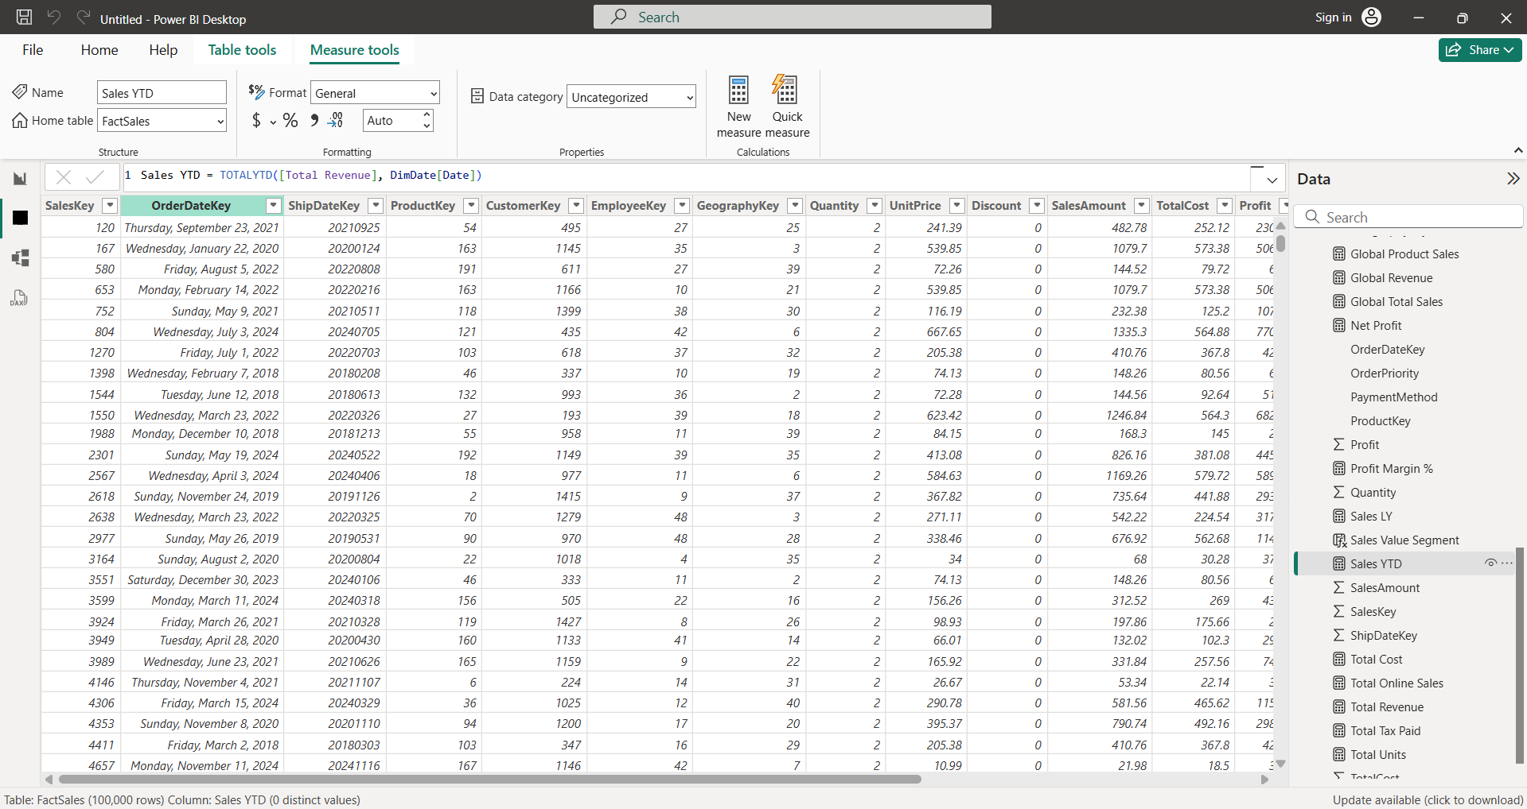
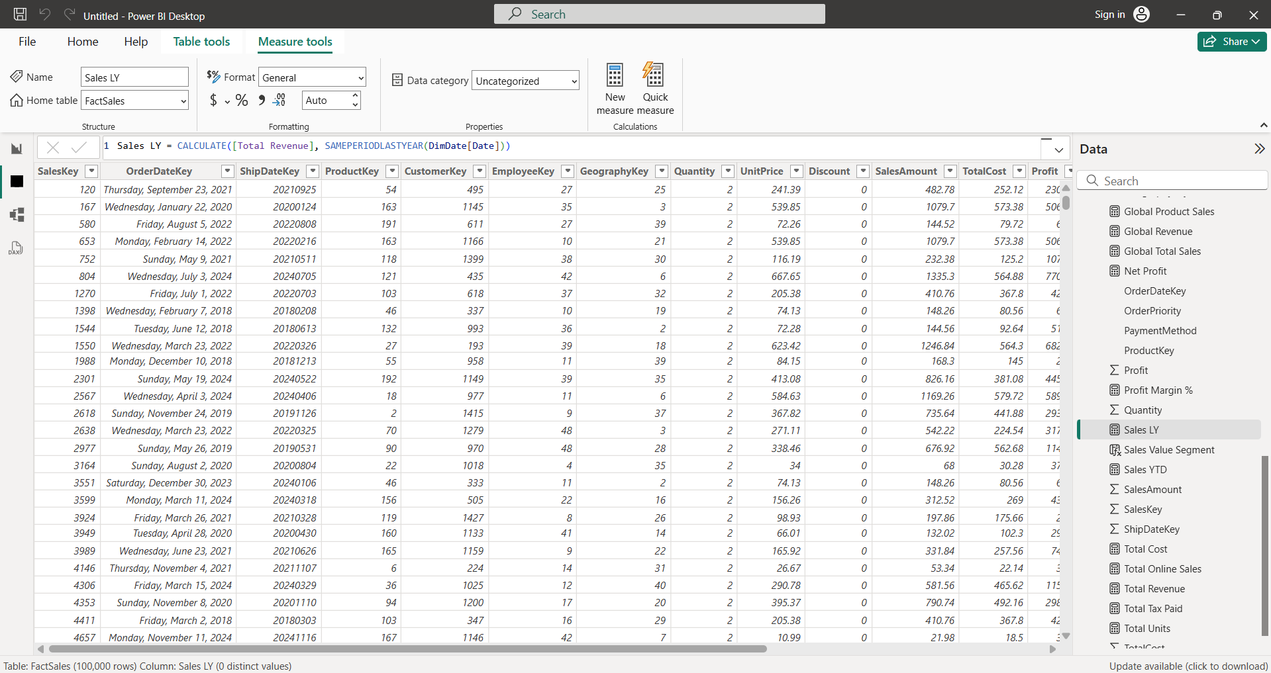
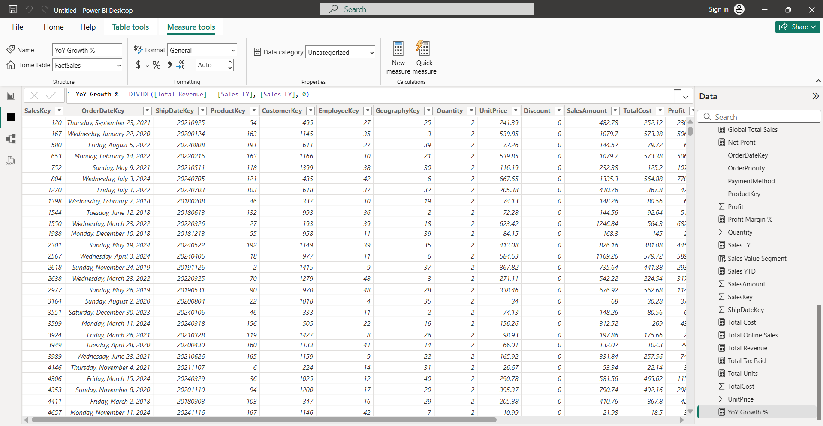
I utilized the dedicated DimDate table to perform Time Intelligence calculations. By using TOTALYTD and SAMEPERIODLASTYEAR referenced against the DimDate[Date] column, I ensured that the calculations remain accurate across different calendar granularities and respond dynamically to the date slicer.
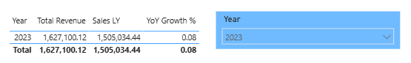
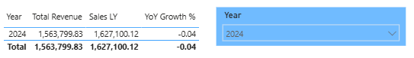

SECTION G: VISUAL VALIDATION
