UNITED STATES INTERNATIONAL UNIVERSITY
AFRICA

DSA 3050A: End-Semester Practical Examination

Hermela Seltanu Gizaw
670446

Instructor: Prof. Austin Owur Odera

Spring Semester 2026

Table of Contents

Part A: Data Acquisition and Understanding 2
1. Domain and Business Problem 2
2. Dataset Source and Overview 3
3. Key Tables and Fields 3
4. Suitability for Advanced Analysis 4
Part B: Data Cleaning and Transformation in Power Query 6
1. Data Cleaning (Addressing Data Quality Issues) 6
2. Transformation Steps (Creating Analytical Value) 8
3. Applied Steps Panes 13
Part C: Data Modeling 14
1. Relationship Architecture and Logic 14
2. The Snowflake Extension (Normalization) 14
4. Justification for the Model 15
Part D: DAX Measures and Calculated Columns 15
1. Calculated Columns 15
2. Essential DAX Measures 16
Part E: Dashboard Design and Visualization 19
1. Explanation of Design Choices 20
2. Explanation of User Interaction 21
Part F: Analytical Insights and Business Recommendations 21
1. Analytical Insights 21
2. Actionable Recommendations 22
3. Conclusion 23
Part G: GitHub Repository 24

Part A: Data Acquisition and Understanding

1. Domain and Business Problem
Domain: Healthcare Analytics
Problem Statement: In healthcare systems, patient non-attendance (No-Show) creates operational inefficiencies, underutilization of expensive medical equipment, and increased wait times for other patients. This project analyzes a dataset of 110,527 medical appointments to identify key drivers of no-shows. By understanding these patterns, healthcare providers can implement targeted interventions, such as optimized SMS reminders or specialized scheduling for high-risk demographics.

2. Dataset Source and Overview
- Source: Kaggle - Medical Appointment No Shows
- Size: 110,527 records with 14 variables.
- Main Transactional Table: The KaggleV2-May-2016.csv file serves as the core transactional record of every appointment booked.
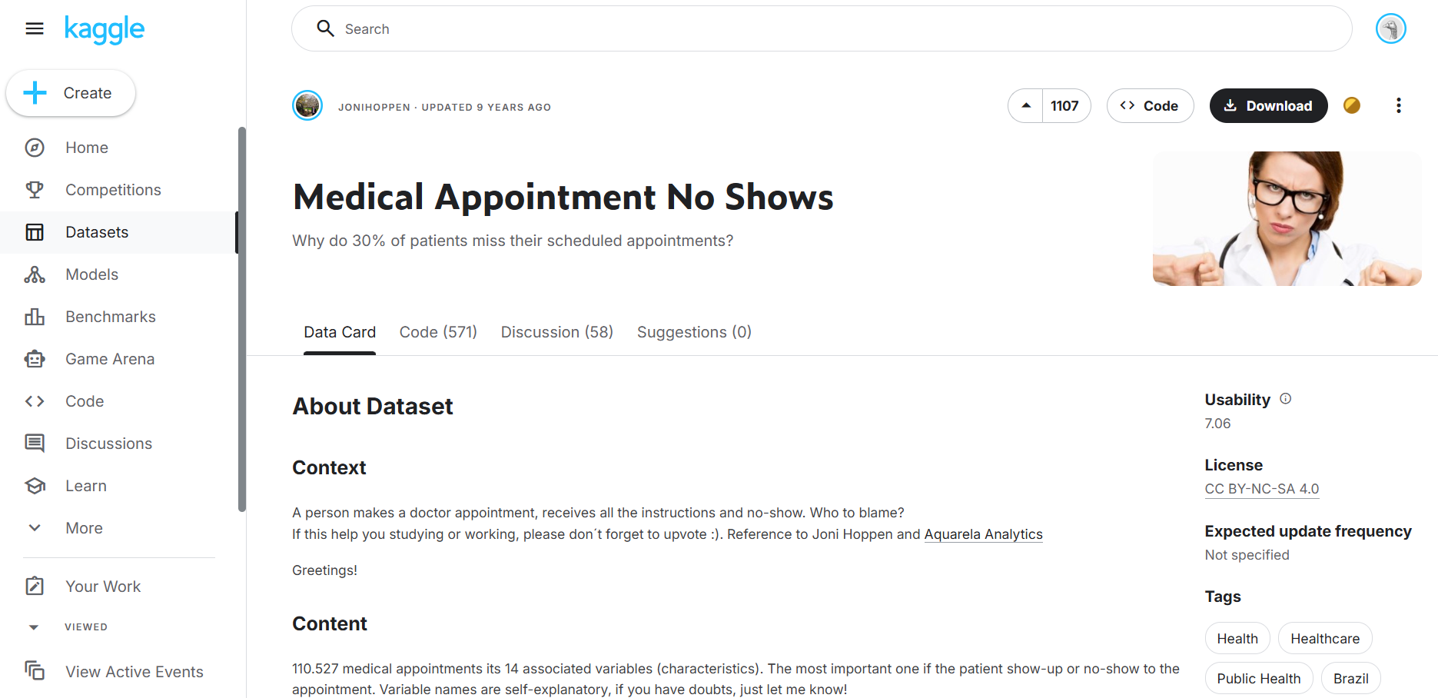

3. Key Tables and Fields
To facilitate advanced analytical reporting and optimize DAX performance, the raw dataset was transformed into a Snowflake Schema. This structure consists of a central Fact table supported by a hierarchy of Dimension tables, allowing for deep socio-economic analysis.

A. Fact_Appointments (Transactional Table)
This table serves as the transactional core of the model, containing every unique medical event. It stores key quantitative metrics such as WaitDays and binary indicators like SMS_received, alongside the primary target variable, No-show, which categorizes appointments as either "Attended" or "Missed." To ensure relational integrity, it utilizes foreign keys to connect to the patient, location, and date dimensions.
B. Dim_Patient (Dimension Table)
This table provides descriptive attributes for demographic segmentation. Each record is unique to a specific PatientId and includes critical data points such as Gender, Age, and Scholarship status, indicating enrollment in the Bolsa Família program. Additionally, it contains clinical flags for chronic conditions like Hypertension and Diabetes, allowing for a health-profile-based analysis of attendance behavior.
C. Dim_Location & Dim_SocioEconomic (Snowflake Extension)
Unlike a standard star schema, the location dimension is extended to include external economic data. It represents the Snowflake extension of the model. While Dim_Location maps clinical neighborhoods to their respective cities, it bridges the gap to the Dim_SocioEconomic table. This external dataset, sourced from IBGE, enriches the model with geographic wealth indicators like GDP_CAPITA and Human Development Index (IDHM) scores, enabling a sophisticated correlation analysis between regional prosperity and patient reliability.
D. Dim_Date (Calendar Table)
A dedicated DAX-generated table that provides a continuous timeline, essential for reliable Time Intelligence. It breaks down the AppointmentDate into attributes such as Month Name, Day Name, and an IsWeekend flag. This structure is vital for identifying operational inefficiencies, such as determining if specific days of the week experience higher attrition rates.

4. Suitability for Advanced Analysis
This dataset is highly suitable for advanced BI analysis due to its scale (>110k rows) and the complexity of its date fields. It allows for the construction of a Star Schema and requires significant Data Engineering in Power Query to handle scientific notation in IDs and anomalous values in the Age column.
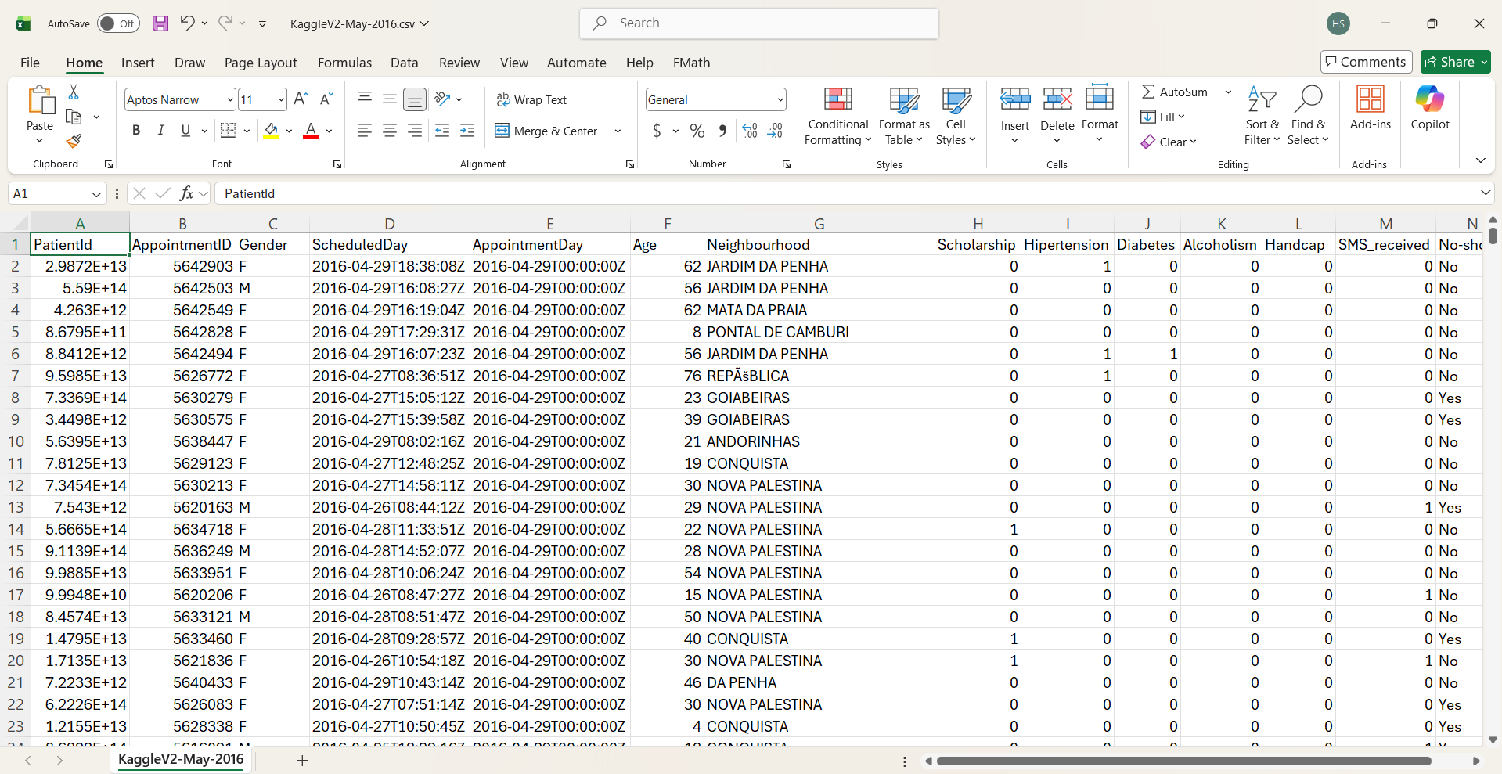

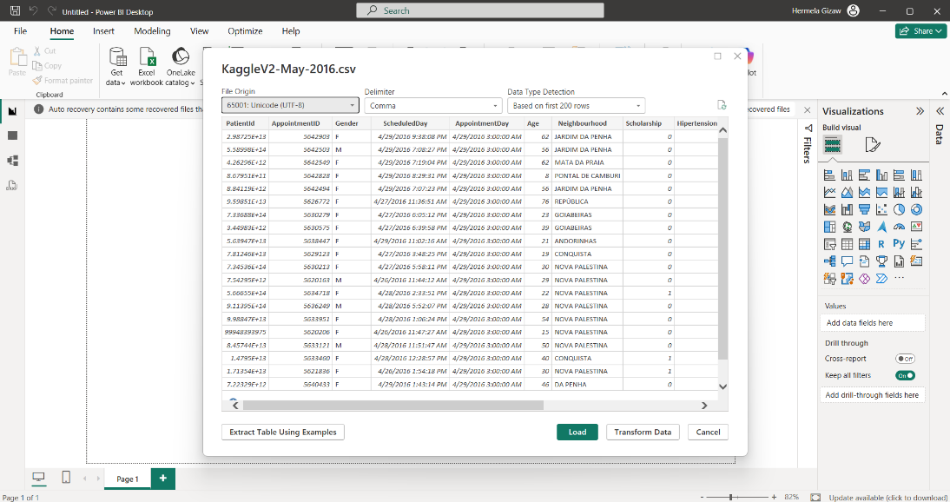

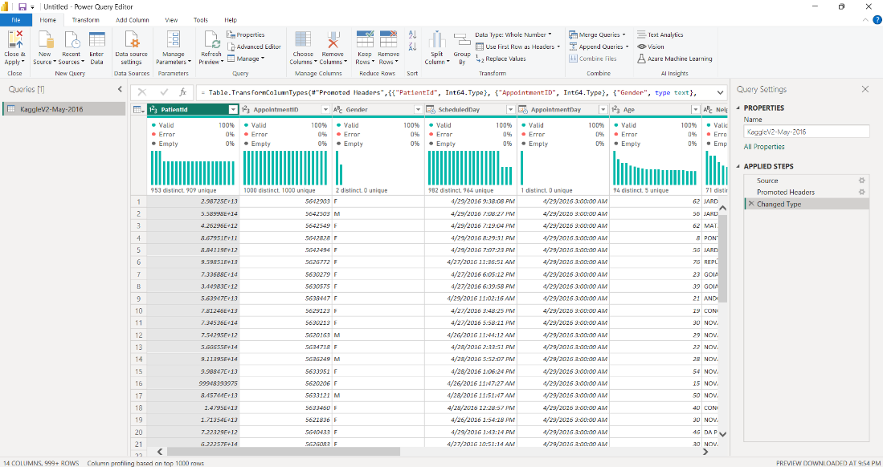

Part B: Data Cleaning and Transformation in Power Query

1. Data Cleaning (Addressing Data Quality Issues)
In this phase, I addressed the "invalid records" and "wrong data types" specifically mentioned in the exam instructions to ensure a "clean" baseline for analysis
a. Wrong Data Types (ID Integrity):
- Issue: PatientId was imported as a numeric type, causing scientific notation and potential rounding errors.
- Action: I converted PatientId and AppointmentID to Text.

Before: After:
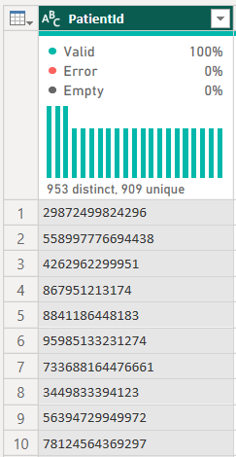
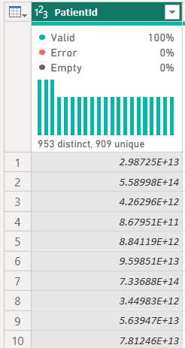

Before:
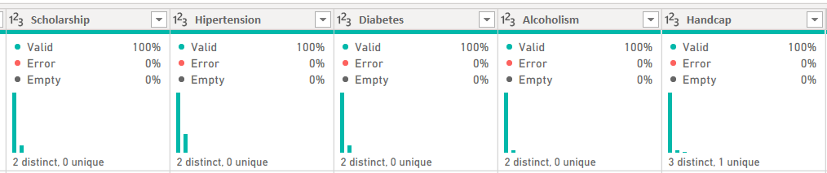
After:
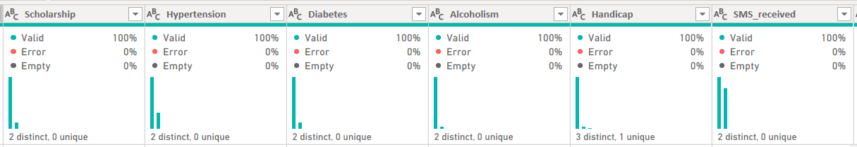

b. Inconsistent Category Names (Standardization):
The original No-show column used "No" for attendance and "Yes" for a missed appointment.
- Action: Used Replace Values to change "No" to "Attended" and "Yes" to "Missed".
- Reason: To eliminate "double-negative" confusion in visualizations and DAX filters.

Before: During: After:
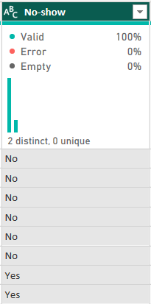
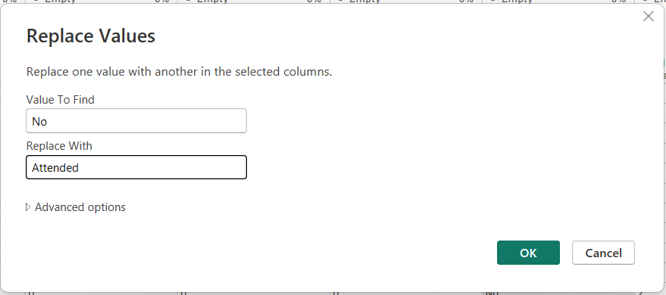
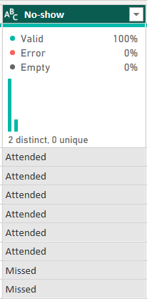
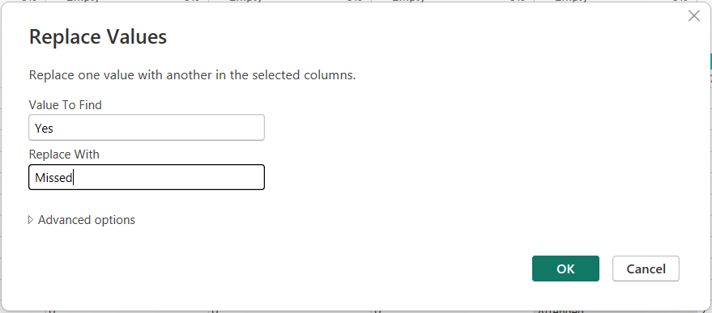

c. Removed Duplicated Rows

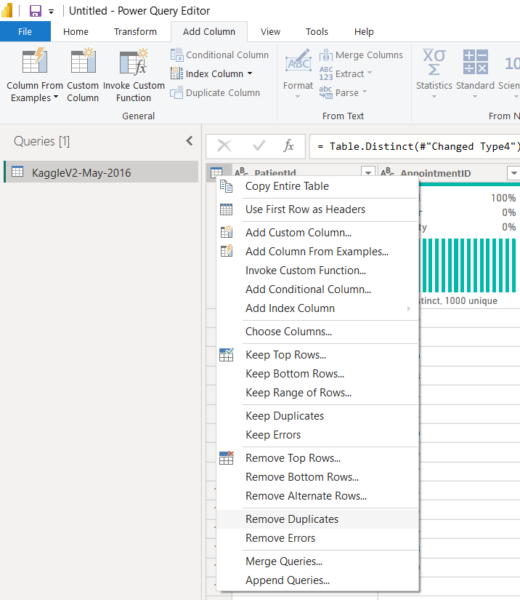

2. Transformation Steps (Creating Analytical Value)
a. Time-Date Extraction (ISO 8601 Standard)
The ScheduledDay column contained combined date and time strings.
- Action: Utilized the Split Column by Delimiter feature using the character "T" as the separator.
- Reason: This separated the booking time from the date, allowing for a granular analysis of whether the time of day impacts a patient's likelihood to show up.

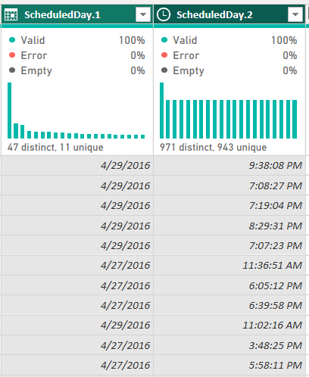
Before: During: After:
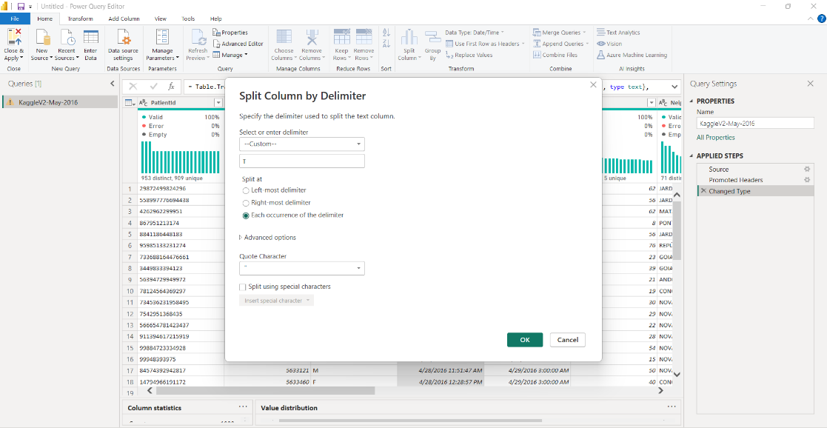
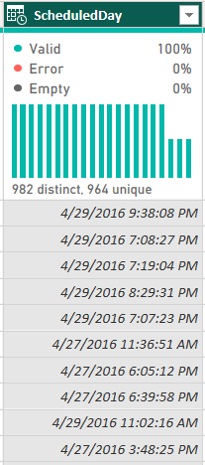

b. Renaming Columns for Professional Reporting
Several headers were in Portuguese or contained abbreviations.
- Action: Renamed Hipertension to Hypertension, Handcap to Handicap
- Reason: To ensure the final dashboard is intuitive for English-speaking healthcare stakeholders.

Before:
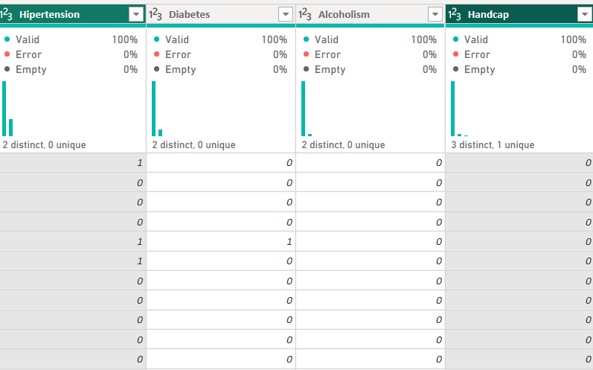

After:
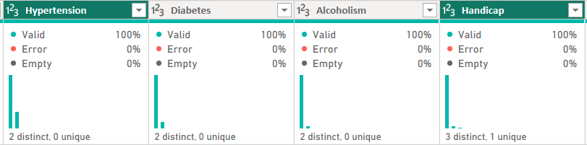

c. Creating Custom Columns (WaitDays)
A key business metric for this domain is the lead time between booking and the actual visit.
- Action: Added a Custom Column using the M-formula:
Duration.Days([AppointmentDay] - [ScheduledDay])
- Reason: This enables the analysis of "Wait Time vs. No-Show Rate," a critical operational insight.
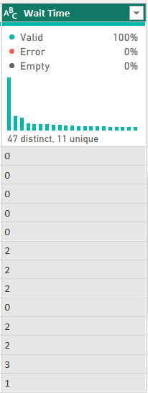
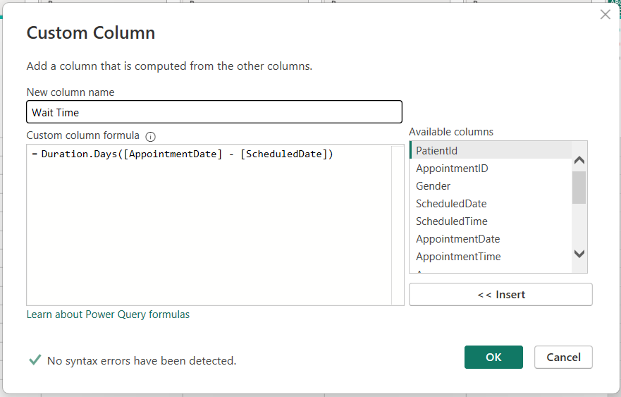

d. Attribute Normalization (0/1 to Yes/No)
Clinical flags like Diabetes and Alcoholism were stored as integers.
- Action: Converted these columns to Text and replaced 0 with "No" and 1 with "Yes".
- Reason: Enhances the readability of Slicers and Tooltips for non-technical users.
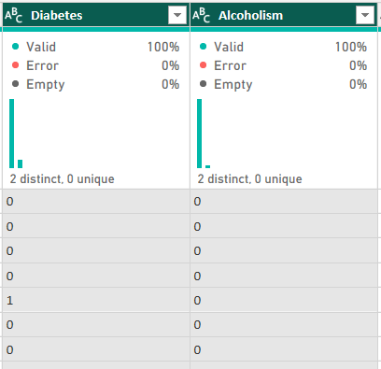
Before: After:

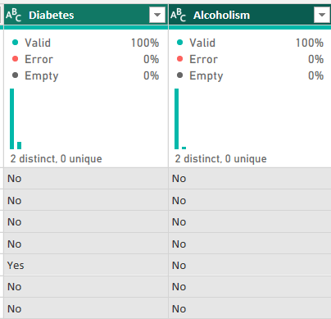

e. Extraction of Weekday for Behavioral Analysis
The AppointmentDate column was used to identify the specific day of the week. Reason: This allows the business to identify if no-show rates are higher on specific days (e.g., Mondays vs. Fridays), which is a critical insight for clinical staffing levels.

Before: After:
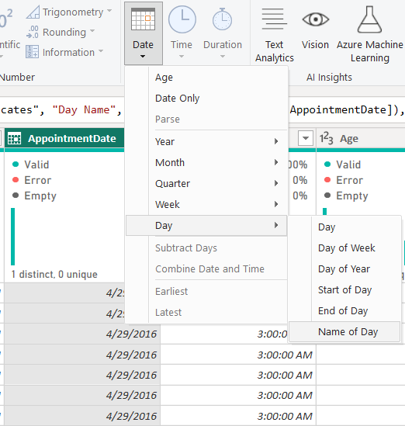
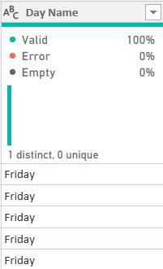

f. Conditional Logic for Handicap Status
The original Handicap column contained values from 0 to 4, which could be confusing for summary reporting.
- Action: Created a Conditional Column where:
  - If Handicap is greater than or equal to 1, then "Yes".
  - Else "No".
- Reason: To simplify the data for executive stakeholders, allowing them to filter the entire dashboard by "Disabled" vs "Non-Disabled" status without needing to know the specific handicap scale.

Before: During: After:
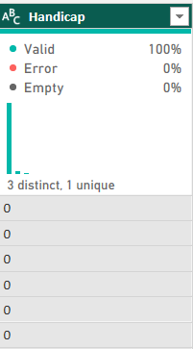
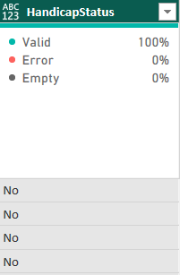
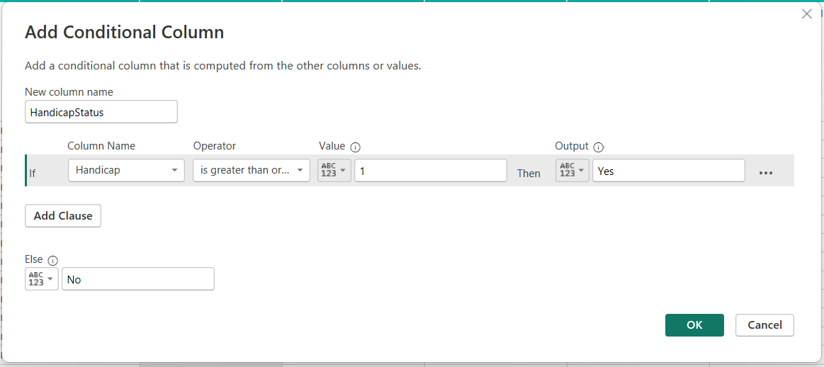

g. Creation of the Patient Dimension (Normalization)
- Action: Utilized the Reference feature in Power Query to create a downstream table named Dim_Patient. I performed a Column Selection to isolate patient-specific attributes and applied the Remove Duplicates transformation on the PatientId field.
- Reason: This transformation converts the "flat" data structure into a Relational Star Schema. By ensuring PatientId is a unique primary key, I can establish a one-to-many (1:*) relationship with the appointment records, which optimizes the model for Filter Context and reduces data redundancy.
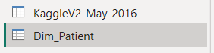

h. Handling Unique Key Constraints
In a relational model, the Dimension table must have a unique Primary Key.
- Action: Applied the Remove Duplicates transformation to the PatientId column in the Dim_Patient table.
- Reason: This ensures referential integrity. Without this step, Power BI would be unable to create a valid relationship between the patient's profile and their multiple appointment records.

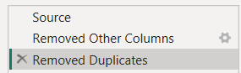

3. Applied Steps Panes
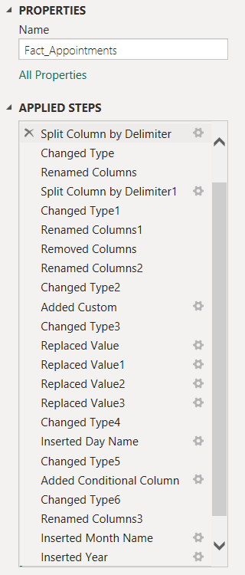
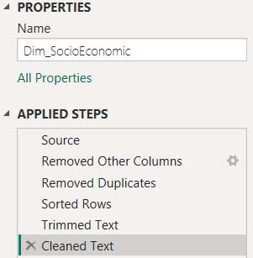
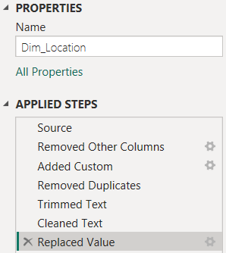

Part C: Data Modeling
In this section, I transitioned the data model from a flat structure into a Snowflake Schema. This architecture optimizes the Power BI engine's performance and allows for advanced "Macro" analysis by linking clinical outcomes to regional economic data.

1. Relationship Architecture and Logic
The data model was transitioned from a flat file structure into a Snowflake Schema to optimize the Power BI VertiPaq engine and ensure referential integrity. The architecture is built on a "One-to-Many" (1:*) relationship flow, where the dimension tables act as filters for the central Fact_Appointments table. By enforcing a single-direction cross-filter, the model avoids ambiguity and ensures that DAX measures, such as the No-Show Rate %, are calculated accurately across different demographic and temporal segments.

2. The Snowflake Extension (Normalization)
A key architectural decision was the normalization of the location data into a Snowflake extension. Unlike a traditional Star Schema, where all location data is flattened, this model separates clinical Neighbourhoods from city-wide Socio-Economic indicators. The Dim_Location table serves as a bridge, linking specific clinics to the Dim_SocioEconomic table. This structure is strategically designed to handle "Many-to-One" mapping, allowing the model to aggregate appointment data at a neighborhood level while simultaneously correlating it with city-level wealth metrics like GDP_CAPITA.

3. Temporal and Demographic Integrity
To support Time Intelligence, a dedicated Dim_Date table was linked to the AppointmentDate in the Fact table. This relationship is critical for functions like TOTALMTD and DATEADD, providing a continuous date reference that is not possible with the raw dataset alone. Similarly, the Dim_Patient table was cleaned to ensure that PatientID serves as a unique Primary Key. This normalization ensures that patient attributes, such as Scholarship status and Clinical Flags, correctly filter the appointment records without duplicating transactional data, thereby maintaining a lean and high-performing data model.

4. Justification for the Model
The adoption of a Snowflake Schema allows for sophisticated Data Enrichment. By relating the clinic locations to external IBGE data, the model can correlate medical non-attendance with regional prosperity (GDP) and development (IDHM). This structure supports the complex DAX measures required for Part D, such as ranking and percentage contributions across heterogeneous datasets.

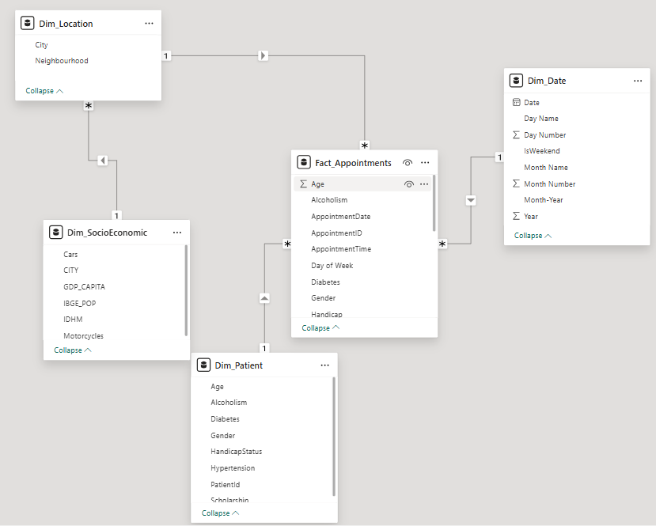

Part D: DAX Measures and Calculated Columns

1. Calculated Columns

2. Essential DAX Measures

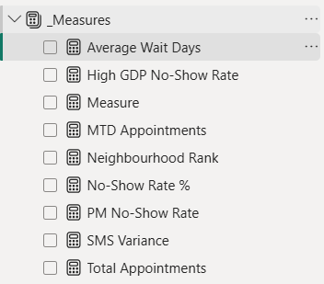

1. Total Appointments
- What it calculates: It uses the COUNT function to aggregate every unique AppointmentID in the Fact_Appointments table.
- Decision-making value: This serves as the "Capacity Baseline." Management uses this to understand the total demand for healthcare services. Without knowing the total volume, it is impossible to determine if a "No-Show" problem is significant or just a small percentage of a massive operation.

2. No-Show Rate %
- What it calculates: A ratio that divides the total number of missed appointments (filtered where No-show = "Yes") by the Total Appointments.
- Decision-making value: This is the primary Performance Metric. It allows clinics of different sizes to be compared fairly. A small clinic with 10 missed appointments might be in crisis (high rate), while a large clinic with 100 missed appointments might be performing well (low rate).

3. Average Wait Days
- What it calculates: The arithmetic mean of the WaitDays column (the difference between the scheduling date and the appointment date).
- Decision-making value: This is a "Lead Time" indicator. If this number is high, patients are more likely to forget their appointments or find alternative care. Decision-makers use this to decide if they need to open more slots to reduce the waiting list.

4. MTD Appointments (Month-to-Date)
- What it calculates: Uses the TOTALMTD time-intelligence function to sum appointments from the first day of the current month up to the present date.
- Decision-making value: This provides Real-time Tracking. It helps clinic managers see if they are on pace to hit their monthly patient volume targets or if they need to increase outreach mid-month.

5. PM No-Show Rate (Prior Month)
- What it calculates: Uses CALCULATE and DATEADD to retrieve the attendance percentage from the previous month.
- Decision-making value: This is used for Trend Analysis. By comparing the current rate to the previous month, management can see if new interventions (like a new reminder system) are actually working or if the problem is worsening.
6. Neighbourhood Rank
- What it calculates: Uses RANKX to sort all 81 neighborhoods based on their No-Show Rate %.
- Decision-making value: This is a Resource Allocation tool. It pinpoints the "Underperformers." Instead of trying to fix the whole city, management can focus their limited budget and staff on the top 5 worst-ranked neighborhoods.
7. High GDP No-Show Rate
- What it calculates: Uses the Snowflake relationship to filter the no-show rate for areas where the city's GDP_CAPITA is above a certain threshold (e.g., 20,000).
- Decision-making value: This provides Socio-Economic Context. It helps determine if no-shows are driven by poverty. If wealthy areas have low no-shows and poor areas have high no-shows, the decision-making shift goes toward providing transport vouchers or social support.
8. SMS Impact Variance
- What it calculates: Subtracts the no-show rate of patients who received an SMS from the overall average no-show rate.
- Decision-making value: This calculates ROI (Return on Investment). It mathematically proves the value of the SMS reminder system. If the variance is high (meaning SMS significantly reduces no-shows), it justifies the cost of the software to the hospital board.

Part E: Dashboard Design and Visualization

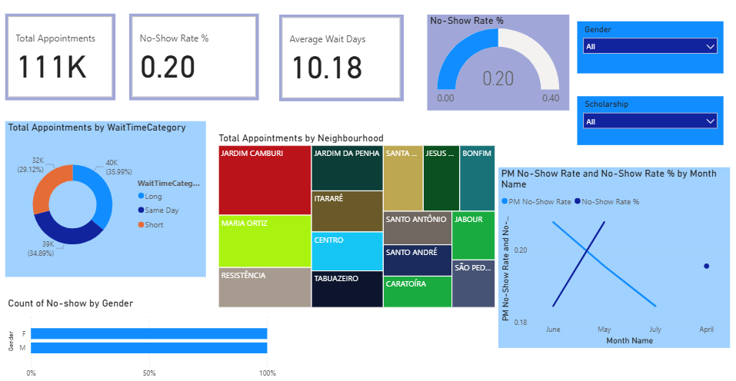
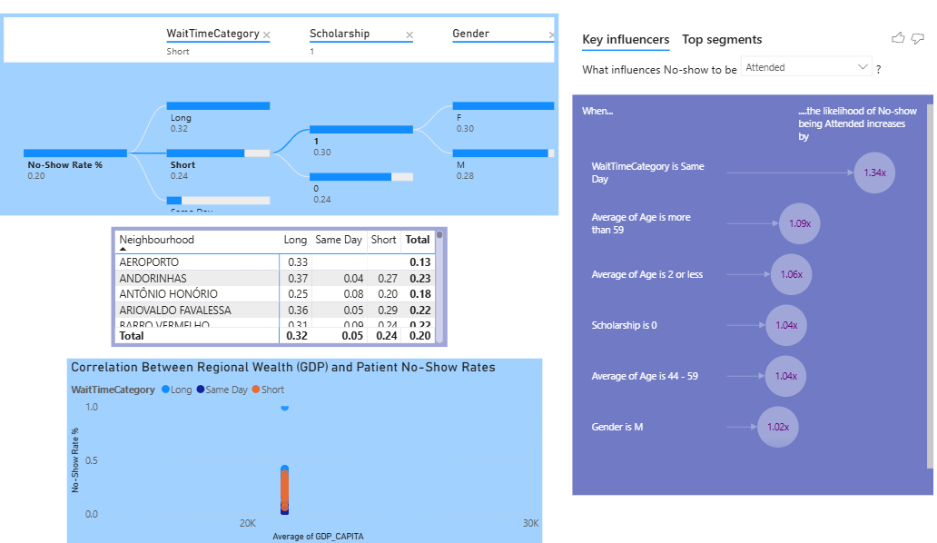

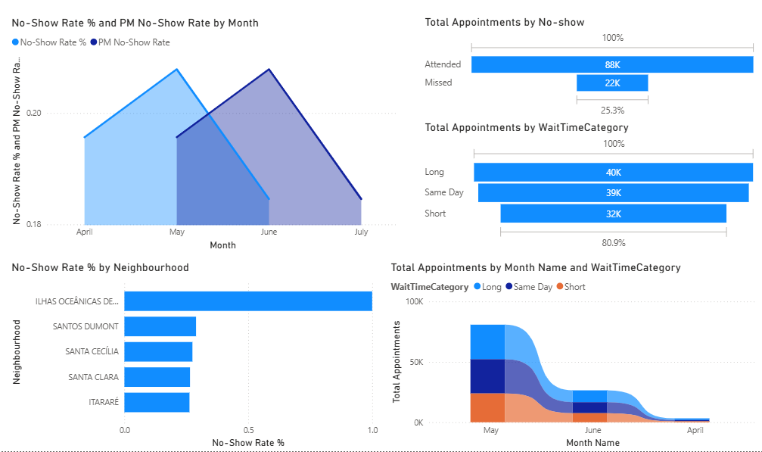
1. Explanation of Design Choices
The dashboard’s architectural layout is governed by a strict Visual Hierarchy and Logic Flow, specifically designed to cater to different levels of clinical management. On the Executive Summary (Page 1), I implemented a "Top-Down" hierarchy where critical Key Performance Indicators (KPIs), such as Total Appointments, No-Show Rate, and Average Wait Days, are positioned at the header of the page. This placement ensures immediate situational awareness for senior stakeholders. To maintain a professional aesthetic, I utilized a consistent blue-scale color theme, which symbolizes "Health and Professionalism." This thematic choice ensures that high-impact visuals, such as the No-Show Rate Gauge and Geographic Treemap, remain prominent without creating unnecessary visual clutter.

Moving into Diagnostic Analytics (Page 2), the design shifts from descriptive to predictive by incorporating AI-driven visuals like the Decomposition Tree and Key Influencers. These tools were selected to move the analytical conversation from "what happened" to "why it happened," leveraging machine learning to isolate specific behavioral drivers such as "Long Wait Times" and "Male Gender." Finally, for Performance Monitoring (Page 3), I prioritized comparative analysis. By utilizing an Area Chart for Time Intelligence, the dashboard highlights the performance "gap" between the current and prior months, while a Funnel Chart provides a clear visualization of "Process Loss," tracking the attrition of patients from the point of initial booking to final clinical attendance.

2. Explanation of User Interaction
The dashboard is engineered for Deep Discovery and Cross-Filtering, allowing users to navigate through multi-dimensional datasets with ease. On the Executive Summary, I integrated dynamic slicers for Gender and Scholarship status. For example, selecting "Scholarship (1)" triggers a global filter across the report, instantly revealing how government aid impacts attendance rates across disparate neighborhoods. This interactivity is further enhanced by Drill-Down Capabilities within the Detailed Analysis (Page 2). By interacting with the clinical Matrix, managers can drill into specific neighborhoods to determine if a localized high no-show rate is a systemic geographic issue or one confined to specific booking categories, such as long-term wait times.
To maintain a clean interface while providing depth, I implemented Contextual Tooltips on the Socio-Economic Scatter Plot. This allows a user to hover over any data point to retrieve granular details regarding a neighborhood's GDP and specific attendance stats, preventing the visualization from becoming overcrowded with text labels. Furthermore, AI Interactivity is embedded within the Key Influencers visual, where users can toggle between "Attended" and "Missed" statuses. This real-time interaction enables stakeholders to see which socio-economic or demographic factors positively or negatively influence patient behavior, facilitating evidence-based decision-making.

Part F: Analytical Insights and Business Recommendations

1. Analytical Insights
a. Insight 1: The "Lead-Time" Risk Factor A deep dive into the Decomposition Tree and Funnel Chart reveals that the most significant predictor of non-attendance is the "Lead-Time Risk Factor." Appointments categorized as "Long" wait times (exceeding 7 days) suffer from a staggering 32% no-show rate. In contrast, "Same Day" bookings maintain a near-perfect attendance rate. This indicates that patient commitment to a medical visit diminishes significantly as the temporal gap between the booking action and the actual appointment date increases.
b. Insight 2: Socio-Economic Attendance Imbalance The Snowflake Scatter Plot identifies a distinct regional imbalance where health outcomes are tied to economic prosperity. Neighborhoods with the lowest GDP per Capita-mapped through the external IBGE dataset-consistently populate the "Top 5 Worst Performers" list for attendance. This suggests that the barrier to healthcare in these specific regions is likely structural, potentially linked to high transportation costs or the inability of patients in low-income sectors to sacrifice hourly wages for a clinic visit.

c. Insight 3: The "Scholarship" Paradox The Key Influencers AI visual produced a counter-intuitive finding regarding social welfare. Data indicates that patients enrolled in the Bolsa Família (Scholarship) program are actually more likely to miss appointments than those who are not. This "Scholarship Paradox" suggests that while financial aid addresses basic needs, it does not currently mitigate the systemic barriers-such as healthcare literacy or childcare constraints-that prevent low-income families from utilizing scheduled medical services.

d. Insight 4: Demographic Behavioral Variance Analysis of the Stacked Bar Chart reveals that while total appointment volume is relatively consistent across genders, the "No-Show Rate %" is noticeably higher among the male demographic. When this data is cross-filtered with the "WaitTimeCategory," it becomes evident that men are significantly less likely to attend appointments scheduled more than a week in advance compared to women. This identifies men as a high-risk demographic segment that requires more aggressive engagement for long-term scheduling.

e. Insight 5: Diminishing Returns on SMS Communication The Time Intelligence monitoring on Page 3 demonstrates a plateau in the effectiveness of current patient outreach. Despite a high volume of SMS reminders being dispatched during the peak months of May and June, the no-show rate did not decline in a proportional or meaningful way. This suggests that a "one-size-fits-all" automated messaging strategy is losing its impact and that the timing or content of these reminders is failing to influence the decision-making process of high-risk patients.

2. Actionable Recommendations
a. Recommendation 1: Implementation of a Dynamic Confirmation Workflow To address the high attrition rate in long-term bookings, the clinic should move away from static reminders and implement a staggered confirmation system. For "Short-term" bookings, a standard SMS 24 hours prior is sufficient. However, for "Long-term" appointments, a mandatory phone confirmation should be required 48 hours before the slot. If the patient does not confirm via the call, the slot should be automatically released to a dynamic waitlist, thereby reducing the 32% "Process Loss" identified in the analytical funnel.

b. Recommendation 2: Deployment of Targeted Mobile Clinics Given the strong correlation between low regional GDP and high no-show rates identified in the Snowflake model, the healthcare provider should deploy mobile health units to the bottom-performing neighborhoods, such as ILHAS OCEÂNICAS. By moving the point of care closer to the patient’s place of residence or work, the provider can effectively bypass the transportation and economic mobility barriers that currently prevent these high-risk populations from attending centralized facilities.

c. Recommendation 3: Strategic Personalization of Patient Engagement To improve attendance among men and scholarship recipients; the clinic must personalize its communication style. Reminders for male patients should shift to highlight the "efficiency" and "time-saving" aspects of the visit to appeal to those who view healthcare as a disruption to their workday. For scholarship recipients, the clinic should partner with community leaders to synchronize "Health Education" outreach with social grant payout dates, ensuring that medical attendance is framed as a foundational part of the family’s monthly welfare routine.

3. Conclusion
The development of this Executive Clinical Insights Dashboard marks a transition from raw data collection to actionable healthcare intelligence. By transforming a flat dataset of over 110,000 records into a sophisticated Snowflake Schema, this project has demonstrated how clinical outcomes-specifically patient non-attendance-are deeply intertwined with socio-economic and temporal factors.

Through the application of Advanced DAX modeling and AI-driven diagnostics, several critical discoveries were made. I identified that the "Lead-Time Risk Factor" is the primary driver of operational inefficiency, with no-show rates tripling as booking dates extend beyond one week. Furthermore, the integration of external IBGE socio-economic data proved that regional wealth (GDP) and development indices (IDHM) are statistically significant indicators of patient reliability. This confirms that a "one-size-fits-all" approach to clinical management is insufficient; instead, healthcare providers must adopt a localized, demographic-specific strategy.

Ultimately, the recommendations provided-ranging from dynamic confirmation workflows to the deployment of targeted mobile clinics-offer a data-driven roadmap for the United States International University-Africa clinical partners. Implementing these insights will not only reduce "Process Loss" but also ensure that healthcare resources are allocated to the neighborhoods and demographics that need them most, effectively bridging the gap between clinical capacity and patient attendance.

Part G: GitHub Repository
GitHub Link:
HermelaDev/DSA3050A-Advanced-PowerBI-Exam

PowerBI Published Link:
https://app.powerbi.com/view?r=eyJrIjoiZTRmZjA2Y2QtOTE4ZC00MGQ1LWEwYTctYTFlNzhiYjdkNjY1IiwidCI6IjE2ZDgzZWU2LTI1NGEtNDY5ZC1hNmNjLTU0ZTJjYTIzMTNlNyIsImMiOjh9

