Data Loading
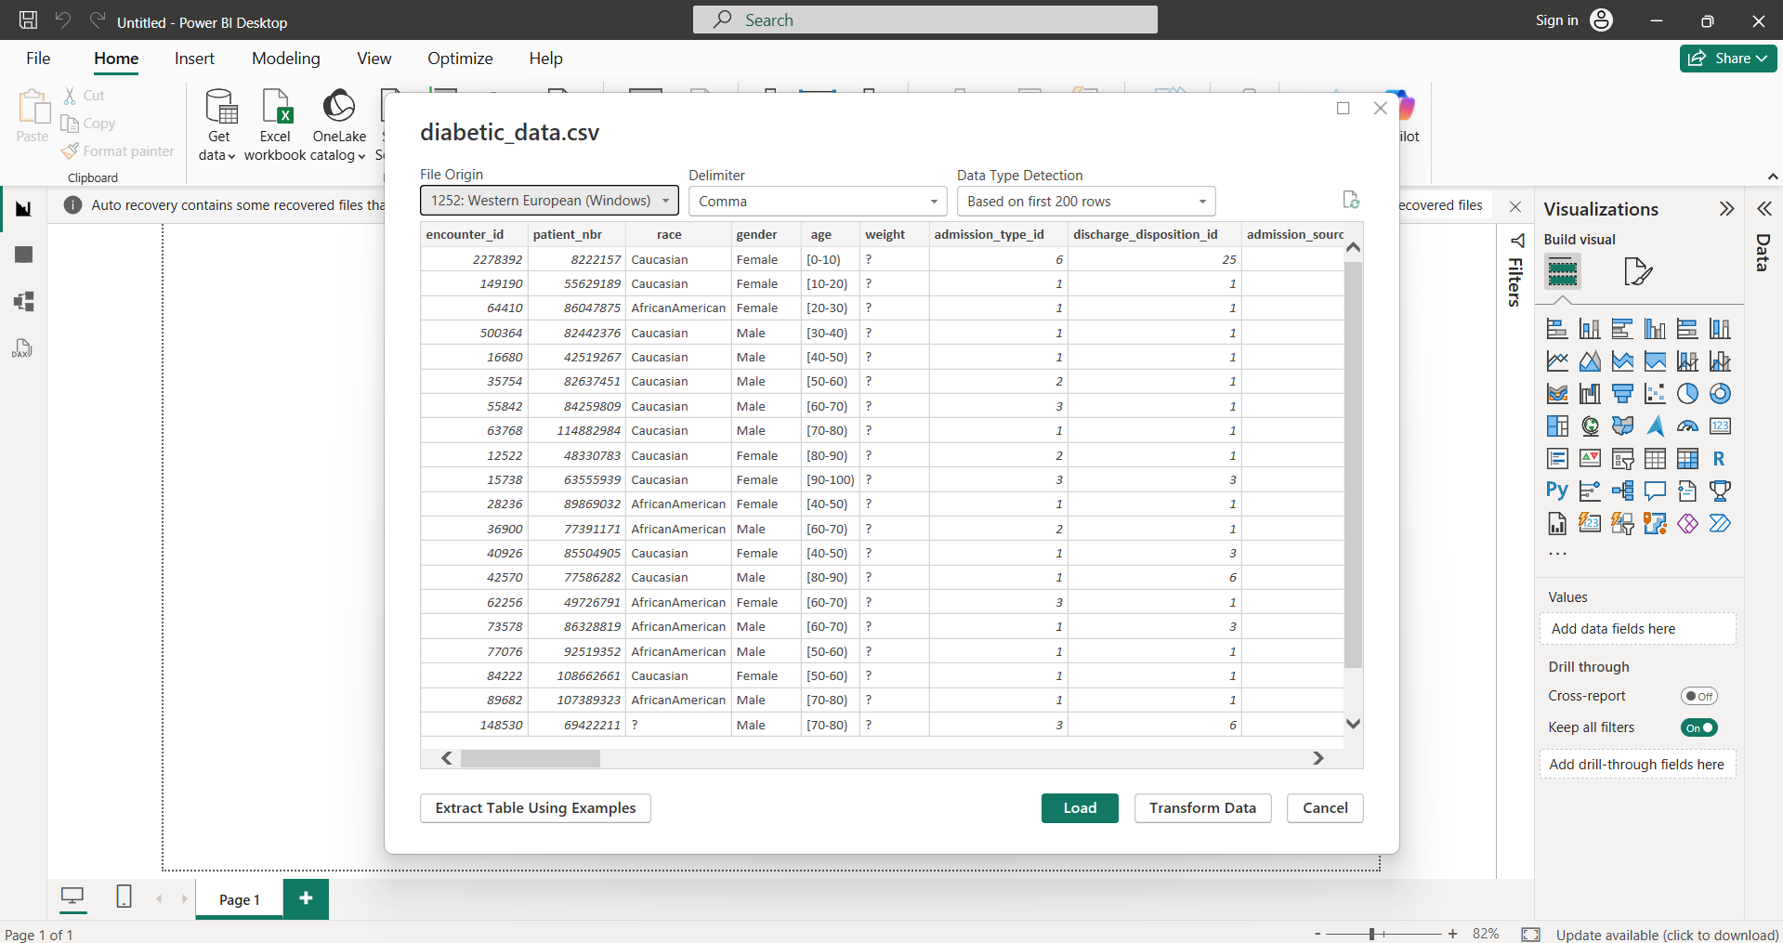
Column 1 & 2: encounter_id and patient_nbr
The Situation: These are our Unique Identifiers. In the raw data, Power BI often imports these as Numbers. However, we will never sum an ID or calculate the average Patient Number. So, we convert these to Text. This prevents Power BI from trying to aggregate them and keeps our data model lean.
Before: After:
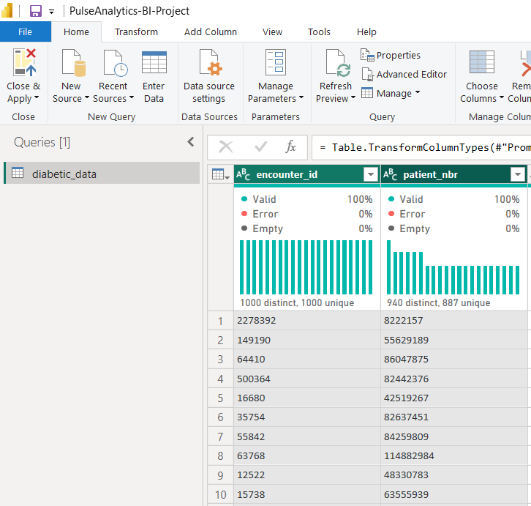

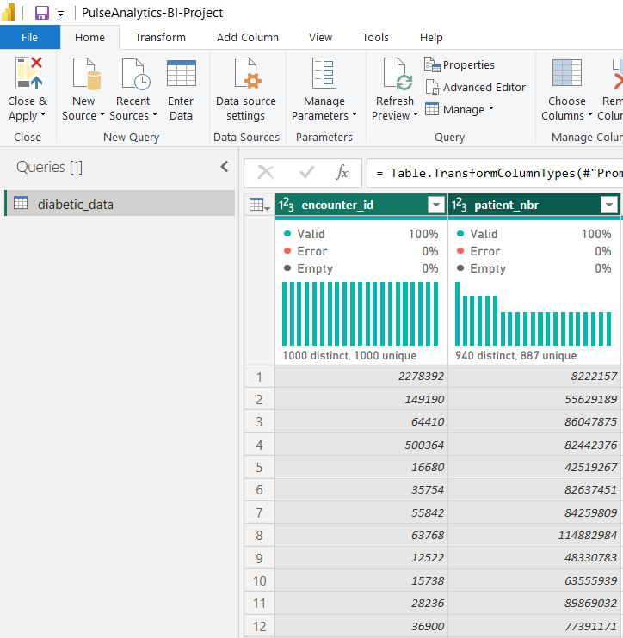

Column 3: race
We replaced the ? placeholder with Other and applied Trim and Capitalize Each Word transformations. This is because We identified ? as a non-standard null value that would skew demographic visualizations. We standardized the text to ensure consistent grouping, ensuring that variations in spacing or casing do not result in fragmented data points during analysis.

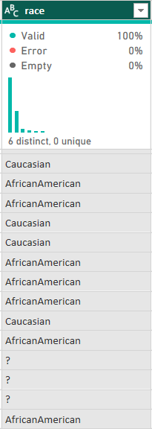
Before: After:
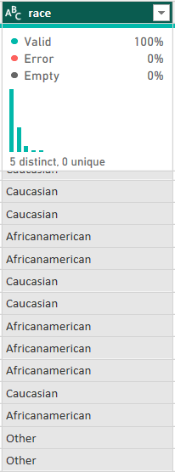

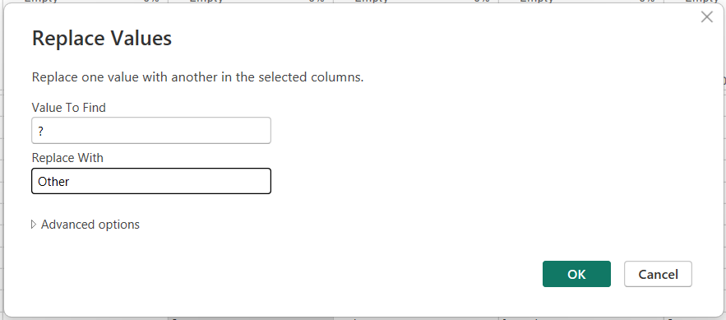
During:

Column 4: gender
We standardized the casing to "Capitalize Each Word" and filtered the dataset to remove "Unknown/Invalid" entries. We did this to maintain clinical accuracy, our group decided to focus on verified gender data. Removing invalid records ensures that our demographic insights, particularly regarding readmission trends, are grounded in high-quality data.

Column 5: age
We stripped the mathematical symbols [ ans ), split the ranges into two numeric columns, and generated an Age_Midpoint using a custom column formula. This is because we recognized that the original text-based age brackets were unusable for mathematical modeling. By calculating a midpoint, we enabled our group to perform advanced DAX calculations, such as finding the average age of patients or identifying age-based correlations with readmission.

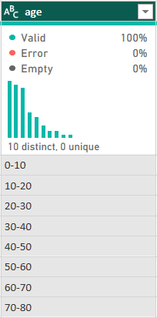
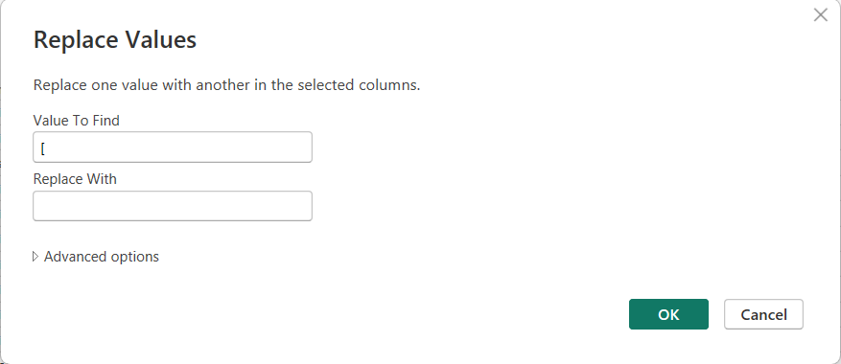
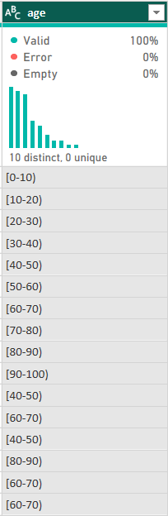
Before: After:
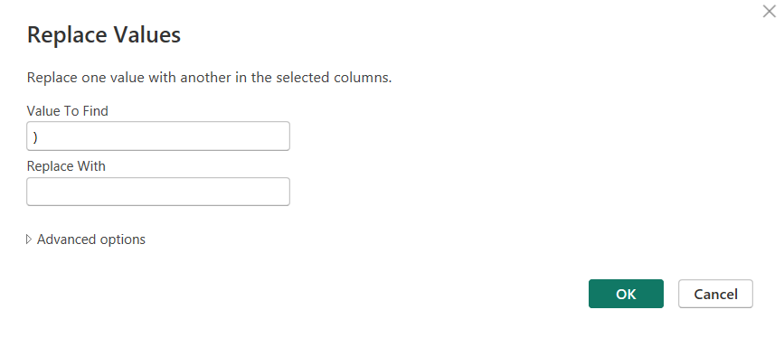

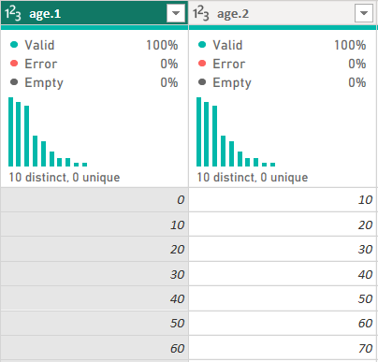
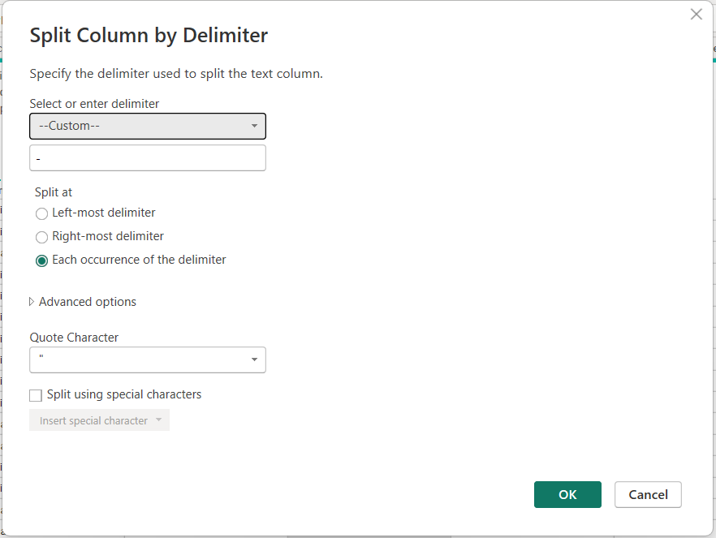

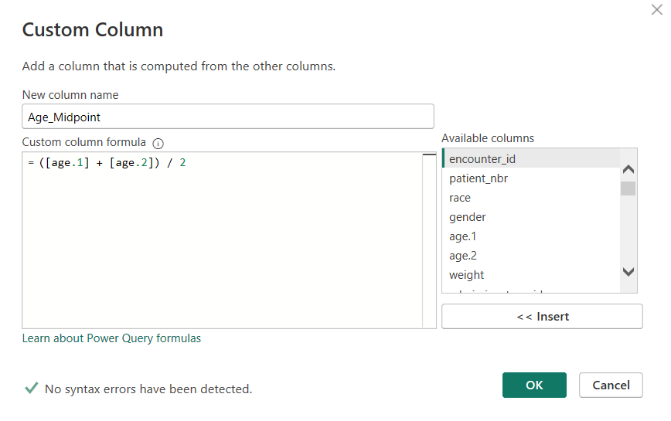

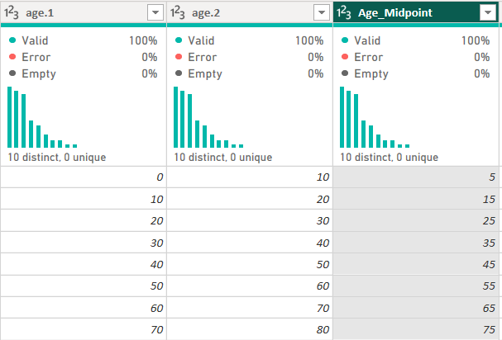

Column 6: weight
After reviewing the research documentation, we noted that 97% of the weight data was missing. We decided that retaining a nearly empty column would add unnecessary "noise" and increase file size without providing any statistically significant value to our BI implementation. Thus, we removed this column entirely from the dataset.

Column 7: admission_type_id
We verified and set the data type to Whole Number. Our group maintained these as numeric IDs to facilitate a clean 'Star Schema' relationship with a secondary mapping table. This allows us to categorize admissions, such as Emergency vs. Elective, which is vital for understanding which admission types lead to higher readmission rates.

Column 8: discharge_disposition_id
We implemented a strict Row Filter to exclude IDs associated with mortality or hospice care (IDs 11, 13, 14, 19, 20, 21). To ensure our BI system delivers medically sound insights, we removed records where readmission was physically impossible. This ensures our 'Readmission Risk' calculations are only performed on the 'at-risk' living population, following the rigorous methodology of our reference research study."
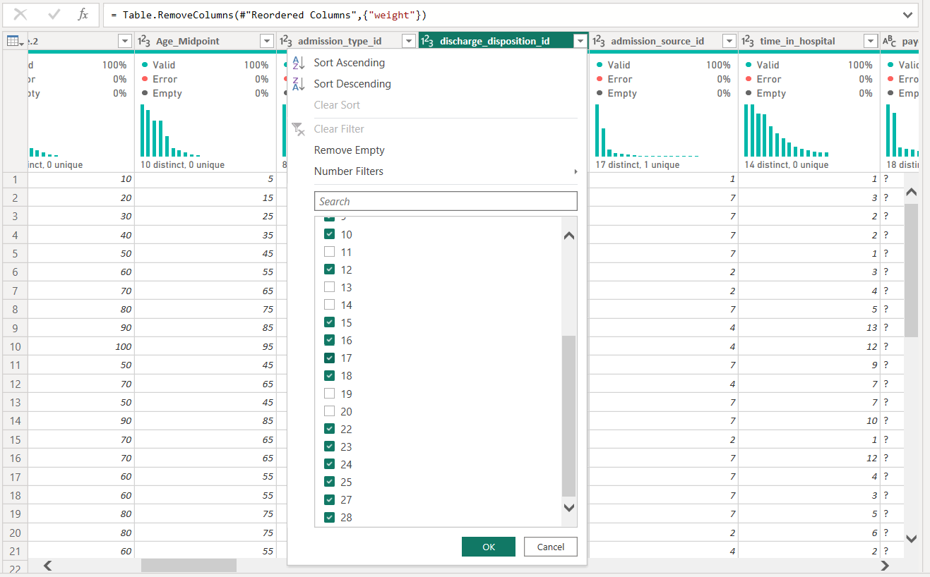

Column 9: admission_source_id
We standardized this column as a Whole Number. Our group kept this column to analyze the 'Patient Journey.' By tracking the source of admission, we can identify if patients coming from specific clinics or emergency departments have higher rates of complications or longer stays."
Column 10: time_in_hospital
We validated this column as a Whole Number and verified the range (1-14 days). We identified this as a critical performance metric. By ensuring it is numeric, we can calculate the Average Length of Stay (ALOS). This allows us to see if patients who stay longer are more or less likely to be readmitted, which is a core business question for hospital resource optimization."
Column 11: payer_code
We replaced the ? placeholder with 'Not Specified'. Although 52% of the data in this column is missing, our group chose to retain and label the nulls rather than delete the column. This allows us to at least analyze the 'Known' payer segments (like Medicare) to see if insurance type impacts readmission rates.

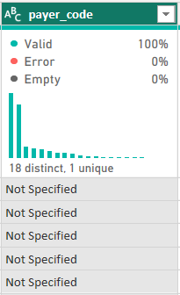
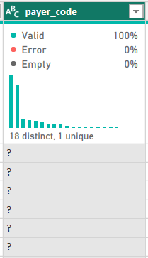

Column 12: medical_specialty
We replaced the ? placeholder with 'Not Specified'. While there is missing data, retaining this column allows us to analyze the patient volumes and readmission rates across known hospital departments (e.g., Cardiology vs. Internal Medicine) to identify specific areas that may need resource optimization.
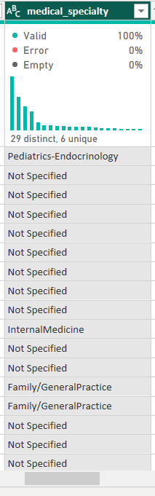
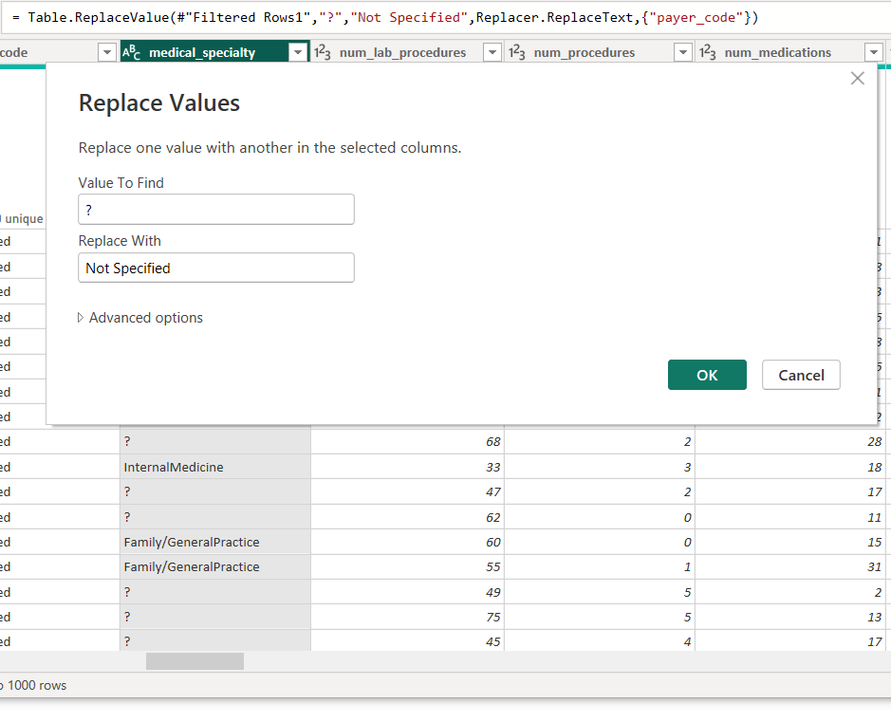
Before: After :

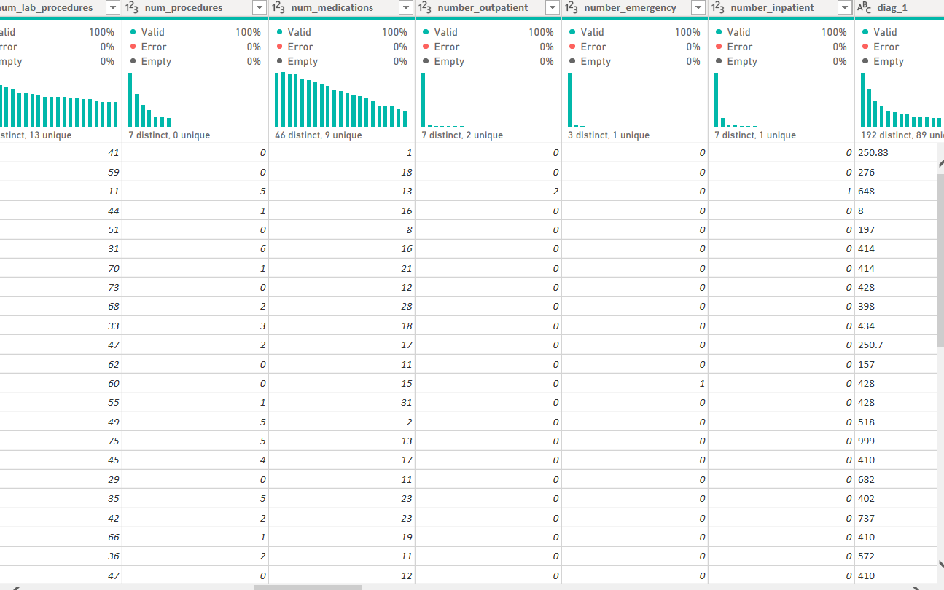
Columns 13 to 18: Health Utilization Metrics

We standardized columns 13 through 18 by explicitly casting them as Whole Numbers. Validating these as quantitative metrics is essential for our downstream DAX measures. This allows us to calculate averages and totals to answer critical business questions, such as whether a higher number of medications or emergency visits correlates with an increased risk of readmission.

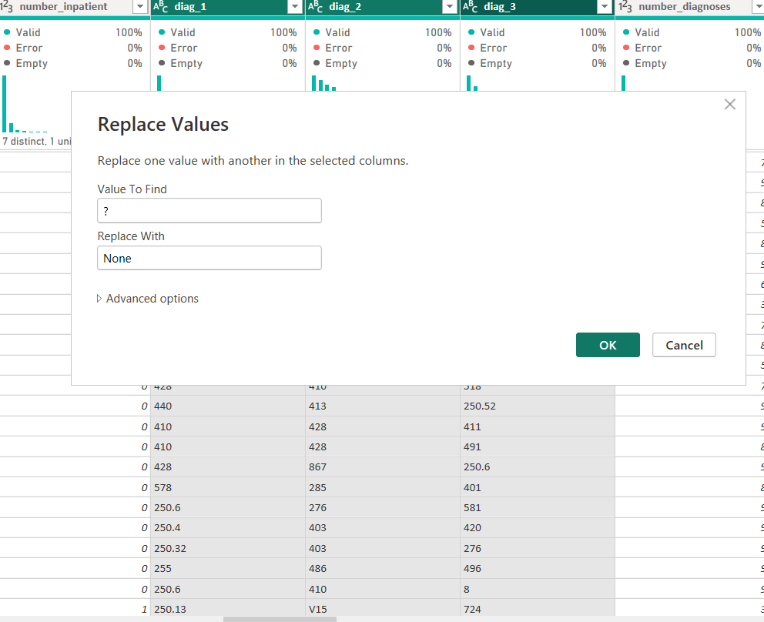
Columns 19, 20 & 21: diag_1, diag_2, diag_3

We validated and locked the Data Type for the diagnosis columns as Text. While many of these look like decimal numbers (e.g., 250.83), they are categorical ICD-9 medical codes. If Power BI detects them as decimals, it could corrupt alphanumeric codes (such as V-codes or E-codes) or drop crucial trailing zeros. Treating them strictly as text ensures our categorical filtering remains clinically accurate for our dashboard.
Column 22: number_diagnoses
We validated that the number_diagnoses column was correctly imported as a Whole Number. Retaining this strictly as a numeric value is essential, as it will serve as a key complexity indicator in our DAX measures. It allows us to segment patients by poly-morbidity (having multiple concurrent conditions) to quantitatively assess how complexity impacts the length of stay and readmission risk.
Columns 23 & 24: max_glu_serum and A1Cresult
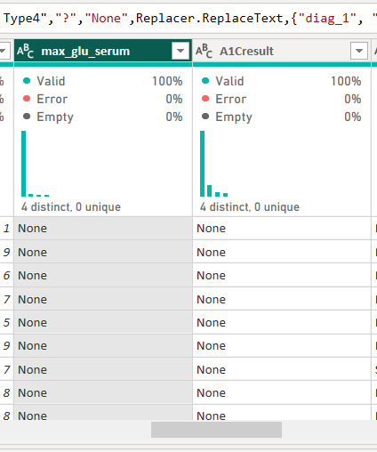
Before: After:
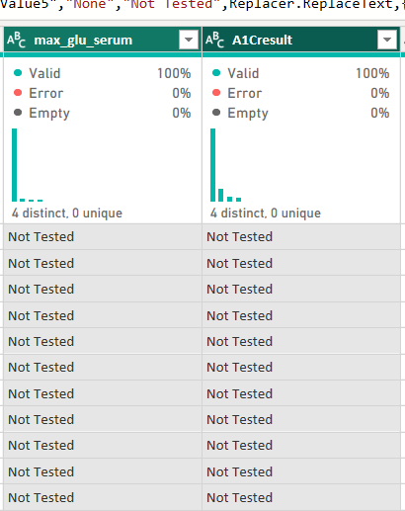

We replaced the string 'None' with 'Not Tested' across both lab result columns. In a clinical and reporting context, 'None' can mistakenly imply missing or dirty data. 'Not Tested' accurately reflects a deliberate medical reality where the procedure was omitted. This semantic correction ensures our dashboard slicers and legends are intuitive and immediately understandable to executive stakeholders.
Column 25: metformin
We validated and locked the Data Type as Text. This column will act as a critical categorical dimension in our data model, allowing us to analyze whether adjusting specific medication dosages during a hospital stay influences the likelihood of a 30-day patient readmission.
Columns 26 to 36: Medication Dosage Tracking
We validated and bulk-assigned the Data Type as Text for columns 26 through 36, which track individual medication dosages. Grouping these transformations demonstrates efficient Power Query utilization and keeps our applied steps lean. In our data model, these categorical dimensions will be crucial. They will allow us to filter patient populations by specific pharmacological treatments and analyze if certain drug combinations (polypharmacy) or dosage adjustments correlate with higher 30-day readmission rates.
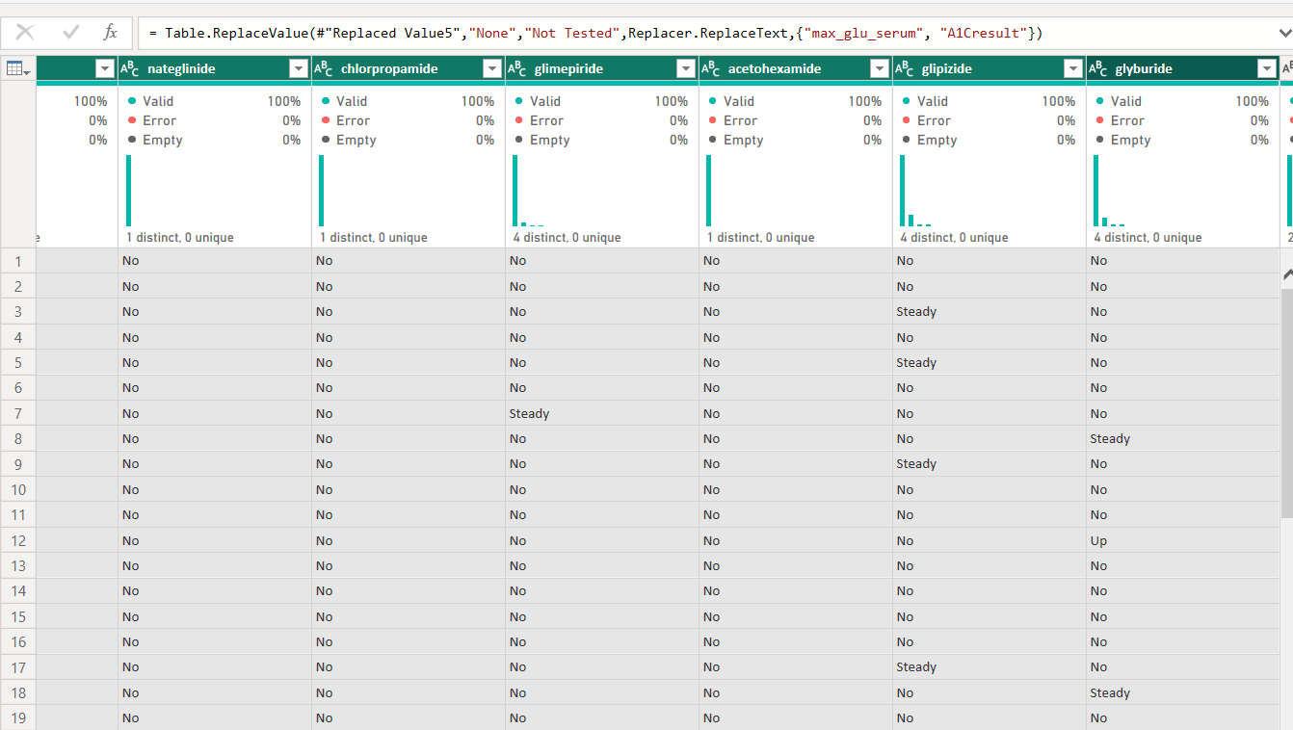
Columns 37 to 47: Additional Medication Dosage Tracking
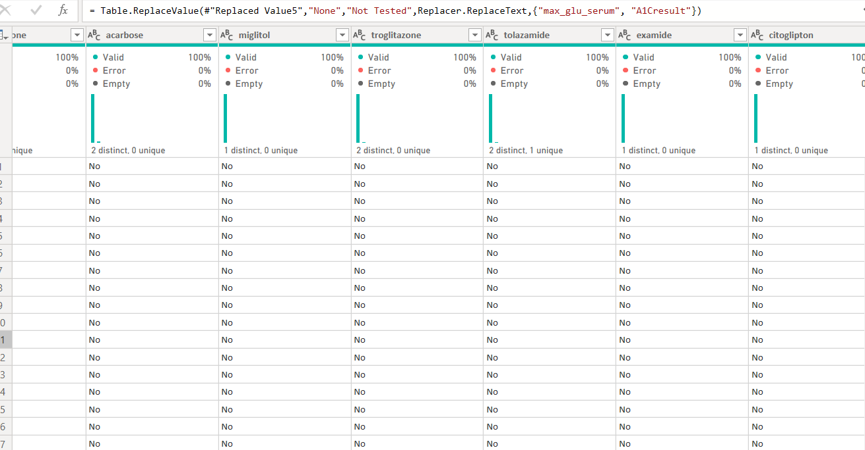
We bulk-validated the Data Type for the remaining 11 medication columns as Text. This includes complex combination drugs. Ensuring these are strictly categorical allows us to create precise DAX filters later. For example, we can isolate patients specifically treated with 'insulin' to see if their readmission rates differ significantly from those managed on oral combination therapies.

Column 48: change
Before: After:
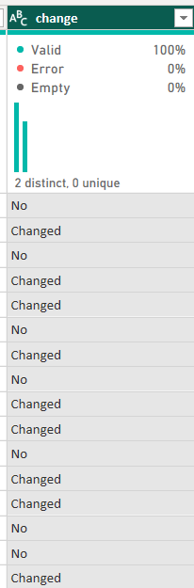
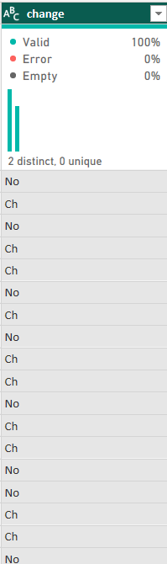

We validated the column as Text and replaced the shorthand 'Ch' with 'Changed'. This simple semantic transformation greatly improves the professional quality of our dashboard. This boolean indicator is a powerful analytical pivot point, allowing stakeholders to instantly filter visuals to see if altering a patient's medication regimen during a stay increases or decreases readmission risk.
Column 49: diabetesMed
We validated the Data Type as Text. This column serves as a high-level categorical flag. In our final Star Schema, this will allow us to easily separate patients actively receiving pharmacological diabetes treatment from those managed purely through diet or other means.

Column 50: readmitted (The Target Variable)
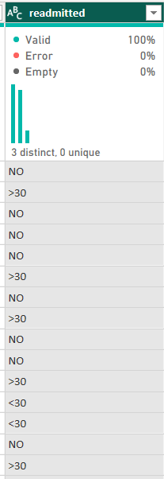
Before: After:
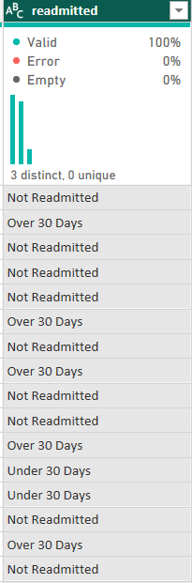

As our primary Target Variable, it was critical to ensure these labels were executive-ready. We replaced the raw system outputs ('<30', '>30', 'NO') with clean, descriptive text ('Under 30 Days', 'Over 30 Days', 'Not Readmitted'). This ensures that all primary KPIs, pie charts, and decomposition trees generated in Week 5 will have professional, self-explanatory legends that require no technical translation for business stakeholders.

