To create the fact table and all dimension tables, I used “Reference” and not “Duplicate”. This was done to ensure all tables connected to the same original source.

Fact Table Creation (Fact_Encounter):
‘Fact_Encounter’ columns: ‘encounter_id (PK)’, ‘patient_nbr’, ‘admission_type_id’, ‘admission_source_id’, ‘discharge_disposition_id’, ‘diag_1’ ‘diag_2’, ‘diag_3’, ‘time_in_hospital’, ‘num_lab_procedures’, ‘num_procedures’, ‘num_medications’, ‘number_outpatient’, ‘number_emergency’, ‘number_inpatient’, ‘number_diagnoses’, ‘readmitted’, ‘Admission_Key’, ‘Diagnosis_Key’
Below is a screenshot of choosing the appropriate columns for ‘Fact_Encounter’ table. I kept numeric/measurable attributes and removed descriptive attributes.
Screenshot of part of the ‘Fact_Encounter’ table after creating it:
Choosing appropriate columns:

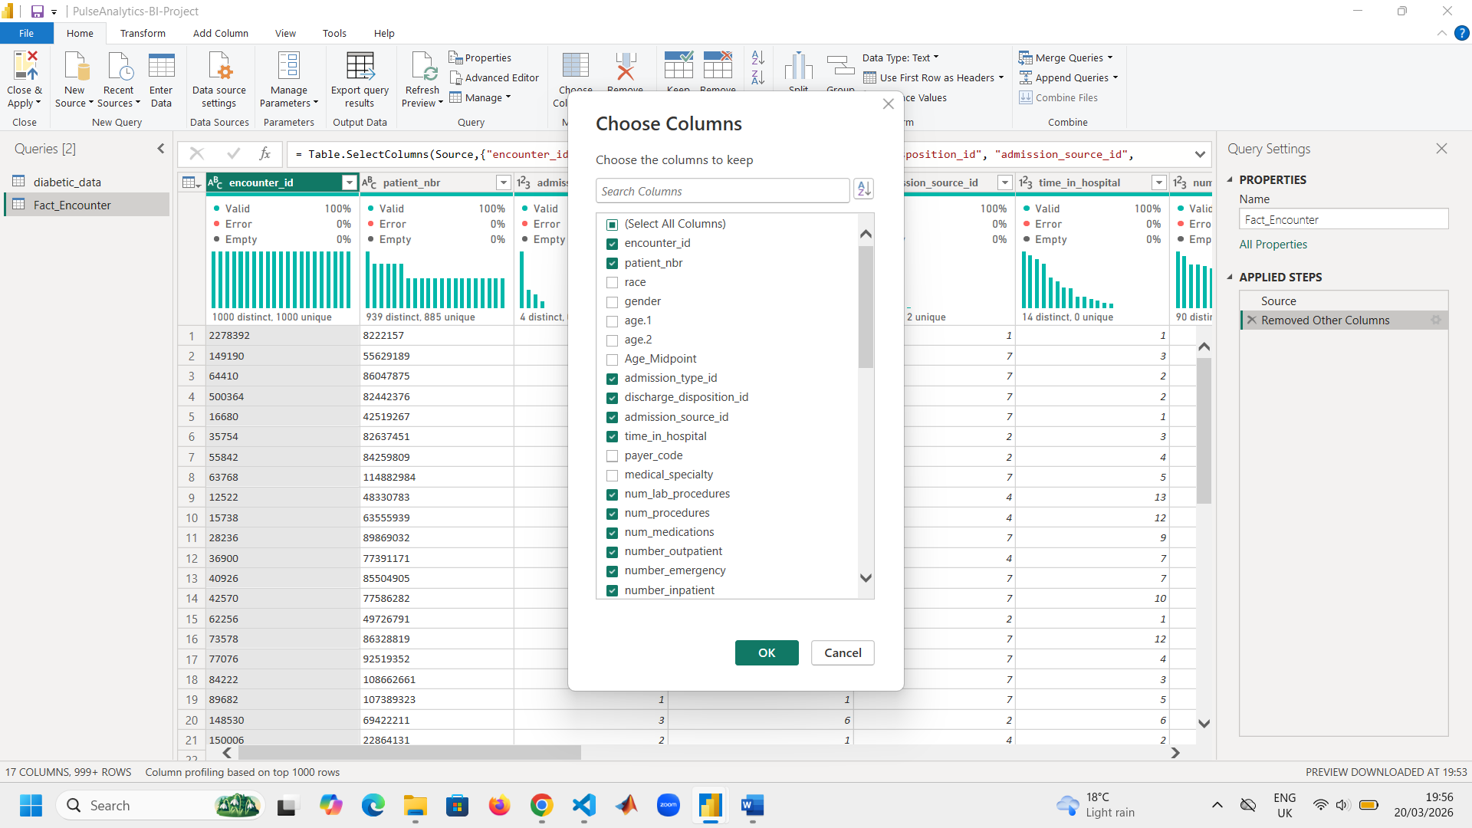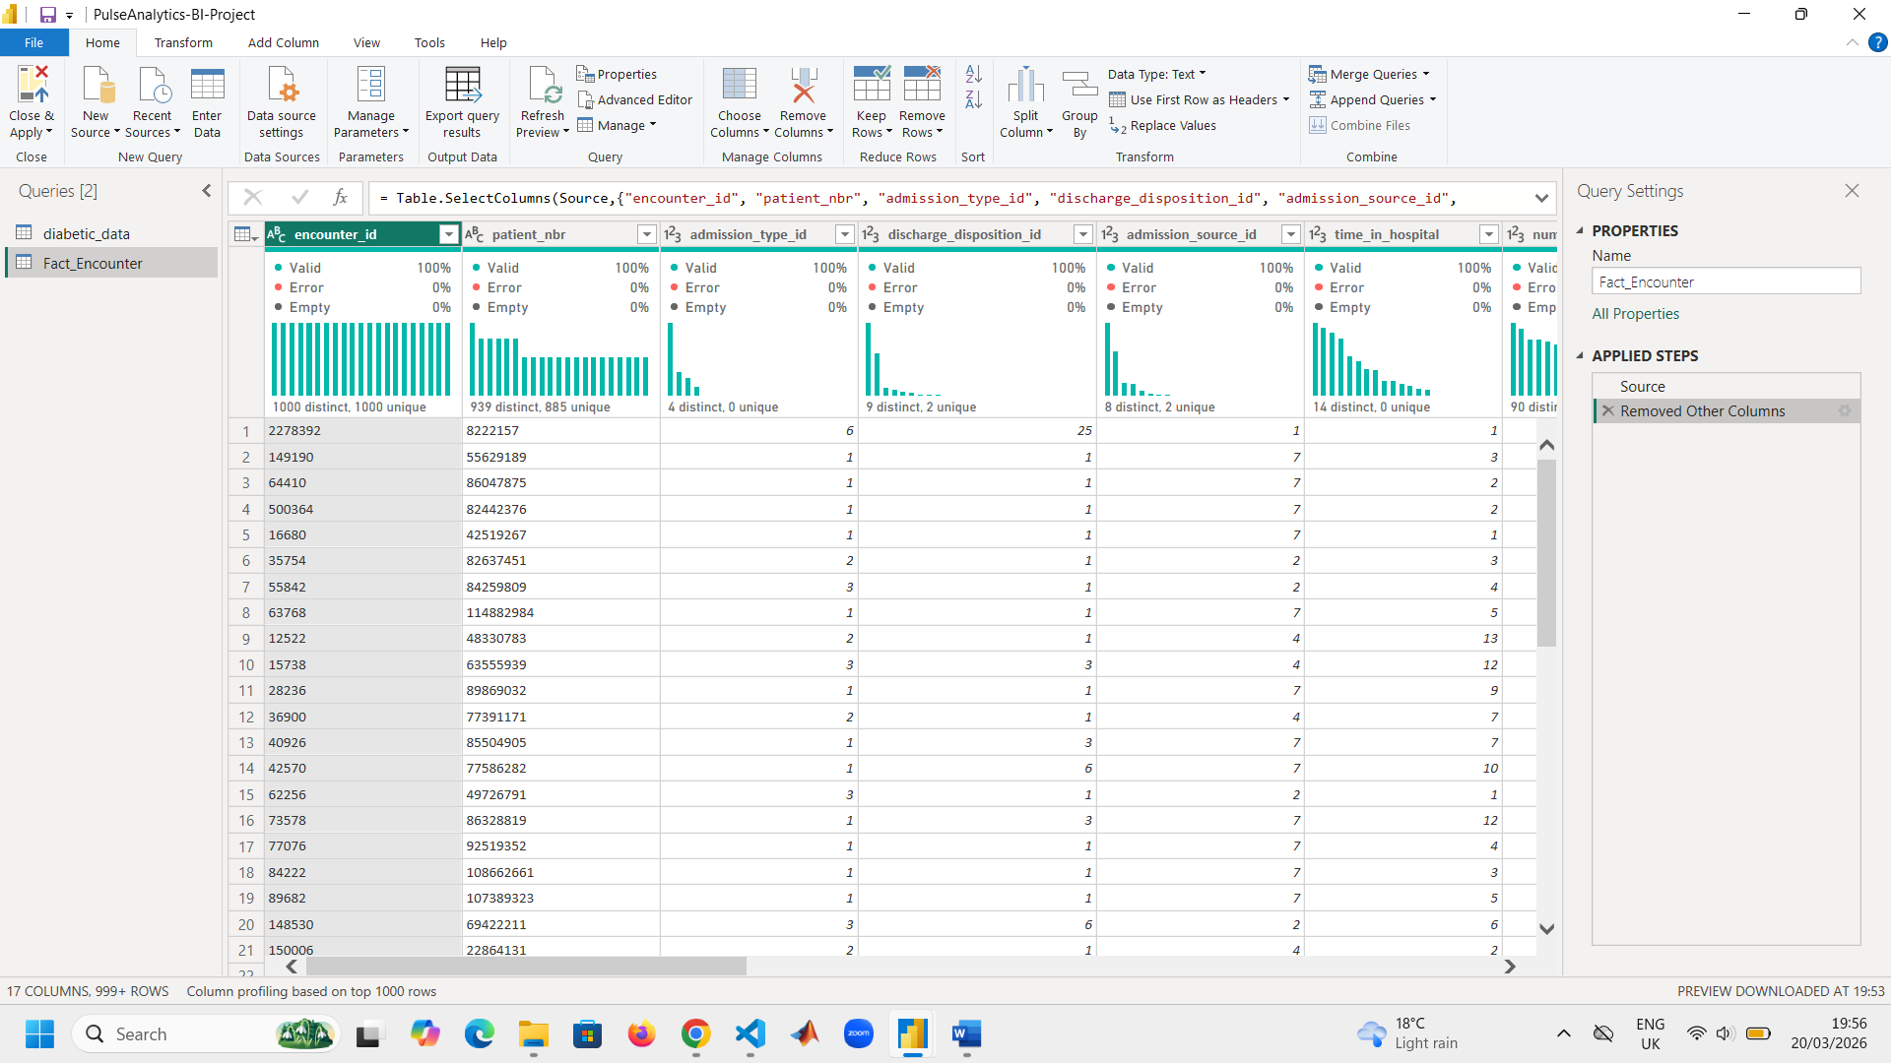

Building ‘Dim_Patient’:
This table contains only patient demographic attributes which include: ‘patient_nbr (PK)’, ‘race’, ‘gender’, ‘Age_Midpoint’, ‘payer_code’.
Below is a screenshot of choosing the appropriate columns for ‘Dim_Patient’ dimension table. Thereafter, I removed duplicate rows to ensure each patient appears once, all demographics are consistent, fact table can safely reference patient_nbr, and there are no broken relationships.
Screenshot the ‘Dim_Patient’ table after creating it:
Choosing appropriate columns:

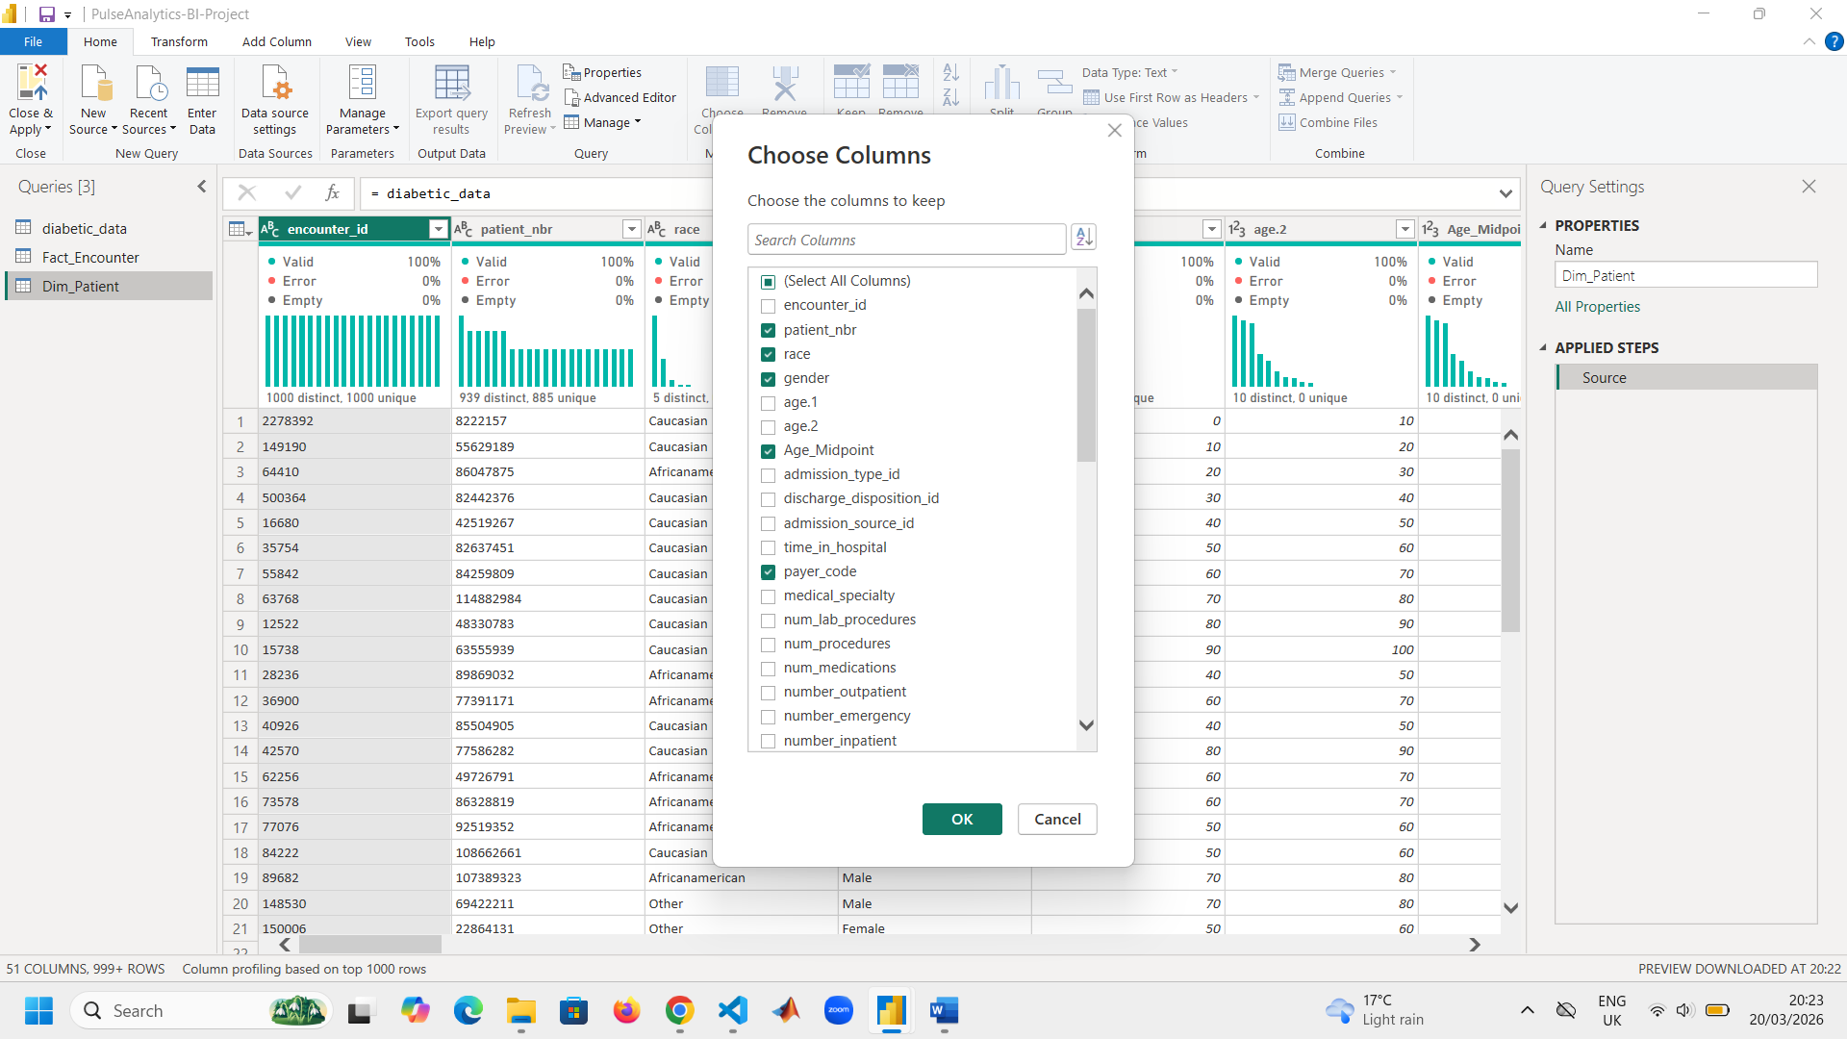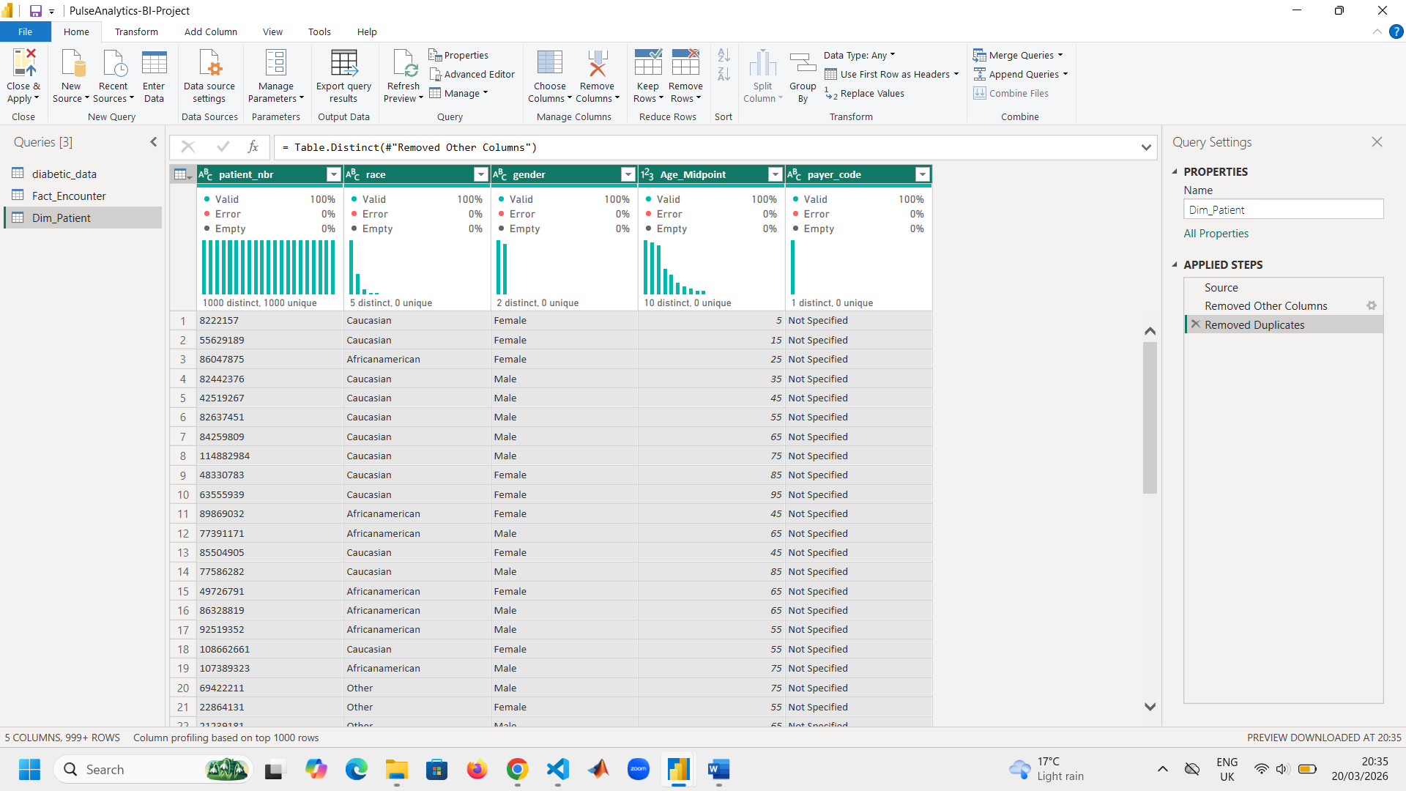
Building ‘Dim_Admission’:
This table categorizes how the patient entered and exited the hospital. Attributes include: ‘admission_type_id’, ‘admission_source_id’, ‘discharge_disposition_id’, ‘Admission_ID’, ‘Admission_Key’.
Below is a screenshot of choosing the appropriate columns for ‘Dim_Admission’ dimension table. Thereafter, I removed duplicate rows, created an index key (Admission_ID), and created a composite key (Admission_Key) to aid while creating a relationship between Fact_Encounter and Dim_Admission.
Choosing appropriate columns:

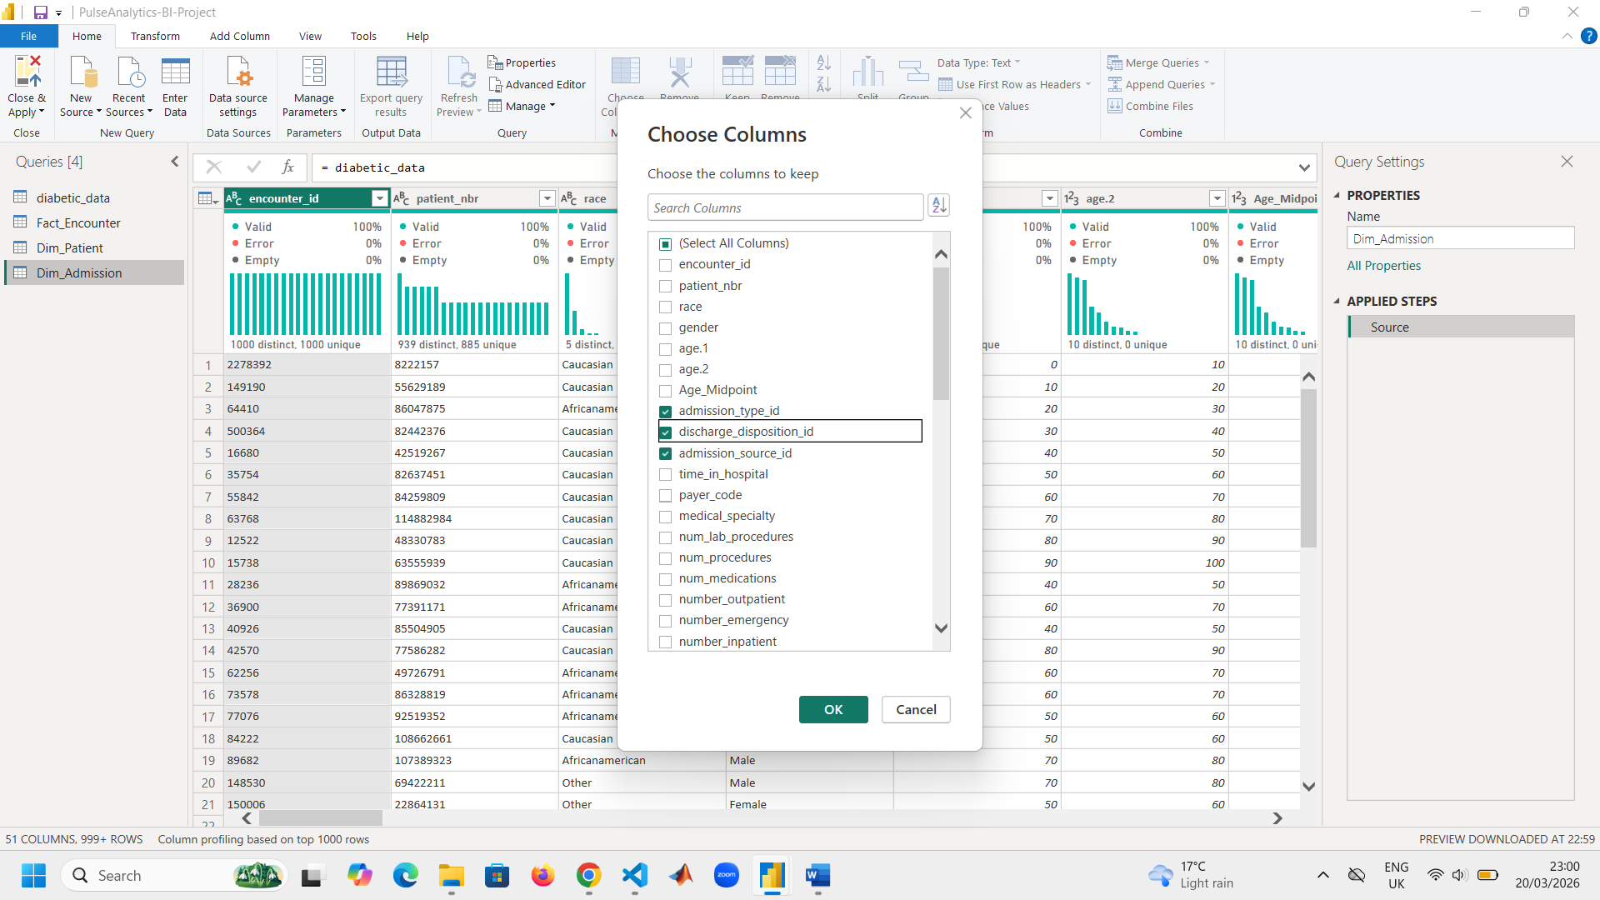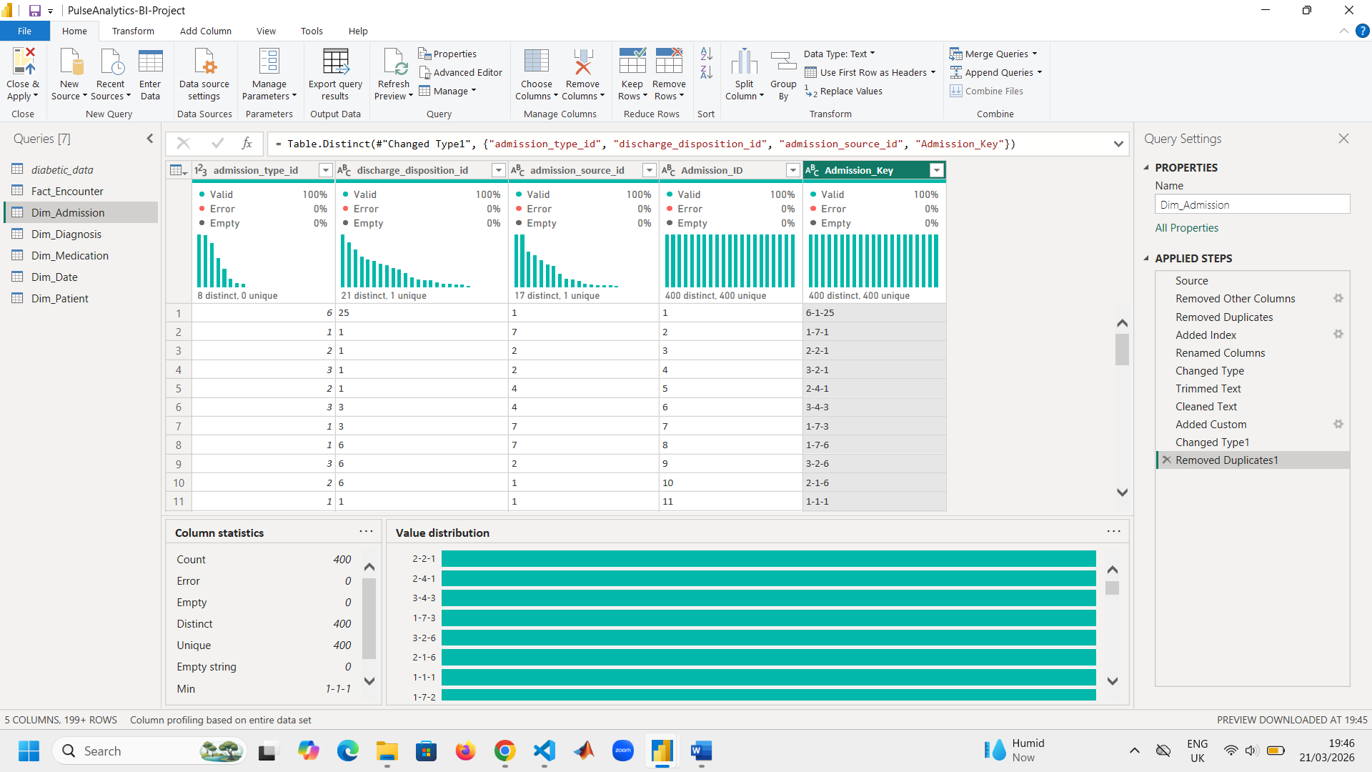
Screenshot of the ‘Dim_Admission’ table after creating it:
Building ‘Dim_Diagnosis’:
This table has categorical diagnostic labels. Attributes include: ‘diag_1’, ‘diag_2’, ‘diag_3’, ‘Diagnosis_ID’, ‘Diagnosis_Key’.
Below is a screenshot of choosing the appropriate columns for ‘Dim_Diagnosis’ dimension table. Thereafter, I removed duplicate rows, created an index key (Diagnosis_ID), and created a composite key (Diagnosis_Key) to aid while creating a relationship between Fact_Encounter and Dim_Diagnosis.
Choosing appropriate columns:

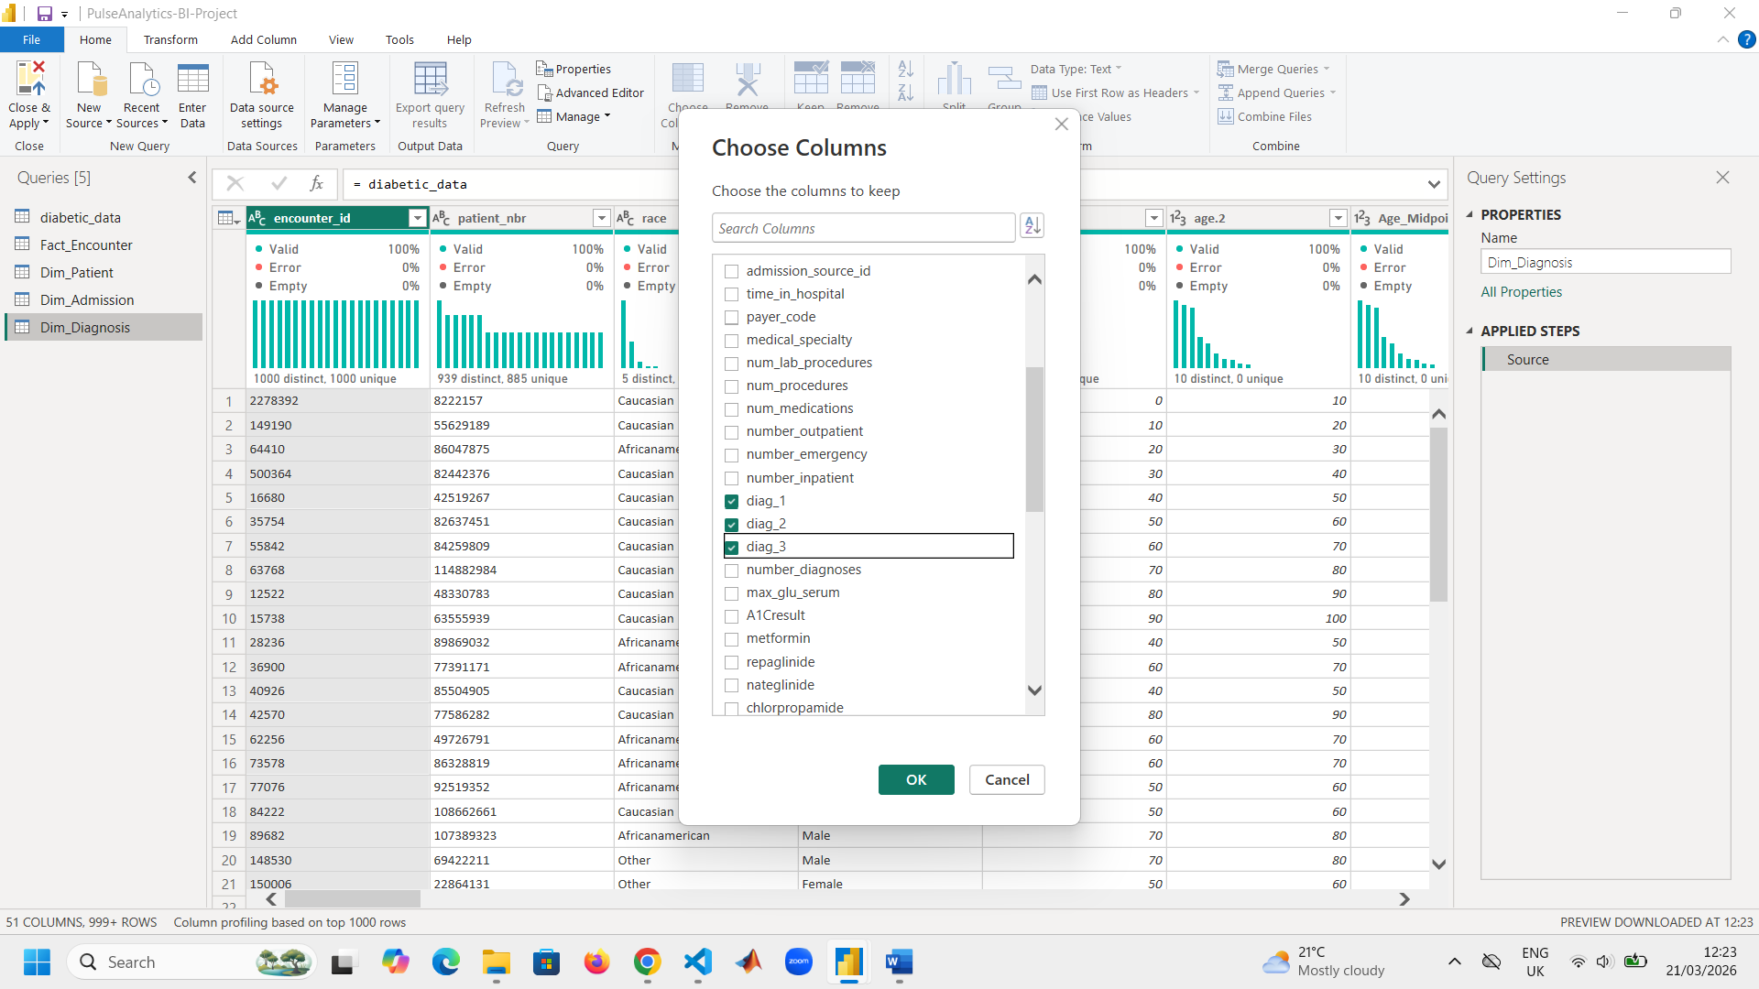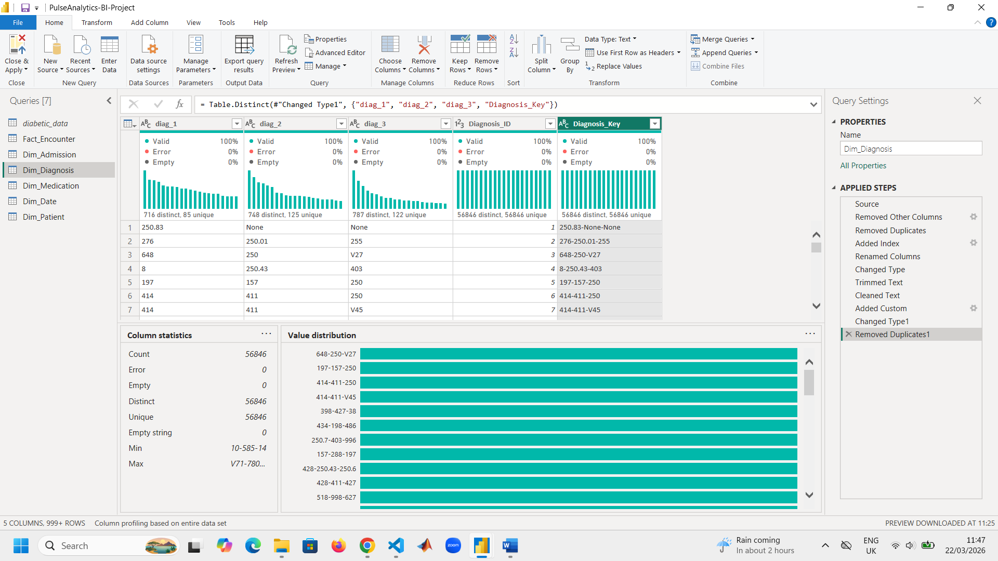
Screenshot of the ‘Dim_Diagnosis’ table after creating it:

Building ‘Dim_Medication’:
This table has medication attributes describing which drug and how dosage changed. Attributes include: ‘Drug_Name’, ‘Dosage_Change_Type’, ‘Medication_ID’, ‘Medication_Key’.
I referenced the cleaned main table and renamed the new table to ‘Dim_Medication’. Thereafter, I unpivoted all 24 medication columns to ‘Attribute’ (which is medication name) and ‘Value’ (which is dosage change). I renamed ‘Attribute’ to ‘Drug_Name’ and ‘Value’ to ‘Dosage_Change_Type’. I then added an index column and renamed it to ‘Medication_ID’. Created a composite key ‘Medication_Key’ to aid when creating a relationship.
Before unpivoting:
After unpivoting:

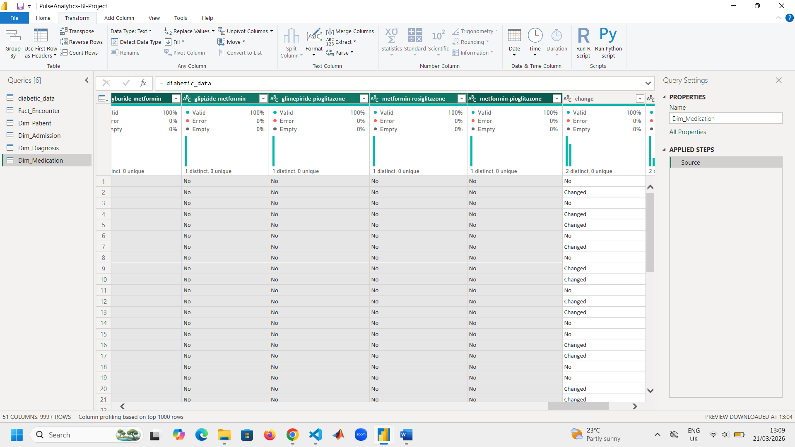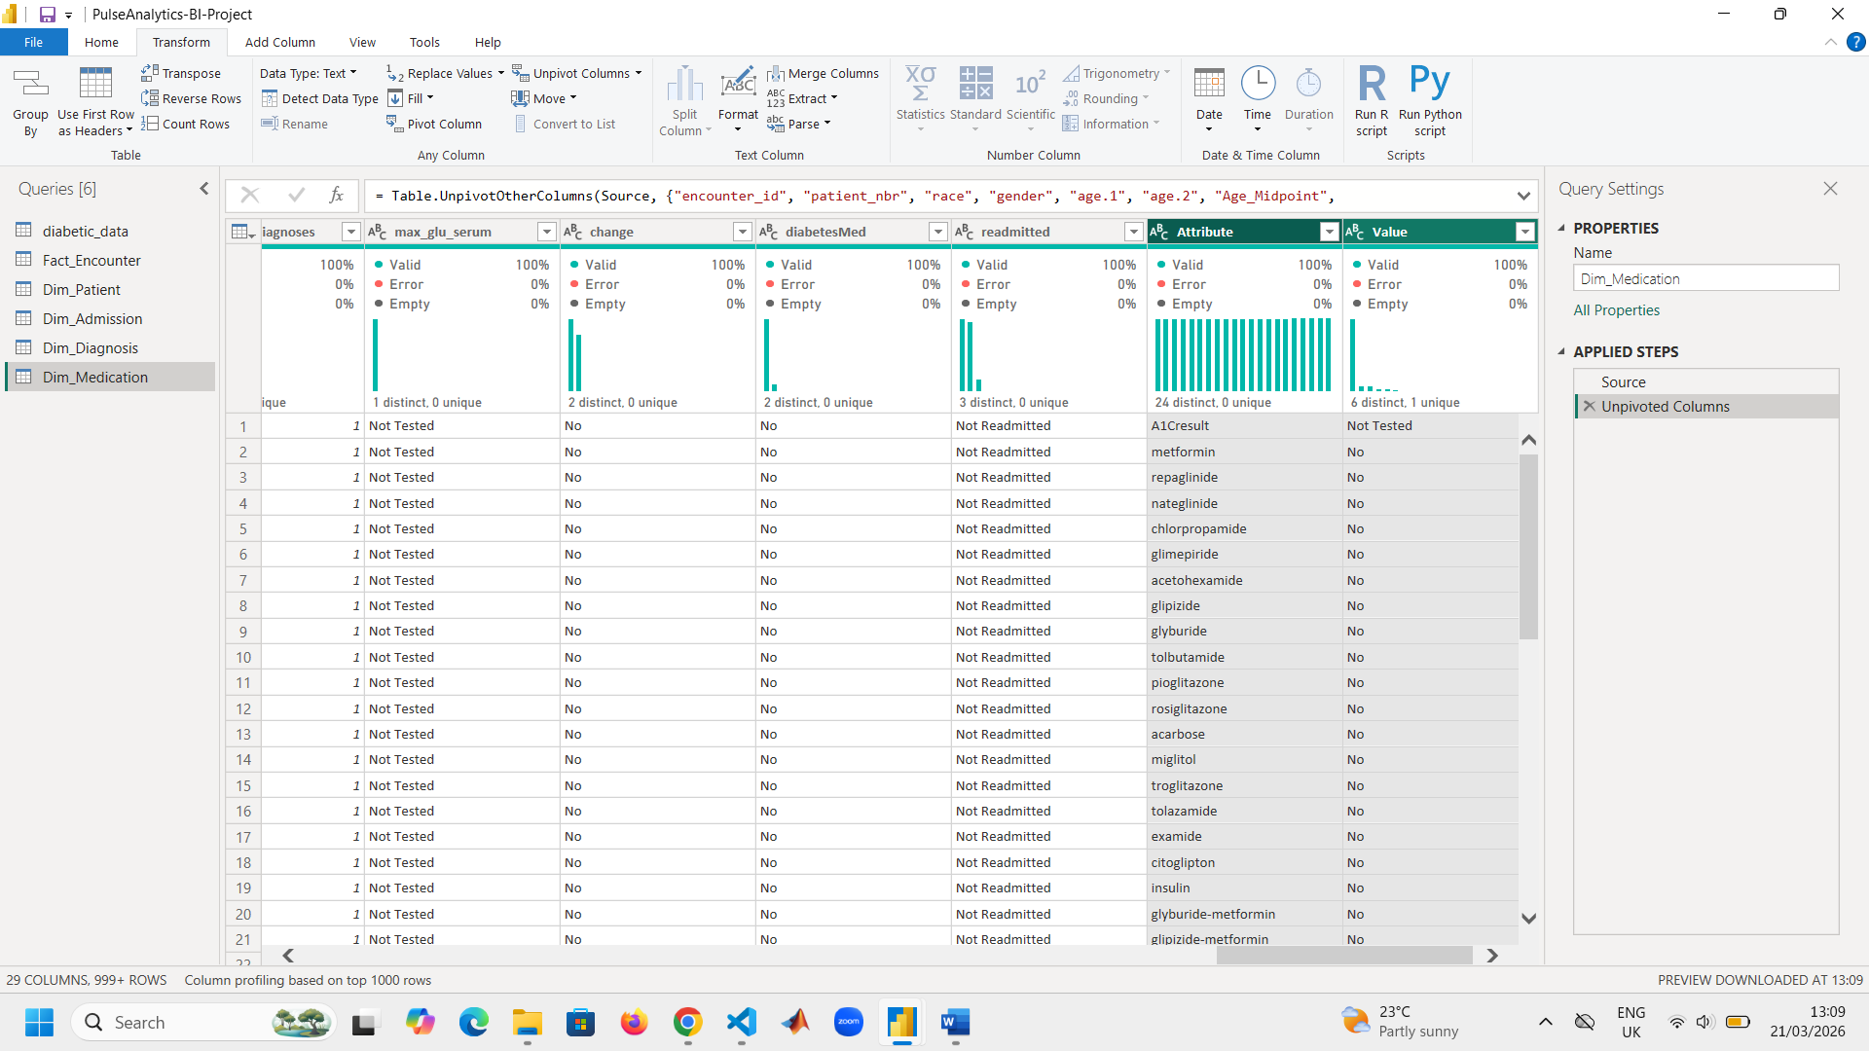
Screenshot of ‘Dim_Medication’ table after creating it:

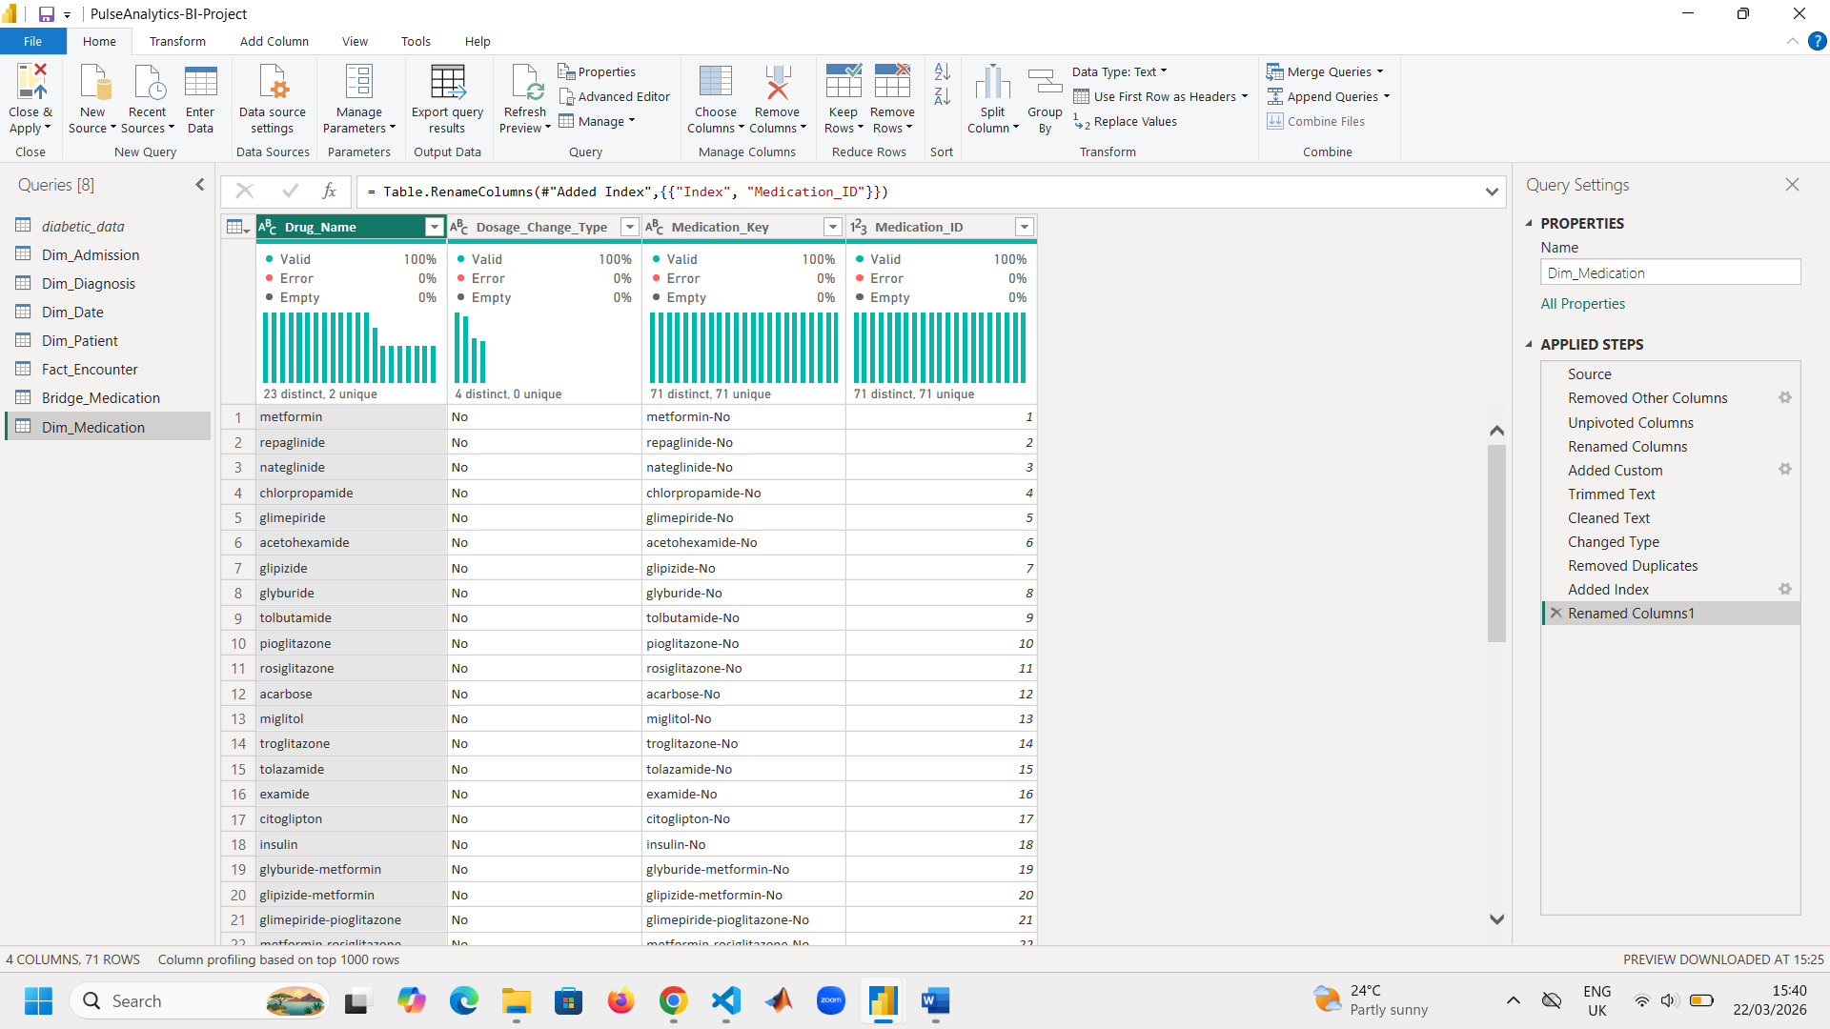

Building ‘Dim_Date’:
This table is a standard calendar table for time intelligence in DAX. Attributes include: ‘Date’, ‘Year’, ‘Month Number’, ‘Month Name’, ‘Quarter’, ‘Day Name’, ‘Date ID’.
Screenshot of ‘Dim_Date’ table after creating it:

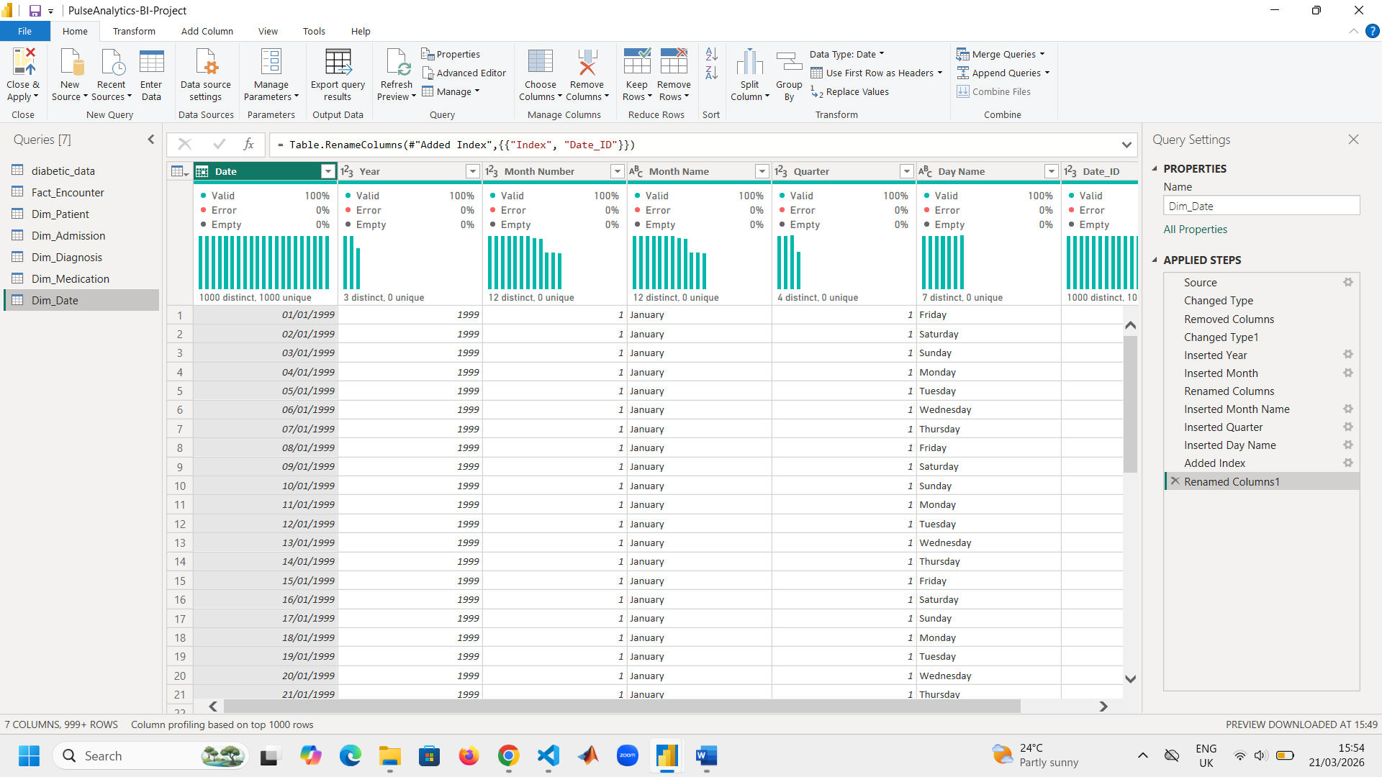

Creating relationships:
Relationship between Dim_Admission and Fact_Encounter is one-to-many because one admission type can apply to many encounters.

Relationship between Dim_Patient and Fact_Encounter is one-to-many because one patient can have many encounters.

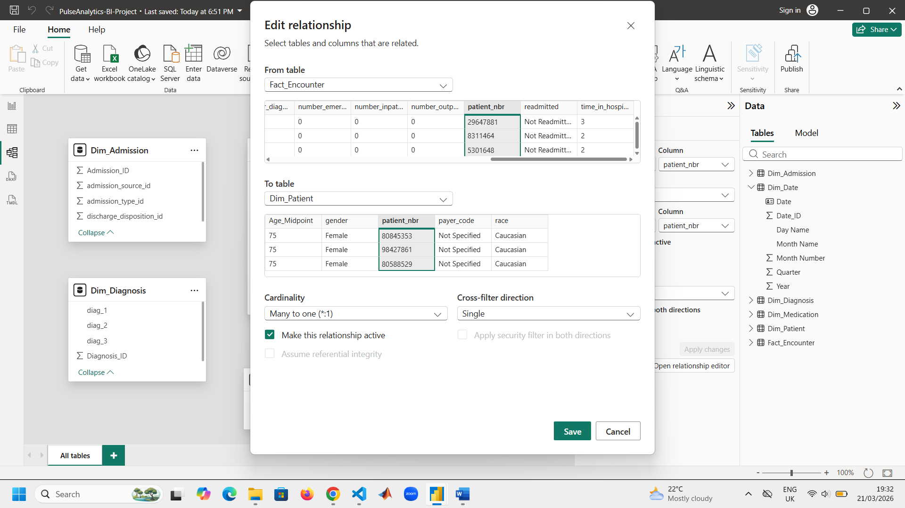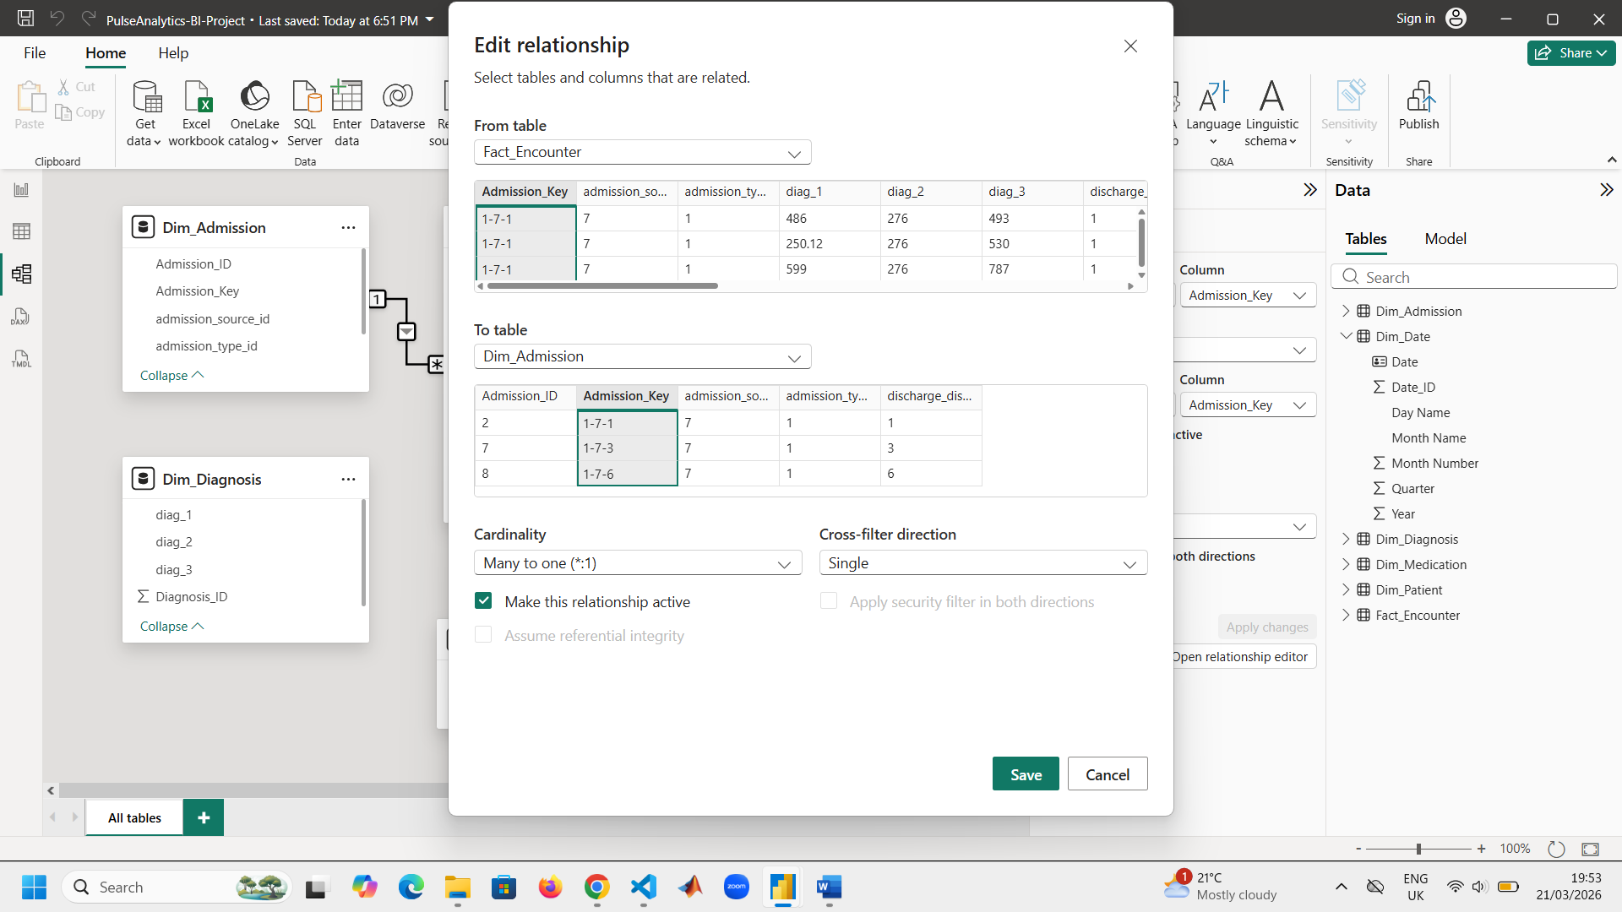

Relationship between Dim_Diagnosis and Fact_Encounter is one-to-many because diagnosis profiles are resued aross encounters.

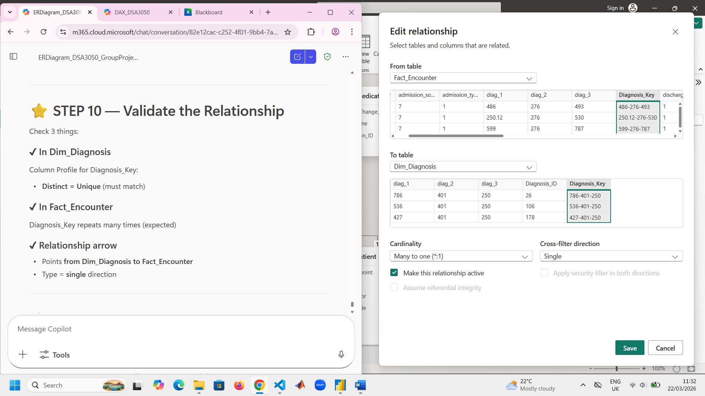
‘diabetes_data’ contains multiple medication columns per row whereas ‘Dim_Medication’ contains one medication per row. There grains do no match this can’t relate them directly. To create a relationship between these two tables a bridge table (Brirdge_Medication) was created.
Fact_Encounter has a one-to-many relationship with Bridge_Medication (left screenshot). Dim_Medication has a one-to-many relationship with Bridge_Medication (right screenshot).

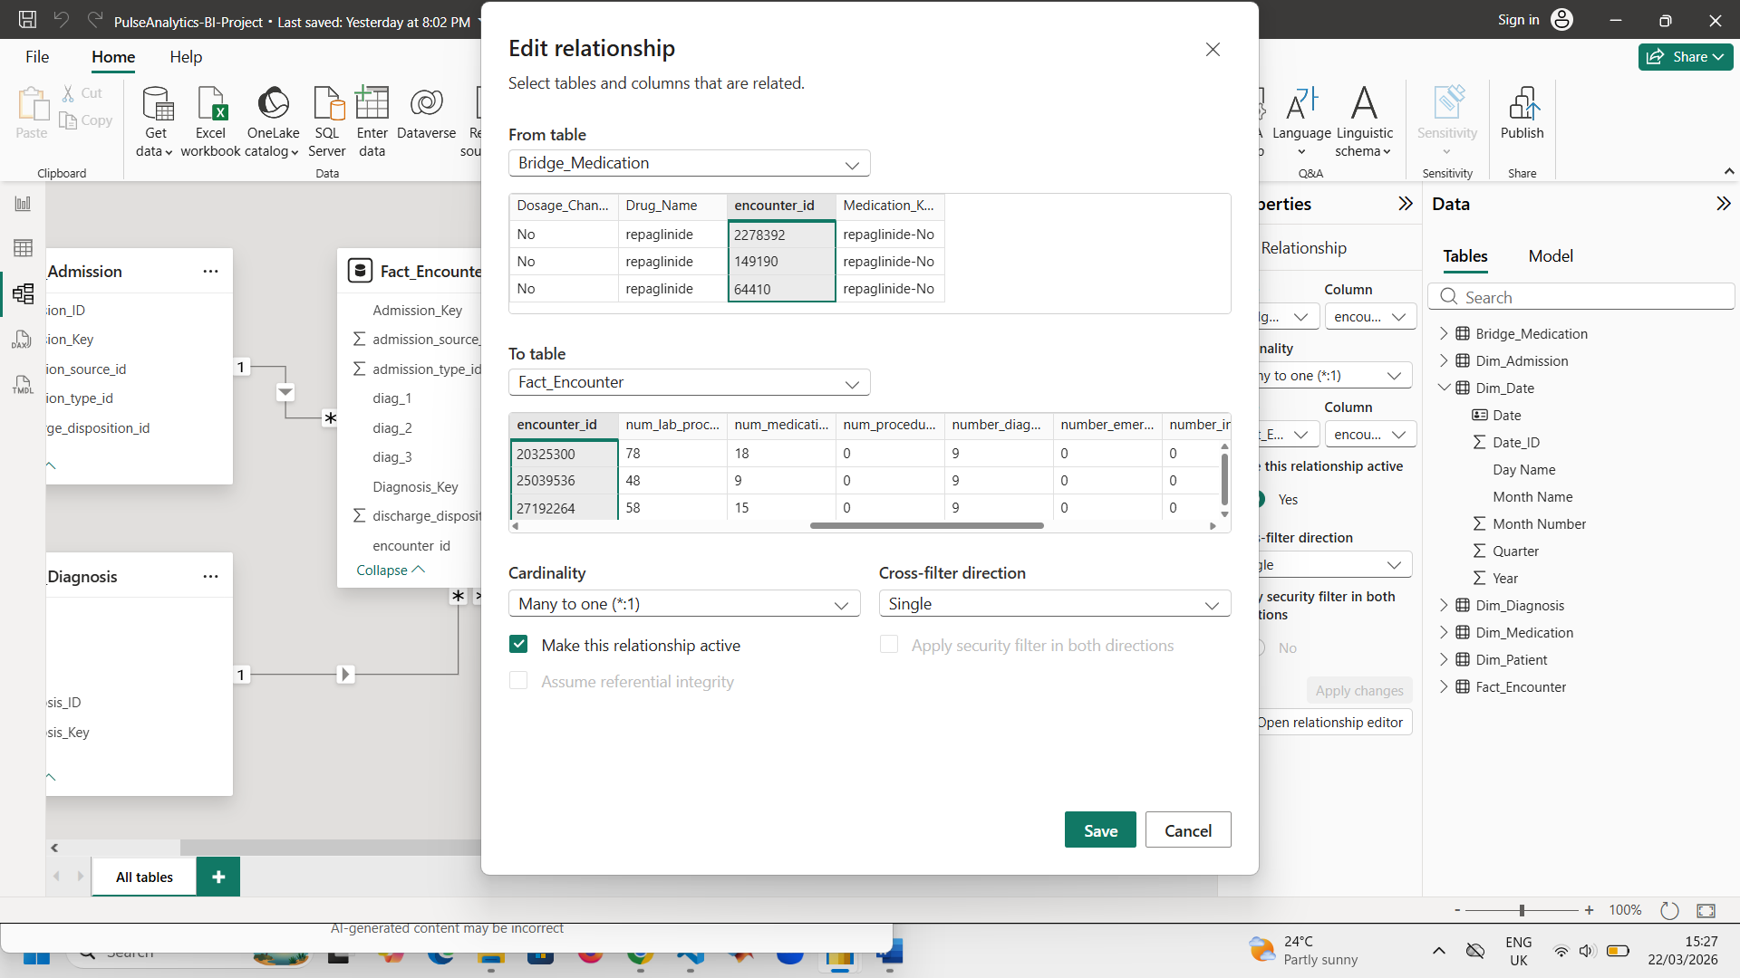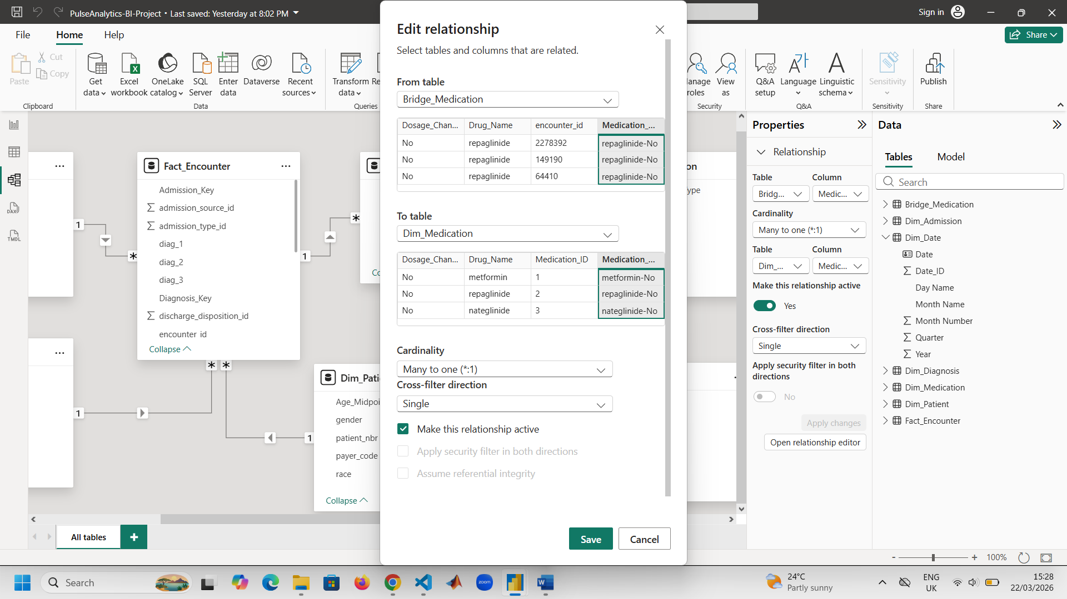
Model View screehshot:
