Data Loading
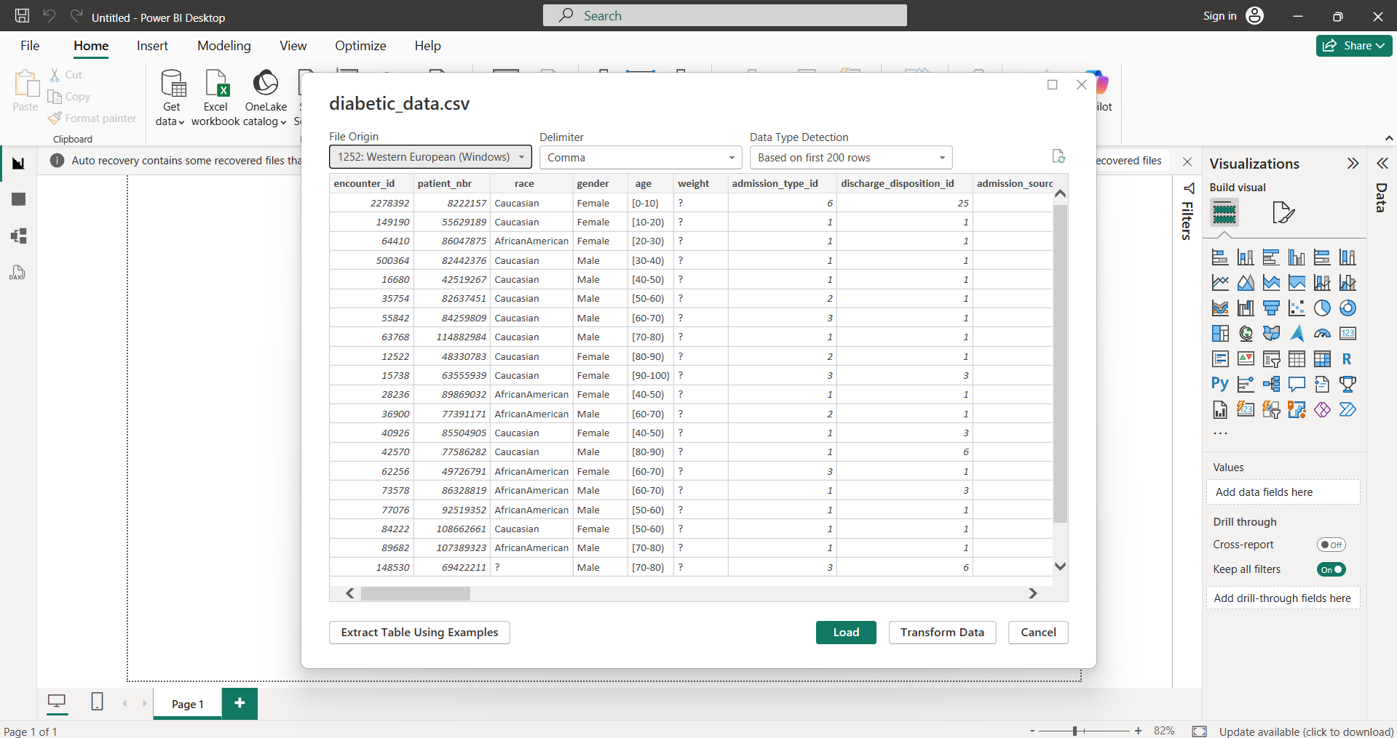
Column 1 & 2: encounter_id and patient_nbr
The Situation: These are our Unique Identifiers. In the raw data, Power BI often imports these as Numbers. However, we will never sum an ID or calculate the average Patient Number. So, we convert these to Text. This prevents Power BI from trying to aggregate them and keeps our data model lean.
Before: After:
