ACCENTURE INNOVATION CHALLENGE 2026 / ROUND 2

TriageLoop.ai
The deadline-aware operating layer for emergency-department waiting rooms
The proposition A changing patient creates a changing clinical deadline. TriageLoop turns that need into an Action Window, checks whether the live queue can act in time, and exposes any shortfall as Clinical Slack—without taking the decision away from the clinician.
  - Detailed business proposal • 22 August 2026
  - Prepared for the Accenture Innovation Challenge jury
Research prototype | Synthetic data | No autonomous diagnosis, treatment, discharge or downgrade

1. Executive decision brief
  - What the jury should remember
A conventional triage category is recorded at arrival; the patient and the queue keep changing. This creates a hidden operational risk: a patient can deteriorate or wait beyond a safe reassessment threshold while the original category still looks unchanged.
One invention, three moves Patient need becomes time. Time is tested against capacity. A clinician closes the loop.
Question | TriageLoop answer
Who needs attention next? | A deadline board re-ranks waiting patients using rules, trajectory, uncertainty and queue feasibility.
By when? | A bounded Dynamic Action Window recommends when review or action is required; it is not a guarantee of safety until that time.
Can the ED meet it? | Clinical Slack = Action Window minus predicted time to action. Negative Slack is an explicit capacity conflict.
What if the model is unsure? | Safe Mode, conservative review and a first-observation suggestion; never autonomous clearance or downgrade.
Who decides? | The clinician accepts, modifies or overrides with a reason; every material transition is hash-audited.

What has been built
- A working nurse-facing web product with a live Deadline Board, patient inspector, surge scenario, deterioration event, clinician decision flow, evidence view and audit ledger.
- A rules-first, calibrated trajectory-risk and uncertainty service over a versioned patient contract, 28 curated scenarios and a seeded 10,000-encounter synthetic generator.
- A paired three-site Queue Twin comparing static, periodic re-triage and deadline-aware policies under baseline and 3× demand.
- A reproducible repository with 73 automated tests, container configuration and explicit degraded-mode behavior.
Lead verified result Across 1,200 paired synthetic verification shifts, Action Window misses under 3× surge fell from 17.7% to 14.1% versus fixed 15-minute periodic re-triage: a 20.5% relative reduction (95% CI 17.4%–23.8%).

2. Problem framing
  - The risk is not only misclassification; it is unmanaged change while waiting

The operational gap
Most triage workflows produce an arrival category or score. That output is useful, but it is a snapshot. Subsequent deterioration, missing data, age-specific presentation and queue congestion create a second problem: deciding when each waiting patient must be reassessed or seen, and whether the department is operationally capable of meeting that need.
Problem-statement complexity | Visible response in the prototype
Ambiguous, overlapping or under-reported symptoms | Repeated observations, data reliability, uncertainty state and conservative review.
Paediatric, adult and geriatric differences | Age-banded synthetic cohorts and age-aware deterministic red-flag gates.
Limited intake / zero history | Strict provenance contract, missingness checks and Safe Mode; no dependency on prior records.
Asymmetric under- and over-triage harm | Recall-constrained operating points and 5:1 / 10:1 / 20:1 sensitivity analysis.
Hospitals vary in size, specialty and staffing | Configurable community, regional and urban-trauma Queue Twin profiles.
Patients deteriorate while waiting | Re-recorded vitals and wait thresholds trigger reassessment and queue recomputation.
Clinician review and auditability | Accept / modify / override with reasons and a recomputed SHA-256 event chain.
Adoption, protection and scaling | One consolidated signal, synthetic-only boundary, role context, adapters and staged rollout.

Target users and decision owners
User | Job to be done | Value delivered
Triage nurse | Maintain awareness across all waiting patients | A ranked, explainable queue with a clear next action and deadline.
Charge nurse | Resolve capacity conflicts and allocate attention | Negative Slack and site-level infeasibility become visible early.
Clinical quality / safety lead | Govern rules, thresholds, audit and monitoring | Versioned logic, traceable decisions and measurable safety gates.
Hospital digital / IT team | Integrate without replacing core systems | FHIR-like JSON, CSV/manual prototype adapters and a thin operational layer.
Hospital leadership | Evaluate operational value without unsupported ROI | A staged pilot with baseline measures, go/no-go gates and attributable value levers.

3. Solution design
  - From risk score to deadline-aware control loop
1 NEED → TIME | 2 TIME → CAPACITY | 3 CLINICIAN → ACTION
Rules, trajectory, data quality and uncertainty produce a bounded Action Window. | Queue Twin projects time to next action; Clinical Slack exposes feasibility. | Nurse reviews the why, accepts/modifies/overrides and creates an auditable event.

Core objects
Object | Definition | Safety boundary
Dynamic Action Window | The recommended maximum time until the next assessment or clinical action, bounded by deterministic category/rule limits. | Never described as ‘safe until’; red flags can force immediate action.
Clinical Slack | Action Window minus predicted time to action. | A negative value exposes a capacity conflict; queue optimization cannot relax clinical need.
Safe Mode | A conservative state for missing, stale, implausible, OOD or ambiguous inputs. | Preserves or raises priority and requests review; the model cannot autonomously downgrade.
Next Best Observation | A first measurement likely to reduce decision uncertainty. | Not a substitute for reassessment; the single-observation gate failed.
Decision receipt | Recommendation, actor, reason and resulting state linked to an event hash chain. | Tamper-evident prototype control, not a claim of production immutability.

Why this is distinct
The contribution is not a claim to have invented AI triage, queues, conformal prediction or active acquisition. The distinction is their safety-oriented recomposition into one waiting-room operating loop.
- Predictive-maintenance idea: translate changing condition into time remaining to intervention.
- Real-time scheduling idea: rank by deadline and laxity, while exposing infeasible demand rather than hiding it.
- Active-acquisition idea: ask for the most decision-useful first observation when uncertainty matters.
- Clinical safety constraints: age-aware rules first, conformal/OOD uncertainty, no autonomous downgrade and clinician authority.

4. Working product
  - A calm clinical instrument, not a generic AI dashboard
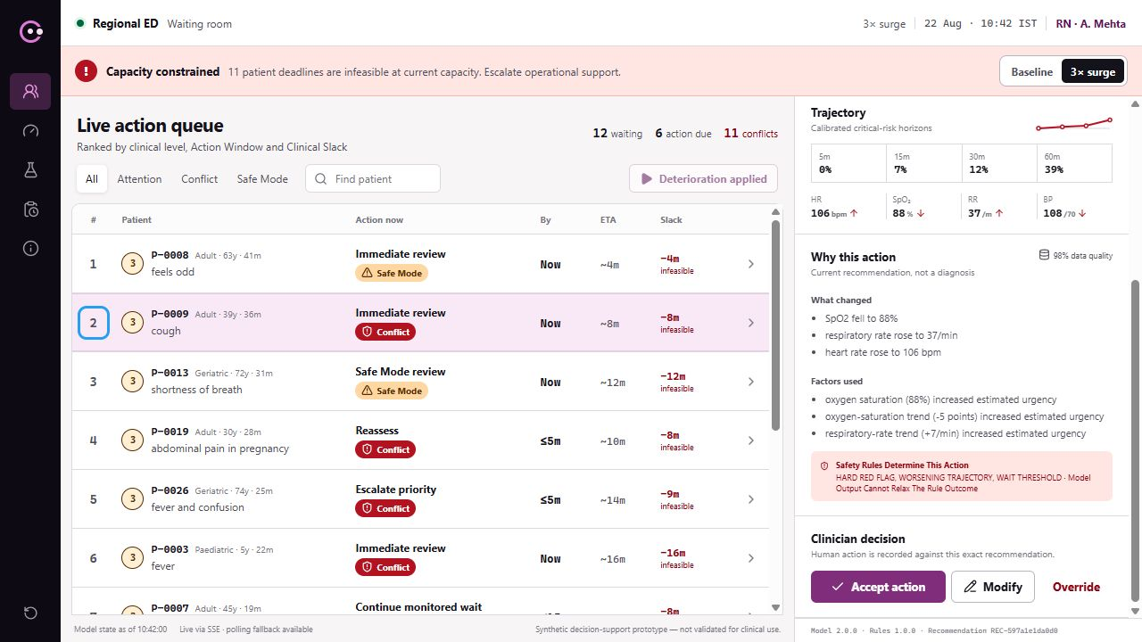
Working Deadline Board after a deterministic deterioration event: P-0009 moves to queue position 2 with an immediate Action Window, ETA of 8 minutes and Clinical Slack of −8 minutes. Synthetic prototype data.

Designed for seconds, not exploration
- Deadline before score: the action, latest recommended time and Clinical Slack lead; probabilities support the decision.
- One patient, one consolidated signal: rules, trajectory, uncertainty and capacity are combined instead of creating multiple alerts.
- Capacity truth remains visible: re-ranking never implies that insufficient capacity has become safe.
- Explanation in the workflow: what changed, reliability, reasons, uncertainty and first observation sit beside the decision.
- Human authority is a first-class state: accept, modify and override are explicit, reasoned and auditable.

4A. Hero journey
  - One deterioration event makes the operating model concrete
A waiting patient’s oxygen saturation falls to 88%, respiratory rate rises to 37 and heart rate rises. Deterministic red-flag logic runs first. The system recomputes the recommendation and live queue, moves the patient to position two, sets the Action Window to ‘now’ and shows that the projected eight-minute response produces −8 minutes of Slack. The clinician sees the reason, acts and records the decision.
Moment | What TriageLoop computes | What becomes visible
Baseline | Current level, trajectory, Action Window, Queue Twin ETA | P-0009 is waiting with positive Slack.
Observation arrives | Freshness, plausibility and age-aware rules run before the model | SpO₂ 88%, RR 37 and rising heart rate are named as the change.
Deadline recomputes | Hard-rule constraint produces an immediate Action Window | The patient moves to queue position two; the recommendation says act now.
Capacity is tested | Queue Twin projects an eight-minute response | Clinical Slack becomes −8 minutes and is labeled a capacity conflict.
Clinician responds | Accept / modify / override is linked to the exact recommendation | A reasoned decision receipt and audit event close the loop.

What the system refuses to do It does not describe the patient as safe, silently move the clinical deadline because the queue is busy, or act without a clinician.

4B. Product evidence appendix
  - The safety, governance and capacity surfaces are implemented—not paper promises
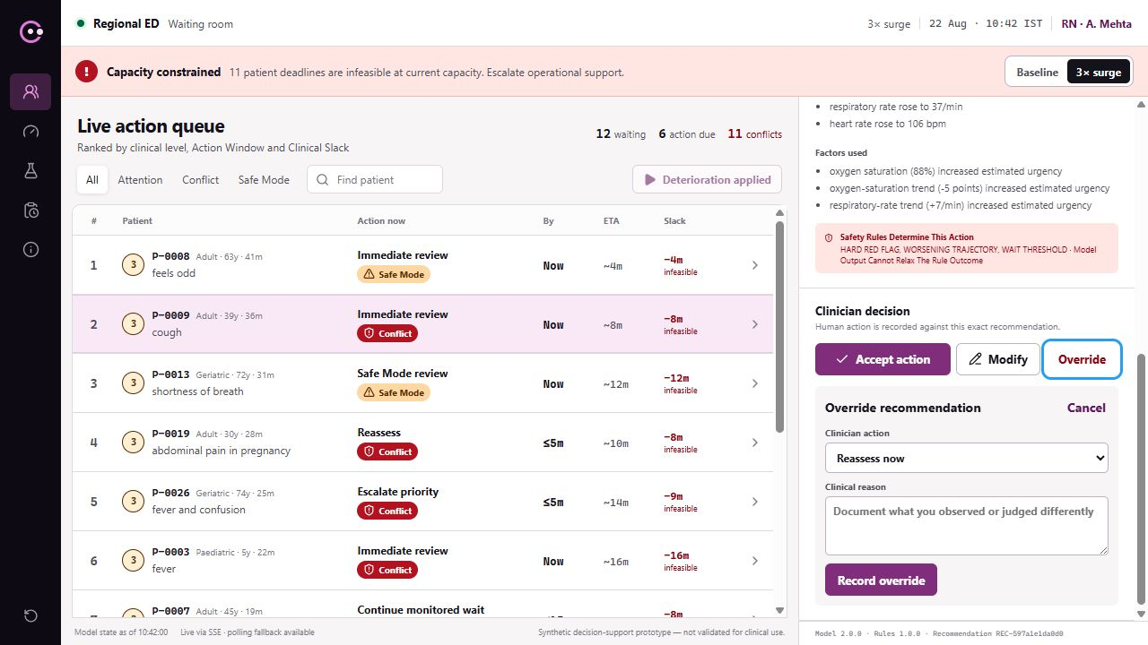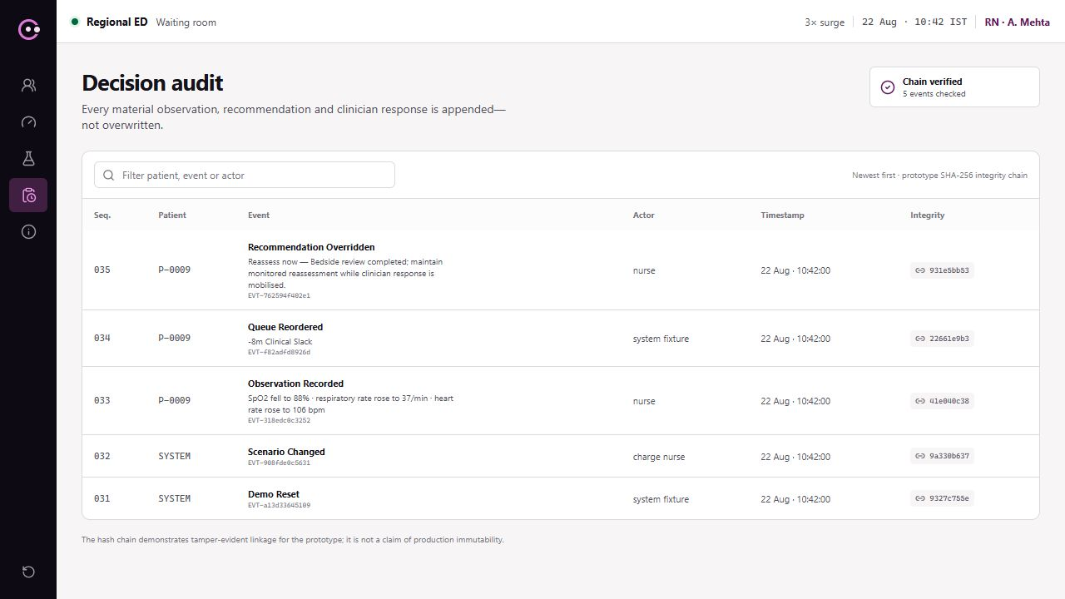
Reasoned clinician override | Recomputed audit chain
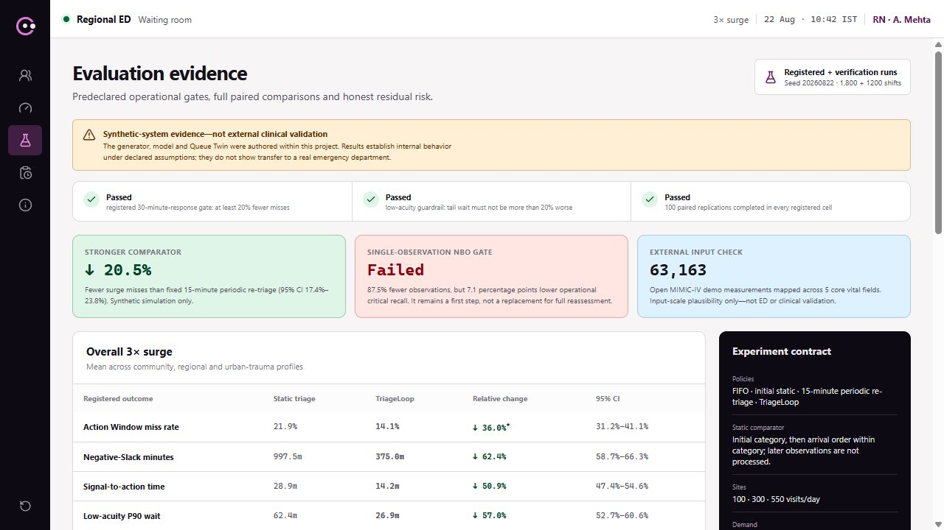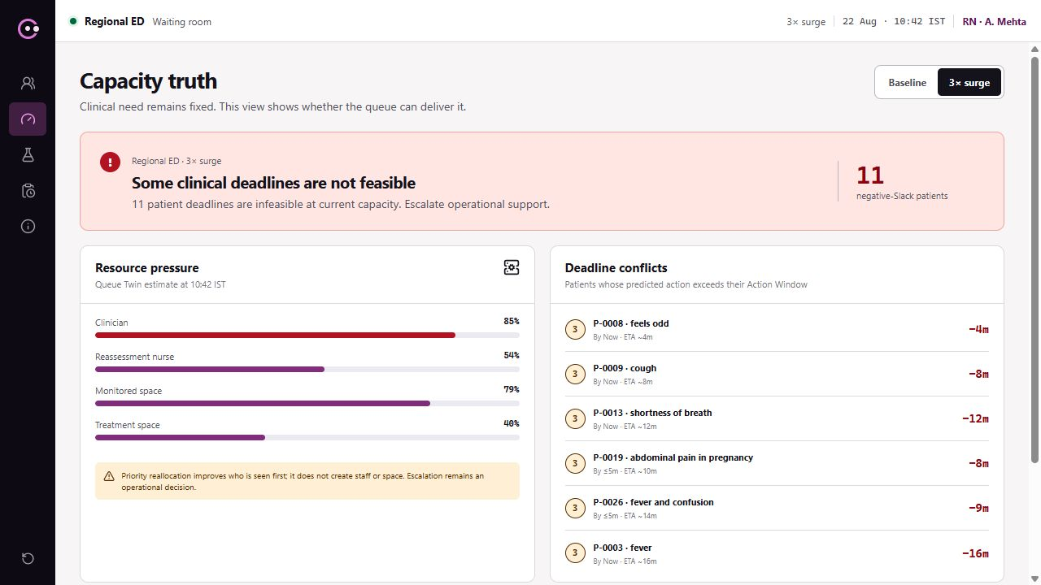
Verification and negative-result evidence | Capacity truth under surge
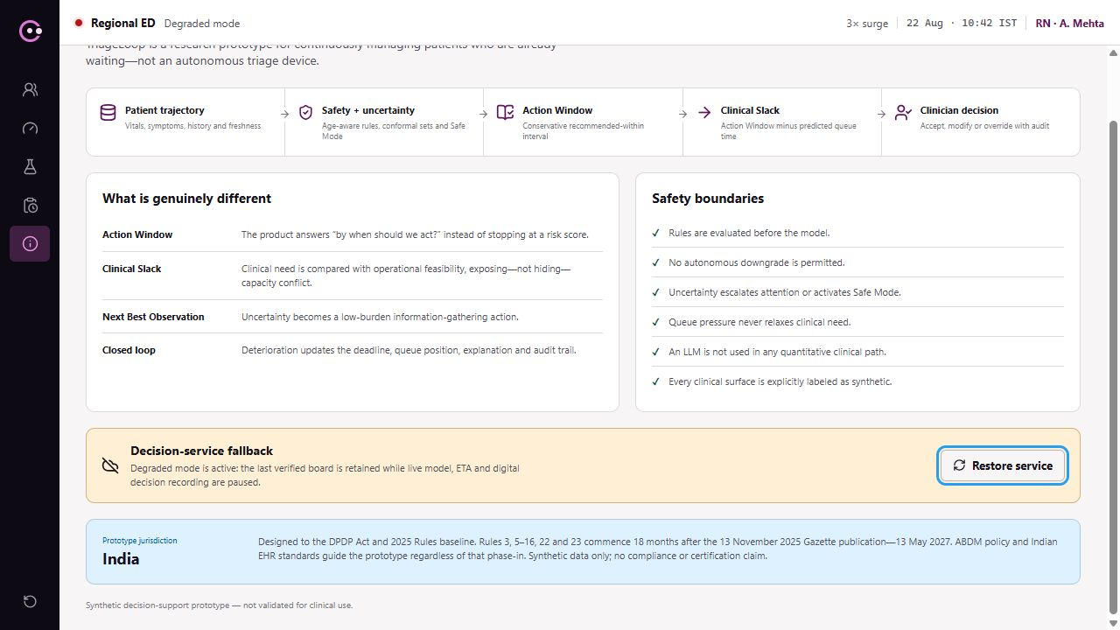
Degraded-mode contract | Corrected live-board explanation
All screens show the deterministic synthetic prototype. The override, audit, evidence, capacity and degraded-mode views are also indexed in submission/visuals/product-surfaces/README.md.

5. Technical architecture
  - Rules first; model bounded; capacity and audit explicit
Layer | Purpose | Prototype implementation
Input and quality | Normalize encounters and repeated observations; preserve provenance and freshness. | Versioned JSON contracts, synthetic manual intake, completeness/reliability and plausibility checks.
Safety gate | Catch age-specific red flags before model inference. | Deterministic paediatric/adult/geriatric rules; no-demotion invariant.
Trajectory engine | Estimate time-horizon deterioration risk from longitudinal data. | Calibrated four-horizon hazard model over selected structured features.
Uncertainty shell | Recognize ambiguity and distribution shift. | Mondrian conformal set, OOD/data-quality signals and Safe Mode.
Action policy | Translate evidence into bounded time to reassessment/action. | Dynamic Action Window with fixed category and hard-rule limits.
Queue Twin | Project time to action under site capacity and demand. | Paired event simulation for community, regional and urban-trauma profiles.
Product/API | Expose queue, patient explanation, decisions, evidence and audit. | Next.js web application + FastAPI service; deterministic demo reset.
Audit | Preserve material state changes and clinician decisions. | Append-only event model with recomputed SHA-256 hash links.

Failure-safe design If the model is unavailable, deterministic rules and fixed category windows remain. If the Queue Twin is unavailable, the clinical requirement remains visible and feasibility becomes ‘unknown.’ If audit persistence fails, state-changing clinician actions are blocked rather than silently lost.

Deployment posture
The prototype is containerized as separate web and API services. A hospital deployment would place the service behind hospital identity, network and observability controls, consume approved messages through a local adapter, and retain only the minimum necessary fields. The core system is an overlay; it does not require replacement of the EHR or ED information system.

6. Data, model and uncertainty
  - Evidence without pretending that synthetic data is clinical validation

Data strategy
Asset | Scale / role | What it supports
Curated edge cases | 28 named patient journeys | Brief coverage: ambiguity, under-reporting, age bands, no history, missingness and deterioration.
Synthetic longitudinal population | 10,000 seeded encounters | Model development and stress evaluation under controlled, reproducible assumptions.
Queue shifts | Three site profiles; baseline and 3× demand | Paired policy comparison and capacity/fairness guardrails.
MIMIC-IV demo plausibility | 63,163 mapped measurements from an open 100-patient hospital/ICU demo | Rules out gross input-scale mismatch only; not ED or performance validation.

Model policy
- Hard clinical red flags run before quantitative inference and cannot be relaxed by the model.
- Risk is calibrated across four time horizons and evaluated with recall constraints because under-triage cost is asymmetric.
- Conformal prediction, OOD and data quality contribute to an explicit uncertainty state.
- The Action Window is bounded by category/rule limits, then passed to the Queue Twin; the model does not directly allocate staff.
What the prototype does not prove It does not establish real-world clinical accuracy, patient benefit, safe staffing, generalizability to another hospital, or legal/regulatory compliance. Those require local retrospective and prospective validation.

7. Verification and evidence
  - Strong comparator, confidence interval, negative result
Verification item | Result | Interpretation
Action Window misses under 3× surge | 17.7% → 14.1%; 20.5% relative reduction; 95% CI 17.4%–23.8% | Versus fixed 15-minute periodic re-triage across 1,200 paired synthetic shifts.
Negative-Slack exposure | 14.0% fewer negative-Slack minutes | Suggests earlier recognition/handling of infeasible waits in the simulation.
Signal-to-action | 15.7% faster | Synthetic operational result, not a clinical outcome.
Low-acuity P90 wait | 14.4% lower | No starvation signal in the registered synthetic comparison.
Automated verification | 73 tests (71-test TL-05 baseline + 2 TL-06.5 regressions), production build and deterministic reruns | Covers contracts, safety gates, scenarios, queue logic, decisions and audit.
Next Best Observation gate | 87.5% fewer observations; −7.1 percentage points operational critical recall | FAILED the fixed ≤2-point loss gate; cannot replace full reassessment.

Credibility by design
The single-observation NBO result is deliberately retained. The product therefore calls it a first measurement suggestion, shows the full reassessment/escalation fallback, and prohibits workload-saving or clearance claims. This is an example of the governance expected for every future model feature: predeclare a safety gate, publish the result and constrain the product when the hypothesis fails.

Comparator discipline
A simpler initial-category static comparator produced a larger 36.0% relative reduction, but it ignores later observations. The proposal therefore leads with fixed 15-minute periodic re-triage. In a TL-06.5 post-verification sensitivity run against that same periodic comparator, the relative reduction was 12.8% at 10 minutes, 13.0% at 20 minutes and 24.1% at 30 minutes; only 30 minutes exceeded 20%. This was not a retroactively registered TL-05 gate, so no universal ‘20%+’ claim is permitted.

8. Safety, governance and privacy
  - A decision-support layer that earns trust before scale
Control | Prototype evidence | Deployment requirement
Human oversight | Accept / modify / override; reasons required for modify/override | Hospital-approved SOP, responsibility mapping and escalation protocol.
No autonomous downgrade | Rules can promote urgency; model cannot suppress a hard red flag | Independent clinical safety review and locked configuration governance.
Uncertainty | Safe Mode for missing/stale/implausible/OOD/ambiguous inputs | Local recalibration, drift thresholds and monitored abstention rate.
Auditability | Recommendation and decision linked in a recomputed hash chain | Durable store, access controls, retention, time synchronization and external audit.
Data minimization | Pseudonymous synthetic-only prototype; direct identifiers rejected | Purpose limitation, minimum necessary fields, approved retention and incident process.
Availability | Rules/category fallback, unknown feasibility state, polling/manual refresh | Downtime procedure, redundancy, monitoring, recovery objectives and drills.

India deployment context
Any deployment would require hospital legal, information-security and clinical-governance review against the Digital Personal Data Protection Act 2023, the phased DPDP Rules 2025, the ABDM Health Data Management Policy and applicable Indian EHR standards. Referencing these instruments is a design baseline—not a declaration of compliance or regulatory status.
Release blockers Autonomous downgrade; suppressed hard red flag; missing uncertainty state; age-band rule leakage; unlogged clinician decision; unsupported impact claim; broken hero journey; or irreproducible evaluation.

9. Business case
  - Measure value before monetizing it

Value hypothesis
Value lever | Pilot measure | Who benefits
Fewer missed reassessment/action windows | Baseline vs shadow-mode Action Window adherence, stratified by acuity and age band | Patients, triage and quality teams
Faster recognition of deterioration | Signal-to-clinician-review time and escalation completion | Triage and charge nurses
Lower manual queue-scanning burden | Time-on-task, duplicate checks and unchanged-alert rate | Nursing workforce
Earlier capacity visibility | Negative-Slack minutes, unresolved capacity conflicts and response actions | Charge nurse and operations
Auditable decisions | Decision-receipt completion, override reasons and integrity checks | Quality, compliance and clinical governance

Economic model
No rupee-saving claim is made at prototype stage. The pilot business case should use locally observed baselines and an attributable-benefit formula:
Annual attributable value (avoidable process time × loaded staff cost) + value of prevented operational exceptions + documentation/audit efficiency − integration, validation, change and operating cost.
Patient harm avoided must not be monetized from synthetic results. It can enter the investment case only after an independently governed clinical evaluation supports the causal link.

Commercial shape
Stage | Commercial posture | Customer commitment
Discovery / retrospective | Fixed-scope validation and workflow mapping | De-identified approved extract, clinical owner, data/IT owner.
Shadow pilot | Site-based pilot fee covering configuration, monitoring and evaluation | No patient-facing autonomy; weekly safety/adoption review.
Controlled production | Annual platform + site/configuration support | Governance approval, integration, operating model and agreed service levels.
Network scale | Multi-site license with shared governance and site-specific calibration | Central model governance plus local clinical ownership.

10. Adoption and integration
  - Fit the clinical workflow; do not ask the workflow to fit the model

Integration levels
Maturity | Input path | TriageLoop behavior
Low | Validated manual or batch CSV input | Limited shadow-mode observation with explicit provenance and staleness.
Medium | Hospital adapter maps approved messages to the versioned contract | Near-real-time board with reconciliation and downtime procedure.
High | Standards-aligned event/API integration and hospital identity | Role-aware, monitored workflow with feedback and governed audit export.

Change-management design
- Start in shadow mode: nurses see no autonomous action and can compare recommendations to standard practice.
- Co-design thresholds, reason language and escalation routes with triage nurses and clinical safety leadership.
- Measure alert burden using both waiting-patient-hour and reassessment-nurse-hour denominators, and suppress unchanged signals.
- Review overrides as learning signals, never as staff-performance scores without separate governance.
- Publish a model/system card, change log, known limitations and rollback path for every release.

Accessibility
The prototype targets WCAG 2.2 AA. Urgency is never encoded by color alone; labels, ordering and text equivalents accompany visual states. The principal workflows support keyboard use, visible focus, zoom/reflow and reduced motion. The zero-finding automated accessibility result applies to this proposal document only; formal nurse usability and assistive-technology testing of the live product remain external validation work.

11. Phased roadmap
  - A 16-week path to a defensible shadow pilot
Phase | Weeks | Deliverables | Exit gate
0. Governance and workflow | 1–2 | Clinical owner, intended use, data map, SOP/downtime map, safety case skeleton | Named accountable owners and approved non-autonomous scope
1. Local retrospective | 3–6 | Data-quality assessment, cohort definitions, local rules review, calibration and subgroup analysis | Predeclared safety/performance gates met or product constrained
2. Technical integration | 5–8 | Adapter, identity, monitoring, audit store, security/privacy review | Test environment replay and failure-mode acceptance
3. Shadow deployment | 9–12 | Nurse board, silent recommendations, usability and alert-burden study | No critical safety blocker; adoption and reliability thresholds met
4. Controlled workflow pilot | 13–16 | Limited decision-support use, weekly governance, rollback and independent analysis | Joint clinical/quality/IT go-no-go for expansion

Pilot success scorecard
- Safety: hard-rule sensitivity, missed-window rate, subgroup parity, Safe Mode/abstention and override review.
- Operations: signal-to-review, negative-Slack resolution, low-acuity wait guardrail and system availability.
- Human factors: comprehension in seconds, alert burden, task completion, trust calibration and override quality.
- Governance: complete decision receipts, incident closure, model/configuration traceability and approved release record.

12. Risks and mitigations
  - Designing for the reasons clinical AI projects fail
Risk | Mitigation | Fallback / stop condition
Synthetic logic appears clinically arbitrary | Publish assumptions; local clinician review; retrospective recalibration | Simplify and disclose; no clinical use until plausibility accepted
Action Window is mistaken for a safety guarantee | Use ‘recommended within,’ show basis and capacity separately | Block release on any ‘safe until’ language
Rare critical cases are under-covered | Recall constraints, conformal uncertainty, stress/subgroup tests | Raise review rate; revert to deterministic rules
Alert burden overwhelms nurses | Consolidated signal, unchanged suppression and two-denominator alert budget | Current synthetic surge range is 0.86–1.12 alerts/waiting-patient-hour and 2.20–5.56 alerts/reassessment-nurse-hour; Community is the warning case
Queue policy starves lower-acuity patients | Absolute deadline aging and low-acuity P90 guardrail | Add fairness constraint and rerun evaluation
Integration or service fails | Thin adapter, versioned contract and explicit degraded states | Rules/category workflow; feasibility unknown; local downtime SOP
Privacy/regulatory language becomes outdated | Official sources, minimum necessary data and scheduled legal review | Pause deployment claim and re-verify
Metrics are selectively reported | Predeclared protocols, paired seeds, confidence intervals and negative results | Do not release unsupported claim

13. Proposal to the jury
  - Why TriageLoop deserves to advance

The innovation
TriageLoop changes the unit of triage from a static category to an operational promise that can be checked: what must happen, by when, and whether the current ED can deliver it. The system is valuable precisely when capacity is constrained because it refuses to treat ranking as a substitute for capacity.

The proof
The concept is implemented as a working product with reproducible synthetic evidence, a stronger comparator, deterministic safety behavior, clinician control and a visible negative result that changes the product boundary. It covers the problem statement from ambiguous input and age-specific risk through surge, integration, adoption, privacy and auditability.

The next responsible step
Advance TriageLoop into a jointly governed local retrospective and shadow-mode evaluation. The objective is not to deploy an unvalidated model; it is to test whether deadline-aware triage can measurably improve waiting-room situational awareness and Action Window adherence without increasing unsafe misses, alert burden or inequity.
Closing line When clinical need and operational reality diverge, TriageLoop makes the gap visible early enough for a clinician and charge nurse to act.

Appendix A. Full problem-statement coverage
  - Every stated complexity has a visible or verified response
Coverage group | Implemented evidence
Clinical complexity | Ambiguity, under-reporting, age bands, missing data, zero history, repeated vitals and safe-wait triggers.
Modeling and uncertainty | Rules-first hybrid path, calibrated horizon risk, conformal/OOD state, asymmetric-cost analysis and explicit confidence.
Operations | 100/300/550 visits/day profiles, baseline/3× demand, static/periodic/dynamic comparators and low-acuity guardrail.
Human authority | Seconds-oriented explanation, accept/modify/override, reason receipt and audit integrity.
Integration | FHIR-like JSON, CSV/manual prototype intake, adapters, container deployment and degraded modes.
Adoption and protection | Alert budget, workflow-first UI, synthetic/pseudonymous boundary, India governance baseline and staged rollout.
Evaluation | 28 curated cases, 1,200 paired shifts, confidence intervals, 73 tests, NBO failure and external plausibility limitation.

Appendix B. Source and evidence notes
  - External references support rationale; local artifacts support prototype claims
Source | Use / location
Official competition brief | Accenture Innovation Challenge 2026 Round 2 Patient Triage problem statement, supplied PDF, pp. 3–4 and 7.
Official submission page | Unstop, Accenture Innovation Challenge 2026: https://unstop.com/competitions/accenture-innovation-challenge-2026-accenture-1714566/amp
Repeated vital signs | Churpek et al., repeated vital signs and deterioration recognition: https://pubmed.ncbi.nlm.nih.gov/30005671/
Dynamic risk modeling | Time-varying deterioration modeling reference: https://pubmed.ncbi.nlm.nih.gov/41827109/
Prioritisation precedent | Prognosis-informed patient prioritisation: https://pubmed.ncbi.nlm.nih.gov/37318826/
Deadline scheduling | UC Berkeley real-time scheduling notes: https://people.eecs.berkeley.edu/~kubitron/courses/cs262a-F19/lectures/lec11-Scheduling.pdf
Predictive maintenance | NASA prognostics/RUL reference: https://ntrs.nasa.gov/api/citations/20140010623/downloads/20140010623.pdf?attachment=true
Active feature acquisition | IBM Research: https://research.ibm.com/projects/active-feature-acquisition
Age-aware triage | WHO triage tools: https://www.who.int/tools/triage
Conformal decision support | ‘I don't know’: an uncertainty-aware ED-triage model using conformal prediction (2025), PMID 40318497: https://pubmed.ncbi.nlm.nih.gov/40318497/
India governance | DPDP Act 2023: https://www.indiacode.nic.in/handle/123456789/22037?col=123456789%2F1362&view_type=search
India governance | DPDP Rules 2025: https://www.meity.gov.in/documents/act-and-policies/digital-personal-data-protection-rules-2025-gDOxUjMtQWa?pageTitle=Digital-Personal-Data-Protection-Rules-2025.pdf
Health-data policy | ABDM Health Data Management Policy: https://abdm.gov.in/static/media/health_management_policy_bac9429a79.80f74bc3e039c00acd4f.pdf
EHR standards | MoHFW EHR Standards for India (2016): https://www.mohfw.gov.in/sites/default/files/EMR-EHR_Standards_for_India_as_notified_by_MOHFW_2016_0.pdf
External plausibility | PhysioNet MIMIC-IV demo 2.2: https://physionet.org/content/mimic-iv-demo/2.2/
Local verification evidence | docs/tl-05-verification-report.md, artifacts/tl-05-periodic-retriage.json, artifacts/tl-05-nbo-evaluation.json, test suite and working product.

All numerical performance claims in this proposal refer to registered synthetic experiments unless explicitly labeled otherwise. Accessed 22 August 2026.

