Aivancity School for technologies business and society.

COMPREHENSIVE SUMMARY OF THE SPIDER METHODS
Hermes NDJENG

Abstract

SPIDER (Stochastic Path Integrated Differential Estimator) is a revolutionary method uses to reckon non-convex problems with significantly reduced computational cost. Associated with the famous concept of normalized gradient descent gradients, SPIDER becomes SPIDER-SFO. We will discuss about how it works in this paper.

Introduction
We study the nonconvex optimization problems:
Minimize x ∈ R f (x) ≡ E [F(x; ζ)] (*)
Optimization problems of this form contains many large-scale learning tasks like PCA (Principal Component Analysis), estimation of graphics models and training deep neural networks.
When ζ take only finite values, (*) can be further reduced to:
Minimise x ∈ R f (x) = 1/n ∑ fi(x) (**)
The paper studies both finite-sum case (n is finite) and online case (n is ∞).
The gradients costs to find an ε-first-order stationary point (ε-FSP) that satisfies k∇f (x) ≤ ε for nonconvex function f (x) are already been establish for some methods:
- GD/ NGD/ SGD: nε −2 ∧ ε −4
- SVRG / SCSG: (n + n 2/3 ε −2 ) ∧ ε −3.333
Where a ∧ b := min(a, b).
Question: can the gradient cost be further reduced?

Stochastic Path-Integrated Differential Estimator: Core idea
Let us first establish the predicates to clearly state the theorem.
Observe a sequence X = {x1,…,xk} (often moves continuously), goal is to dynamically track, for an arbitrary deterministic vector quantity Q(x), Q(xk) for k= 0,1, …, k. Qe is hold for Q tilde
• Initial estimate Qe (x 0 ) ≈ Q(x 0 )
• Unbiased estimate ξk (x0:k ) of Q(xk ) − Q(x k−1 ) such that for each k = 1, . . . , K
E [ξk (x0:k ) | x0:k ] = Q(x k ) − Q(x k−1 )
• Integrate (in the discrete sense) the stochastic differential estimate as
Qe(xb0:K ) := Qe(x 0 ) + ∑ξk (x0:k )
• Call estimator Qe(x0:K ) the Stochastic Path-Integrated Differential EstimatoR, or Spider for brevity
• In this talk our Q(x) is picked as ∇f (x) (or f (x))

To bound the second moment of the error for our estimator ||Qe(x 0:K ) − Q(x K )||. Let us establish this first proposition:
E||Qe(x0:K ) − Q(x K )|| 2
= E||Qe(x 0 ) − Q(x 0 )|| 2 + ∑ k=1 E||ξk (x0:k ) − (Q(x k ) − Q(x k−1 ))||
Proposition 1 can be easily concluded using the property of square-integrable martingales.

Finding FSP, Finite-Sum Case, Expectation:
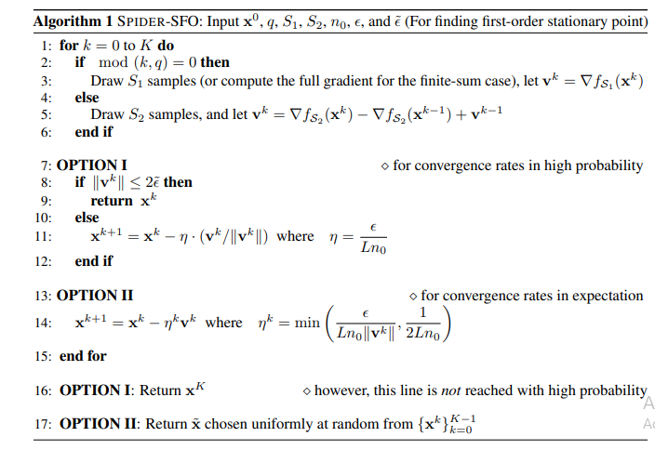
Theorem (First-order Stationary Point, finite-sum setting):
Algorithm 1 outputs in K = (4L∆n 1/2 )є −2 + 1 iterations E [||∇f (xe)||] ≤ 5є. The gradient cost upper bound is
n + (12L∆n 1/2 )є −2 = Oe(n + n 1/2 є −2 )
• The recursive update equation of v k
v k = ∇fi(x k ) − ∇fi(x k−1 ) + v k−1 is a Spider for ∇f (x k ) [Seeing ξk (x0:k ) = ∇fi(x k ) − ∇fi(x k−1 ) as in Qe(xb0:K ) := Qe(xb 0 ) + PK k=1 ξk (xb0:k ) of Spider]
• Compared with SVRG update rule where
v 0 = ∇f (x 0 ) = 1 n Pn i=1 ∇fi(x 0 ) and
v k = ∇fi(x k ) − ∇fi(x 0 ) + v 0 Satisfying unbiasedness E[v k | Fk−1] = ∇f (x k )
• Spider-SFO drops unbiasedness in exchange for a sharper estimate!
Assumption:
- ∆ := f (x 0 ) − f (x ∗ ) < ∞ where x ∗ is a global minimizer of f (x)
- (ii) The component function fi(x) has an averaged L-Lipschitz gradient Ek∇fi(x) − ∇fi(y)k 2 ≤ L 2 kx − yk 2

Under the above averaged L-Lipschitz gradient assumption, Spider-SFO matches the lower bound modified to the finite-sum setting:

Theorem (Lower bound for SFO for the finite-sum setting)
For any L > 0, ∆ > 0, and 2 ≤ n ≤ O(∆2 L 2 · ¤ −4), for any algorithm F satisfying

x k = F k−1
there exists a dimension d = O(∆2 L 2 · nє −4), and a function f satisfies the above Assumption, such that in order to find a point x for which || ∇f (x) || ≤ є, F must cost at least Ω ( L∆ · n 1/2 є −2) stochastic gradient accesses.

Theorem (First-Order Stationary Point, finite-sum setting):

Algorithm 1 outputs in K = (4L∆n 1/2 )є −2 iterations E [||∇f (xe)||] ≤ 5є with probability ≥ 1 − δ. The gradient cost upper bound is n + (12L∆n 1/2 )є −2 = Oe(n + n 1/2 є −2 )
Applying Proposition 1 gives us the following lemma, which indicates that Spider maintains an error of ||v k − ∇f (x k )|| = O(є) in second moment:
Lemma:
Let k0 = bk/qc · q. Then under the Assumption, Algorithm 1 satisfies E h ||v k − ∇f (x k )|| 2 | x0:k0 i ≤ є 2
Standard descent analysis for our algorithm gives a second lemma
Lemma:
E h f (x k+1) − f (x k ) i ≤ − ¤ 4Ln1/2 E v k + 3¤ 2 4n 1/2L

SARAH VS SPIDER-SFO:
Both adopt the recursive stochastic gradient update framework, and SPIDER-SFO can be viewed as a variant of SARAH with normalization. However, Difference from the works SARAH are in two aspects:
(i) The analysis techniques are totally different from the version of SARAH proposed by Nguyen et al. (2017a,b). SARAH proposed can be seen as a variant of gradient descent, while ours hybrids the Spider with normalized gradient descent

- Nguyen et al. (2017a,b) adopt a large stepsize setting (in fact their goal was to design a memory-saving variant of SAGA), while the SPIDER algorithms adopt a small stepsize that is proportional to ε
- The proposed Spider technique is a much more general variance-reduced estimation method for many quantities (not limited to gradients) and can be flexibly applied to numerous problems, e.g. stochastic zeroth-order method It remains open whether a modification of SARAH can achieve a desirable gradient cost that matches (or surpasses) the cost of Spider-SFO

Summary:
- Proposed Spider technique for tracking:
• Avoidance of excessive access of oracles and reduction of time complexity
• Potential application in many stochastic estimation problems
- Proposed Spider-SFO and Spider-SFO+ algorithms for first-order non-convex optimization
• Achieves Oe(ε −3 ) rate for finding ε-FSP and (ε, √ρε)-SSP
• Convergence rate in both high-probability and expectation
• Proved that Spider-SFO matches the lower bound in the finite-sum case [Carmon et al 2017]
- Proposed Spider-SZO algorithm for zero-order non-convex optimization
• Achieves an improved rate of O(dε −3 )
• More done: SFO mini-batches in inner loops
• To be done: proximal case SpiderBoost, lower bounds for the online case
referenced in the text, enclose the citation number in square brackets, for example [4]. Where appropriate, include the name(s) of editors of referenced books.

