Impact Analysis Tool How To

# Purpose

This document describes how the impact analysis tool (short: IA tool) can be used to analyse the impact of a requirement. At the moment this document is described from the view of the SWSD who owns the Issue SW.

# Indented audience

The indented audience for this document are the employees who have Issues SW or Issue FD assigned and also responsibles for Requirements Engineering within a department.

# Prerequisites

Before you read the how to or the documentation chapter please make sure that you understand the below described principles.

## Requirements Based (RBD) vs. Change Based Development (CBD)

ASpice projects have to work according to the “Requirements based Development” processes defined in the Process Library 5.0. In either case you will have to perform the Impact Analysis, but the impact analysis tool will ask you different questions based whether you need RBD or CBD. *If you work according to CBD you will not need to answer questions related to System Architecture. This means that you do not need to identify System or Infrastructure Units.*

## System units vs. Infrastructure units

***System units*** are system elements which functionality can be changed or extended by a requirement. In the standard case these are lowest level elements from the Powertrain System Architecture (PTSA), also known as System Functionalities (SF).

***Infrastructure units (IS)*** are system elements which can be used by other system elements to implement a certain functionality. If the usage also includes a configuration or change in SW for the corresponding IS, then it is necessary to make an Impact Analysis for this infrastructure unit. ***Examples are****: ComVeh, ComDia, DeLib, DSM, SwSharing, EEPROM, etc.*

Most infrastructure units do also implement functional requirements. If a functional requirement of a IS needs to be changed or implemented, than it has to be treated as a normal system unit.

## Initial IA vs. System Unit IA vs. Infrastructure IA

* The ***Initial IA*** contains basic questions which have to be filled out in any case.
* For each ***system element*** you will need to fill out additional questions. The questions differ based on the type of system element. This means that there are different questions for System Units and Infrastructure Units.

# How to and workflow

In this chapter you can find a short how to for the impact analysis tool (IA tool). If you are new to the IA tool please ***read the chapter 5 first***, because it contains a more detailed documentation about the features of the IA tool.

**Storyline.**

A project manager, the CCB or your team leader assigns you (the SWSD) a new Issue SW because of a customer or internal request. The first thing you need to do with new Issues is the analysis of the impact the issue has on the system, projects, the time schedule, your team, etc.Therefore you open the IA tool by clicking on the link in the internal comment.

1. **Login.** Enter your credentials and the IssueSW-ID and click on the button below.

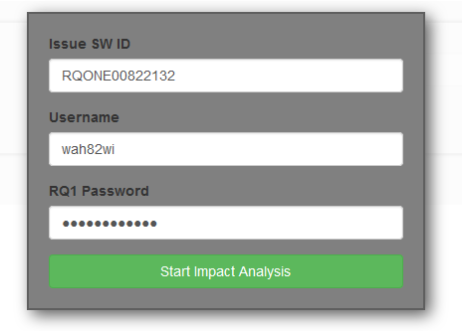

1. Optional: Answer the question if you want to work accordingly to requirements based development (RBD). This question is only asked if your Issue is not connected to an RBD/ASpice project.

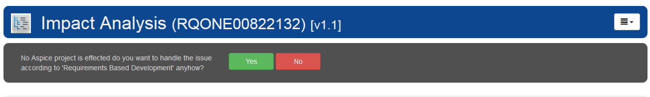

1. **Start answering the “Initial Impact Analysis” questions.**

After you have answered a question you will see the action you have to execute. Also give comments if necessary. If you want more information about a question (risks, examples, actions, how to, etc.) you can click on the “More information” link. You can always look up the previous state of the questions and comments be clicking on the “show log” link.

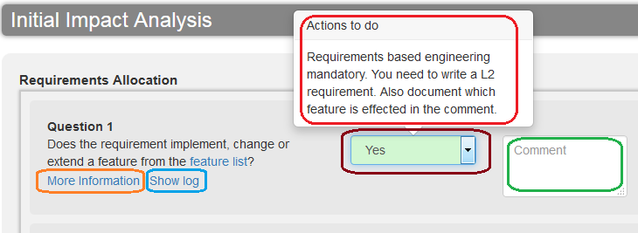

1. **Save/upload the Impact Analysis.**

Once you have answered all the Initial Impact Analysis questions you will get a green notification in the right top corner and the status of the “Initial IA page” is switching from “Open” or “Doing” to “Done”.

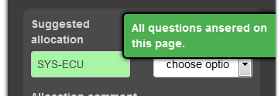 

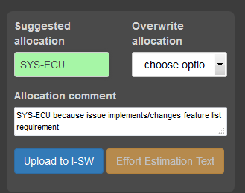Now it’s time to store your results and to set the allocation/allocation comment. The IA Tool automatically pre-suggests both. Check the values of the two fields. If there is something wrong or information missing you can overwrite the allocation and the comment. Once you are done hit the “upload to I-SW” button. This will upload the IA as JSON file to the Issue SW as attachment.

1. **Create the Issue FDs and forward them**

In the Initial IA you have identified the system elements (system units and infrastructure units) which need to be changed/configured. Each change need to be planned and implemented. This means that you need to create corresponding Issue FDs to trigger this process. Depending on your departments strategy you will create one Issue FD per SF or one Issue FD per affected SW-Unit (BC). Either way, all the identified system elements have to be covered.

1. 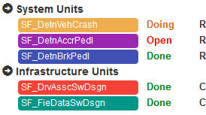**Fill out the Impact Analysis for the System elements**

The owners of the Issue FDs are responsible for filling out the System Element Impact analysis pages. You can access those by simply clicking on the System Elements.

The current status of the different pages can be seen next to the system elements.

After the owner of the Issue FD has filled out the questions he/she can upload the Impact Analysis to the Issue SW by clicking on the “Upload to I-SW” button. If he/she changed the allocation or allocation comment it will be overwritten.

* While the owner of the Issue FD is responsible for the System Element IA, he or she might not be the one who is actually doing it.
* If a risk/problem has been identified the corresponding action should be executed and the owner of the Issue SW should be notified.

1. **Check if Impact Analysis is finished**

The responsible for the Issue SW has to make sure that the Impact Analysis has been filled out by all the effected Issue FD owners. This should be the case before development is initiated.

Before the issue is closed this has to be checked.

In case you need a more detailed description of the IA tool features, please have a look at chapter 5 of this document.

# Documentation

Performing the impact analysis with the IA tool should be quite intuitive, but depends on how your department has customized the tool. Anyhow, there for the purpose of completeness this document describes how the standard impact analysis can be done. If your department is deviating from the standard IA, then please use the departments How To.

1. **Opening the Impact Analysis Tool**

The impact analysis tool can be opened in 3 different ways:

* ***From the Issue SW***

Simply click on the link and log yourself in.

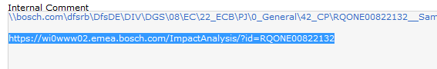

* ***From the IPE Tool***

Not yet implemented.

* ***From a bookmark***

Store the following link as a bookmark:

<https://wi0www02.emea.bosch.com/ImpactAnalysis>

In this case you will need to remember the IssueSW ID.

1. **Requirements Based vs. Change Based Development**

Once you’ve entered an Issue SW ID and your credentials and you’ve clicked on the “Start Impact Analysis” button, the tool will perform the following steps:

1. Verify your credentials
2. Analyse if the Issue is connected to a project which needs “requirements based development” (RBD). This is done by checking if there exists an IRM which has a mapped Release which belongs to a Project which has the following tag set to true: ***<ReqBasedDev>true</ReqBasedDev>***
3. Load department specific content and scripts (the ASpice or RE responsible of your department has pre-configured the Impact Analysis tool for you)
4. Load the Impact Analysis questions

If your issue **is** **not** linked to any project which needs RBD then you need to answer the following questions:



Depending on your answer you will either get the questions for RBD or the questions for “changed based development” (CBD).

If the issue is linked to a RBD-project, then you won’t see this question and will immediately see the RBD-questions.

1. **The graphical user interface and structure of questions**

e

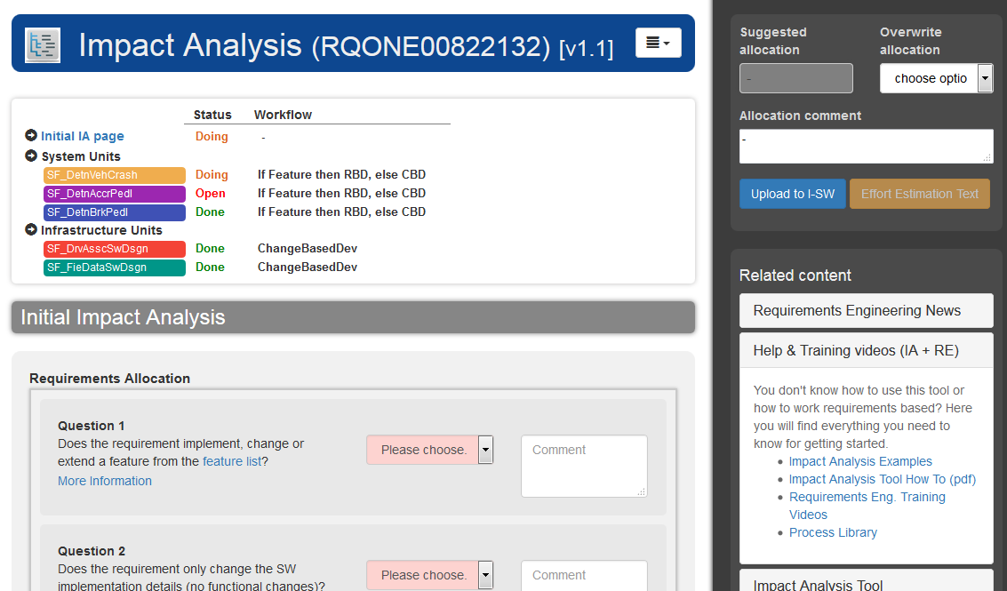

c

d

b

a

The IA-Tool consists of 5 main elements:

1. The blue header which contains the Issue ID, the current version of the Impact analysis and the menu.
2. Below the blue header there is the overview section. In this you will find the summary of the impact analysis. You can see which parts of the IA are already done and which ones are open. Also you can see the workflow which should be used for the system and infrastructure units (the difference between those two has been described in chapter 3).
3. Questions for the Initial Impact Analysis. Shows questions which have to be answered by the owner of the Issue SW.
4. Questions for the System Element Analysis. Shows questions for the system elements which have to be answered by the owners of the Issue FDs. The questions are shown if you click on a system element (like “SF_DetnVehCrash”).
5. Sidebar. Contains the allocation and upload to Issue SW options and also a section for help and related content.
6. 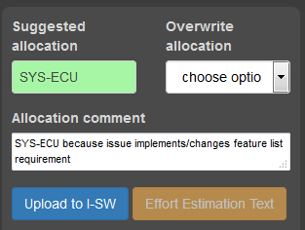**Initial Impact Analysis and automatic Allocation**

Based on the questions with type “Requirements Allocation” an automatic suggestion for the allocation and allocation comment is done by the IA tool. You can overwrite the allocation suggestion, but you need to give a comment why you use another approach.

1. **System unit Impact Analysis**

***System units*** are system elements which functionality can be changed or extended by a requirement. In the standard case these are lowest level elements from the Powertrain System Architecture (PTSA), also known as System Functionalities (SF).

In case there is one Issue FD for multiple Infrastructure Units: While the owner of the Issue FD is responsible for answering the questions for the system units, the questions can also be answered by the responsibles for the System elements.

1. **Infrastructure Unit Impact Analysis**

***Infrastructure units (IS)*** are system elements which can be used by other system elements to implement a certain functionality. If the usage also includes a configuration or change in SW for the corresponding IS, then it is necessary to make an Impact Analysis for this infrastructure unit. ***Examples are****: ComVeh, ComDia, DeLib, DSM, SwSharing, EEPROM, etc.*

Most infrastructure units do also implement functional requirements. If a functional requirement of a IS needs to be changed or implemented, than it has to be treated as a normal system unit.

In case there is one Issue FD for multiple Infrastructure Units: While the owner of the Issue FD is responsible for answering the questions for the system units, the questions can also be answered by the responsibles for the System elements.

1. **The menu**

The menu offers different additional functionalities like printing, saving to file or showing the global log.

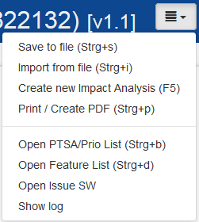

1. **Logging**

Each change on the answer of a question or the comment is logged. The whole log is stored within the json file which is uploaded to the Issue SW or stored locally. The tool offers two views for the log:

* ***Global log:*** Shows all activities for a given Issue. Available via the

menu.

* ***Question log:*** Shows activities for a certain question. Available as link

for every questions with a history.

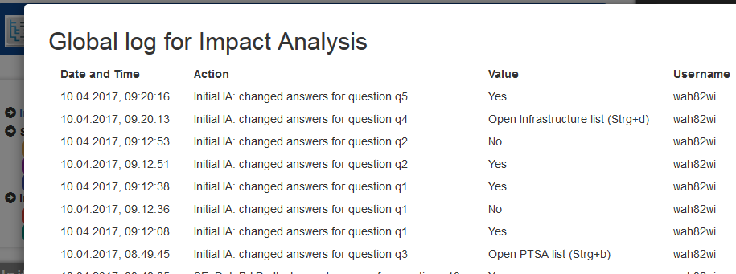

1. **Printing**

You can print the whole impact analysis (all pages) by pressing Strg+p or choosing the corresponding menu item. The IA tool will create an extra print view for this purpose.

1. **Related content**

The section related content in the sidebar offers links related to the Impact Analysis tool and to Requirements Engineering in general. This includes the IA Tool help, documentation and examples.

# Help

In case you get stuck or if you can’t follow the instructions above, you should contact the responsible for Requirements Engineering or the ASPICE coordinator in your department.

# Abbreviations

BC Base component

IA Impact Analysis

CBD Change Based Development

RBD Requirements Based Development

# Bugs, changes and improvement

In case you

* find a bug,
* have improvement suggestions,
* want to build a tool on top of or based on the impact analysis tool

you can contact the developer of the IA tool: [hermann.wagner2@bosch.com](mailto:hermann.wagner2@bosch.com).