LUNA'S PHARMACY
POS & Inventory
Management System
Use Case Diagram & Use Case Descriptions
Database Systems Project
October 24, 2026
A companion document to the ERD and normalization report

1. Introduction
This document describes the use case model for Luna's Pharmacy, a web-based point-of-sale (POS) and inventory management system. The model answers two questions: who uses the system, and what each person must be able to accomplish. It complements the ERD and normalization report by showing how the normalized data is created, read, and protected in everyday work.
The model covers the features that are implemented in the application: signing in, browsing the catalog, completing a sale, viewing a receipt, applying a discount, maintaining products, updating stock (one item or many), managing categories, reading the stock log, generating sales reports, exporting a report to CSV, and managing staff accounts.
The diagram uses the UML conventions that matter for this project: actors outside the system boundary, use cases inside it, solid association lines, and dashed «include» and «extend» relationships. The descriptions in Section 4 follow the actual request flow and validation rules in the server code, not an idealized version of the app.
Scope note. The use case model describes user-visible goals. It does not model internal details such as SQL joins, bcrypt hashing, or cookie signing as separate use cases; those are recorded as business rules inside the relevant use case.

2. Actors
Two human actors interact with the system. Both authenticate through the same login form; the role stored on the account decides which pages and API routes are available.
ACTOR | DESCRIPTION | MAIN USE CASES
Cashier | Front-of-shop staff. Signs in, looks up products, builds a cart, optionally applies a discount, completes the sale, and shows the receipt. | Log In; Browse / Search Products; Complete Sale; View Receipt; Apply Discount (extension).
Admin | Owner or manager. Performs every cashier task and also maintains the catalog, stock, categories, reports, stock log, and staff accounts. | All cashier use cases plus Manage Products; Update Stock; Bulk Update Inventory; Maintain Categories; View Stock Log; Generate Sales Reports; Export Report to CSV; Manage Accounts.
Admin inheritance. The Admin can perform every Cashier use case. To keep the diagram readable, the Admin is connected only to the use cases that are specific to the admin role; the shared cashier goals are shown once. This is a presentation choice, not a restriction in the application.
Enforcement. The browser hides admin-only pages, but the server does not trust the browser. requireAuth validates the signed session cookie, and requireAdmin guards the admin routes. The cashier who owns a sale is taken from the session (session.uid), never from the request body.

3. Use Case Diagram
Figure 1 shows the system boundary, the two actors, the 15 use cases, and the include/extend relationships. The colours group the use cases by area: indigo for the shared sales flow, green for internal stock operations, and amber for admin-only inventory and reporting goals.
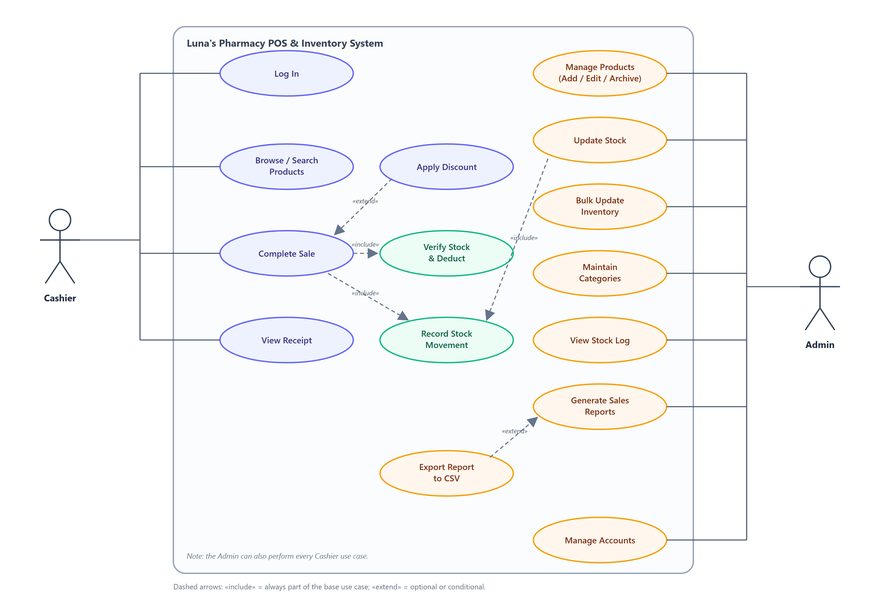
Figure 1. Use case diagram for Luna's Pharmacy POS & Inventory Management System.
NOTATION | MEANING IN THIS DIAGRAM
Solid line | Association: the actor can initiate or take part in the use case.
Dashed arrow «include» | The base use case always performs the included behaviour as part of its normal flow. Example: Complete Sale always verifies stock and records a movement.
Dashed arrow «extend» | The extending use case adds optional or conditional behaviour to the base use case. Example: a discount is applied only when the cashier enters one.
System boundary | The rounded rectangle: everything inside is part of Luna's Pharmacy; the actors are outside it.

4. Detailed Use Case Descriptions
This section describes the four use cases that carry the most business risk: authentication, checkout, stock correction, and reporting. Each description lists the actor, preconditions, main flow, alternate flows, postconditions, and the rules the server enforces. The remaining use cases are summarized in Section 5.

4.1 UC-01 — Log In
Primary actors | Cashier, Admin
Goal | Prove identity and open a session with the correct role.
Preconditions | The user has an account with status active.
Trigger | The user opens the app and is not signed in, or the session has expired.
Main flow | 1. The user opens the login page.  2. The user enters a username and password.  3. The server looks up the account and compares the password with the stored bcrypt hash.  4. The server creates a signed session cookie containing the user ID, username, and role.  5. The server redirects the user to the POS or the admin dashboard.
Alternate flows | • 2a. Either field is empty → HTTP 400, “Enter your username and password.”  • 3a. Username not found or password incorrect → HTTP 401, “Incorrect username or password.” The same message is used for both cases so the form does not reveal which usernames exist.  • 3b. Account is archived → HTTP 403, “This account has been archived. Ask an administrator.”  • 4a. The cookie cannot be set → the login page shows an error; no session is created.
Postconditions | A valid session exists; protected pages load; the API can identify the caller and role.
Business rules | Passwords are hashed with bcrypt (cost 10) and never stored in plain text. The session is signed, and the role is read from the users table, not from the browser. An unknown username is still compared against a dummy hash so response time does not reveal valid accounts.
Related use cases | None. Every other use case assumes a successful login.

4.2 UC-03 — Complete Sale
Primary actor | Cashier
Goal | Record a sale, reduce stock, and produce a receipt in one atomic transaction.
Preconditions | The cashier is signed in. The cart has at least one product, and every quantity is a positive whole number.
Trigger | The cashier clicks Complete Sale.
Main flow | 1. The cashier searches or scans a product and adds it to the cart.  2. The page shows each line total (quantity × price) and the running gross total.  3. The cashier optionally enters a discount percentage between 0% and 20%.  4. The page shows the discount amount and the net total.  5. The cashier clicks Complete Sale.  6. The server opens a transaction and locks each product row with SELECT … FOR UPDATE.  7. The server verifies that each product still exists and has enough stock, and recalculates the gross from the current database prices.  8. The server inserts one sales row with user_id, discount, and discount_pct.  9. For each line, the server inserts a sale_items row, subtracts the quantity from products.stock, and inserts a stock_movements row with a negative delta, type sale, and the cashier's user_id.  10. The server commits the transaction and returns the receipt.  11. The cashier views or prints the receipt.
Alternate flows | • 7a. A product no longer exists → HTTP 404, rollback, “A product in the cart no longer exists.”  • 7b. Stock is short → HTTP 409, rollback, and the message names the item and the remaining stock.  • 3a. Discount above 20% → HTTP 400, rollback, “Discount cannot exceed 20%.”  • 3b. A negative percentage is treated as 0%. An older client may send a flat discount amount instead; that path is also capped at 20% of gross.  • 10a. Any database error → rollback and HTTP 500. No partial sale, stock change, or movement remains.
Postconditions | The sale, its line items, the stock movements, and the reduced product stock are committed together. The receipt returns the sale ID, receipt number, cashier, items, gross, discount, discount percentage, and net.
Business rules | Gross is calculated from the current database prices, not from the browser. Gross and net are derived at read time; sales stores only user_id, discount, and discount_pct. Line totals are qty × price. Discounts are capped at 20%. The transaction and row locks prevent two cashiers from selling the same last unit. On a database that still has the legacy sale_items.total column, the server detects it and writes the derived line total; on the normalized schema the column is absent and the total is always computed.
Related use cases | Includes UC-06 Verify Stock & Deduct and UC-07 Record Stock Movement. Extended by UC-05 Apply Discount.

4.3 UC-09 — Update Stock
Primary actor | Admin
Goal | Correct the stock level (and optionally the price) of one product and leave an audit trail.
Preconditions | The admin is signed in and the product exists.
Trigger | The admin edits a row on the Update Inventory page and saves it.
Main flow | 1. The page shows the product's current stock, price, and category.  2. The admin enters a new stock count; the price or category may also change.  3. The server validates stock as a non-negative whole number and price as a non-negative amount.  4. The server reads the existing row and computes delta = new stock − old stock.  5. The server updates the product row inside a transaction.  6. If the delta is not zero, the server inserts a stock movement with the delta, type restock for a positive change or adjust for a negative change, and the admin's user_id from the session.  7. The page reloads the row with the saved values.
Alternate flows | • 2a. No fields changed → no write and no movement.  • 3a. Invalid stock or price → HTTP 400.  • 3b. The name or an existing barcode is changed → HTTP 400 (the same immutable-field rule as UC-08).  • 4a. The product was deleted in another tab → HTTP 404; refresh the page.
Postconditions | The product is updated. If stock changed, exactly one movement is appended with the product ID, the admin's user ID, the delta, and the movement type.
Business rules | The stock log is append-only; a correction adds a new movement instead of rewriting history. Names are not copied into stock_movements: the log joins products and users when it is displayed. A deleted product is labelled “Deleted item” and a missing user is labelled “Unknown user.”
Related use cases | Includes UC-07 Record Stock Movement. UC-10 Bulk Update Inventory applies the same idea to many rows in one transaction.

4.4 UC-13 — Generate Sales Reports
Primary actor | Admin
Goal | Understand sales performance for a chosen period without changing any data.
Preconditions | The admin is signed in.
Trigger | The admin opens Reports.
Main flow | 1. The page requests GET /api/sales for the default range (today).  2. The admin picks today, this week, this month, a specific day, or all time. The page sends the range and the browser's timezone offset.  3. The server computes gross as SUM(sale_items.qty × sale_items.price), discount as SUM(sales.discount), and net as gross minus discount.  4. The server groups the result by hour (today or a chosen day), day (week or month), or month (all time), shifted to the shop's timezone.  5. The server builds the KPI totals, sales series, top products, category totals, busy hours and weekdays, dead stock, and stock-velocity alerts.  6. The page renders KPI cards, charts, and a recent-sales table with receipt details.  7. The admin may export the current view to CSV (UC-14).
Alternate flows | • 3a. No sales in the range → zeros and empty charts, not an error.  • 5a. One optional analysis query fails → that section is empty; the rest of the report still loads.  • 2a. Invalid or missing range → the server falls back to today.  • 2b. Invalid timezone offset → clamped to the supported range; the default is Asia/Manila (+480 minutes).
Postconditions | No data is written. The report reflects the normalized sales and sale_items tables.
Business rules | Reports never read stored gross or net columns. The category breakdown currently groups by products.category, the text field the app still writes. The categories table and products.category_id are part of the normalized schema and ERD, but the category screen has not been migrated to the lookup table. That gap is recorded here and in the normalization report.
Related use cases | Extended by UC-14 Export Report to CSV.

5. Use Case Summary
Table 5.1 lists all 15 use cases in the diagram. The last column records the include/extend links and the main implementation note.
Table 5.1. Summary of the 15 use cases.
ID | USE CASE | PRIMARY ACTOR | RELATIONSHIP / IMPLEMENTATION NOTE
UC-01 | Log In | Cashier, Admin | Shared entry point. The role from the users table decides the landing page.
UC-02 | Browse / Search Products | Cashier | Read-only product list. The POS loads active products, searches by name, filters by category, and accepts barcode scans.
UC-03 | Complete Sale | Cashier | Includes UC-06 and UC-07; extended by UC-05. POST /api/sales.
UC-04 | View Receipt | Cashier | Receipt data comes from the checkout response: receipt number, cashier, items, gross, discount, and net.
UC-05 | Apply Discount | Cashier | Extends UC-03. 0–20%; the server derives the peso amount from the percentage.
UC-06 | Verify Stock & Deduct | System (included) | Locks product rows with FOR UPDATE, checks stock, and subtracts the quantities.
UC-07 | Record Stock Movement | System (included) | Appends product_id, user_id, delta, and type. No names are copied.
UC-08 | Manage Products | Admin | Add, edit, archive/restore, and delete. POST/PUT/DELETE /api/products.
UC-09 | Update Stock | Admin | One row; includes UC-07. Writes a restock or adjust movement.
UC-10 | Bulk Update Inventory | Admin | Many rows in one transaction; POST /api/products/bulk; stock changes use type bulk.
UC-11 | Maintain Categories | Admin | Rename or clear a category across products; GET/POST /api/categories; updates products.category.
UC-12 | View Stock Log | Admin | Newest 100 by default, up to 500; GET /api/movements; joins product and user names.
UC-13 | Generate Sales Reports | Admin | Read-only; GET /api/sales; KPI, series, top products, categories, busy periods, dead stock, and velocity.
UC-14 | Export Report to CSV | Admin | Extends UC-13. Builds the CSV in the browser from the current report and downloads sales-report-YYYY-MM-DD.csv.
UC-15 | Manage Accounts | Admin | Create, edit, archive, and restore. GET/POST /api/users, PUT /api/users/:id; no hard delete.
The inventory list also has a CSV export button for the visible rows. It is a convenience inside UC-08 and UC-09, not a separate user goal, so it is not drawn as its own use case.

6. Relationships, Rules, and Data Notes

6.1 Include and extend at a glance
Table 6.1. Include and extend relationships.
FROM | TYPE | TO / MEANING
Complete Sale | «include» | Verify Stock & Deduct. Every sale must lock the rows and check stock before writing anything.
Complete Sale | «include» | Record Stock Movement. Every sold line writes a sale movement with a negative delta.
Update Stock | «include» | Record Stock Movement. Every changed stock level writes a restock or adjust movement.
Apply Discount | «extend» | Complete Sale. The discount is optional; the base sale works when the percentage is zero.
Export Report to CSV | «extend» | Generate Sales Reports. The export is optional; the report works without it.

6.2 Role enforcement
• POST /api/login verifies the bcrypt hash and sets a signed session cookie.
• requireAuth protects signed-in routes. requireAdmin protects products, categories, movements, users, and GET /api/sales.
• POST /api/sales accepts any signed-in staff member. The cashier's user_id comes from the session, not from the request body.
• The browser hides admin navigation, but the server rejects unauthorized requests even if the page is bypassed.

6.3 Data notes that affect the use cases
Why the sale and stock screens can be trusted. The database does not store values that can be derived from other rows. A sale's gross and net are rebuilt from its line items; a stock movement's product and staff names are resolved through foreign keys. The trade-off is a SUM or a join at read time.

• Derived money. sales has no gross or net column. Gross = SUM(sale_items.qty × sale_items.price); net = gross − sales.discount. In the normalized schema, sale_items has no total column; the line total is qty × price.
• Normalized references. stock_movements stores product_id and user_id, not copied names. The log joins the names when it is read. If the product was deleted, the label is “Deleted item”; if the user is missing, “Unknown user.”
• Immutable identity. A product's name and an existing barcode cannot be changed after it is saved because they identify the item on historical receipts and reports. A product without a barcode may receive its first one.
• Category gap. The live category screen and report still use products.category (text). The normalized categories table and products.category_id are in the schema and ERD, but the UI has not been migrated. This is a documented gap, not a claim that the app already uses the lookup table everywhere.
• Archive instead of delete. Products with sales history and user accounts are archived, not hard-deleted, so historical rows keep their foreign keys. A product with no sales may be deleted; its stock movements then show “Deleted item.”

6.4 What is intentionally not modeled
• The sample catalog import (/api/products/import) is a backend setup tool, not a daily user goal, so it is not a use case.
• The inventory CSV export is a convenience inside the inventory screens, not a separate goal.
• SQL transactions, bcrypt, and cookie signing are steps and business rules, not separate use cases.
• Payment processing is not integrated. Complete Sale records the sale and assumes the customer pays at the counter; there is no card terminal or e-wallet integration.

7. Conclusion
The use case model covers the workflows the application actually implements: authentication, sales, inventory, stock history, reporting, and accounts. The diagram and descriptions agree with the server routes, the role checks, and the normalized schema used by the running database.
The main design decision visible in the use cases is that derived values are not stored. A sale's gross and net are rebuilt from its line items, and a stock movement's product and staff names are resolved through foreign keys. This keeps the receipt, the report, and the stock log consistent with the rows they describe, at the cost of a join or a SUM at read time.
The remaining known gap is the category screen: it still writes products.category text, while the normalized schema offers categories and category_id. Migrating that screen would complete the 3NF story in the UI as well as in the database. Until then, the ERD and this document both record the gap rather than pretending it does not exist.

Appendix A — Use Case to API Map
This table is a quick reference for a code walkthrough or project defense. It maps each use case to the route that implements it. The routes are defined in server/index.js; the handlers enforce the access rules.
Table A.1. Use case to API map.
USE CASE | ROUTE(S) | ACCESS
Log In | POST /api/login | Public
Browse / Search Products | GET /api/products | Any signed-in staff
Complete Sale | POST /api/sales | Any signed-in staff
View Receipt | Response of POST /api/sales; no separate route | Cashier
Apply Discount | Part of POST /api/sales | Cashier
Verify Stock & Deduct | Inside the POST /api/sales transaction | System
Record Stock Movement | Helper used by sales, products, and bulk update | System
Manage Products | GET/POST /api/products; PUT/DELETE /api/products/:id | Admin
Update Stock | PUT /api/products/:id | Admin
Bulk Update Inventory | POST /api/products/bulk | Admin
Maintain Categories | GET/POST /api/categories | Admin
View Stock Log | GET /api/movements?limit=100 | Admin
Generate Sales Reports | GET /api/sales?range=today|week|month|day|all | Admin
Export Report to CSV | Browser-side; no server route | Admin
Manage Accounts | GET/POST /api/users; PUT /api/users/:id | Admin
End of document.

