**GOOGLE DRIVE**

**Company history (**[**WIKI**](https://es.wikipedia.org/wiki/Google_Drive)**)**

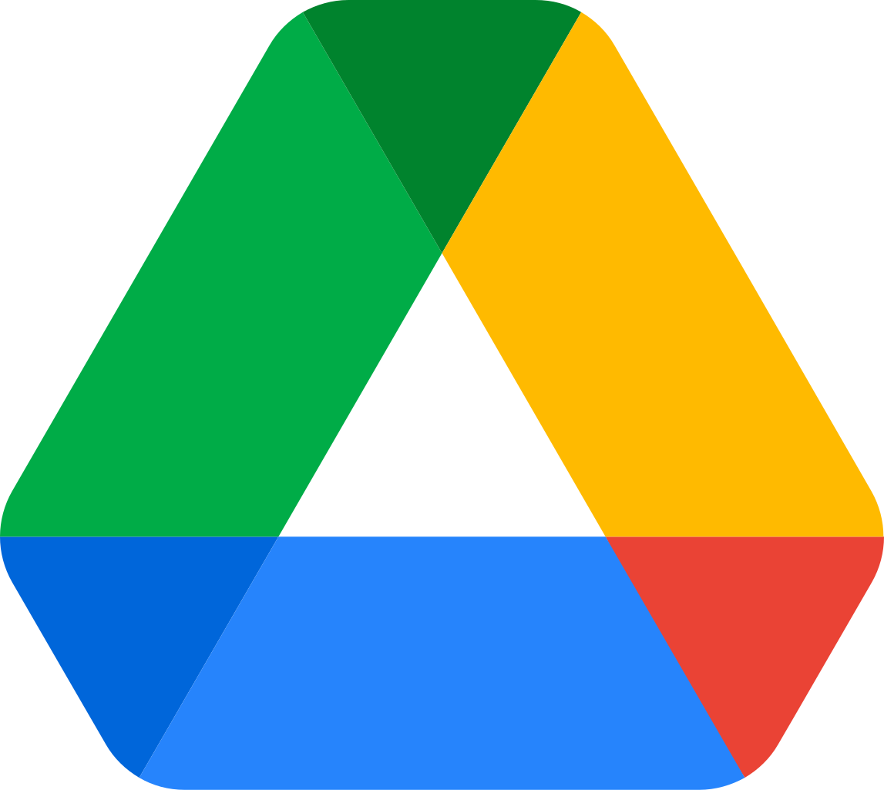

Google Drive is a file hosting and synchronization service developed by Google. Launched on April 24, 2012, the platform enables users to store files in the cloud, leveraging Google's servers to provide secure and accessible storage. It also allows seamless file synchronization across multiple devices, ensuring that users can access their data from anywhere.

Additionally, Google Drive makes it easy to share files and collaborate in real time, offering tools for sharing links, setting permissions, and even integrating with other Google Workspace apps such as Google Docs, Sheets, and Slides. This makes it a versatile solution for personal, educational, and professional use.

**Google Drive plans**

Google has 2 main plans:

1. **Personal (FREE).** In this plan you get 15GB of base storage for free (You can pay for more storage) and access to share functions, mail, google docs etc.
2. **Business Plan (11,50€/Month for a year).** This plan is meant for corporations who need more functions and assistance. It includes:

* Custom domain for the mail. ([example@corporate.com](mailto:example@corporate.com))
* Google Meet participants up to 150. (100 on the basic plan)
* Centralized administration with a Google administration panel. ([Panel](https://workspace.google.com/intl/es/products/admin/)) 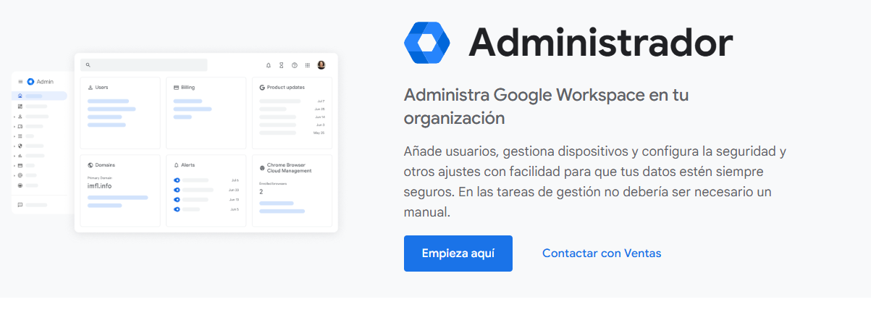
* Control of sensible data with custom groups.
* 24h assistance.
* 2Tb of base storage.

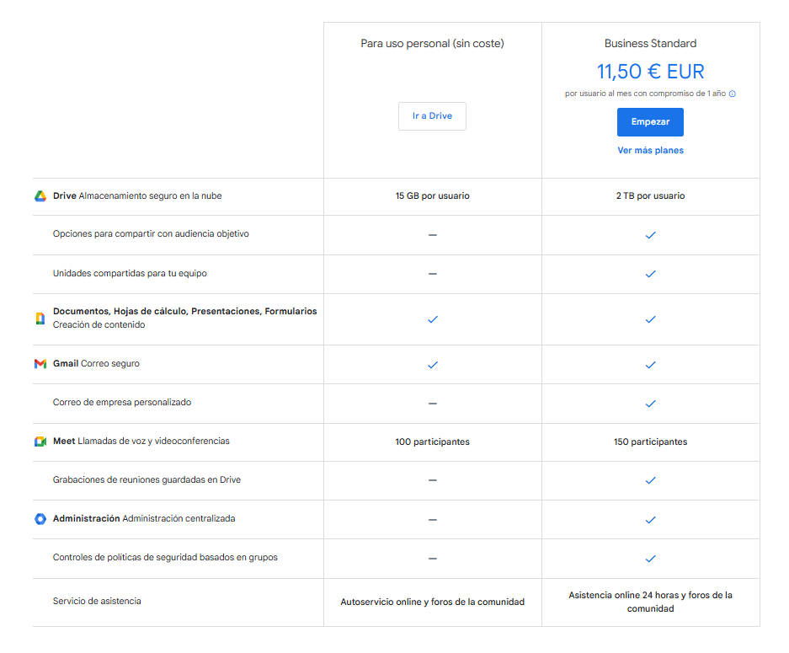

**Services and functionalities (**[**Google Drive**](https://www.google.com.mx/intx/es/drive/index.html)**)**

Google offers some functionalities with drive.

* **Shared folders**. With Drive you can share folders and files with other accounts using a link or by an invitation. Google Drive, by default, doesn't have a device limit to use the service. You can use as many devices as you need. Additionally, you can establish the permissions that affect other users who want to have access to edit, read, etc. permission.

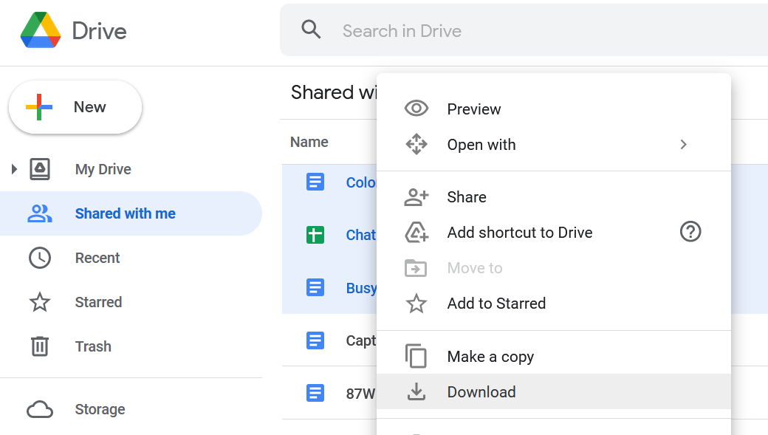

* **Backups.** Drive provides backup options through its desktop app, "Google Drive for Desktop." Users can synchronize selected folders from their computer to Drive or set up automatic backup for specific folders. Additionally, files in the "My Drive" section are automatically backed up in the cloud. Enhanced versions like Google One provide extended storage and backup options for photos and device data.

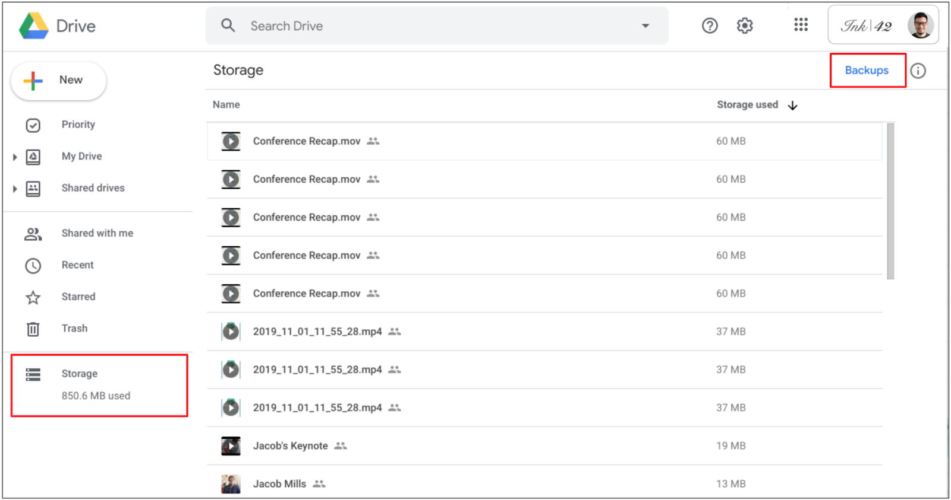

* **IA.** Google Drive has an integration with Google IA that can help the user to make the experience better.

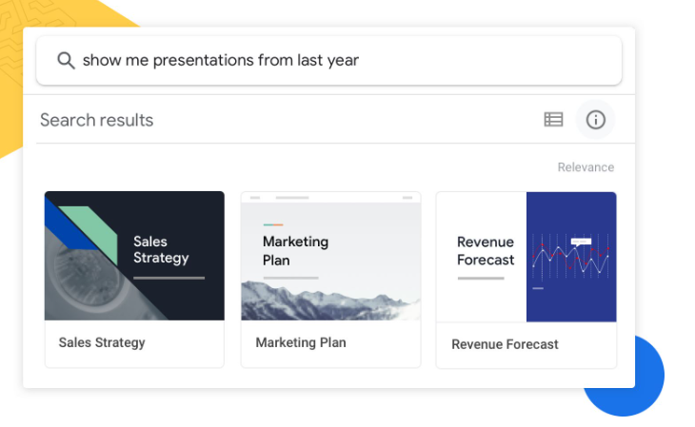

**Security & piracy**

At Google, they strive to implement large-scale anti-piracy solutions. For example, in 2010, they began making significant investments to simplify the process of removing copyright-infringing content from Search results. These improved procedures have allowed them to process millions of copyright takedown requests each week.

* How does Google Drive Security work? ([LockLizard](https://www.locklizard.com/document-security-blog/is-google-drive-secure/))

Google Drives Security has a few layers of security:

### Encryption in Transit:

Encryption in transit refers to the protection of data while it is moving from one location to another, in this case, when you upload or download files from Google Drive. Google uses **Transport Layer Security (TLS)** to encrypt the connection between your device and Google's servers. This protocol ensures that any data transmitted cannot be intercepted or altered by third parties while it is in transit, protecting the confidentiality and integrity of the information.

For example, when you upload a file from your computer or mobile device to Google Drive, the file is sent to Google's servers in an encrypted form, preventing malicious actors from reading or modifying the file while it is traveling over the internet.

### Encryption at Rest:

Encryption at rest protects data when it is stored on Google’s servers, meaning when it is not in transit. Google uses **AES (Advanced Encryption Standard) 256-bit encryption**, which is a highly secure encryption standard, to protect files stored on its servers.

This means that even if someone gains access to Google’s servers, the files will be protected by high-level encryption, and only those with the appropriate keys can access them. Encryption at rest ensures that data remains secure even if the server is compromised.

### Browser-based Security:

When you access a document on Google Drive from a web browser, Google implements several security measures to ensure that your information is not exposed to unnecessary risks. Some of these controls include:

* **Editing and viewing controls**: Google allows document owners to set permissions regarding what actions users can take on the files. You can set permissions to allow only viewing, editing, or printing of the document. These controls are managed through JavaScript, which executes the controls directly in the browser and is not solely dependent on server-side security.
* **Protection against printing and downloading**: In some cases, file owners can disable the options to print or download documents, ensuring that information is not distributed without authorization.
* **Authentication and authorization**: When you access a file on Google Drive, you are required to sign in with your Google account. The system also uses two-factor authentication (if enabled) to enhance account security, adding an extra layer of protection against unauthorized access.

All of this stuff is nice to have but major cloud services are not perfect. It's important to keep local backups and avoid storing highly sensitive information only in the cloud.

In 2018 a researcher, known as "an0n," discovered three vulnerabilities in Google Drive and Google Photos that allowed attackers to access private files illegally. The issues included manipulating invitation links, exploiting an unprotected API, and gaining unauthorized access to Google Photos libraries. Google quickly fixed these vulnerabilities and rewarded the researcher with over $4,000.

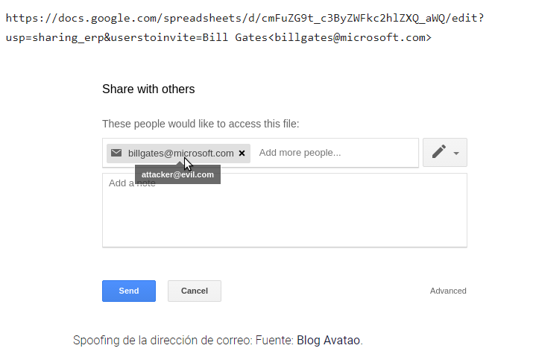

## **How to install and use Google drive**

### On Desktop

* On your computer, open:
  + **GoogleDriveSetup.exe** on Windows.
  + **GoogleDrive.dmg** on Mac.
* Follow the screen instructions.

#### To open Drive for desktop:

* You can find Drive for desktop Menu in a different place, depending What computer you use:
  + **Windows:** At the bottom right of your screen.
  + **Mac:** At the top right of your screen.

When you install Drive for desktop on your computer, it creates a drive in ***My Computer*** or a location in ***Finder*** named Google Drive. All of your Drive files appear here. Any new files or folders you create in Drive or Drive for desktop sync and appear on all your devices.

* Click Drive for desktop → click your name → Open Google Drive.
* In ***My Drive*** or ***Shared drives***, double-click the file that you want to open.

Files created by Google Docs, Sheets, Slides, or Forms open in your browser.

Other files open in their regular applications on your computer.

You can manage how much local storage you use and where your content is located by configuring Drive to stream or mirror your files and folders.

Source: [***https://support.google.com/a/users/answer/13022292?hl=en***](https://support.google.com/a/users/answer/13022292?hl=en)

## On Mobile

If the mobile phone is ***Android*** the app comes preinstalled. But if the mobile is ***IPhone*** you must download it from the ***App Store.***

* On your phone or tablet, open the **Google App Drive** On the **Home** page, you can:
  + Folders
  + Docs
  + Sheets
  + Slides
  + Forms
* Switch between ***”Suggested”*** and ***”Activity”*** tabs.
* To find the files and folders you're most likely to use, you can use the ***”Suggested”*** tab.
* To find the files and folders based on recent changes and actions, you can use the **Activity** tab.
* To quickly find your important files or folders, you can add them to the **Starred** section.
  + On your phone or tablet, open Google Drive.
  + Next to your file or folder, tap ***More actions,*** ***Add*** to ***starred***.
* In the **Shared** section, you can find files and folders others have shared with you and you have shared with others. To share a file or folder:
  + On your Android phone or tablet, open Google Drive.
  + Next to your file or folder, tap ***More actions***, ***Share***.
* In the **Files** section, you can find a list of all your files, regardless of their location. You can switch between ***My Drive*** and ***Computer*** tabs. To find the files and folders you:
  + **Stored in Google Drive:** You can use the ***My Drive*** tab.
  + **Sync in Drive for desktop:** You can use the ***Computer*** tab.

Source: <https://support.google.com/drive/answer/2424384?hl=en&co=GENIE.Platform%3DAndroid&oco=0>

<https://support.google.com/drive/answer/2424384?hl=en&co=GENIE.Platform%3DiOS&oco=0>

On the webpage

Alternatively you can access Google Drive through the web browser via entering drive.google.com and use it as if you were using the desktop version.