COLORS

With hexadecimal values you get solid colors

Colors that require transparecy are not specified in hexadecimal, but in rgb (where a transparecy value is needed)

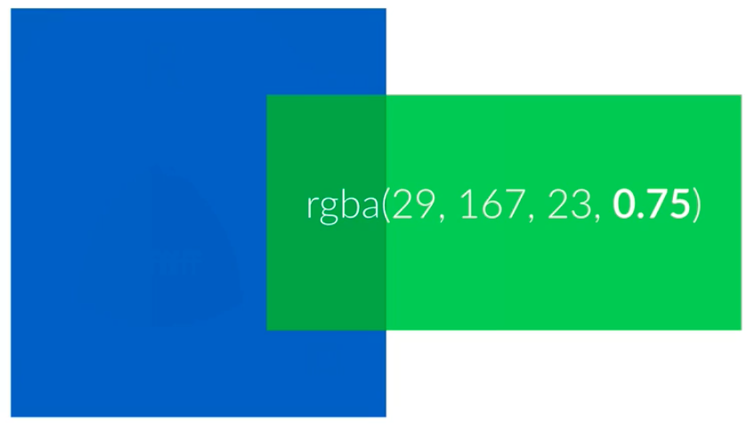

press cmd + E to see the color picker

BOX MODEL

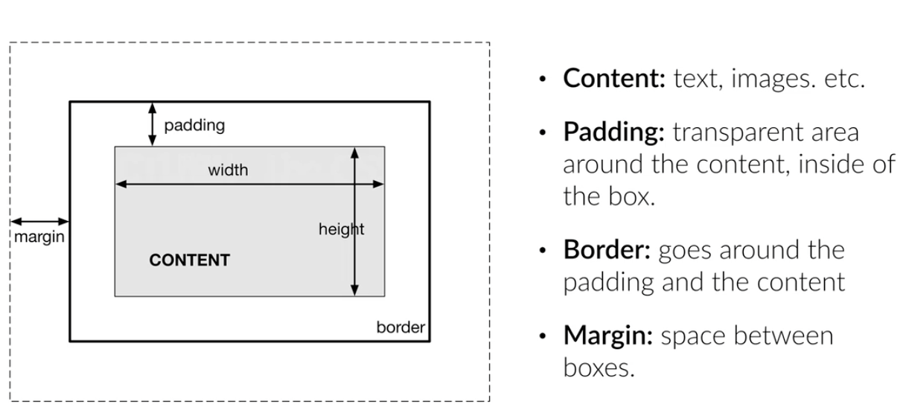

if we increase the height and width, we are only increasing the properties of the content, not of the box. This can be fixed by using box-sizing: border-box

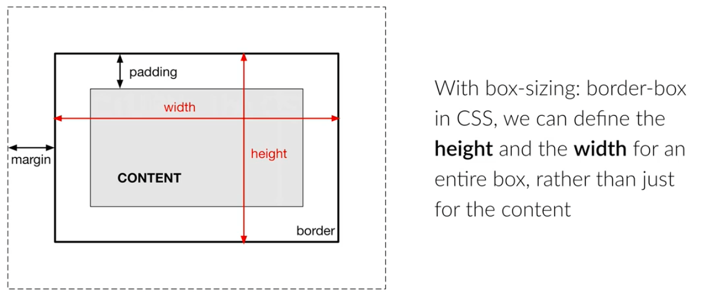

block elements: occupy the entire width of the browser and force line breaks

inline elements: do not occupy the entire width of the browser

* You can’t neither set their height or their width

SIMPLE LAYOUT

auto

* Margins are adjustable according to content context (ex: to center content)

Float

* An element can be pushed to the left or to the right, allowing other elements to wrap around it

RELATIVE VS ABSOLUTE

Relative

* The position of these elements is determined by other elements

Absolute

* Can be positioned anywhere we want inside their parent elements
* The parent element needs to be relative

**WEB DESIGN BASICS**

Front-end: the visual stuff

Go for flat designs

TYPOGRAPHY

1. Use a font size between 15 and 25 pixels for body content
2. Use really big font sizes for headlines (ex: 60px for main and 32 px for secondary)(if you choose a really big font-size, remember to decrease the font-weight of the heading; this will make sure that the header does not steal all of the attention )
3. Use line spacing between 120% and 150% of the font size
4. 45 to 90 characters per line
5. use good fonts

web fonts

* fonts you can include in project without downloading any files

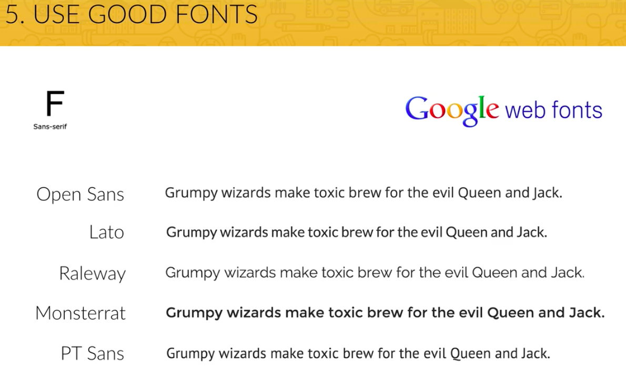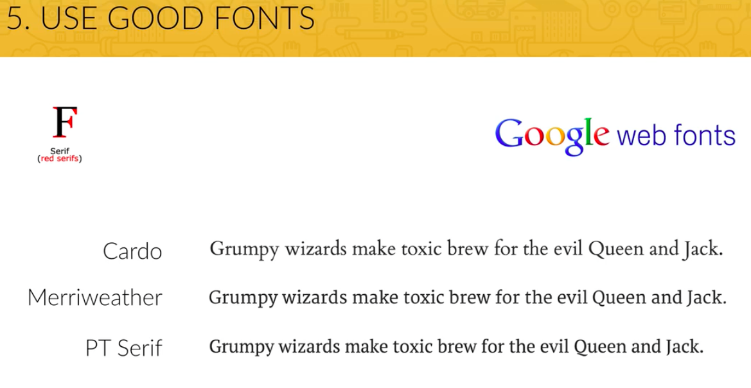

USING COLORS LIKE A PRO

1. use just 1 base color (any different color from black, white or some shade of grey)

* you can have a main color that will draw attention to the most important elements of your website, and a second or thir color can complement the main color

1. use a tool if you want to use more colors
2. use color to draw attention

* when in doubt about what color to choose, just pick one that stands out and include it in buttons, etc.

1. never use black in your design

* black does not appear on the real world, so it appears unnatural

1. choose color wisely (each color causes a psychological effect on your audience)

WORKING WITH IMAGES

Different techniques to put text on images:

1. put text directly on the image
2. overlay the image
3. put your text in a box
4. blur the image (the text must be in the blurred part)
5. the floor fade (technique where the image fades towards black at the bottom, with white text written on it) (best way if you want text at the bottom of images)

Websites with heavy images convert better

Don’t do’s

* don’t just put some text above an image, the only way this works is if your image is pretty dark and your text white; otherwise it will be very hard to read the text

do’s

* overlay your image with a color (the most usual is black), hence turning it darker
* you can use color gradiants too

WORKING WITH ICONS

1. use icons to show features or steps
2. use them for actions and links (icons should be recognizable and labeled)
3. should not take a center stage, but a supportive one

SPACING AND LAYOUT

1. Use whitespace (space where there is not any stuff) well

* Put whitespace between elements
* Put whitespace between your group of elements
* Put whitespace between your website’s section
* But don’t exaggerate

1. Define hierarchy (organizations of your section through whitespace)

BUILDING THE HEADER PART 2

Inline-block elements

* They don’t force a line break, and you can assign them margin and padding (unlike a normal inline-element)