Command Line Interface

The constructed user interface is a command line finance assistant. The UI is coded in ruby programming language, because we believed it is a good language for quick prototyping. The main goal of the UI is to provide help in how a user could pay for a big purchase. They can achieve this by inputting specific commands on the command line. When considering a purchase, the software considers bank account, credit card and loan as possible options as well as considers monthly costs and profits. In this prototype these values are set manually but in a real version they could be tied to a account
The commands are as follows:

status or st - See all the values you have entered to the software (Account Balance, Credit Balance, Monthly Fees, Monthly Profits)
set or s - Set the values used by the software (Account Balance, Credit Balance, Monthly Fees, Monthly Profits)
invest or i - Enter a sum that you wish to invest and the program will suggest you how to finance it
loan or l - See your banks loan information
cloan or c - Access your banks loan calculator
help or h - Show this info
exit or e - quit the program

When the user first starts the system, he is greeted with a welcome text and a small info text. (picture 1) This is to make user familiar with the basic functionality of the UI.
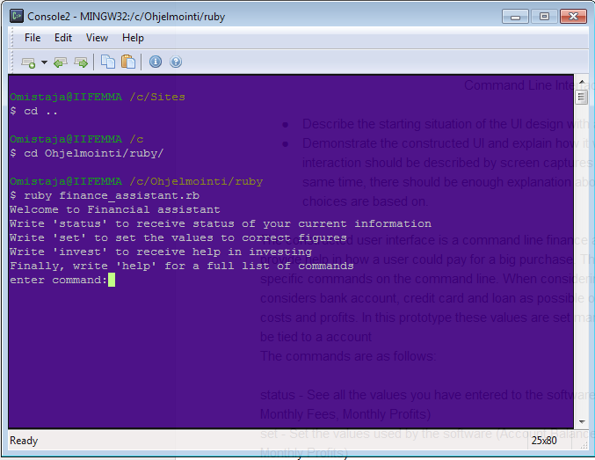
Picture 1, welcome text

One of the important things in designing a CLI is to try and reduce the amount of memorization the user has to do.[1] ‘Help’ and ‘status’ command are designed to help in this task. Help-command displays the full list of available commands when the user desires so that he doesn’t have to constantly remember them. The status-command shows all the values currently inserted by the user. (Picture 2)

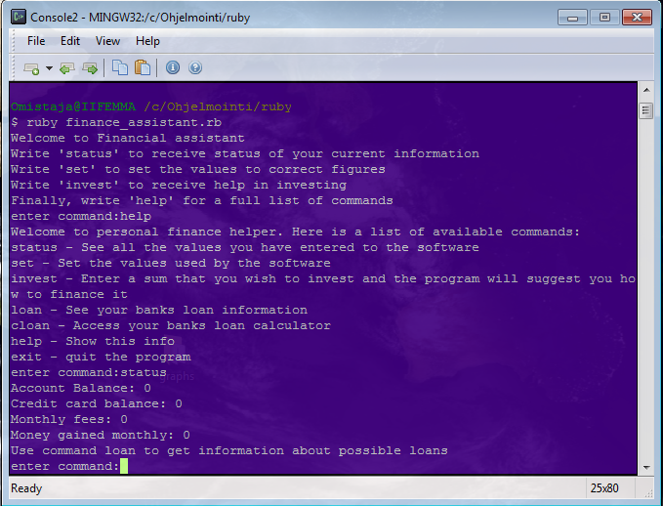
Picture 2, status and help commands

Set- and Invest-commands are the main commands of the UI (picture 3). The set command allows the user to set the values to match the correct values. In the prototype these values are not persistent but in the real version they could be stored to a database to make them persistent. Once the values are set, the user can use the invest-command to get help with an investment. The program will ask the user how much he is investing and then propose the best possible way to pay that investment.
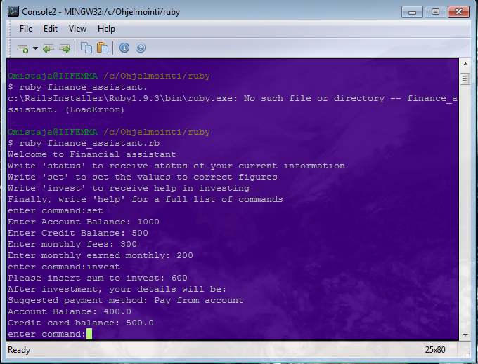
Picture 3, set and invest commands

The two final commands, loan and cloan, are used for loan information. Loan-command opens a web page containing information about the loans. In the prototype, we are using Nordea’s loan information, but in the real version the user could select his bank. Cloan-command is meant to be loan calculator. Currently it opens Nordea’s own loan calculator, but because all banks might not have this, it might be good to implement one to the software in the real version.

There are two version of the UI attached, the raw ruby script and a windows executable (.exe) version. Their functionality is the same but the ruby script is included so the UI can be tested on other OS as well if needed.

The main guidelines followed for this UI were natural language and trying to lessen the need for memorization [1]. All the commands used are logical words associated with that action, except for “cloan”, which is abbreviated from “calculate loan”. This makes it easier for the user to use the program. Memorization is removed by allowing the user to call the full command list with the help command. The program can also try to guess what the user wanted to do if an unknown command is inputted. The program will then respond with “Did you mean: xxxx?” (Picture 4)
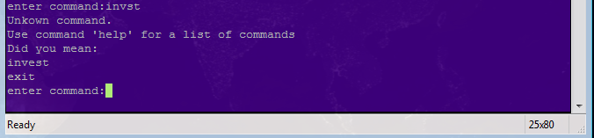
Picture 4, “Did you mean: x”

It should be noted that all commands also have shortened version for experienced users. For all the other commands the shortened version is just their first letter, and for status it is “st”.

[1] All the guidelines taken from the Command Line Interface lecture slides (Lecture 2b: CLI)
https://noppa.aalto.fi/noppa/kurssi/t-121.5300/luennot/T-121_5300_slides__2b__cli_.pdf

Running the program

finance_assistant.exe:
Should work on all modern Windows Environments (tested on Windows 7) simply by running the program.

finance_assistant.rb:
Should work on all platforms (though only tested on Windows 7)
To run the script, install latest ruby version from http://www.ruby-lang.org/en/downloads/
navigate to the folder that has the .rb file with terminal, and run command “ruby finance_assistant.rb”

