Web UI

The web UI is coded in java language with the help of Play framework.

The main goal was to build the web UI and desktop UI as much similar as possible, and therefore, they look a lot the same. This decision was made in order to improve transition from one environment to another. If user has used one application, he is able to use the other one as easy as possible.

Not all functionality is implemented in the application, because it's a prototype. On the other side, we think that there is everything that is needed to see what is the application is supposed to do.

The application is explained in detail below. You can use the application at http://lakka.kapsi.fi:61886.
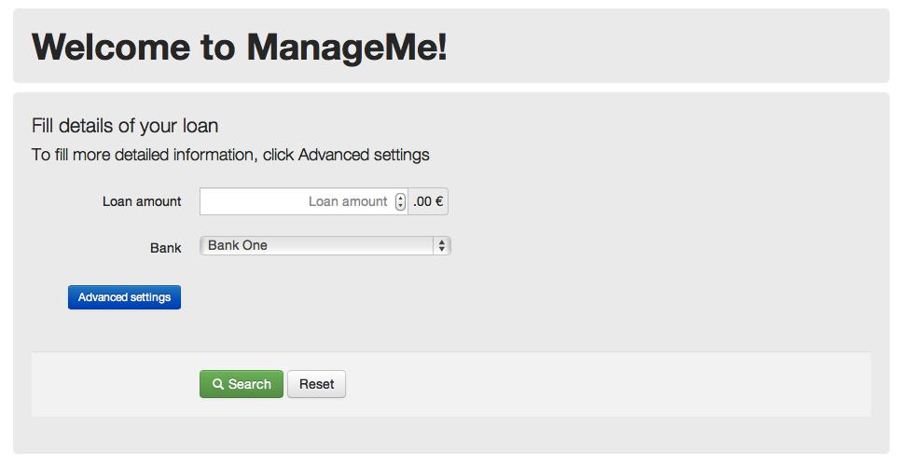
Picture 1: The Main Screen

This is the main screen of the program. From here, the user can search for available loans and through advanced settings, also explore other ways to finance his purchase.
The basic feature is simply searching for info about possible loans. By entering the amount of money the user wishes to loan, and the bank he wishes to loan from, the program will show user different loan options. (Picture 2)
If the Advanced Settings button is clicked, then the program will determine if the user even needs to take a loan by using the information submitted by the user. The user will input his Account Balance, Credit Card Balance and Regular income and bills, and the program and then press search. The program will determine if there is any need for the user to take a loan and show it in the result page. (Picture 3)
The program will also always show any relevant bonus card info (Both Picture 2 and 3)
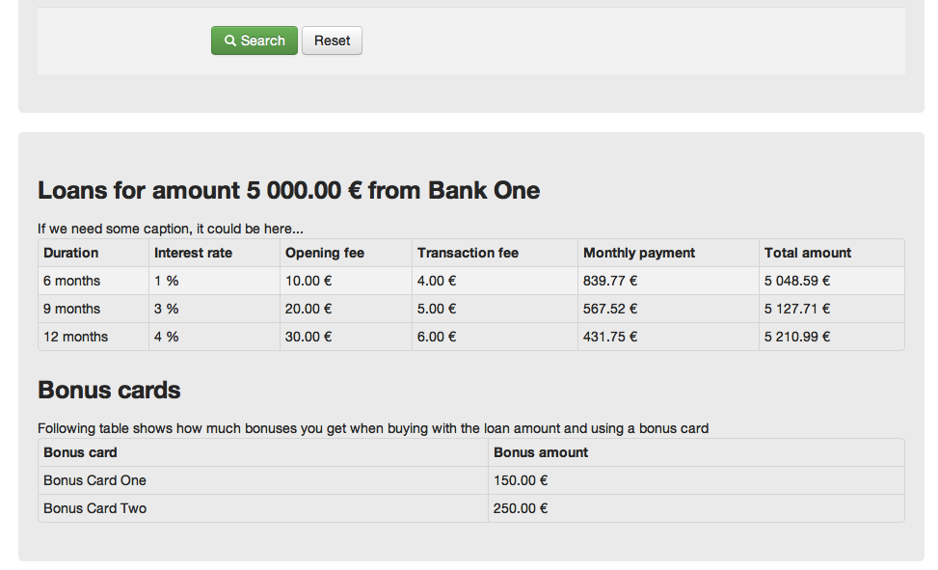
Picture 2, Loan Information

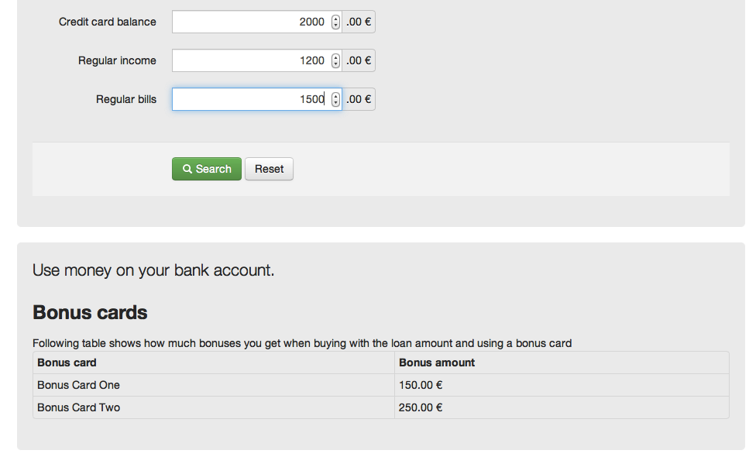
Picture 3, the program has determined that there is no need for loan

Running the Program

The program can be run through the file named “desktop.jar”

desktop.jar:
It is a executable .jar file that can be launched simply by double-clicking it. It has only been tested on Windows 7, but it should theoretically work on all operating systems that support Java.
Java 1.6 or newer is required to run the program, java can be installed from:
http://www.java.com/en/download/index.jsp

