Web UI

The web UI is coded in java language with the help of Play framework.

The main goal was to build the web UI and desktop UI as much similar as possible, and therefore, they look a lot the same. This decision was made in order to improve transition from one environment to another. If user has used one application, he is able to use the other one as easy as possible.

Not all functionality is implemented in the application, because it's a prototype. On the other side, we think that there is everything that is needed to see what is the application is supposed to do.

The application is explained in detail below. You can use the application at http://lakka.kapsi.fi:61886.
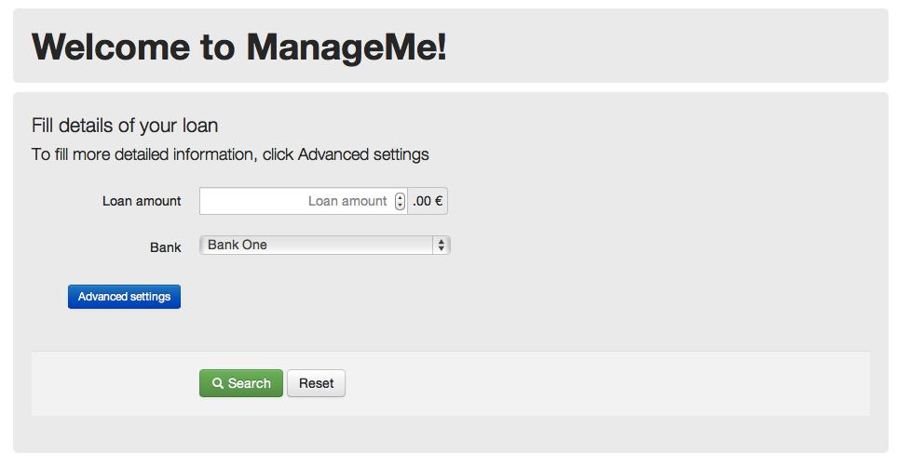
Picture 1: The Main Screen

This is the main screen of the program. From here, the user can search for available loans and through advanced settings, also explore other ways to finance his purchase.

All amount input fields are numeric HTML5 input fields, and if the user's browser supports these, some improvements are shown, e.g. error message if the given input is not numeric. Also, after each amount input field, there's note about accuracy (only whole numbers are accepted) and currency. If user has filled in some input with incorrect data, a error message is shown next to the input field and a common error message, that the form contains errors, is shown above the form (Picture 4).

The basic feature is simply searching for info about possible loans. By entering the amount of money the user wishes to loan, and the bank he wishes to loan from, the program will show user different loan options. (Picture 2)

If the Advanced Settings button is clicked, then the program will show advanced input fields. If these are used, the program will determine if the user even needs to take a loan by using the information submitted by the user. The user can input his Account Balance, Credit Card Balance and Regular income and bills, and the program and then press search. The program will determine if there is any need for the user to take a loan and show it in the result page. (Picture 3)
The program will also always show any relevant bonus card info (Both Picture 2 and 3)

After user has clicked search and results are shown on the page, focus of the user's web browser is set on the results. This helps the user to find the results more easier.
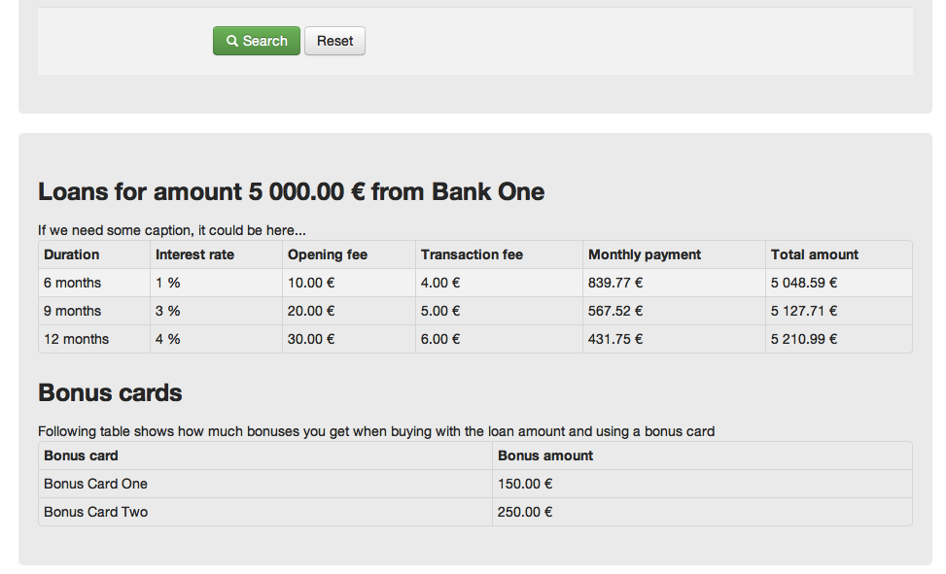
Picture 2, Loan Information

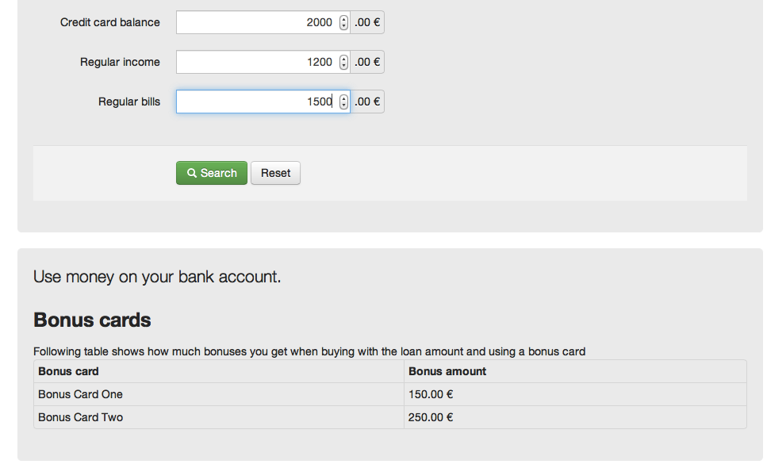
Picture 3, the program has determined that there is no need for loan
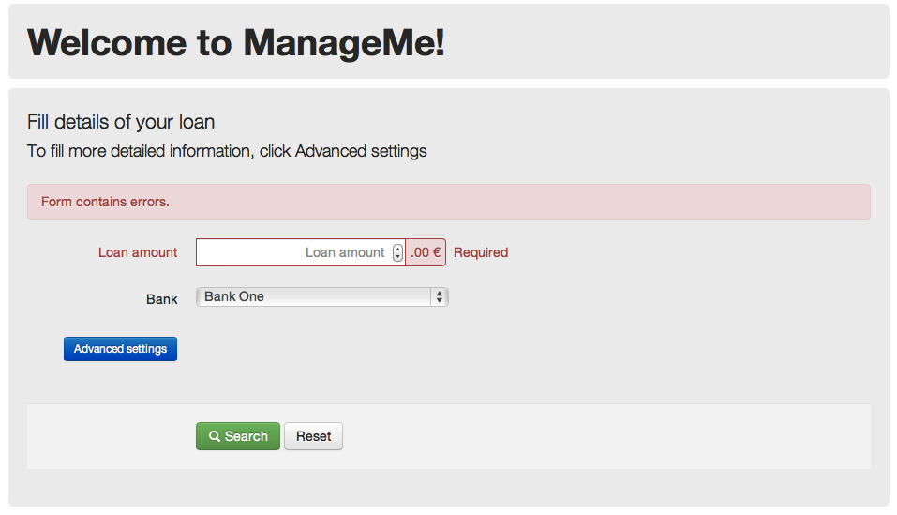
Picture 4, Error messages are shown

