Desktop UI

The desktop UI is coded in java programming language, because that allowed us to use the same solutions for both web and desktop UI. The main goal of the UI is to provide help in how a user could pay for a big purchase. When considering a purchase, the software considers bank account, credit card and loan as possible options as well as considers monthly costs and profits. It also considers possible bonus cards the user might have. In this prototype these values are set manually but in a real version they could be tied to a account.

The UI is very simple, partly because of the fact that it is only a prototype but also because we believe it is a good design choice. Managing personal finances can be very complicated, so to reduce that complexity, we have tried to keep the UI easy and clean.

The UI consists of three screens. The main screen, and two different kinds of result screens. They are all explained in detail below.

There was some empty grey areas left into the UI, visible in Pictures 1 and 3. We wanted to remove those but since we didn’t have any experience with Swing we couldn’t do it. In the final version the useless gray space would be removed.

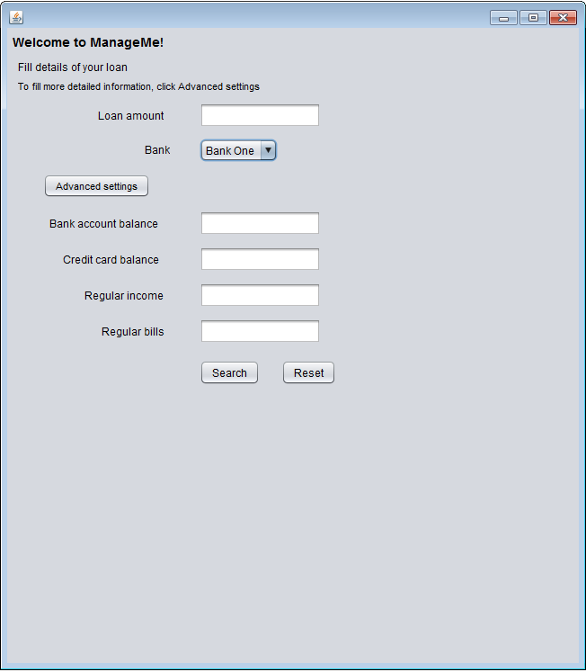
Picture 1: The Main Screen

This is the main screen of the program. From here, the user can search for available loans and through advanced settings, also explore other ways to finance his purchase.
The basic feature is simply searching for info about possible loans. By entering the amount of money the user wishes to loan, and the bank he wishes to loan from, the program will show user different loan options. (Picture 2)
If the Advanced Settings button is clicked, then the program will determine if the user even needs to take a loan by using the information submitted by the user. The user will input his Account Balance, Credit Card Balance and Regular income and bills, and the program and then press search. The program will determine if there is any need for the user to take a loan and show it in the result page. (Picture 3)
The program will also always show any relevant bonus card info (Both Picture 2 and 3)
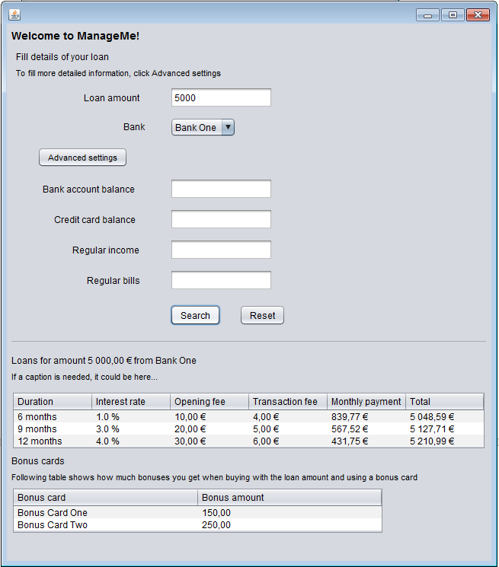

Picture 2, Loan Information

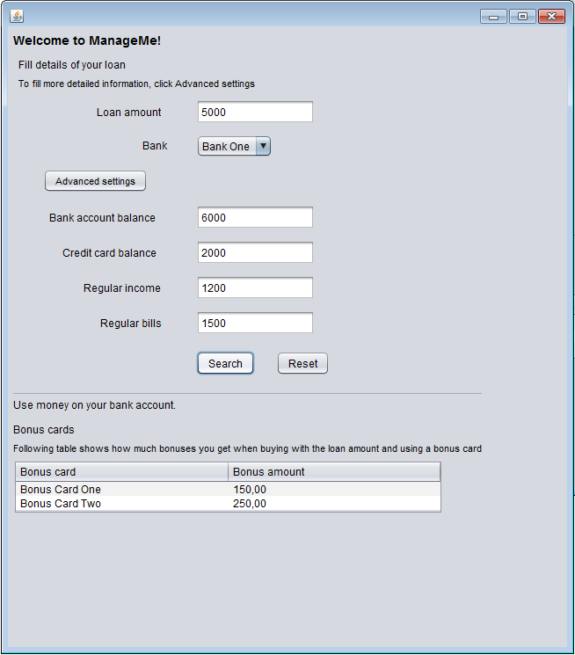
Picture 3, the program has determined that there is no need for laon

Running the Program

The program can be run through the file named “desktop.jar”

desktop.jar:
It is a executable .jar file that can be launched simply by double-clicking it. It has only been tested on Windows 7, but it should theoretically work on all operating systems that support Java.
Java 1.6 or newer is required to run the program, java can be installed from:
http://www.java.com/en/download/index.jsp

