Introduction : In this assignment focuses on developing a calculator application in JavaScript, split into two modules: ”simpleCalculations.js” for basic operations (addition, subtraction, multiplication, division) and ”complexCalculations.js” for advanced operations (modulus, exponentiation, square root).I created these two files to organize the calculator's functionality and ensure comprehensive code coverage during unit testing. Using Jest as the unit testing framework and ChatGPT as a generative AI tool, I created and executed unit test cases to validate the functionality of the calculator. The project also involved analyzing the effectiveness of the AI tool in generating test cases and improving test coverage in software testing.

Prerequisites: intall node and npm (node package manager),Run the following command to install jest and jest-html-reporter.
“npm i jest jest-html-reporter”

TASK-1: Implementing Calculator

There are 2 files. ”simpleCalculations.js” for basic operations (addition, subtraction, multiplication, division) and ”complexCalculations.js” for advanced operations (modulus, exponentiation, square root). The code snippet is provided below

File 1: simpleCalculations.js

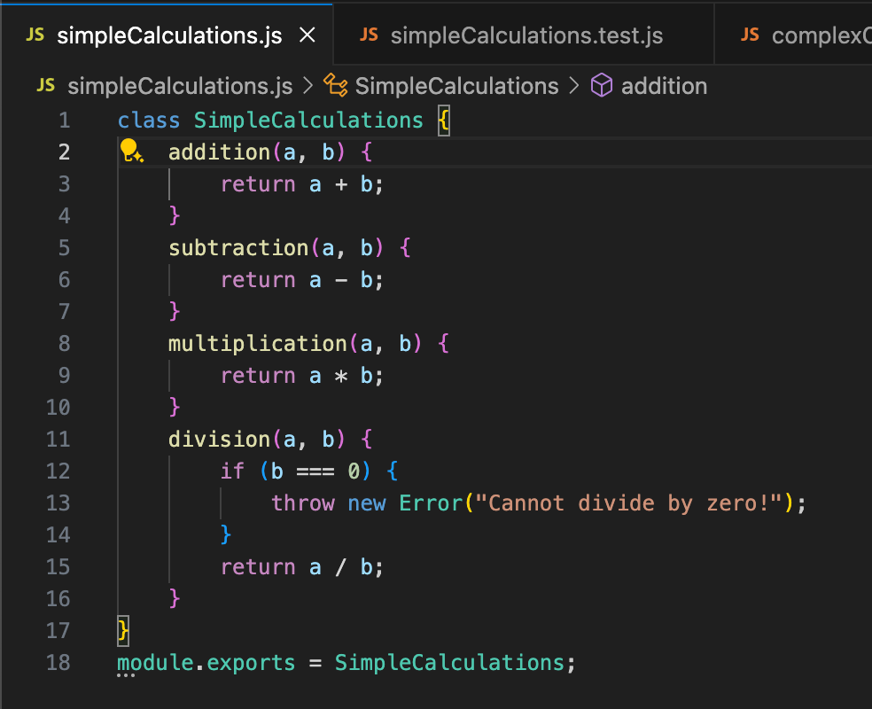

File 2: complexCalculations.js

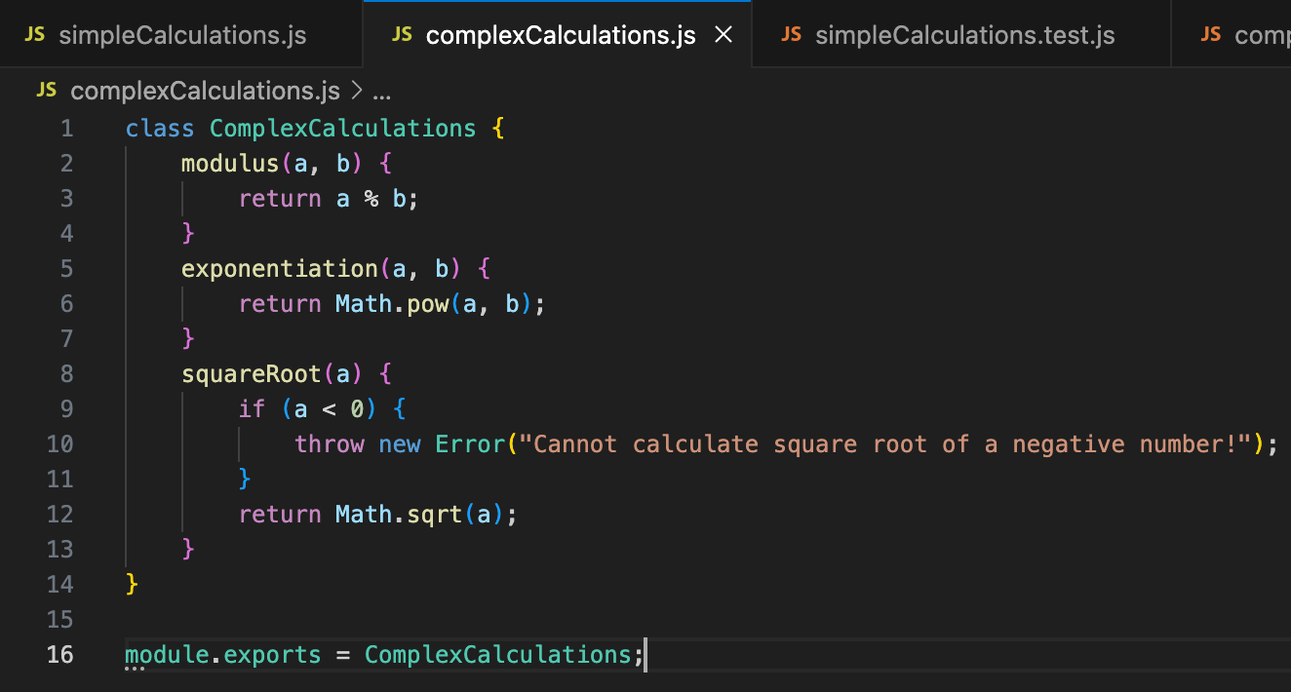

Run the script using node <filename>, e.g., node simpleCalculations.js.

Task 2:
When it comes to unit testing in JavaScript, there are several popular frameworks like Jest, Mocha, and Jasmine. After assessing these frameworks, I chose Jest for its simplicity, functionality and simplicity to write the test cases.
Jest does not require configuration and comes with a built-in test runner. There is no need to spend time setting up or configuring the testing environment unlike Mocha and Jasmine.
Another reason for choosing Jest is its built-in assertion library. Jest uses its own expect function for making assertions in tests, which means I don’t need to install third-party libraries like Chai, which Mocha relies on. While Jasmine also comes with its own expect functionality.
Jest shines when it comes to mocking. It provides built-in mocking and spying capabilities, which makes it easy to simulate function calls and track how they are used in tests.
Jest is able to handle async/await, promises, and other asynchronous patterns with ease, making it a strong choice for testing asynchronous code for javaScript. While Mocha also supports async testing, its setup for async operations (such as using the done callback) can be more cumbersome. Similarly, Jasmine supports async testing but relies on callbacks, which can make tests harder to read and manage. Jest also offers unique features like snapshot testing, allowing you to capture “snapshots” of components or data at a specific point in time and compare them in future tests. Unlike Jest, Mocha and Jasmine do not support snapshot testing out of the box, which is another reason why Jest was the better choice for my projects.
Additionally, Jest supports parallel test execution, which allows it to run multiple tests at the same time, speeding up the overall testing process. Finally, Jest has built-in code coverage tracking. It automatically provides detailed code coverage reports without needing any external configuration or tools. Mocha and Jasmine require integration with tools like Istanbul for code coverage, which adds extra steps to the setup and configuration process.
Overall, I chose Jest because it offers a complete, easy-to-use testing solution with everything I need built-in. Its zero configuration setup, powerful mocking, snapshot testing, and parallel test execution make it the most efficient and user-friendly choice. Compared to Mocha and Jasmine, Jest is simply more streamlined and modern, making it the best fit for my JavaScript testing needs.

To create unit test cases for the calculator application. I provided clear prompts to the AI tool (ChatGpt), specifying the functions to be tested and the unit testing framework (Jest). The AI tool generated test cases based on these prompts

Setting up for tests to run :

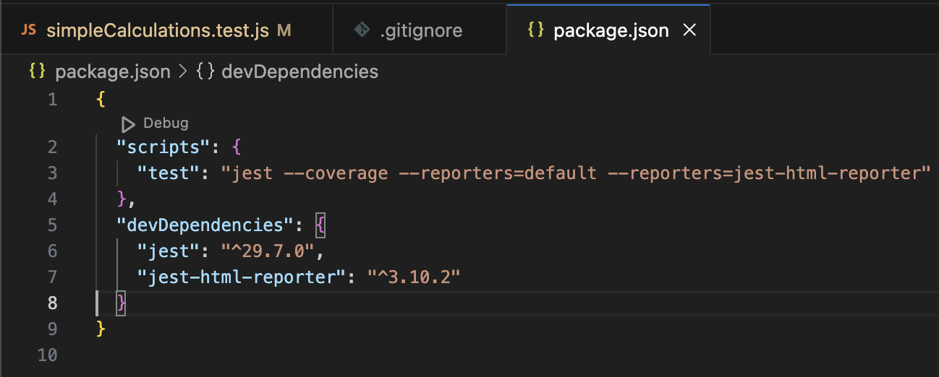

Prompts Used to generate test cases:

Prompt 1: Generate Jest unit test cases for a JavaScript class SimpleCalculations with methods for addition, subtraction, multiplication, and division. Include edge cases like division by zero
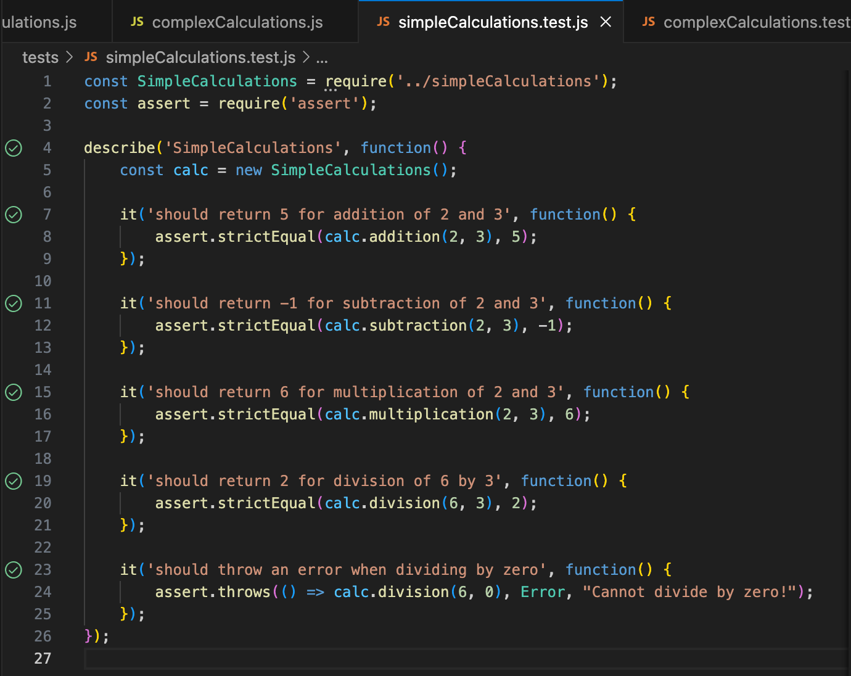

Prompt 2: Generate Jest unit test cases for a JavaScript class ComplexCalculations with methods for modulus, exponentiation, and square root. Include edge cases like square root of a negative number.

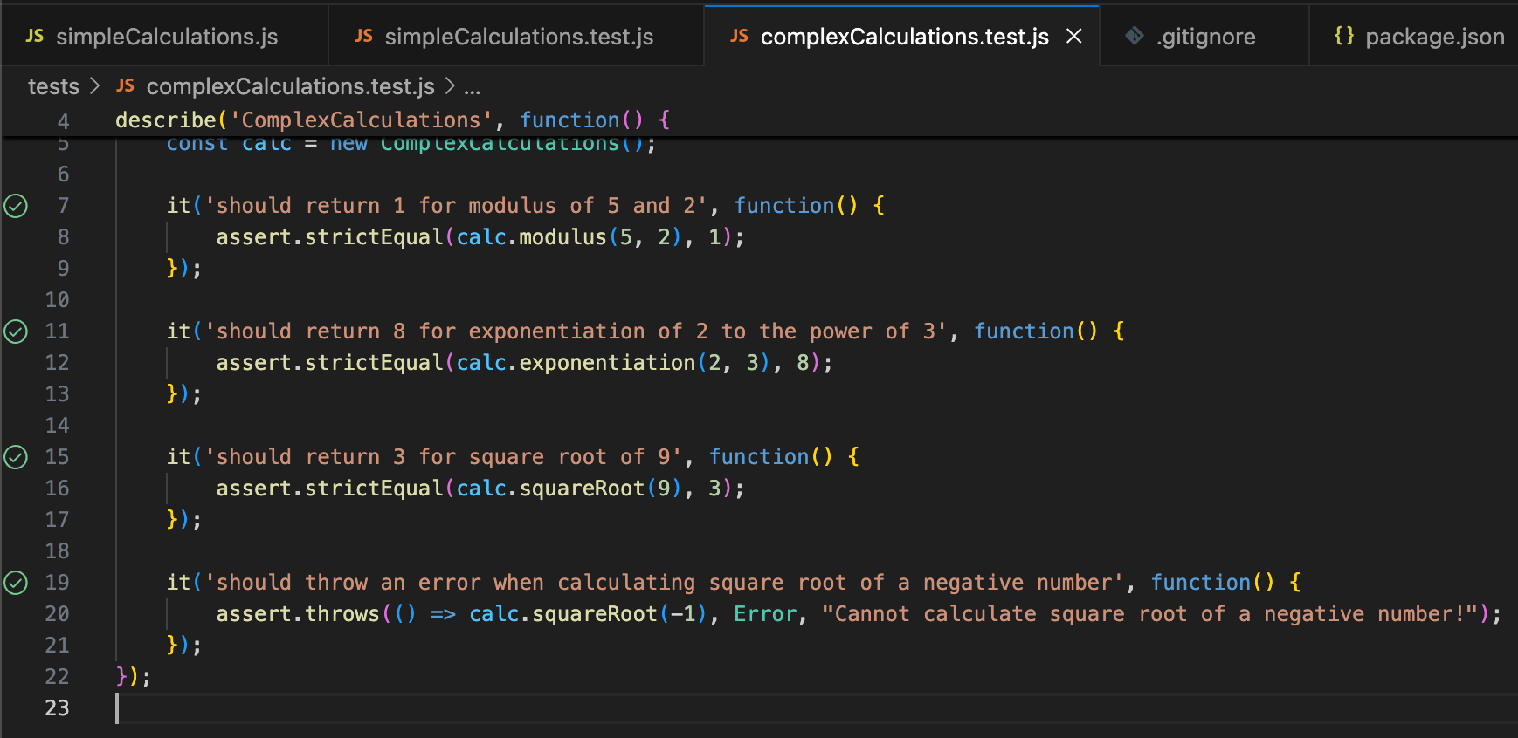

Task 3
Test coverage

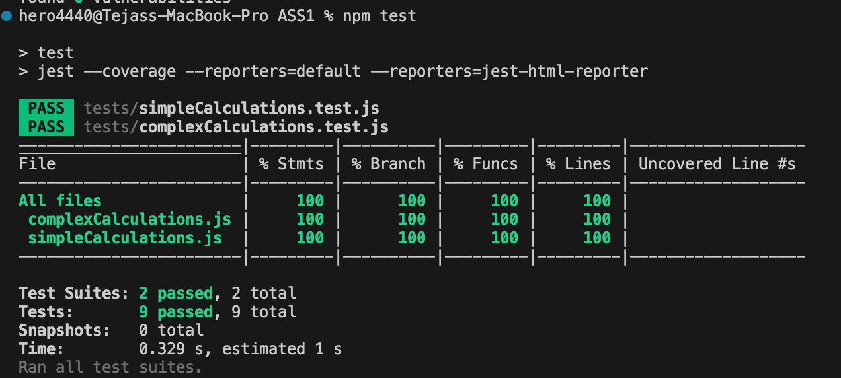

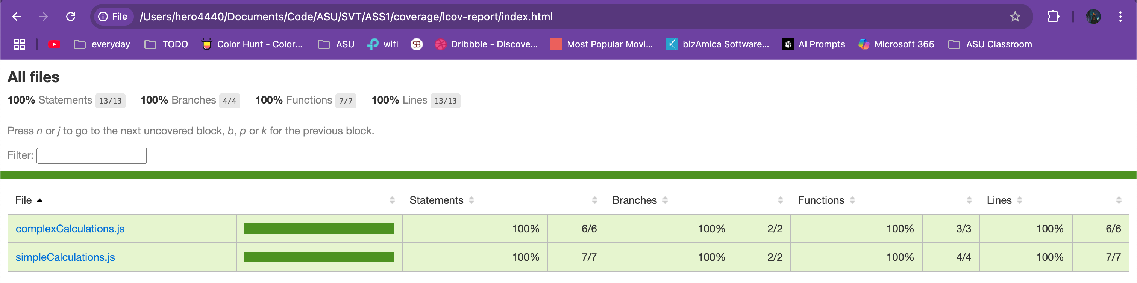

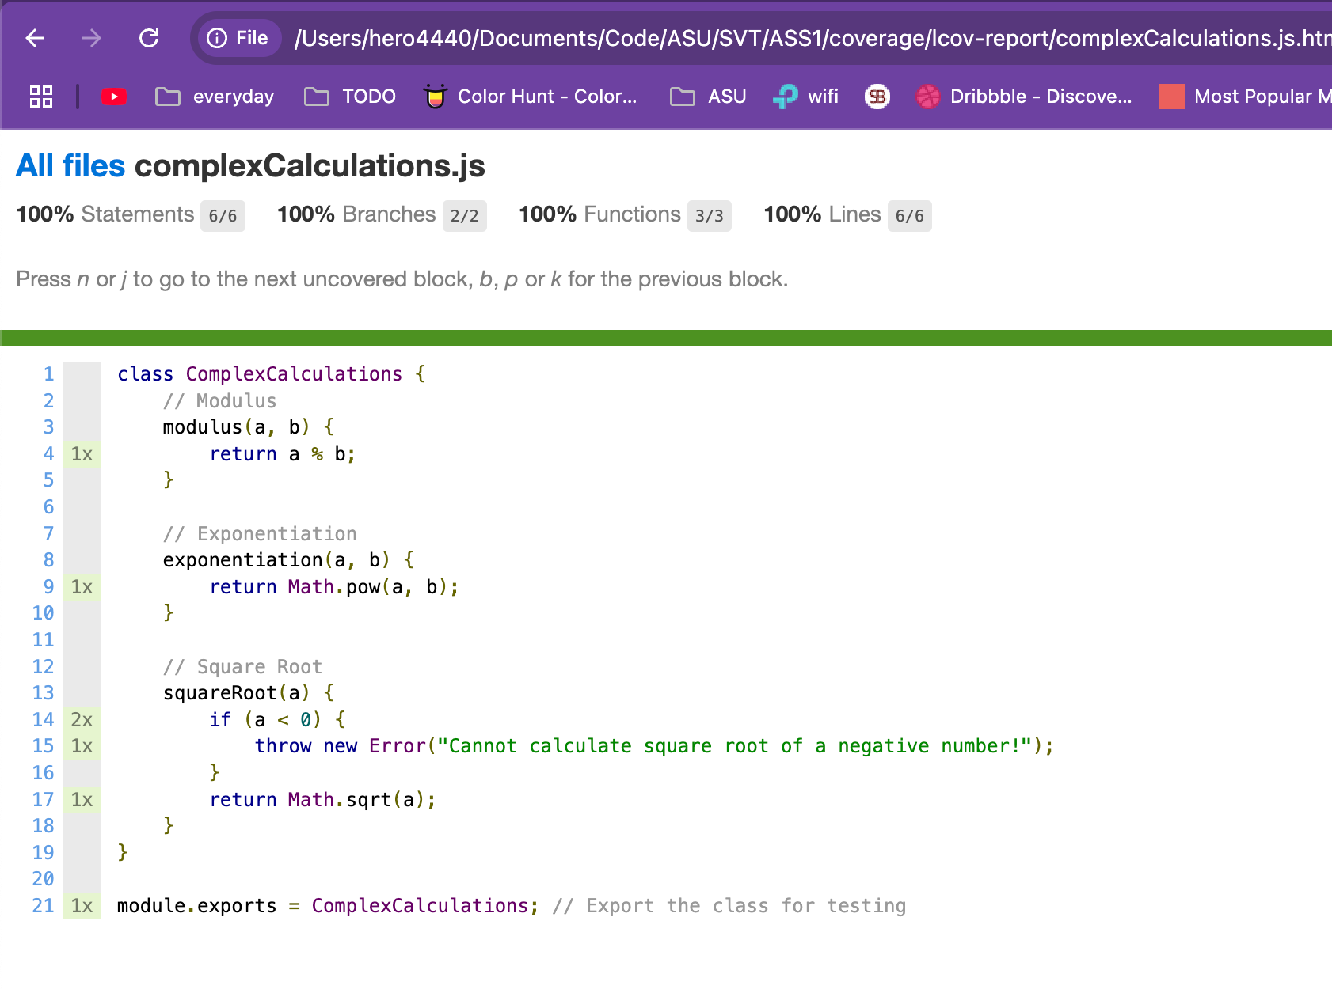


Task 4:
Update the test files to include comprehensive test cases. Ensure the tests cover all edge cases, validate the functionality, and align with the requirements. Use Jest for testing, and include both unit tests and integration tests where applicable. Generate descriptive test names and ensure the code is clean and well-documented.

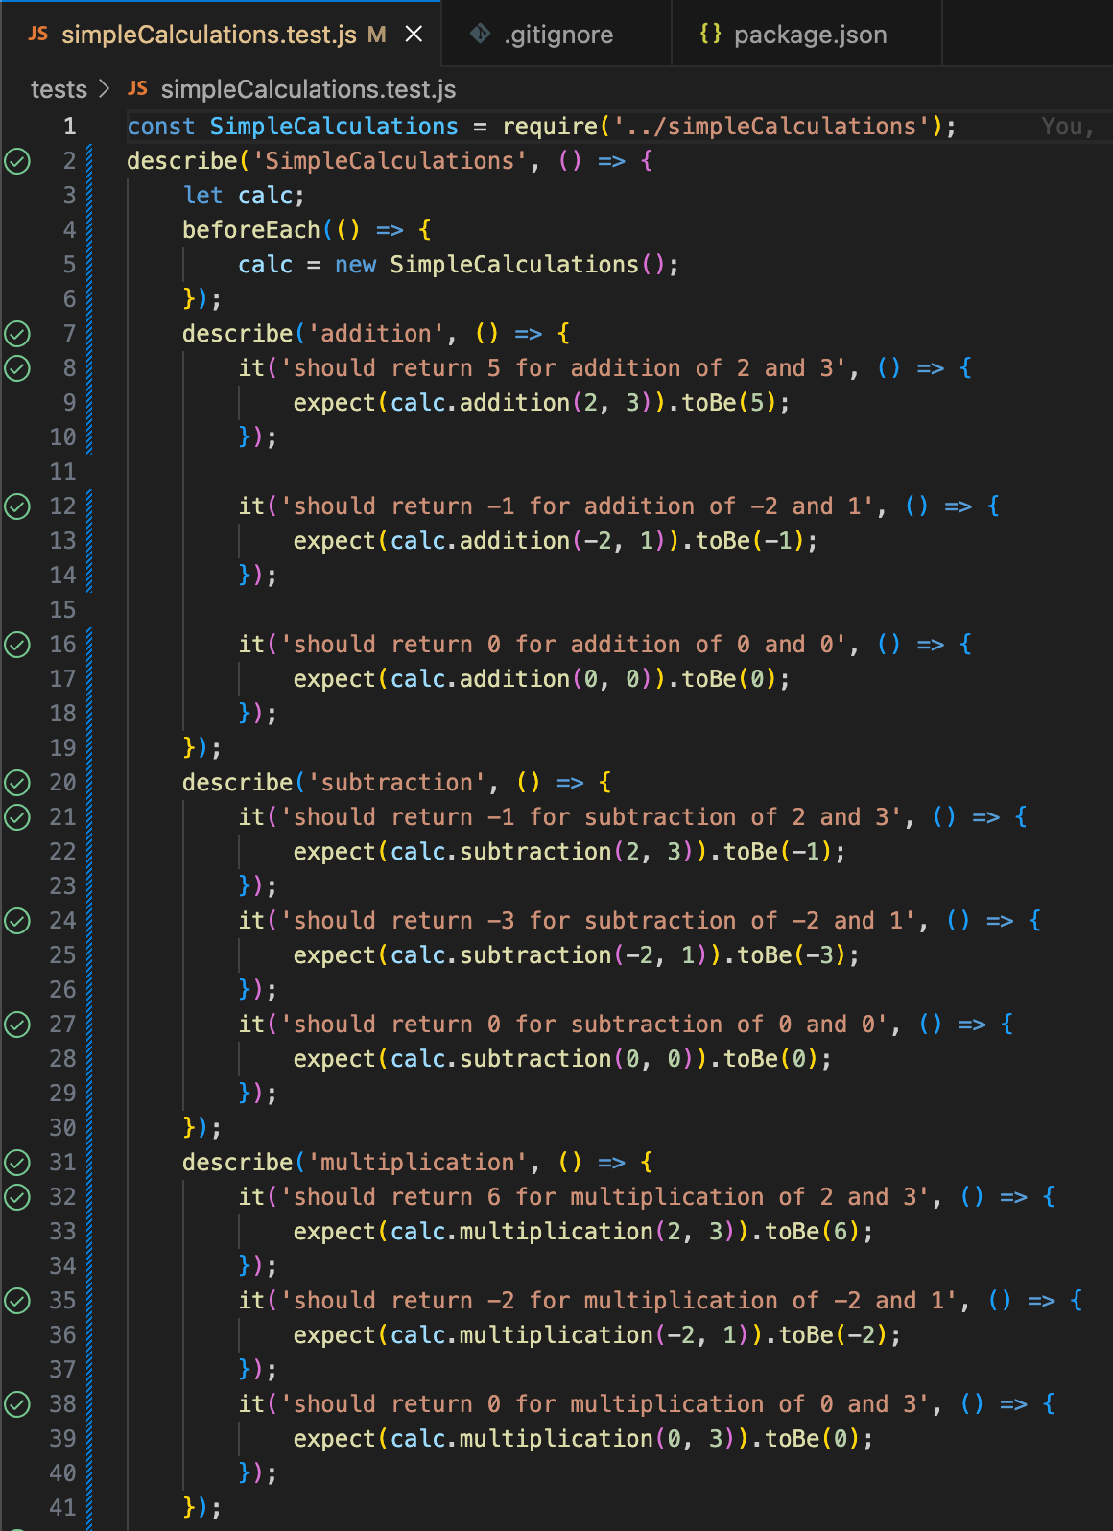

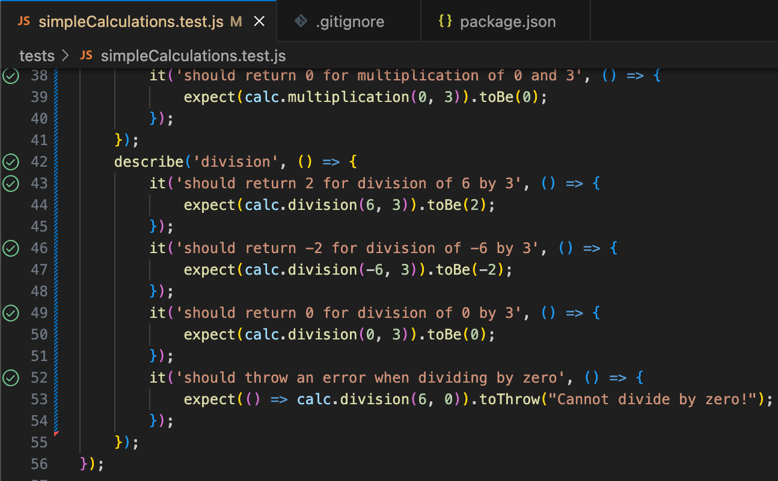

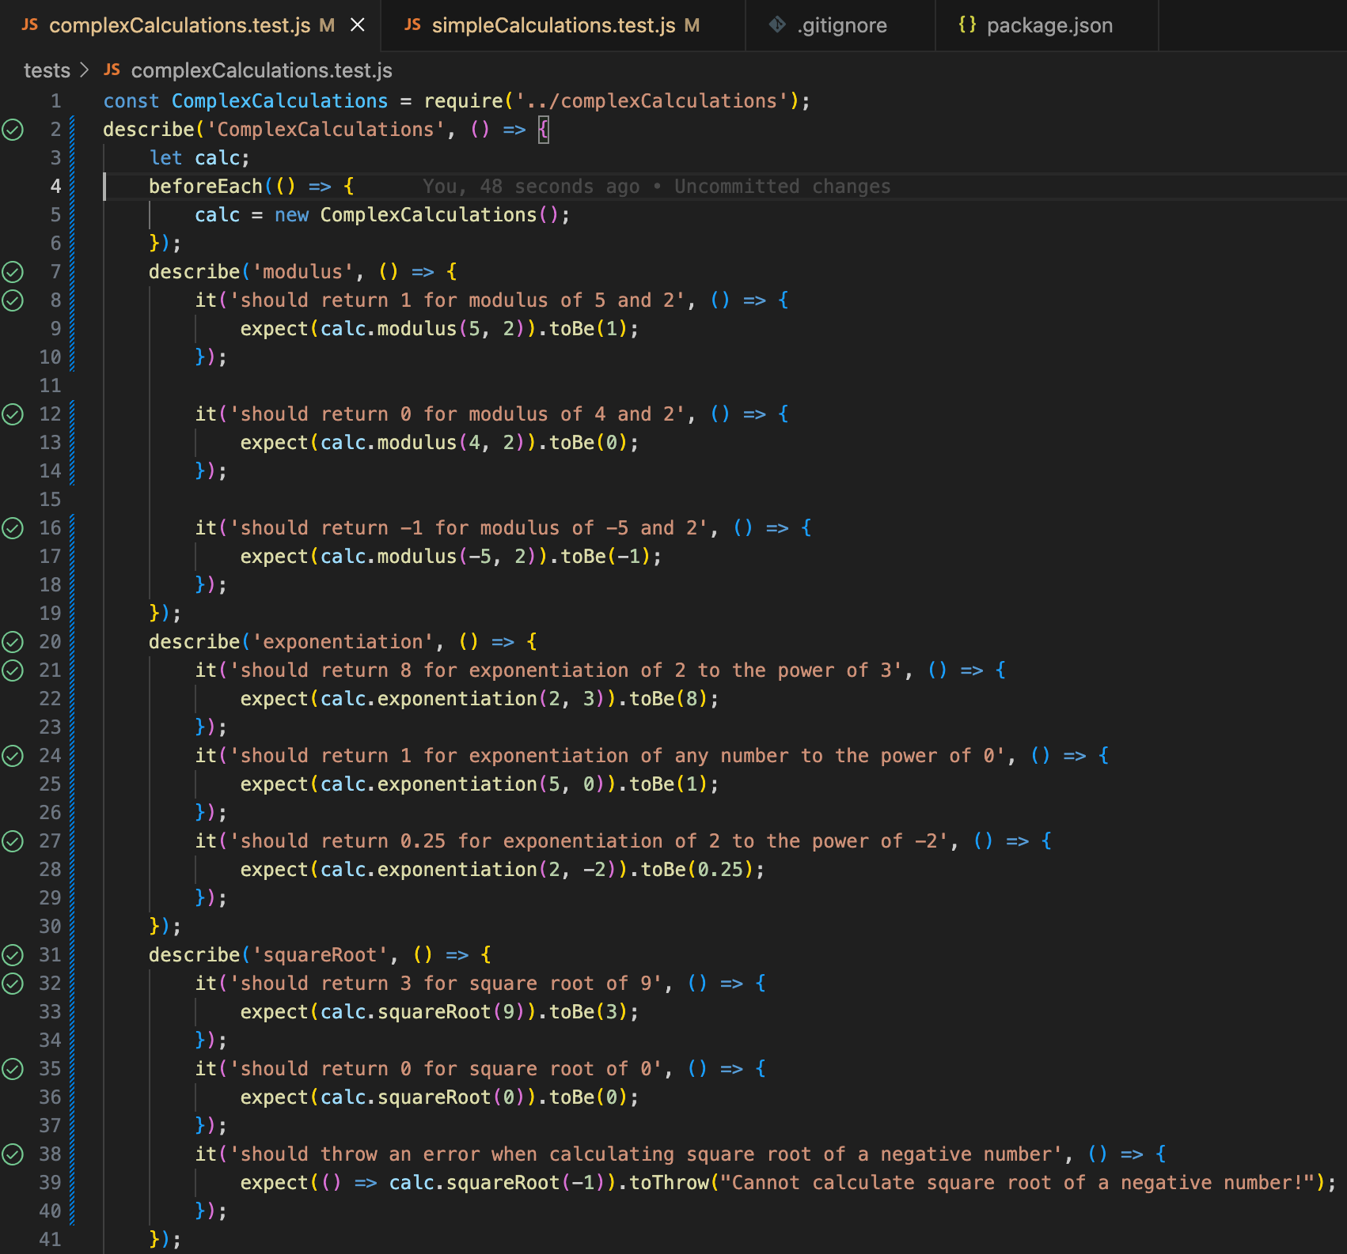

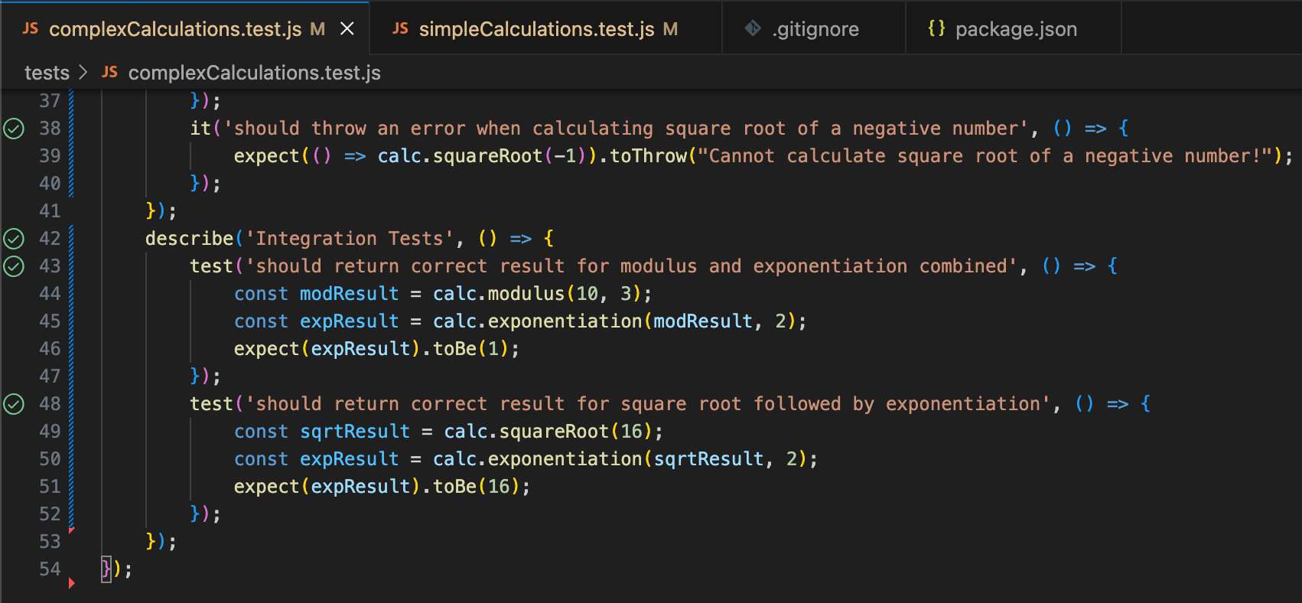

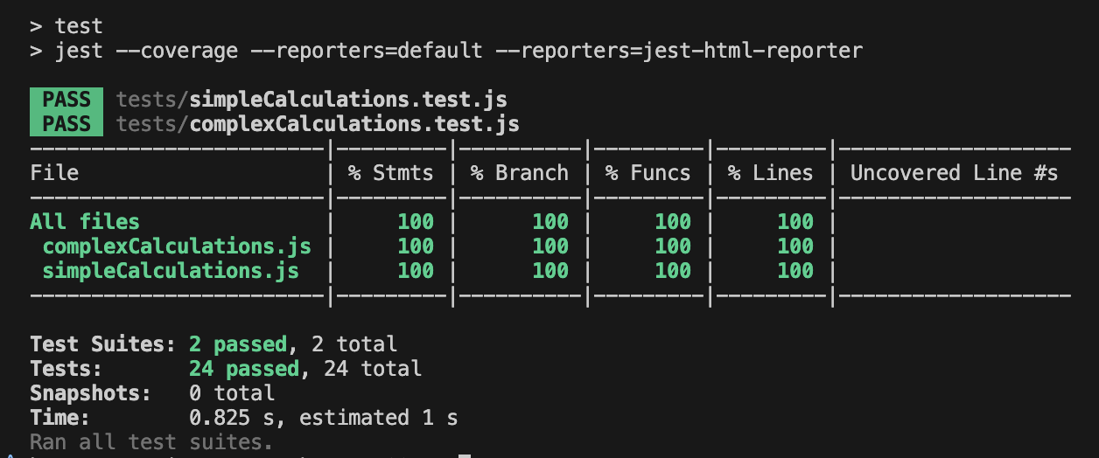

Task 5:
I feel that every software developer should learn to write unit test cases by themselves, at least understanding the basics of unit testing. During my time as a Node.js developer in a company , I worked with complex repositories where writing unit tests was often challenging. My team frequently struggled with mocking functions that were tightly integrated with multiple components. While generative AI tools like ChatGPT and Perplexity are extremelys useful , they sometimes hallucinate or provide incorrect solutions, leading developers to write improper unit test cases. This highlights the importance of having a solid foundational understanding of unit testing principles, as relying solely on AI can result in unreliable or ineffective tests. Mastering these skills ensures that developers can write robust, maintainable, and accurate test cases, even in complex scenarios.

