TASK-1:
Programming language used is JavaScript

File 1: simpleCalculations.js

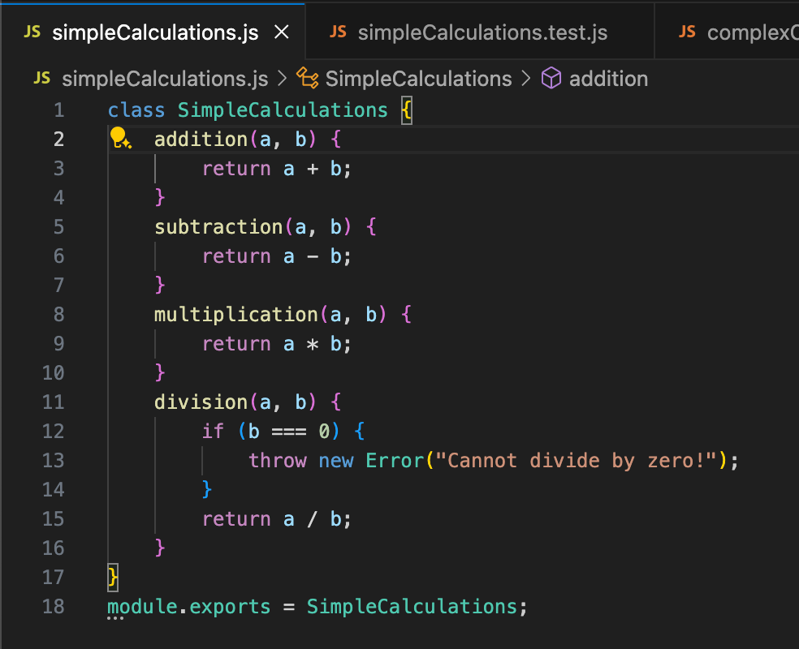

File 2: complexCalculations.js

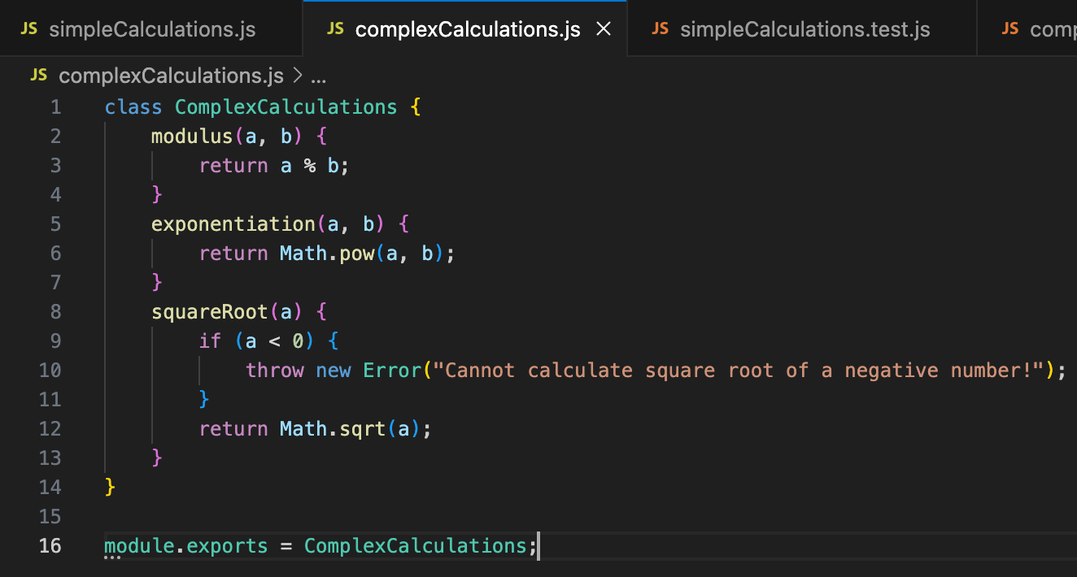

To run the code Please run “node <FileName>” example “node simpleCalculations.js”

Task 2:

When it comes to unit testing in JavaScript, there are several popular frameworks like Jest, Mocha, and Jasmine. After evaluating their features, I chose Jest for its simplicity, power, and ease of use.
One of the main reasons I went with Jest is its zero configuration setup. There is no need to spend time setting up or configuring the testing environment. This is a huge advantage when compared to Mocha and Jasmine.
Jest comes with a built-in test runner, which means I don’t need to install or configure any external tools. In contrast, Mocha requires an external test runner, which adds an extra step in the setup process. While Jasmine has its own test runner.
Another reason for choosing Jest is its built-in assertion library. Jest uses its own expect function for making assertions in tests, which means I don’t need to install third-party libraries like Chai, which Mocha relies on. While Jasmine also comes with its own expect functionality, Jest’s integrated approach feels more streamlined and modern.
Jest shines when it comes to mocking. It provides built-in mocking and spying capabilities, which makes it easy to simulate function calls and track how they are used in tests.
When it comes to testing asynchronous code, Jest is fully equipped to handle async/await, promises, and other asynchronous patterns with ease. Mocha also handles async testing well, but its setup for async operations (like using the done callback) can be a bit more cumbersome. Jasmine also supports async testing but requires callbacks, which can sometimes make tests harder to read and manage.
Jest also offers some unique features that set it apart, such as snapshot testing. This allows you to take "snapshots" of components or data at a certain point in time and compare them in future tests. This is particularly useful for UI testing, where you want to ensure that nothing has changed unexpectedly. Neither Mocha nor Jasmine supports snapshot testing out of the box, which is another reason why Jest was the better choice for my projects.
Additionally, Jest supports parallel test execution, which allows it to run multiple tests at the same time, speeding up the overall testing process. Mocha and Jasmine do not have built-in support for parallel testing, so tests are run sequentially, which can be slower, especially for large test suites.
Finally, Jest has built-in code coverage tracking. It automatically provides detailed code coverage reports without needing any external configuration or tools. Mocha and Jasmine require integration with tools like Istanbul for code coverage, which adds extra steps to the setup and configuration process.
Overall, I chose Jest because it offers a complete, easy-to-use testing solution with everything I need built-in. Its zero configuration setup, powerful mocking, snapshot testing, and parallel test execution make it the most efficient and user-friendly choice. Compared to Mocha and Jasmine, Jest is simply more streamlined and modern, making it the best fit for my JavaScript testing needs.

I used ChatGPT to understand the …………………………., a generative AI tool, to create unit test cases for the calculator application. I provided clear prompts to the AI tool, specifying the functions to be tested and the unit testing framework (Jest). The AI tool generated test cases based on these prompts

Generate Jest unit test cases for a JavaScript class SimpleCalculations with methods for addition, subtraction, multiplication, and division. Include edge cases like division by zero

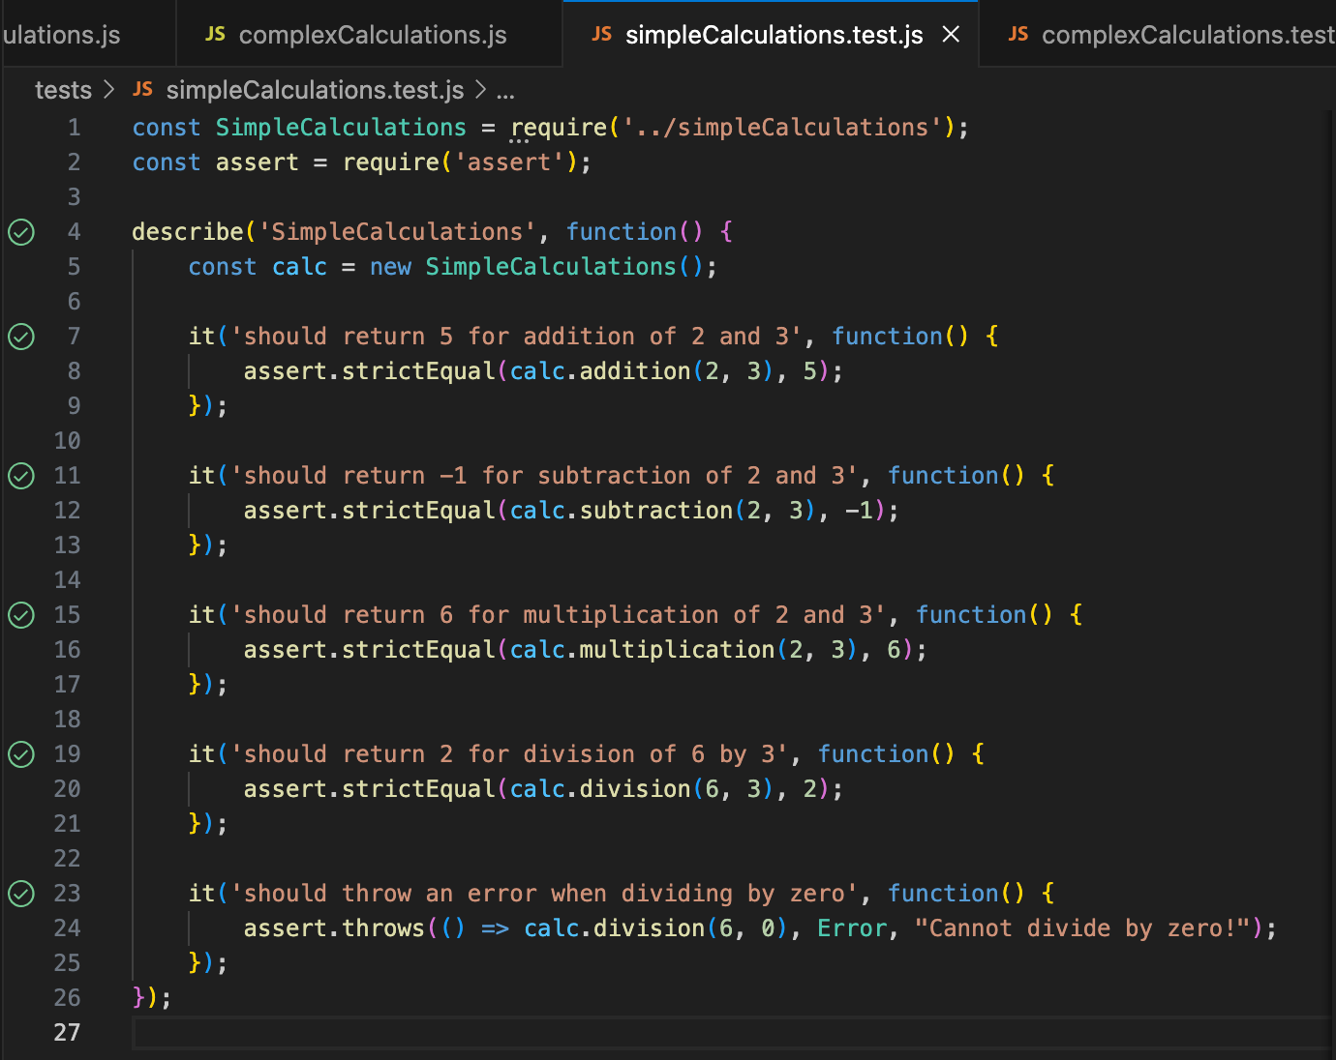

Generate Jest unit test cases for a JavaScript class ComplexCalculations with methods for modulus, exponentiation, and square root. Include edge cases like square root of a negative number.

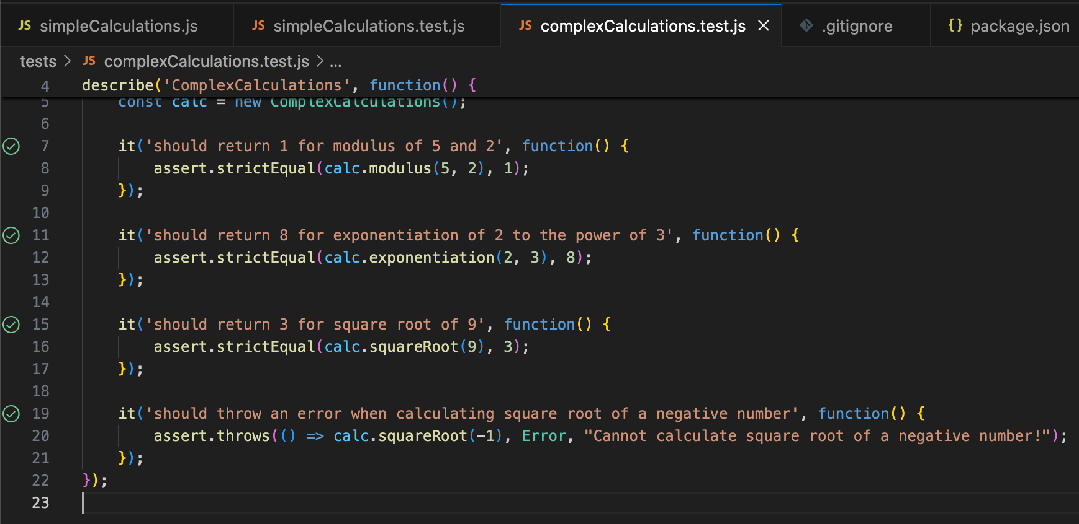

Task 3
Test coverage

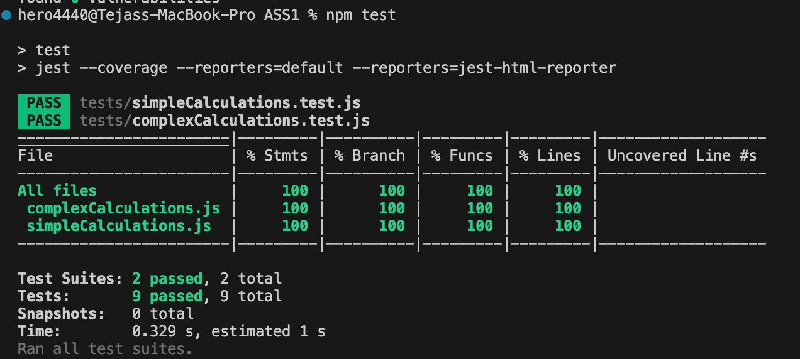

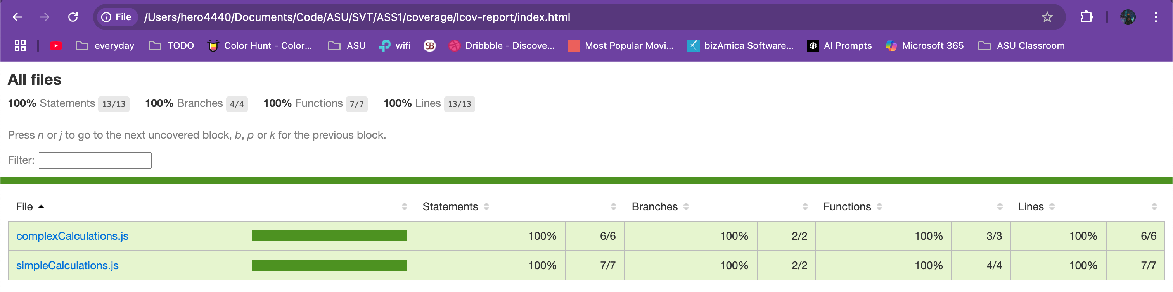

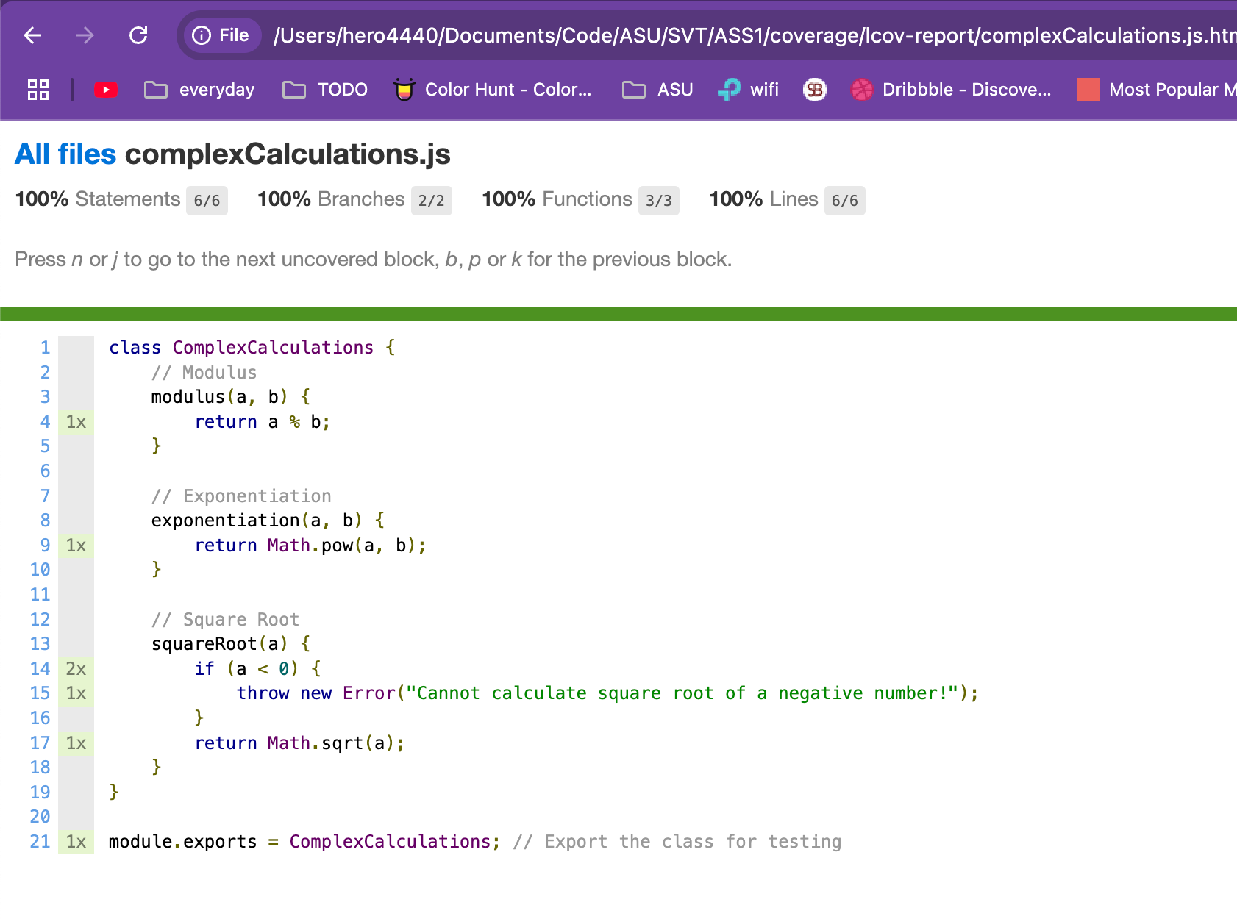


Task 4:
Update the test files to include comprehensive test cases. Ensure the tests cover all edge cases, validate the functionality, and align with the requirements. Use Jest for testing, and include both unit tests and integration tests where applicable. Generate descriptive test names and ensure the code is clean and well-documented.

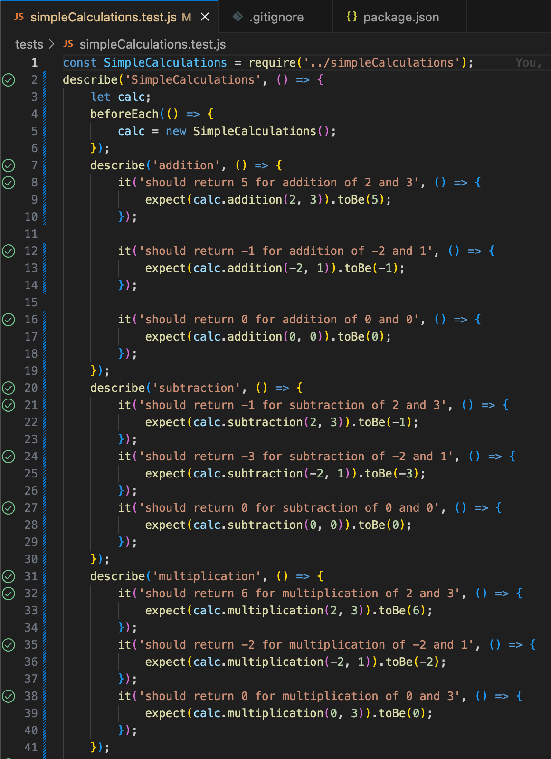

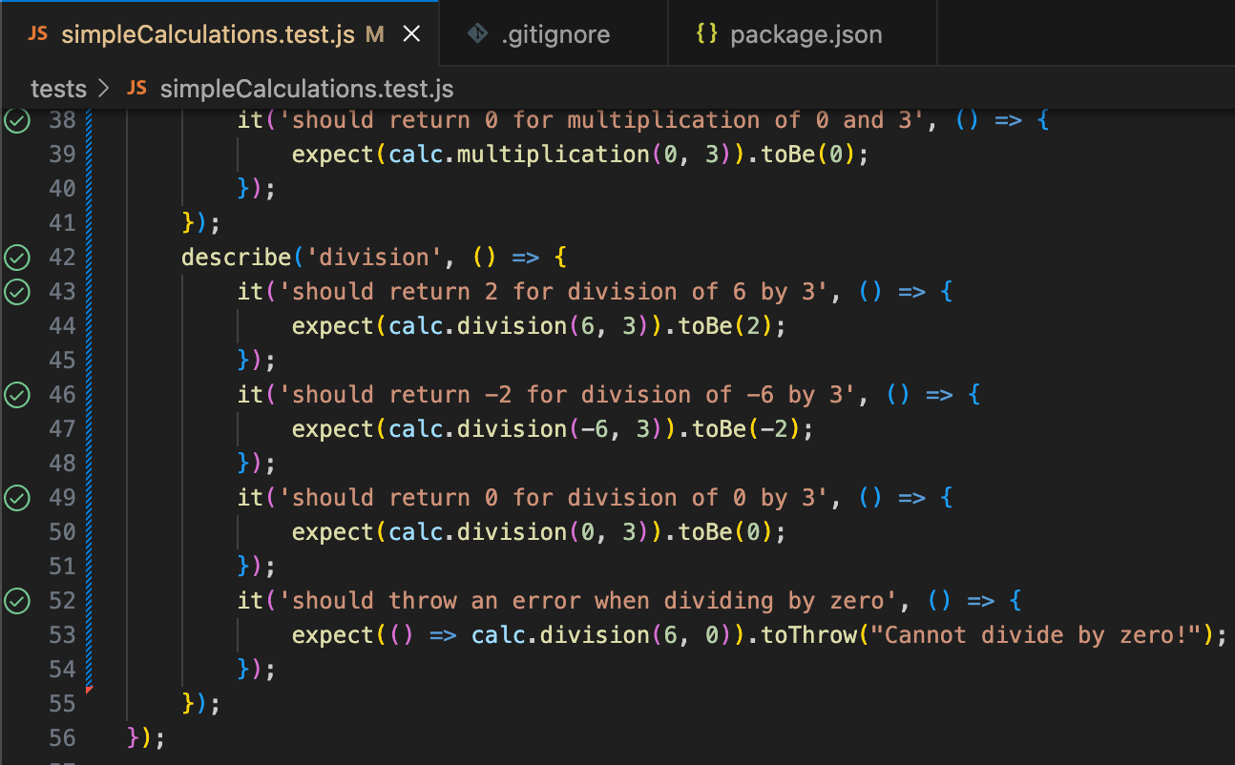

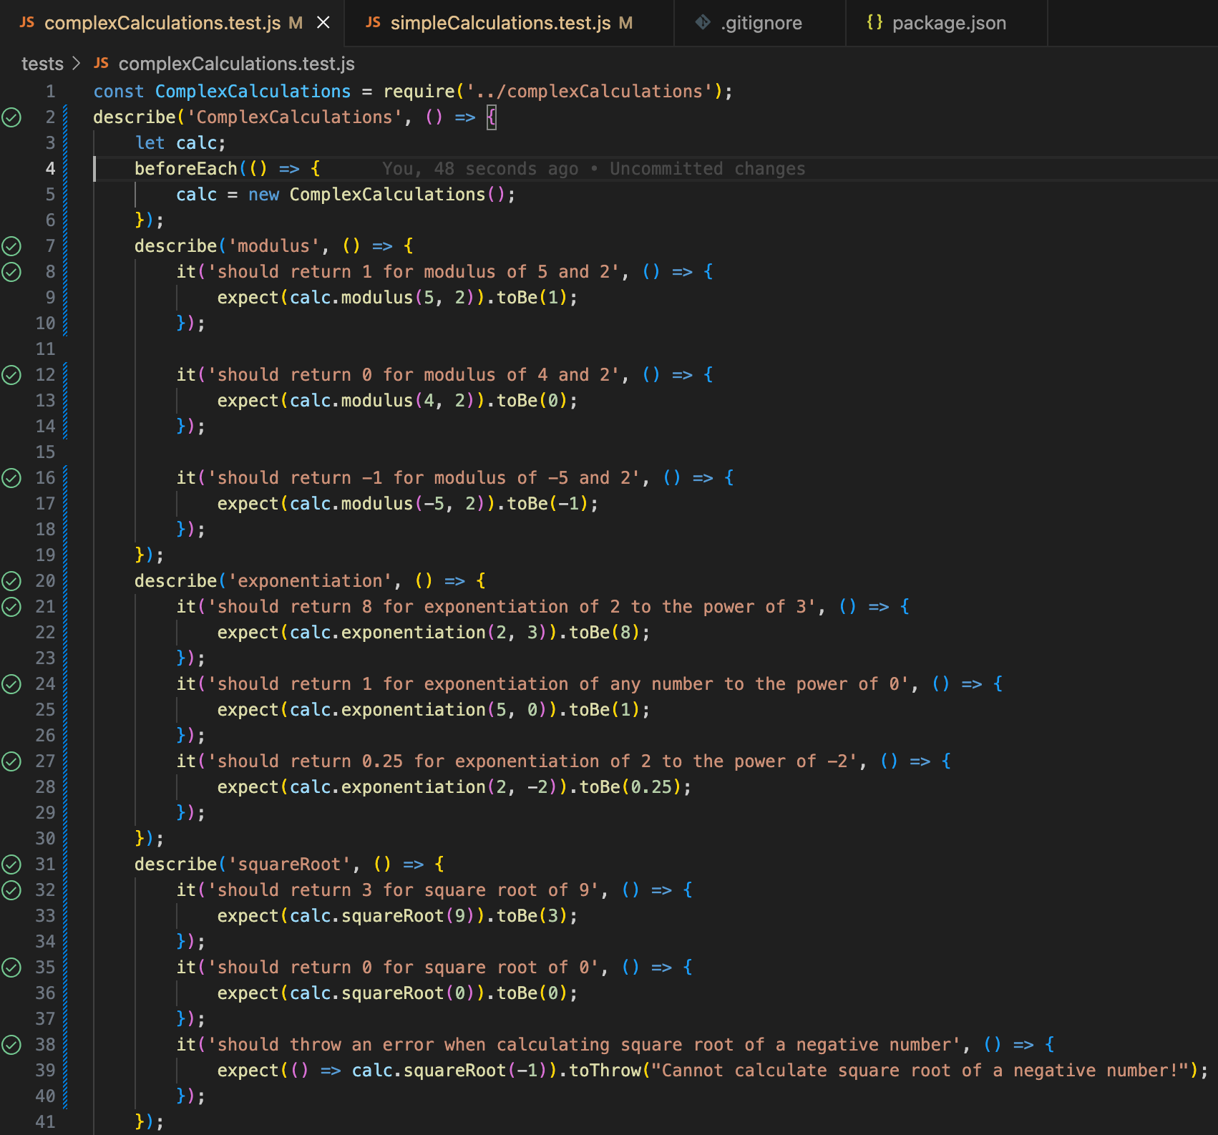

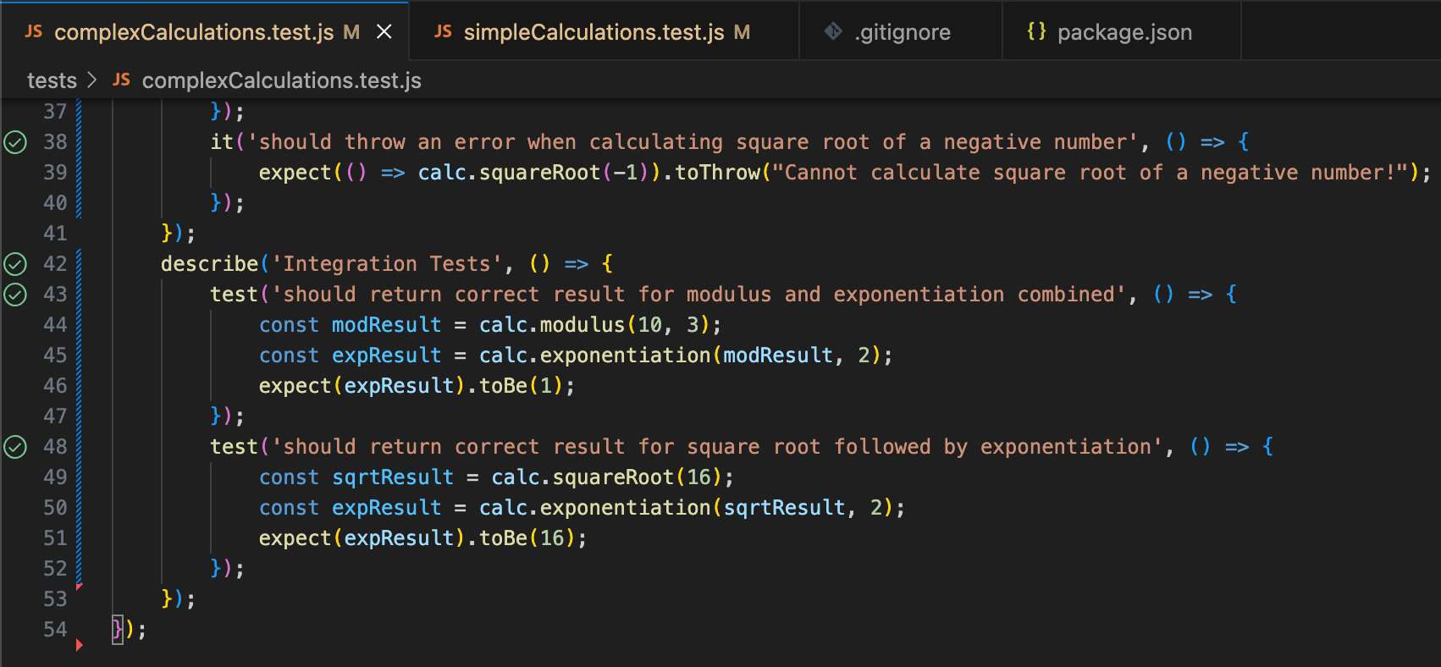

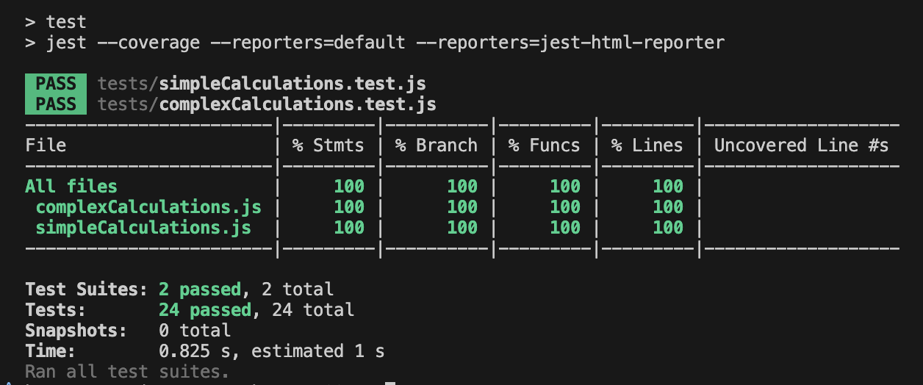

Task 5:
I feel that every software developer should learn to write unit test cases, at least understanding the basics of unit testing. During my time as a Node.js developer in a company , I worked with complex repositories where writing unit tests was often challenging. My team frequently struggled with mocking functions that were tightly integrated with multiple components. While generative AI tools like ChatGPT and Perplexity are extremelys useful , they sometimes hallucinate or provide incorrect solutions, leading developers to write improper unit test cases. This highlights the importance of having a solid foundational understanding of unit testing principles, as relying solely on AI can result in unreliable or ineffective tests. Mastering these skills ensures that developers can write robust, maintainable, and accurate test cases, even in complex scenarios.

