Armada Public Adjusting
213 Della Ct.
Spring Hill, FL 34606
(352) 556-3988



Insured: {insured}

Loss Address: {loss_address}
Claim #: {claim_number}
Policy #: {policy_number}
Date of Loss: {date_of_loss} Cause of loss: {cause_of_loss}

Attention Claims Department:
Please Contact us at (352) 556-3988 or claims@armadapa.com with any questions regarding this loss.

Mailing Address:
14391 Spring Hill Dr
Spring Hill, FL 34609

Please find attached a copy of our Letter of Representation and W9.

Notice to Insurance Company:
Please allow this letter to formally request the following items:

- Opening of the above claim for consideration
- Copy of the insured’s policy to be emailed to claims@armadapa.com and mailed to us.
- Inclusion of our name as payee on all payments
- Payments shall be made to our office at the address above
- All correspondence, calls, questions, etc. should be addressed to Armada Public Adjusting as listed above
- Please ensure that all payments are accompanied by an adjuster’s estimate to facilitate in mortgage company endorsements.
- Notice that Insured intends to comply with all conditions under the policy that would require replacement cost value to be fully recoverable and any time limit to comply only begins to run upon payment of insurance proceeds.

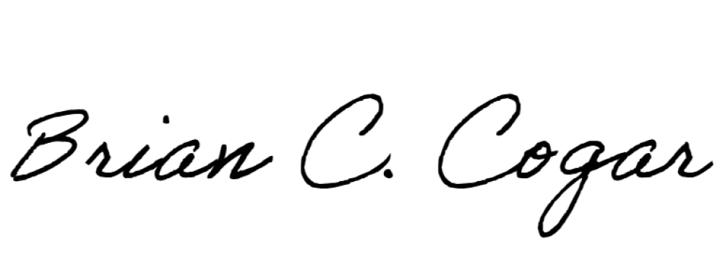
Thank you,

Brian Cogar – W393299
Principal Public Adjuster

