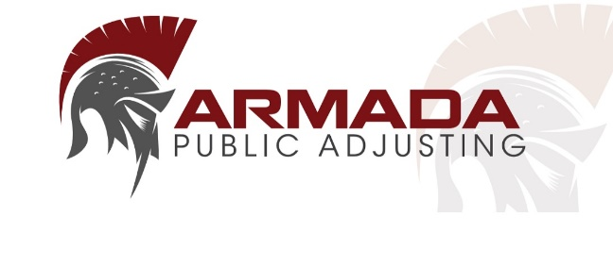
Armada Public Adjusting
(352) 556-3988
License#: W393299
213 Della Ct.
Spring Hill, FL 34606

Re: Welcome Letter
Insured:
Policy Number:
Claim Number:
Date of Loss:
Insured Location:

Welcome Letter
(Important, please read until the end)

Dear ____,

We would like to thank you for selecting Armada Public Adjusting to represent you in handling your insurance claim. Our team understands that you have suffered a loss and realize that you may be encountering difficult and frustrating times. Nevertheless, we want to assure you that we value your business and will work diligently to achieve results. It is important that you recognize that neither I, nor any public adjuster can guarantee the outcome of your claim. If the insurance carrier calls you directly, please let them know you are being represented by a public adjuster and direct all communications towards our office.

In an effort to make this process smooth, please review the list below and if you already haven’t provided, please send us these documents. Also, if you need EMS services like a roof tarp, mold testing, water dry out etc. We can provide you a list of contractors or you are free to hire whomever you like, just be sure to take photos and notify your adjuster. Also, if you have additional living expenses like food spoilage, food costs, hotel and lodging, etc., please make an excel spreadsheet and submit supporting documents to us.

- Any claim documents sent via email or mail – including requests for information or proof of loss requests
- Before and after photos of the damaged property
- If a water loss- save photos of the pipe, and send us any plumbers invoices or receipts
- Invoices/Receipts/Contracts/Estimates for repairs related to the claim
- Prior Claims – Let us know if you have any prior claims with similar damages or if you were unhappy with your settlement.

Please be advised that will be meeting and working with the insurance company’s claims representative(s) to recover the money you are owed. Once your claim is filed the insurance company has 90 days to inspect and make a claims determination. As your public adjuster, we will prepare a detailed repair estimate of the damage and assist you in responding to any requests for information from your insurance company. After your insurance company makes a claims determination, we will begin negotiating on your behalf. Your insurance company will then either make a settlement offer on your claim, which we will accept or deny. We are by your side either way, and as the next step we will keep attempting to negotiate a settlement on your behalf. Generally, through appraisal, mediation, and/or litigation, we’ve been able to consistently get favorable claim settlements. Finally, the last step is the claim payout which is the best part. We always strive to get you the most for your damage, every time.

Periodically, you will be updated by your adjuster or our office as to the status of the claim. Typically, it takes 45- 60 days to get a significant response from your insurance carrier. We will provide you updates based upon the progress of your case via email, telephone, or U.S. Mail. Should you desire an update at any given time, please contact our office.

*Important Reminder* If you plan to sell the property of which the insurance claim was made or if you plan to make repairs to the property, you need to inform us of your plans to sell and/or repair the property immediately as there may be consequences for your claim which we will need to discuss with you. Please take before and after photos before any repairs are made and save all receipts. Please do not discard anything until after the insurance company had an opportunity to inspect the loss.

At this time Armada Public Adjusting would like to remind you that we are solely representing you and your best interests throughout the claims process. We are in no way affiliated with any carrier(s) or vendor(s) whom may also be involved in your insurance claim, including restoration services. Please keep in mind that any contract you may enter into with any vendor is solely your responsibility.

We thank you for showing your confidence in Armada Public Adjusting to assist you with your loss. We will work hard to make sure you receive the most fair and just settlement possible.

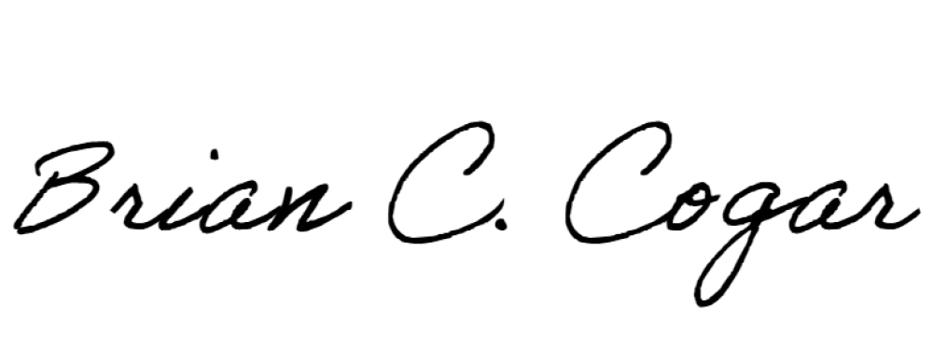
Sincerely,

Brian Cogar – Principal Adjuster
Armada Public Adjusting

