1. INTRODUCTION

1.1 Background and Motivation
The growing global demand for electrical energy, together with increasing environmental concerns and international climate commitments, has significantly accelerated the development of renewable energy technologies. Reducing greenhouse gas emissions and transitioning toward sustainable energy systems have become major priorities worldwide. Among the available renewable energy sources, wind energy has become one of the most mature and economically viable options for large-scale electricity generation.
Modern horizontal-axis wind turbines are designed to convert the kinetic energy of wind into electrical energy with high efficiency. Progress in aerodynamics, materials engineering, power electronics, and control technology has considerably improved the reliability and performance of wind turbines under a wide range of operating conditions.
However, despite these technological advances, wind energy conversion systems remain strongly affected by the variable and nonlinear nature of wind. Wind speed changes continuously over time, causing fluctuations in aerodynamic forces, mechanical torque, rotor speed, and generated power. These variations can reduce energy conversion efficiency, increase structural loads, shorten component lifetime, and affect the overall stability of the power system. For this reason, effective control strategies are essential for ensuring safe operation, improving performance, and maximizing energy extraction.
In variable-speed wind turbine systems operating below rated wind speed, maximum power extraction is commonly achieved using Maximum Power Point Tracking (MPPT) techniques. The purpose of MPPT is to maintain the turbine near its optimal operating point, usually corresponding to the optimal tip-speed ratio, so that the maximum available wind power can be captured. To support this objective, classical feedback controllers such as proportional-integral (PI) and proportional-integral-derivative (PID) controllers are widely used because of their simple structure, robustness, and ease of implementation.
Nevertheless, wind turbines are inherently nonlinear systems due to the nonlinear relationship between aerodynamic power, tip-speed ratio, and blade pitch angle, as well as the continuous variation of wind speed. Under such conditions, the performance of conventional linear controllers may deteriorate, leading to slower dynamic response, increased oscillations, and reduced energy capture.
To overcome these limitations, intelligent control methods have attracted increasing attention in recent years. Among them, fuzzy logic control is considered a promising approach for handling nonlinear and uncertain systems. Unlike conventional controllers, fuzzy logic controllers do not require a highly accurate mathematical model and can incorporate expert knowledge through linguistic control rules. This makes fuzzy logic control particularly suitable for wind turbine applications, where system nonlinearities and external disturbances play a significant role.

1.2 Problem Statement
Wind turbine systems operate under highly variable and uncertain wind conditions, which makes efficient control a challenging task. Since wind speed changes continuously over time, the aerodynamic power available to the turbine also varies continuously. As a result, the wind turbine must be able to adapt its operating conditions in order to maintain stable performance and maximize energy extraction.
In variable-speed wind turbines, the amount of power captured from the wind depends strongly on the aerodynamic characteristics of the turbine, particularly the power coefficient CpC_pCp​, which is a nonlinear function of the tip-speed ratio λ\lambdaλ and the blade pitch angle β\betaβ. For each turbine, there exists an optimal tip-speed ratio at which the aerodynamic efficiency reaches its maximum value. Maintaining operation near this optimal point is therefore essential for achieving maximum power extraction.
In the below-rated wind speed region, this objective is commonly achieved using Maximum Power Point Tracking (MPPT) combined with generator torque control. The purpose of MPPT is to generate the reference operating condition corresponding to the maximum available power, while the controller regulates the turbine response to follow this reference. However, because the wind turbine is a nonlinear system and wind conditions are constantly changing, maintaining accurate tracking and stable operation remains difficult.
Classical control methods, such as PI controllers, are widely used because of their simple structure and ease of implementation. Nevertheless, their performance may deteriorate when the turbine is subjected to rapidly varying wind speeds and nonlinear operating conditions. This can lead to oscillations, slower dynamic response, and reduced efficiency in power extraction.
Therefore, there is a need for a control strategy that can improve tracking performance and maintain efficient operation under variable wind conditions. In this thesis, a classical MPPT–PI control strategy is used as a baseline method and compared with a fuzzy logic control approach. The aim is to investigate whether fuzzy logic control can provide better adaptability and improved performance for wind turbine efficiency optimization.

1.3 Aim and Objectives of the Thesis
The main objective of this diploma thesis is to design, implement, and evaluate a fuzzy logic control strategy for the dynamic optimization of wind turbine efficiency under variable wind conditions.
To accomplish this objective, the following tasks are carried out:
- To analyze the dynamic behavior of a horizontal-axis wind turbine system.
- To develop a nonlinear mathematical model of the wind turbine, including its aerodynamic power conversion characteristics and rotor dynamics.
- To implement the developed model in the MATLAB/Simulink environment for simulation purposes.
- To design a classical control strategy based on Maximum Power Point Tracking (MPPT) and PI control for generator torque regulation.
- To develop a fuzzy logic controller aimed at improving tracking performance and system robustness.
- To evaluate and compare the performance of the classical and fuzzy control strategies based on dynamic response and energy efficiency criteria.

1.4 Methodology
The methodology of this thesis is based on mathematical modelling and simulation-based analysis. The study begins with the development of a nonlinear wind turbine model derived from the fundamental principles of wind energy conversion and rotor dynamics. The aerodynamic part of the model is described using the power coefficient function, which depends on the tip-speed ratio and blade pitch angle. The mechanical behavior of the turbine is represented by the rotor dynamic equation, where the aerodynamic torque and generator torque determine the rotor speed response.
The developed mathematical model is implemented in the MATLAB/Simulink environment in order to simulate the dynamic behavior of the wind turbine under variable wind conditions. Based on this model, a classical control strategy combining Maximum Power Point Tracking (MPPT) and PI control is designed and used as a reference approach for maximum power extraction and generator torque regulation.
After that, a fuzzy logic controller is developed to improve turbine performance under changing wind conditions. The fuzzy controller is designed using the Mamdani inference method and implemented in MATLAB/Simulink with the Fuzzy Logic Toolbox. Its performance is evaluated under the same simulation conditions as the classical controller.
Simulation tests are carried out using variable wind speed profiles representing realistic operating conditions. The control strategies are evaluated and compared using selected performance indicators, such as tracking accuracy of the optimal tip-speed ratio, rotor speed response, torque smoothness, and overall energy extraction efficiency. On the basis of these results, the effectiveness of the fuzzy logic controller is assessed relative to the classical MPPT–PI control strategy.

1.5 Structure of the Thesis
The thesis is structured as follows:
- Chapter 2 provides the theoretical background of wind turbine systems, including wind energy conversion principles, turbine components, and operating regions.
- Chapter 3 presents the nonlinear mathematical model of the wind turbine system developed for simulation and control purposes.
- Chapter 4 describes the classical control strategy based on Maximum Power Point Tracking (MPPT) and PI control, together with its implementation in MATLAB/Simulink.
- Chapter 5 presents the design and implementation of the fuzzy logic controller.
- Chapter 6 discusses the simulation results and provides a comparative analysis of the classical and fuzzy control strategies.
- Chapter 7 summarizes the main findings of the thesis and suggests possible directions for future work.

CHAPTER 2

Wind Turbine System Overview

2.1 Principle of Wind Energy Conversion

Wind turbines generate electricity by converting the kinetic energy of moving air into mechanical rotational energy, which is then transformed into electrical energy by an electric generator. Air movement in the atmosphere occurs mainly because the Earth’s surface is heated unevenly by solar radiation. This uneven heating creates pressure differences that drive wind currents, and these currents contain significant kinetic energy.
The theoretical power contained in the airflow passing through the rotor area of a wind turbine can be described by the following relationship:
Pw=12ρAv3P_w = \frac{1}{2}\rho A v^3Pw​=21​ρAv3
where:
• ρ\rhoρ is the air density (kg/m3)(kg/m^3)(kg/m3)
• AAA is the rotor swept area (m2)(m^2)(m2)
• vvv is the wind speed (m/s)(m/s)(m/s)
The rotor swept area represents the circular area covered by the rotating blades and is defined as:
A=πR2A = \pi R^2A=πR2
where RRR is the radius of the turbine blades.
Because power depends on the cube of the wind speed, even small increases in wind velocity can lead to large increases in available power. However, it is impossible for a wind turbine to extract all the kinetic energy from the wind. According to Betz’s law, the maximum theoretical efficiency of a wind turbine is about 59.3%. This limitation exists because the air must continue moving after passing through the rotor to allow continuous airflow.
The mechanical power actually captured by the turbine rotor is expressed as:
Pt=12ρACp(λ,β)v3P_t = \frac{1}{2}\rho A C_p(\lambda,\beta) v^3Pt​=21​ρACp​(λ,β)v3
where:
• CpC_pCp​ is the power coefficient
• λ\lambdaλ is the tip-speed ratio
• β\betaβ is the blade pitch angle
The power coefficient CpC_pCp​ represents the aerodynamic efficiency of the turbine. It depends nonlinearly on both the tip-speed ratio and the blade pitch angle. In real wind turbines, CpC_pCp​ is always lower than the Betz limit because of aerodynamic losses, blade imperfections, and mechanical inefficiencies.
The tip-speed ratio is defined as:
λ=Rωrv\lambda = \frac{R\omega_r}{v}λ=vRωr​​
where ωr\omega_rωr​ is the rotor’s angular velocity (rad/s)(rad/s)(rad/s).
Each turbine design has a specific optimal tip-speed ratio λopt\lambda_{opt}λopt​ at which the power coefficient reaches its maximum value. Operating the turbine near this optimal ratio enables the system to extract the maximum possible energy from the wind.

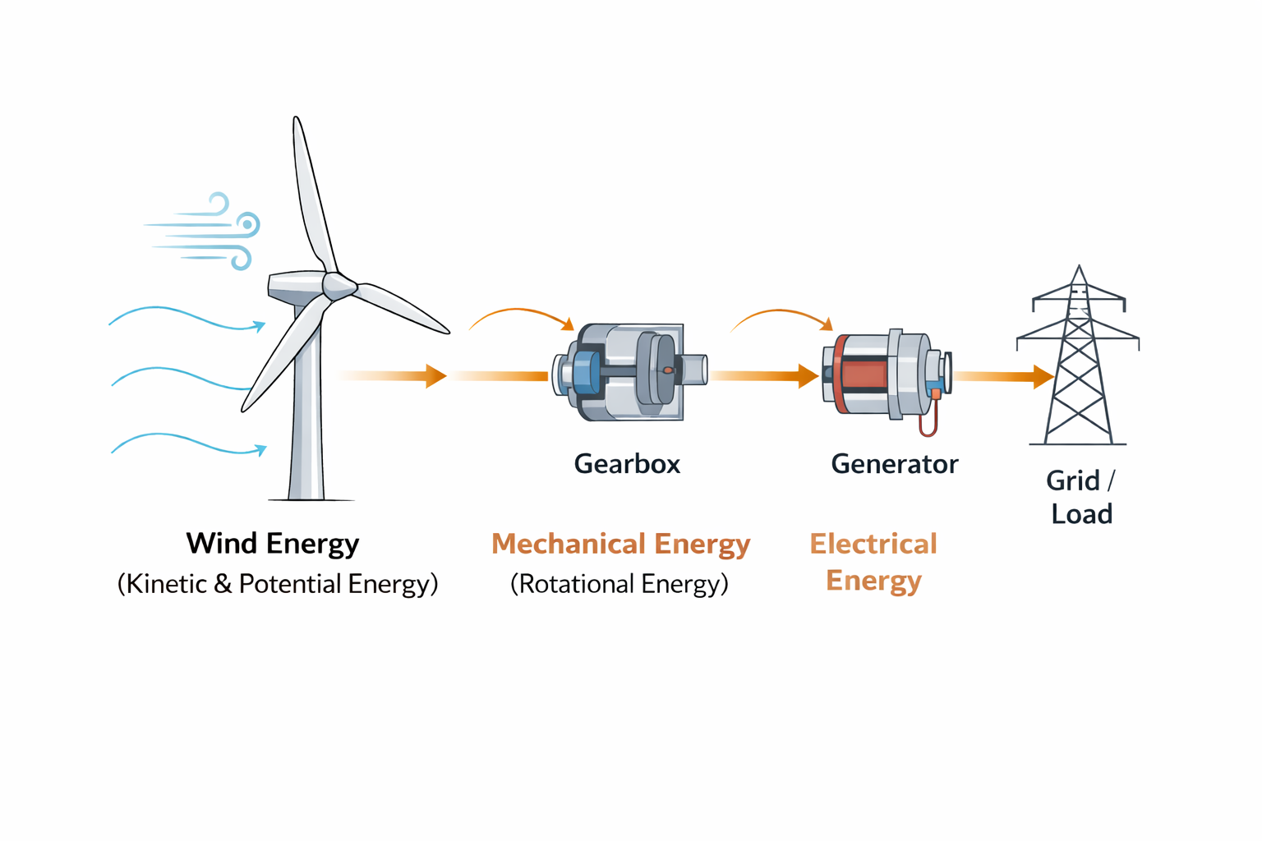
Figure 2.1
Energy conversion process in a wind turbine.

2.2 Main Components of a Wind Turbine
Modern horizontal-axis wind turbines consist of several mechanical and electrical subsystems that operate together to convert wind energy into usable electrical power.
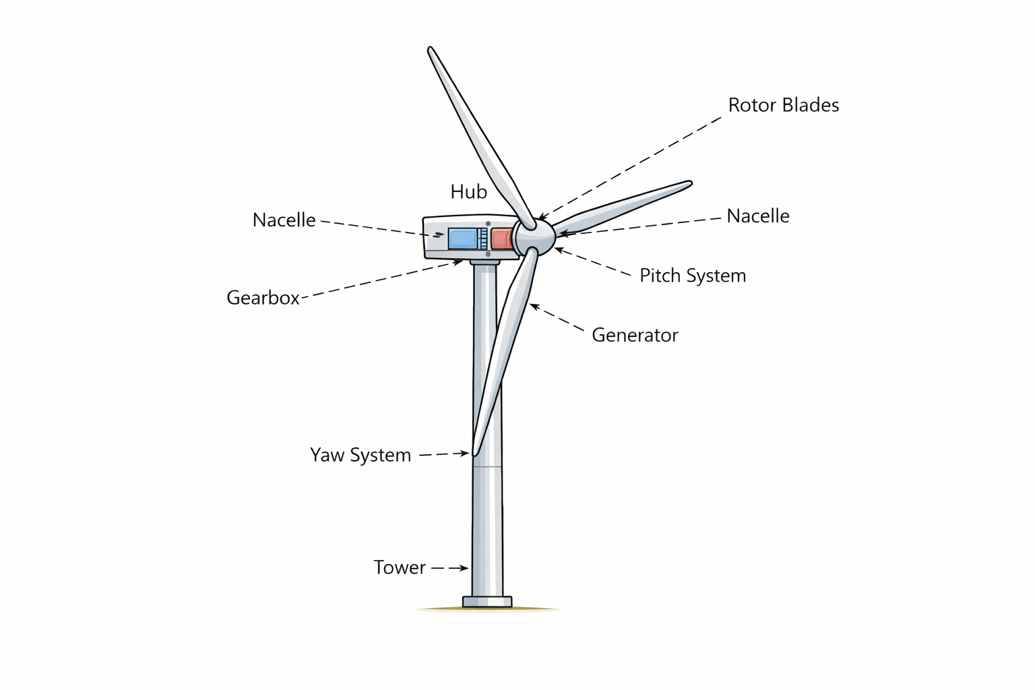
Figure 2.2
Main components of a horizontal-axis wind turbine.

Rotor Blades
Rotor blades are responsible for capturing the kinetic energy of the wind. The aerodynamic shape of the blades generates lift forces when wind flows over their surfaces, causing the rotor to rotate. Blade geometry and aerodynamic design strongly influence the efficiency and dynamic performance of the turbine.

Hub and Main Shaft
The hub connects the rotor blades to the main shaft. The main shaft transfers mechanical torque generated by the rotor to the drivetrain system. In variable-speed wind turbines, shaft dynamics can significantly influence system stability and transient behavior.

Gearbox
Many conventional wind turbines include a gearbox that increases the low rotational speed of the rotor to the higher rotational speed required by the electrical generator. Although gearboxes improve generator efficiency, they also introduce additional mechanical complexity and potential sources of mechanical losses and vibrations.
Some modern wind turbines utilize direct-drive generators, which eliminate the gearbox and reduce mechanical losses and maintenance requirements.

Generator
The generator converts mechanical rotational energy into electrical energy. Common generator technologies used in wind turbines include:
- Doubly-fed induction generators (DFIG)
- Permanent magnet synchronous generators (PMSG)
The generator dynamics play an important role in the electrical behavior of the wind energy conversion system.

Pitch Control System
The pitch control system adjusts the blade pitch angle β\betaβ. By rotating the blades around their longitudinal axis, the aerodynamic efficiency of the turbine can be controlled. Pitch control is primarily used at higher wind speeds to regulate power output and protect the turbine from excessive mechanical loads.

Yaw System
The yaw system rotates the nacelle so that the rotor remains aligned with the wind direction. Proper alignment maximizes aerodynamic efficiency, while misalignment can reduce power production.

2.3 Operating Regions of a Wind Turbine
Wind turbines operate in several distinct regions depending on wind speed. Each region requires a different control objective and operational strategy.

Region I – Below Rated Wind Speed
In this region, the wind speed lies between the cut-in speed and the rated wind speed. The primary objective in this region is to maximize energy capture. This is achieved by maintaining the optimal tip-speed ratio
λ=Rωrv\lambda = \frac{R \omega_r}{v}λ=vRωr​​
To maintain the optimal tip-speed ratio λopt\lambda_{opt}λopt​, the rotor speed must vary proportionally with wind speed. Generator torque control is commonly used to track the maximum power point (MPPT).
During this operating region, the blade pitch angle is typically kept constant at
β=0∘\beta = 0^\circβ=0∘

Region II – Above Rated Wind Speed
When wind speed exceeds the rated value, the mechanical power captured from the wind would exceed the generator's rated capacity if left uncontrolled. Therefore, the control objective shifts from maximizing power extraction to regulating the power output.
In this region, the blade pitch angle β\betaβ is adjusted to reduce aerodynamic efficiency and maintain constant rated power output. Pitch control introduces nonlinear dynamics due to actuator response and aerodynamic coupling.

Region III – Cut-Out Region
At very high wind speeds, the wind turbine is shut down to prevent structural damage. This operating region ensures safe turbine operation during extreme environmental conditions.

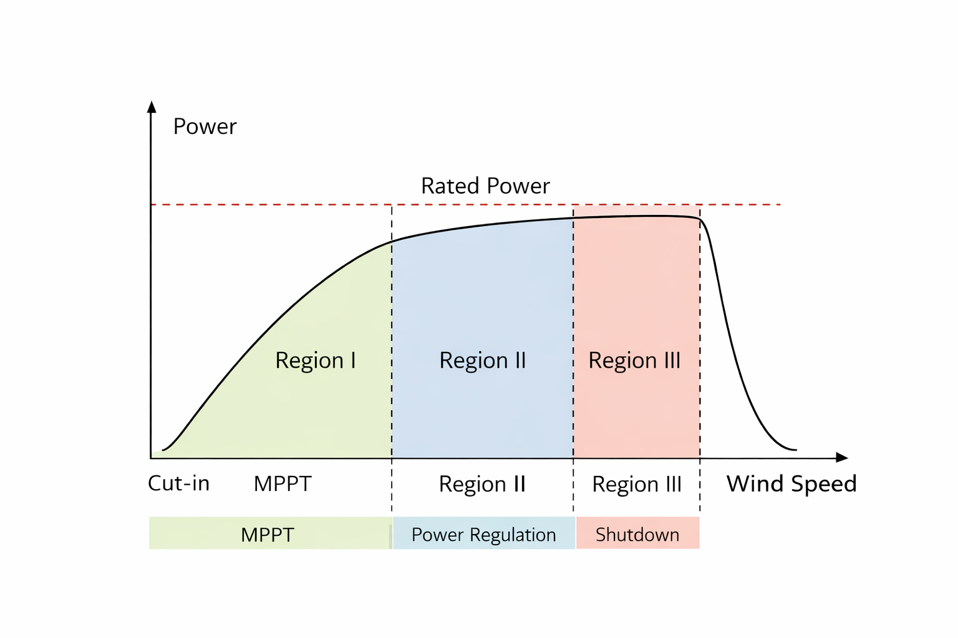
Figure 2.3 – Wind turbine power curve and operating regions.

2.4 Dynamic Characteristics of the Wind Turbine
Wind turbine systems exhibit complex dynamic behavior due to the interaction between several interconnected subsystems, including the aerodynamic, mechanical, electrical, and control subsystems. These subsystems operate simultaneously and exchange energy and information during the wind energy conversion process. As a result, the overall system exhibits nonlinear and multi-domain dynamics that must be carefully considered during controller design. The interaction between these subsystems is illustrated in Figure 2.4.
The aerodynamic subsystem converts the kinetic energy of the wind into aerodynamic torque acting on the turbine rotor. This process is governed by the aerodynamic power coefficient Cp(λ,β)C_p(\lambda,\beta)Cp​(λ,β), which depends on the tip-speed ratio λ\lambdaλ and the blade pitch angle β\betaβ. The generated aerodynamic torque drives the mechanical subsystem, which includes the rotor, drivetrain, gearbox, and generator shaft.
The mechanical subsystem transmits rotational motion from the rotor to the generator while also introducing additional dynamic effects such as shaft elasticity and torsional oscillations. These mechanical dynamics influence the rotational speed of the turbine and directly affect the electrical subsystem.
The electrical subsystem converts mechanical energy into electrical power through the generator and associated power electronics. The generated electrical power is then delivered to the grid or connected load. The electrical subsystem is also influenced by control inputs that regulate generator torque and system stability.
In addition to these energy conversion processes, the wind turbine system includes a control subsystem responsible for regulating turbine operation under varying wind conditions. Control inputs such as blade pitch angle and generator torque are used to maintain stable operation, maximize energy extraction, and protect the turbine from excessive mechanical loads.
Several important dynamic characteristics arise from the interaction of these subsystems, including:
• nonlinear aerodynamic behavior caused by the power coefficient function Cp​(λ,β)
• coupling between rotor mechanical dynamics and generator electrical dynamics
• torsional oscillations and elastic behavior in the drivetrain system
• sensitivity to stochastic and rapidly varying wind disturbances
• actuator dynamics associated with pitch control and generator torque control.
These nonlinear and strongly coupled dynamics make wind turbine control a challenging problem. Classical linear control strategies can provide acceptable performance near specific operating points; however, their effectiveness may decrease when the turbine operates under rapidly changing wind conditions.
For this reason, advanced control techniques capable of handling nonlinear behavior and system uncertainties have received significant attention in recent years. Among these techniques, fuzzy logic control offers a promising approach for improving wind turbine performance under variable wind conditions. The design and implementation of such advanced control strategies will be discussed in the following chapters.
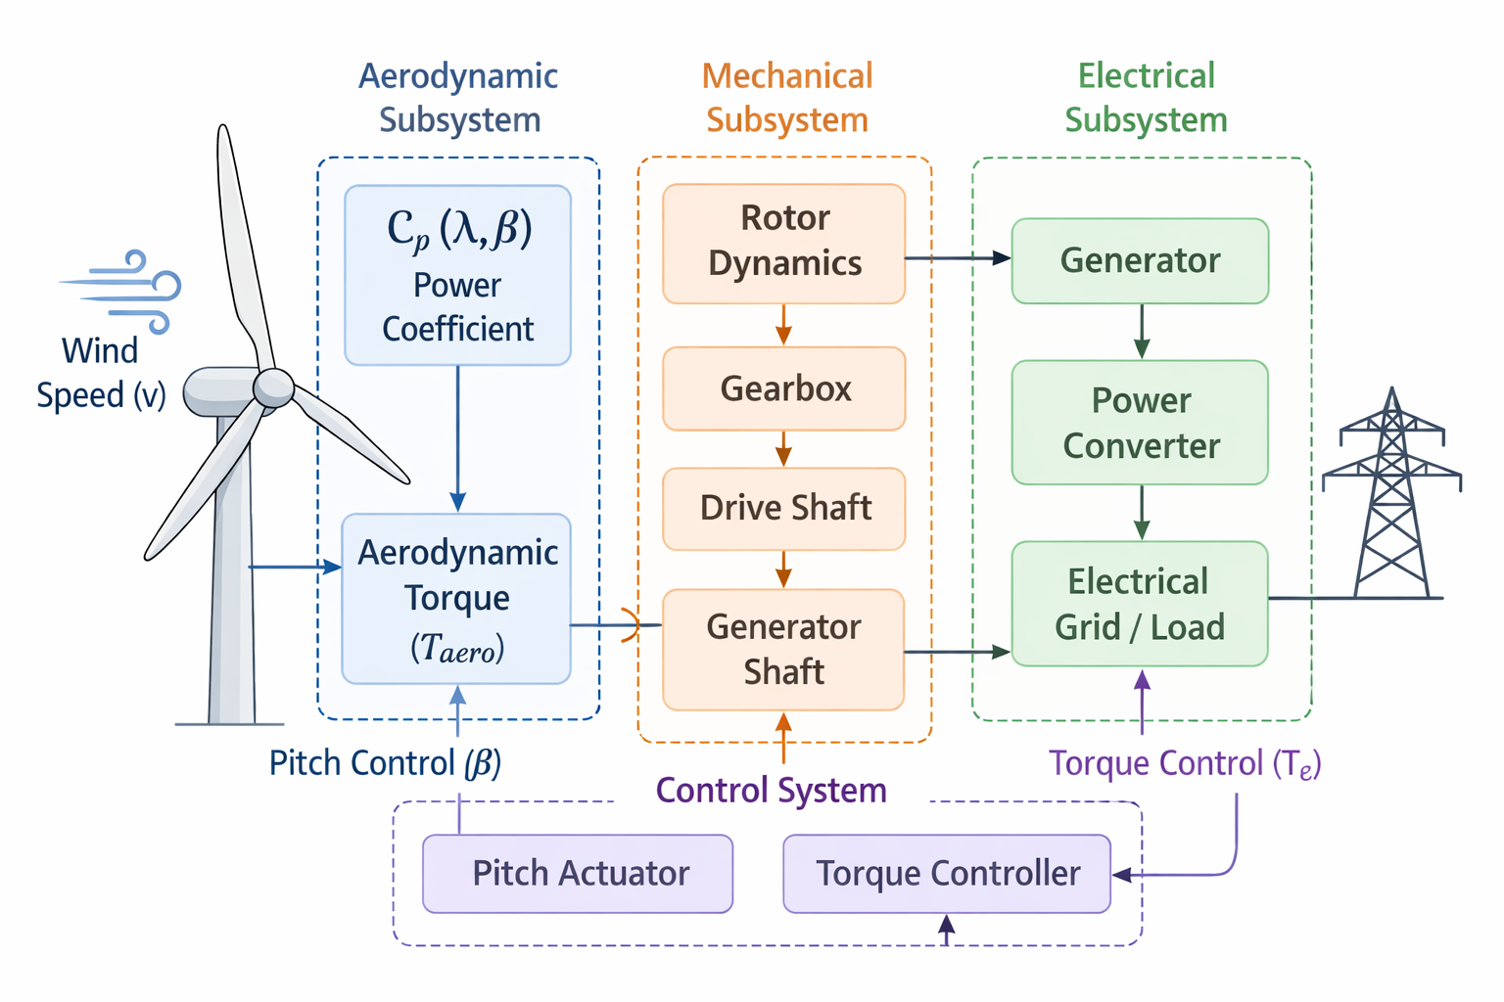
Figure 2.4 – Interaction of aerodynamic, mechanical, electrical, and control subsystems in a wind turbine system.
CHAPTER 3
Mathematical Modeling of the Wind Turbine System
3.1 Introduction
Wind turbines convert the kinetic energy of wind into mechanical energy and subsequently into electrical energy. The efficiency of this conversion process depends strongly on the aerodynamic characteristics of the turbine and its operating conditions. To design an effective control system capable of optimizing turbine performance, it is essential to develop an accurate mathematical model of the turbine dynamics.
This chapter presents the mathematical modeling of the wind turbine system used in this research. The model describes the relationship between wind speed, aerodynamic power extraction, rotor dynamics, and mechanical torque. The derived equations are implemented in the MATLAB/Simulink environment to simulate turbine behavior under variable wind conditions.
The developed model forms the plant model for the control system design described in later chapters. The overall structure of the mathematical model of the wind turbine system used in this work is illustrated in Figure 3.1.
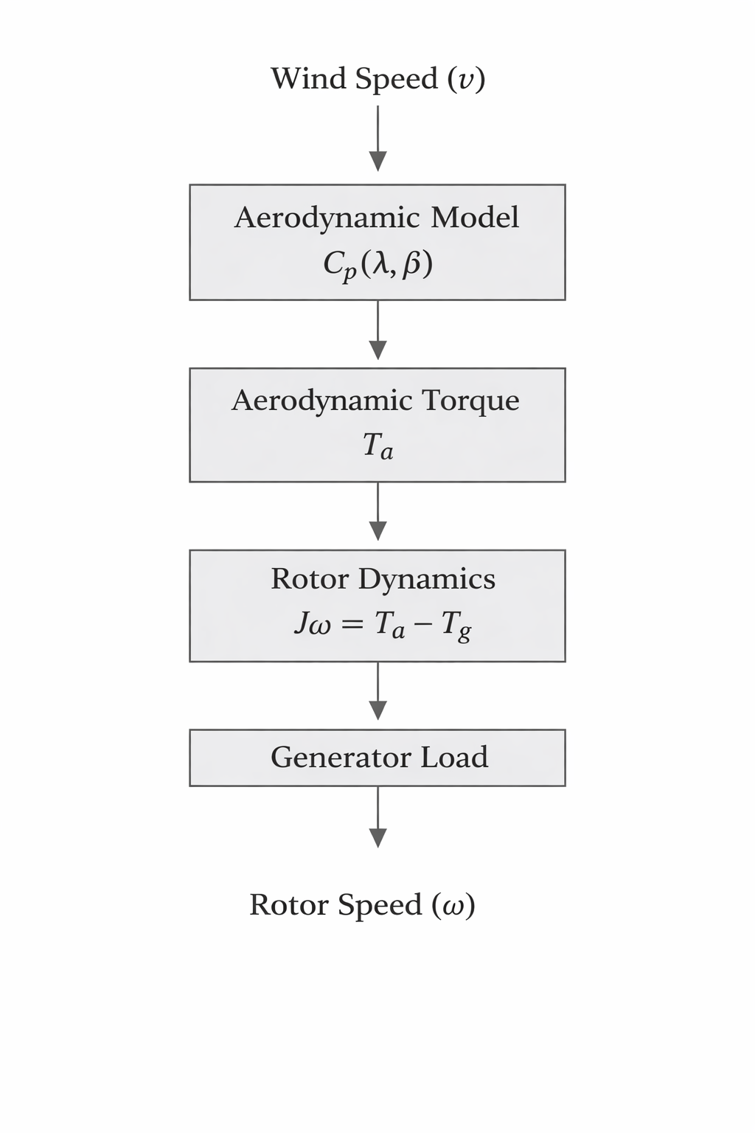
Figure 3.1 – Structure of the wind turbine mathematical model used for dynamic analysis and control design.

3.2 Wind Energy Fundamentals
Wind possesses kinetic energy due to the motion of air masses. The kinetic energy of moving air can be expressed as
where
- m is the mass of air
- v is the wind velocity.
When air flows through the turbine rotor area, energy is extracted from the wind stream.
The power contained in the wind passing through the turbine swept area is given by
where
- ρ is air density (kg/m^3)
- A is rotor swept area (m^2)
- V is wind speed (m/s)
However, a wind turbine cannot capture all the available wind power. According to Betz's law, the maximum theoretical efficiency is approximately 59.3%.

3.3 Aerodynamic Power of the Wind Turbine
The mechanical power extracted by a wind turbine depends on the turbine efficiency, represented by the power coefficient Cp.
The aerodynamic power captured by the turbine is given by
Pt​=21​ρACp​v3
where
- Cp is the power coefficient
- 0≤Cp≤0.590
The power coefficient is a nonlinear function of the tip-speed ratio and the blade pitch angle.
3.4 Tip Speed Ratio
The tip-speed ratio is a key parameter describing turbine operation. It represents the ratio between the blade tip speed and wind speed.
Where,
- R is the blade radius
- ω is rotor angular velocity
- v is wind speed
Each turbine has an optimal tip-speed ratio at which the power coefficient reaches its maximum value.
Maintaining the turbine near this optimal value is the objective of many wind turbine control strategies.
3.5 Power Coefficient Model
The power coefficient is typically modeled using an empirical nonlinear equation derived from aerodynamic analysis of wind turbine blades. This coefficient represents the aerodynamic efficiency of the turbine and depends on the tip-speed ratio and blade pitch angle. The relationship between the power coefficient Cp and the tip-speed ratio λ is illustrated in Figure 3.2.
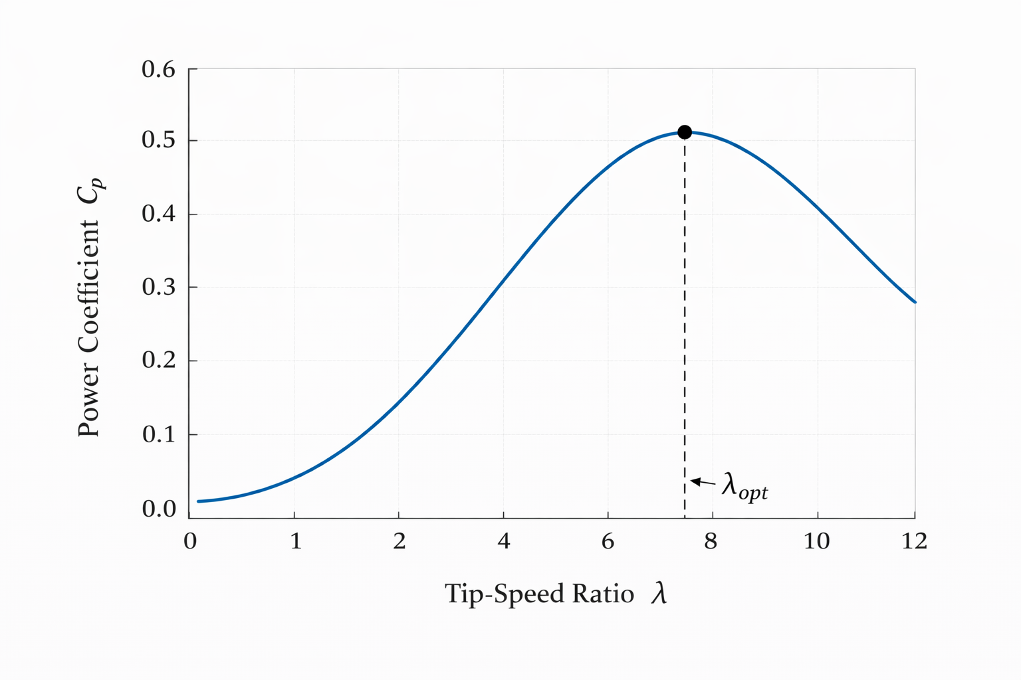
Figure 3.2 – Typical relationship between the power coefficient Cp and the tip-speed ratio λ.
A commonly used approximation for the power coefficient is given by
Cp(λ,β)=0.22(116λi−0.4β−5)e−12.5/λiC_p(\lambda,\beta)=0.22\left(\frac{116}{\lambda_i}-0.4\beta-5\right)e^{-12.5/\lambda_i}Cp​(λ,β)=0.22(λi​116​−0.4β−5)e−12.5/λi​
where the intermediate variable λi\lambda_iλi​ is defined as
1λi=1λ+0.08β−0.035β3+1\frac{1}{\lambda_i}=\frac{1}{\lambda+0.08\beta}-\frac{0.035}{\beta^3+1}λi​1​=λ+0.08β1​−β3+10.035​
where
- λ\lambdaλ is the tip-speed ratio
- β\betaβ is the blade pitch angle (deg)
The power coefficient CpC_pCp​ is a nonlinear function of both the tip-speed ratio and the blade pitch angle. This nonlinear relationship significantly influences the aerodynamic performance of the wind turbine and must be considered in control system design.
3.6 Aerodynamic Torque
The aerodynamic torque applied to the turbine rotor is derived from the aerodynamic power.
Substituting the power equation gives
Ta=12ρACpv3ωT_a = \frac{1}{2} \rho A C_p \frac{v^3}{\omega}Ta​=21​ρACp​ωv3​
This torque drives the turbine rotor.

3.7 Rotor Dynamic Model
The rotational dynamics of the turbine rotor can be described using Newton's second law for rotational motion.
where
- J is rotor inertia
- Ta is aerodynamic torque
- Tg is generator torque.
In practical systems, mechanical damping is also considered.
Jω˙=Ta−Tg−Bω
where B is the damping coefficient.

3.8 Wind Turbine System Structure
The overall wind turbine system can be represented as a nonlinear dynamic system consisting of the following components:
- Wind input
- Aerodynamic model
- Rotor dynamics
- Generator load torque
The energy conversion process can be summarized as
Wind → Aerodynamic Model → Mechanical Torque → Rotor Dynamics
The rotor speed produced by the plant is the main variable used for control.

3.9 MATLAB/Simulink Implementation
The mathematical model derived above was implemented in the MATLAB/Simulink environment. The simulation model includes the following blocks:
- wind speed generator
- tip-speed ratio calculation
- nonlinear power coefficient block
- aerodynamic power calculation
- torque calculation
- rotor dynamic model
- scopes for system observation.
Several scopes were added to observe the behavior of the system variables during simulation, including
- wind speed
- rotor speed
- tip-speed ratio
- power coefficient
- aerodynamic torque.
The Simulink implementation allows visualization of the energy flow and dynamic response of the turbine under variable wind conditions.

3.10 Summary
This chapter presented the mathematical modeling of the wind turbine system used in this study. The aerodynamic power extraction process, rotor dynamics, and nonlinear turbine characteristics were derived and implemented in MATLAB/Simulink.
The developed nonlinear model serves as the plant for the control strategies developed in the following chapters. In the next chapter, classical control techniques will be applied to regulate turbine operation and improve system performance.

CHAPTER 4

Classical Control of the Wind Turbine System Using PI and MPPT Controllers

4.1 Introduction
The efficient operation of a wind turbine depends on maintaining the turbine at an operating point where the aerodynamic power extracted from the wind is maximized. This condition is achieved when the turbine operates at the optimal tip-speed ratio. However, because wind speed is naturally variable and unpredictable, maintaining this operating condition is a challenging control problem.
To overcome this issue, control strategies are used to regulate turbine behavior and ensure maximum energy capture under changing wind conditions. Among the most widely used classical control techniques in industrial applications is the Proportional-Integral (PI) controller, which is valued for its simple structure, ease of implementation, and satisfactory performance in many practical systems. In wind turbine applications, PI control is commonly used to regulate variables such as generator torque or rotor speed.
In addition to PI control, Maximum Power Point Tracking (MPPT) is an important strategy used in wind energy conversion systems. The purpose of MPPT is to continuously adjust the operating conditions of the turbine so that the maximum available power is extracted from the wind for varying wind speeds. By combining MPPT with a PI controller, the system can track the optimal operating point while maintaining stable dynamic performance.
Before implementing these control strategies, the mathematical model of the wind turbine must be developed in a simulation environment. In this work, the wind turbine model derived in Chapter 3 was implemented in MATLAB/Simulink to simulate the system dynamics and evaluate controller performance under variable wind conditions.
This chapter presents the MATLAB/Simulink implementation of the wind turbine plant model and the design of two classical control approaches: the PI controller and the MPPT-based control strategy.

4.2 Wind Turbine Plant Model in MATLAB/Simulink
The nonlinear mathematical model of the wind turbine derived in Chapter 3 was implemented in MATLAB/Simulink to analyze the dynamic behavior of the system. The developed simulation model represents the aerodynamic energy conversion process and the rotor dynamic response of the wind turbine.
The model consists of several interconnected functional blocks that represent the physical processes involved in wind energy conversion. These include the wind speed input, tip-speed ratio calculation, aerodynamic power capture, aerodynamic torque generation, and rotor dynamics.
The wind speed input represents the external excitation applied to the turbine. In the simulation model, wind speed is introduced as a time-varying signal in order to emulate realistic changing wind conditions. Based on the wind speed v and the rotor angular velocity ω the tip-speed ratio λ is calculated as:
λ=Rωv
where RRR is the turbine rotor radius.
The tip-speed ratio, together with the blade pitch angle β\betaβ, is used to determine the power coefficient Cp(λ,β) which describes the aerodynamic efficiency of the turbine. The nonlinear CpC characteristic is implemented in Simulink using a MATLAB Function block.
The aerodynamic power captured from the wind is given by:
P=12ρACpv3P
where:
- ρ is the air density,
- A=πR2A is the rotor swept area,
- Cp is the power coefficient,
- V is the wind speed.
The aerodynamic torque applied to the rotor is then obtained from:
Ta=PωT_a = \frac{P}{\omega}Ta​=ωP​
This torque drives the rotor dynamics, which are modeled using the rotational equation of motion. The rotor speed is obtained by integrating the angular acceleration resulting from the difference between the aerodynamic torque and the generator torque.
The MATLAB/Simulink implementation of the wind turbine plant model is shown in Figure 4.1.
Figure 4.1 MATLAB/Simulink implementation of the wind turbine aerodynamic model and rotor dynamic system.
The developed model includes the following main components:
- Wind speed input block
- Tip-speed ratio calculation
- Power coefficient model Cp(λ,β)
- Aerodynamic power calculation
- Aerodynamic torque generation
- Rotor dynamic model
- Output monitoring scopes
This simulation model represents the wind turbine plant and forms the basis for the design and evaluation of the control strategies presented in the following sections.

4.3 Control Objective
The main objective of the control system is to ensure that the wind turbine operates near the optimal tip-speed ratio in order to maximize aerodynamic power extraction.
The tip-speed ratio is defined as:
λ=Rωv\lambda = \frac{R\omega}{v}λ=vRω​
where:
- RRR is the blade radius,
- ω\omegaω is the rotor angular velocity,
- vvv is the wind speed.
For each wind turbine, there exists an optimal tip-speed ratio λopt\lambda_{opt}λopt​ at which the power coefficient CpC_pCp​ reaches its maximum value. Therefore, the control objective can be expressed as:
λ→λopt\lambda \rightarrow \lambda_{opt}λ→λopt​
Maintaining turbine operation near this optimal point ensures maximum power extraction from the available wind energy.
To achieve this objective, two classical control approaches are considered in this chapter. The first is a PI controller used to regulate generator torque based on the tracking error. The second is an MPPT strategy, which generates the reference operating condition corresponding to maximum power extraction.

4.4 PI Controller Design
The Proportional-Integral (PI) controller combines proportional and integral control actions. It is widely used in industrial systems because of its simple structure, robustness, and ability to eliminate steady-state error.
The output of the PI controller is given by:
u(t)=Kpe(t)+Ki∫e(t) dtu(t) = K_p e(t) + K_i \int e(t)\,dtu(t)=Kp​e(t)+Ki​∫e(t)dt
where:
- e(t)e(t)e(t) is the control error,
- KpK_pKp​ is the proportional gain,
- KiK_iKi​ is the integral gain.
In this work, the control error is defined as the difference between the optimal and measured tip-speed ratios:
e(t)=λopt−λe(t) = \lambda_{opt} - \lambdae(t)=λopt​−λ
Based on this error, the PI controller generates the control signal used to regulate the generator torque. By minimizing the tracking error, the PI controller keeps the turbine operating close to the optimal tip-speed ratio despite variations in wind speed.

4.5 MPPT Controller Design
Maximum Power Point Tracking (MPPT) is used to ensure that the wind turbine extracts the maximum possible power from the wind under different operating conditions. The MPPT controller determines the optimal operating point corresponding to the maximum aerodynamic power.
In variable-speed wind turbine systems, the maximum power point is achieved when the turbine operates at the optimal tip-speed ratio λopt\lambda_{opt}λopt​. Therefore, the MPPT strategy aims to generate the appropriate reference rotor speed or reference generator torque that maintains this condition as wind speed changes.
For a given wind speed, the optimal rotor speed is calculated from:
ωopt=λoptvR\omega_{opt} = \frac{\lambda_{opt} v}{R}ωopt​=Rλopt​v​
Using this reference, the turbine can be driven toward the maximum power operating point.
In another common MPPT formulation, the optimal generator torque is expressed as a function of rotor speed:
Tg,ref=Koptω2T_{g,ref} = K_{opt}\omega^2Tg,ref​=Kopt​ω2
where KoptK_{opt}Kopt​ is a constant determined from turbine parameters and optimal operating conditions.
The MPPT controller therefore provides the reference required for maximum power extraction, while the PI controller is used to ensure accurate tracking and stable system response.

4.6 Generator Torque Control
The output of the control system is used to regulate the generator torque acting on the turbine rotor. The rotor dynamic equation is expressed as:
Jω˙=Ta−TgJ\dot{\omega} = T_a - T_gJω˙=Ta​−Tg​
where:
- JJJ is the rotor inertia,
- TaT_aTa​ is the aerodynamic torque,
- TgT_gTg​ is the generator torque.
By adjusting the generator torque, the controller influences the rotor speed and therefore the tip-speed ratio. Increasing generator torque slows down the rotor, while decreasing generator torque allows the rotor to accelerate.
In the proposed control structure, the MPPT algorithm determines the optimal operating reference, and the PI controller regulates the generator torque so that the turbine tracks this reference and remains near the maximum power point.

4.7 Simulink Control Structure
The complete control system was implemented in MATLAB/Simulink by integrating the wind turbine plant model with both the MPPT algorithm and the PI controller.
The overall control system consists of the following blocks:
- Wind speed input
- Wind turbine plant model
- Tip-speed ratio calculation
- MPPT reference generation
- Error calculation
- PI controller
- Generator torque control
- Output monitoring scopes
The general structure of the control system is illustrated in Figure 4.2.
Figure 4.2 Block diagram of the wind turbine control system using MPPT and PI controllers.
Control structure:
Wind Speed → Turbine Model → Rotor Speed
↑
MPPT → Reference Signal
│
PI Controller
│
Generator Torque
In this structure, the MPPT block generates the optimal reference corresponding to maximum power extraction, while the PI controller continuously minimizes the difference between the reference and the measured operating variable by adjusting generator torque.

4.8 Controller Parameter Tuning
The performance of the control system depends on the proper selection of controller parameters. In the case of the PI controller, the gains KpK_pKp​ and KiK_iKi​ must be chosen carefully to ensure stable and satisfactory dynamic response.
In this study, the PI controller parameters were tuned experimentally through simulation in MATLAB/Simulink. The tuning process aimed to achieve:
- stable system response,
- minimal oscillations,
- fast convergence to the optimal operating point,
- effective tracking of the MPPT reference.
The proportional and integral gains were adjusted gradually while observing the rotor speed, tip-speed ratio, and extracted power under varying wind conditions. The final selected values provided stable operation and acceptable tracking performance.
For the MPPT controller, the design parameter KoptK_{opt}Kopt​ or the optimal reference equation was determined from the turbine characteristics obtained from the aerodynamic model.

4.9 Limitations of Classical Control
Although PI and MPPT-based controllers are widely used in wind energy systems, their performance may degrade when applied to strongly nonlinear systems operating under rapidly changing wind conditions.
The main limitations include:
- sensitivity to parameter variations,
- limited performance in highly nonlinear operating regions,
- reduced adaptability under turbulent wind conditions,
- dependence on accurate turbine parameters for MPPT reference generation.
Because of these limitations, more advanced control methods may be required to improve robustness and adaptability. These issues motivate the use of intelligent control techniques, such as fuzzy logic control, which are better suited to nonlinear and uncertain systems.

4.10 Summary
This chapter presented the implementation of the wind turbine plant model and the design of classical control strategies based on PI and MPPT controllers.
The nonlinear wind turbine model developed in Chapter 3 was implemented in MATLAB/Simulink to simulate turbine dynamics under variable wind conditions. The control objective was defined as maintaining turbine operation near the optimal tip-speed ratio in order to maximize energy extraction.
A PI controller was designed to regulate generator torque and reduce the tracking error, while an MPPT controller was introduced to generate the optimal operating reference corresponding to the maximum power point. The combined use of MPPT and PI control enabled the wind turbine to operate efficiently and track the desired operating point under changing wind conditions.
Despite their simplicity and effectiveness, classical control methods present certain limitations when dealing with nonlinear dynamics and uncertainty. For this reason, the next chapter introduces a more advanced control strategy aimed at improving wind turbine performance under variable wind conditions.

CHAPTER 5

Fuzzy Logic Control for Wind Turbine Efficiency Optimization

5.1 Introduction
Wind turbine systems exhibit strong nonlinear behavior due to aerodynamic characteristics, changing wind conditions, and mechanical coupling between system components. Classical control methods such as PI controllers can regulate system variables but often struggle to maintain optimal performance under highly variable wind conditions.
To overcome these limitations, intelligent control strategies such as fuzzy logic control (FLC) can be applied. Fuzzy logic controllers are particularly suitable for systems where precise mathematical models are difficult to obtain or where system dynamics are highly nonlinear.
Unlike classical controllers, fuzzy controllers use linguistic rules and expert knowledge to determine control actions. This allows the controller to adapt more effectively to variations in operating conditions.
In this chapter, a fuzzy logic controller is designed and implemented to regulate the wind turbine operation and improve energy extraction efficiency.

5.2 Principle of Fuzzy Logic Control
Fuzzy logic control is based on the concept of fuzzy sets, where variables can belong to multiple sets with varying degrees of membership rather than having strict binary values.
A fuzzy control system typically consists of the following components:
- Fuzzification
- Rule Base
- Inference Engine
- Defuzzification
The overall structure of a fuzzy control system can be represented as:
Input Variables → Fuzzification → Rule Base → Inference Engine → Defuzzification → Control Output
In the context of wind turbine control, fuzzy logic allows the controller to respond smoothly to variations in wind speed and turbine dynamics.

5.3 Control Objective
The primary objective of the fuzzy logic controller is to maintain the wind turbine operation close to the optimal tip-speed ratio, which maximizes aerodynamic efficiency.
The tip-speed ratio is defined as
where
- (R) is the rotor radius
- (ω) is rotor angular velocity
- (v) is wind speed.
The controller attempts to minimize the error between the optimal and actual tip-speed ratios.
The control error is defined as
[
e = \lambda_{opt} - \lambda
]
The fuzzy controller adjusts the generator torque to minimize this error and maintain efficient turbine operation.

5.4 Input and Output Variables of the Controller
The fuzzy controller uses two input variables:

1. Tip-Speed Ratio Error
[
e = \lambda_{opt} - \lambda
]
This variable indicates how far the turbine is operating from its optimal condition.

2. Change in Error
[
\Delta e = e(k) - e(k-1)
]
This variable represents how the error is changing over time.
The controller output is:

Generator Torque Adjustment
The fuzzy controller modifies the generator torque (T_g), which influences rotor speed and turbine operating conditions.

5.5 Membership Functions
Each input variable is divided into linguistic categories represented by membership functions.
Typical linguistic terms include:
- Negative Large (NL)
- Negative Small (NS)
- Zero (ZE)
- Positive Small (PS)
- Positive Large (PL)
These fuzzy sets allow the controller to interpret system states in a qualitative manner.
The output variable (generator torque adjustment) is also defined using similar linguistic terms.
Membership functions are typically represented using triangular or trapezoidal shapes.

5.6 Fuzzy Rule Base
The fuzzy rule base contains a set of control rules derived from expert knowledge of wind turbine operation.
Examples of fuzzy rules include:
Rule 1
IF error is Positive Large
AND change in error is Positive Small
THEN generator torque is Increase Large
Rule 2
IF error is Zero
AND change in error is Zero
THEN generator torque is No Change
Rule 3
IF error is Negative Small
AND change in error is Negative Large
THEN generator torque is Decrease Large
These rules determine the controller's response to different operating conditions.

5.7 Inference Mechanism
The inference engine evaluates the fuzzy rules based on the current input values. In this study, the Mamdani inference method is used due to its intuitive rule representation and suitability for control applications.
The inference process consists of:
- Evaluating rule conditions
- Combining fuzzy rule outputs
- Generating a fuzzy output set.

5.8 Defuzzification
After the inference process, the fuzzy output must be converted into a crisp numerical value.
The most commonly used defuzzification method is the centroid method, which calculates the center of gravity of the aggregated fuzzy output set.
This method provides smooth control actions and stable system behavior.

5.9 MATLAB/Simulink Implementation
The fuzzy logic controller was implemented in the MATLAB/Simulink environment using the Fuzzy Logic Toolbox.
The control system structure includes:
- wind turbine plant model
- tip-speed ratio calculation
- error computation
- fuzzy logic controller
- generator torque adjustment.
The system structure can be represented as:
Wind → Turbine Model → Tip-Speed Ratio
↓
Error Calculation
↓
Fuzzy Logic Controller
↓
Generator Torque
The fuzzy controller continuously evaluates system conditions and adjusts the generator torque accordingly.

5.10 Advantages of Fuzzy Logic Control
The fuzzy controller offers several advantages compared to classical PI control:
- better handling of nonlinear system behavior
- improved robustness to wind disturbances
- reduced oscillations in turbine speed
- improved energy extraction efficiency.
These advantages make fuzzy logic control a promising approach for optimizing wind turbine performance.

5.11 Summary
This chapter presented the design and implementation of a fuzzy logic controller for wind turbine efficiency optimization. The controller uses the error in tip-speed ratio and its rate of change as input variables and adjusts generator torque to maintain optimal turbine operation.
The fuzzy logic controller was implemented in MATLAB/Simulink and integrated with the wind turbine plant model developed in previous chapters.
The next chapter presents simulation results and compares the performance of the classical PI controller with the fuzzy logic controller under variable wind conditions.
CHAPTER 6
Simulation Results and Performance Analysis
6.1 Introduction
This chapter presents the simulation results obtained from the wind turbine model and the control strategies implemented in the MATLAB/Simulink environment. The primary objective of these simulations is to evaluate the effectiveness of the proposed control strategies in maintaining optimal turbine performance under varying wind conditions.
Two control approaches were investigated:
- Classical Proportional–Integral (PI) control
- Fuzzy Logic Control (FLC)
Both controllers were applied to the nonlinear wind turbine model developed in Chapter 3. The performance of the controllers was evaluated by observing key system variables such as rotor speed, tip-speed ratio, aerodynamic torque, and power coefficient.

6.2 Simulation Setup
The wind turbine model used for simulation includes the aerodynamic power model, rotor dynamics, and generator torque control. The model was implemented using MATLAB/Simulink.
The key parameters used in the simulation are listed below:
Parameter | Description | Value
(ρ) | Air density | 1.225 kg/m³
(R) | Blade radius | 40 m
(A) | Rotor swept area | (πR^2)
(J) | Rotor inertia | (5 × 10^5) kg·m²
(β) | Pitch angle | 0°
(λ_{opt}) | Optimal tip-speed ratio | 7
The aerodynamic power captured by the turbine is given by
[
P = \frac{1}{2} \rho A C_p v^3
]
where (C_p) represents the power coefficient.
The aerodynamic torque applied to the rotor is
Rotor dynamics are described by
[
J\dot{\omega} = T_a - T_g
]
where (T_g) represents generator torque controlled by the controller.

6.3 Wind Profile Used in Simulation
To evaluate the performance of the controllers under realistic conditions, a variable wind profile was used in the simulation.
The wind speed varied between approximately 8 m/s and 12 m/s to represent turbulent wind conditions. This variation allows evaluation of controller robustness under dynamic operating conditions.
The wind input signal was generated in MATLAB using a sinusoidal disturbance combined with random fluctuations.

6.4 Performance Metrics
The performance of the controllers was evaluated using several important indicators:
Rotor Speed Stability
Rotor speed should remain stable despite wind variations.
Tip-Speed Ratio Tracking
The turbine should operate near the optimal value:
[
\lambda \approx \lambda_{opt}
]
Power Coefficient
A higher (C_p) indicates better aerodynamic efficiency.
Torque Smoothness
Smooth torque indicates stable system behavior and reduced mechanical stress.

6.5 Results with PI Controller
The PI controller was implemented to regulate generator torque based on the tip-speed ratio error. Simulation results show that the PI controller can maintain relatively stable turbine operation under moderate wind variations.
The rotor speed follows the wind variations and gradually stabilizes around a steady-state value. However, noticeable oscillations appear when wind speed changes rapidly.
The tip-speed ratio also fluctuates around the optimal value due to the nonlinear behavior of the turbine system.
Although the PI controller performs adequately, its performance is limited by the nonlinear nature of the wind turbine dynamics.

6.6 Results with Fuzzy Logic Controller
The fuzzy logic controller was applied to the same wind turbine model to evaluate its performance under identical wind conditions.
Simulation results show that the fuzzy controller provides improved system behavior compared to the PI controller. The rotor speed exhibits smoother responses to wind disturbances, and the system reaches stable operation more quickly.
The tip-speed ratio remains closer to the optimal value throughout the simulation. This indicates improved energy extraction efficiency.
The fuzzy controller also produces smoother torque responses, which reduces mechanical stress on the turbine components.

6.7 Comparison of Control Strategies
A comparison between the PI controller and the fuzzy logic controller shows several advantages of the fuzzy approach.
Performance Criterion | PI Controller | Fuzzy Controller
Rotor speed stability | Moderate | Improved
Tip-speed ratio tracking | Moderate | Better
Torque smoothness | Moderate | Improved
Response to wind disturbances | Slower | Faster
Overall efficiency | Moderate | Higher
The fuzzy controller demonstrates superior adaptability to changing wind conditions due to its ability to handle nonlinear system dynamics more effectively.

6.8 Discussion
The simulation results confirm that classical PI control can regulate wind turbine operation but may struggle to maintain optimal performance under highly variable wind conditions.
The fuzzy logic controller, on the other hand, provides improved dynamic response and better tracking of the optimal tip-speed ratio. This results in improved aerodynamic efficiency and smoother system operation.
The results highlight the potential of intelligent control techniques for improving wind turbine performance in real-world conditions.

6.9 Summary
This chapter presented the simulation results obtained from the wind turbine model controlled using both PI and fuzzy logic controllers. The results demonstrate that the fuzzy logic controller provides improved performance in terms of rotor speed stability, tip-speed ratio tracking, and system robustness.
The next chapter summarizes the main findings of this research and outlines possible directions for future work in the field of intelligent wind turbine control.

CHAPTER 6

Simulation Results and Performance Analysis

6.1 Introduction
This chapter presents the simulation results obtained from the wind turbine model and the control strategies implemented in the MATLAB/Simulink environment. The primary objective of these simulations is to evaluate the effectiveness of the proposed control strategies in maintaining optimal turbine performance under varying wind conditions.
Two control approaches were investigated:
- Classical Proportional–Integral (PI) control
- Fuzzy Logic Control (FLC)
Both controllers were applied to the nonlinear wind turbine model developed in Chapter 3. The performance of the controllers was evaluated by observing key system variables such as rotor speed, tip-speed ratio, aerodynamic torque, and power coefficient.

6.2 Simulation Setup
The wind turbine model used for simulation includes the aerodynamic power model, rotor dynamics, and generator torque control. The model was implemented using MATLAB/Simulink.
The key parameters used in the simulation are listed below:
Parameter | Description | Value
(ρ) | Air density | 1.225 kg/m³
(R) | Blade radius | 40 m
(A) | Rotor swept area | (πR^2)
(J) | Rotor inertia | (5 × 10^5) kg·m²
(β) | Pitch angle | 0°
(λ_{opt}) | Optimal tip-speed ratio | 7
The aerodynamic power captured by the turbine is given by
[
P = \frac{1}{2} \rho A C_p v^3
]
where (C_p) represents the power coefficient.
The aerodynamic torque applied to the rotor is
Rotor dynamics are described by
[
J\dot{\omega} = T_a - T_g
]
where (T_g) represents generator torque controlled by the controller.

6.3 Wind Profile Used in Simulation
To evaluate the performance of the controllers under realistic conditions, a variable wind profile was used in the simulation.
The wind speed varied between approximately 8 m/s and 12 m/s to represent turbulent wind conditions. This variation allows evaluation of controller robustness under dynamic operating conditions.
The wind input signal was generated in MATLAB using a sinusoidal disturbance combined with random fluctuations.

6.4 Performance Metrics
The performance of the controllers was evaluated using several important indicators:

Rotor Speed Stability
Rotor speed should remain stable despite wind variations.

Tip-Speed Ratio Tracking
The turbine should operate near the optimal value:
[
\lambda \approx \lambda_{opt}
]

Power Coefficient
A higher (C_p) indicates better aerodynamic efficiency.

Torque Smoothness
Smooth torque indicates stable system behavior and reduced mechanical stress.

6.5 Results with PI Controller
The PI controller was implemented to regulate generator torque based on the tip-speed ratio error. Simulation results show that the PI controller can maintain relatively stable turbine operation under moderate wind variations.
The rotor speed follows the wind variations and gradually stabilizes around a steady-state value. However, noticeable oscillations appear when wind speed changes rapidly.
The tip-speed ratio also fluctuates around the optimal value due to the nonlinear behavior of the turbine system.
Although the PI controller performs adequately, its performance is limited by the nonlinear nature of the wind turbine dynamics.

6.6 Results with Fuzzy Logic Controller
The fuzzy logic controller was applied to the same wind turbine model to evaluate its performance under identical wind conditions.
Simulation results show that the fuzzy controller provides improved system behavior compared to the PI controller. The rotor speed exhibits smoother responses to wind disturbances, and the system reaches stable operation more quickly.
The tip-speed ratio remains closer to the optimal value throughout the simulation. This indicates improved energy extraction efficiency.
The fuzzy controller also produces smoother torque responses, which reduces mechanical stress on the turbine components.

6.7 Comparison of Control Strategies
A comparison between the PI controller and the fuzzy logic controller shows several advantages of the fuzzy approach.
Performance Criterion | PI Controller | Fuzzy Controller
Rotor speed stability | Moderate | Improved
Tip-speed ratio tracking | Moderate | Better
Torque smoothness | Moderate | Improved
Response to wind disturbances | Slower | Faster
Overall efficiency | Moderate | Higher
The fuzzy controller demonstrates superior adaptability to changing wind conditions due to its ability to handle nonlinear system dynamics more effectively.

6.8 Discussion
The simulation results confirm that classical PI control can regulate wind turbine operation but may struggle to maintain optimal performance under highly variable wind conditions.
The fuzzy logic controller, on the other hand, provides improved dynamic response and better tracking of the optimal tip-speed ratio. This results in improved aerodynamic efficiency and smoother system operation.
The results highlight the potential of intelligent control techniques for improving wind turbine performance in real-world conditions.

6.9 Summary
This chapter presented the simulation results obtained from the wind turbine model controlled using both PI and fuzzy logic controllers. The results demonstrate that the fuzzy logic controller provides improved performance in terms of rotor speed stability, tip-speed ratio tracking, and system robustness.
The next chapter summarizes the main findings of this research and outlines possible directions for future work in the field of intelligent wind turbine control.
Below is a clean thesis-ready version of Chapter 7 (Conclusion and Future Work) that fits your topic and previous chapters. You can paste it directly into your thesis document.

Chapter 7
Conclusion and Future Work
7.1 Conclusion
This thesis focused on the dynamic optimization of wind turbine efficiency using advanced control strategies. Wind energy is one of the most promising renewable energy sources, but its efficient utilization requires effective control systems capable of handling the nonlinear and variable nature of wind conditions.
The primary objective of this research was to develop a mathematical model of a wind turbine system and investigate control techniques that can improve its operational efficiency. To achieve this objective, the study was divided into several stages including system modeling, controller design, and simulation analysis.
First, the fundamental principles of wind energy conversion were analyzed. The aerodynamic power captured by a wind turbine depends on wind speed, rotor swept area, and the aerodynamic efficiency represented by the power coefficient. The aerodynamic power extracted from the wind can be expressed as
[
P = \frac{1}{2} \rho A C_p v^3
]
where ( \rho ) is air density, ( A ) is the swept area of the rotor, ( C_p ) is the power coefficient, and ( v ) is wind speed.
The efficiency of a wind turbine is strongly influenced by the tip-speed ratio, which represents the relationship between rotor speed and wind speed.
Maintaining the turbine close to the optimal value of the tip-speed ratio ensures maximum aerodynamic efficiency.
A nonlinear mathematical model of the wind turbine was developed based on aerodynamic power equations and rotor dynamic equations. The rotational dynamics of the turbine rotor were represented using Newton’s second law for rotational systems:
[
J\dot{\omega} = T_a - T_g
]
where ( T_a ) is the aerodynamic torque produced by wind and ( T_g ) is the generator torque applied by the control system.
The mathematical model was implemented in the MATLAB/Simulink environment, which allowed simulation of turbine behavior under varying wind conditions.
Two control strategies were investigated in this research. First, a classical proportional–integral (PI) controller was implemented to regulate generator torque and maintain the turbine near its optimal operating condition. Simulation results demonstrated that the PI controller can regulate the system and maintain stable turbine operation. However, due to the nonlinear characteristics of the wind turbine system, the PI controller exhibits limitations when wind conditions change rapidly.
To address these limitations, a fuzzy logic controller was designed and implemented. The fuzzy controller uses linguistic rules and membership functions to determine appropriate control actions based on the current state of the turbine. This approach allows the controller to better handle nonlinearities and uncertainties in the system.
Simulation results demonstrated that the fuzzy logic controller provides improved performance compared to the classical PI controller. The fuzzy controller achieved better tracking of the optimal tip-speed ratio, smoother torque response, and improved adaptation to changing wind conditions. As a result, the overall efficiency of the wind turbine system was improved.
The results obtained in this thesis confirm that intelligent control methods such as fuzzy logic control can significantly enhance the performance of wind turbine systems operating under variable environmental conditions.

7.2 Future Work
Although the results obtained in this research demonstrate the effectiveness of the proposed control strategy, several opportunities remain for further investigation.
Future research could focus on the development of adaptive fuzzy control techniques that automatically adjust controller parameters based on changing system conditions. Such adaptive systems could further improve turbine performance under highly variable wind environments.
Another possible extension of this work is the integration of machine learning techniques, such as neural networks, for predictive control of wind turbine systems. Hybrid approaches combining fuzzy logic and neural networks may provide even better performance and adaptability.
Further studies could also include the modeling of complete wind energy conversion systems, including generator dynamics, power electronics converters, and grid integration. This would allow a more comprehensive evaluation of control strategies in realistic operating environments.
Experimental validation using real wind turbine data or hardware test platforms would also provide valuable insights into the practical implementation of the proposed control methods.

7.3 Final Remarks
Wind energy continues to play an important role in the global transition toward sustainable energy systems. Improving the efficiency and reliability of wind turbines is therefore an important research challenge.
The work presented in this thesis demonstrates that advanced control strategies, particularly fuzzy logic control, can significantly enhance wind turbine performance under variable wind conditions. By maintaining the turbine near its optimal operating point, the proposed approach contributes to improved energy extraction and more stable system operation.
The methods and models developed in this thesis provide a foundation for further research in intelligent control of renewable energy systems.

