Project Report: TrendSense – Reddit E-commerce Insights Platform
Author: Hero Bala
Supervisor: doc. Ing. František Dařena, Ph.D.

Overview
This project, TrendSense, is an end-to-end pipeline designed to extract, clean, analyze, and visualize Reddit data from e-commerce-related subreddits. It enables real-time insight discovery through topic modeling, sentiment analysis, and an interactive dashboard. The complete architecture is modular, automated, and extensible, serving both technical and business stakeholders.
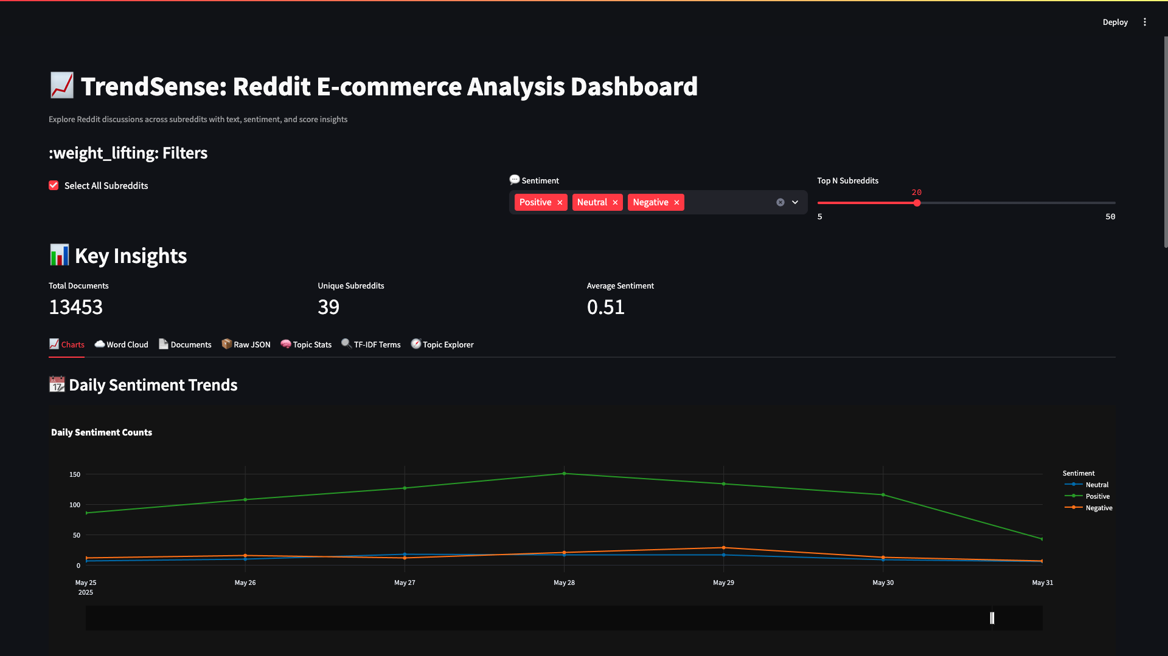
System Architecture
The system follows a four-stage pipeline:
- Data Collection – fetcher.py
- Data Cleaning – cleaner.py
- Analysis (Topic Modeling + Sentiment) – analyzer.py
- Interactive Dashboard – dashboard.py

1. Data Collection – fetcher.py

Key Libraries:
- praw – Python Reddit API Wrapper, for structured Reddit data access.
- logging – Standard Python module for traceable logs.
- json, socket, time – For IO and network handling.

What It Does:
- Connects to Reddit via praw.Reddit using OAuth credentials.
- Iterates 40 e-commerce-related subreddits like r/shopify, r/dropshipping, etc.
- Collects submissions via different sorting methods (hot, new, top, rising).
- Filters content based on minimum score and maximum retries.
- Parses top comments for context.

Important Functions:
- get_reddit_instance() – Authenticates Reddit connection.
- parse_post() – Parses metadata and up to 10 top-level comments.
- fetch_subreddit() – Manages retry logic and deduplication using seen_ids.
- fetch_all_data() – Orchestrates and saves final output to ecommerce_advanced.json.

2. Data Cleaning – cleaner.py

Key Libraries:
- spaCy – For lemmatization and linguistic tokenization.
- BeautifulSoup – Removes HTML tags and structures.
- re – Regex patterns to clean emojis, markdown, URLs, etc.
- pandas – Efficient dataframe manipulation.

Cleaning Workflow:
- Normalize text fields (title, text) using:
  - Regex patterns for emojis, markdown, special characters, and URLs.
  - HTML tag removal with BeautifulSoup.
- Lemmatization:
  - Uses spaCy in multi-processing mode for faster token reduction.
  - Custom stopwords exclude generic e-commerce terms (shopify, product, etc.).
- Save Output:
  - Cleansed data is saved as cleaned_data.xlsx.

Core Functions:
- basic_clean() – Pre-cleans raw text.
- lemmatize_texts() – Performs lemmatization in batches.
- clean_dataframe() – Integrates cleaning steps into one dataframe.
- save_excel() – Exports to .xlsx format.

3. Analysis – analyzer.py

Objectives:
- Discover latent topics from Reddit discussions.
- Evaluate sentiment polarity for user-generated content.
- Enrich dataset with scores, topics, and term statistics.

Key Libraries:
- BERTopic – Topic modeling on sentence embeddings.
- SentenceTransformers – Converts sentences into vector embeddings.
- nltk – For VADER-based sentiment analysis.
- scikit-learn – Cosine similarity and TF-IDF extraction.

Major Components:
- Topic Modeling:
  - train_topic_model() – Trains BERTopic with UMAP + HDBSCAN.
  - Uses all-MiniLM-L6-v2 as the embedding model.
  - Generates cluster-wise topics and confidence probabilities.
- Sentiment Analysis:
  - SentimentIntensityAnalyzer computes polarity (compound, pos, neg, neu).
  - Mapped to Positive, Neutral, or Negative.
- TF-IDF Per Topic:
  - save_outputs() computes topic-specific important terms.
  - Labeled results saved as labeled_data.xlsx.
- Query Engine:
  - query_similar_docs() supports content-based retrieval using cosine similarity.

4. Dashboard – dashboard.py

Objective:
An interactive Streamlit-based dashboard for exploring Reddit trends and insights using filtered, labeled data.

Libraries Used:
- Streamlit – Web UI framework.
- Plotly Express – Interactive charts.
- WordCloud – Text cloud visualizations.
- matplotlib, pandas, json – Standard data utilities.

Dashboard Modules:
- Sidebar Filters:
  - Subreddit selector.
  - Sentiment filter.
  - Top-N ranking.
- KPIs: Total posts, average sentiment, subreddit/topic count.

Tabs Breakdown:
- Daily Sentiment Trend (Line Chart)
- Top Subreddits by Score (Bar Chart)
- Sentiment vs Score (Scatter Plot)
- Score Distribution (Histogram)
- Documents
- Raw JSON
- Topic Stats
- TF-IDF Terms

Daily Sentiment
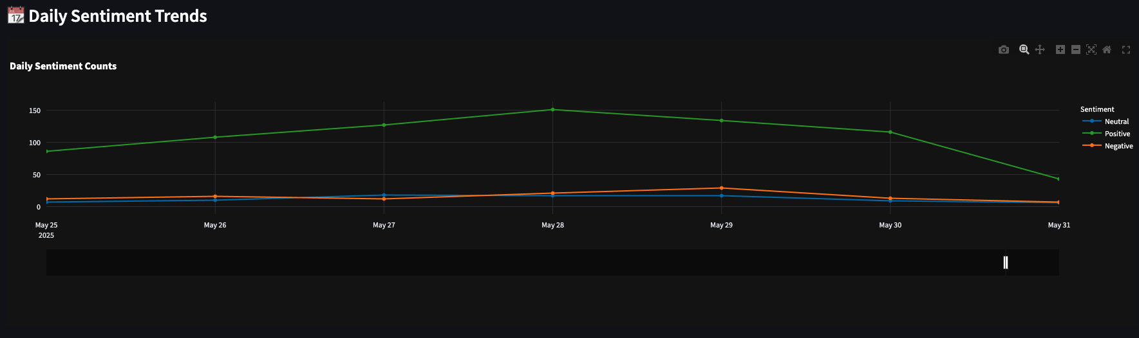
Sentiment Vs Score Scatter
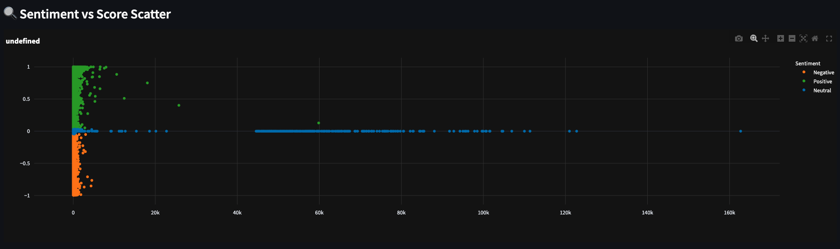
Score Distribution
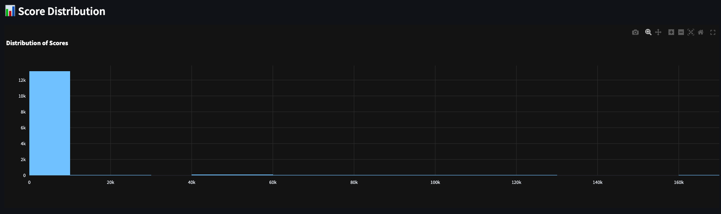

Word Cloud
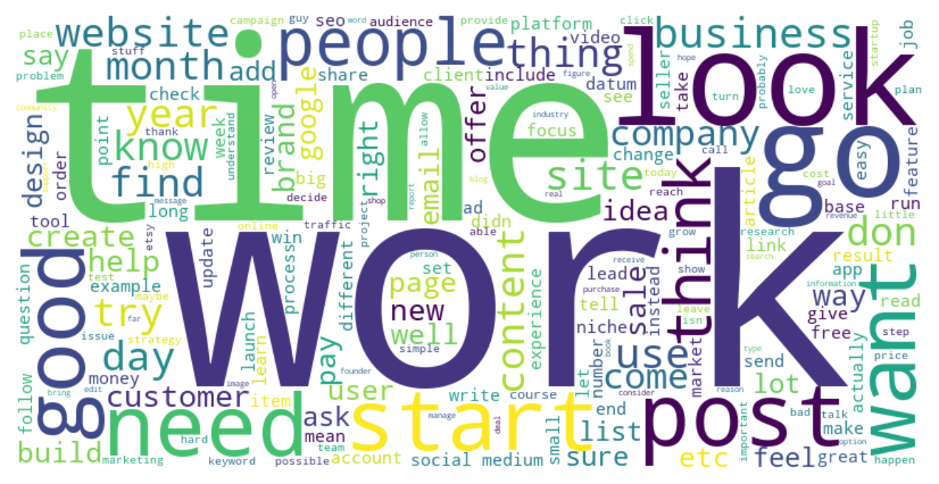
Documents
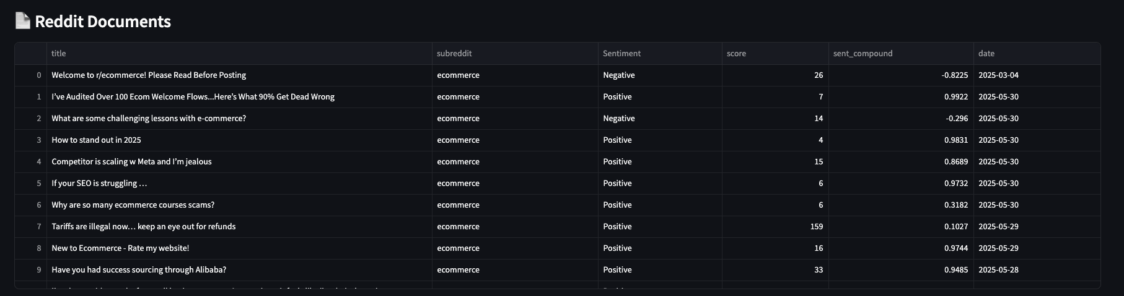
Preview of raw unprocessed Reddit data.
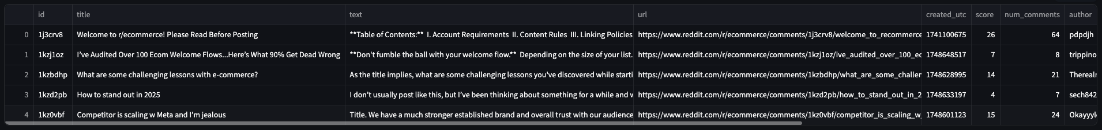
Topic sentiment matrix.
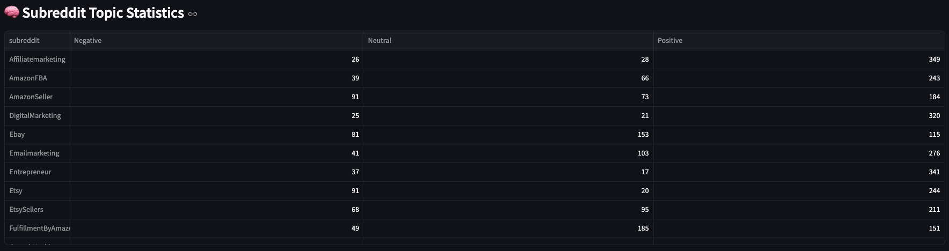
Sentiment stack bar by subreddit.
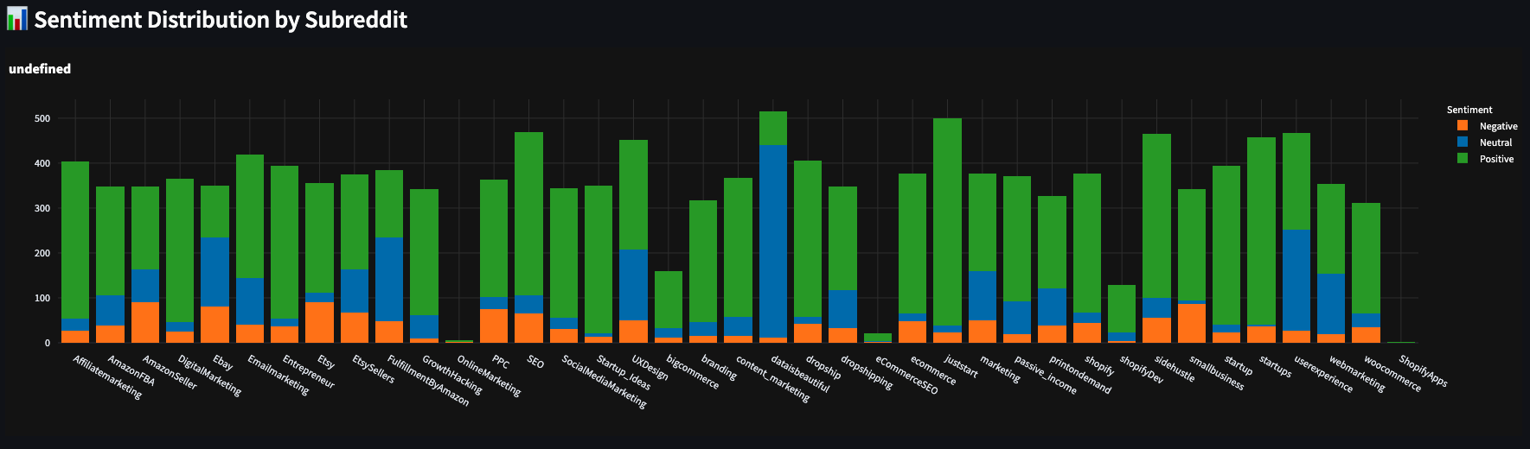
TF-IDF keyword table per topic.
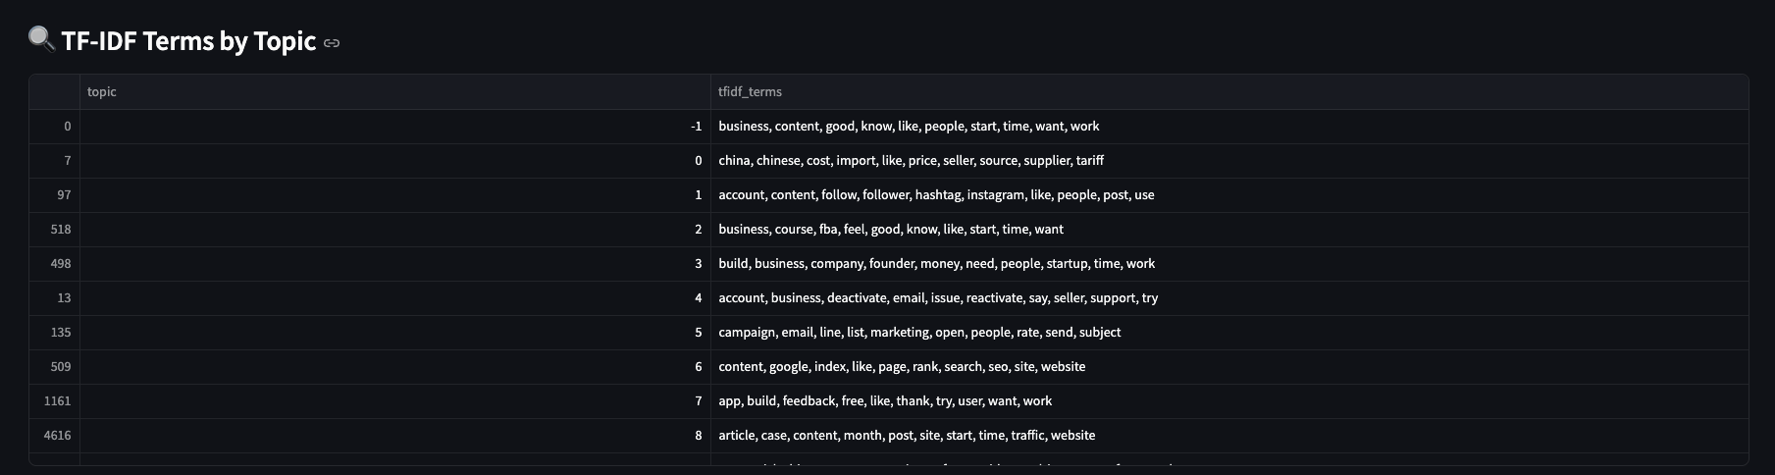

Conclusion
TrendSense is a robust, automated platform designed to convert social signals from Reddit into actionable intelligence for e-commerce stakeholders. From scalable data fetching to advanced NLP and interactive visualizations, the system ensures high clarity, real-time decision support, and data transparency.

