**Proposal**

**Hero Pinball**

**Hunter Oka, Alex Murphy-White, A.J Ryan**

**Summary Statement:**

Hero Pinball is a desktop fantasy themed 2D, arcade style platformer that takes place inside of a pinball machine. Like if Link from Link’s Awakening was trapped in a pinball machine.

**Description:**

Type of project: 2D Arcade style game

Output: Desktop

Objective Goal: Create a 2D arcade style game using the Unity engine, utilizing physics simulation.

Style: Fantasy theme, chibi characters

References:

Legend of Zelda: Link’s Awakening DX

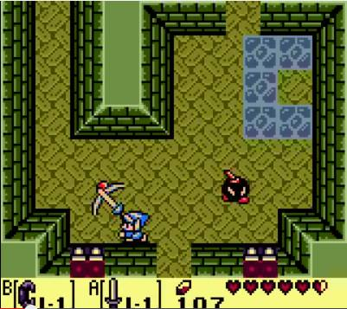

Devil’s Crush

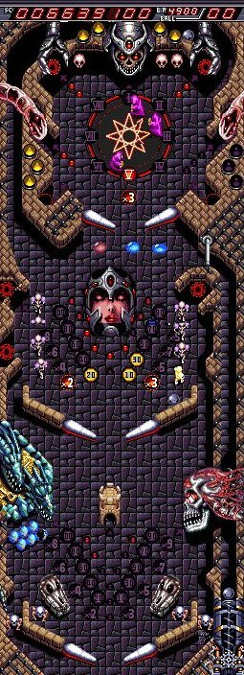

Sonic Spinball

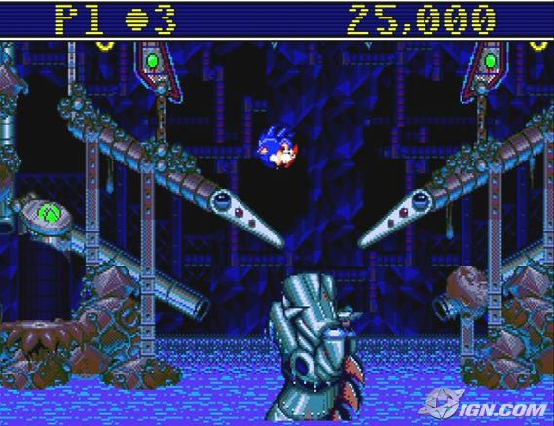

Key Elements:

* The player character is trapped inside of a pinball machine.
* The character is heavily affected by the environment using physics simulation, bouncing and flipping off of game elements.
* The player must fight their way to the top of the pinball machine to defeat the evil monster there.
* The player can be damaged by the environment or enemies, or fall off of the bottom of the stage.