**Design Document**

**Hero Pinball**

**Alex Murphy-White, Hunter Oka, A.J. Ryan**

**Mission Statement**

Elevator pitch: Hero Pinball is a desktop fantasy themed 2D arcade style platformer, that takes place inside of a pinball machine. Like if Link from Link’s Awakening was trapped in a pinball machine**.**

Hero Pinball is a desktop fantasy themed 2D arcade style platformer, that takes place inside of a pinball machine. Hero Pinball aims to provide fast paced action gameplay ideal for short pick-up-and-play sessions. High score tracking and challenging levels keep players coming back for more.

The hero Leroy, shrunk to the size of a ball, is trapped inside of a monster pinball machine. Players must master navigation through the dynamic environment to reach the top of the machine, and defeat the boss that lives there. A key gameplay element is physics simulation, with the player hero realistically interacting with the pinball machine environment, bouncing off of surfaces and obstacles.

**Objective Goals**

* Create an exciting 2D action game using Unity
* Create a game whose gameplay utilizes Unity physics simulation
* Create engaging scoring features to add replay value and to promote competition
* Create unique pinball tables with authentic medieval design
* Create engaging combat along with fast-paced action
* Create large bosses as guardians of each pinball table

**Thematic Element**

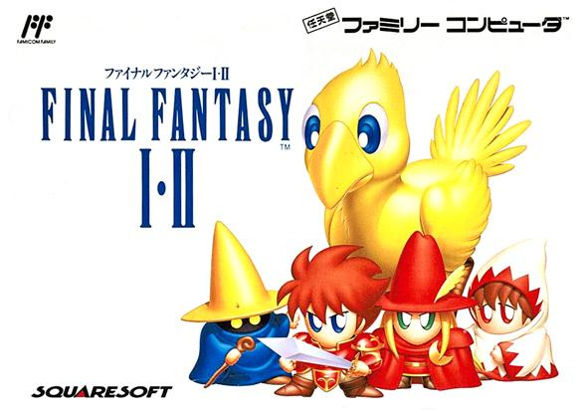

Chibi medieval design from original Final Fantasy concept art.

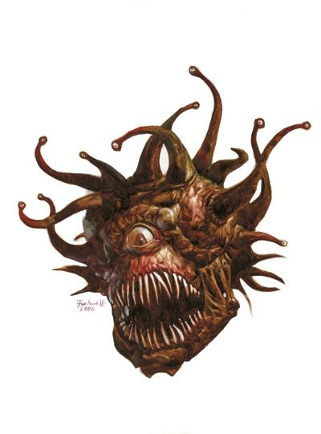

Boss monsters designed like the Beholder from Dungeons and Dragons.

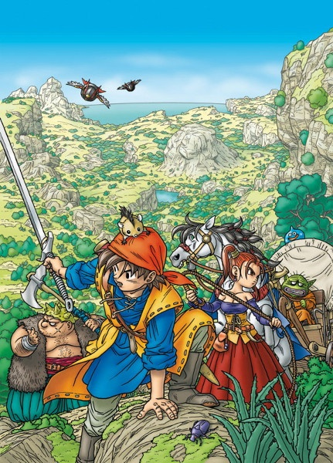

Unique character design like in Dragon Quest VIII.

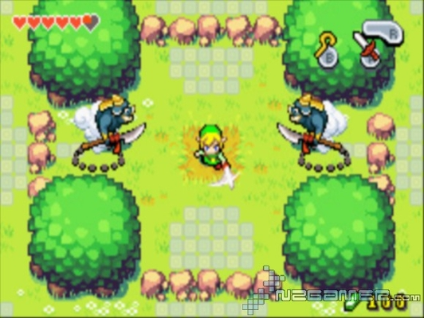

Art style top-down in a medieval setting like in Zelda: Minish Cap.

**Resource Library**

Software:

Engine:

Unity

-Code in C#

-Visual Studio (Windows)

-VSExpress (Windows)

Graphics:

Adobe Photoshop

Adobe Illustrator

Sound:

Logic Pro

Version Control:

Bitbucket

Required Art:

Menu Screen

Pause Screen

Backgrounds

Pinball Features:

Flippers

Bumpers

-Round bumpers

-Triangle Bumpers

Tubes

Platforms

-One sided platforms

Launcher

Spikes

-Spiked Bumpers

Character

-Character Animations

-Movement

-Attacking

-Death

-Victory

Enemies

-Boss

•Boss Eye

•Boss Eye socket

•Boss Projectiles

Small Enemies

-Small Enemy Animations

•Movement

•Death

Pickups

-Treasure

-Health restore

GUI

-Health Bar

-Score

Application icon

Required Sounds:

Character Sounds

Enemy Sounds

Environment Sounds

Music

Game Screens:

Start screen

-Play

-Instructions

-High Scores

Game screen

-Pause

Pause screen

Instructions Screen

-back to start

High Score Screen

-back to start

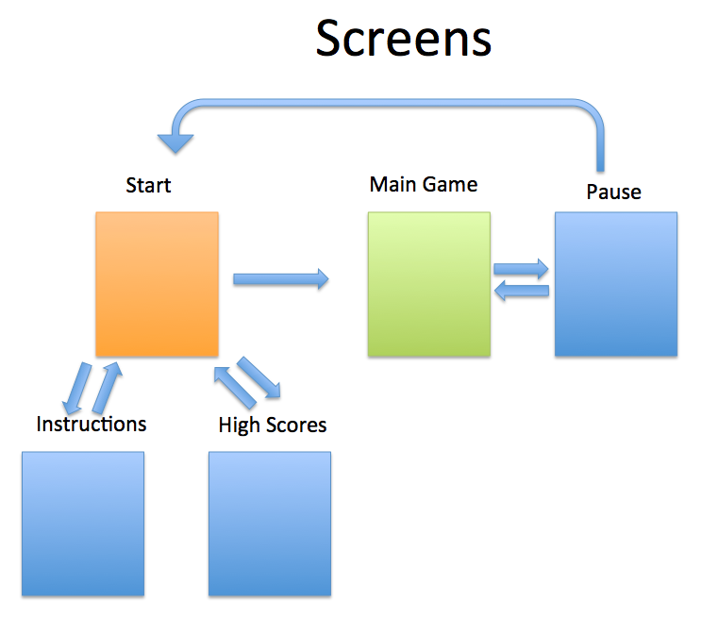

**Design Elements**

Fonts:

Title: Dubstep Dungeons

http://www.fontspace.com/darrell-flood/dubstep-dungeons

Score: Agency FB

http://fontsgeek.com/fonts/Agency-FB-Regular

Color Schemes:

Main Character- Red

Enemy color schemes depends on the level

Thunder Table- Yellow

Ice Table- Light blue

Fire Table- Orange

1. Type of game

Action platformer in pinball environment

Physics simulation

2. Gameplay

Moving the Player Character

-While standing, player can move right and left, and jump slightly

-While in midair, limited player-influenced control for movement

-Pinball objects will influence movement more than the player

Health, Damage, LIVES

-Player can take 6 hits (6 hit points) before losing a life

-Player will take hits from contacting small enemies, boss projectiles, or spikes

-Player will have 3 lives total

-Boss 1 will have 8 hit points, Boss 2 10 hit points, Boss 3 12 hit points

-Player’s sword will do 1 damage, killing small enemies instantly

-Health powerups will be on each table

Enemy behavior

-Bosses will have 3 hittable areas, each will open shortly to be attacked

-Bosses will have projectile attacks to defend themselves

-Bosses will be at the top of each table

-Small enemies will drop from the top of the level

-Small enemies will hone in towards the Player

Beginning the Level

-Player will launch into the bottom of the table

-Score will be the sum of all previously beaten table scores

-Player will have health refilled

-Bonus jackpot will be reset

Beating the Level

-Boss will explode

-Bonus score will be applied to total score

Level progression

Player will advance through 3 levels, after which the first level will repeat. Levels will continue to repeat in sequence until all of the players lives are used up. After each set of 3 levels, the damage dealt by enemies and the environment will increase by 1, and the strength of flippers and bumpers will increase.

Levels

-Thunder table

-Ice table

-Fire table

(All tables use the same basic assets recolored/repurposed for each theme)

Scoring

-Bonus will start at 10000 points and will go down 50 points every 5 seconds

-Player collision with bumpers will award 10 points

-Small enemy kills will award 100 points

-Boss kill points: Boss 1=1000 points, Boss 2=2000 points, Boss 3=3000 points

-Treasure on the map will award 250 points

-Extra balls awarded at 20000 and 50000 points total

- The users all time top scores are recorded

Camera Movement

-Camera will always track the player

-Camera will zoom out slightly as player velocity increases

-Optionally a full table view can be selected

Pausing

The game can be paused by pressing P, or by clicking the pause button in the

lower right corner. While paused, the camera mode can be changed. Bonus

points do not decrease while paused.

3. Character List:

Player Character - Leroy

Leroy is a traveling warrior, always on the lookout for his next meal.

Character Movement -

Left/Right and Jump while standing

Limited Left/Right movement in midair

Character Attacks - Sword swing

Character Health - 6 hit points

Enemy Characters

-Small Enemy - Elemental Creep

Movement - Moves slightly towards the player.

Creep is affected by gravity and environment

-Boss - Elemental Pinbeast

•3 eye sockets

• Eyeball appears in a socket

• If you hit the eyeball, moves to another socket

• Hit the eyeball enough times to win

4. Environment List

Flippers

-Flippers activate automatically when touched

-Flippers hit the player in a different direction depending on where they were

contacted

Bumpers

-Bumpers bounce players and creeps away at the same angle they were

contacted.

-Round bumpers are circular

-Triangle Bumpers are right triangles

Tubes

-Tubes move players from one side to the other when the player contacts one

end.

-One-way tubes only move the player when they contact the entrance.

Platforms

-Platforms provide a place for players and enemies to stand. They can be at any angle

-One sided platforms allow the player to move through from below, but not from

above.

Launcher

-The launcher provides a strong vertical force when contacted. The player begins each level on top of a launcher.

Spikes

-Spikes deal 1 point of damage to the player when contacted

-Spiked Bumpers behave like bumpers but deal a point of damage

5. Pickups

-Pickups begin the game on each level. When contacted they disappear and provide their effect. Pickup are not affected by gravity.

Treasure

-Awards 250 points

Health restore

-Restores 2 hit points to the player

6. Controls Schemes

Keyboard

-Arrow keys control character movement

-A to swing sword

-S to jump

-P opens the menu

Xbox 360

-Left stick or D-Pad control character movement

-A jumps

-X or B swings sword

-Start opens the menu

7. Story

The evil wizard Ghaskel has just finished his ultimate trap, the pinbeast! Designed to swallow adventurers whole, and never let them escape from the bouncy hell inside its stomach. Needing to test the invention, Ghaskel lures our poor young hero Leroy with the smell of tasty meat. Entranced by meaty goodness, Leroy doesn't notice until it is too late! Swallowed by a pinbeast, Leroy must now battle for his freedom. Destroy the pinbeast, and make the world safer for adventurers everywhere!

8. Wireframes

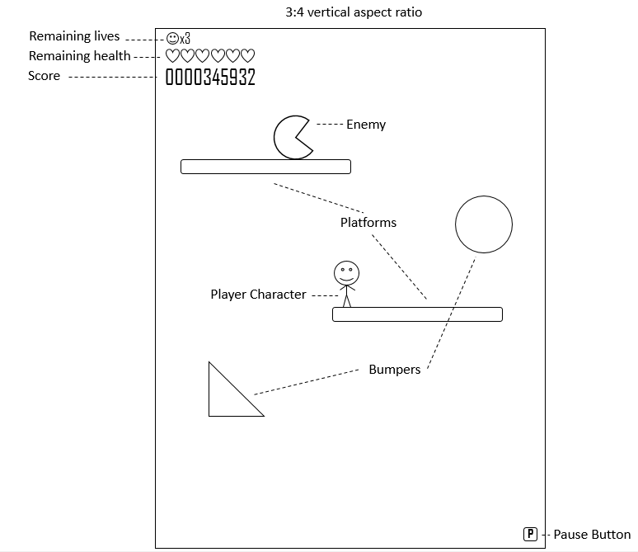

9. Wishlist:

Wishlist ideas will be implemented if time allows

Sword upgrades

Powerups

More enemy types

360 Controller Support

Full table view

Wall Kicks

Online Leaderboards

**User Experience**

Intended user experience:

The intended user of Hero Pinball is someone looking for a short, fast paced game session, perfect for a lunch break or killing time for 30 minutes.

Hero Pinball users enjoy the easy to understand but satisfying and exciting game mechanics, the short time commitment required to play, and the challenge of attaining a new high score.

Keeping user interest is done through high score tracking, and the increasing challenge as gameplay progresses.

User experience map:

After double clicking on the Hero Pinball application icon, Hero Pinball is launched. The Start screen presents three options, Play, Instructions and High Scores. Play begins the main game at level 1. Instructions presents how to play. High scores shows the top 10 scores of previous games.