**Project proposal and data**

* **Mission Statement**

Build up the database by using scientific statistical method combining with the reviews by the formal customer, to efficiently providing latest information of restaurants around the university as well as ranking and sorting the result based on their specific preference on the flavor and service to help the customers choose wisely among various catering business.

* **Mission Objectives:**

1.The system shall list available restaurants around University of Maryland.

2. The system shall precisely filter the result of restaurants based on various requests, e.g. location, flavor, price, etc.

3. The system shall provide reviews and tips from previous customers to give suggestions to new customers.

4.The system shall allow customers to add, alter and delete reviews and tips.

**ER diagram:**

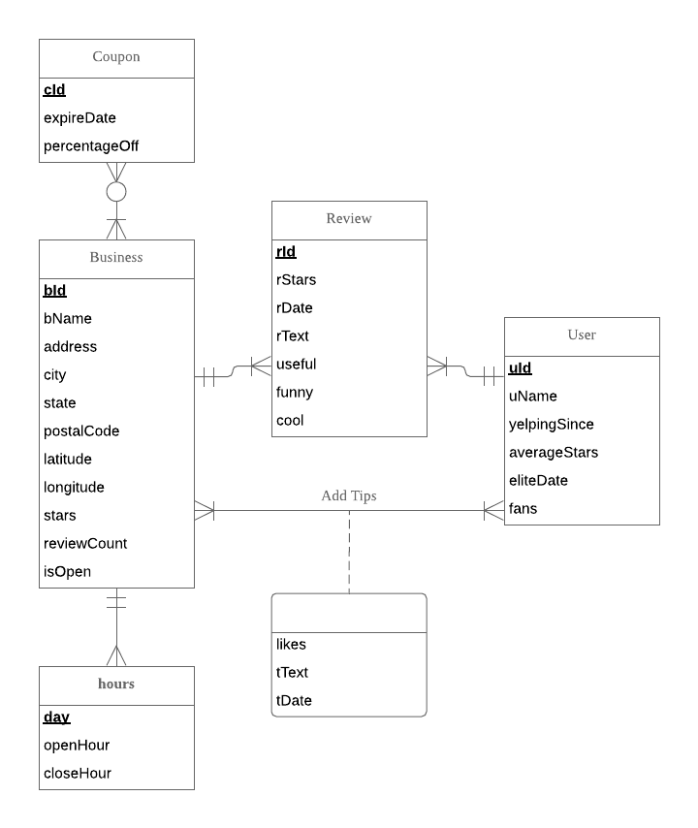

* **Relational schema**

Coupon (**cId,** *bId*, expireDate, percentageOff)

Business (**bId**, bName, address, city, state, postCode, latitude, longitude, stars, reviewCount, isOpen)

Review (**rId**, *bId, uId*, rStars, rDate, rText, useful, funny, cool)

User (**uId**, uName, yelpingSince, averageStars, eliteDate, fans)

Hours (**day, *bId*,** openHours, closeHours)

Addtips (***bId, uId***, likes, tText, tDate)

* **Business rules and referential integrity actions**

|  |  |  |  |  |  |  |  |
| --- | --- | --- | --- | --- | --- | --- | --- |
| Relation | Foreign Key | Base Relation | Primary Key | Business Rule | Constraint: ON DELETE | Business Rule | Constraint: ON UPDATE |
| Coupon | bId | Business | bId | R1 | CASCADE | R2 | NO ACTION |
| Review | bId | Business | bId | R3 | CASCADE | R4 | NO ACTION |
| Review | uId | User | uId | R5 | CASCADE | R6 | CASCADE |
| Hours | bId | Business | bId | R7 | CASCADE | R8 | CASCADE |
| Addtips | bId | Business | bId | R9 | CASCADE | R10 | NO ACTION |
| Addtips | uId | User | uId | R11 | CASCADE | R12 | CASCADE |

**Business rules:**

[R1] When one restaurant is deleted from the database, the coupons of this restaurant should be deleted accordingly.

[R2] When the information of one restaurant changes in the database, the coupons of this restaurant should not change.

[R3] When one restaurant is deleted from the database, the reviews of this restaurant should be deleted accordingly.

[R4] When the information of one restaurant changes in the database, the reviews of this restaurant should not change.

[R5] When one user is deleted from the database, the reviews of this user should be deleted accordingly.

[R6] When the information of one user changes in the database, the reviews of this user should be changed accordingly.

[R7] When one restaurant is deleted from the database, the information of opening hours of this restaurant should be deleted accordingly.

[R8] When the information of one restaurant changes in the database, the opening hours of this restaurant should be changed accordingly.

[R9] When one restaurant is deleted from the database, the tips of this restaurant should be deleted accordingly.

[R10] When the information of one restaurant changes in the database, the tips of this restaurant should not change.

[R11] When one user is deleted from the database, the tips of this user should be deleted accordingly.

[R12] When the information of one user changes in the database, the tips of this user should be changed accordingly.

* **Sample data for every relation**

Business:

{"business_id":"45bWSZtniwPRiqlivpS8Og","name":"The Coffee Bean & Tea Leaf ,"address":"20235 N Cave Creek Rd, Ste 1115","city":"Phoenix","state":"AZ","postal_code":"85024","latitude":33.6713751,"longitude":-112.0300171,"stars":4.0,"review_count":63,"is_open":1}

Review:

{"review_id":"dDl8zu1vWPdKGihJrwQbpw","user_id":"msQe1u7Z_XuqjGoqhB0J5g","business_id":"45bWSZtniwPRiqlivpS8Og ","stars":5,"date":"2012-11-13","text":"I love this place! My fiance And I go here atleast once a week. The portions are huge! Food is amazing. I love their carne asada. They have great lunch specials... Leticia is super nice and cares about what you think of her restaurant. You have to try their cheese enchiladas too the sauce is different And amazing!!!","useful":0,"funny":0,"cool":0}

User:

{"user_id":" msQe1u7Z_XuqjGoqhB0J5g","name":"Jonathan",,"yelping_since":"2014-08-04","fans":0,"eliteDate":"2014-08-05","average_stars":4.05" }

Hours:

{"business_id":"45bWSZtniwPRiqlivpS8Og","day":"Monday","open hour": "5：30"，"close hour":" 20:00"}

Addtips:

{"business_id":"45bWSZtniwPRiqlivpS8Og", "user_id":" msQe1u7Z_XuqjGoqhB0J5g","text":"Come early on Sunday's to avoid the rush","date":"2016-07-03","likes":0 }

Coupon:

{"business_id":"45bWSZtniwPRiqlivpS8Og","coupon_id":"F1UHGw4-6OYyvFFb-E4LMg","expiredDate":"2015-09-06","percentageOff":"90%"}