I2C_SPI 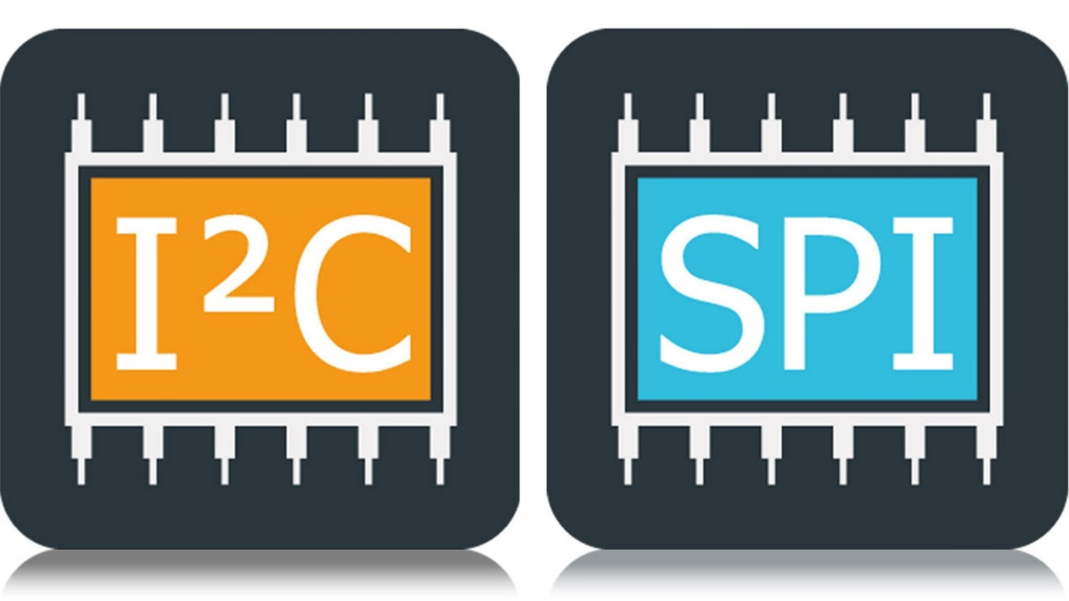

Semester 3 Communication

I2C_SPI Assignment

Dec 12, 2022.

Students: Andre Sanao

Course: Technology

Table of Contents

Introduction 4

Part 1 5

Introduction 5

Implementation 5

Conclusion 5

Part 3 6

Introduction 6

Implementation 6

Conclusion 6

Part 6 7

Introduction 7

Implementation 7

Conclusion 7

Acronyms

*Table 1 – List of acronyms used throughout the report*

|  |  |
| --- | --- |
| **Acronym** | **Meaning** |
| I2C | *à*  *Inter-Integrated Circuit* |
| SPI | *à Serial peripheral interface* |

# Introduction

The assignment on which this document presents is the approach and implementation of which has an end goal of merging the knowledge of the previous assignments from this subject.

Tasks in this assignment requires us to know how communication protocol works between 2 hardware devices. Therefore, we are using an Arduino to connect to a CAN module and put our knowledge that we have received during the lecture. The assignment is split into 4 parts, each regarding one concept of the CAN module.

# Part 1

## Introduction

## Implementation



## Conclusion

# Part 3

## Introduction

## Implementation

## Conclusion

# Part 6

## Introduction

## Implementation

## Conclusion