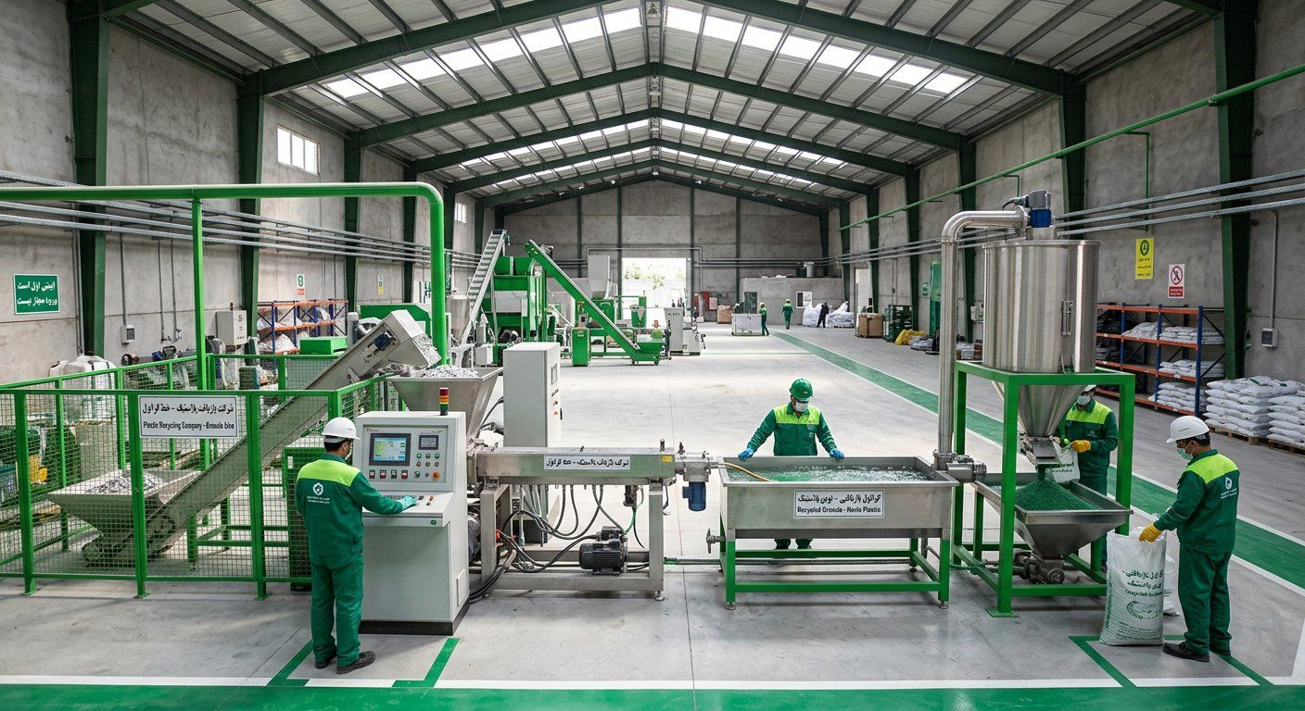
GreenPars Recycling
Critique from a Turkish Trader's View and Sanctions Impact
How much, for what stake and how a Turkish granule trader would engage — under the tightened sanctions of Sept 2026
September 2026

1. Sanctions and banking situation (Sept 2026)
• UN sanctions returned via snapback in Sept 2025; the list names 43 people and 78 entities.
• In Aug–Sept 2026 the US launched 'Operation Economic Outcast' and sanctioned Turkey's Golden Global Bank for moving Iranian funds; the Treasury Secretary said more banks may follow.
• On 23 Sept 2026 Turkey ordered banks to report and delay transactions of UN-listed persons and firms via MASAK.
• Practical result: no mainstream Turkish bank will openly process Iran-linked payments; letters of credit are practically impossible.
Explanation: US petrochemical sanctions cover Iranian polymer products; recycled PE/PP granule may be viewed the same way. The main risk falls on the Turkish side, not on us.

2. What does a Turkish trader look at?
Factor | Reality
Recycled granule price in Turkey | Recycled PP $0.85–1.50/kg; virgin $1.40–2.00
Granule price in Iran | 105–135k Toman ≈ $0.45–0.57/kg
Price gap | ~$0.40–0.60/kg — attractive, but part is eaten by sanctions risk, freight and customs
His risk | SDN listing, bank account closure, losing European customers

Explanation: Our estimate: because of the risk, a Turkish trader would pay at most 30–40% below Turkish market price, i.e. ~$0.55–0.70/kg delivered at the border. This is an estimate to be confirmed in real negotiations.

3. How much, what stake, and how?
Model | Typical amount | Stake / terms | Likelihood
Trial purchase (no investment) | 1–2 containers (20–50 t) ≈ $15–30K | Payment after quality inspection | High
Long-term offtake | 50–200 t/month | 6-month fixed price, $0.55–0.70 | Medium
In-kind (machinery) | $50–150K | 20–30% stake + first right to buy output | Low–medium
Cash / joint venture | $200K+ | 40–51% stake, financial control, 35%+ USD return | Very low (in current conditions)

Explanation: The most realistic start is a trial purchase, then an offtake contract. Turkish cash investment is nearly impossible now, and the plan must not depend on it.

4. How should payment work?
Method | Pro | Con / risk | Verdict
Bank transfer / LC | Transparent | Practically closed | ✗
Barter (granule for Turkish machinery/parts) | No money transfer | Complex valuation and customs | ✓ Best
Netting with an Iranian importer of Turkish goods | Lira stays in Turkey, rial in Iran | Needs trusted counterparty; compliance risk | ✓ With caution
Exchange house / hawala | Fast | Direct target of new sanctions | ⚠ High risk
Crypto / third-country company | Access | UAE also under pressure; high legal risk | ✗ Not recommended

• Proposal: 30% before loading and 70% after independent quality inspection at the border; or full barter for washing and melt-filter machinery.
• All parties must be screened against the US SDN and UN lists before any deal; no US dollars.
• Before exporting, Iran's rules on granule export and FX repatriation must be checked with customs.

5. Critique of the plan under the new conditions
Plan element | Before | Now | Fix
Turkish partner with 15–20% stake | 5/10 | 2/10 | Turn into buyer/supplier, not shareholder
FIPPA to protect foreign capital | 6/10 | 3/10 | Only if sanctions ease
Granule export to Turkey | 6/10 | 4/10 | Side revenue, not the plan's base
Iranian domestic market | 7/10 | 8/10 | Plan's base; expensive virgin polymer raises demand
Iranian equipment (Pendar) | 7/10 | 9/10 | Biggest advantage under sanctions

Explanation: Conclusion: the plan must run fully domestically, with no dependence on foreign money. The Turkish link — as trial purchases and barter — is an upside, not a pillar. The Turkish letters and deck should shift from 'investment' to 'trade cooperation and purchasing'.

6. Concrete offer to a Turkish trader
• Step 1: 25 kg free sample + lab sheet (MFI, moisture, ash).
• Step 2: one 20 t trial container, paid after inspection.
• Step 3: 6-month contract, 50 t/month at a fixed price.
• Step 4: if successful, barter machinery against future granule.

