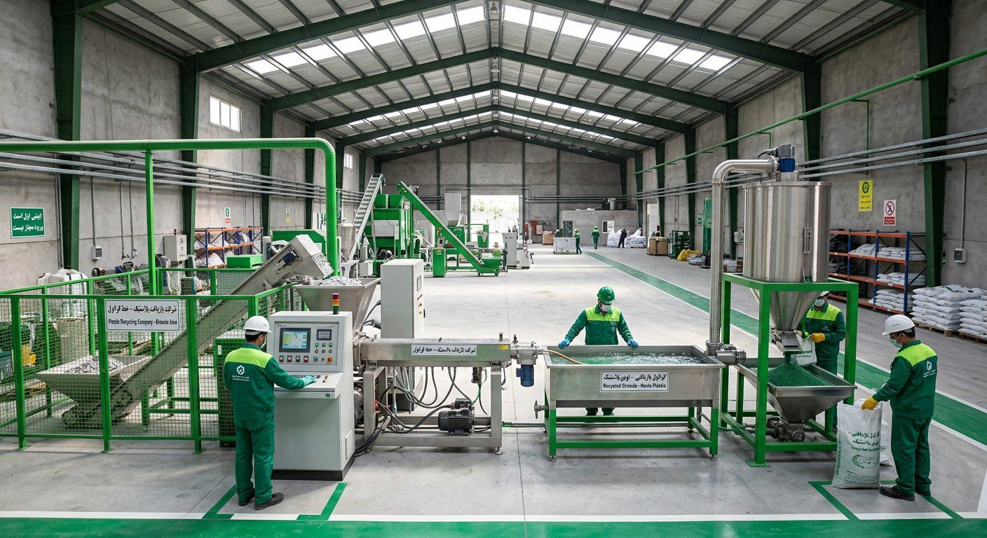
GreenPars Recycling
New Plans: Five Complementary Business Models
Options to cut price risk and capital needs — based on fundraising-guide lessons
September 2026

Why new models?
• Main critique: profit depends on the granule-waste spread; a 15% price drop means a loss.
• Thiel: big share of a small market first. Floodgate: 'proprietary power' means not needing to compete — for us, waste supply.
• The models below either cut price risk, need less capital, or raise margins.

Comparing the five models
Model | Extra capex | Revenue | Price risk | Sanctions fit
A) Toll processing | None | 40–45k Toman fee per kg | Very low | ●●●
B) Buying-station network (franchise) | 1–2 bn per station | 5–8k Toman/kg margin + cheaper waste for the plant | Low | ●●●
C) Producer compliance service (Art. 12) | Low (software, audit) | Recycling certificates sold to packaging producers | Low | ●●●
D) Integration: garbage bags / pipe | 10–15 bn | 30–50% value added on granule | Medium | ●●○
E) Mobile baler/shredder for small towns | 3–5 bn per unit | Lower haulage, more waste | Low | ●●○

Explanation: All figures in this table are first estimates and must be confirmed with real quotes.

A) Toll processing
• The waste owner (factory, dealer) brings material; we return granule for a fee.
• Pro: no waste purchase and no granule price risk; near-zero working capital.
• Use: fill idle capacity in year 1 (40% utilisation) — mix 30% toll + 70% own trading.

B) Buying-station network
• Small neighbourhood stations buy waste from pickers and residents at a fixed price, sort and bale it.
• Franchise: the local partner funds the station; we provide brand, training and guaranteed purchase.
• This is the proprietary supply power — the direct answer to Game 1 (waste competition) in the game-theory report.

C) Producer compliance service
• Under bylaw Art. 12, producers that don't recycle pay a levy.
• Offer: direct contracts with packaging producers to recycle an equivalent tonnage + auditable certificate.
• Revenue independent of granule prices — similar to Turkey's ÇEVKO model.

D) Making garbage bags or pipe
• After the granule market saturates (year 3+), part of the granule becomes a final product.
• Ready customers: the municipality (garbage bags) and farmers (irrigation pipe).

E) Mobile unit for small towns
• A truck with a baler and shredder compacts waste from nearby small towns so hauling to the plant pays off.

Recommended combination
When | Model | Goal
Year 1 | Pilot + A (toll) + 3 stations B | Fill capacity, cheap waste
Year 2 | + C (producer compliance) | Price-independent revenue
Year 3+ | + D (bags/pipe) and E (mobile) + 10 cities | Higher margin, growth

Explanation: With this mix, even in the pessimistic case (granule at 85k), toll and compliance revenue cover part of fixed costs, so the plan no longer hangs on one price.

