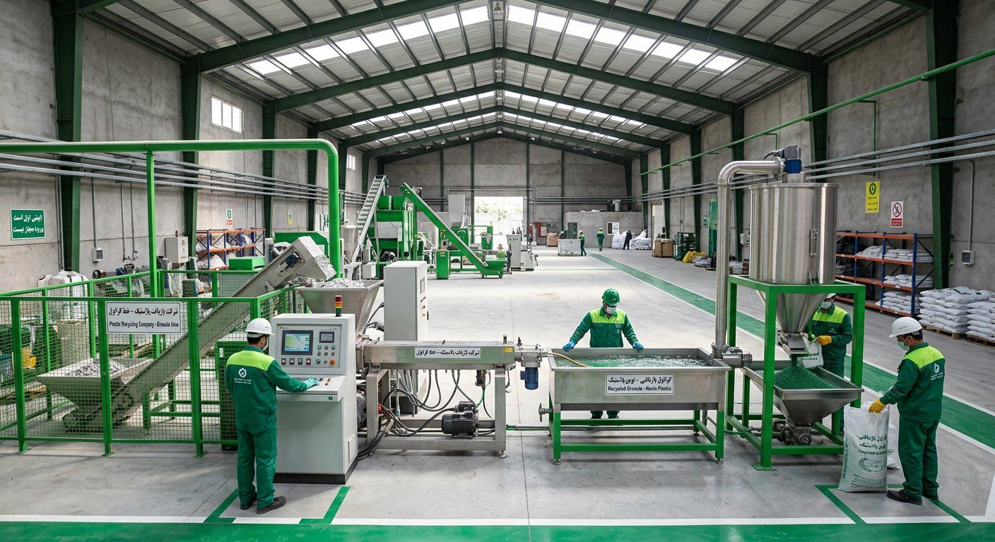
GreenPars Recycling
Investor Cover Email and One-Pager
Per David Teten's checklist: name, location, status, amount and exact terms on one page
September 2026

Email text
• Subject: GreenPars Recycling — Mashhad plastic recycling plant — 31 bn Toman
• Hello [Name], I was introduced to you by [referrer].
• We turn city plastic waste into granule that cuts raw-material cost for pipe and bag makers by 20%.
• Location: Mashhad. Status: financial model, technical partner (Pendar Polymer) and formal letters ready; obtaining quote and municipal MoU.
• Ask: 5 bn Toman for 15–20% equity, part of the 31 bn Toman pilot funding (rest: founders, Pendar instalments, National Environment Fund).
• We state the main risk upfront: granule price sensitivity; our answer is pre-sales, a waste contract and toll revenue.
• Attached: 16-slide deck. Do you have 30 minutes next week?
• [Name] — [Phone] — [Email]

One-pager
Item | Summary
Problem | 20k t/day plastic dumped; virgin polymer expensive
Solution | Washed, filtered, certified granule, 20% cheaper
Market | Mashhad → 10 cities → national
Economics | Capex 31 bn; payback 2.1–5.3 yrs
Edge | Municipal contract + buying stations + Iranian equipment
Ask | 5 bn Toman = 15–20% equity

