Mini-Store Database System
Hero A. Del Mundo  delmundo.hero@marsu.edu.ph | Marc Reiven M. Macaraig  macaraig.marcreiven@marsu.edu.ph
Lexter R, Tolentino  tolentino.Lexter@marsu.edu.ph | Ken Gabriel L. Montellano  montellano.kengabriel@marsu.edu.ph
Kate Jhevin M. Lozano
lozano.katejhevin@marsu.edu.ph

System Overview
Tea Shop Order Management System is a simple and easy-to-use tool that helps manage the daily tasks of running a milk tea business. As more milk tea shops open and grow, it’s important to have a system that can handle orders quickly, keep track of stocks, and show clear sales reports. This system was made to help with all of that making it easier to take orders, manage products, and see how the business is doing, all in one place.
Objectives:
- Automate order-taking and inventory deduction.
- Provide real-time sales tracking and reporting.
- Enable efficient product and inventory management.
- Offer an intuitive user interface for customers and admins.
Key Features:
- Customer and Admin login system
- Product browsing by categories
- Ordering system with size and quantity customization
- Inventory management with stock updates
- Sales and payment tracking with reporting features
- Dashboard with visual analytics
- Reports: Sales, Inventory, Customer, and Payment
Technical Specification
Database Schema (Tables):
Table1. Users Tab
Column | Data Type | Constraint
user_id | int | Primary Key, Auto_Increment
username | varchar(50) | Unique, Not Null
password | varchar(255) | Not Null
role | enum(admin,customer) | Not Null

Table2. orders table
Column | Data Type | Constraint
order_id | int | Primary Key, Auto_Increment
user_id | int | Foreign Key → users(user_id)
order_date | datetime | Not Null
customer_name | varchar(100) | Not Null
total_amount | decimal(10,2) | Not Null
payment_method | varchar(50) | Not Null

Table.3 order_items table
Column | Data Type | Constraint
order_item_id | int | Primary Key, Auto Increment
order_id | int | Foreign Key → orders(order_id)
product_id | int | Foreign Key → products(product_id)
quantity | int | Not Null
subtotal | decimal(10,2) | Not Null
size | varchar(50) | Not Null

Table.4 products table
Column | Data Type | Constraint
product_id | int | Primary Key, Auto_Increment
product_name | varchar(100) | Not Null
stock | int | Not Null

Table5. product_inventory table
Column | Data Type | Constraint
product_id | int | Primary Key or FK (ambiguous)
category | varchar(100) | Not Null
product_name | varchar(100) | Not Null
quantity | int | Not Null
created_at | timestamp | Not Null
last_updated | datetime | Not Null

Table6. Sales table
Column | Data Type | Constraints
sale_id | int | PRIMARY KEY, AUTO_INCREMENT
order_id | int | FOREIGN KEY (orders.order_id)
total_amount | decimal(10,2) | NOT NULL
payment_method | varchar(50) | NOT NULL
sale_date | datetime | NOT NULL

Table7. payments table
Column | Data Type | Constraints
payment_id | int | PRIMARY KEY, AUTO_INCREMENT
order_id | int | FOREIGN KEY (orders.order_id)
amount | decimal(10,2) | NOT NULL
payment_date | datetime | NOT NULL

Table8. customizations table
Column | Data Type | Constraints
customization_id | int | PRIMARY KEY, AUTO_INCREMENT
name | varchar(100) | NOT NULL
type | varchar(50) | NOT NULL

Table9. order_customizations table
Column | Data Type | Constraints
id | int | PRIMARY KEY, AUTO_INCREMENT
order_id | int | FOREIGN KEY (orders.order_id)
customization_id | int | FOREIGN KEY (customizations.customization_id)

Table10. reports table
Column | Data Type | Constraints
report_id | int | PRIMARY KEY, AUTO_INCREMENT
type | varchar(100) | NOT NULL
content | text | NOT NULL
created_at | datetime | NOT NULL

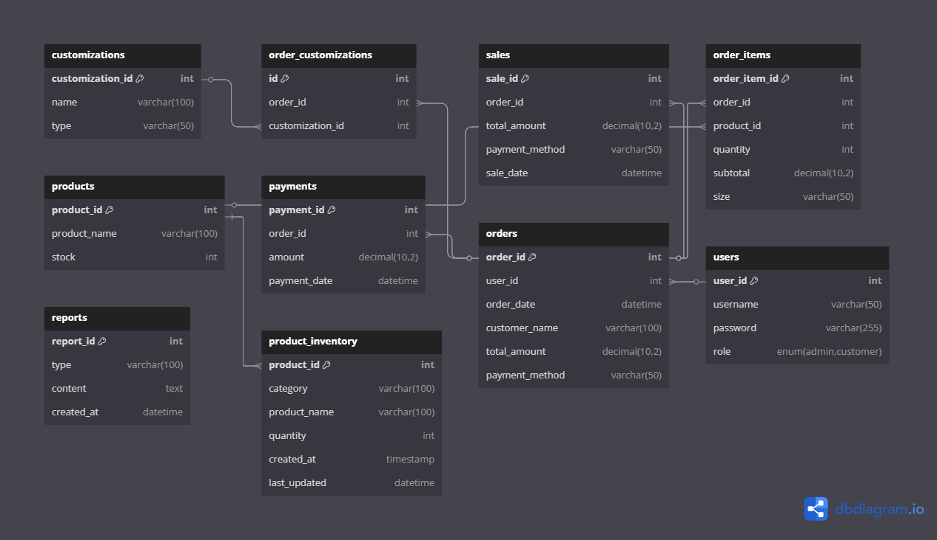
Relationship Diagram (ERD):

Relationships and Cardinalities
- Users → Orders
1 User can place many Orders
Cardinality: 1:N
- Orders → Order_Items
1 Order can contain many Order_Items
Cardinality: 1:N
- Order_Items → Products
Many Order_Items belong to 1 Product
Cardinality: N:1
- Orders → Order_Customizations
1 Order can have many Order_Customizations
Cardinality: 1:N
- Order_Customizations → Customizations
Many Order_Customizations reference 1 Customization
Cardinality: N:1
- Orders → Payments
1 Order has 1 Payment
Cardinality: 1:1
- Orders → Sales
1 Order results in 1 Sale
Cardinality: 1:1
- Products → Product_Inventory
1 Product has 1 Inventory Record (in current schema)
Cardinality: 1:1

Implementation Details
Technology | Purpose
HTML | Markup language used to structure the web pages. It defines the layout and content of the user interface for the ordering system, such as forms, product listings, and other pages.
CSS | Stylesheet language used to design and style the user interface. It was applied to enhance the visual appearance of the site, including layout, colors, fonts, and responsiveness.
JavaScript | Scripting language for client-side interactivity and validation. It was used to handle dynamic content, user input validation, interactive UI components, and toggling between pages or views.
PHP | Server-side scripting language used to implement backend logic. It handles form submissions, communicates with the MySQL database, processes orders, and generates reports dynamically.
MySQL | Relational database management system used to store and retrieve application data such as users, orders, products, inventory, sales, and others.
Visual Studio Code (VS Code) | Code editor used for developing and organizing the project files. It provided features like syntax highlighting, live server preview, and integration with version control.
Google Chrome | Web browser for testing and debugging

Query Optimization Techniques:
Feature | Description | Example Usage
UPDATE information | Efficient use of UPDATE for updating some data or informations | UPDATE orders  SET payment_method = '$payment_method', status = 'Processed'  WHERE order_id = $order_id;
ENUM Data Type | Limits column values to a predefined set of options. | role ENUM('admin', 'customer')
JOIN Optimization | Efficient use of JOINs by indexing and selecting only necessary columns to reduce processing time. | SELECT o.order_id, c.name AS customization  FROM orders o  JOIN order_customizations oc ON o.order_id = oc.order_id  JOIN customizations c ON oc.customization_id = c.customization_id  WHERE o.order_id = $order_id;
Query Caching | Speeds up performance by storing the result of a query and reusing it for identical requests. | $productQuery = $conn->query("SELECT product_id FROM products WHERE product_name = '$product_name' LIMIT 1");
Pagination with LIMIT and OFFSET | Used to retrieve a limited number of records per page, improving load times in large datasets. | SELECT product_id FROM products WHERE product_name = '$product_name' LIMIT 1;
Aggregate Functions for Reporting | Functions used to calculate summaries such as totals, averages, and counts in reports. | SELECT DATE(sale_date) as date, SUM(total_amount) as daily_total  FROM sales  GROUP BY DATE(sale_date)  ORDER BY date DESC;

User Manual
Feature | Steps / Description | Purpose
Accessing the System | Open your browser and go to: http://localhost/databasesystem/login.php  You will be directed to the login page where you can choose to log in as either: - Admin or Customer | To access by the users.
Logging In | • Enter username and password.  • If Admin: redirected to Admin Dashboard.  - Admin username: admin  - Admin password: password123  • If Customer: redirected to product ordering page. | Secure access to the system based on user roles (Admin or Customer).
Admin: Inventory Management | • Navigate to Inventory section.  • Add new products with name, size, category, and quantity.  • Edit or delete existing items.  • Fully supports CRUD operations. | Allows admins to maintain and manage product inventory efficiently.
Admin: Order Management | • View all customer orders.  • Track order status, product quantities, and payment methods. | Helps admins oversee order flow and keep records organized.
Admin: Sales Tracking | • Access sales log with payment type, amount, and date.  • Monitor sales by day, week, or month. | Provides financial insight and tracks business performance.
Admin: Report Generation | • Generate reports: sales summaries, product performance, and inventory levels.  • Reports are viewable and printable. | Supports business decision-making and auditing through detailed documentation.
Customer: Product Selection | • Browse milk tea products by category (e.g., Iced Lattes, Bubble Teas).  • Select size (Solo, Jumbo) and customize. | Enables customers to explore and choose from a wide range of products.
Customer: Placing Orders | • Proceed to checkout after selecting a product.  • Choose payment method (Cash or Online).  • Submit the order and receive confirmation. | Facilitates easy and quick ordering with flexible payment options.
Customer: Order Confirmation | • Once order is submitted, system displays a success message.  • Orders are recorded and visible to the admin. | Confirms order placement and ensures it's recorded for fulfillment.

Screenshots and Sample Output
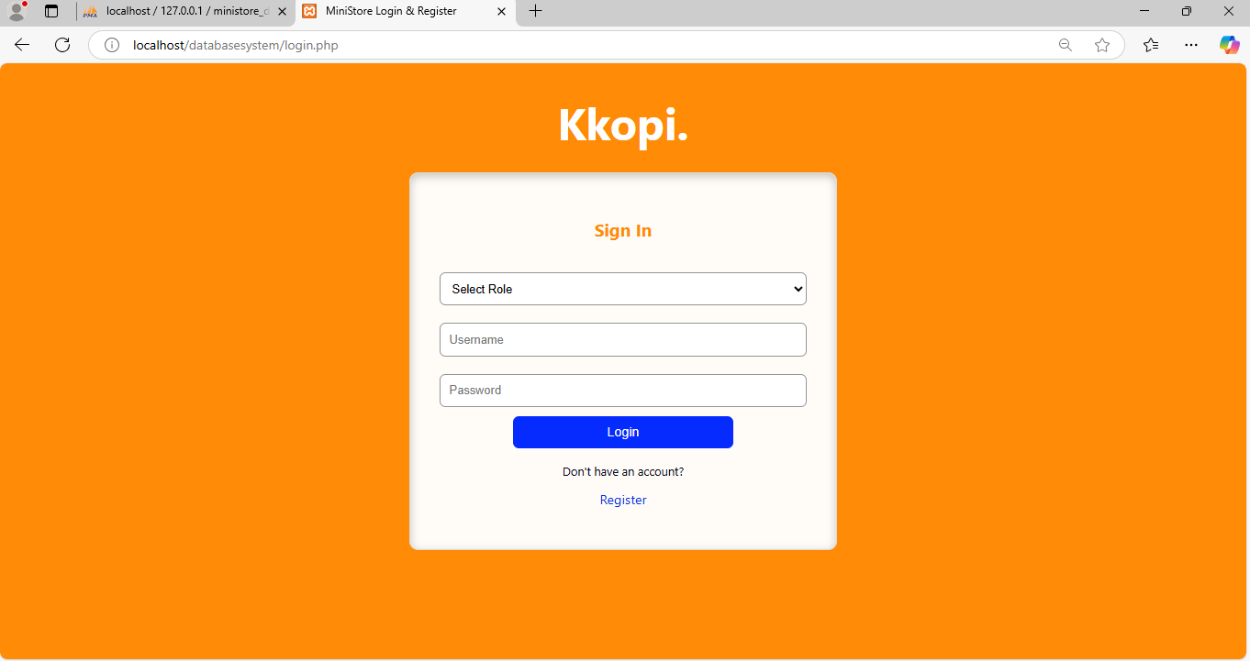
Login page
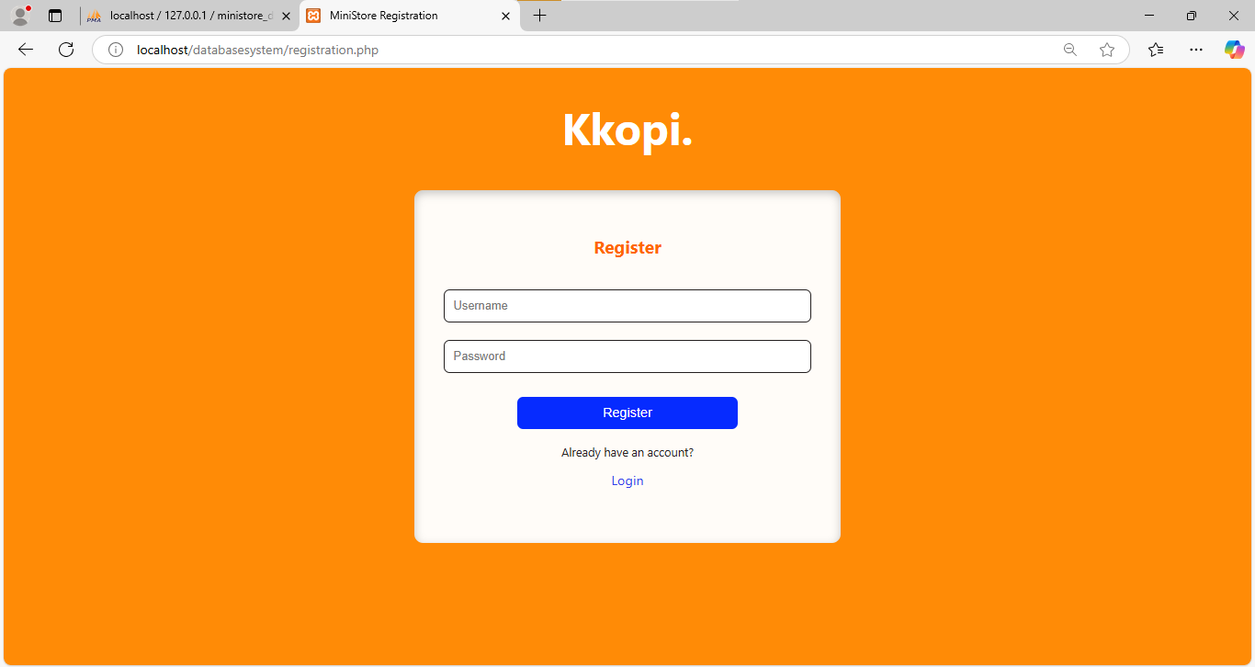
The entry point for both customers and admins. The customers can create new account if they are new user.

Order Page
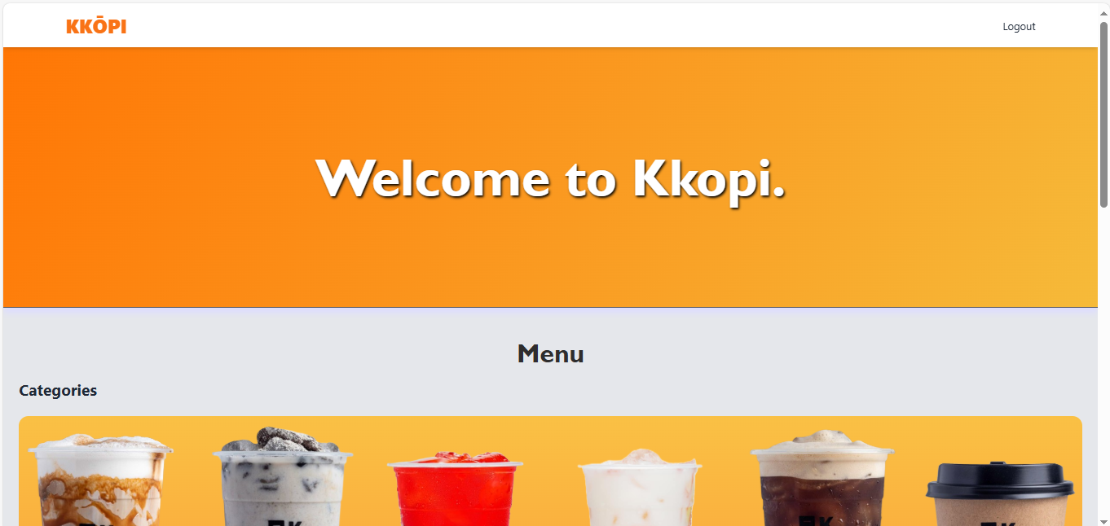

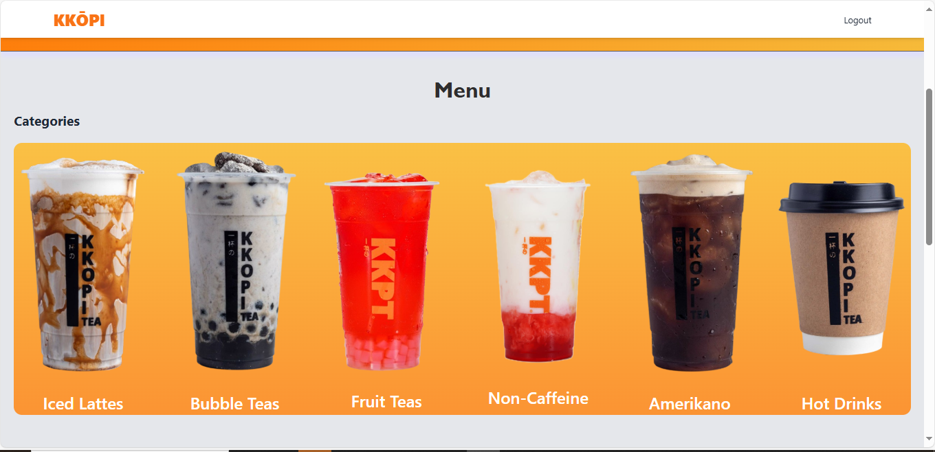

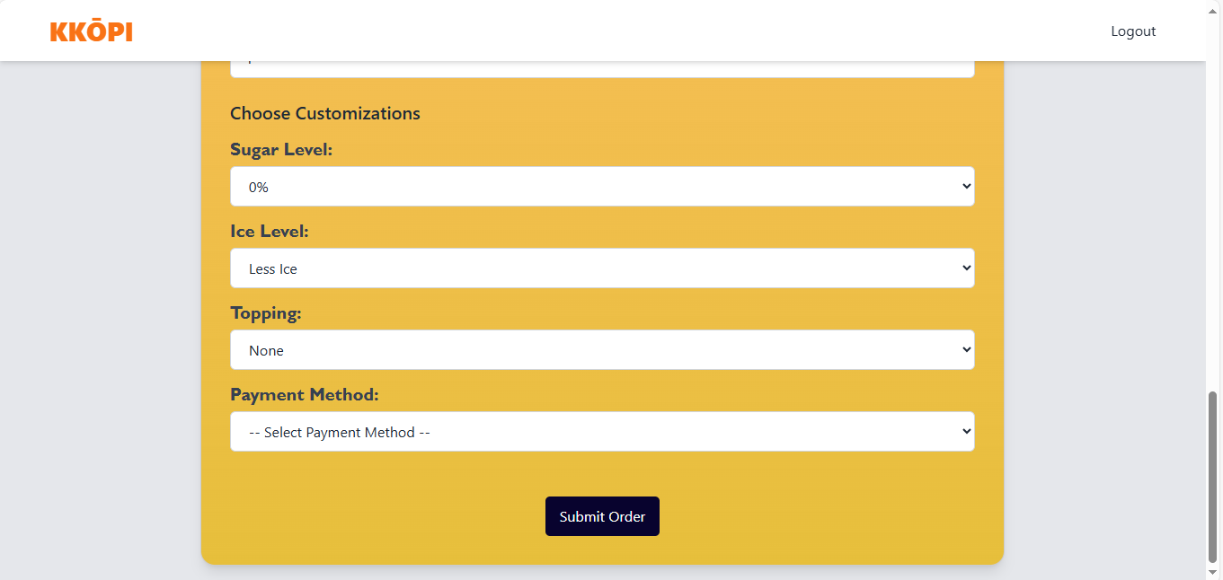
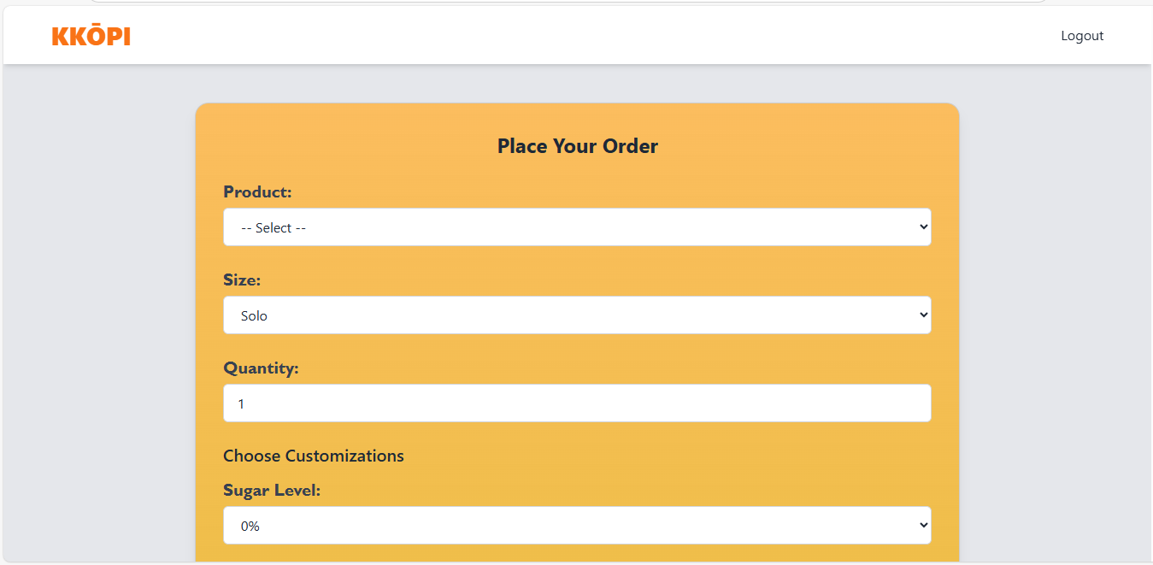
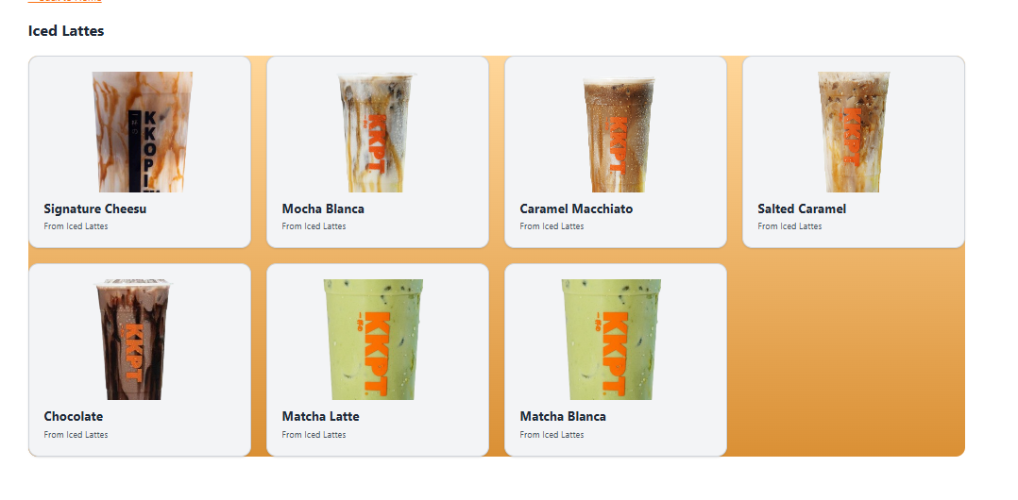
Where customer can browse, customize, and order products.

Dashboard

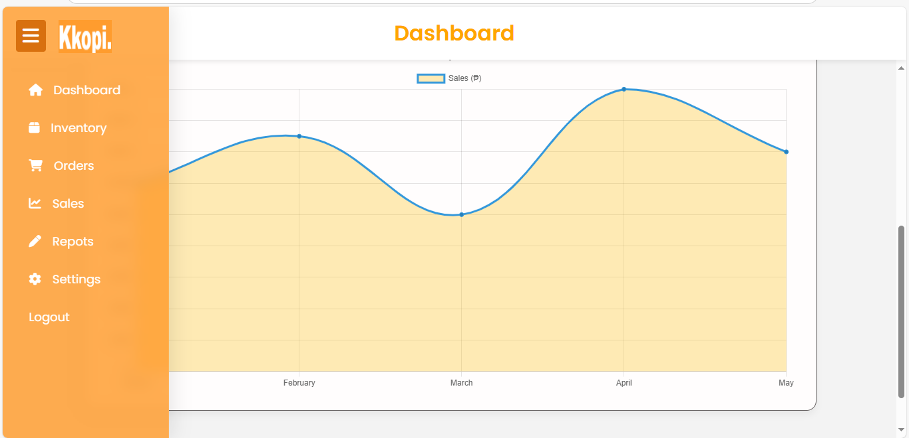
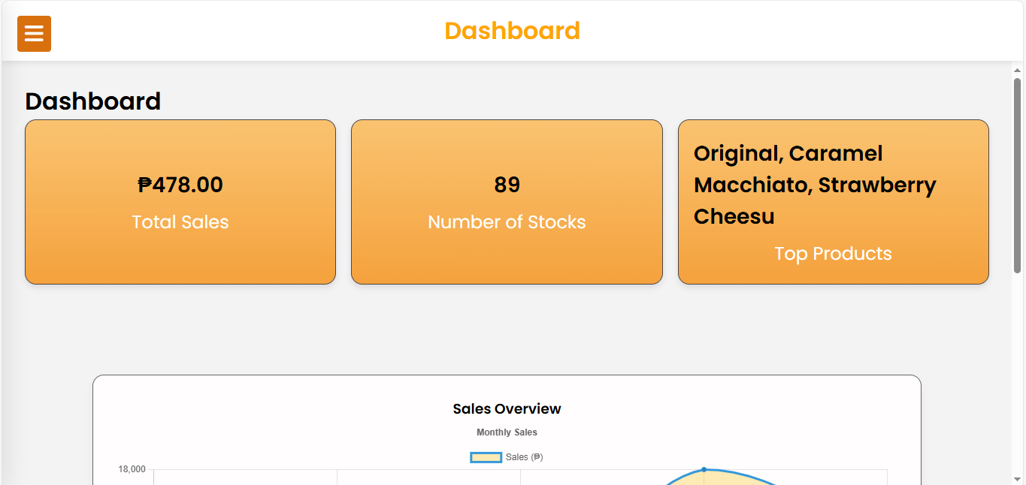

Inventory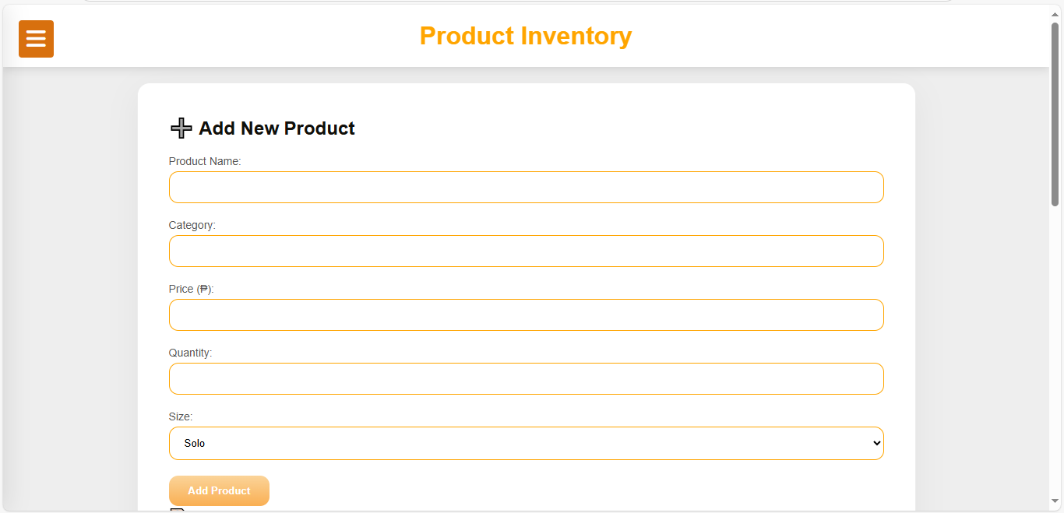

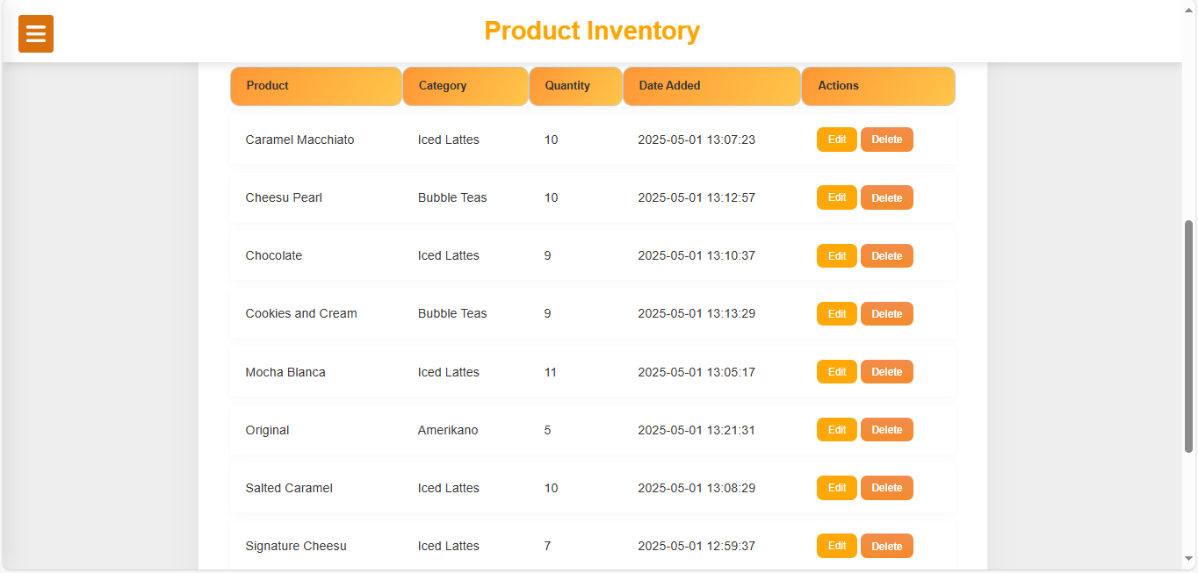
Shows the list of the products and also it can track, add, delete and edit products here.

Order Management
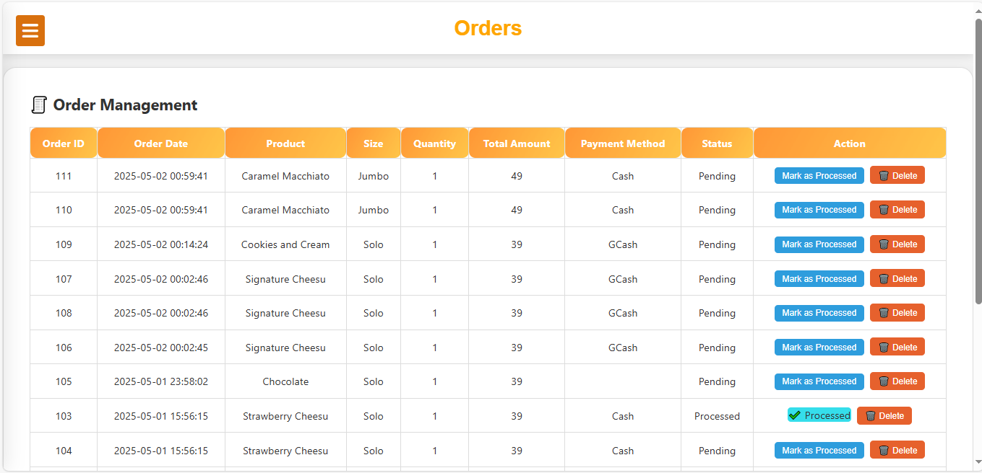
Shows the list of customers’ orders.

Sales Tracker
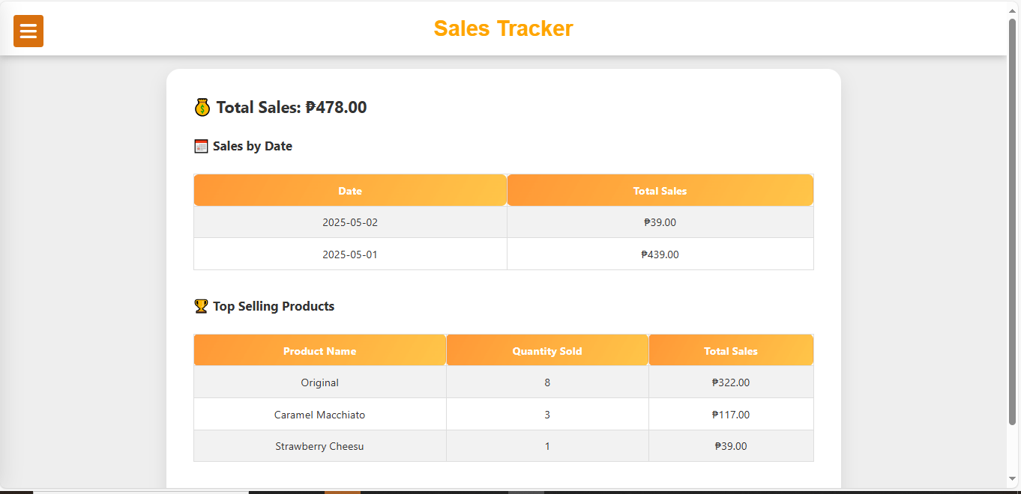
Shows the total sales and top selling products.

Reports 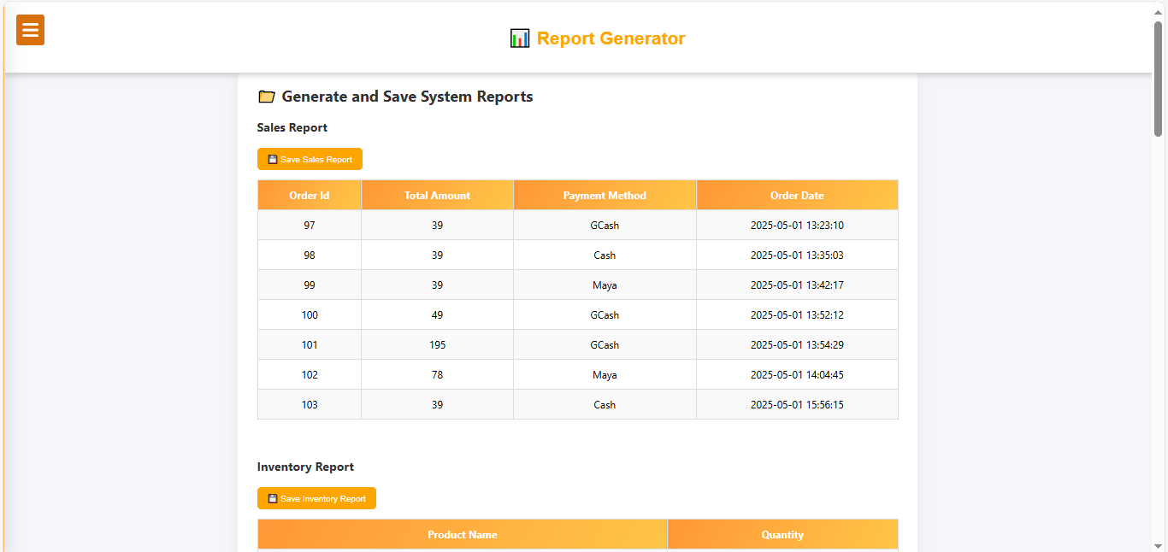
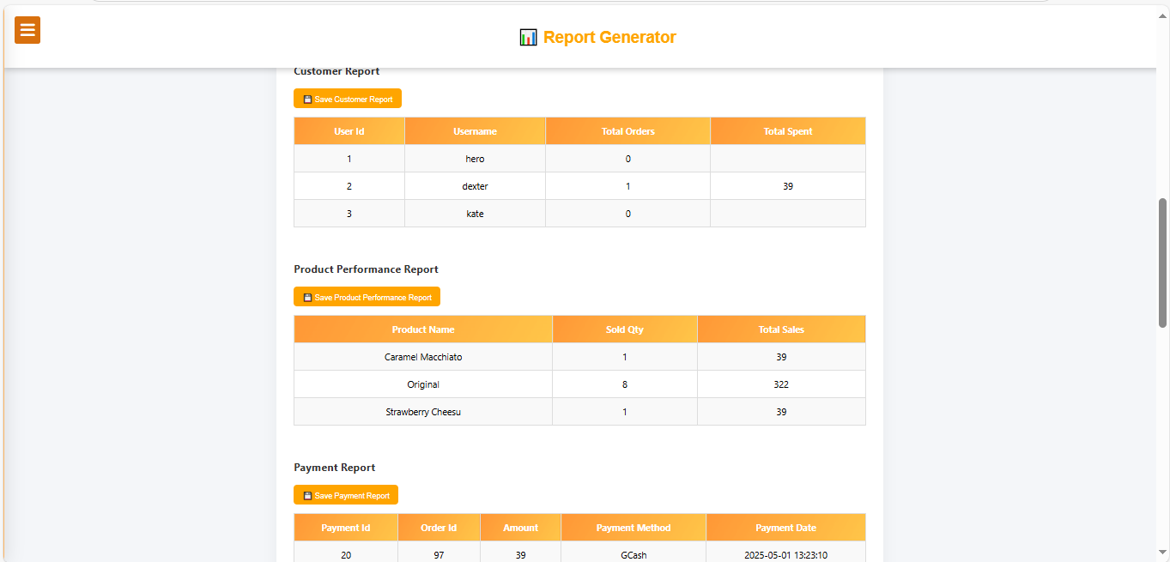
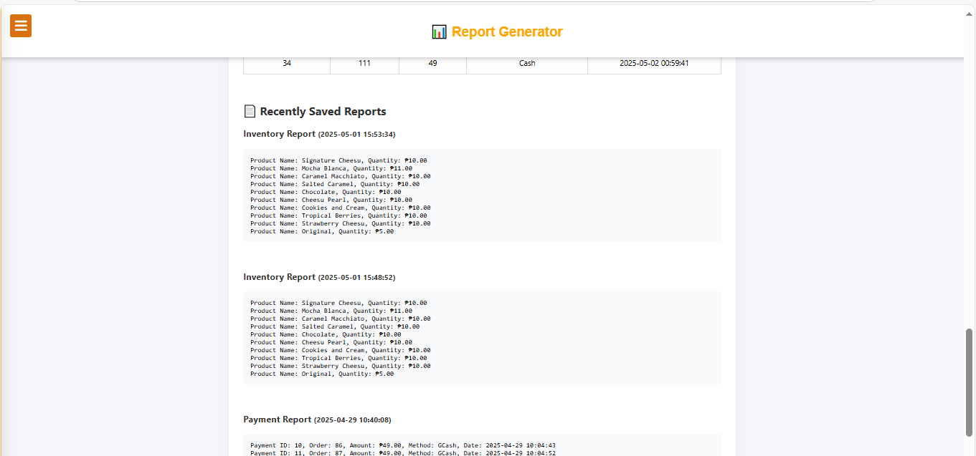

The report generator is used to analyze sales, inventory, and customer behavior by presenting organized data summaries.

